Hi. We’d like to ask you a couple of questions to help us know how many young carers there are in school, so that we can help you if you’re looking after someone in your family because they need extra help. This information will only be looked at by school and by Sheffield Young Carers, unless a teacher is worried about you.
Dad
Mum
No-one
- Do you help to look after someone in your family because they need extra help? (please circle or tick as many boxes as apply to you) 

School:
Year group: Form:
Your Name and Surname:
Date of Birth:
Today’s date:

Grandparents
Other
Brother/Sister

2. Why do you need to look after them? (please circle or tick)
They have a physical  disability | 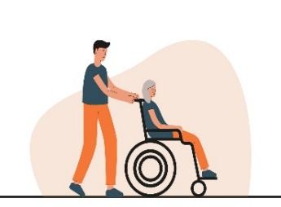 | They use drugs |  | They are ill in another way |  | They drink too much alcohol | 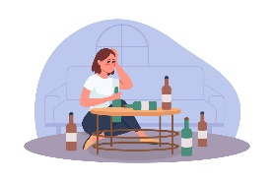
They have a learning disability |  | They have a long term illness (e.g cancer or epilepsy, or many others) |  | They have mental health problems |  | I prefer not to say
What sort of things do you do to help? (please tick the column that applies to you for each question)
 |  | Never  X | Some of the time | A lot of the time |  |  | Never  X | Some of the time | A lot of the time
- Clean your own bedroom | 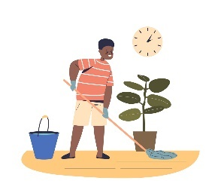 |  |  |  | - Clean other rooms | 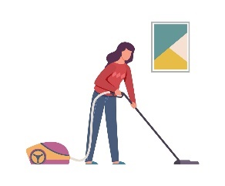
- Wash up dishes or put away dishes in a dishwasher | 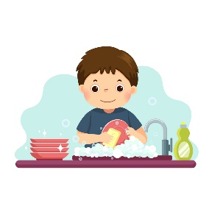 |  |  |  | - Decorate rooms | 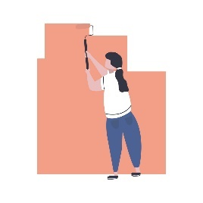
- Take responsibility for shopping for food |  |  |  |  | - Help with lifting or carrying heavy things | 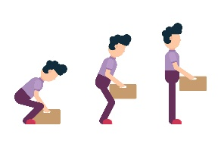
- Help with financial matters such as dealing with bills, collecting benefits |  |  |  |  | - Work part time to bring money in | 
- Interpret, sign or use another communication system for the person you care for |  |  |  |  | - Help the person you care for to dress or undress | 

 |  | Never  X | Some of the time | A lot of the time |  |  | Never  X | Some of the time | A lot of the time
- Help the person you care for to have a wash | 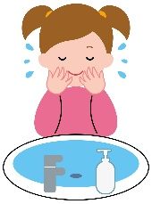 |  |  |  | - Help the person you care for have a bath or shower | 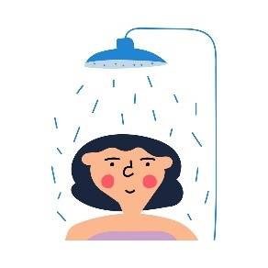
- Keep the person you care for company e.g. sitting with them, reading to them, talking to them | 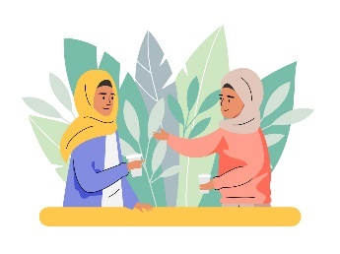 |  |  |  | - Keep an eye on the person you care for to make sure they are alright | 
- Take the person you care for out e.g. for a walk or to see friends or relatives | 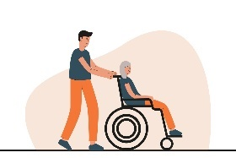 |  |  |  | - Take brothers or sisters to school | 
- Look after brothers or sisters whilst another adult is near by | 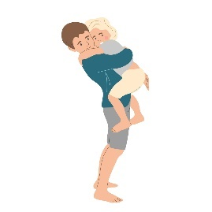 |  |  |  | - Look after brothers or sisters on your own | 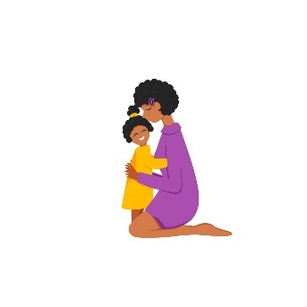
Thank you for answering this. If you have any more questions, or want to tell us anything else, please ask to speak to your teacher.
Anything else you would like to tell us?

