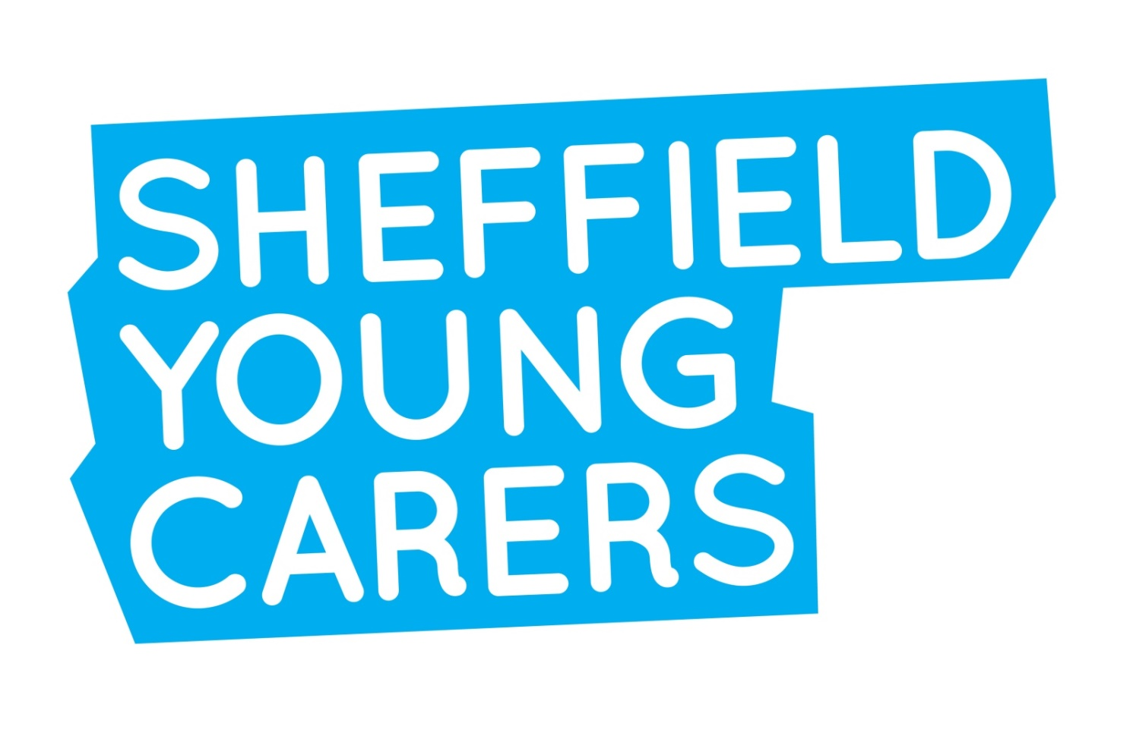

Session Plans for a four - five week transition programme young carers for Y5/6 primary pupils (programme 2)
Identifying and supporting young carers in a primary setting
Sheffield Young Carers (SYC) aims to support schools to identify and support young carers in order to reduce the impacts that caring responsibilities can have on pupils’ attendance, attainment, aspiration and well-being.
Caring responsibilities often remain hidden until a crisis happens, due to stigma, fear or because some pupils do not realise their life is different to other people their own age. This package has been developed to support young carers to build resilience and coping strategies with a particular focus on transition from Y6 to Y7
Who will benefit from attending the course?
Any pupils who are vulnerable or at risk of not reaching their potential. In particular, any children who are known to have parents who have issues around substance misuse or mental health issues are strongly encouraged to attend the sessions.
Session plans
The following pages detail the course content and projected aims and outcomes.

For further information, please contact Laura Selby at Sheffield Young Carers on:
Tel 0114 2584595
Email laura.selby@sheffieldyoungcarers.org.uk

Session 1
Aims: To develop a sense of team and get to know one another. To develop problem solving skills.
Objectives: To contribute to the team charter. To solve a problem individually and as a team.
Outcomes: Group agreement, road map, ‘build a bridge’ challenge and discussion.

Time | Activity-Details | Resources
10 minutes  10 -15 minutes  25 minutes  5 minutes | Warm up game: use a warm up ball. If you don’t have one design one. Write on the ball simple open questions that are non- intrusive to answer. When the young person catches the ball they answer the question their right thumb lands on.  Introduction to the group about why we are here and clarify today’s objectives. Group agreement to be completed and signed by all young people and group facilitators.  Build a bridge: introduce problem solving and team work as a skill.  Split the group in to two teams. Each team to choose a name, draw a plan and construct a bridge across a bowl of water with limited materials. The aim of the task is to make the strongest bridge. Each team has 25 minutes to do this. The bridge is tested with pebbles one at a time until the bridge collapse. The strongest bridge is the winner. Spend some time after to discuss how the teams could have worked better and what things would have helped it to succeed.  Circle time: ask each group member one thing they have learned and one thing they have enjoyed about the session. Score today’s 1-10 on the road map around to today’s session. | Flip chart paper  Plan for the course drawn as a road map on flip chart, pens  Lolly pop sticks, putty or blue tack, paper clips, string, glue, flip chat, pens, plastic sheeting and material limit list.  Road map (from above)

Session 2
Aims: To explore feelings about caring and identify support networks for young carers.
Objectives: For group members to develop an awareness about the strengths and difficulties of being a young carer. For young carers to identify support networks both individually and as a group.
Outcomes: To produce a creative visual plate of food of the group’s positive experiences and struggles of being a young carer and to show our support networks.

Time | Activity-Details | Resources
10 minutes  30 Minutes  10 minutes  5 minutes | Introduction game: Zip, Zap, Boing  ‘A lot on your plate’:  On a large piece of paper have a picture of a plate.  Lay out the laminated food cards & prompt the young people to choose three foods they really enjoy eating and three things they dislike. On the foods they like, ask them to write down one thing that they like / enjoy about caring for their family member and on the food they don’t like write one thing they find difficult about caring.  Once all the food has all been distributed on the plate discuss why people like particular foods, are there any foods (elements of caring) on the dislike side that others in the group like? Discuss in the group how young people can find it challenging looking after someone in their family.  How can we support each other? Each group member gets a small plate and the food is shared out equally. Explain it often helps to share the load of the difficult things  Circle time: Ask the young people one thing they have learned and one thing they have enjoyed about the session. Score 1-10 on the road map for today’s session. | Laminated pictures of food, large picture of a plate on lining paper, glue, pens.  Paper plates, glue.  Road map

Session 3
Aims: To explore friendship, bullying and moving to secondary school.
Objectives: To be able to describe the qualities of a good friend and explain the importance of friendship. To resolve a scenario involving bullying in a positive way through the form of a letter. To share worries and concerns about moving to secondary school.
Outcomes: To produce a visual ideal friend, identifying positive qualities we would like to get and give in our friendships. To produce a reply to a young person in a bullying situation about a positive way to deal with bullying.

Time | Activity-Details | Rescores
10 minutes  20 minutes  20 minutes  10 minutes | Warm up game: Two Truths One Lie  What makes a good friend: Ask the group to draw round one of the members of the group. Then as a group ask the young people to write/draw/cut and paste all the things that make a good friend by thinking about their own friendships.  Agony Aunt: Give the group a letter to an agony Aunt/Uncle about someone being bullied. Either as a large group or two small groups, get them to pen a reply to how they could help the young person.  Discussion about if these are any of the fears they might be feeling about moving to secondary school and how this might impact on their caring role.  Circle time: ask each group member one thing they have learned and one thing they have enjoyed about the session. Score 1-10 on the road map | Flip chart paper  Marker pens  Magazines if you wish  Example agony aunt letter from a suitable magazine/ website (or create your own)  Pens  Road map

Session 4
Aims: To alleviate fears about the transition to secondary school.
Objectives: To build confidence and understanding about what to expect at secondary school.
Outcomes: To produce a tool kit to enable discussion and give group members tools to support them in their transition to secondary school.
Time | Activity-details | Recourses
10 minutes  20 minutes  20 minutes  10 minutes | Warm up game: 1-15  Tool Kit:  The young people are asked to create a tool kit/survival kit of everything they are going to need for beginning their new school/educational journey.  This should include practical things. Get the group to write or draw these and put them in to the tool box.  Get them to also think about qualities they will take with them to secondary school : Using affirmation Sheets asked the young people to write down all the positive qualities they feel each other have: resourceful, good listening, good friend etc.  Celebrate these and place them in the tool box  Top tip survival guide Explore coping strategies and strengths.  Get the group to share some of the difficulties or worries they have about going secondary school –write these on a flip chart. Then come up with a top tips guide to combat these anxieties!  Circle time: ask each group member one thing they have learned and one thing they have enjoyed about the session. Score 1-10 on the road map.  Complete end of group evaluation and give out certificates. | A tool Box (real or a big picture of one)  Paper, pens  Flip chat  Marker pens  Road map  School evaluations  School certificates
Additional session if useful for the group - Anger management session:

Aims: Identifying what anger is and how to deal with it in a positive and constructive way.
Objectives: To support young people to find strategies in order to deal with anger in a productive way using art and drama techniques.

Time | Activity-Details | Resources
10 minutes  20 minutes  20 minutes  10 minutes | Warm up game:  Anger wall: Ask the group to write on the wall all the things that make them angry  Get them to act out or draw their angry faces on the wall.  Discuss how they feel (in their bodies and their minds) and act when they are angry and add these to the wall  Consequences of negative actions of anger. Ask the group to act out a situation when they feel angry and a negative response, either as a short play or in 3 freeze frames. As a group, talk about ways of dealing with anger in positive ways and write this as a list on a flip chart. (e.g. breathing exercises, counting techniques, avoidance).  Ask them to do their drama again to get a different ending that they prefer (a positive outcome).  Do a relaxation  Circle time: ask each group member one thing they have learned and one thing they have enjoyed about the session. Score 1-10 on the road map. | Lining paper to cover a wall area  Marker pens  Pens, colours crayons  Flip chart paper  Pens  Use a creative visualisation  Road map

