Tarves Heritage Centre/Project | RISK ASSESSMENT | 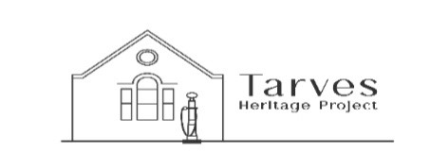
Process/Activity: Visits to Heritage Centre and Victorian Classroom by primary aged children on a planned trip accompanied by school staff. | Location: Tarves Heritage Centre  1The Square, Tarves AB417GX | Date: 1/7/2026  Catherine S Smith  THP Volunteer
Describe activity: Children and staff visiting the classroom and Heritage Centre
Hazard | Person/s Affected | Risk | Risk level before controls are in place (delete as appropriate) |  |  | Control Measures | Risk level after controls are in place  (delete as appropriate)
Classroom desks | Children and staff | Fingers being trapped by the hinges, wooden splinters in the seats | LOW | MED | HIGH | Desk are checked before visits and any repairs done promptly or desk not available sign displayed. | LOW | MED | HIGH
Slates and pencils | Children and staff | Small pencils being swallowed. Slates with damaged wooden edges | LOW | MED | HIGH | Warnings about use and all equipment checked before visit. | LOW | MED | HIGH
Pinafores and waistcoats | Children and staff | Unclean clothing and loose buttons | LOW | MED | HIGH | Clothing is regularly laundered and checked for signs of wear and tear. Any repairs are done promptly. | LOW | MED | HIGH
Handling of Victorian objects | Children and staff | The objects are old and some may be fragile. | LOW | MED | HIGH | Any object that could cause harm e.g. mincer are disabled and children are always supervised when around them. | LOW | MED | HIGH
Courtyard area | Children and staff | Steps, metal railings, metal gate, retaining wall, door hinges, picnic table and chairs | LOW | MED | HIGH | Children will be told not to climb on the wall/railings/gate under any circumstances. They will be supervised at all times whilst in the courtyard | LOW | MED | HIGH
Use of the Centre | Children and staff | Display cabinets, toilets, artefacts | LOW | MED | HIGH | All facilities used by visitors will be thoroughly checked for any signs of damage.  First-aid equipment is checked and updated  A fire evacuation procedure is explained to staff and children.  Fire extinguishers are checked annually | LOW | MED | HIGH

