Event information   | Tarves Heritage Project - SC No 021511  2025 Scarecrow Festival Entry form  Your own cartoon themed character
Dates | Scarecrows to be on display from Friday 17 October to Friday 31 October 2025 and must be displayed at the address given on the contact details below.
Event organisers | Tarves Heritage Project
Contact details | tarvesheritage@outlook.com; or via Tarves Heritage Project Facebook page
Your contact details
Name
Address
Phone number
Email address
Completed entry forms  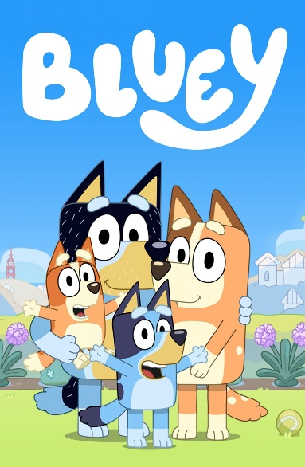  This Photo by Unknown Author is licensed under CC BY-SA-NC | Please return completed entry form no later than Friday 10 October. You can reply via:  - email to tarvesheritage@outlook.com  - hand in your form directly to the Centre when it is open from 1 - 4pm on Thursdays, Fridays and Sundays  - hard copy to the Heritage letter box at the back of the Heritage building, just off Haddo Lane  We will be in touch with you after then to allocate a number to be displayed on your scarecrow.  Please also take time to look at the guidelines on the other side of this form.

2025 Scarecrow Festival Guidance

1 | Registration begins on Friday 19 September until Friday 10 October.
2 | Contest is open to all ages; individuals, families, clubs and groups and there is no entry fee.
3 | All entrants agree to allow use of their name/s and photos for promotional purposes.
4 | Any materials can be used for your scarecrow and we especially welcome recycling/re-use of what you already have.
5 | Entries must be appropriate for a community/family event so please no politics/gore etc
6 | Entries must be sturdy and freestanding and easily visible from the pavement/road.
7 | Contest entries must be registered by Friday 10 October and on display from Friday 17 October until Friday 31 October. Scarecrow entries must be displayed at the address given on the entry form.
8 | Judging will be by an independent adjudicator and will begin week commencing Monday 27 October; judge’s decision will be final.

