Event information  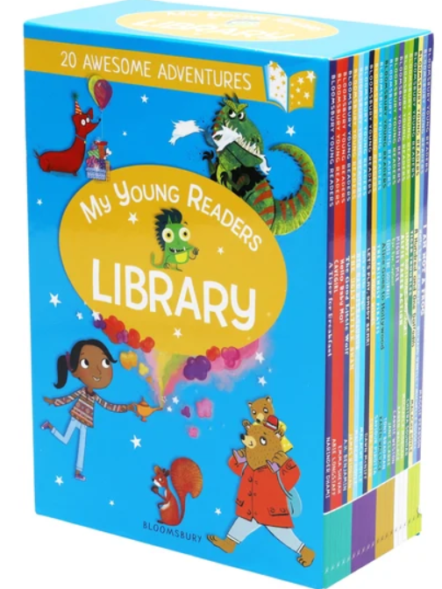 | Tarves Heritage Project - SC No 021511  2026 Scarecrow Festival Entry form  Your own book themed character
Dates | Scarecrows to be on display from Saturday 17/10/26 to Saturday 31/10/26 and must be displayed at the address given on the contact details below.
Event organisers | Tarves Heritage Project
Contact details | tarvesheritage@outlook.com; or via Tarves Heritage Project Facebook page
Your contact details
Name
Address
Phone number
Email address
Completed entry forms  Need new pic here | Please return completed entry form no later than Monday 13/10/26. You can reply via:  - email to tarvesheritage@outlook.com  - hand in your form directly to the Centre when it is open from 1 - 4pm on Thursdays, Fridays and Sundays  - hard copy to the Heritage letter box at the back of the Heritage building, just off Haddo Lane  We will be in touch with you after then to allocate a number to be displayed on your scarecrow.  Please also take time to look at the guidelines on the other side of this form.

2026 Scarecrow Festival Guidance

1 | Registration begins on Friday 2/10/26 until Monday 12/10/26
2 | Contest is open to all ages; individuals, families, clubs and groups and there is no entry fee.
3 | All entrants agree to allow use of their name/s and photos for promotional purposes.
4 | Any materials can be used for your scarecrow and we especially welcome recycling/re-use of what you already have.
5 | Entries must be appropriate for a community/family event so please no politics/gore etc
6 | Entries must be sturdy and freestanding and easily visible from the pavement/road.
7 | Contest entries must be registered by Monday 12/10/26 and on display from Saturday 17/10 until Saturday 31/10 . Scarecrow entries must be displayed at the address given on the entry form.
8 | Judging will be by an independent adjudicator and will begin week commencing Monday 19/10/26; judge’s decision will be final.

