Podcast outreaches
Hi [name],
My name is [your name] and I am part of Scale International - we're recruiting experts in the Tech industry that strongly believe in Tech for Good.
We recently launched the HR Tech for Good Podcast, a podcast about ethics, diversity & inclusion, sustainability, and innovation in the HR Tech space that you are part of too.
I’d like to invite you to attend our show. Our target audience would be interested in your work within the sector, as well as the impact you have and causes you believe in, and how your product can shape the future.
Take a look at our first episodes with Bill Boorman, Frida Polli, and Vern Howard Jr. - it would be a pleasure to continue having quality guests like yourself among them, as our listenership is growing.
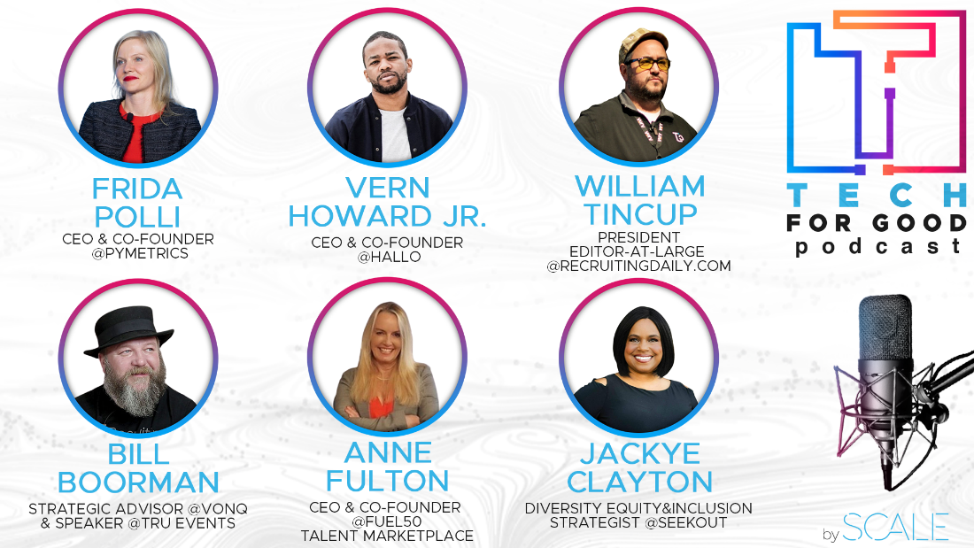
Here is the first episode we recorded with Bill Boorman, we're really excited about publishing the rest very soon.
Would this interest you? Interviews are typically 30 minutes long and are conducted via Zoom.
I know you are terribly busy, so we are happy to accommodate the time according to your needs.
Thank you,
[your name]

Hi FIRST_NAME,
We're looking for recruitment founders to be on our podcast. We want to hear your story and what you've learned in the process.
In the past months we have had increased requests from companies asking us to help them find talent - there is a lot of competition out there, which means it's tough to stand out as an agency and attract the best people.
That is why we created the Recruiter Startup Podcast in the first place! The podcast allows recruitment founders to tell their stories and talk about their company in order to make themselves more appealing on the market.
Listeners will get some great insights into what goes on behind-the-scenes at different recruiting agencies around the world and the founders will get to reach a wider audience that is genuinely interested in them.
Here’s just a few of the people that joined our podcast over time:
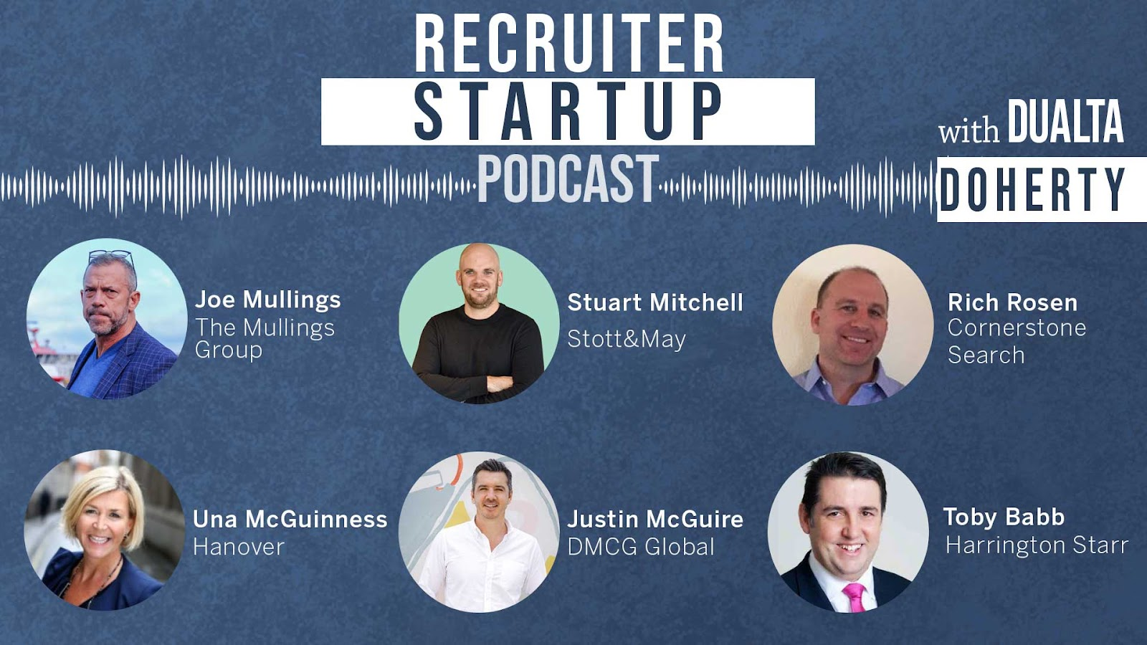
We've had some amazing episodes in the last few months with people like Boris Epstein, CEO of BINC, Jordan Rayboy - The Digital nomad Recruiter and Rich Rosen, the Million Dollar Biller. These guys are incredible founders and specialists who took different paths to get where they are today--and their stories are inspiring. Let me know if you're interested in being a guest on the podcast and I’ll send an invitation as soon as possible.
Dualta

After doing a poll asking for guest recommendations/ interest in being a guest:

Hi {{first_name}},
Thanks for engaging with Dualta's poll recently. As you already know, we are looking for recruitment founders to be on our podcast.
We want to hear your story and what you've learned in the process so I wanted to reach out and see if you’d like to be a guest in the coming weeks.
We've had some amazing episodes so far with people like Boris Epstein, CEO of BINC, Jordan Rayboy - The Digital nomad Recruiter and Rich Rosen, the Million Dollar Biller.
These guys are incredible founders and specialists who took different paths to get where they are today--and their stories are inspiring.
Let me know if coming on the podcast is of interest and my assistant can come back shortly with times to record.
Best regards,
X

Follow up 1
Hi {{first_name}}
Hope you are well and are having a good week. Appreciate I have sent a previous message about our Tech for Good podcast however I also wanted to connect again with you as we would like the opportunity to introduce ourselves properly, get to know you and see how we might be able to partner together to assist with your company's growth.
Below is a little information regarding ourselves, how we assist our clients, and our fees, forease of reference. I'd love to send you some more details about us.
- Our podcasts bring attention to our clients brands with guest spots for our clients
- We have a strong DEI ethos
- We have international leadership groups to assist in a reseller capacity for our clients if suits
- We use a vast database of contacts to engage with passive and proactive candidates
- We headhunt rather than rely on advertising
- We have circa 20 years of experience working with scaling tech companies
- We work with our clients to build long lasting relationships rather than purely transactional
We keep our contingency recruitment fee model as simple as possible so it would be great to schedule an exploratory call to see where we align, are you free this week?
Best regards,
X

Follow up 2
Hi {{first_name}},
Appreciate I sent you an email and a LinkedIn message about our Tech for Good podcast -have you had a chance to consider it yet?
You can find links to the podcast below which can be accessed on iTunes, Google Podcasts and Spotify through Anchor FM –

We have now reached over a quarter of a million downloads across our podcasts so it would be great to schedule a quick call to further discuss, you can book into my calendar direct here – www.calendly.com .
We'd love to have you get involved!
Thank you,
X
Pre recording email template
Hello first name,
We are very excited to have you on the Recruiter Startup Podcast show!J
ust wanted to get in touch with you and make sure nothing has changed and you can still attend the event on Date, at Time.
I’ll come back to you one day prior to the event to send you the invite to the zoom which you can also find details of in the calendar invite.
The podcast will be approx. 30 minutes in length, and you will have time before we start recording to catch up with Dualta.
We aim to turn around the editing of the podcast quickly and will keep you updated to let you know as soon as it is publicly available. At that stage we hope you will also share the podcast link with your network to maximize it's reach.
Thank you and have a great day!
Best regards
X

Post recording email template
Hello first name,
Thank you for taking part in the Recruiter Startup Podcast show, it was great having you on as a guest.
We have recently released the podcast and you can find a link to it here below
-Link insert
We have shared these on our social channels and tagged you in the posts so if you can like and share these with your network that would be great.
It was great recording together, if you know of anyone else who you think would make an interesting guest for the podcast please let me know as we'd love to have them on.
Thank you and have a great day!
Best regards,
x

