V1 - Sourcewhale – Linkedin, Email and phone

- Connection request:
Be great to connect!

- Inmail:
Hi {{firstName}},

Hope all is well? How's the week going? 😊

I sent through a connection request {[previousStepDay]} and wanted to follow up with an InMail as well.

(INPUT SOMETHING PERSONAL HERE)

Appreciate you must get bombarded with messages on LinkedIn however keen to introduce myself. I'm an International Rec2Rec Consultant focusing on recruitment roles across LOCATION.

Have you thought about making an international move before? Your background is amazing, my clients would bite my hand off for a profile like yours.

We work on some exciting opportunities across the US, Australia, Cayman Islands & Dubai, not sure if you are open to a career move at present but I'd love to speak to you more about this opportunity and others if you are open to a confidential call {[tomorrow]}?

- Email:
Hi {{firstName}},

Hope you are having a good {[timeOfDay]}{[dayOfWeek]}.
I tried reaching out on LinkedIn {[previousStepDay]} however thought it best to try and follow up here by email.

Have you had any thoughts recently about whether it's time for something new? I'd love to talk to you more about what is next for you and your career.

Cheers

- InMail:
Hi {{firstName}},

Not sure if you are into listening to podcasts however, I am hosting the Recruiter Startup Podcast and I've recorded an episode previously with Jamie Gardiner from Lumicity and thought it might be of interest to you.

https://www.youtube.com/watch?v=XO_qBBmlalw&ab_channel=RecruiterStartupPodcast

I'd be keen to get your thoughts on it, and on the locations I mentioned in my last message - if a move abroad isn't for you I have lots on in LOCATION working hybrid or fully remote. If you are open to an initial exploratory call I'd welcome the opportunity to find out more about what you want next for your career.
Let me know if that sounds good!:)

- InMail
Ok am going to take the hint that maybe now isn't the right time for you. Our team have put together a quick salry survey here which is completely anonymous and will provide some fantastic insights into salaries, commission structures, bonuses and benefits internationally within the recruitment industry.

It take around 4 minutes to complete and I'd love if you took a moment to take part - the more data we can gather on this the better to provide as accurate a picture as we can.

- Task: Phone call
Reminder to call

- InMail
Hi {{firstName}},

How have you been? I was in touch regarding some of our roles a few weeks ago so just touching base. I get that a move might not be for everyone or the timing just isn't right at the moment, but keen to keep in touch should anything change.
I also wanted to check if you know anyone interested to explore new local, international, or remote opportunities. If so, feel free to connect them with me as we have a great referral scheme, please see below

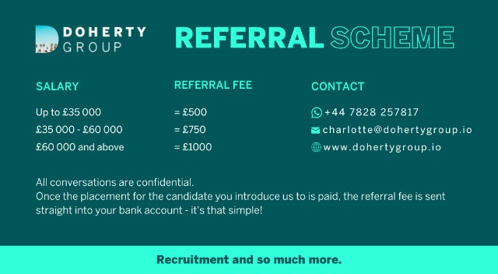

Hope you have a great day!
Should you have any questions, please let me know

V2 - Sourcewhale – InMail only

- Connection request:
Hey {{firstName}}, I'll get straight to the point, have you ever thought about upgrading to {location}, where the market is hot, the taxes are non-existent, and the sun is always shining? Keen to connect and give you more details about how it all works!
- Inmail:
Hey {{firstName}}, thanks for connecting! / hope you are well! I sent a connection request {[previousStepDay]} so wanted to follow up with an InMail :)

I know you're probably swamped with LinkedIn messages, but hear me out. I'm a Rec2Rec specialist and I have a proposition for you that's too good to pass up: How about a one-way ticket to paradise? aka {location}.

In short, here's what's on offer: UK- owned agencies, focused on Tech, 4,5 day work week, one of the busiest markets in the world - also tax-free (it's so good I had to mention it twice :D)! Would you like to hear more?

Let's chat about how you can swap snow for sand and advance your career!

If it's easier you can WhatsApp me at {phone_number)

- InMail:

Hi {{firstName}}, I reached out about opportunities in Dubai {[previousStepDay]} so thought it might be useful to share our brochure that outlines the process and how it all works! I have attached it here, and let me know if you have any questions! Always happy to jump on a quick call and give you more details

- InMail

I'll take the hint that maybe you are not interested right now (persistence is key, hey 😅). I'd love to know if the timing is not right at the moment, or if you are simply not interested? That way I'll know if I should try again in a few months :)

If it's just the timing, we made a quick survey which is an easy way to tell us more about what may interest you in future. I'd love to make sure I keep you updated with roles more closely aligned with what you are looking for next.

https://7so2yjerx1a.typeform.com/to/BCADZcFk

- InMail

Hi {{firstName}}, hope all is well!

How are things going at {{company}}?

We have recently launched our monthly newsletter which is full of industry articles, podcast links as well as hot jobs. If you are happy to receive it you can sign up directly here - https://mailchi.mp/dohertygroup/subscribe-to-newsletter

If things have changed and you are now open to reviewing new opportunities don't hesitate to reply to me here or WhatsApp me on {phone_number}

- InMail
Hi {{firstName}},
How is your {[dayOfWeek]} going?

Our marketing team has put together for us a hey link which is an easy way for our network to see how they can connect/follow us on all our socials - https://heylink.me/dohertygroup/.

We are posting more on Instagram as well as our LinkedIn company page so if you want to keep us on your radar then make sure to give them both a follow 😀

- InMail

Hi {{firstName}},

How is your {[dayOfWeek]} going?

I just got off the phone with one of my exclusive clients who is looking for ............ (input role specific details here).

This is a fantastic company because ..... (insert company USPs here).

Would you be interested in finding out a bit more about them and what they could offer you?

- InMail

Hi {{firstName}},

We have just recently released our latest Recruitr Startup Podcast episode - insert here - which Dualta recorded with - insert name.

Not sure if you follow the podcast already but thought I'd flag it to you as it's a really interesting listen!

- General Task

Reminder to send a completely tailored message dependent on what LinkedIn live, articles, podcasts we have out or roles you have on.

