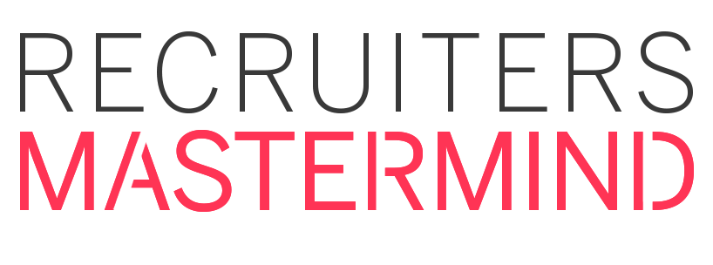

Title: Social Media Admin & Community Manager

About

I’m a creative Social Media specialist focused on growth and community engagement. I love creating content for social media, as well as designing social media graphics to make all of our posts look amazing!

I specialize in a range of administrative and strategy related activities with the aim of maintaining meaningful relationships with business partners and supporting marketing efforts through efficient communications throughout various platforms.

Other skills:
- Problem-solving skills
- Time-management and organizational skills
- Goal oriented with a can-do attitude
- Strong planning and project management skills
- Social media content creation

Experience:

As a Communications & Social Media Admin at RecWired, I work closely with the team and our business partners to support and empower marketing & social media campaigns that drive engagement and lead generation.

I am accountable for:
• Planning, curating and promoting relevant social media content
• Maintain efficient communications with external business partners
• Community management and communications
• Marketing support and content strategy
• Managing all social channels
• Performing competitive research and keeping us front of mind
• Administrative operations

