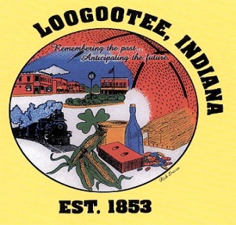

**The City of Loogootee**

**Common Council**

**The Loogootee Municipal Building**

**Noel D. Harty, Mayor of LoogooteeMay 8, 2023**

Roger Downey Clerk Treasurer

Arianna Wright City Attorney

James E. Wilson Public Works Superintendent

Aaron Means Police Chief

Eric Thomas Fire Department Chief

**City Council Members**

Carroll Rayhill

Teresa Nolley, Ron Gilbert

Rick Norris, Tim Lawrence

**AGENDA**

**1. Call to Order**

**2. Roll Call**

**3. Minutes from April 2023 Meeting**

**4. Claims**

**5. Transfer of Appropriations-**

**6. Public Works Recommendations**

**7. Unfinished Business**

**A. Chickens ordinance**

**B. Tax Abatement (Jessica Potts)**

**C. TIF District**

**8. New Business**

**A. Ordinance 2023-2 Amending Sewer Rates and Changes**

**B. Ordinance 2023-3 Amending Water Rates and Changes**

**C. Cross Connection Control**

**D. Internal Controls report**

**E. ERP Update (signed)**

**F. School Resource Officer Agreement 2023**

**G. SIDC (Non-interest-bearing account)**

**H. Pickleball (Terri Smith)**

**9. Other Announcements**

**10. Citizens Input / Comments**

**11. Adjournment**



**The City of Loogootee**

**Board of Public Works & Safety**

**The Loogootee Municipal Building**

**Noel D. Harty, Mayor of Loogootee May 8, 2023**

James E. Wilson Public Works Superintendent

Aaron Means Police Chief

Eric Thomas Fire Department Chief

**Board Members**

Rick Norris Danny Clark

Roger Downey Clerk Treasurer

Arianna Wright City Attorney

## **AGENDA**

1. **Call to Order**

**2. Pledge of Allegiance**

**3. Roll Call**

**4. Minutes from April 2023 Meeting**

**5. Unfinished Business**

**6. New Business**

**A. Police Vehicle**

**B. Police Dept. (Radios)**

**C. Fire Dept. (Radios and equipment)**

**D. Building Commissioner / Police ( First Net cell phone provider)**

**7. Utility Adjustments / Write-offs**

**8. Department Reports— (Bo, Aaron, Eric, Justin)**

**9. Citizens Input / Comments**

**10. Adjournment**