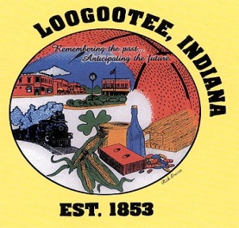

**The City of Loogootee**

**Common Council**

**The Loogootee Municipal Building**

**Noel D. Harty, Mayor of LoogooteeJune 12, 2023**

Roger Downey Clerk Treasurer

Arianna Wright City Attorney

James E. Wilson Public Works Superintendent

Aaron Means Police Chief

Eric Thomas Fire Department Chief

**City Council Members**

Carroll Rayhill

Teresa Nolley, Ron Gilbert

Rick Norris, Tim Lawrence

**AGENDA**

**1. Call to Order**

**2. Roll Call**

***Public Hearing: Abatement***

**3. Minutes from May 2023 Meeting**

**4. Claims**

**5. Transfer of Appropriations-**

**6. Public Works Recommendations**

**7. Unfinished Business**

**A. Chicken ordinance (Terry Campbell)**

**B. SRO Contract**

**8. New Business**

**A. Terri Kelso Ins-(AFLAC)**

**B. Internal Control report**

**9. Other Announcements**

**A. Budget Hearing for 2024 October 2nd, 2023**

**B. Budget Adoption for 2024 October 19th, 2023**

**10. Citizens Input / Comments**

**11. Adjournment**

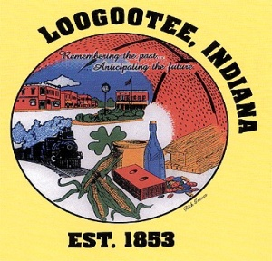

**The City of Loogootee**

**Board of Public Works & Safety**

**The Loogootee Municipal Building**

**Noel D. Harty, Mayor of Loogootee June 12, 2023**

James E. Wilson Public Works Superintendent

Aaron Means Police Chief

Eric Thomas Fire Department Chief

**Board Members**

Rick Norris Danny Clark

Roger Downey Clerk Treasurer

Arianna Wright City Attorney

## **AGENDA**

1. **Call to Order**

**2. Pledge of Allegiance**

**3. Roll Call**

**4. Minutes from May 2023 Meeting**

**5. Unfinished Business**

**A. Fire Dept. (equipment)**

**6. New Business**

**A. Request for Stop sign at High St and Kentucky Ave**

**B. Re-name Trimble Lane.**

**7. Utility Adjustments / Write-offs**

**8. Department Reports— (Bo, Aaron, Eric, Justin)**

**9. Citizens Input / Comments**

**10. Adjournment**