Attached are the agendas for the board of public works and common council meetings for Monday evening Jan 8. Note, board of public works meeting begins at 6 pm, not 5:30 pm as with the previous meetings.

One change that will be implemented for the meetings is there will be a sign in sheet for any and all citizens who wish to speak at the meeting. You will sign your name and the topic you wish to speak about and will be given two minutes to address the board of public works and/or common council with your question or topic. This will allow anyone who wishes to speak, the opportunity to do so. The objective is to help the meetings flow better and be conducted appropriately and professionally with decorum.

After all the city council meetings are public meetings where the business of the city will be conducted, they are not meetings to conduct personal businesses of the public.

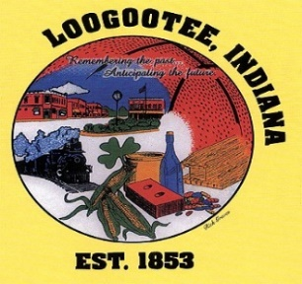**T****HE CITY OF LOOGOOTEE**

**BOARD OF WORKS & SAFETY**

**THE LOOGOOTEE MUNICIPAL BUILDING**

**BRIAN T. ADER, MAYOR JANUARY 8, 2024**

______________________________________________________________________________

**Board Members**

Mayor Ader, Danny Clark, Jason Greene, Brandon Carrico, Mark McAtee

Attorney David Smith, Clerk Treasurer Lori Carrico, Public Works Superintendent Bo Wilson, Police Chief Kyle Long, Fire Dept. Chief Eric Thomas, Building Commissioner, Justin Davis

______________________________________________________________________________

1. Call to Order
2. Pledge of Allegiance
3. Roll Call
4. Minutes from previous month’s meeting
5. Unfinished Business
6. Second Police Car
7. Greenspace
8. New Business
9. Assistant Chief
10. Resolution on Board of Works
11. Gear Box at Waste Water Plant
12. SIDC- Jenny Dearwester Bid Award on Housing
13. SIDC- Michelle Carrico Recovery Housing Grant
14. Additional Meters
15. GPS on Vehicles
16. Drug Testing Implement
17. Rehire Jeff Sanders
18. Property on North St.
19. Pump For Pool
20. Police Car Repairs
21. M&M Electric Bill for Summerfest Electric Panel Damage
22. Utility Adjustments
23. Department Reports
24. Adjournment

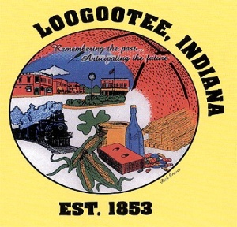**THE CITY OF LOOGOOTEE**

**COMMON COUNCIL**

**THE LOOGOOTEE MUNICIPAL BUILDING**

**BRIAN T. ADER, MAYOR JANUARY 8, 2024**

______________________________________________________________________________

**City Council Members**

Carroll Rayhill, Dave Smith, Mike Engleman, Jeremy Holland, Mark McAtee

Attorney David Smith, Clerk Treasurer Lori Carrico, Public Works Superintendent Bo Wilson, Police Chief Kyle Long, Fire Dept. Chief Eric Thomas, Building Commissioner, Justin Davis

______________________________________________________________________________

1. Call to Order
2. Pledge of Allegiance
3. Roll Call
4. Nomination of Council President
5. Minutes from previous meeting
6. Claims
7. Unfinished Business
8. Update Budget/Spending/State of the City
9. Infrastructure
10. Fountain Issue
11. Greenspace
12. New Business
13. Update on Ordinances
14. Second Police Car

c. Cell for Mayor’s Office

d. Nominations of Boards & Committees

e. Fire Protection Agreement

f. M&M Electric Bill for Summerfest Electric Panel Damage

g. Ordinance on Cost & Use of City Property

8. Adjournment