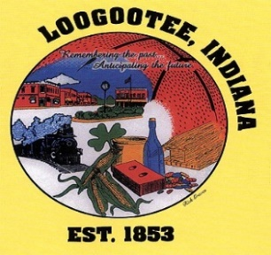**T****HE CITY OF LOOGOOTEE**

**BOARD OF WORKS & SAFETY**

**THE LOOGOOTEE MUNICIPAL BUILDING**

**BRIAN T. ADER, MAYOR FEBRUARY 29, 2024**

______________________________________________________________________________

**Board Members**

Mayor Ader, Danny Clark, Jason Greene, Brandon Carrico, Mark McAtee

Attorney David Smith, Clerk Treasurer Lori Carrico, Public Works Superintendent Bo Wilson, Police Chief Kyle Long, Fire Dept. Chief Eric Thomas, Building Commissioner, Justin Davis

______________________________________________________________________________

1. Call to Order
2. Pledge of Allegiance
3. Roll Call
4. New Business
   1. Hiring of Employees
5. Adjournment

***Announcements: Reminder that public comments have 2-minute limit and no repetitive comments. Also, we will be having a silent auction on unused city items.***