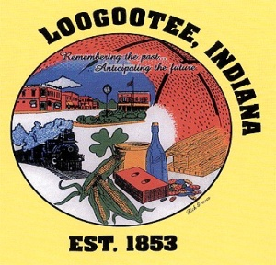**THE CITY OF LOOGOOTEE**

**COMMON COUNCIL**

**THE LOOGOOTEE MUNICIPAL BUILDING**

**JULY 24, 2024**

**7:30 PM**

**BRIAN T. ADER, MAYOR**

______________________________________________________________________________

**City Council Members**

Carroll Rayhill, Dave Smith, Mike Engleman, Jeremy Holland, Mark McAtee

Attorney David Smith, Clerk Treasurer Lori Carrico, Public Works Superintendent Bo Wilson, Police Chief Jimmy Hunt, Fire Dept. Chief Eric Thomas, Building Commissioner Justin Davis

______________________________________________________________________________

1. Call to Order-Special Meeting
2. Pledge of Allegiance
3. Roll Call
4. New Business
5. Updated Comprehensive Plan
6. Adjournment

**Announcements: Public comments have a 2-minute limit and no repetitive comments.**

***President May Modify Agenda***