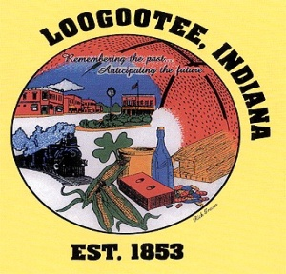**THE CITY OF LOOGOOTEE**

**COMMON COUNCIL**

**THE LOOGOOTEE MUNICIPAL BUILDING**

**AUGUST 26, 2024**

**6:00 PM**

**BRIAN T. ADER, MAYOR**

______________________________________________________________________________

**City Council Members**

Carroll Rayhill, Dave Smith, Mike Engleman, Jeremy Holland, Mark McAtee

Attorney Steven Teverbaugh, Clerk Treasurer Lori Carrico, Public Works Superintendent Bo Wilson, Police Chief Jimmy Hunt, Fire Dept. Chief Eric Thomas, Building Commissioner Justin Davis

______________________________________________________________________________

1. Call to Order-Special Meeting
2. Pledge of Allegiance
3. Roll Call
4. New Business
5. Review of Downtown Event
6. Adjournment

**Announcements: Public comments have a 2-minute limit and no repetitive comments.**

***President May Modify Agenda***