Autumn 2025 Week 1 01/09 22/09 13/10

Pepperoni Pizza served with Homemade Potato Wedges & Carrot Sticks or Sweetcorn (V)
BBQ Chicken Wrap served with Rice & Peas or Salad
Roast Chicken in Gravy with Roast Potato, Yorkshire Pudding & Carrots or Broccoli
Beef Lasagne served with Homemade Bread & Cucumber Sticks or Sweetcorn
Oven Baked Fish with Chips & Baked Beans or Peas

Cheese & Tomato Pizza served with Homemade Potato Wedges & Carrot Sticks or Sweetcorn (V)
BBQ vegetarian Wrap served with Rice & Peas or Salad
Quorn Fillet in Gravy with Roast Potato, Yorkshire pudding & Carrots or Broccoli
Tomato & Basil Pasta with Homemade Bread & Cucumber Sticks or Sweetcorn (VE)
Cheese and Bean Wrap with Chips and Peas (VE)

Ham Roll
Turkey Sandwich
Tune Mayo Sandwich
Turkey Sandwich
Cheese Wrap

Crispy Baked Jacket Potato with a Choice of Baked Beans (VE), Tuna Mayo or Cheese (V) with Mixed Salad (VE) Dessert of the Day, Yoghurt (V) or Fresh Fruit (VE)

Strawberry Whip (V) Shortbread (VE) & with
Fresh Fruit
Chocolate and Beetroot Brownie (V)
Blueberry Muffin (V) Ice Cream with Mandarins (V)

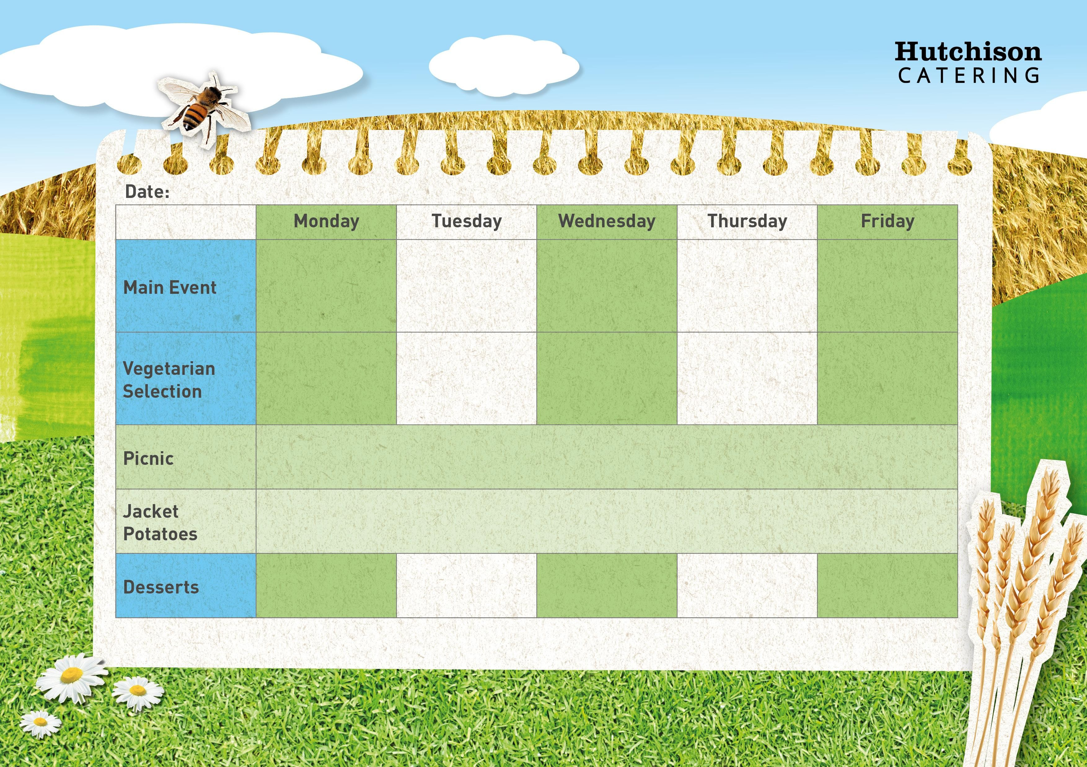

Key: V – Vegetarian, VE – Vegan
Available Daily: Water, Bread, Salad, Fresh Fruit, and Yoghurt

