Autumn 2025 Week 3 15/09 06/10

Beef Burger served with Homemade Potato Wedges & Sweetcorn or Cucumber Sticks (V)
Beef Bolognaise with Pasta & Broccoli or Green Beans
Roast Chicken in Gravy with Roast Potato, Yorkshire Pudding & Carrots or Broccoli
All Day Breakfast Oven Baked Fish Fingers with Chips & Peas or Baked Beans

Quorn Burger served with Homemade Potato Wedges & Sweetcorn or Cucumber Sticks (V)

Quorn Bolognaise with Pasta & Broccoli or Green Beans
Quorn Fillet in Gravy with Roast Potato, Yorkshire Pudding & Carrots or Broccoli (V)

Vegetarian All Day Breakfast
(V)
Cheese & Bean Pinwheel with Chips & Peas or Baked Beans (V)

Ham Roll
Turkey Sandwich
Tuna Mayo Sandwich
Cheese Sandwich
Ham Wrap

Crispy Baked Jacket Potato with a Choice of Baked Beans (VE), Tuna Mayo or Cheese (V) with Mixed Salad Dessert of the Day, Yoghurt or Fresh Fruit

Chocolate Crunch Cookies (VE)
Oaty Biscuit (VE) Strawberry Bun with Fresh Fruit (V)
Iced Sponge School Cake (V)
Ice Cream with Mango (V)

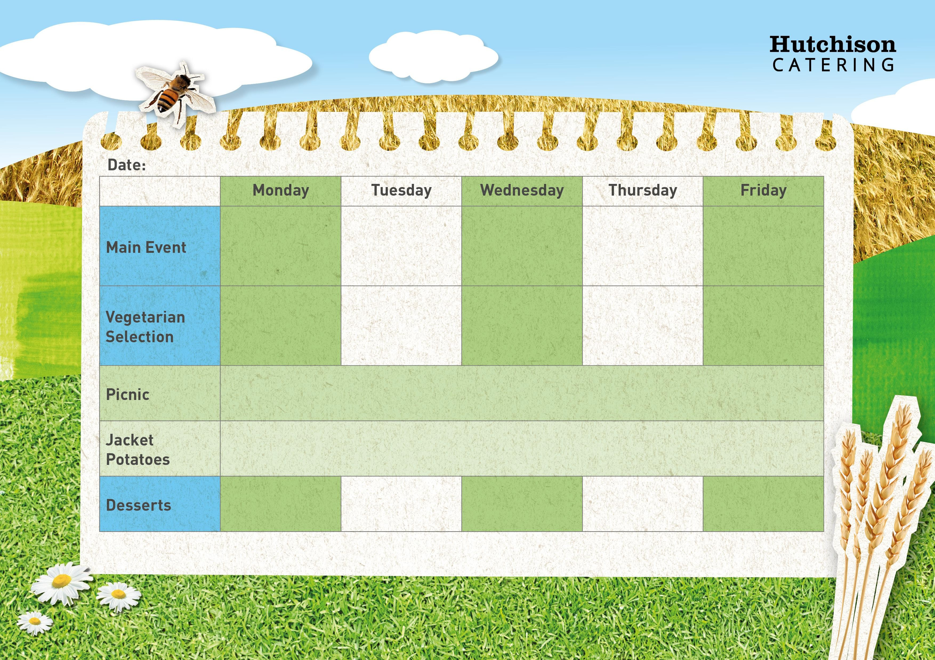

Key: V – Vegetarian, VE – Vegan
Available Daily: Water, Bread, Salad, Fresh Fruit, and Yoghurt

