AeroShield White Paper

Occupational scatter radiation exposure remains a persistent challenge in cardiac catheterization laboratories (CCLs), particularly as procedural complexity, fluoroscopy time, and multi-angle imaging continue to increase. Conventional shielding strategies—such as under-table lead drapes and ceiling-mounted shields— provide incomplete coverage, particularly for the main operators and for staff positioned outside fixed shielding footprints.

Disclosure of Unbiased Research
Opinions and conclusions are entirely those of researchers and formed independently based on systematic, objective analysis of data collected with the experimental protocol described. Funding and equipment support were provided by Salus Scientific. The data, results and discussion were focused on scientific integrity, identifying strengths and weaknesses in the testing, and where future testing improvements may be made. This is an honest representation of the bench study’s outcomes and implications.

Objective
This evaluation assessed the effectiveness of AeroShield™, a table-mounted enhanced radiation protection device (ERPD), across a comprehensive set of clinically relevant imaging angulations and staff positions. The specific objective was to quantify scatter radiation reduction of AeroShield™ compared to that provided by traditional table drapes accompanied by an above table shield (Fig.1), simultaneously assessing workflow, imaging and procedural flexibility, and immediate patient access.
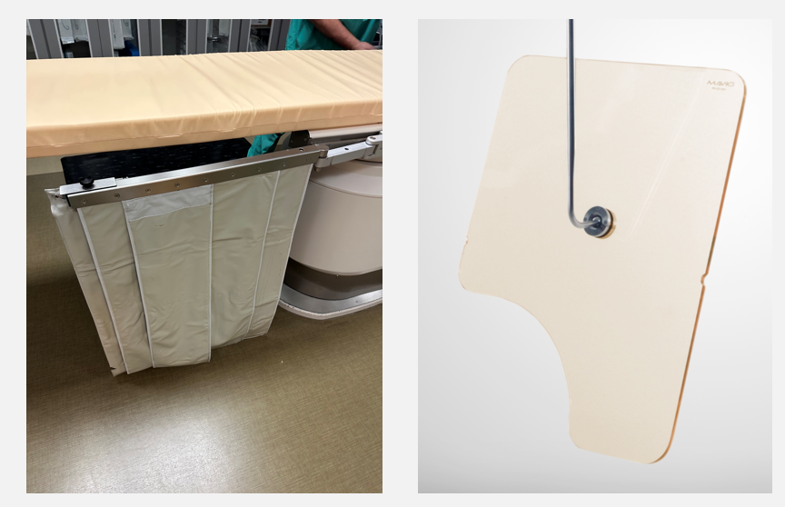
Fig. 1. Traditional Shielding – table side lead drape, plus above table Mavig shield

Setup and Methods
Experimental Setup and Imaging Angulations
Five distinct shielding configurations were evaluated to assess their effectiveness in reducing occupational scatter radiation exposure to clinical staff in a catheterization laboratory. Measurements were performed across a comprehensive range of fluoroscopic and cine imaging angulations commonly used during fluoroscopic interventions. The following 11 imaging projections were tested:
- Anteroposterior (AP)
- Left anterior oblique (LAO) 30°
- Left anterior oblique (LAO) 45°
- Right anterior oblique (RAO) 30°
- Right anterior oblique (RAO) 45°
- LAO 50° with caudal 30° (spider view)
- Cranial 40°
- Caudal 30°
- RAO 40°, Cranial 30°
- RAO 30°, Caudal 30°
- Full Lateral
The shielding configurations evaluated included:
- Traditional lead under-table apron
- Traditional lead under-table apron with ceiling-mounted Mavig shielding
- AeroShield™ lower shield only
- AeroShield™ with ceiling-mounted Mavig shielding
- AeroShield™ with OptiShield™ above table shielding

Staff Positions Evaluated
Five staff positions routinely present during cardiac catheterization procedures were evaluated:
- Position 1: Primary operator
- Position 2: Scrub technologist/2nd operator
- Position 3: Cardiac imager (head of table)
- Position 4: Anesthesiologist
- Position 5: Circulator
The spatial locations of each staff position compared to the procedure table are illustrated in Figure 5. This reference picture depicts staff positioning with the C-arm in the AP orientation and the entire thoracic region within the imaging field.
To ensure consistency across measurements, all staff positions remained fixed at marked locations on the floor throughout the study. The ceiling-mounted C-arm remained on the same track location for all acquisitions; source-to-staff distance varied as a function of C-arm angulation.
For each projection, the patient table was repositioned as necessary to maintain the full thoracic cavity within the imaging field of view. This approach preserved clinically realistic geometry while allowing the effects of shielding on scatter radiation exposure to be evaluated across a range of imaging angles.
Dose Assessment Methodology
Occupational dose to each staff position was estimated using External Dose due to External Exposure (EDEX), as defined in U.S. Nuclear Regulatory Commission (NRC) Regulatory Guide 8.40. This methodology estimates whole-body effective dose resulting from non-uniform external radiation exposure by applying compartmental weighting factors (Fig. 2) to measured deep-dose equivalents.
The EDEX calculation is defined as:
$$EDEX= \sum{W_{C}}* {DDE}_{C}$$
- W_{C} = compartmental weighting factor
- DDE_{C} = deep-dose equivalent for each body compartment
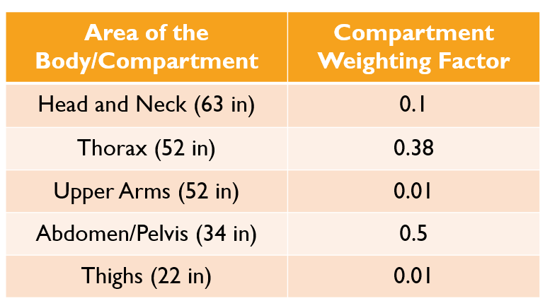
Fig. 2 – compartmental weighting factors
For each staff position, dose rates (mrem/hr) were measured during fluoroscopy and cine acquisition at representative body heights corresponding to the defined compartmental weighting factors. Measurements were obtained at four distinct vertical heights, as the thorax and upper arm were defined at the same height for the purposes of this study (Figs. 3 and 4).

Body Compartment | Measurement Height (in)
Head and Neck | 63
Thorax | 52
Upper Arms | 52
Abdomen/Pelvis | 34
Thigh | 22

Fig. 3 Measurements at 4 distinct vertical heights corresponding with relevat body compartment (Head, thorax/upper arm, abdomen/pelvis, and thigh)
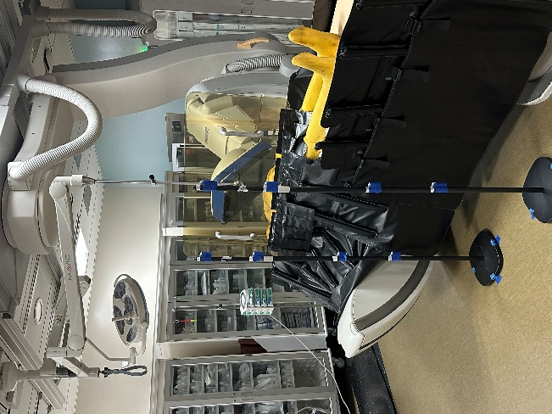
Fig. 4 Poles with sensors in Positions 1 and 2, with C-arm LAO 45 (shown here during AeroShield and OptiShield arm of study)
Dose rate measurements were collected using Polimaster RadFlash electronic personal dosimeters, all of which were factory-calibrated in February 2025. Dosimeters were affixed to adjustable poles positioned at the specified measurement heights. Each stand was placed at pre-measured and taped floor locations corresponding to each staff position.(Fig. 5)
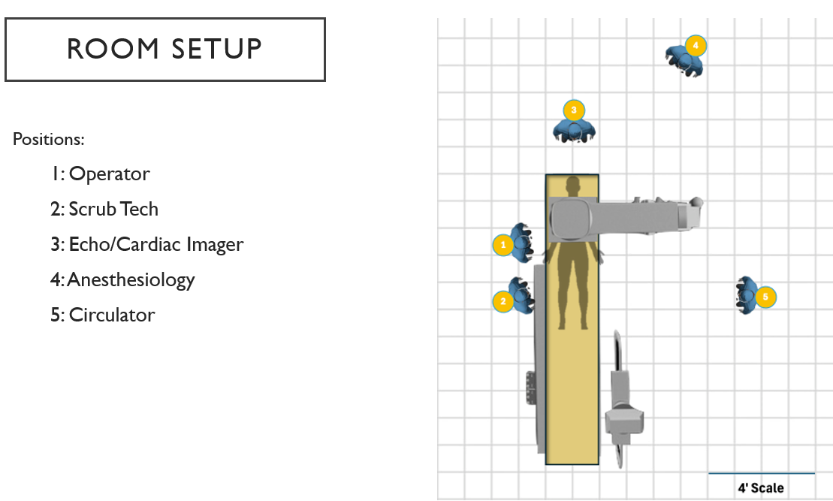
Fig. 5 Room Setup and staff positions

Phantom and Scatter Simulation
An anthropomorphic full-body phantom (loaned by the U.S. Department of Energy) was positioned on the procedure table to simulate patient-generated scatter radiation. To better approximate attenuation from a human patient and to drive system kilovoltage peak (kVp) values to clinically realistic levels, a 0.5-mm lead-equivalent soft-shield fabric was affixed to the image receptor.
Imaging Parameters
Fluoroscopic imaging parameters were held constant across all shielding configurations and angulations. The field of view was maintained at 19 inches (with no collimation or wedges), and the source-to-image distance (SID) was set to 111 cm for all projections, with the exception of the LAO 50° with caudal 30° projection, where SID was increased to 115 cm to maintain full thoracic coverage.
Table height was maintained at −3 cm for all projections except the lateral view, which required a table height of 0 cm. Fluoroscopy frame rate was standardized at 15 frames per second.
Although the C-arm position remained fixed, the procedure table was translated along the horizontal axis as necessary to ensure complete thoracic coverage for each imaging angulation.
Dose Estimation and Comparative Analysis
Following acquisition of dose rates for each staff position and imaging angulation, procedural workload assumptions and fluoroscopy-to-cine time distributions were applied to estimate annual occupational dose (mrem/year) for each position (Fig. 6). These estimates assumed deep dose equivalent (DDE) by utilizing Hp(10) measurements (dose rates at a tissue depth of 10 mm).
Estimated annual doses were then compared across all five shielding configurations for each imaging angulation to assess relative shielding effectiveness and characterize reductions in occupational radiation exposure across staff roles.
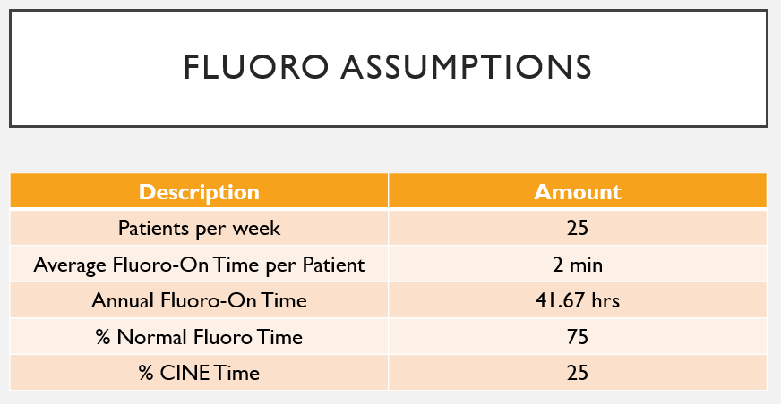
Fig. 6 Dose estimation assumptions for study

Results
Overall Scatter Radiation Reduction
Across all imaging angulations, staff positions, and measurement conditions, AeroShield-based shielding configurations demonstrated substantial and consistent reductions in occupational scatter radiation when compared with traditional under-table lead shielding alone.
Among the five configurations evaluated, AeroShield™ with OptiShield™ provided the highest overall reduction in scatter radiation, with dose reductions typically ranging from 80% to 95% across standard clinical projections. Importantly, no imaging angulation or staff position demonstrated increased radiation exposure relative to conventional shielding. (Fig. 7)

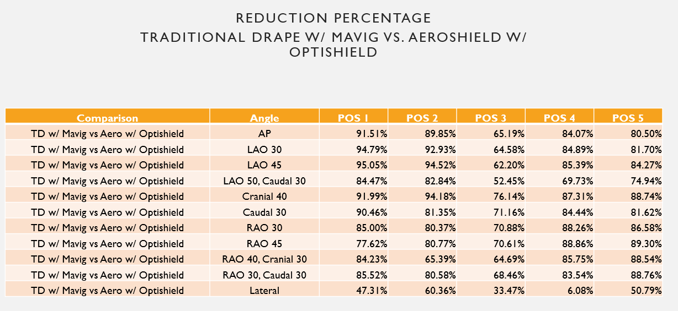
Fig. 7 Comparison of Traditional Shielding (TD) with Mavig vs. AeroShield with OptiShield
Staff Position–Specific Dose Reduction
Radiation dose reduction varied by staff role, consistent with differences in proximity to the patient and scatter field geometry:
- Primary Operator (Position 1):
The primary operator experienced the greatest benefit from AeroShield-based configurations. Across commonly used LAO and RAO projections—known to generate higher scatter—dose reductions routinely exceeded 85%, with peak reductions greater than 94% observed in steep LAO angulations.
- Scrub Technologist/Secondary operator (Position 2):
The scrub technologist demonstrated similarly robust protection, with dose reductions generally exceeding 80% across most angulations. These findings indicate effective attenuation in close proximity to the patient and procedural field.
- Cardiac Imager (Position 3):
Moderate but consistent reductions were observed for the cardiac imager position, typically ranging from 60% to 75%, reflecting significantly improved coverage beyond the partial protection offered by conventional under-table and ceiling-mounted shielding.
- Anesthesiologist and Circulator (Positions 4 and 5):
Positions frequently located outside the effective footprint of traditional shielding experienced substantial reductions in scatter radiation, generally exceeding 80% with AeroShield-based configurations. These reductions were consistent across most angulations tested.
Impact of Imaging Angulation
Shielding effectiveness was preserved across a broad spectrum of clinically relevant imaging angulations, including AP, oblique, cranial, and caudal projections. Reduced effectiveness was observed during lateral projections for all shielding configurations and staff positions, consistent with known alterations in scatter radiation geometry during lateral imaging.
AeroShield-based configurations were superior to traditional shielding in achieving dose reduction, regardless of angulation.
Estimated Annual Occupational Dose
When measured dose rates were combined with procedural workload assumptions and fluoroscopy-to-cine time distributions, estimated annual occupational dose (mrem/year) was substantially reduced for all staff positions using AeroShield shielding. The greatest reductions were observed for staff members with the highest baseline exposure, including the primary operator and scrub technologist, supporting the potential for meaningful reductions in cumulative lifetime occupational radiation exposure.
Discussion
Clinical Relevance of Scatter Reduction
Occupational radiation exposure remains an unavoidable risk in cardiac catheterization laboratories, particularly as procedural complexity and case duration continue to increase. The findings of this evaluation demonstrate that enhanced table-mounted shielding with AeroShield provides clinically meaningful reductions in scatter radiation across a wide range of well-defined imaging angulations and staff roles.
The magnitude and consistency of observed dose reductions—especially during high-scatter LAO and RAO projections—highlight the improvements in protection that are achievable, as well as the limitations of traditional under-table and ceiling-mounted shielding, which often leave gaps in protection above the waist and in areas outside fixed shielding footprints.
Workflow Integration and Procedural Efficiency
A critical determinant of real-world adoption for any specific radiation protection solution is its impact on workflow. Throughout testing in the current experimental protocol, AeroShield was fully integrated into standard cath lab setups and did not interfere with table positioning, imaging flexibility, or procedural efficiency.
Unlike ceiling-mounted shields, which require frequent manual repositioning and are often moved out of the field during complex cases, AeroShield maintained effective protection across dynamic changes in gantry angulation. This is particularly relevant in contemporary interventional practice, where a significant proportion of procedures involve frequent transitions between multiple projections rather than prolonged use of a single imaging angle.
In typical coronary and structural interventions, operators may spend the majority of procedural time rotating through AP, oblique, cranial, and caudal views. The ability of AeroShield to provide protection across a high percentage of these angulations—without requiring adjustment between views—supports its suitability for real-world procedural workflows.
Immediate Patient Access and Safety
Direct visualization and immediate access to the patient are critical requirements in interventional cardiology and vascular procedures. During all tested configurations, AeroShield enabled unobstructed access to the patient, preserving the ability to recognize and respond rapidly to emergent situations.
The system’s inflatable, table-mounted design allows for rapid deflation or repositioning, ensuring that shielding can be removed quickly when full patient access is required. This feature addresses a key limitation of rigid or ceiling-mounted shielding systems, which may delay access and discourage consistent use during high-acuity cases.
Performance Across Procedure Types and Dynamic Angulations
Modern catheterization laboratories support a diverse range of procedures—including coronary, peripheral, structural, and hybrid interventions—each characterized by different imaging demands and angulation profiles. The demonstrated effectiveness of AeroShield across AP, oblique, cranial, and caudal projections indicates adaptability to procedures with high variability in gantry positioning. Furthermore, the lack of obstruction to C-arm movement, even in extreme angulations, sets Aeroshield apart and makes this system more pragmatic than other ERPD’s that may inhibit gantry movement.
Importantly, staff roles that are often underserved by conventional shielding—such as anesthesiology and circulator positions—experienced meaningful reductions in scatter radiation. This suggests that enhanced table-mounted shielding from Aeroshield may provide more comprehensive, lab-wide protection across a broad spectrum of procedure types and staffing configurations.
Implications for Occupational Wellness
By reducing scatter radiation exposure while preserving workflow efficiency and immediate patient access, AeroShield addresses both radiation safety and usability—two factors that frequently limit adoption of protective technologies. The ability to provide consistent protection across dynamic angulations and multiple procedure types supports a shift toward proactive occupational wellness strategies that do not rely solely on heavy personal lead or staff behavior for effectiveness.
Limitations
This evaluation has several limitations that should be considered when interpreting the results.
First, dose measurements were obtained using an anthropomorphic phantom rather than live patients. While this approach enables standardized, repeatable measurements and is commonly used in radiation physics studies, it does not fully capture patient-to-patient variability in body habitus, anatomy, or tissue composition. Although a lead-equivalent soft-shield fabric was applied to approximate human attenuation and drive clinically realistic imaging parameters, real-world scatter patterns may vary.
Second, measurements were performed in a single cardiac catheterization laboratory environment using a fixed C-arm system and standardized equipment configuration. Scatter radiation geometry can vary across different fluoroscopy systems, room layouts, table designs, and ceiling heights. As such, the absolute magnitude of dose reduction observed may differ in other laboratory environments, although relative performance trends are expected to remain consistent.
Third, staff positions were evaluated using fixed spatial locations relative to the procedure table to ensure measurement consistency across shielding configurations and angulations. In clinical practice, staff frequently reposition throughout a procedure in response to workflow demands, imaging requirements, or patient needs. While the evaluated positions reflect typical working locations, they do not capture all transient movements or atypical positioning that occurs during complex cases.
Fourth, shielding effectiveness was assessed across a defined set of imaging angulations representative of common clinical use. Although these angulations encompass the majority of standard coronary and structural projections, they do not represent every possible gantry position or extreme imaging scenario encountered in practice.
Fifth, radial access–specific “kick-out” positioning was not directly evaluated in this study. Radial procedures frequently require the operator and scrub technologist to step laterally or away from the table during catheter exchanges, altering distance from the scatter source and shielding geometry. As a result, measured dose reductions may not fully capture exposure patterns unique to radial access workflows. To address this limitation, AeroShield is currently being evaluated in real-world clinical settings that include radial access procedures and associated “kick-out” positioning, allowing for direct assessment of shielding performance under these dynamic and commonly encountered conditions. The relative reductions in radiation dose would be expected to be maintained in these positions.
Sixth, estimated annual occupational dose was derived using procedural workload assumptions and fluoroscopy-to-cine time distributions rather than direct longitudinal staff monitoring. While this approach is consistent with accepted radiation safety modeling practices, actual annual dose will vary based on case mix, operator technique, fluoroscopy usage, and individual laboratory practices.
Finally, this study represents a controlled, preclinical evaluation and does not fully capture the iterative refinements that may emerge during early real-world deployment. The initial formative study phase of clinical installation is expected to identify small, rapid-turnaround design or positioning optimizations that may further enhance scatter protection while preserving—rather than impeding—procedural workflow and immediate patient access. These iterative improvements will be evaluated prospectively as part of ongoing real-world use.
Future Directions
The carefully thought out study design, with comprehensive angulation set and consistent measurement methodology utilized in this study, provides a robust framework for comparing relative shielding performance across configurations. Furthermore, previous evaluations of ERPD’s have demonstrated great variability in study design and methodology. The current study underscores the need for rigor in such evaluations and may serve as a model for standardizing across platforms. All future assessments should incorporate factors that render the findings relevant to contemporary catheterization laboratory practice.
Future evaluation of AeroShield specifically will focus on expanding real-world clinical validation, refining system performance through formative study insights, and further characterizing its role within comprehensive occupational radiation protection strategies.
A key next step includes prospective, real-world clinical studies conducted during routine catheterization procedures in the fluoroscopy suite. These studies will incorporate live patient imaging, diverse patient body habitus, multiple physician operators and a broad spectrum of procedure types, including coronary, peripheral, structural, and hybrid interventions. Emphasis will be placed on various access routes, including femoral, jugular and radial access workflows, to more fully characterize scatter radiation exposure patterns under dynamic clinical conditions.
Subsequent studies will evaluate AeroShield performance across multiple laboratory environments, fluoroscopy platforms, and room configurations to assess generalizability of shielding effectiveness and identify environment-specific optimization opportunities. Longitudinal staff monitoring using wearable dosimetry will be incorporated to better quantify cumulative occupational exposure over extended time periods.
Insights gained during the formative study phase of early clinical installations will inform rapid, iterative refinements in system configuration, positioning, and accessory integration. These refinements are intended to further enhance scatter attenuation while maintaining—or improving—workflow efficiency, immediate patient access, and procedural flexibility. Iterative changes will be evaluated prospectively to ensure that improvements do not introduce unintended workflow or access constraints.
Additional areas of investigation will include assessment of user adoption, ease of use, and long-term compliance, as well as evaluation of the potential to reduce reliance on heavy personal lead protection. Within the framework of the ALARA principle, the “reasonable” component also warrants consideration; radiation protection systems must balance shielding performance with workflow integration, procedural access, and usability to achieve consistent adoption across a high percentage of procedures. The AeroShield system was designed with these practical considerations in mind, providing meaningful scatter reduction while maintaining procedural workflow and accessibility, which may facilitate broader real-world utilization.
Together, these future efforts aim to establish AeroShield as an effective ERPD solution as an adaptable, passive protection system optimized for real-world interventional practice and evolving occupational wellness standards.

