
Mogotes Metals Inc.
#401, 217 Queen St. W., Toronto, ON M5V0R2, Canada
T +1(647) 846-3313 | info@mogotesmetals.com
NEWS RELEASE
Mogotes Metals Secures Option to Acquire Advanced Beskauga Copper-Gold-Silver Project
Resource-Stage Porphyry Cu-Au-Ag System in Kazakhstan with Near-Surface Higher-Grade Core, District-Scale Exploration Upside and Established Infrastructure
February 27, 2026 – Toronto, Ontario – Mogotes Metals Inc. (TSXV: MOG, FSE: OY4, OTCQB: MOGMF) (“Mogotes” or the “Company”) is pleased to announce that it has entered into a definitive option agreement (the “Option Agreement”) to acquire a 100% interest in the Beskauga copper-gold-silver porphyry project (the “Beskauga Project”) located in Pavlodar Province, Republic of Kazakhstan.
Transaction and Project Highlights
- Near-Surface, Potentially Low-Cost: The higher-grade Au-Cu-Ag core of the resource starts at approximately 40 metres below surface, beneath clay overburden, potentially amenable to open-pit mining (Figures 1& 2). Highlight drill intercepts within the MRE include (Table 2):
  - BG21001: 957.0m at 0.58 g/t Au, 0.34% Cu, 1.92 g/t Ag from 44m
    - Incl. 203.0m at 1.12 g/t Au, 0.67% Cu, 3.70 g/t Ag from 48m
  - BG-033: 751.5m at 0.56 g/t Au, 0.25% Cu, 1.86 g/t Ag from 48.5m
  - BG-064: 616.2m at 0.46 g/t Au, 0.23% Cu, 1.14g/t Ag from 47.7m

FIGURE 1. Plan of Beskauga Main Gold Block Model and Drill Hole Collars, High Grade Core
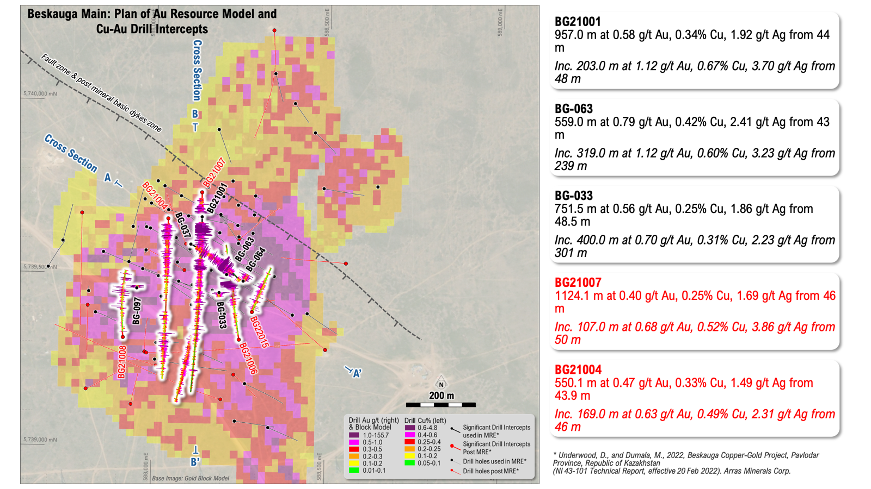

FIGURE 2. Cross Section SE Plunging Shoot – Gold Block Model and Cu-Au Drill Intercepts
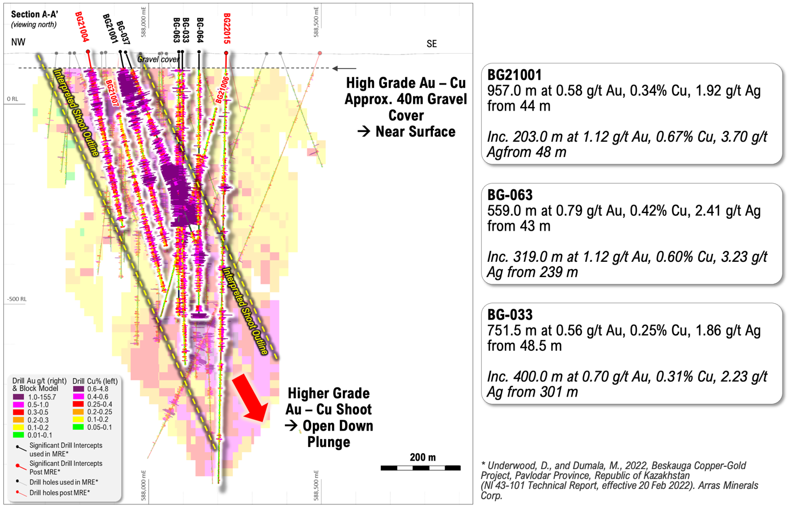

- Significant Existing Resource: The Beskauga Main deposit has a 2022 National Instrument NI 43-101 (“NI 43-101”) mineral resource estimate⁶ (MRE) within a conceptual pit shell at a gross metal value (GMV) cut-off of US$20/t (Table 1):
  - Indicated: 111.2 Mt at 0.30% Cu, 0.49 g/t Au and 1.34 g/t Ag (containing 333.6 kt Cu, 1.8 Moz Au, 4.8 Moz Ag)
  - Inferred: 92.6 Mt at 0.24% Cu, 0.50 g/t Au and 1.14 g/t Ag (containing 222.2 kt Cu, 1.5 Moz Au, 3.4 Moz Ag)
  - This represents a robust starting-point resource with expansion potential.

- Favourable Deal Terms: Deferred Consideration Under Option Agreement: Mogotes has the right to purchase a 100% interest in the Beskauga Project with an initial US$2.5 million payment (of which US$1.5 million in cash and US$1.0 million in cash or shares), followed by annual payments of US$1.0 million in 2027, 2028 and 2029, with each payment up to 50% paid in common shares of Mogotes, and a final payment of US$19.2 million on or before February 8, 2029, for total consideration of US$24.7 million (US$17.2M in cash and up to US$7.5M of value in common shares of Mogotes).

- Considerable Resource Expansion Potential: Mogotes’ initial analysis suggests the higher-grade mineralization within the MRE defines a large southeast-plunging shoot that remains open at depth (Figure 2). Post-MRE drilling totalling 18,657 metres in 28 holes has returned significant new mineralised intercepts extending outside of the 2022 resource, confirming the potential to grow the deposit with further drilling. Post-resource drilling highlights include (Table 3):
  - BG21007: 1,124.1m at 0.40 g/t Au, 0.25% Cu, 1.69 g/t Ag from 46m
    - Incl. 107.0m at 0.68 g/t Au, 0.52% Cu, 3.86 g/t Ag from 50m
  - BG22015: 955.0m at 0.29 g/t Au, 0.12% Cu, 0.97 g/t Ag from 45m
    - Incl. 17.0m at 1.05 g/t Au, 0.37% Cu, 1.70 g/t Ag from 337m

FIGURE 3. North-South Cross Section – Gold Block Model and Cu-Au Drill Intercepts
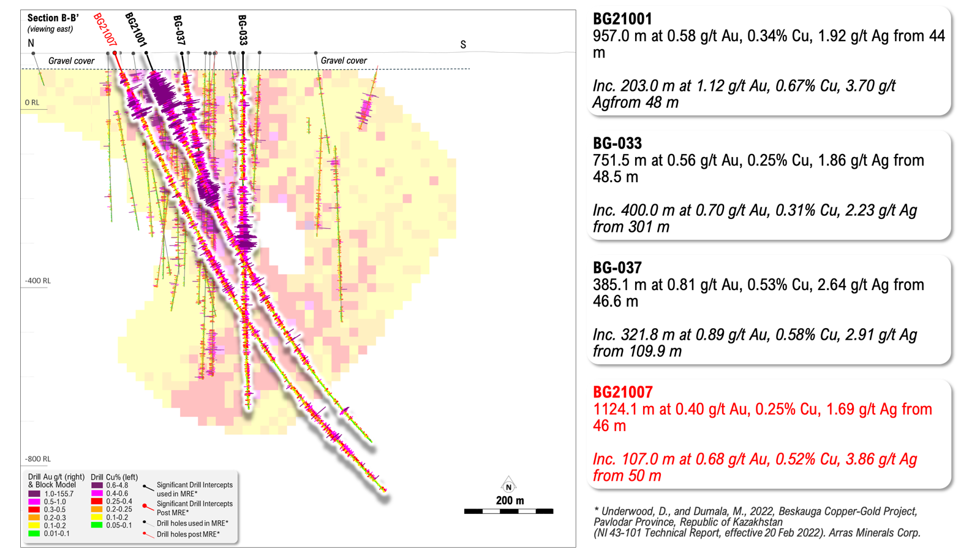

- District-Scale Exploration Upside: The Beskauga Project exploration licence covers a large tenure package hosting multiple untested porphyry-style magnetic targets with similar geophysical signatures to the Beskauga Main deposit. The Beskauga Central and Beskauga South prospects, among others, display magnetic depletion signatures consistent with epithermal alteration within the broader intrusive complex and have received limited to no modern exploration drilling, representing compelling satellite targets that could host additional mineralised systems.

- Established Mining Jurisdiction: Kazakhstan is a globally significant mineral producer.
  - The country is the world’s largest uranium producer (~40% of global output¹), a top-10 copper and gold producer, and holds the 3rd-largest chromite reserves globally².
  - Kazakhstan’s new Tax Code (effective January 2026) provides 100% capital deductions for exploration expenditures and a 0% mineral extraction tax for five years on new sites, reinforcing its investor-friendly credentials.³
  - The government targets US$150 billion in foreign direct investment by 2029, and recent legislative reforms (January 2025) further strengthen protections for foreign investors.⁴
  - Since 2020, Rio Tinto, Ivanhoe, Fortescue, BHP (through its Xplor generative exploration programme), Barrick Mining, First Quantum Minerals and Teck Resources have established exploration programmes in the country.⁵ The willingness of these globally significant operators to deploy capital into Kazakhstan validates both the geological prospectivity and the regulatory and operating environment of the jurisdiction.

- Highly Developed Infrastructure: The Project is located approximately 370 km from the national capital, Astana, and 70 km south-west of the provincial capital, Pavlodar, within the heart of Kazakhstan’s mining and heavy industry belt. Established rail and sealed national highway infrastructure lie within 20 km, a 1,100 kVA powerline traverses the project⁷, and the region hosts a skilled workforce and large-scale Cu-Au mining operations including the Bozshakol mine (1.1Bt at 0.34% Cu and 0.16 g/t Au)⁹ (Figures 4 & 5).

FIGURE 4. Beskauga Project and Infrastructure
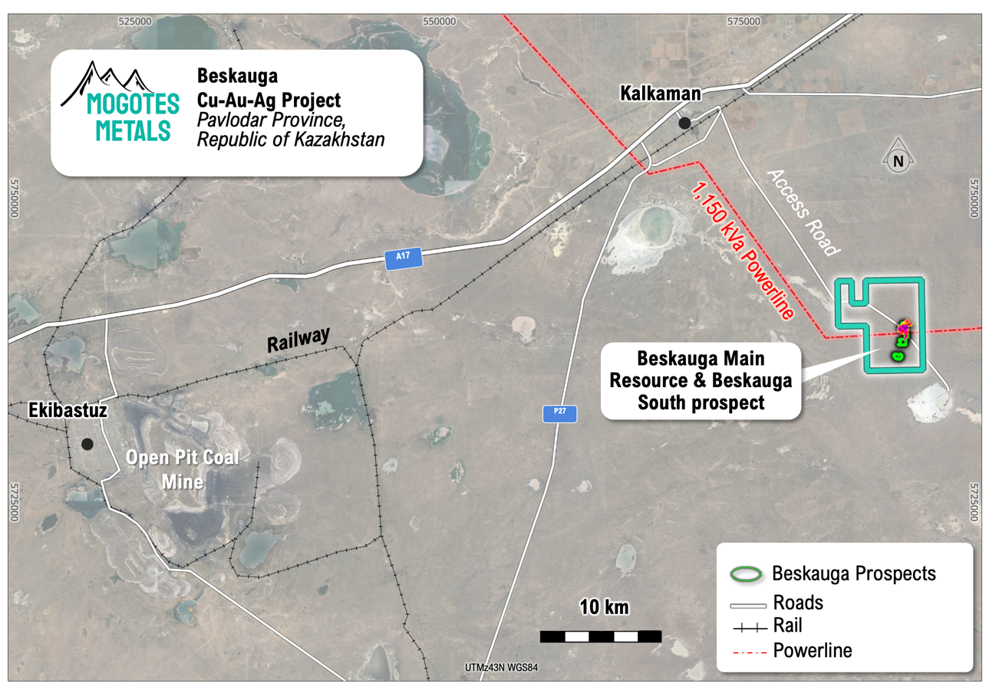

FIGURE 5. Overview of Porphyry projects in Kazakhstan⁹
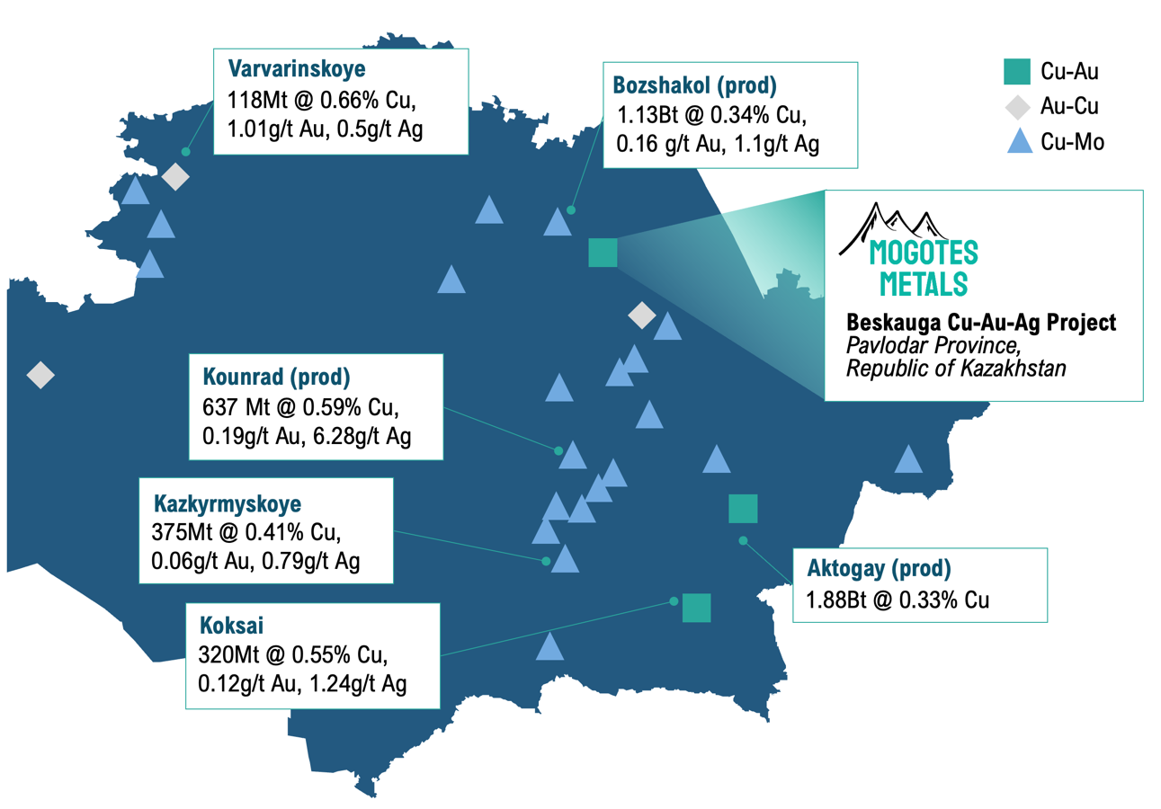

- Favourable Metal Price Environment: Mogotes’ analysis suggests that positive results from post-MRE drilling, combined with significantly improved metal prices since the 2022 resource estimate was prepared (the MRE used US$3.50/lb Cu and US$1,750/oz Au versus current prices well above those levels), offer considerable potential to update and improve the MRE.
- Counter-Cyclical Exploration Calendar: The Beskauga Project exploration season is counter-cyclical to the exploration season for Mogotes’ Filo Sur project in the Vicuña district, providing potential for year-round exploration and news flow for the Company.
- Further Updates: Mogotes will provide further technical information on the Beskauga Project in coming days as the Company prepares for the 2026 exploration season.

CEO Allen Sabet commented:
“The Beskauga Project acquisition marks a transformational step for Mogotes Metals. We have secured the right to earn a 100% interest in a resource-stage copper-gold-silver project that combines scale, grade, near-surface mineralisation and district-scale exploration upside – all in a jurisdiction that is increasingly recognised as one of the most attractive in the world for responsible mineral exploration and development.
With over 200 million tonnes already delineated and a higher-grade core starting at just 40 metres below surface, Beskauga Project offers a compelling foundation for value creation. The deposit remains open at depth and along strike, with post-resource drilling confirming that the system extends well beyond the current resource boundary. Equally exciting, the broader exploration licence hosts multiple untested targets with geophysical signatures analogous to the main deposit - any one of which could represent a significant new discovery.
Kazakhstan’s combination of favourable geology, established mining infrastructure, competitive operating costs, and a strengthened investor protection framework makes it an ideal environment for an exploration company of our size to create outsized value. We are already on the ground preparing for the 2026 field season and look forward to updating shareholders as we advance our integrated exploration and targeting program”
Strategic Rationale - A Complementary Portfolio
The addition of Beskauga Project is designed to complement the value of Mogotes’ flagship Filo Sur project in the Vicuña district.
- Filo Sur remains the Company’s primary exploration asset and continues to receive priority funding and technical focus.
- The Beskauga Project is being acquired under an option structure that preserves the Company’s financial flexibility: all payments are discretionary and staged over three years, the initial cash outlay is modest relative to the value of the resource being secured, and a portion may be settled in shares rather than cash, protecting treasury for Filo Sur drilling programmes.
- Critically, the two projects operate on opposite seasonal calendars - the Kazakh field season runs during the Northern Hemisphere summer while Filo Sur’s high-altitude Andean season is concentrated in the Southern Hemisphere summer - allowing Mogotes’ technical team and management bandwidth to be deployed year-round without competing for the same resources.
- The Beskauga Project cost of drilling is expected to run approximately US$100 per metre drilled, allowing a small investment in exploration budget to go a long way.
- For shareholders, this means continuous exploration newsflow, reduced single-asset concentration risk, and a second pathway to value creation through a resource-stage deposit with near-term development optionality, all achieved with relatively low cost of operation and option payments in the first years.
Summary of Option Agreement Terms
Pursuant to the Option Agreement, Mogotes, through its wholly-owned subsidiary Mogotes Metals Kazakhstan Inc. (the “Optionee”), has been granted the sole and exclusive option to acquire 100% of the participating interests in Dostyk LLP (the “Target Company”), a Kazakh limited liability partnership that holds the Beskauga Project exploration licence, from Copperbelt AG (the “Optionor”). Key terms are summarised below:
- Option Consideration: Total payments of US$24.7 million comprising US$17.2 million in cash payments (“Cash Only Amounts”) and US$7.5 million payable in cash or Mogotes common shares at the Optionee’s election (“Eligible Amounts”).
- Payment Schedule:
  - US$2.3 million within two business days of execution (US$1.3 million cash, US$1.0 million in cash or shares).
  - US$1.0 million on January 1, 2027 (US$500,000 cash, US$500,000 in cash or common shares)
  - US$1.0 million on January 1, 2028 (US$500,000 cash, US$500,000 in cash or common shares)
  - US$1.0 million on January 1, 2029 (US$500,000 cash, US$500,000 in cash or common shares)
  - US$19.2 million on or before February 8, 2029 (US$14.2 million cash, US$5.0 million in cash or common shares)
- Share Pricing: The common shares issued in satisfaction of Eligible Amounts are priced at the greater of: (i) the 20-day VWAP ending on the last trading day prior to the election notice; and (ii) the market price on the execution date subject to a floor price of C$0.48 per share and TSXV approval.
- Minimum Expenditure Commitments: The Optionee must incur or fund minimum exploration expenditures totalling US$860,000 over the Option Period.
- Mining Licence: The Optionee will prepare a Mining Licence application for submission by January 1, 2027.
- Discretionary Payments: All option payments and expenditure commitments are at the sole discretion of the Optionee. The Optionee may accelerate payments at any time without penalty.
Location and Previous Exploration Summary
The Beskauga Project is located in Pavlodar Province in the north-east of the Republic of Kazakhstan, approximately 370 km from the national capital, Astana. The Pavlodar provincial economy is largely driven by mining and heavy industry, including large-scale open-pit and underground mining. The Beskauga Project is located 70 km south-west of the provincial capital and is well serviced by established infrastructure, with the project located within 20 km of rail and sealed national highway. A 1,150 kVA powerline also traverses the project⁷ (Figure 4).
Kazakhstan sits within the Central Asian Orogenic Belt (CAOB), one of the world’s most richly mineralised metallogenic domains. The CAOB hosts numerous porphyry copper-gold deposits⁸. The Beskauga Project is situated in the same geological terrane as the Bozshakol and Aktogai porphyry copper-gold operations, among others, underscoring the district’s prospectivity.
The Beskauga Project area is covered by up to 40 m of post-mineral clay overburden. As a result, pre-discovery exploration was driven by project-scale IP geophysics and magnetics, wide-spaced grid-based KGK drilling (similar to “wet” reverse circulation drilling) through cover to collect basement geochemistry and geology samples. Exploration drilling of anomalies generated by this process led to the discovery of the Beskauga Project deposit in 2007. For a detailed exploration and company ownership history of the project please see the NI 43-101 report⁶.
Mogotes is undertaking an integrated reprocessing and targeting programme of the Beskauga Project ahead of the Kazakh field season and will provide a technical update on the Project in the coming weeks. The Company has commenced engaging a local team and service providers to advance the 2026 programme at the Beskauga Project.
TABLE 1. Mineral Resource Estimate for the Beskauga Main Project⁶
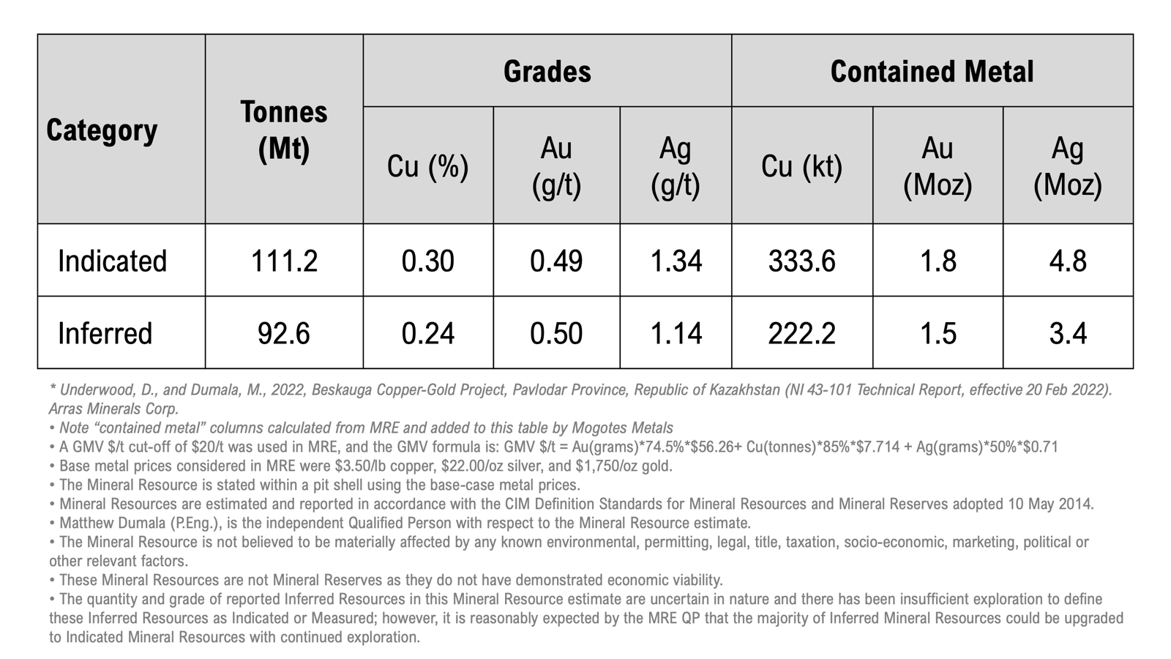

TABLE 2. Beskauga Select Intercepts From Drilling, from Drill Holes used in Mineral Resource Estimate⁶
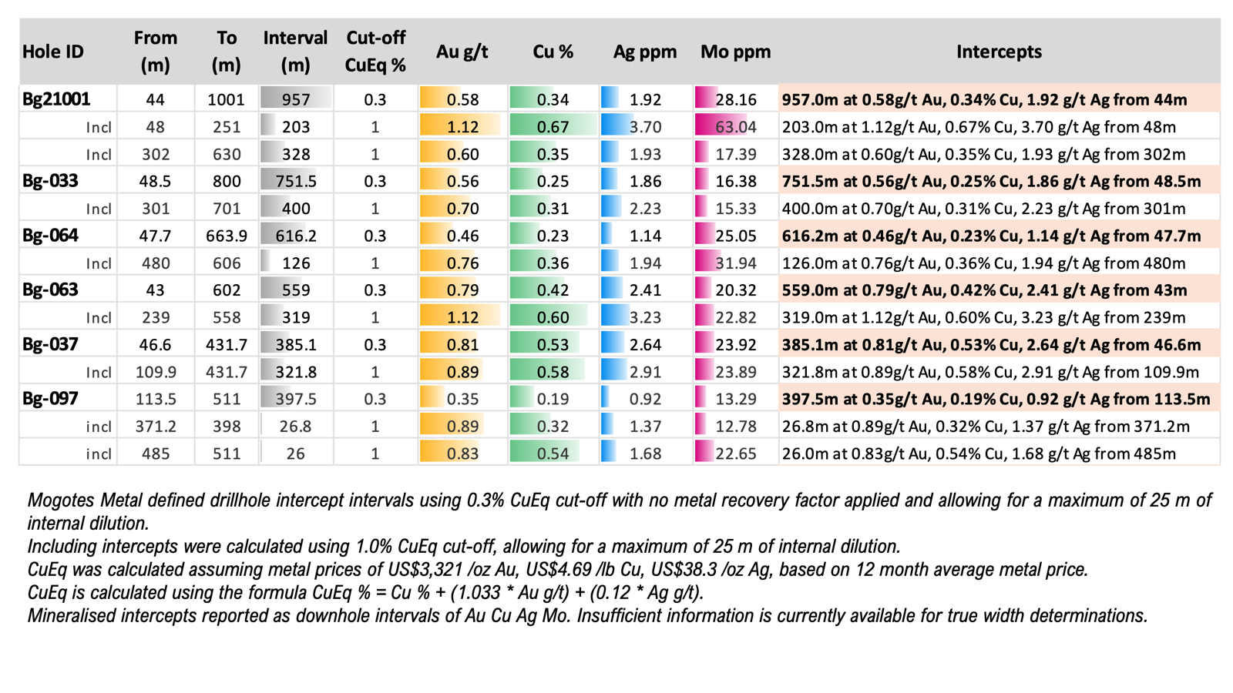

TABLE 3. Beskauga Select Intercepts From Drilling Completed Post Mineral Resource Estimate
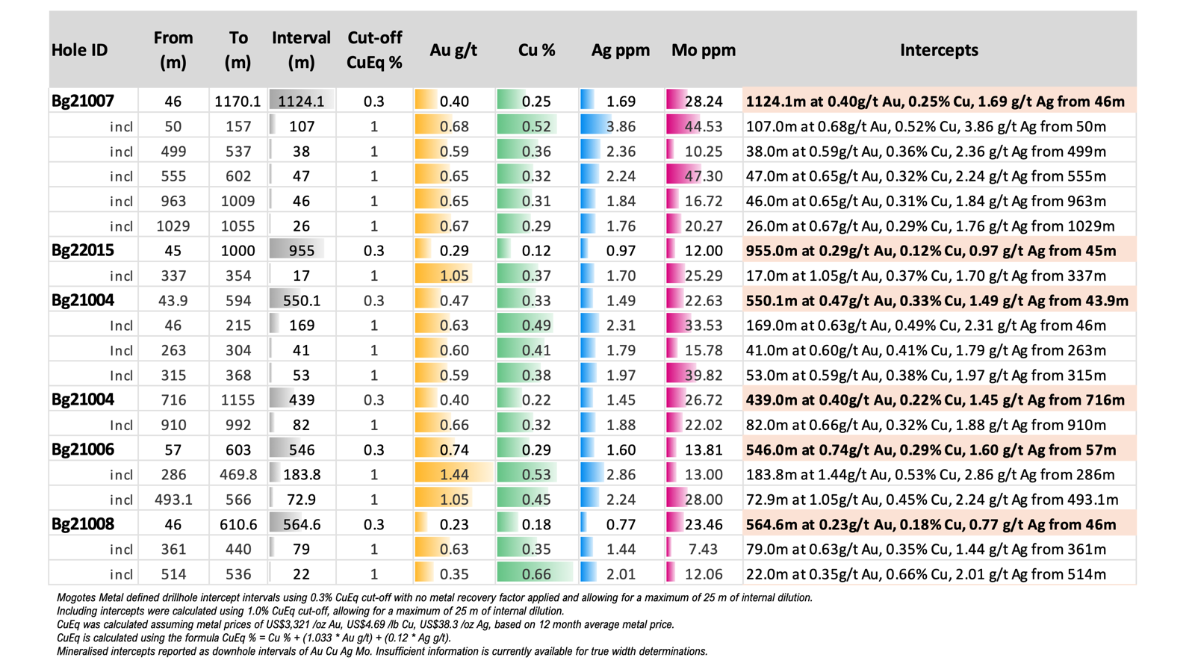
References
¹ World Nuclear Association, “Uranium and Nuclear Power in Kazakhstan”, world-nuclear.org (accessed February 2026).
² MINEX Kazakhstan 2024 Forum, “Shifting Dynamics in Kazakhstan’s Mining and Metals Industry”, 2024.minexkazakhstan.com.
³ Moore Kazakhstan, “New Tax Code: Key Changes”, kazakhstan.moore-global.com; Aequitas Law Firm, “New Tax Code – What Should Subsoil Users Expect?”, aequitas.kz. New Tax Code of the Republic of Kazakhstan signed July 18, 2025, effective January 1, 2026.
⁴ Concept of Investment Policy of the Republic of Kazakhstan 2024–2029, approved October 18, 2024. UNCTAD Investment Policy Monitor, investmentpolicy.unctad.org.
⁵ https://primeminister.kz/en/news/large-international-companies-investments-in-geological-exploration-amounted-to-about-41-billion-tenge-29409
⁶ Underwood, D., and Dumala, M., 2022, Beskauga Copper-Gold Project, Pavlodar Province, Republic of Kazakhstan (NI 43-101 Technical Report, dated 20 Feb 2022). Arras Minerals Corporation and associated press release (https://www.arrasminerals.com/arras-minerals-files-ni43-101-resource-of-1-75-million-ounces-of-gold-333-6-thousand-tonnes-of-copper-in-the-indicated-category-and-1-49-million-ounces-of-gold-222-2-thousand-tonnes-of-copper-i)
⁷ Mogotes Metals internal project review, 2025–2026. Kazakhstan Electricity Grid Operating Company (KEGOC) map of electrical networks, 2026 (https://www.kegoc.kz/electric-power/natsionalnaya-energosistema/eng%20Карта%20схема%20ЕЭС%20Казахстана-2026%20г.%20cdr.pdf).
⁸ Porphyry Copper Assessment of the Central Asian Orogenic Belt, U.S. Geological Survey Scientific Investigations Report 2010-5090-X (https://pubs.usgs.gov/sir/2010/5090/x/pdf/sir2010-5090-X.pdf).
⁹ KAZ Minerals Supplementary Information – Mineral Reserves and Mineral Resources, Year ended 31 December 2021 (https://www.kazminerals.com/media/22382/mineral-reserves-and-resources-estimation-methods-2021.pdf); Porphyry Copper Assessment of the Central Asian Orogenic Belt, U.S. Geological Survey Scientific Investigations Report 2010-5090-X (https://pubs.usgs.gov/sir/2010/5090/x/pdf/sir2010-5090-X.pdf).

About Mogotes Metals Inc.
Mogotes Metals Inc. is a mineral exploration company focused on copper, gold and silver exploration and development. The Company’s portfolio includes the Filo Sur project, which adjoins the large Filo del Sol copper-gold-silver discovery in the prospective Vicuña district of Argentina and Chile, and the Beskauga Project (copper-gold-silver) in the Pavlodar Province of Kazakhstan.
For further information, please contact:
Mogotes Metals Inc.
Allen Sabet, President and Chief Executive Officer
Phone: (647) 846-3313
Email: info@mogotesmetals.com
Follow Us
Twitter: https://x.com/mogotesmetals
Additional Information
The information contained in this news release was accurate at the time of dissemination but may be superseded by subsequent news release(s). The Company is under no obligation, nor does it intend to update or revise the forward-looking information, whether as a result of new information, future events or otherwise.
Qualified Person
The scientific and technical disclosure for the Beskauga Project included in this news release has been reviewed and approved by Stephen Nano, who is a Qualified Person as defined by National Instrument 43-101 — Standards of Disclosure for Mineral Projects ("NI 43-101"). Mr. Nano is a Director and Technical Advisor of the Company and is therefore not considered independent of the Company for the purposes of NI 43-101.
Cautionary Note Regarding Historical Estimates
The mineral resource estimate referenced in this news release was originally prepared by David Underwood BSc (Hons) Registered Professional Natural Scientist, an independent Qualified Person as defined by NI 43-101, and disclosed in a technical report titled “Beskauga Copper-Gold Project, Pavlodar Province, Republic of Kazakhstan, Amended & Restated NI43 101 Technical Report” with an effective date of 20 February 2022, which is available under Arras Minerals Corp. SEDAR+ profile at www.sedarplus.ca.
Mineral resources referenced in this news release are classified in accordance with the Canadian Institute of Mining, Metallurgy and Petroleum ("CIM") Definition Standards for Mineral Resources and Mineral Reserves (May 10, 2014). Mineral resources that are not mineral reserves do not have demonstrated economic viability.
The mineral resource estimate for the Beskauga deposit referenced in this news release is treated as a historical estimate for the purposes of NI 43-101. The estimate was prepared by David Underwood, B.Sc. (Hons) (Osino Resources) and Matthew Dumala, B.Sc. (Archer, Cathro & Associates) with an effective date of February 20, 2022, and key assumptions including top cut values for copper, gold and silver of 3.00%, 10.0 g/t and 25.0 g/t respectively, a gross metal value cut-off of $20/t, base metal prices of $3.50/lb copper, $22.00/oz silver and $1,750/oz gold, and recovery factors of 85.0% for copper, 74.5% for gold, and 50.0% for silver. The estimate was disclosed in Underwood, D., and Dumala, M., 2022, Beskauga Copper-Gold Project, Pavlodar Province, Republic of Kazakhstan (NI 43-101 Technical Report, effective 20 Feb 2022). Arras Minerals Corp.
The Company considers the historical estimate to be relevant to investors as it provides an indication of the mineralization potential of the Beskauga property. However, the Company's Qualified Person, Mr. Nano, has not completed sufficient work to verify or classify the historical estimate as a current mineral resource or mineral reserve in accordance with NI 43-101 and CIM Definition Standards. The Company is not treating the historical estimate as a current mineral resource or mineral reserve, and the historical estimate should not be relied upon.
In order to verify or upgrade the historical estimate to current mineral resources or mineral reserves, the Company anticipates that work would include, among other things: compilation and independent verification of the historical drill hole database, including re-logging and re-assaying of selected drill core where available; integration of the 18,657 metres of post-resource drilling completed to date; an updated geological and structural interpretation; revised resource estimation incorporating current commodity prices and economic parameters; and, if warranted, additional infill and step-out drilling to support reclassification. The Company intends to evaluate and advance this work as part of its 2026 exploration and technical programme at the Beskauga Project.
Inferred mineral resources, where referenced, have a great amount of uncertainty as to their existence and as to whether they can be mined legally or economically. It cannot be assumed that all or any part of an inferred mineral resource will ever be upgraded to a higher category.
Cautionary Note Regarding Forward-Looking Statements
This news release contains "forward-looking information" and "forward-looking statements" within the meaning of applicable Canadian securities legislation (collectively, "forward-looking information"). Generally, forward-looking information can be identified by the use of forward-looking terminology such as "plans", "expects", "does not expect", "is expected", "budget", "scheduled", "estimates", "forecasts", "intends", "projects", "budgets", "targets", "assumes", "strategy", "goals", "objectives", "potential", "possible", "anticipates", "does not anticipate", "believes", or variations of such words and phrases, or statements that certain actions, events, conditions or results "will", "may", "could", "would", "should", "might" or "will be taken", "will occur" or "will be achieved", or the negative connotations thereof. All statements other than statements of historical fact may be forward-looking statements.
In particular, this news release contains forward-looking information pertaining to, without limitation: the proposed acquisition of the Beskauga Project, including the anticipated terms, conditions precedent, expected closing date, and anticipated benefits of the acquisition; assumptions made in the interpretation of drill results, geology, grade, geochemistry, potential implications of geophysics interpretations, and continuity of mineral deposits; the Company's planned exploration programs and expenditures at the Beskauga Project; expectations regarding access to and demand for equipment, skilled labour and services needed for exploration and development of mineral properties; potential exploration upside at the Beskauga Project, including the extent and significance of mineralization and the prospectivity of exploration targets; the ability of the Company to conduct its field programs as planned; the success of future exploration activities; potential for resource expansion; the ability to build shareholder value; expectations with regard to establishing mineral resources or mineral reserves through exploration; the ability to execute planned work programs; plans or ability to mobilize or add additional drill rigs; timing or anticipated results of laboratory assay results; and the Company's ability to obtain required financing.
The forward-looking information contained in this news release is based on certain assumptions, including, without limitation: that the acquisition of the Beskauga Project will be completed on the terms and timeline anticipated; that required regulatory approvals, including any approvals required under the laws of Kazakhstan and Canada, will be obtained in a timely manner; that financing will be available if and when needed on reasonable terms; that the Company will be able to obtain all necessary permits, licences, and authorizations to conduct exploration in Kazakhstan; that the Company will not experience any material adverse change in its business or financial condition; that commodity prices and foreign exchange rates will not decline materially; that the Company will not experience any material labour dispute, accident, or failure of plant or equipment; that there will be no material adverse changes to the political, legal, or regulatory environment in Kazakhstan; that the Company will be able to operate without being materially affected by international sanctions regimes; and that contracted counterparties will perform their obligations as agreed.
Forward-looking information involves known and unknown risks, uncertainties and other factors that may cause actual results or events to differ materially from those anticipated in such forward-looking information. Such risks and uncertainties include, but are not limited to: general business, economic and mining industry conditions; fluctuations in commodity prices; changes in foreign exchange rates, particularly as between the Canadian dollar, United States dollar, and Kazakhstani tenge; the speculative nature of mineral exploration; geological conditions and variability; uncertainty of mineral resource estimates; that the Company may not discover commercially viable quantities of minerals; environmental risks and compliance costs; the supply and demand for commodities; title disputes or claims; limitations on insurance coverage; and uninsured risks. The Company's operations in Kazakhstan are subject to the risks of operating in a foreign jurisdiction, including: changes to Kazakhstan's mining legislation, subsoil use rights framework, and tax regime, including potential increases in tax rates applicable to subsoil users; political instability or changes in government policy affecting the mining sector; inconsistent enforcement of laws, regulations, and contractual obligations; the potential for government-mandated participation in mining projects; currency fluctuations and volatility of the Kazakhstani tenge, which may be correlated with fluctuations in the Russian ruble and global commodity prices; risk of exposure to international sanctions regimes affecting the importation of equipment, technology, and services, and the Company's ability to transact with international counterparties; changes to environmental legislation, including restrictions on water usage under Kazakhstan's water code; repatriation and currency conversion risks; inadequacy of infrastructure in remote areas of Kazakhstan; potential for expropriation or nationalization; difficulties in enforcing judgments obtained in foreign jurisdictions; the need to comply with Kazakhstan's obligations under the Extractive Industries Transparency Initiative (EITI); and the potential for social or community opposition to mining activities; that the acquisition of the Beskauga Project may not be completed on the anticipated terms or timeline, or at all; that required regulatory, governmental, or other approvals may not be obtained or may impose conditions that are not anticipated; that due diligence may not identify all risks and liabilities associated with the acquired assets; that financing required to complete the acquisition and fund planned exploration may not be available on acceptable terms; that the Company may not realize the anticipated benefits of the acquisition; and that integration of the acquired project may be more costly or complex than anticipated. Risks also include the stability and predictability of the political and legal environments in jurisdictions where the Company operates; that financing will be available if and when needed on reasonable terms; the ability of the Company to continue as a going concern; dilution to existing shareholders from future equity financings; and general economic, market, or business conditions.
These factors are not, and should not be construed as being, exhaustive. Although the Company has attempted to identify important factors that would cause actual results to differ materially from those contained in forward-looking information, there may be other factors that cause results not to be as anticipated, estimated, or intended. There can be no assurance that such statements will prove to be accurate, as actual results and future events could differ materially from those anticipated in such statements. Additional risk factors are identified in the Company's periodic filings with Canadian securities regulators, available under the Company's SEDAR+ profile at www.sedarplus.ca.
Statements relating to "mineral resources" are deemed to be forward-looking information, as they involve the implied assessment, based on certain estimates and assumptions, that the mineral resources described can be profitably produced in the future.
The forward-looking information contained in this news release is made as of the date hereof. Except as required under applicable securities legislation, the Company does not intend, and does not assume any obligation, to update or revise this forward-looking information, whether as a result of new information, future events, or otherwise. Readers are cautioned not to place undue reliance on forward-looking information due to the inherent uncertainty thereof.
This news release has been prepared in accordance with the requirements of Canadian securities laws, which differ in material respects from the requirements of United States securities laws applicable to U.S. companies. Information concerning the Company's mineral properties has been prepared in accordance with NI 43-101 and the CIM Definition Standards. These standards differ from the requirements of the U.S. Securities and Exchange Commission (the "SEC") set forth in Subpart 1300 of Regulation S-K. Accordingly, mineral resource and mineral reserve information contained herein may not be comparable to similar information disclosed by companies subject to SEC reporting requirements. Investors are cautioned not to assume that all or any part of measured or indicated mineral resources will ever be converted into mineral reserves. Investors are further cautioned not to assume that all or any part of an inferred mineral resource exists, or is economically or legally mineable.
The information contained in this news release was accurate at the time of dissemination but may be superseded by subsequent news release(s). The Company is under no obligation, nor does it intend to update or revise the information contained herein, except as required by applicable securities legislation.
Neither TSX Venture Exchange nor its Regulation Services Provider (as that term is defined in the policies of the TSX Venture Exchange) accepts responsibility for the adequacy or accuracy of this release.

