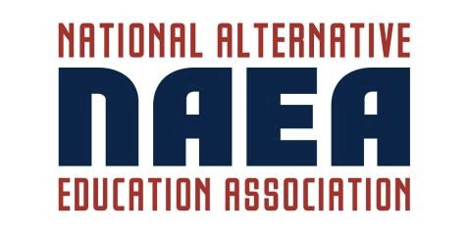

November 14, 2025

FOR IMMEDIATE RELEASE:

On October 6, 2025, Shannon Ellis received the Excellence in Alternative Education Award from the National Alternative Education Association at their annual conference held in New Orleans, LA.

This award recognizes an individual who has demonstrated
exemplary service to youth in alternative/non-traditional education.
The recipient of this award is an advocate for students in alternative/non-traditional schools and believes that students in alternative settings have the same aptitudes and abilities as students in traditional settings.

NAEA strives to empower alternative educators to make a meaningful impact on students' lives. Our mission is to advocate for equitable access to innovative educational practices. The NAEA has empowered alternative educators through advocacy, collaboration, and innovative educational practices since 2002.

For more information regarding the NAEA, please visit: www.the-naea.org

