Code of Practice on Complaint Handling and Dispute Resolution

21st Century Network Solutions Limited (hereafter 21cns) is an independent company that delivers communications services to business customers. While we may not provide all the component parts of our services ourselves, we do take responsibility for the services delivered to you. We will liaise with our suppliers to ensure that any problems with their services are resolved promptly.

We make every effort to ensure that our customers are happy with the level of service, and the products and service they receive from us. However, despite our best efforts, things can go wrong. We take customer complaints very seriously and aim to resolve them quickly and efficiently.

If you have a complaint about any part of our service, please contact our Customer Service Team using one of the following:
By Phone: 01704540547
By Email: support@adaptivecomms.co.uk
By Letter: Customer Service Department, 21st Century Network Solutions Ltd, t/a AdaptiveComms. 11b Hoghton Street, Southport, PR9 0NS.

If you telephone, our advisors will ask you about your complaint and seek to resolve the problem while you are on the line. During any discussions we will protect the privacy of the information that we hold on you. To do this we may have to ask questions to confirm that we are speaking to the right person.

If you make your complaint by email or in writing, we will acknowledge receipt, advise how and when we will next respond and provide you with a contact point for checking progress on the resolution of your complaint.

We will try to resolve your complaint quickly and efficiently, and to keep you informed at all times. We normally aim to resolve complaints within 10 working days but, depending on the nature of the complaint, this is not always possible. However, if you are not happy with progress in resolving your complaint you can ask the person to whom you are speaking to escalate the matter to their manager, and ultimately to the Group Director. If we cannot resolve the problem, we will write to you to say so.

If it has been more than 6 weeks from the date you first contacted us to complain or you have received a letter from us saying that your complaint has reached “deadlock”, then you may ask for help from: CISAS.

CISAS
70 Fleet Street, London, EC4Y 1EU T: 0845 1308 170 or 0207 520 3827
E: info@cisas.org.uk W: www.cisas.org.uk

CISAS is an independent organisation which is approved by Ofcom to provide an alternative dispute resolution (ADR) service. Ofcom-approved ADR services sort out disputes between communications providers and their consumer and small business customers. Their job is to investigate complaints fairly by listening to both sides of the story. They look at the facts given to them before recommending any action that may be needed to put things right.

Alternatively, if at any time you are not satisfied with the progress of your complaint you can ask us to agree to an early referral to ADR (i.e. that we issue a deadlock letter). However, we may decline to do so if we believe we will shortly resolve your complaint and are taking active steps to do so.

Useful Addresses

CISAS
100 St. Paul’s Churchyard, London, EC4M 8BU
T: +44 (0)20 7536 6000
E: info@cisas.org.uk
W: www.cisas.org.uk

Ofcom
Riverside House, 2a Southwark Bridge Road, London, SE1 9HA
T: 020 7981 3040 or 0300 123 3333
E: contact@ofcom.org.uk
W: www.ofcom.org.uk

Phone-paid Services Authority
40 Bank Street London, E14 5NR
T: 0300 30 300 20 or 020 7940 7474
E: info@psauthority.org.uk
W: www.psauthority.org.uk

Telephone Preference Service
DMA House, 70 Margaret Street, London W1W 8SS
T: 0207 291 3320
E: tps@dma.org.uk
W: www.tpsonline.org.uk

Federation of Communication Services (FCS)
Unit 14, The Stottie Shed, Baker’s Yard, Christon Road, Gosforth, Newcastle upon Tyne, NE3 1XD
T: +44 020 7186 5432
E: fcs@fcs.org.uk
W: www.fcs.org.uk

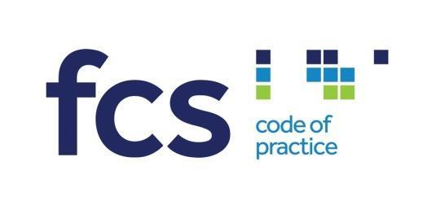
Licence Number 1686
Correct at the time of printing, published March 2023

