HOW TO BOOK

Step 1: Create an account

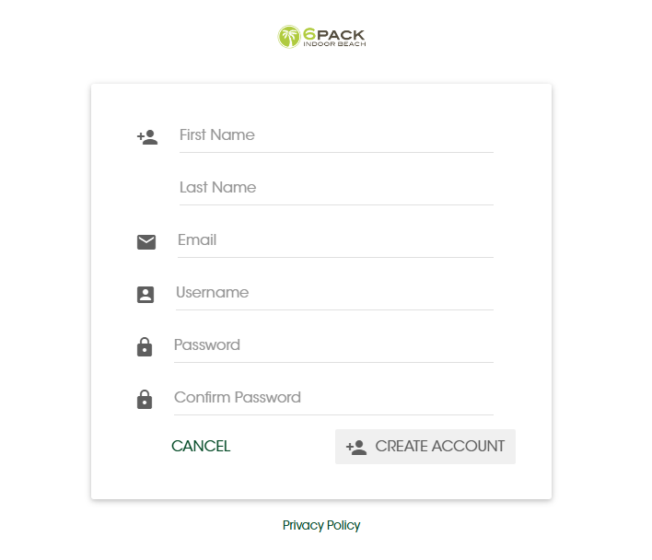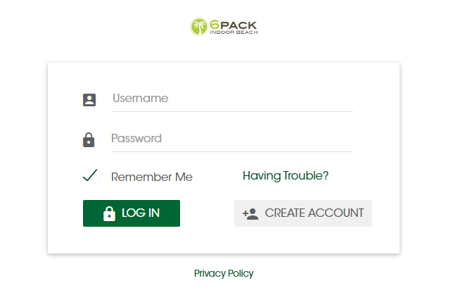

Step 2: Complete registration by using the registration confirmation email sent to your email. You will not be able to login before you complete the registration through email. It will display the following error if the registration is incomplete.

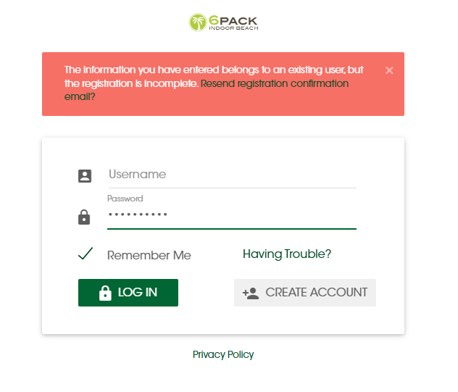

Step 3: Once logged in, click on ‘Book 6Pack’ to make a reservation.

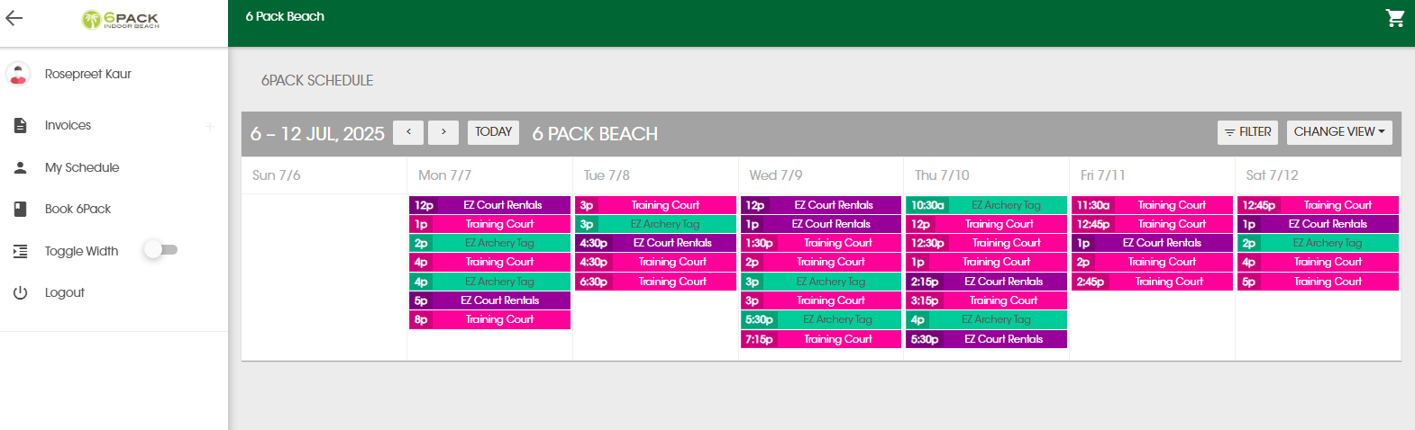

Step 4: Click on the reservation you would like to book. Please read the description prior to payment.

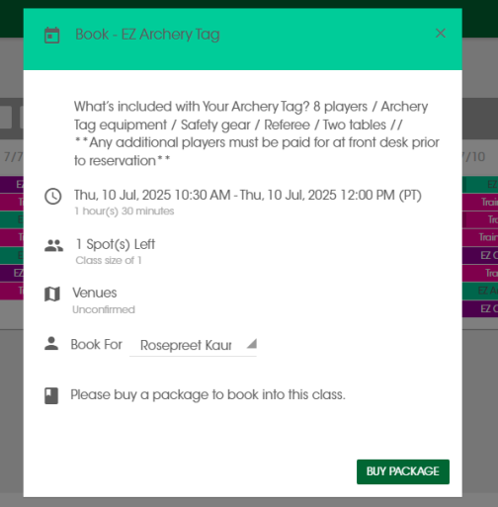

Step 5: Click on ‘Buy Package’ and then ‘Buy’. Complete the check out by entering your card details and billing address.

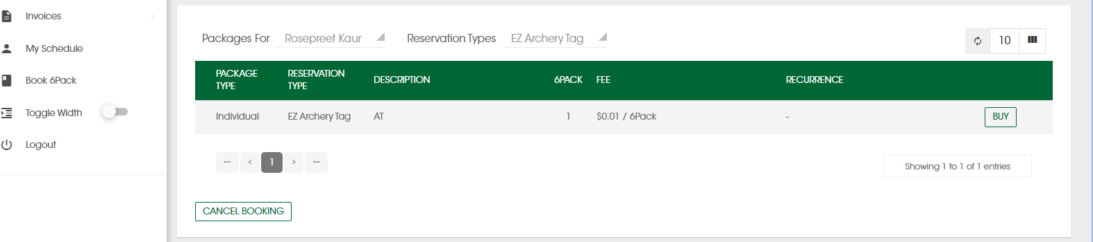

Step 6: You can view your booked reservations in ‘My Schedule’.

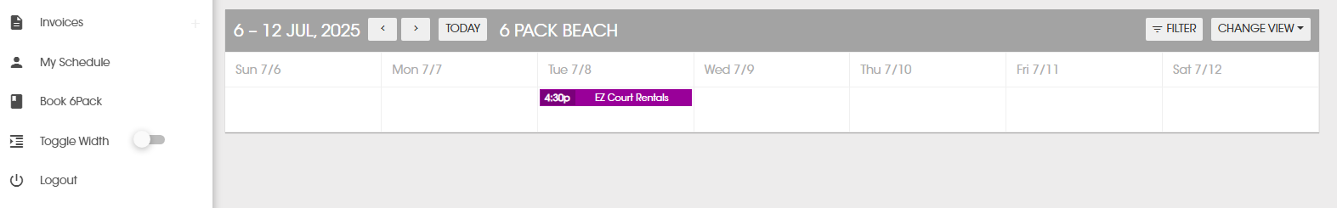

*For questions or concerns, please contact us at 604-321-6800 or* [*staff@6packbeach.com*](mailto:staff@6packbeach.com)

**FAQs**

Q: How do I book?

*Please see the ‘How to Book’ section on our website.*

Q: I created my account but I’m unable to log in.

*Please check your email that you used to create the account. Look for an email from 6Pack Beach for registration confirmation. Click on the ‘Complete Registration’ button in the email. Make sure to check your spam folder.*

Q: How do I cancel my reservation?

*Reservations can be cancelled by clicking on the scheduled reservations in ‘My Schedule’. Click on ‘Cancel Session’. The amount will be credited to your account to use for next reservation. Only training court reservations can be cancelled online. For any other cancellations, please call 604-321-6800 or email staff@6packbeach.com*

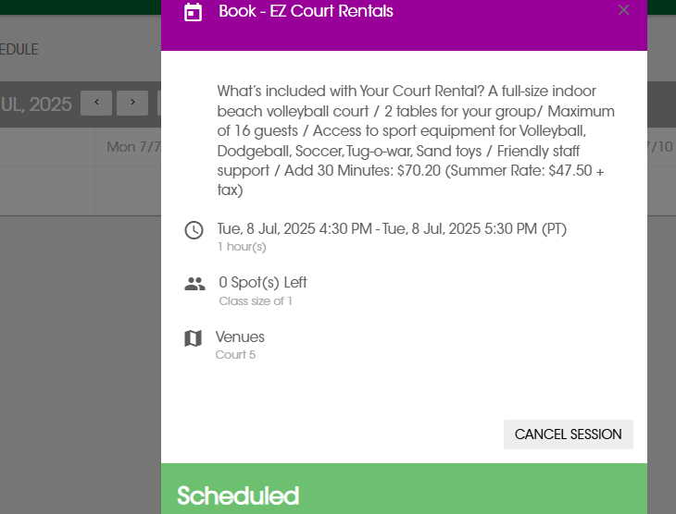

Q: I cancelled my reservation but did not receive the credit.

*All reservations must be cancelled 48 hours before to receive the credit.*

Q: I cancelled my reservation but cannot see the refund amount in my account.

*You will not be able to see the refund in your account. However, when you reserve again, you will not be required to pay before you book.*

Q: I cancelled my reservation for archery tag within the cancellation window. I am trying to book for a court rental but the website is asking me to pay again.

*If you have paid for and cancelled your archery tag reservation. You can use that credit towards another archery tag reservation only. To book for a court rental, you will be required paying again.*

*For questions or concerns, please contact us at 604-321-6800 or* [*staff@6packbeach.com*](mailto:staff@6packbeach.com)