RM OF CLINWORTH
NOTICE

STORAGE PARKING
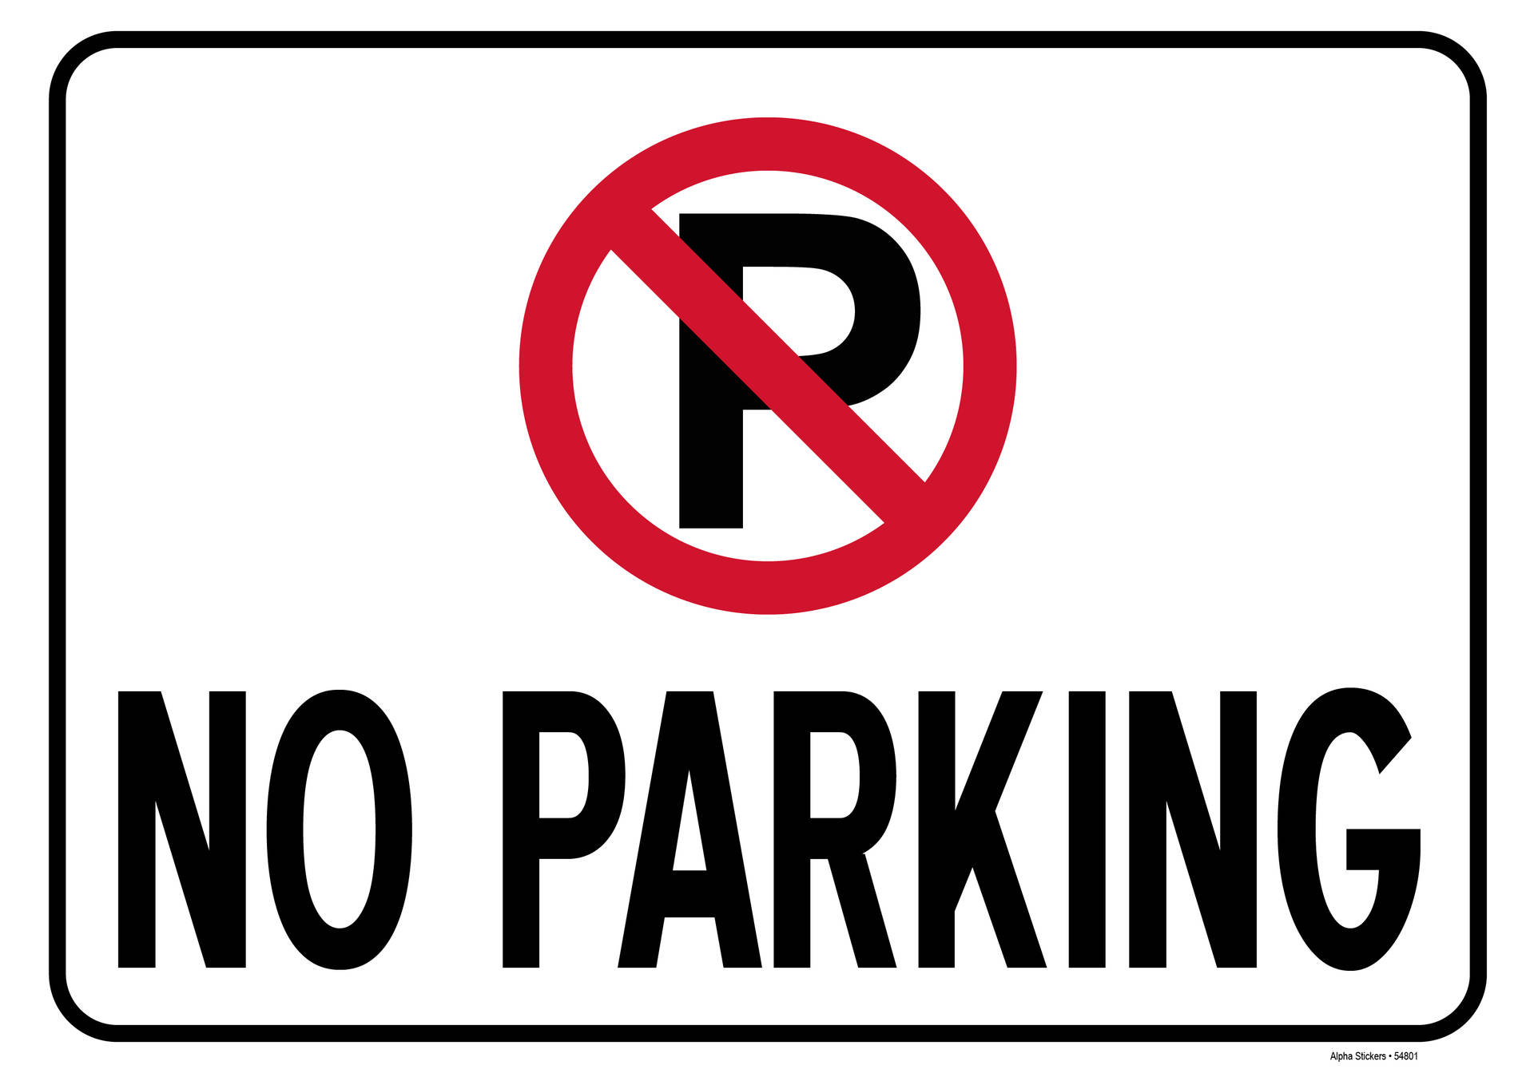
AROUND THE CURLING RINK IS PROHIBITED
PARKING DESIGNATED FOR 24 HRS OR LESS

