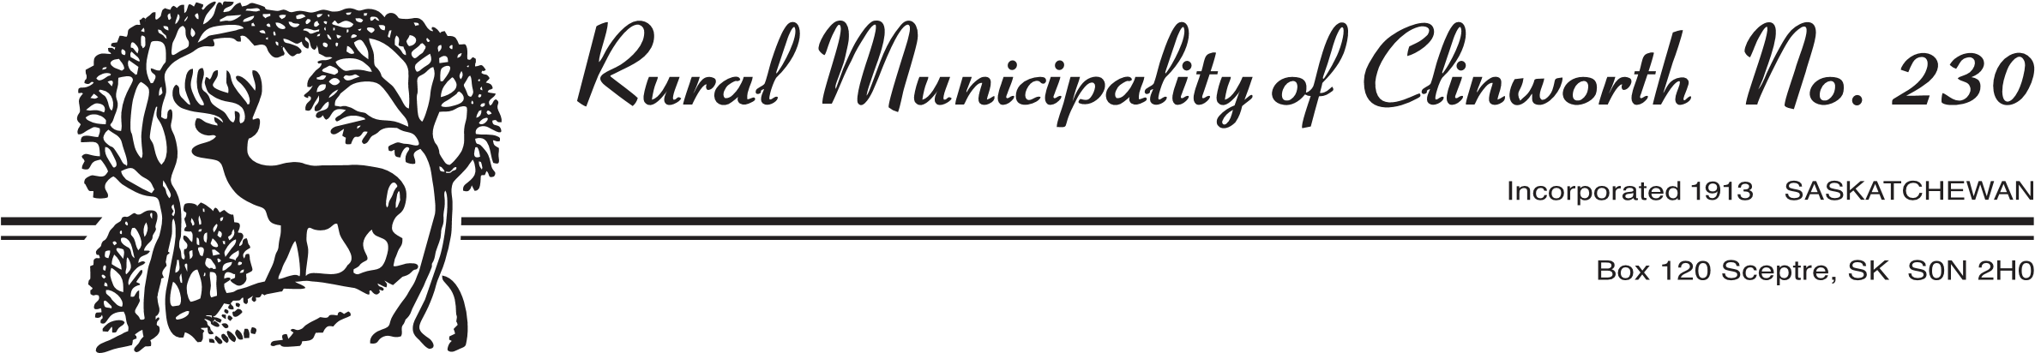

The Rural Municipality of Clinworth No. 230 is accepting applications for the position of a Contract Pest Control Officer.

Applicants must:

- Hold a valid Structural Applicator License (Pesticide License)
- Possess a valid Saskatchewan Class 5 Drivers License; and
- Supply their own vehicle.

The PCO will be expected to work as many hours per day as may be required to control or
destroy any pests within the municipality. The PCO will be required to fill out Rat Infestation reports and PCO Inspection Reports. These are required as part of the Saskatchewan Association of Rural Municipalities (SARM) Rat Control Program.

Specific Skills:
- Advise ratepayers on how to prevent pest infestation
- Place and set traps to capture and remove animals if necessary
- Inspect buildings and outside areas to detect signs of infestations.
- Neutralize pests through control measures such as pesticide application, baiting and trapping.

Personal Suitability:
- Effective interpersonal skills
- Flexibility
- Team player
- Reliable
- Organized

This position will remain posted until filled. Please submit your contract rate, which would include travel, along with your qualifications, certifications and references by mail, email or drop off at the RM Office located at 128 Kingsway Street, Sceptre, SK.

R.M. of Clinworth No. 230
Box 120
Sceptre, SK S0N 2H0
rm230@yourlink.ca

The R.M. of Clinworth No. 230 wishes to thank all applicants for their interest. However, only those selected for an interview will be contacted.

