ISYS20291 Business Marketing & Innovative Digital Venture Design
Assignment 2 Business Plan

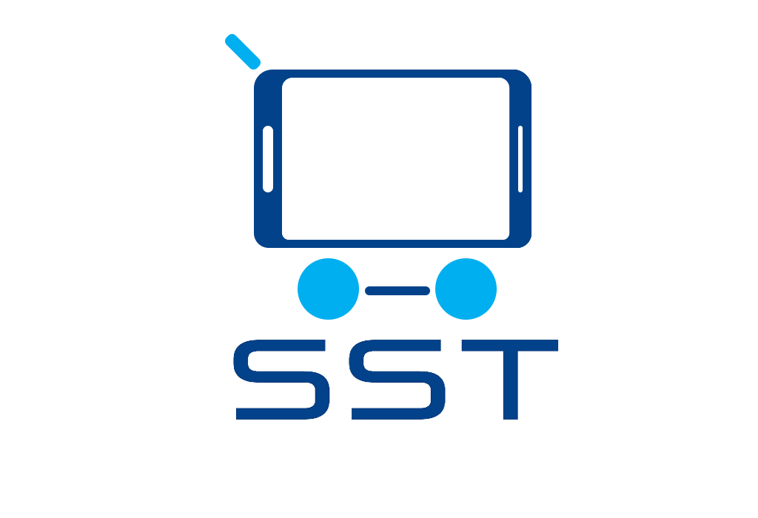

Smart Shopper Tech LLP

‘Revolutionising the retail experience through technology’

Smart Shopper Trolley

Inderjit Sandhu N0578334

Table of Contents
Executive Summary 4
Current Business and Market Context: 4
Financial Summary: 4
Business Aim: 5
Business Objectives 5
The Product – the SST Trolley 5
Competitive Advantage 6
Intellectual Property (IP) Plans 7
Patents 7
Trademarks 7
Confidentiality & Non-disclosure agreements 7
Design registration 7
Future Products and Product Improvements 7
Product Expansion: SST Basket 8
Product Expansion: SST Shelves 8
Market Research 8
Secondary research 8
Problem identification and target marker 9
Primary research 9
Competitor analysis 10
Pestle Analysis 11
SWOT Analysis 12
TOWS Matrix 13
Market segmentation 13
Potential clients 14
Market position 14
Market position mapping 15
Marketing mix – the 4Ps 15
Product 15
Pricing 16
Place 16
Promotion 16
Design and development 17
Estimated Stages of development and time-scale 18
Time to market 18
Manufacturing and logistics 18
Manufacturer Contingency plans 19
Financial plans 20
Profit and Loss summary 20
Sensitivity Analysis 21
Breakeven Analysis 22
Cash Flow forecasts 22
Appendices 24
Appendix A - Jobs / Skills required 24
Appendix B - Technical product information 25
Appendix C - Advantages / disadvantages of outsourcing and manufacturing the SST in China 27
Appendix D - Questionnaire – primary research 28
Appendix F - Use case Scenario 30
References 31
Bibliography 32

Executive Summary
Smart Shopper Tech (SST) LLP introduces the SST Trolley - an innovative, technology-driven shopping solution designed to streamline the in-store retail experience for both customers and retailers. Equipped with dual cameras, the trolley automatically scans items as customers place them inside, eliminating the need for manual scanning. A built-in tablet interface displays all scanned products, allowing users to manage their baskets in real time, while an integrated chip and PIN terminal enables seamless, queue-free payment upon completion of shopping.

Beyond enhancing customer convenience, the SST Trolley offers significant operational advantages for retailers. It enables valuable data collection on customer behaviour and product interaction, helps reduce staffing requirements at checkouts, and alleviates the issue of long queues—often a key factor in customer dissatisfaction and lost sales. By merging smart technology with everyday shopping habits, the SST Trolley presents a forward-thinking solution for the evolving retail environment.

Current Business and Market Context:
The UK food retail sector is a high-revenue, oligopolistic market dominated by major players such as Tesco, Asda, Sainsbury’s, and Morrisons. While these giants lead in market share, a number of smaller but still substantial retailers also operate within the space - many generating billions in annual turnover.

A persistent challenge across the sector is the lack of efficiency and convenience at the point of payment. Customers frequently experience frustration due to long queues and outdated checkout processes. In recent years, several retailers have experimented with different solutions to streamline this experience; however, no single approach has yet proven scalable or universally effective across large retail environments.

Financial Summary:
An initial £25,000 in start-up capital is required, comprising a £12,500 personal investment from the directors and a £12,500 business loan. These funds will be allocated toward the development of a functional prototype and used to support initial pitches and trial placements with potential retail partners.

Financial Projections – Key Highlights
- Retained Profit:
  - Year 1: –21,790
  - Year 2: £8,429
  - Year 3: £19,489
- Projected Break-even Point:
  - January 2020, following the deployment of approximately 259 SST Trolley units

Business Aim:
To design and deliver innovative smart technology solutions for retailers, positioning the business as a pioneering force within an emerging market segment.

Business Objectives
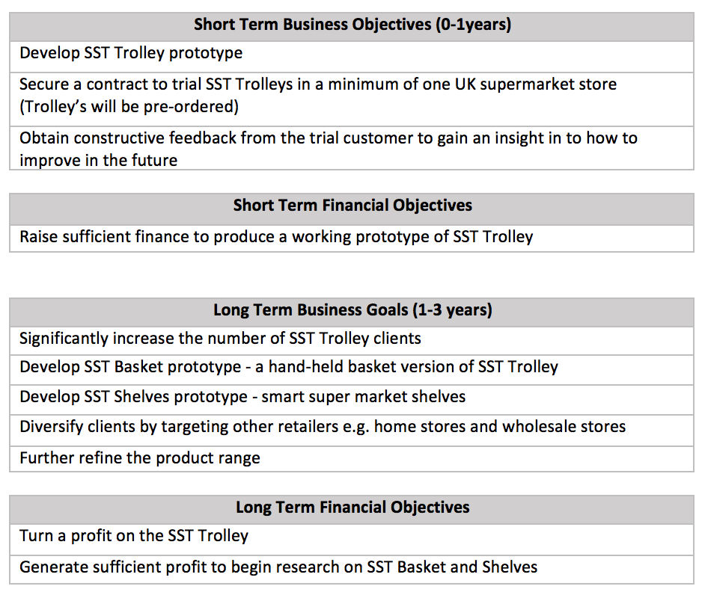

The Product – the SST Trolley
The SST Trolley is an all-in-one smart shopping solution that integrates the functionality of a trolley and self-service checkout. Equipped with cameras, it automatically detects and logs items as they are placed inside, significantly enhancing the speed and convenience of the shopping experience.

A built-in touchscreen interface displays a real-time summary of the trolley's contents and provides users with flexible payment options—either through the dedicated SST mobile app or via a chip and PIN terminal. The chip and PIN system mimics the "pay-at-the-pump" model seen in petrol stations, allowing customers to pre-pay before shopping.

Beyond improving customer convenience, the SST Trolley offers valuable benefits to retailers by collecting and analysing shopping data. This enables supermarkets to gain insights into consumer behaviour and refine the overall customer experience, contributing to continuous business improvement.

Application of Product use
The SST Trolley is designed for seamless integration into any retail environment that currently utilises traditional trolleys and staffed or self-service checkouts.

Retail clients would purchase a tailored quantity of SST Trolleys based on store size and expected customer flow. SST would provide consultation and support to ensure the necessary infrastructure—such as network connectivity, database integration, and in-store layout—is in place to support efficient deployment.

Following setup, the client's product range would be registered with the SST item recognition system, with product data linked to a central database. Once configured, customers can begin using the SST Trolleys to shop independently, enabling a frictionless, data-driven in-store experience.

Please see Appendix F for a Use Case Scenario.

Competitive Advantage
The SST Trolley presents a distinct competitive edge by combining customer convenience with valuable data insights for retailers—functionality currently unavailable in the UK market.
While elements of smart shopping technology have been explored internationally, no existing solution integrates automated item recognition and payment directly within the trolley itself. This innovative approach positions SST as a first-mover in the UK retail space, offering retailers a unique opportunity to enhance operational efficiency and customer experience simultaneously.
Top 3 product benefits: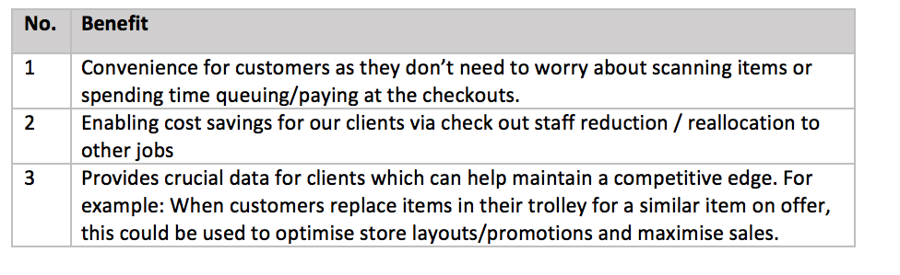

Intellectual Property (IP) Plans

Patents
A review of existing patents via Google Patents indicates no registered patents in Great Britain for smart supermarket trolleys using camera-based product recognition. While some international designs incorporate RFID or barcode scanning, none utilise integrated camera technology for real-time item detection within the trolley.

SST LLP intends to file a UK patent application for this innovative use of camera-based identification within a smart trolley, to secure exclusive rights and safeguard our competitive advantage.

Trademarks
The SST name, logo, and slogan will be trademarked to establish clear brand ownership, enhance market credibility, and protect our brand identity from imitation.

Confidentiality & Non-disclosure agreements
To protect sensitive information, non-disclosure and confidentiality agreements will be required before any engagement with third parties—such as investors, manufacturers, accountants, financial advisors, and both permanent and contract employees. These agreements will be signed prior to any confidential discussions to mitigate the risk of industrial espionage or idea theft.

Design registration
The physical configuration and appearance of the SST Trolley will be submitted for design registration, offering an additional layer of legal protection for the product’s distinctive design.

Future Products and Product Improvements
As SST evolves, both the core SST Trolley and the broader product ecosystem will be enhanced to increase value for retailers and improve the shopping experience. Several feature improvements and new product lines are under consideration.

Planned Feature Enhancements for SST Trolley
To enhance usability and deepen customer engagement, the following features are proposed for future iterations of the SST Trolley:
- In-store Navigation: An interactive store map on the touchscreen interface to help shoppers locate items quickly and efficiently.
- Recipe Suggestions: Intelligent recipe prompts based on items in the trolley, sent via the touchscreen or mobile app, enhancing the shopping experience and encouraging upselling.
- Location-Based Promotions: Real-time location tracking within the store to enable targeted advertising of relevant products, driving potential increases in sales and promotional engagement.

Product Expansion: SST Basket
A compact, handheld version of the SST Trolley technology will be developed for use in shopping baskets. This innovation will expand SST’s appeal to smaller-format retailers and urban convenience stores, while diversifying the company's product portfolio.

Product Expansion: SST Shelves
The underlying SST technology can also be applied to retail shelving units and fridges, offering a range of operational and merchandising benefits:
- Expiry Monitoring: Automated scanning of products to flag items nearing their sell-by dates, helping staff take action to minimise food waste.
- Dynamic Pricing: Digital pricing displays that can be remotely updated based on stock levels, expiry dates, or promotional strategies.
- Smart Inventory Management: Data collected through shelf interactions could be used to automatically trigger reorders and provide insights into consumer trends and purchasing patterns.

Market Research

Secondary research
Although the smart shopping technology market in the UK is still in its early stages of development (as further detailed in the Competitors section), the wider UK food retail sector operates within a highly oligopolistic structure.
According to Economics Online (2016), the market is dominated by four major players: Tesco (28.47%), Sainsbury’s (16.78%), Asda (16.18%), and Morrisons (10.79%). These supermarkets not only lead in market share but also in capital expenditure. As reported by Statista (2017), in the year ending March 2017:
- Tesco spent £7.1 billion
- Sainsbury’s spent £4.2 billion
- Asda spent £4.1 billion
- Morrisons spent £2.7 billion
Notably, mid-tier retailers also demonstrate significant spending power:
- Aldi invested £1.8 billion
- The Co-operative spent £1.6 billion
- Waitrose allocated £1.3 billion
These figures underscore the intense competition across all tiers of the market. While larger chains seek innovation to maintain dominance, smaller supermarkets are actively investing to narrow the gap. This climate presents a prime opportunity for smart shopping technologies like the SST Trolley, which can serve as a differentiator for both large and mid-sized retailers.

Problem identification and target marker
According to FashionUnited (2014), a report by Intel revealed that UK shoppers spend over a year of their lives waiting in store queues. This prolonged queuing not only leads to customer frustration but also has a direct impact on sales performance. The report found that shoppers are likely to abandon purchases due to long wait times, and 86% would avoid entering a store altogether if they perceive the till queues to be too long.

This highlights a clear need for innovative queue-reduction solutions in the retail sector. Given their scale, spending power, and ongoing need for customer experience improvements, supermarkets represent SST’s primary initial client base. SST aims to demonstrate how the SST Trolley can offer a modern, tech-driven solution—redefining the role of the shopping trolley while enhancing customer satisfaction and streamlining store operations.

Primary research
To better understand supermarket shopping behaviours and assess interest in the SST Trolley, a questionnaire was distributed via Facebook and received 44 responses. While the sample skewed slightly towards males aged 20–30, the findings offer valuable early insights into customer pain points and preferences. (Full results and charts available in Appendix D.)

Key findings include:
- 67% of respondents spend over 30 minutes shopping at large supermarkets, with 32% queuing for 10–14 minutes, and 9% for 15–20 minutes—highlighting that checkout delays represent a significant portion of the overall experience
- 86% expressed a desire to skip queuing and payment steps if given the option
- 41% shop at large supermarkets once per week, and 25% twice weekly, with 73% using a trolley on each visit—demonstrating frequent engagement with traditional shopping formats
- A strong majority showed interest in technology-enhanced solutions:
  - 91% prefer digital receipts
  - 82% are interested in using the SST Trolley

Although designed for consumers rather than business stakeholders, the results clearly suggest that customers are open to innovative shopping technologies and view tools like the SST Trolley as a meaningful improvement to their in-store experience. This data provides potential retail clients with early validation of the product’s market appeal.

SST Basket is regarded highly
Though the primary focus of the questionnaire was the SST Trolley, the results also found that the participants were equally as interested in a basket equivalent, suggesting that the future SST Basket would also benefit shoppers.

Competitor analysis
While no direct competitors currently offer a product with the same integrated functionality as the SST Trolley, the competitive analysis has focused on businesses providing similar or partial smart shopping solutions. These have been thoroughly researched and evaluated to understand market positioning, technological approaches, and potential gaps the SST Trolley can uniquely address.

Summary of indirect competitors:

(Product/service) & description | Strengths/Advantages | Weaknesses/Disadvantages
(Amazon Go)  Amazon Go is Amazon’s prototype grocery store (2016) that has no customer checkouts, allowing customers to scan before entering the shop, and pay using their Amazon account. Camera detection technology is used to detect when products are taken from or returned to shelves. | - Large company with many resources, head start verses competition  - Customers avoid lines or checkouts, making shopping convenient  - Technology use can save staffing costs by | - Only used in one small store in the US  - New, has a margin for error  - Issues with technology has meant no new store openings
(Scan as you shop)  Tesco (2016) and Asda (2013) stores use technology which allows their customers to scan their shopping as they add it to their trolley. Customers then attend a checkout to finalise their payment. | - Well established retailers, giving them a head versus competitors  - Technology saves customers time  - Implementation is relatively cheap | - Requires need to queue/check out  - Requires manual scanning of items  - Requires checkout staffing  - Easy method of product theft
(Conventional metal trolleys)  Shopfitting Warehouse Reids (2018) are providers of conventional shopping trolleys. These are used by most food retailers and are a basic metal trolley that is simply used to store products. | - Cheap costs - around £100 average  - No risk of software failure  - Allows customers to use any till type | - Doesn’t make use of modern technology  - Can’t track customer behaviour, providing useful data
(Walmart App)  Walmart provide a mobile application (2015) which allows customers to scan items in-store and pay for their shopping through their mobile phone. | - Saved money by using an application and developing it internally  - Customers can pay using their phone  - Customers can scan on the go  - Allows the use of other features such as refilling prescriptions and shopping lists | - Customers must still queue  - Requires manual scanning  - Limited to US Walmart stores  - Customers require mobile device  - Software bugs are often reported

While a number of companies are working toward automating the shopping experience, most solutions are still in early development, highlighting both emerging competition and a clear market gap. The entry of larger, established firms signals rising interest in this space, but also underscores the need for scalable, effective solutions.

These competitors may hold advantages in terms of size, brand recognition, and resources, yet they are pursuing varied strategies—many of which still present limitations in convenience, scalability, or accessibility. Some are confined to single-store trials or national rollouts, restricting their broader impact.

The SST Trolley enters this space as a differentiated solution—offering a more seamless and universally adaptable shopping experience. By bringing the product to market early, SST aims to secure a first-mover advantage, positioning itself as a leading innovator in a developing niche that benefits both retailers and their customers.

Pestle Analysis
Issue | Impact
Political
Brexit | The outcomes of Brexit are a current unknown, trade deals between the UK and China (where we aim to manufacture) will impact the cost and time to market of our products.
Economic
Supermarket share decline | Commercial UK supermarkets such as Tesco, M&S, Sainsbury have all seen drops in share value over the past 5 years. All are looking for ways to cuts costs and remain competitive, our products aim to give our clients an advantage by using technology and could be how they remain ahead of their competition.
Interest rates | Fluctuations of interest rates will affect the cost of borrowing for our business
Social
Internet of Things and generational perceptions | Consumers are becoming more open to integrated technology as younger generations who are aligned to technology begin to age. However, the older population still represents a large portion of the population. A generalisation could be made that older generations are less welcoming to new technology and may struggle to see the benefits or become confused by our products.
Job losses | SST’s technology may reduce the number of checkout staff needed. This could be perceived negatively by the general public.
Technology
New Technology | Our technology could become dated, this could result in more competitors emerging in our potential market, this would impact our market share and sales figures.
Legal
EU Standards | Stability and loading of the trolley needs to meet EU regulations. Testing will be required to ensure this.
Data Protection Act | Our product needs to be designed to the principles of the act.
Health and safety | Our products and employees will have to adhere to the laws, this will require rigorous product testing and staff training.
Environmental
Sustainability | Components will need to be recyclable where possible. In compliance with UK Government regulations.
Pressure for supermarkets to reduce waste | Our product allows clients to optimise stores therefore helping to reduce waste of perishable goods

SWOT Analysis
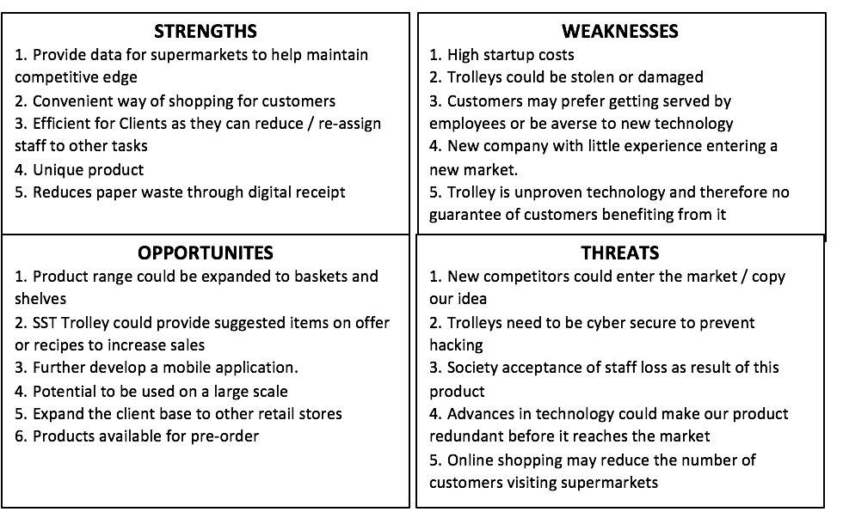

TOWS Matrix

 | External Opportunities  (O)  1,2,3,4,5 | External Threats  (T)  1,2,3,4,5
Internal Strengths  (S)  1,2,3,4,5 | SO  Data gathered can be used to suggest items/ deals a customer maybe interested in (S1 + O2)  Further develop the unique product range to develop the basket and shelves (S4 + O1)  The benefits of data, reduction of staff / paper waste and convenience for shoppers ensures this is an appealing product for all stores using trolleys (S1,S2,S3,S5,O4, O5) | ST  Re-assigning staff roles will negate job loss and social perception of our products. (S3,T3)  The uniqueness of the product and lack of competitors allows for a head start in the market. (S4,T1)  Our products convenience may negate the need to shop online. (S2,T5)
Internal Weaknesses (W)  1,2,3,4,5 | WO  High start-up costs could be negated by pre-orders for trolleys (W1, O6)  Proving our technology works will enable us to gain a strong client base (W5, O5) | WT  Patenting our idea will minimise competition and prevent competitors exploiting our lack of experience (T1, W4)

Market segmentation
The SST Trolley is positioned within a niche market, offering a specialised smart shopping solution tailored to food retailers. By focusing on a specific market segment, SST can more precisely address client needs, delivering tailored value and fostering strong, long-term business relationships.
Initial Target Segment – Firmographic Criteria:
- Industry Type:
Food retailers (supermarkets) will be the primary focus. These businesses are most likely to utilise shopping trolleys due to their store format and customer flow. Supermarkets, in particular, offer ideal conditions for deploying the SST Trolley due to their larger physical footprint and need for operational efficiency.
- Business Size:
Medium to large retailers will be prioritised, as the SST Trolley is a premium-priced product with long-term ROI benefits. These businesses are more likely to have the budget and scale required for adoption and roll-out.
- Store Format:
Large-format stores will be targeted initially. Smaller outlets, such as Tesco Express or other convenience formats, typically do not accommodate trolleys due to limited floor space, making the SST Trolley less applicable in these settings.
- Location:
The initial rollout will focus on suburban areas of Nottingham, where larger retail sites are more common. As SST is based in Nottingham, this provides operational convenience and allows for easier prototyping, testing, and direct client engagement. Suburban locations also generally accommodate larger store layouts, where trolleys are standard.
Scalability and Future Expansion:
As the business grows, SST will broaden its market reach:
- The introduction of new products, such as a smart basket (see Section X), will open opportunities in smaller store formats and non-food retail sectors (e.g. fashion or electronics).
- Smaller branches of existing supermarket clients and new chains such as Wilko may be viable future customers.
- Geographic expansion into major city centres like London, Birmingham, and Manchester, where smart baskets and trolleys are also in use, will further extend SST’s market potential.

Potential clients
After distinguishing the target market, several potential clients have been identified:
- Morrisons – West Bridgford (NG2 6PS)
- Asda superstore – West Bridgford (NG2 7JA)
- Sainsbury’s – Nottingham (NG9 2LA)
- Tesco Extra – Nottingham (NG6 6EQ)
Each of the businesses above fits the firmographics identified during market segmentation, and could potentially become clients of SST should an agreement be reached.

Market position
While certain products offer similar features, no existing solution replicates the full functionality and client benefits provided by the SST Trolley. This presents a clear market opportunity, which SST aims to capitalise on by becoming a leader within its niche segment. Through the strategic approaches outlined throughout this proposal, SST is well-positioned to establish a strong competitive foothold and deliver meaningful value to both retailers and their customers.

Market position mapping
The SST Trolley has been placed on the map in its envisaged position, along with its competitors.
Utilisation of technology +

SST Trolley
Amazon Go

Walmart app
Widespread business use +
Widespread business use -

Conventional trolley

Utilisation of technology -

While Amazon Go and the Walmart application make use of technology, they are not used on a large scale. They are both focused on utilising technology for their own companies. Conventional trolleys don’t utilise technology but are used very commonly by a range of businesses. The SST trolley will target this gap in the market by making use of technology while being available in a variety of retail stores.

Marketing mix – the 4Ps

Product
The SST Trolley’s Unique Selling Proposition (USP) lies in its unmatched functionality—no existing solution on the market integrates automated product scanning, real-time basket tracking, and built-in payment processing within a single trolley. Its value proposition is twofold: it provides customers with a more efficient, queue-free shopping experience, while offering retailers access to valuable consumer behaviour data, improving both customer satisfaction and operational insight.
Product Branding
SST aims to establish a strong brand identity that reflects its technological focus and retail innovation:

- Logo – The SST logo visually combines a trolley and a mobile device, symbolising the integration of smart technology into traditional retail. It will appear on all SST Trolleys and marketing materials to maintain brand consistency.
- Strapline – "Revolutionising the retail experience through technology" succinctly communicates the company’s mission and value-driven approach.

Pricing
With no direct equivalent on the market, the SST Trolley is priced at a premium £999 per unit. This price reflects its advanced technology, high production quality, and the long-term value it delivers. Initial manufacturing costs are projected at approximately £450 per unit (see Section X for a full breakdown), allowing for healthy margins.

This margin also enables future pricing flexibility, including volume-based discounts and strategic reductions if necessary. These incentives will be considered in the long term as the business scales and client relationships are established.

Place
SST will operate primarily through direct sales, supported by a company website that presents the product offering, company values, and contact details. In Year 1, initial prototypes and a limited batch of five trolleys will be manufactured in-house by the founding team, keeping overheads low during early testing.

From Year 2, production will be outsourced to a manufacturer in China to optimise costs. Units will be produced on-demand and shipped directly to clients upon confirmation of pre-orders.

Promotion
Given SST’s niche B2B market, promotion will focus on highly targeted, personalised outreach. A dedicated team will directly approach senior decision-makers within retail chains to present the SST Trolley and propose trial partnerships, reducing perceived risk and encouraging adoption.

Additional promotional strategies will include:
- Presence at industry trade shows (e.g. Retail Business Technology Expo – RBTE, London)
- Advertising in business and retail trade publications
- Live demonstrations to showcase product capabilities

SST believes in quality over quantity when it comes to promotion. The strategy is precise, consultative, and relationship-focused, designed to build credibility and interest within the industry. Once adopted by one major retailer, visibility and industry recognition are expected to drive broader interest and adoption organically.

Design and development
The 3D models below show a prototype of the SST Trolley and the technology required.
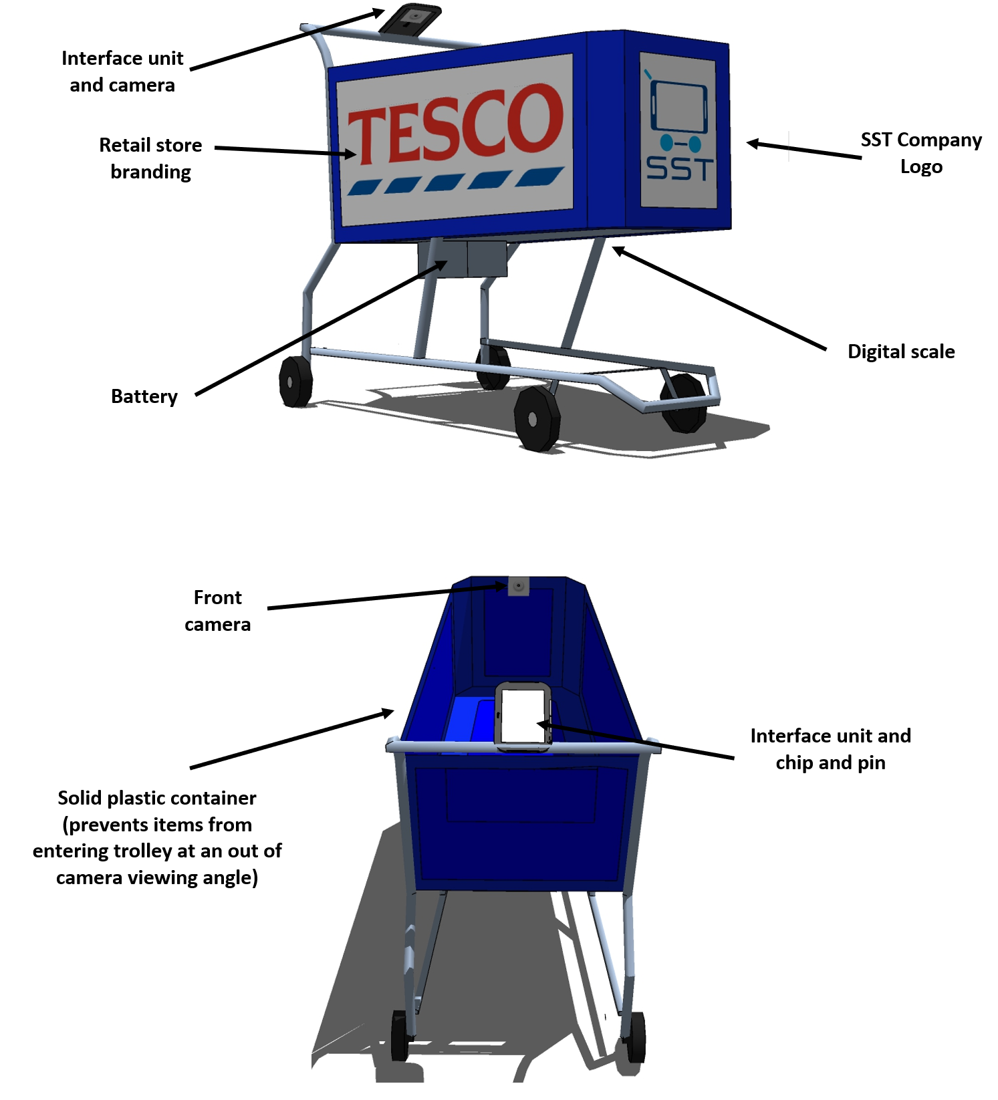
For more details of the technology, including descriptions, pricing, suppliers and estimated costs, see appendix D.

Design advantages:
- Environmentally friendly plastic (Polypropylene- Can be injection moulded making manufacturing processes efficient)
- Rear camera positioning so that the trolleys can fold into each other
- Quick user interface with all of the information that the user needs (total, checkout, account)
- Barcode scanner attached if on the rare occasion a product does not automatically scan
- Plastic outer container means supermarket customers cannot steal the goods
Design difficulties/risks:
- Attaching the user interface (could be prone to theft and vandalism)
- High start-up costs
- Cost of repairing parts
- If supermarkets are not convinced by the product and the design, they may not take a trial and therefore no sales will be made
- Difficulty in implementing a cash payment system

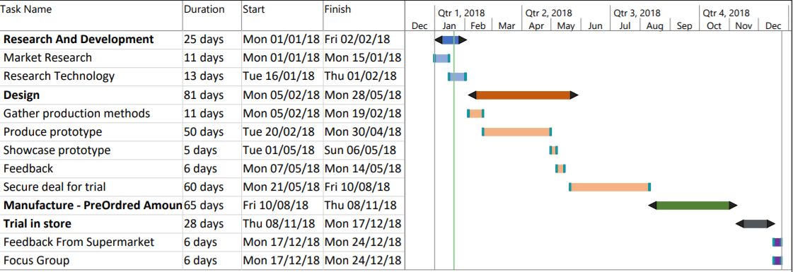
Estimated Stages of development and time-scale

Time to market
7 months is our estimation of time to market – from design through to development and manufacturing of the first 5 trial trolleys.

Manufacturing and logistics
Year 1: In-House Production
During the initial year, SST will manufacture the first five prototype trolleys in a home-based workshop. This approach allows the business to keep costs low, refine the product, and test its functionality before committing to large-scale production.

Year 2: Outsourced Manufacturing
From Year 2 onwards, manufacturing will be outsourced to China, where lower labour and production costs offer a more cost-effective solution compared to the UK and Europe. Outsourcing will also enable bulk purchasing of components, helping reduce unit costs despite international shipping expenses.

SST will partner with a reliable manufacturer equipped with the necessary capabilities, including:
- Plastic injection moulding
- Precision welding
- Skilled electronic assembly and testing

A Just-in-Time (JIT) production model will be adopted to minimise warehousing and inventory holding costs.

Delivery and Fulfilment
To streamline logistics and avoid storage costs in the UK, SST will utilise a drop-shipping model. Products will be shipped directly from the manufacturer to the client, ensuring timely delivery while keeping overheads low.

For a detailed analysis of the advantages and disadvantages of overseas outsourcing, please refer to Appendix C.

Manufacturer Contingency plans
Disruption | Plan
Natural disaster disturbing manufacturer | - Plan for alternate transportation  - Find backup suppliers in other parts of the world  - Audit suppliers- Assess suppliers’ risk for natural disasters, labour uprisings and geopolitical issues
Choosing a poor manufacturer | Perform a full risk assessment of suppliers including their business continuity plans, geopolitical exposures and their processes.
Raw material shortages | Increase the safety stock the business has

Financial plans
Each founding member will contribute a personal investment of £2,500, totalling £12,500. This will be matched by a £12,500 business bank loan at a 3% interest rate, bringing the total initial investment for Year 1 to £25,000.

The primary focus during Year 1 will be to develop a working prototype, secure trial placements, and gather feedback from early adopters. To maintain financial sustainability, the business will operate on a lean model, minimising expenses wherever possible. This includes working from home and retaining full-time employment outside of the project during the development phase.

While a modest financial loss is anticipated in Year 1, this period is essential for validating the product, demonstrating its value to potential clients, and refining its functionality based on real-world insights.

From Year 2 onward, SST anticipates a significant uplift in sales as a result of early traction. All trolleys beyond the initial trials will be manufactured on a pre-order basis, ensuring positive cash flow and reduced financial risk as the business scales.

Profit and Loss summary

 | Year 1 | Year 2 | Year 3
Price Per Unit (£) | 250 | 999 | 999
Units | 5 | 240 | 600
Sales (£) | 1250 | 239,760 | 599,400
Cost of Sales (£) | 3,390 | 143,856 | 359640
Gross Profit (£) | -2,140 | 95,904 | 239,760
Expenses (£) | 19649.97 | 85497.24 | 215700
Operating Profit (£) | -21,790 | 10,407 | 24,060
Retained profit (£) | -21,790 | 8,429 | 19,489

Sensitivity Analysis
Year 1 will be focused on securing a trial into a store, so sensitivity analysis begins in year 2:

 | -30% | Year 2 | +30%
Sales (£) | 167832 | 239,760 | 272,727
Cost of Sales (£) | 100699 | 143,856 | 163,636
Gross Profit (£) | 67133 | 95,904 | 109,091
Expenses (£) | 85497.24 | 85497.24 | 85497.24
Operating Profit (£) | -18,364 | 10,407 | 23,594
Retained profit (£) | -18,364 | 8,429 | 19,111

Our financial analysis indicates that if sales fall 30% below projections, the business would face a negative balance of £18,364. While this represents a significant risk, early detection would allow for a strategic response. In such a scenario, measures may include adjusting the retail price to improve affordability and stimulate demand, even if it requires a temporary reduction in profit margins to prioritise higher sales volume.

Conversely, if sales exceed expectations by 30%, we plan to slightly increase pricing to maximise revenue while maintaining value perception. Surplus profit would be strategically reinvested into hiring additional staff and scaling up manufacturing capacity to meet growing demand efficiently.

This agile approach ensures SST is prepared to respond flexibly to market performance, while protecting long-term viability and growth potential.

Breakeven Analysis
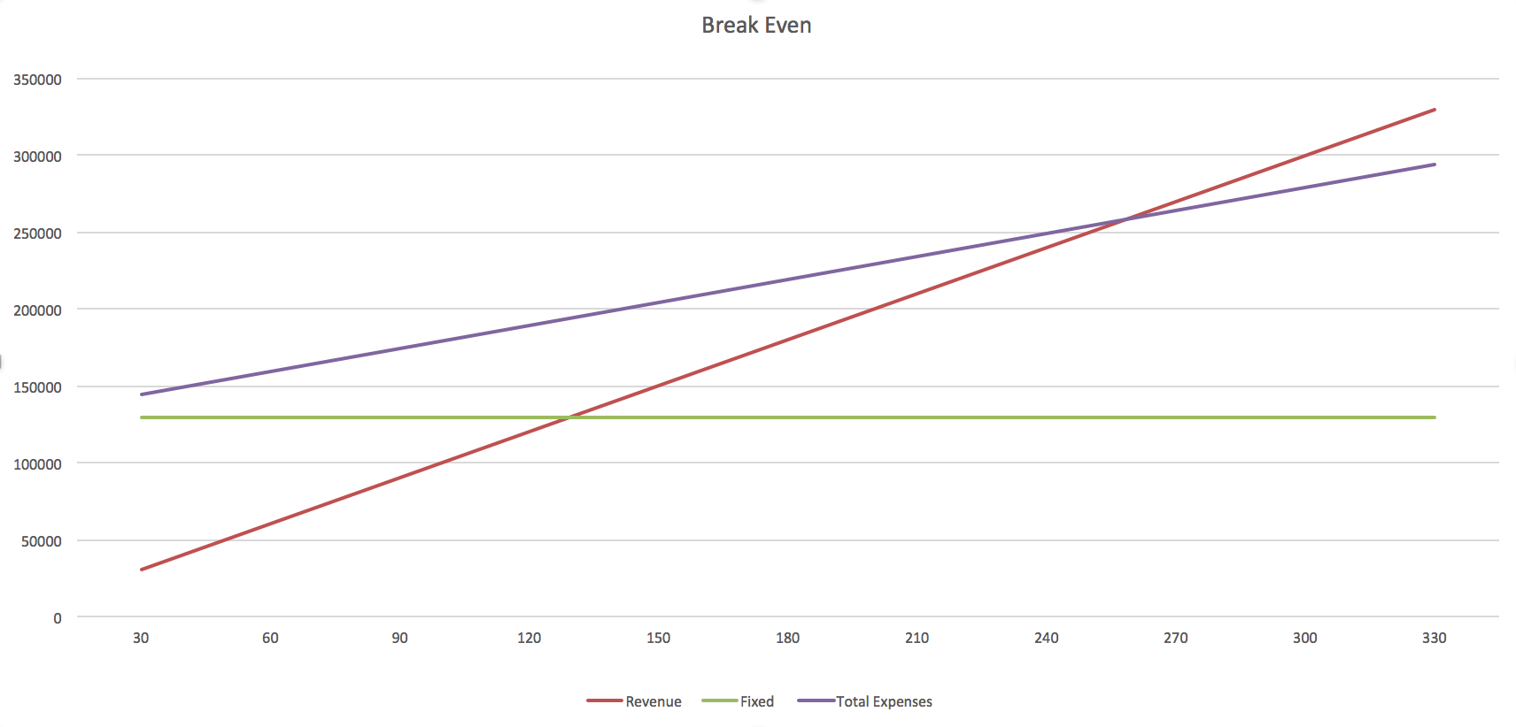

Cash Flow forecasts
Year 1:
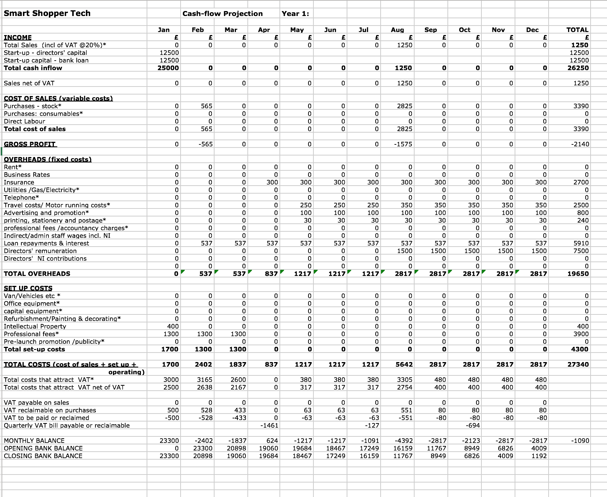
Year 2:
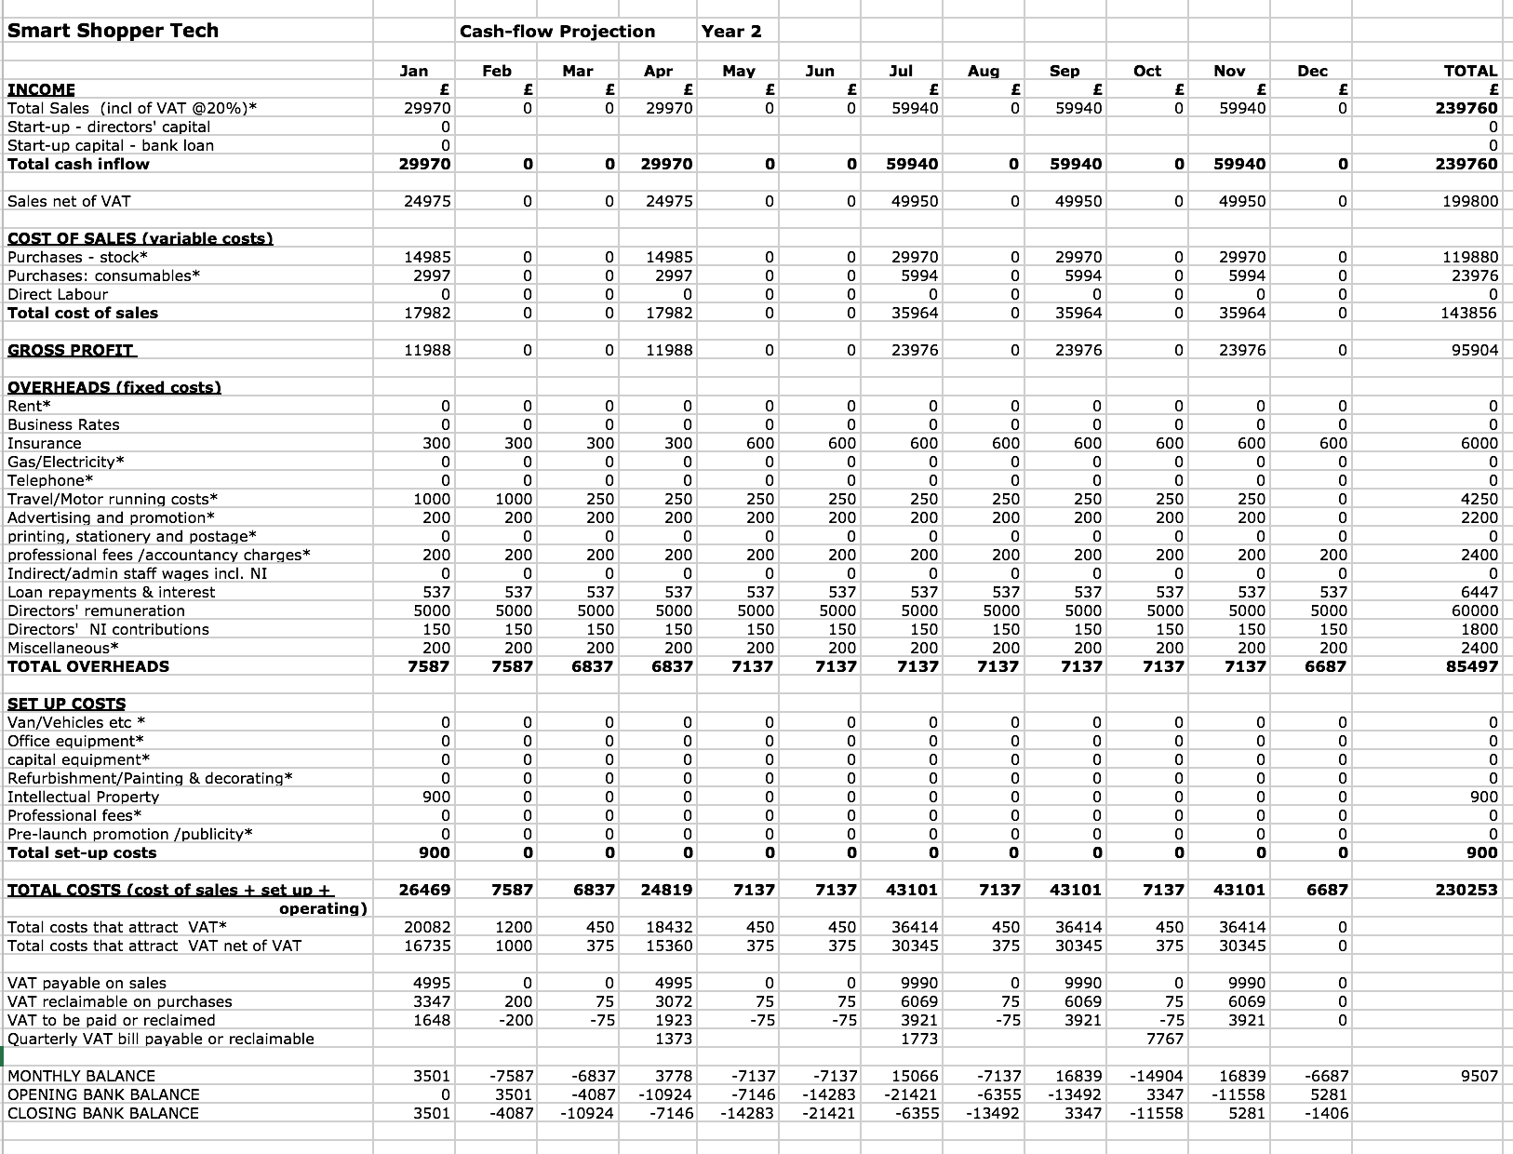

Year 3:
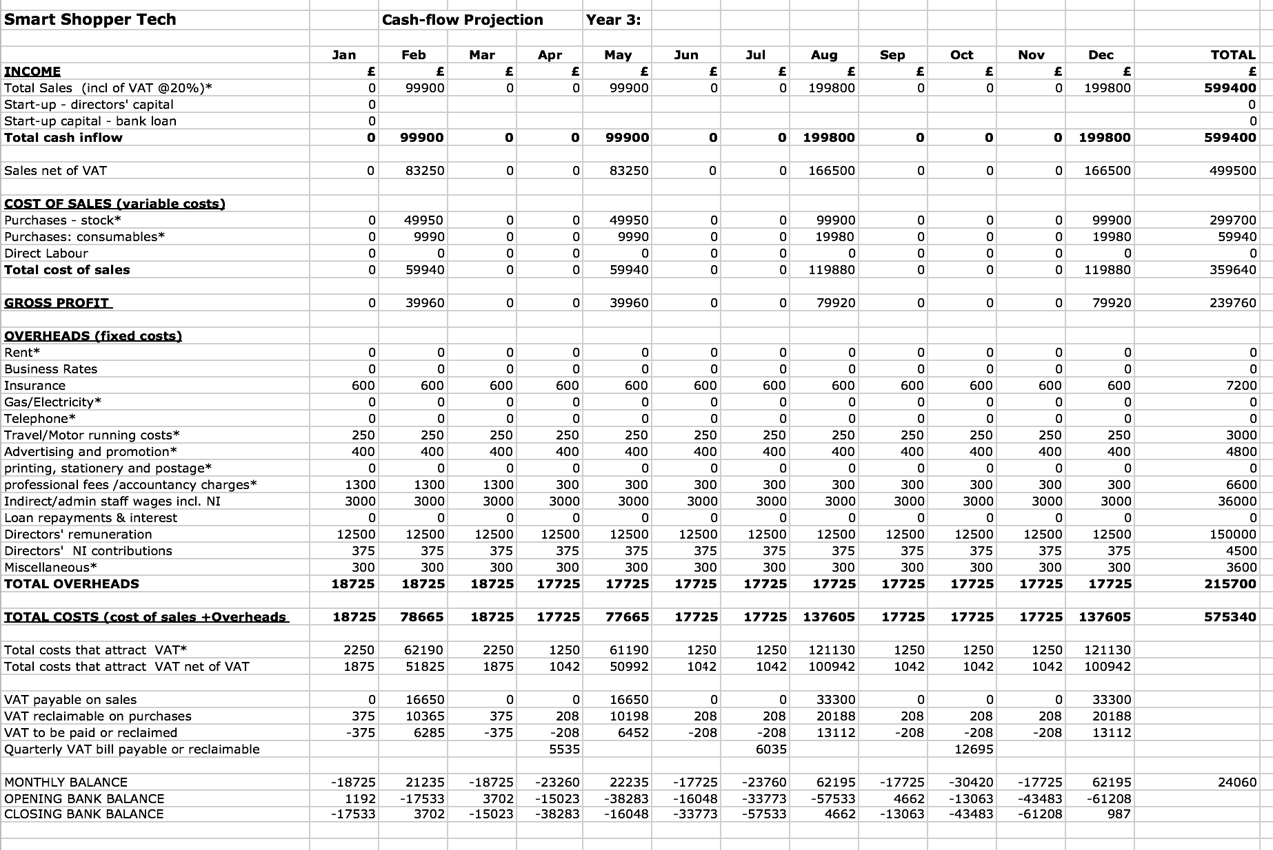

Appendices

Appendix A - Jobs / Skills required

Job / Skill required | Description | Fulfilled by | Justification
Application developer | To develop the touchscreen application and associated mobile application | Inderjit | All team members can contribute but Inderjit has studied computing BSc and has the strongest programming skills
IT infrastructure developer | To oversee client implementation of the network infrastructure needed to support the products | James | James’ experience on IT projects makes him perfect to oversee the infrastructure side of the project
Product designer | To oversee physical product development | Nikesh | Nikesh’s skills in with CAD and product design makes him most suited for this role
Client staff trainer | To train client staff on the products | Inderjit | Inderjit’s skills tutoring first year students and his knowledge of the products development
Sales lead | To facilitate client sales | George | George has past experience in supermarkets and understands the needs of the customers and the shop floor, this makes him perfectly suited for the sales role as he can show how SST’s products solve those problems
International operations | Mandarin speaking to head operations in China | Recruited  Staff | Needs to be fluent in Mandarin and English
Customer service team | Manage client complaints / queries | Outsourced | Not needed initially
Maintenance | Manage breakdowns of products | Recruited  Staff | Not needed initially
R&D | To develop working prototypes | All directors | Everyone’s skills will need to utilise to develop a fantastic product
HR / Admin | Manage human resources aspects | Outsourced | Not needed until external staff have been hired
Legal Advisory | Manage legal aspects | External Consultant | The legal system is complicated, having a trained professional handle SST’s legal needs as and when they are required.

Appendix B - Technical product information
Trolley
The SST Trolley will retain several design elements of a conventional supermarket trolley, including a plastic handle, rubber swivel wheels, and a durable steel frame. However, rather than a traditional wire cage, it will feature a solid container constructed from recycled plastic. This design ensures a single top-entry point for inserting items, which is essential for accurate automated scanning. Unlike wire frames, the enclosed structure prevents smaller items from slipping through gaps and bypassing the scanning system. Additionally, the plastic container will be fully customisable to align with each supermarket's branding, enhancing brand visibility and integration.

Technology:

Camera unit - A camera unit will be fixed onto the front lip of the trolley (as shown above). Facing across the top of the trolley’s container.

Secondary camera – The secondary camera is needed to scan and confirm the identity of all products in the trolley.

Interface Unit - An interface united will be fixed onto the right-hand side of the trolley’s push bar.

User Interface - Hardware / Software – a small touchscreen interface will display to the user: instructions on how to use, the list of products, total cost, payment information.

Chip and Pin Card Reader - Hardware / Software – if users wish to pay with their debit or credit card they will be able to through this the built-in card reader. Payment will be similar to how fuel customers can ‘pay at the pump’. The trolley will ask customers to place their credit/debit card in the trolley at the beginning of their shop, they will enter their pin, remove their card and they can then begin shopping.

Central Processing Unit (CPU) - Hardware - using the feeds from the cameras and scale the CPU will utilise the same technology as facial recognition to identify products customers have put into their trolleys.

Wi-Fi Technology - Hardware / Software – a network card will need to be built in to connect the trolley to the supporting IT Infrastructure.

Barcode scanner - Hardware / Software – will be placed on the back of the interface so if the automatic detection doesn’t work, the customer can scan the product and put it into the trolley.

Battery – A battery will be required to power the technology on the trolley. Trolleys will charge when they are stored via sockets that connect to the trolley or docking station in front.

Digital Weighing scale – this will allow an extra parameter to correctly identify products. This will sit underneath the plastic container and will weigh the contents of the trolley.

Supporting IT infrastructure

Network - Hardware / Software - Each store that uses this technology will need to have a supporting infrastructure in place. This primarily consists of a suitable Wi-Fi network that can support bandwidth for the amount of trolleys in the store. This will mean a server for each store and a number or wireless access points. This is a precursor requirement that clients would have to implement at their expense, with SST consultation.

Item Scanner - Hardware / Software – an item scanner will have to be developed which identifies each product that goes onto the shelves before it is sold. This will consist of a 360 set of cameras and scale. This information will be feed to a database holding the information about products. This will enable quick and easy identification of products by the system when consumers put a new item in the trolley.

Mobile Application

Software - Attaching to a mobile application allows customers to review their receipt ensuring that the correct items have been purchased as well as reducing paper waste It also allows for data to be gathered about individual customer spending similar to the current Club card and nectar schemes. All software will be produced by the directors of the company to save costs.

Item: | Estimated Price: | Potential Supplier:
Front end Micro Camera | £50-£100 | OMRON Vision MINI Smart Camera
Bluetooth Connection Technology | £40 | ASUS PCE-AC55BT AC1200 Dual Band Wireless PCI-E Network Card
Rear end Micro Camera | £50-£100 | OMRON Vision MINI Smart Camera
User Interface Panel | £42 | UIF-5K (LCD + 5 Key)
Chip and Pin Card Reader | £40-£60 | Payleven Chip and Pin Reader
Central Processing Unit | £10-£20 | Shenzhen Share Technology Station Terminal Small CPU
Digital Weighing Scale | £20-£30 | UC Evo Max Line
Barcode Scanner | £17.50 | Proster Barcode Scanner USB Barcode Reader Long Range High Speed Optical Laser
Plastic Handel | £20
Steel Frame | £60-£80
Rubber Wheels | £20
140 Litre Capacity Plastic Container | £35 | 140 Litre Mobile Plastic Storage Trunk Box Container
Total: | £405 - £565

Appendix C - Advantages / disadvantages of outsourcing and manufacturing the SST in China
Advantages:
- we will not need to hire any manual labour as the manufacturer will take care of that and the manual labour cost is also very cheap in China
- outsourcing production of our product to China will allow us to get a closer look at the market that is in China where we could expand to in the future
- the manufacturing team in China will have a great insight into the foreign markets and we may try and use more local products once the team has fully grasped the product and this can help our business save more costs and grow
- the Asian market is growing at an incredible rate and having manufacturing links in China would make it easier to sell into the new market which can lead to mass growth
Disadvantages:
- one big issue is Chinas quality control as the standards and regulations differ from European ones. This is why we would need a team in China to make sure everything is to a good standard
- another issue is the low-quality materials that may be used. We will need make sure that the manufacturing company uses good quality materials
- copyright laws are also very different in Asia so we will need to be careful with the design of our product and set up a contract agreement so no issues will arise in the future
- the final issue is the language barrier as most Chinese people are not proficient in English so operations could be hindered due to misunderstandings and so it is crucial to have a team with Chinese representatives based in China

Appendix D - Questionnaire – primary research
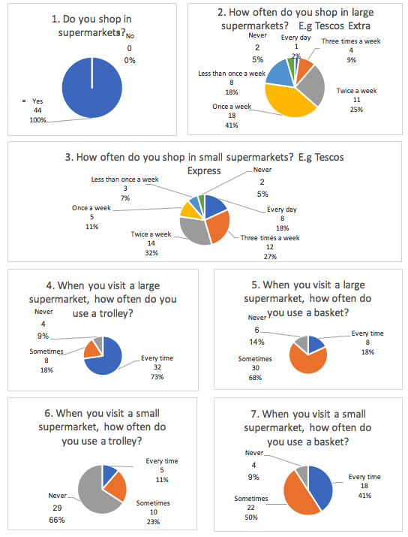
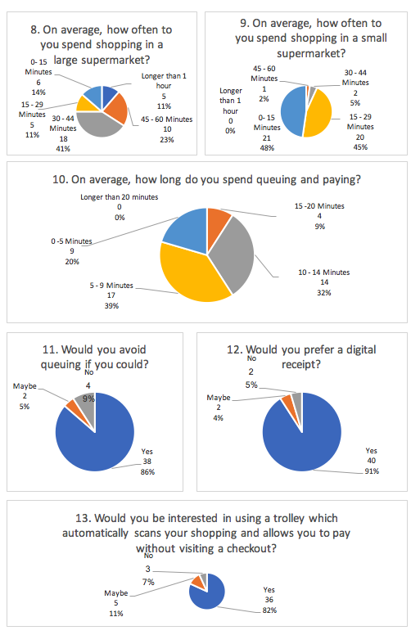

Appendix F - Use case Scenario

‘John’ a customer at ‘Super Supermarkets’ takes a new SST Trolley and places his own bags into the container section. He then opens the SST mobile application on his mobile phone and taps it onto the interface of the SST Trolley. A message on the Trolley screen reads: “Hello John, welcome to super supermarkets. Are all your bags in the trolley?” then appears two buttons: “yes / no”. John clicks yes and begins to find the food on this shopping list. As John wanders around the supermarket, he places the items he wants into the trolley, each item is registered and appears briefly on the screen before being added to a list (also visible on the screen). John finishes his shopping, because John attached his mobile to the trolley, he was therefore able to pay automatically once he left the store. No checkouts and no time queueing.

‘Super Supermarkets’ uses the anonymised data from John’s shop to see: What products he bought, what he put into the container and what he put back, time he spent on which aisles. This data combined with all the other shoppers, allowed ‘Super Supermarkets’ to optimise their layout and targeted promotions which in turn lead to more sales.

References
Barrow, C., Barrow, P., & Brown, R. (2005) The Business Plan Workbook. 5th edn. London: Kogan Page. ISBN-10: 0749443464 ISBN-13: 978-0749443467

Economicsonline, 2018. Analysis of supermarkets. [online] Available at: http://www.economicsonline.co.uk/Business_economics/Supermarkets.html [Accessed 01 Jan. 2018].
FashionUnited, 2014. UK shoppers spend over a year waiting in store queues [online] Available at: https://fashionunited.uk/news/retail/uk-shoppers-spend-over-a-year-waiting-in-store-queues/2014122914998 [Accessed 15 Jan. 2018].
NTU Now, 2018. Belbin Test [online] Available at: https://now.ntu.ac.uk/d2l/le/content/310253/viewContent/1422259/View [Accessed 19 Dec. 2017].
Palmer, A (2004) Principles of Marketing. 4th edn. Oxford University Press. ISBN 0077107942
Statista, 2017. Total expenditure in grocery stores in Great Britain in 1st quarter 2015 to 1st quarter 2017, by grocer* (in million GBP) [online] Available at: https://www.statista.com/statistics/300672/grocery-store-spending-in-great-britain/ [Accessed 15 Jan. 2018].
Tesco, 2018. Tesco logo. [online] Available at: https://www.tescoplc.com/assets/images/logos/tesco-logo.svg [Accessed 15 Jan. 2018].

Bibliography
Amazon.com. (2018). Amazon.com: : Amazon Go. [online] Available at: https://www.amazon.com/b?node=16008589011 [Accessed 5 Jan. 2018].
Asda.com. (2018). Scan & Go | Asda. [online] Available at: http://www.asda.com/scan-and-go/ [Accessed 21 Jan. 2018].

Baysource Glob
al. (2018). The Pros and Cons of Outsourcing Manufacturing to China - Baysource Global. [online] Available at: http://baysourceglobal.com/the-pros-and-cons-of-outsourcing-manufacturing-to-china/#top [Accessed 15 Jan. 2018].

Formations (2018). What is a limited liability partnership?.[online] Rapid Formations Blog. Available at: https://www.rapidformations.co.uk/blog/limited-liability-partnership-llp/ [Accessed 30 Dec. 2017].

Google Books. (2018). Patent CN204452538U - Supermarket self-checkout shopping trolley. [online] Available at: https://www.google.co.uk/patents/CN204452538U?cl=en&dq=supermarket+trolley+camera&hl=en&sa=X&ved=0ahUKEwiqyfD8q8PYAhVjCMAKHehICTUQ6AEIOzAC [Accessed 20 Jan. 2018].

Google Books. (2018). Patent CN204452538U - Supermarket self-checkout shopping trolley. [online] Available at: https://www.google.co.uk/patents/CN204452538U?cl=en&dq=supermarket+trolley+camera&hl=en&sa=X&ved=0ahUKEwiqyfD8q8PYAhVjCMAKHehICTUQ6AEIOzAC [Accessed 20 Jan. 2018].

Google Books. (2018). Patent EP1583050A1 - Smart-Cart with RFID scanner. [online] Available at: https://www.google.co.uk/patents/EP1583050A1?cl=en&dq=smart+trolley&hl=en&sa=X&ved=0ahUKEwjNnciJq8PYAhWBAcAKHYnvAO4Q6AEIMDAB [Accessed 20 Jan. 2018].

Google Books. (2018). Patent US6910697 - Shopping cart that enables self-checkout. [online] Available at: https://www.google.co.uk/patents/US6910697?dq=smart+trolley&hl=en&sa=X&ved=0ahUKEwjNnciJq8PYAhWBAcAKHYnvAO4Q6AEISTAE [Accessed 20 Jan. 2018].

Gov.uk. (2018). Apply to register a trade mark : Apply - GOV.UK. [online] Available at: https://www.gov.uk/how-to-register-a-trade-mark/apply [Accessed 20 Jan. 2018].

Gov.uk. (2018). Patenting your invention: Before you apply - GOV.UK. [online] Available at: https://www.gov.uk/patent-your-invention/before-you-apply [Accessed 18 Jan. 2018].

http://www.accaglobal.com, A. (2018). Example of a business plan | Business plans | Business Finance | ACCA | ACCA Global. [online] Accaglobal.com. Available at: http://www.accaglobal.com/uk/en/business-finance/business-plans/example-plan.html [Accessed 28 Dec. 2018].
Inc.com. (2018). How to Write a Great Business Plan: The Executive Summary. [online] Available at: https://www.inc.com/jeff-haden/how-to-write-a-great-business-plan-the-executive-summary.html [Accessed 2 Jan. 2018].

Patents.google.com. (2018). Google Patents. [online] Available at: https://patents.google.com/?q=smart&q=supermarket&q=trolley&oq=smart+supermarket+trolley [Accessed 20 Jan. 2018].

Reidscastors.co.uk. (2018). Supermarket Trolleys - Reids Castors. [online] Available at: https://reidscastors.co.uk/retail-equipment/supermarket-trolleys [Accessed 20 Jan. 2018].

Shopfittingwarehouse.co.uk. (2018). Metal Supermarket Trolley - 140 Litres Capacity | Shopfitting Warehouse. [online] Available at: http://www.shopfittingwarehouse.co.uk/retail-supplies-c201/supermarket-trolleys-and-baskets-c26/metal-supermarket-trolley-with-blue-or-green-handle-140-litres-capacity-pp368 [Accessed 20 Jan. 2018].

Simpleformations.com. (2018). LLP Benefits and Disadvantages. [online] Available at: https://www.simpleformations.com/llp-benefits-and-disadvantages.htm [Accessed 30 Dec. 2017].
Tesco.com. (2018). Scan as you Shop | Tesco.com. [online] Available at: https://www.tesco.com/scan-as-you-shop/ [Accessed 21 Jan. 2018]

The Balance. (2018). How to Save Even More at Walmart With Its New App. [online] Available at: https://www.thebalance.com/ratchet-up-your-walmart-savings-with-scan-and-go-program-2372117 [Accessed 21 Jan. 2018].

