
A Business Proposal for ‘Poductive’, a New Product Targeted at Medium and Large Businesses
Inderjit Sandhu (N0578334)
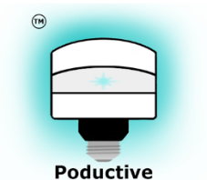

ISYS20291: Business Marketing & Innovative Digital Venture Design

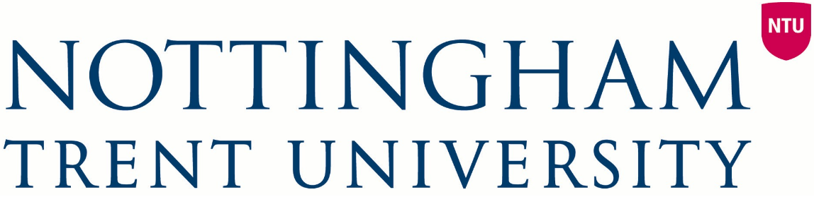
This document consists of a proposal for an innovative technology-based product, Poductive, which could form the basis of a new business.
Phil Clarke

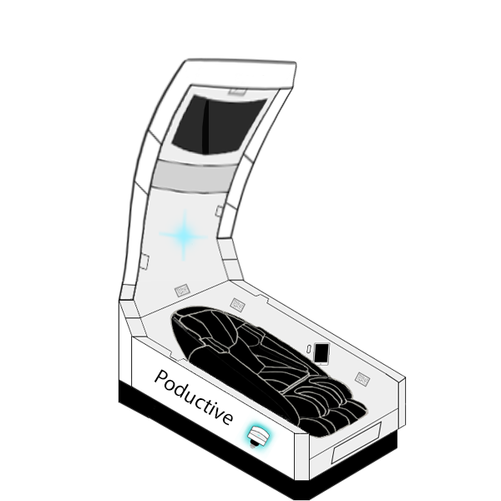
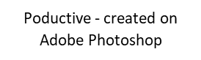
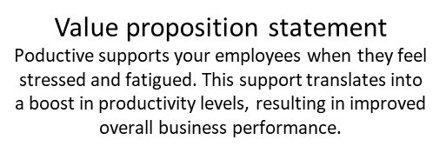
Introduction
Many businesses face the difficult task of maintaining high levels of employee productivity. Declining levels of productivity are often due to fatigued or stressed employees, which negatively affect overall business performance. Even when identifying below par productivity levels, finding a solution is difficult.
Currently, most businesses allow breaks, some own ping pong tables and rarely, sleeping pods are provided. What if businesses could introduce a device designed specifically to allow employees to shine and feel more productive? A personal pod which would improve overall business performance. Poductive.
Poductive is a technologically advanced pod that businesses can purchase or rent for employees to use to improve workplace productivity. Upon entering Poductive, employees choose from a variety of experiences, each boosting productivity in different ways. Employees can experience meditation, visualisation or yoga sessions, reducing stress, inspiring creativity and enhancing concentration. For tired employees, Poductive napping experience leaves users feeling refreshed as they are peacefully awakened by a gradual increase in lighting and alarm volume. Employees may use Poductive’s built-in YouTube application to relax and watch a video, or they may choose to relax by connecting their device to the pod and listening to music. Though users can customise their experience in various ways, employees will all have something in common - they will leave Poductive feeling more productive.
Poductive houses a 12.9” iPad Pro including the Poductive application from which employees select their experience type, access YouTube and set alarms. Videos are displayed on a 34” 3340x1440 (QHD) wide-screen curved LED monitor, while sounds are played through surround sound 500W-3D Bluetooth-enabled speakers, providing an immersive experience. Poductive’s heart rate sensor allows businesses to monitor employees’ stress levels, heart rate and blood pressure, with this data being sent to the application. Whilst sat in a zero-gravity reclining leather massage chair that can fold out, employees choose their preferred lighting colour, using the smart LED lighting system, and enjoy the luxurious, beneficial Poductive. Appendix 1 details more technical information.

The Market

Segmentation
Poductive will initially be targeted at a niche market - businesses with the following firmographics:
- Location: London - as this the most business dense area in the UK
- Size: Medium/Large businesses with:
  - High revenue - these can afford to invest in the high price-high quality Poductive
  - 100+ employees - meaning Poductive is efficiently used
- Type: Office based businesses (such as Premier Group/Salesforce), allowing room for Poductive
- Work atmosphere: Casual, as these atmospheres are more likely to allow the 20minute+ break Poductive requires
As Poductive will be sold to businesses (B2B), many demographics vary between employees. Poductive targets the following demographics:
- Age: 16-65 - typical working ages
- Gender: males and females
- Occupation: various professional office jobs
- Income: typically £20,000+
- Religion/race: various religions/races

Market research - demand, drivers and change
Primary research suggests there is a demand for Poductive’s purpose of boosting workplace productivity.
Towers-Watson surveyed (2014) over 22,000 employees across 12 countries, concluding that high-stress levels are linked to low productivity levels, resulting in disengagement and absenteeism. 57% of those highly-stress felt disengaged with their employer and took off twice as many sick days, 5, as employees with low stress levels. Pulse Institute found that tired employees are also less productive. It concluded that fatigued employees suffer 23% reduced concentration, 18% reduced memory and were likely to commit job errors, ultimately costing almost £2,000 per employee annually. In 2014, Entrepreneur.com reported workplace output increased by 3.2% but hours-worked increased by 5.1% - a productivity decrease of 1.8%.
Workplace stress and tiredness has increased in recent years mainly due to the growth in technology, making tasks more complicated and pressurised. The easiness of streaming a movie and using a smartphone at night is resulting in more tired employees according to Metronaps’ CEO. He explains that a 20-minute nap can boost alertness by 30%.
Though solutions for combatting workplace fatigue and stress were scarce at the beginning of the 21st century, the market has changed in recent years. Large companies (Google, NASA and more) have decided to purchase Metronaps EnergyPods. The CEO of Metronaps stated (2014) that there had been a 186% increase in inquiries for the sleeping pods over the previous year. The increase in demand for EnergyPods has been driven by their ability to boost productivity. If businesses hadn’t noticed a benefit, EnergyPods wouldn’t be on the rise as they currently are.
Results from a Survey Monkey questionnaire (100 Facebook and WhatsApp users with employment experience) suggests that there is demand for Poductive from employees. Two thirds had felt workplace stress, 61% had felt fatigued and 71% believed they could have been more productive. 92% said they would enter Poductive. Appendix 2 lists full survey/results.
The research figures regarding stress, fatigue and productivity are alarming for companies. It is clear that businesses could benefit from Poductive and that employees like the concept of it.

Competition
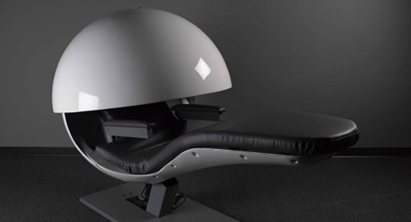
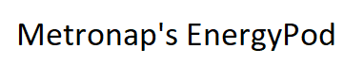

Poductive has monopolistic competition as many sellers exist with differentiating products. Two dominate.
Metronaps’ ‘EnergyPod’ boosts employee energy, focusing specifically on napping. As sleeping is EnergyPod’s priority, it has a more ergonomic and stylish design than Poductive’s - limited to ensure all experience types are possible.
Somadome sells meditation domes leaving users feeling replenished. While Poductive allows lighting customisation, Somadome displays specific colours for different meditation methods, as colours associate with different moods. Somadome includes various meditation tracks and provides an effective meditative experience.
While the EnergyPod and Somadome provide effective napping and meditative experiences, Poductive utilises more technology, offering more customisation and experience options. Poductive does what its competitors do, but has more features.
To compete with EnergyPod, having large clients such as Google/Virgin Active/NASA and more, and other competitors, several areas of focus have been identified:
- Observing competitors – This ensures Poductive remains up to date with trends, prices, technology and advertising methods in its market.
- Providing quality customer service/loyalty offers – Quality service ensures customer happiness, increasing likelihood of re-purchasing and raising positive awareness.
- Investing in developing Poductive’s brand/image – This will grow Poductive by giving it a recognisable identity. Poductive’s uniqueness means that with success, its brand could become known worldwide.

Position
Once released, Poductive will be a market follower, following the lead of Metronaps’ EnergyPods, Somadome and other companies. With persistence, resources and determination, Poductive will then be a market challenger, challenging competitors, before becoming the market leader. Once leading, Poductive will maintain its dominant position by focusing on areas, mentioned in the ‘Future’ section.

Unique selling point
Poductive’s USP is its offering of something not available elsewhere - a pod with a highly customisable user experience. Users can choose from meditation, visualisation, yoga, napping or music listening/relaxing experiences, with each experience boosting productivity. Other customisable aspects include the ability for businesses to add their logo to the device, customise the device colour, change the internal lighting colour and recline/fold out the seat to various positions.
The EnergyPod allows napping, the Somadome allows meditation, but no product offers the wide variety of productivity boosting experiences offered by Poductive.

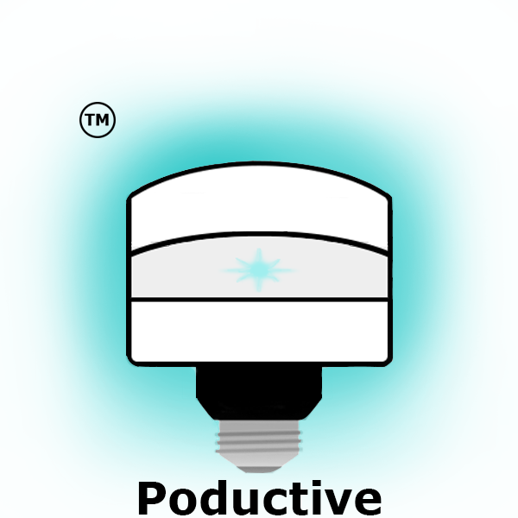


Branding
Poductive’s name is a play on words explaining what the product is and what it focuses on. Poductive is productivity boosting pod.
Poductive’s strapline is ‘Create your Shrine and Shine’. This alliterative and rhyming strapline describes the customisable aspect of Poductive, explains what users effectively do with the product and explains how it benefits customers - by allowing employees to shine and be more productive.
Poductive’s logo (right), is a combination of a pod and a lightbulb shining. This shows off the product and insinuates that it allows employees to shine, as the strapline describes.

Advertising & Promotion
To reach the business dominated target market, several advertisement and promotion methods will be used. These will be used all year long as there is no seasonality in Poductive.
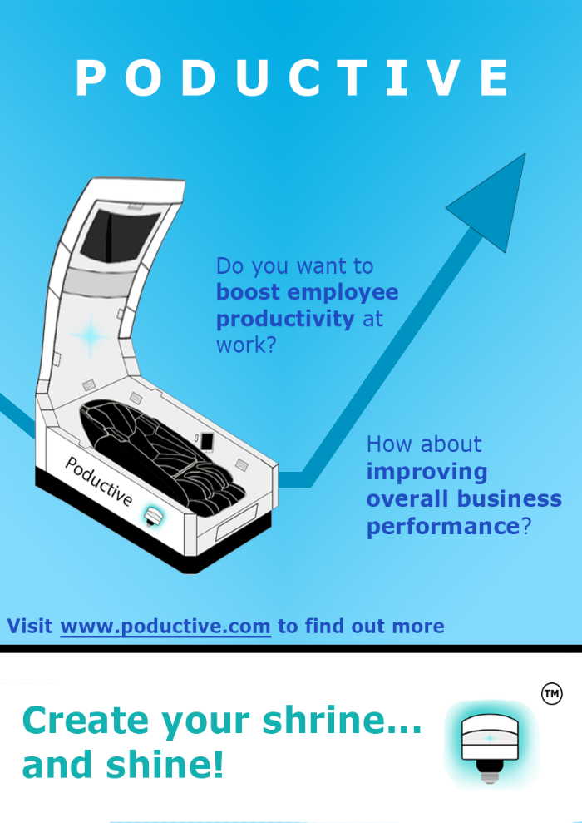
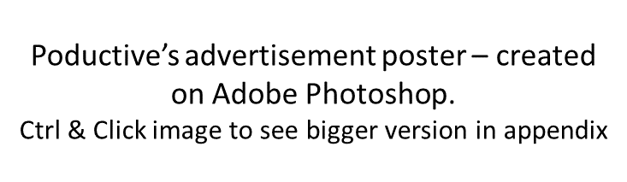

Advertisements for business related magazines/television channel/websites, such as Forbes, Bloomberg Businessweek, and CNBC and business radio stations, such as Bloomberg and KFNN will be purchased. These are generally accessed by people interested in business news and trends who may be looking to improve their business.
Social Media’s 2.28 billion users (2016) provide a huge platform for advertising to various users. Facebook, Instagram and Twitter (in top 10 user numbers) will be used to reach out to potential customers worldwide.
To promote Poductive and attract customers, campaigns, such as free trials of Poductive, and inviting businesses to enticing events, will be run. Posters (right) will be distributed to business dense areas such as city centres.
Advertising methods advertise Poductive’s website (below), which explains the business to viewers and allows customers to purchase/rent Poductive. Though targeted at businesses, individuals may also purchase Poductive as a luxury item.
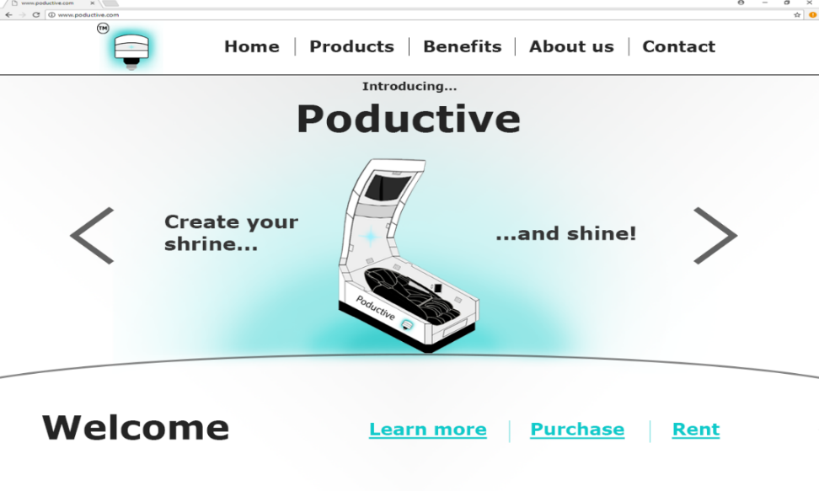
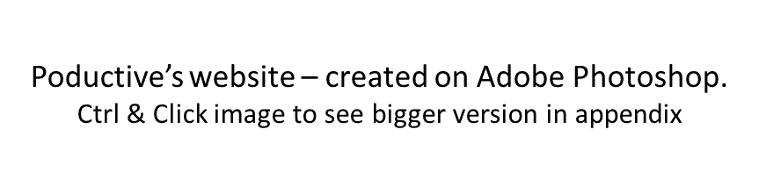

Contrasting colour schemes and Verdana fonts are used throughout Poductive’s branding, promotion and advertising, ensuring content is accessible by viewers with visual impairments/reading disabilities. A bluey-green colour is consistently used as these colours psychologically link with trust and creativity - hopefully inspiring customers to purchase.

The Future
Poductive’s future is bright. Large companies have recently invested in sleeping/relaxation facilities to benefit employees. To attract more customers, plans exist for the future:
- Develop the product - A drawback of Poductive is its expensive luxurious nature, making it unaffordable for many businesses. Future product development could allow focusing on one experience (e.g. napping), making Poductive cheaper. Diversifying Poductive’s product range will attract new customer markets, such as small businesses, with less money.
- Expanding nationally/internationally/globally - Poductive will eventually be sold worldwide rather than just in London. This business expansion will generate more sales and profit.
- Growing branding and internet presence - Growing these will allow the world to recognise the company.
- Acquire/merge with another business - This will enable the business to grow and share expertise, ultimately improving sales.
Poductive has the potential to form a multi-million-pound company and appear in many of the millions of businesses worldwide.

Intellectual property
IP will protect Poductive. The currently trademarked logo will be registered for legal protection and demonstration of ownership. Plans also exist to patent Poductive’s invention and register its design, ensuring Poductive is legally protected from others.

Appendix

Appendix 1 – Poductive technical information

Technology used inside Poductive:
- Monitor – Acer Predator widescreen curved monitor - https://goo.gl/hKTtEq
- iPad – iPad Pro 12.9” - https://goo.gl/BkS50UDG
- Speakers – Samsung 5.1 Smart 3D Home Cinema System - https://goo.gl/6dL2Eb
- Phillips Hue White SMART LED lighting system - https://goo.gl/DSTWyG
- Massage chair – HOMCOM zero gravity reclining massage chair - https://goo.gl/w5pCpq
- Heart rate sensor – Fitbit Alta HR tracker - https://goo.gl/oPX9h1
- Bluetooth system
- Aux connection
- Yoga experience – Gaia Yoga - https://goo.gl/cQwfZ2
- Meditation experience – Headspace Meditation - https://goo.gl/GEh93A
- Visualisation experience – The Joy of Sugar Freedom Visualisation - https://goo.gl/Z3rsJP

Price breakdown
The rough cost of design and development for one product:
- Monitor - £900
- iPad Pro - £1,250
- Speakers - £210
- SMART Lighting system - £129
- Massage chair - £1,200
- Heart rate sensor - £130
- Bluetooth implementation - ~£500
- Aux connection - ~£50
- Materials and product design - ~£3,000
- Other/emergency costs (estimate) - ~£1,000
- Total: £8,349

Other costs
Other costs directly related to the product include:
- Patent - £3,000 - £6,000
- Design registration - £60
- Poductive application development - ~£5,000
- Yoga tracks subscription- £340
- Meditation tracks subscription - £300
- Visualisation tracks subscription - £320

How Poductive works within businesses
- Businesses place Poductive (8ft x 4ft) inside a room or area in which employees can take breaks and connect it to the mains
- Employees book a slot for a certain time of the day through the Poductive application
- Employees spend their allocated time inside Poductive before making way for the next person (time depends on business/personal preferences)

Appendix 2 – Survey Monkey questionnaire questions and results regarding tiredness, stress and productivity in the workplace.

Appendix 3 - Creating Poductive on Photoshop:
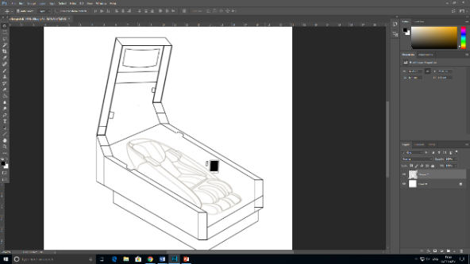
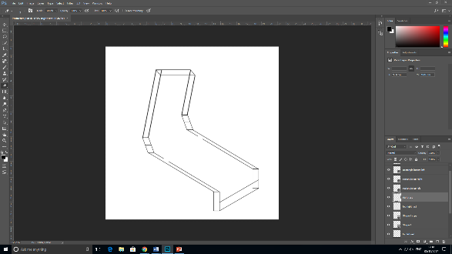

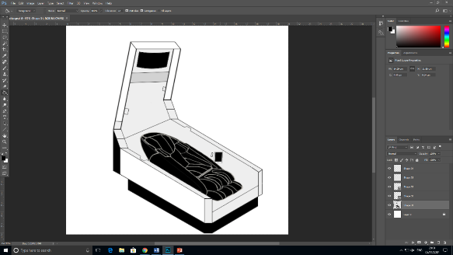
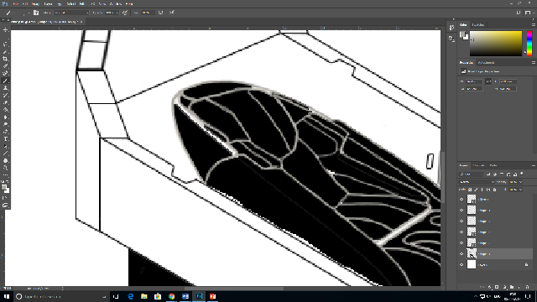

Appendix 4 - Creating Logo:
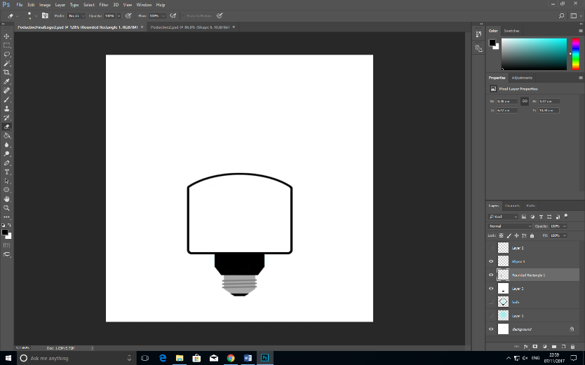

Appendix 5 – Creating website:
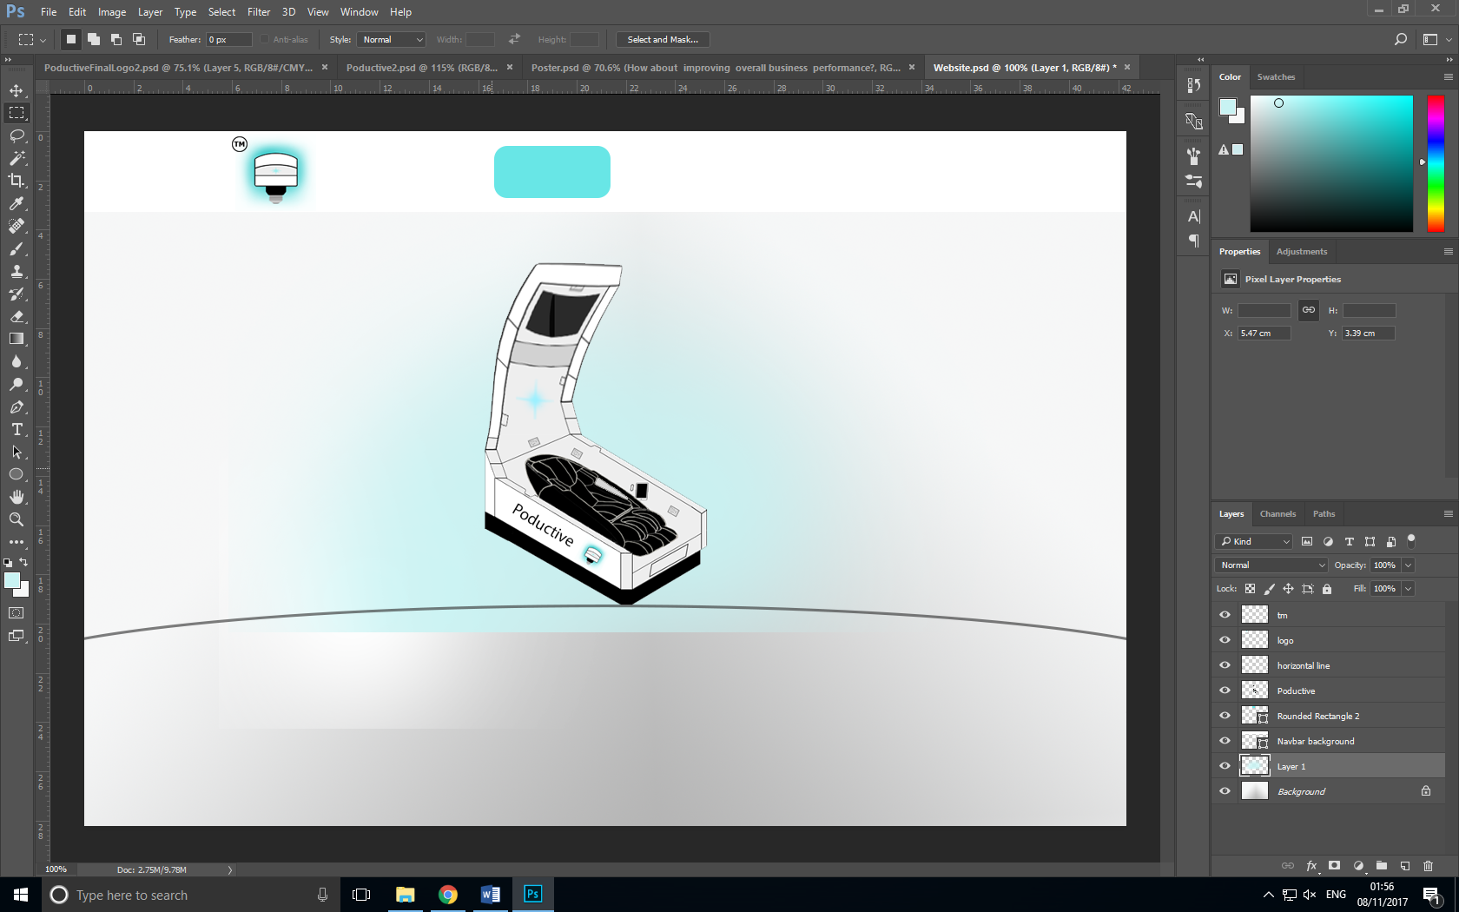

Appendix 6 - Poductive poster (bigger version)
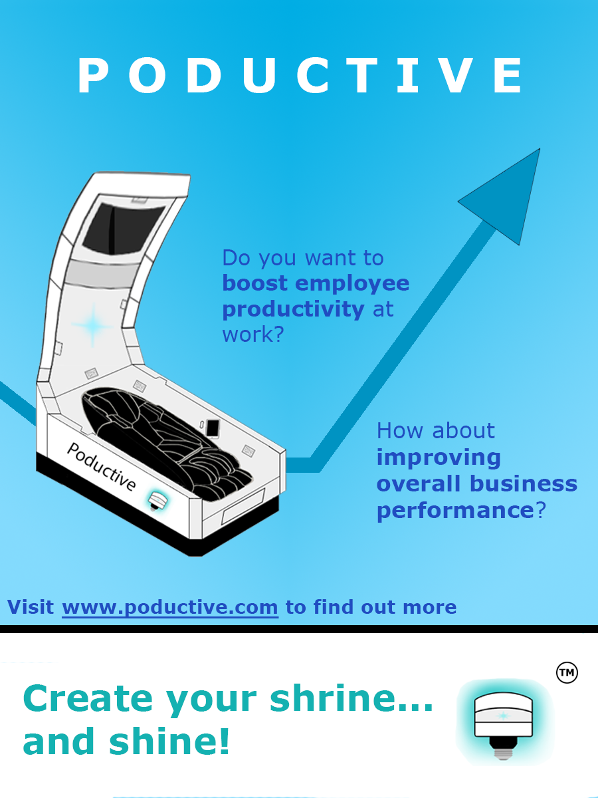

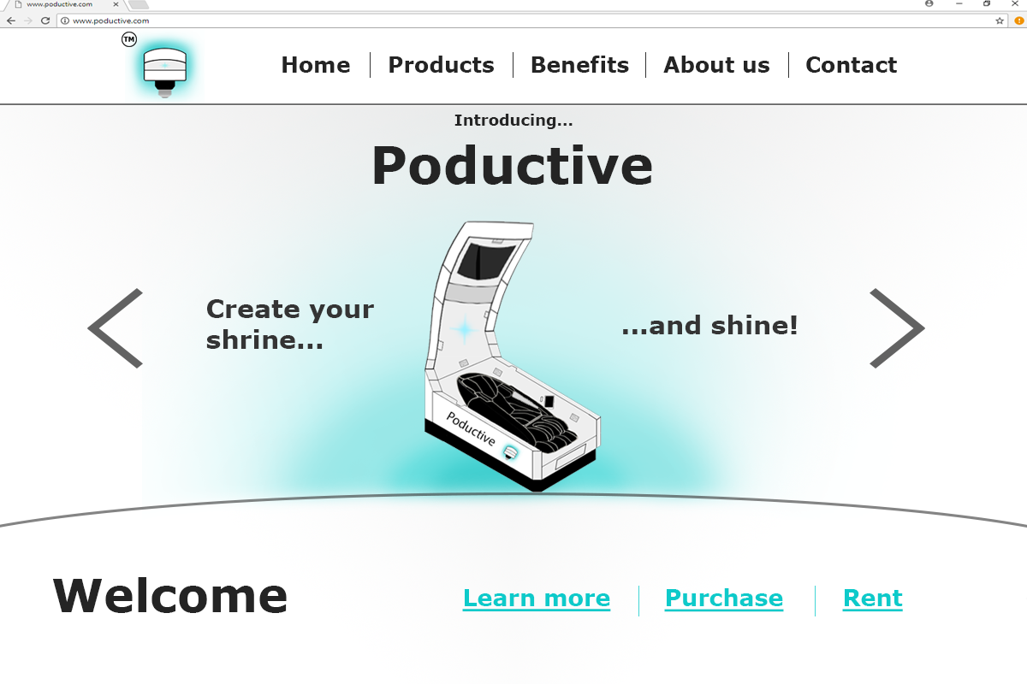
Appendix 7 - Poductive website (bigger version)

