
Design specification
ITEC 20121 Assignment 2

This report consists of a design specification for Assignment 2 of ITEC 20121. The main, assessed parts of the design specification are within the specified 4 page limit and can be found on the following pages:
- PACT Analysis (page 2)
- Design decisions rational (pages 3 - 5)
Other parts of the assignment, such as the sketch of the entire system, original design sketches and creation of images, can be found as part of the appendix.
The table of contents can be referred to for more detailed navigation of the report.
The other part of this assignment, the 3 prototype screens that were chosen to be designed, have also been submitted in the module dropbox on NTU NOW.

Inderjit Sandhu (N0578334)
Nottingham Trent University

Contents
PACT Analysis 2
People 2
Activity 2
Context 2
Technology 2
Design Decisions Rationale 3
Text/screen elements 3
Textual aspects 3
Text and background colours 3
General screen design 3
Bevel effect on buttons 3
Consistent layout and screen elements 3
Photoshop to create screen elements 3
Creating relevant and artistic screen elements 3
Greyed out buttons 4
Clear screen layout 4
A kiosk rather than a website 4
Kiosk - not a website 4
Kiosk design principles 4
Images 5
Use of icons 5
Designing Image sets considering Mullet and Sano (1995)’s principles 5
Image refinement and co-ordination 5
References 6
Image References 6
Appendices 7
Appendix 1 - Sketch of the entire train ticket booking system 7
Appendix 2 - Creating images on Photoshop 8
Appendix 3 - original design plan sketches 11

PACT Analysis

People
The primary users of the system are the general public that intend on purchasing a train ticket or checking ticket times. Secondary users of the system are ticket inspectors, as they inspect the tickets customised by the system. The system is targeted to users of all ages, as people of all ages tend to purchase train tickets.
Visual acuity will vary as of eyesight declines with age, as Heiting (2016) points out, so small, detailed images or design features will not be used. The typical user will have normal colour vision, but a minority may be colour blind or have visual impairments. Contrasting colours will therefore be used.
People that are unable to use the system, such as blind people, would require somebody else would book their tickets. Some users may suffer from dyslexia, so, as Scribe Consulting (2016) recommends, an easily readable sans serif font will be used whilst but long lines of text will not. Audio is not required.
Most users will have good motor control, but some may not, so straight forward steps will be used. Handedness will be mixed, so all touch option locations will be easily accessible for both hands. Users will have a ranging technical experience, from naïve to expert, and varying educational ability so the system will use a simple design and layout, and explain what the user must do next and how to do it. The kiosk will be based in the UK, so English will be the default language, but some users may speak another language, so multiple language options will be available. Many users will have a reasonable or positive attitude to computers, but some may detest them, so the user interface will be easy to use and follow.

Activity
Users of the system will have three main activities to carry out:
- The user will select their destination by typing with the onscreen touch keyboard, while the system generates the most popular destinations chosen by previous users. The user then touches their destination from the list, chooses their ticket options and then pays and receives printed tickets
- The user can view train times on the kiosk
- Finally, the user will be able to collect their prepaid tickets by entering a reservation code

Context
The kiosk will be placed indoors and outdoors, depending on whether the station is building based. Kiosks will be positioned in roofed corners, away from other people, to provide privacy, allow for concentration and reduce screen glare. Though passing trains would create noise, sound is not needed to use the system.
In terms of the social and organisational context, the kiosk will be used in public spaces (train stations) and created for single users. Users may be interrupted by other people making noise around the kiosk, though this would only be the case during busy train periods.

Technology
The system will be driven by a basic desktop computer (as basic tasks are required) that is connected to a till system (with a card reader) to take payments, a printer to print out tickets, and a 12 inch (30cm by 24cm size and 800 x 600 resolution) LCD monitor using anti-glare technology and a capacitive touchscreen. As Lee (2010) points out, capacitive touch screens use glass (durable and easy to clean) and have reduced glare, so they are an ideal choice. Basic images and a progress indicator will be displayed on the kiosk.
The monitor will be mounted on a stand, with the bottom of the screen 86 cm off the ground and the top 110 cm off, which is less than the maximum 120cm the ADA Standards (2010). This ensures wheelchair user will also be able use the kiosk. Within this stand will be the hardware used for the system. A fairly fast network connection will be used so data is processed quickly and customers receive their tickets ASAP.

Design Decisions Rationale
This section details design decisions that have been made regarding the kiosk screen. The three screens that have been designed are the choose activity, destination finder and the ticket option screens, allowing a demonstration of various designs. The system sketch can be found in appendix 1.

Text/screen elements

Textual aspects
The font used on all screens is Trebuchet, which, as Smith (2016) points out, suits many readers due to its long ascenders, small body size and generous line spacing. Trebuchet is a sans serif font, which, as the BDA New Technologies Committee (2015) explains, is easier for dyslexic users to read due to the good ascenders and more rounded letters that speed up reading time. To ensure that all text is easily readable, the font size on each screen is at least 14 (mostly 18 +). Each screen abides by Smith’s principle (2014) of sticking to a limit of 4 sizes of text.
As explained on Sticky Content (2014), plain, conventional English should be used to create a feeling of dialogue with the user and enable them to read quicker, which is especially important in kiosk systems. Due to this reason, sentence case has been used for headings, instructions and short phrases of text have been left aligned. Humans read left aligned text easier and faster as they’re used to reading it like this, as Anthony (2011) concludes. Text on buttons and the progress bar have been centralised to improve appearance. All text used has been justified so uneven word spacing is avoided, as this may make text look messy and slow down reading speed.

Text and background colours
Ambler (2014) suggests that in order to ensure text is readable, the contrast rule should be followed. Each screen follows this rule by using a combination of negative and positive contrast. For most of the text, negative contrast (navy text) is used on a white, orange or light blue background. This ensures that the text is easily readable and as Smith (2016) concludes, that finger marks caused by users and glare are also harder to see, as they typically are on a light background. Positive contrast is occasionally used in an effective manor (white text on a navy background) to provide some variation in terms of the looks of the screen, making it more attractive. The main content background uses a simple but relevant image of a train track that has a low opacity effect mixed with a light blue colour. This image also helps with improving the display appearance against finger marks and glare.

General screen design

Bevel effect on buttons
A bevel effect has been included on each button that has a function. This effect hints to the user that a button is touchable, such as the cancel button, while images without this effect, such as the no coins image are not.

Consistent layout and screen elements
Each screen has a consistent layout and screen elements. For example, the progress bar, back and cancel buttons are positioned at the same point for each activity screen. This consistent repetition means users can use the system again with ease, as Sollenberger (2013) explains. Fadeyev (2009) points out that consistent interfaces help develop usage patterns, so the use of a consistent screen design means that users will be able to complete their activities faster when they next use the system. A consistent colour scheme has also been used on each screen so that the screens look like they belong as a set, and the user isn’t shocked by an overload of random colours.

Photoshop to create screen elements
Photoshop has been used to create images, buttons, the logo and the progress bar (see appendix 2). Various editing and creation techniques have been used to create these, such as combining shapes to create more complex shapes, adding bevel effects, and skewing to create curves in the notes of the ‘no notes’ images.

Creating relevant and artistic screen elements
Each image has been created in a way that is either relevant to trains, or intended to be artistic, with the ultimate goal of making the screen look attractive, which as Fadeyev (2009) points out helps make the experience of using an interface truly satisfying and memorable. The progress bar has been created as a train, with each section of the train representing a different screen. The logo used in the top right corner is also an image of a train created on Photoshop.

Greyed out buttons
Options that are unavailable for the user to touch, such as unavailable letters and the minus button when 0 tickets are already selected, are greyed out so that it is clear to the user that they can’t touch these buttons.

Clear screen layout
Each screen has a clear organised screen layout, with related objects placed together. For example, on the destination finder screen, the progress bar is along the bottom section of the screen, touchable options are along the left section, the keyboard is in the middle section and locations are along the right. This organisation helps the user with navigation, as Ambler (2014) explains, and makes the system easier to understand.

A kiosk rather than a website
This section considers that a kiosk interface, rather than a website, has been designed. This is very important as the functionality and purpose of a kiosk differs from a website, as Smith (2016) clarifies.

Kiosk - not a website
Throughout the screens, kiosk terminology has been used to communicate with the user, rather than website terminology. For example, ‘touch’, ‘press’ and ‘back a step’ have been used rather than ‘click’ or ‘back a page’. This use of kiosk terminology ensures that the user knows their task is a simple one.
Smith (2016) emphasises that kiosks have narrow and immediate requirements, and each screen should only require one or a small number of touches. Following this, the screens each have a narrow tasks:
- the choose activity screen simply requires a touch of the user’s intended activity
- the search screen requires some typing but then simply requires a touch of the user’s location
- the choose ticket options screen requires the user to touch a few buttons if they wish to make any changes, before pressing a button to pay
Smith (2016) also explains that users should be guided to their goal. Therefore, as well as the use of the progress bar, each screen has a heading which explains to the user what they must do next. For example, ‘touch an activity to continue’ and ‘begin typing your destination’ clearly communicate to the user what they must do next.
Kiosks should have a limited amount of text on each screen because as Fadeyev (2009) emphasises, the valuable time of users should be saved by keeping things concise. This is the case for each screen, as clear and concise wording has been used so that the user doesn’t waste time reading unnecessary information.

Kiosk design principles
Smith (2016) explains in her lecture that kiosks have certain design principles, including the following:
- A progress bar - once a user undergoes an activity, a progress bar appears at the bottom of their screen so that the user knows which step they are on at a glance and how many steps they have left. The current step is a different colour and the progress bar is designed in the form of a train, providing a relevant to the system and interesting way of helping the user with navigation.
- Cancel and back buttons - each activity screen has a button that allow the user to cancel their activity and another button to go back a step. Users may want to cancel or go back a screen due to human error, which, as Ambler (2014) asserts, is common occurrence. Due to this, the interface has been designed so that users can recover from mistakes and easily return to an earlier step.
- Responsive actions - responsive buttons are included on each screen to make the system interactive, fulfilling its purpose of allowing users to view train times and collect or buy their tickets. When pressed, each button with the bevel effect takes the user close to their final goal.
- A simple screen layout / readability and clear navigation - each screen clearly details what the user must do next. For example, ‘touch an activity to continue’ concisely provides the user with information on how to advance. All other text is also limited, as users don’t want to be reading a lot of text and wasting their time. A roughly even amount of space between each image/button ensures each screen isn’t too clattered with objects making the screen look confusing to use.
- A finger friendly design - Each touchable button is a size that allows a user to comfortably press the button they want to, and not another one. This is important for kiosks as users don’t want to spend time being precise with their touches. The spacing between buttons evenly separates them. For example each letter on the keyboard is an equal distance to the next. This provides a consistent and professional look.

Images

Use of icons
The screens make use of icons, as the concepts that the images represent are concrete and familiar actions/information. For example the ‘view train times’ icon is an image of a clock with hands on it and the change language button is an image of two different languages. The use of these icons mean that users have a clear idea of what the button does when touched. Logograms have been avoided as they are based on one particular language, as Mullet and Sano (1995) point out, meaning some users might get confused.

Designing Image sets considering Mullet and Sano (1995)’s principles
The images used on the screens have been created specifically, using the guidance of Mullet and Sano (1995)’s principles of immediacy, generality, cohesiveness and communicability.
Mullet and Sano (1995) explain that effective imagery should possess a perceptual immediacy, allowing the image to be recognised at a glance. This principle has been considered in the creation of the images, as it is easy to recognise what the image is, and therefore presume what the button does when touched. For example, the destination finder button shows a map of England with a destination icon, clearly suggesting that this button should be touched to find destinations. The no coins image used has a picture of coins with a cross over it, clearly meaning that the particular machine does not accept coins. This immediacy is an important visual cue for telling the user something about the purpose of the buttons used by the system.
The images used on the screens also have general characteristics rather than specific ones, and communicate information effectively. For example, the cards, notes and coins image include cards, notes and coins, which are used all worldwide and are easily recognisable by anyone. Similarly, the ‘view train times’ button, includes an image of a clock, which again is a general item. This generality means that all users are able to interpret the images or buttons and presume what they mean or do.
It is important to create images that are cohesive and look like they belong as a set when designing a kiosk interface, because, as Mullet and Sano (1995) explain, each image forms parts of a larger system and must work together as a group. The image sets created abide by this. For example, the cards, notes and coins images are all similar sizes and colours and the images used on the activities buttons include the same colours and a circle border, are the same size and have a smaller white circle included within the image.

Image refinement and co-ordination
As Smith (2016) explains, details should be omitted until only the most essential characteristics remain. Images used on the screens follow this, and have been refined, for example, the ‘collect tickets’ button simply includes an image of a hand picking up tickets, and no other details such as text on the tickets. Similarly, the cards, notes and coins images have been designed to make it obvious what they are, but they don’t include any detail. Though refined, the images still communicate their information or purpose effectively.
Smith (2016) recommends that in order to achieve effective image co-ordination, images should use a consistent size, orientation, layout, colour, weighting and use the same elements. The images created follow Smith’s recommendations, for example, each button image on the choose activity screen is the same colour and size, orientated straight up, placed within a circle and uses the same weighting (4px for activity buttons). This image co-ordination makes the images look as if they belong together.

References
ADA, 2010. ADA Standards for Accessible Design [online]. Available at: http://www.ada.gov/2010ADAstandards_index.htm [Accessed 3 February 2016]
Anthony, 2011. Why you should never centre align paragraph text [online]. Available at: http://uxmovement.com/content/why-you-should-never-center-align-paragraph-text [Accessed 27 February 2016]
BDA New Technologies Committee, 2015. Typefaces for dyslexia [online]. Available at: http://bdatech.org/what-technology/typefaces-for-dyslexia/ [Accessed 16 February 2016]
Dmitry Fadeyev, 2009. Characteristics of successful user interfaces [online]. Available at: http://usabilitypost.com/2009/04/15/8-characteristics-of-successful-user-interfaces/ [Accessed 3 March 2016]
Gary Heiting, 2016. How Your Vision Changes as You Age [online]. Available at: http://www.allaboutvision.com/over60/vision-changes.htm [Accessed 2 February 2016]
Kevin Mullet and Darrell Sano, 1995. Communication oriented techniques. Upper Saddle River, NJ, USA: Prentice-Hall
Kyle Sollenberger, 2013. User Interface design fundamentals [online]. Available at: (http://blog.teamtreehouse.com/10-user-interface-design-fundamentals) [Accessed 4 March 2016]
Pauline Smith, 2014. Pauline’s lecture on screen design [online]. Available at: https://now.ntu.ac.uk/d2l/le/content/360283/viewContent/1660408/View [Accessed 25 February 2016]
Pauline Smith, 2016. Pauline’s lecture on Kiosks [online]. Available at: https://now.ntu.ac.uk/d2l/le/content/360283/viewContent/1660401/View [Accessed 26 February 2016]
Pauline Smith, 2016. Pauline’s lecture on text and other screen elements [online]. Available at: https://now.ntu.ac.uk/d2l/le/content/360283/viewContent/1660406/View [Accessed 25 February 2016]
Scott Ambler, 2014. User Interface Design Tips, Techniques, and Principles [online]. Available at: http://www.ambysoft.com/essays/userInterfaceDesign.html [Accessed 2 March 2016]
Scribe Consulting, 2016. Serif and sans-serif fonts [online]. Available at: http://www.scribe.com.au/tip-w017.html [Accessed 2 February 2016]
Sticky Content, 2016. Are you Team Title Case or Team sentence case? [Online]. Available at: http://www.stickycontent.com/blog/are-you-team-title-case-or-team-sentence-case [Accessed 28 February 2016]

Image References
http://www.dxgn.org/images/dxgn-1-22868-0-600px.jpg - Change language button (edited with PS)
http://www.qrcoded.co.uk/images/raillarge.gif - QR code

Appendices

Appendix 1 - Sketch of the entire train ticket booking system
Welcome/choose activity screen
A-Z ticket destination finder screen
Collect prepaid tickets screen
View train times screen
Pay for tickets screen
Printing tickets screen
Choose ticket options screen
Choose ticket type screen
Change destination screen
Choose route

The above image shows an electronic sketch of the entire train ticket booking system. The screens with green ticks in the corners are the ones that have been designed.

Appendix 2 - Creating images on Photoshop

2.1 Creating the logo
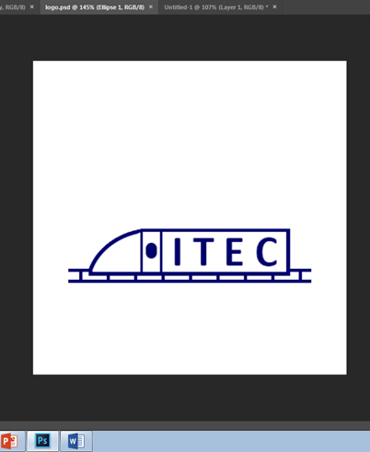
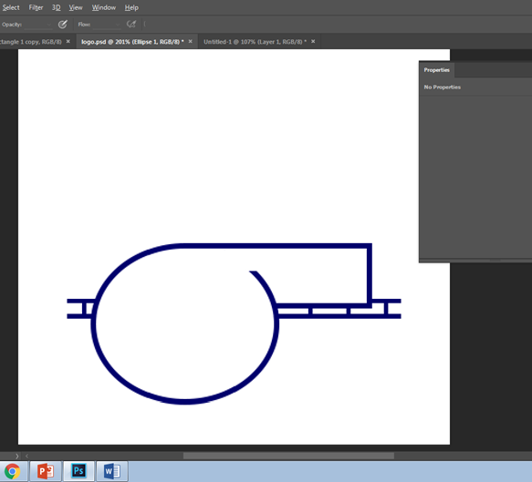

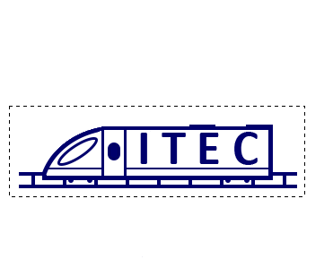

The above screenshots show different stages in the production of the logo. A circle was drawn and erased partially to make the front of the train.

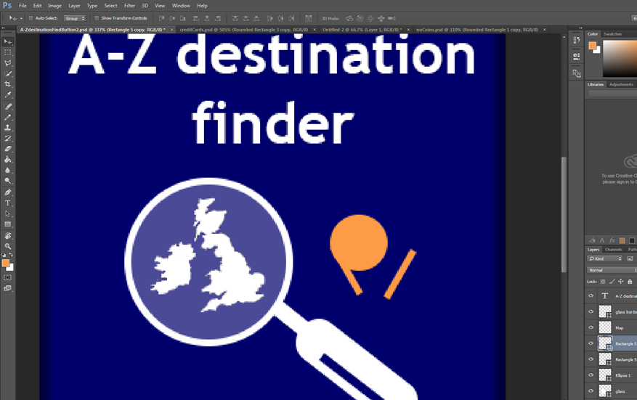
2.2 Creating the choose activity screen button images

The screenshots to the left show different levels of progress of the creation of the buttons designed for the choose activity screen.

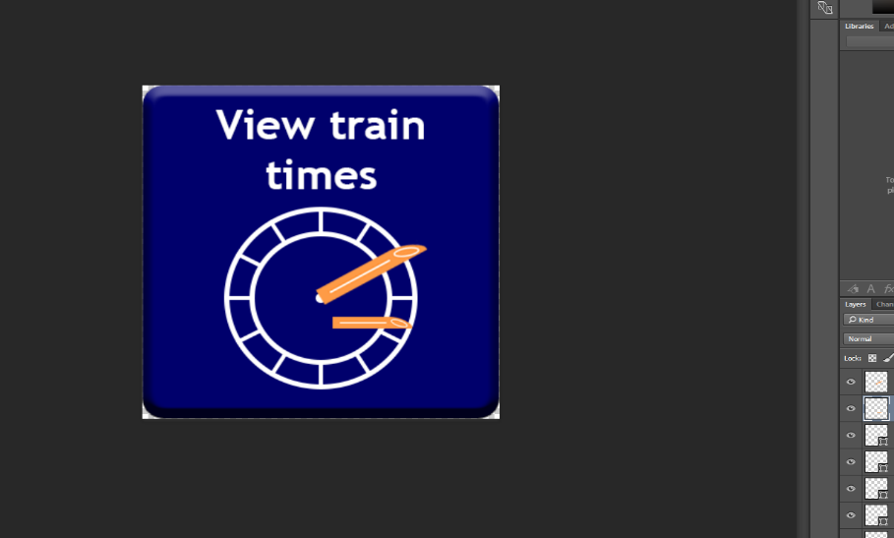

2.3 Creating the no notes / credit/debit card images
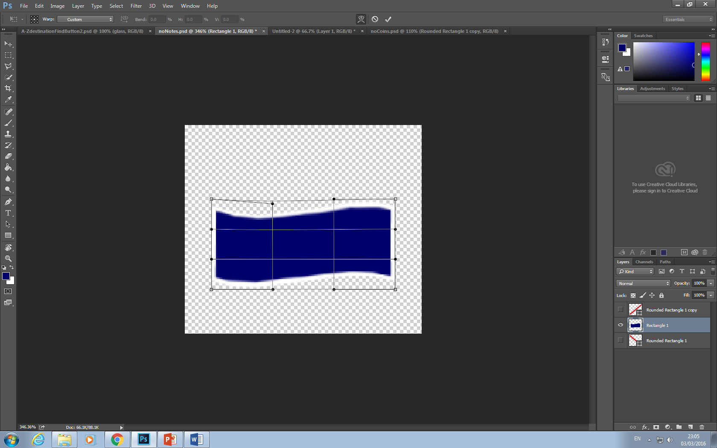
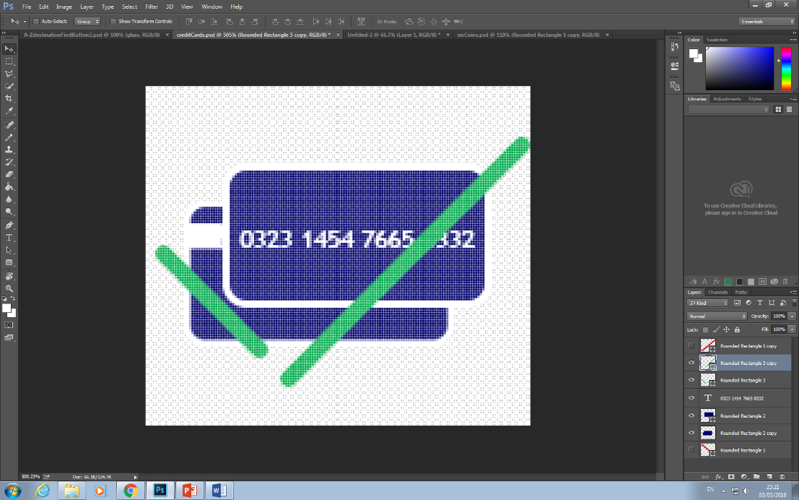
The screenshot to the left shows the initial created of the no notes image. Different points of a regular rectangle were dragged out to make a curve/money note effect.

The screenshot to the left shows the creation of the credit/debit card accepted image used. This image sticks with the colour scheme of its image set and the entire kiosk, and communicated clearly to the used that cards can are accepted on this kiosk.

2.4 – Creating the change language button
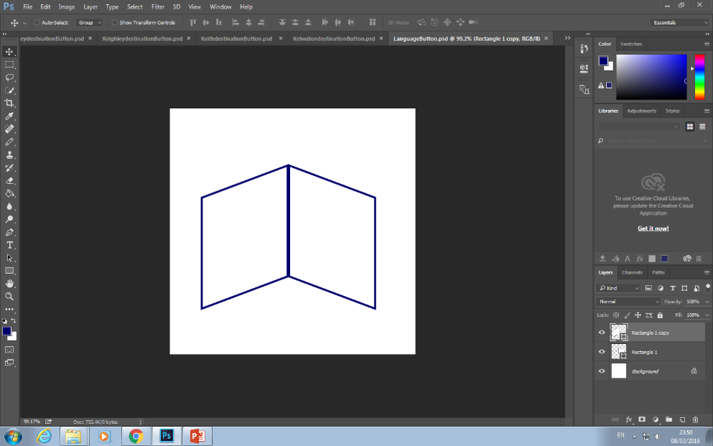
The images below show the creation of the language button used on the first screen
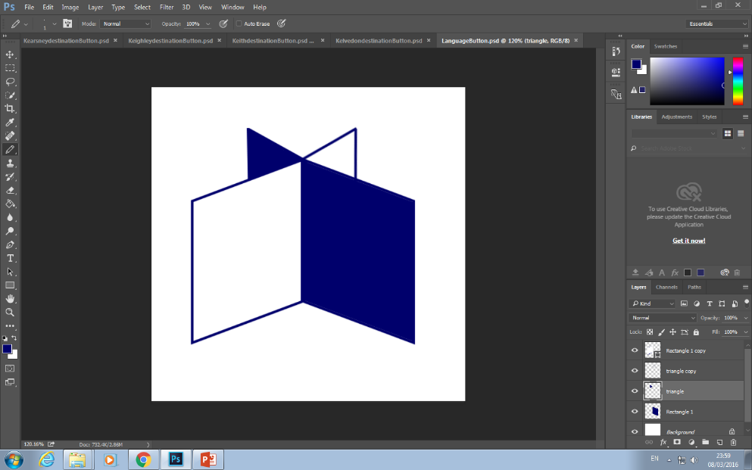

Appendix 3 - original design plan sketches
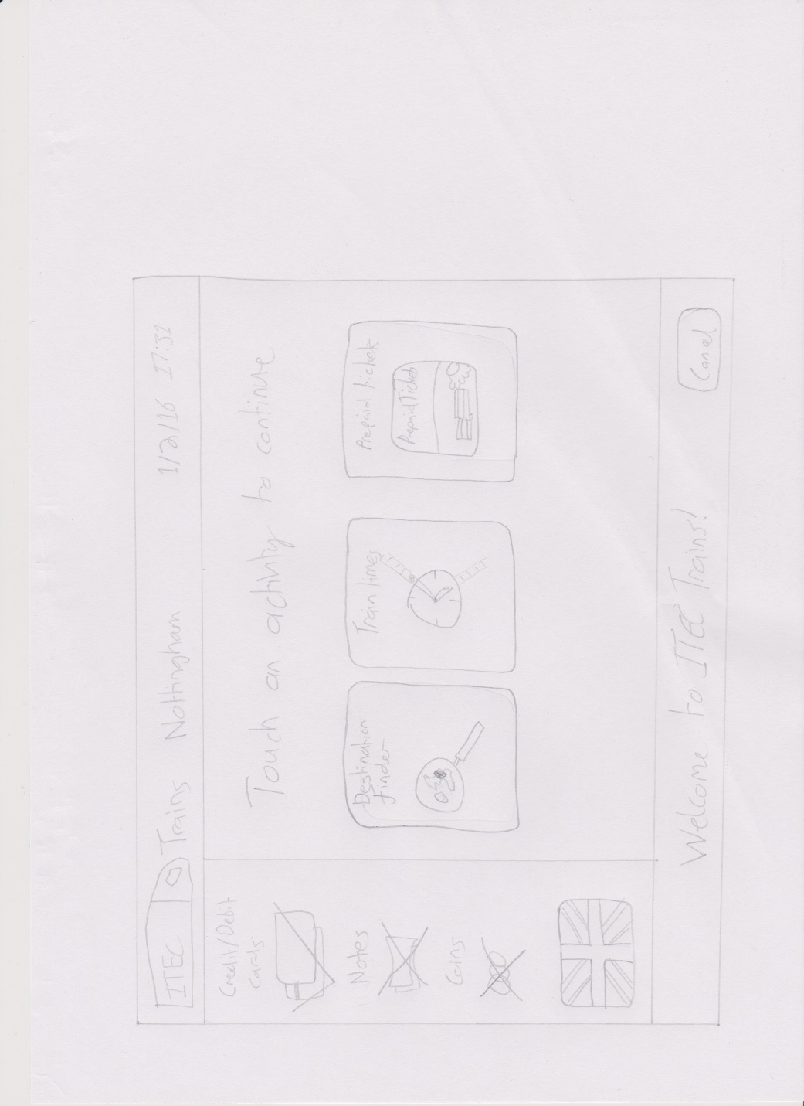
The following images are early sketches of each screen

Appendix 3.1 - The ‘choose activity’ screen

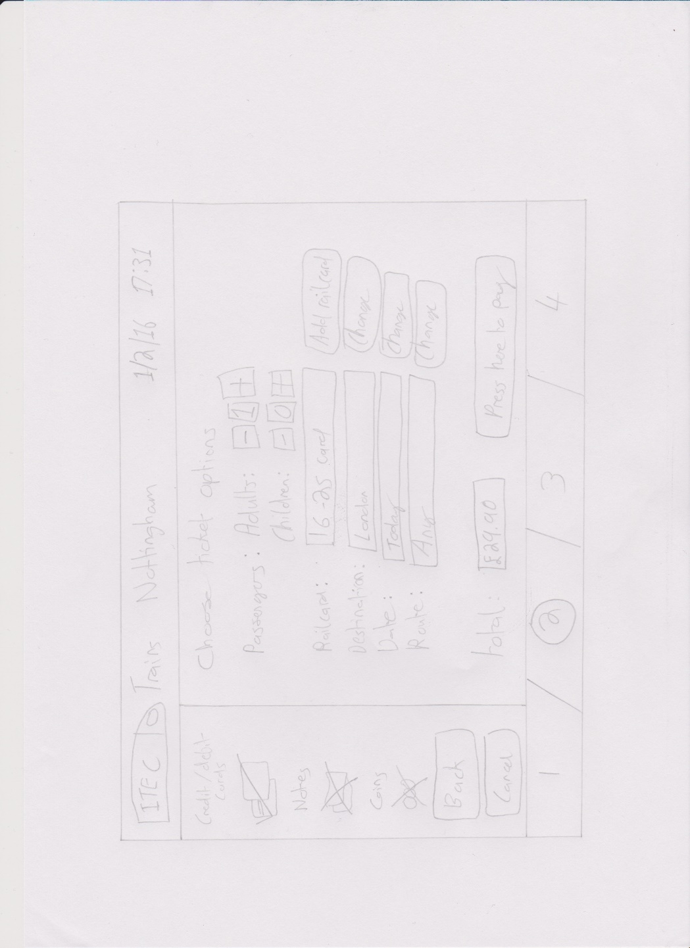

Appendix 3.2 - the ‘choose ticket options’ screen

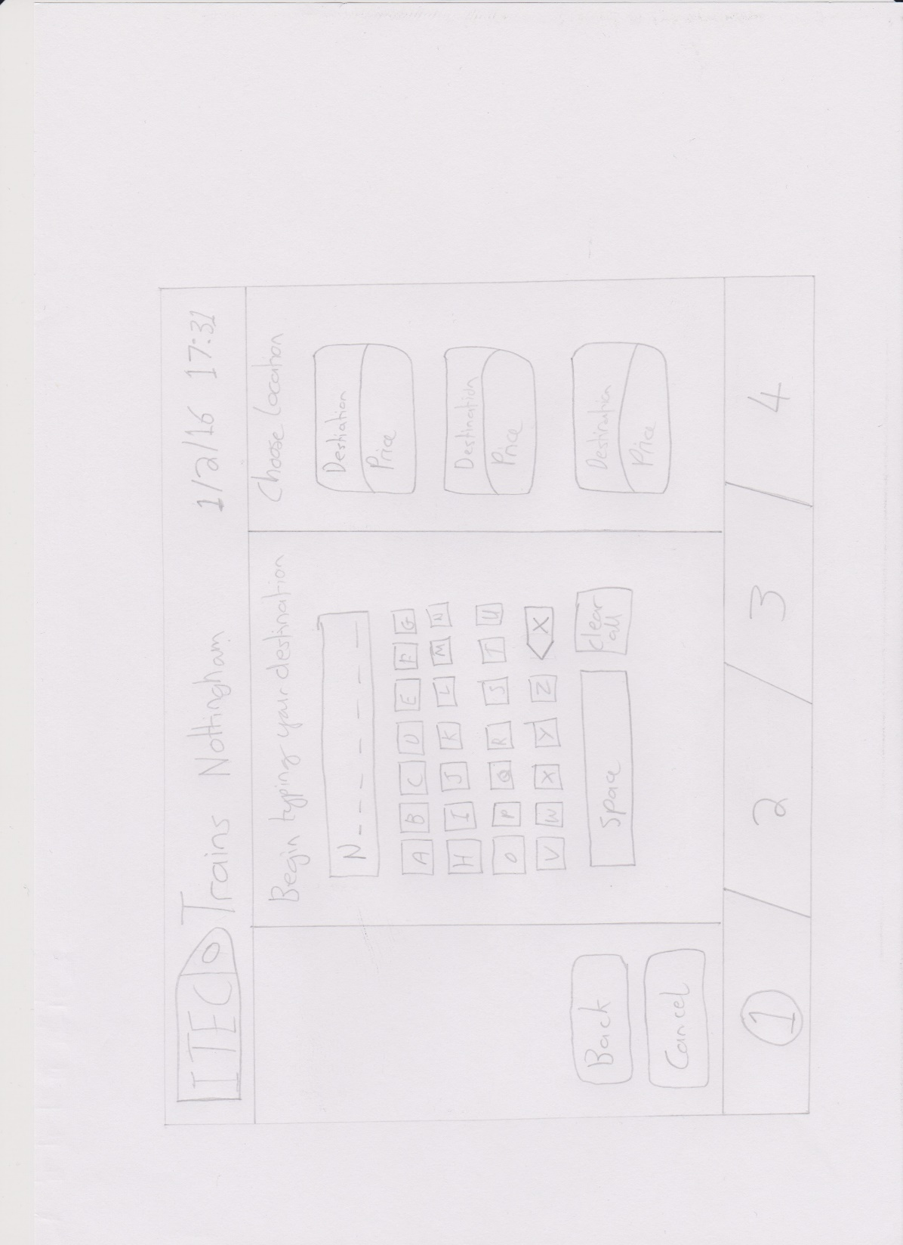
Appendix 3.3 - The ‘destination finder’ screen

.

