
ISYS10241/2: SA&D Systems Proposal Report
Seminar Tutor: Paul Bowden


Page count: 38 (Including Appendices)
By:
N0578334: Inderjit Sandhu
N0606995: Akorede Ajiroba
N0579849: Mehvish Zaidi
‘Stack Your Wealth!’
Table of Contents
Introduction 4
1. Introduction to Team and Methodology 4
1.1. Summary of Strengths with Respect to the Role of a Systems Analyst 4
1.1.2. Group Roles (Considering Belbin Test) 4
1.2. Methodology Chosen - Structured Systems Analysis and Design Method (SSADM) 5
1.2.2. How a Company uses the Waterfall Method 5
1.3. Effective Problem Solving Technique that a Systems Development Team Could use (5 Whys Technique) 6
1.3.2. Example of a Systems Development Team using the 5 Whys Technique 6
1.3.3. How the Problem Solving Technique Relates to an Everyday Situation 6
2. Team Concept Maps 7
2.1. - Week 28 Concept Map 7
2.1.2. - Initial Concept Map evaluation using the Kinchin et al (2000) criteria 7
2.2. - Week 38 Concept Map 7
2.2.2. - Final Concept Map evaluation using the Kinchin et al (2000) criteria 8
2.3 - Sharing our Concept Map online 8
3. Project Schedule & Risk Assessment 0
3.1 - Work Breakdown Structure 0
3.2. – Project Gantt Chart 0
3.3. – Pert Chart 0
3.4. – Risk Assessment Table 2
4. System Proposal 0
4.1. - Name of the game 0
4.1.2. - Motivation or inspiration of the game 0
Screen designs 0
4.3. - Game objective and brief narrative indicating how the game play mimics and/or teaches the systems development methodology 1
Objective (from our game manual) 1
How the game play mimics the methodology 1
How the game teaches the methodology 2
4.4. – Functional Requirements 4
4.5. – Non-Functional Requirements 4
4.6. – Use Case Summary Table 0
4.7. – ‘Stack Your Wealth!’ Context level DFD 0
4.7.2. – Level 0 DFD 1
4.7.3. – Level 1 DFD 2
4.8. – Logic Model (Structured English) 0
4.9. – Logic Data Model – UND, 1NF, 2NF & 3NF Data in table 0
4.9.2 – ERD for 3NF table 0
5. Evaluation 1
How successful was the planning and risk management of the project? 1
How could the team working and planning have been improved? 1
How did the use of MS Project and WinA&D help with the project? What other features might be useful in such tools? 1
How useful was concept mapping for helping you to understand what you had learnt? 2
How successful was the assessment in helping you to learn the principles of systems analysis and design? 2
References 0
Bibliography 1
Appendices 2
Appendix 1 - Game Manual & Data stored by the game 2
Step 1 – Setting up the game 2
Step 2 – Playing the game (starting the game and completing questions/activities) 2
Step 3 - Advancing floors/phases 3
Step 4.1 - A player completing the game 3
Step 4.2 - Finishing the game 3
Extra Information/Rules 3
Appendix 2 – Use Case tables 5
Appendix 3 – Group Minutes 9

*Unfortunately, due to having to rotate some pages landscape, the page numbers in the contents table have become mixed up. This has also applied to page numbers on the document, which is why they are not included.

Introduction
This report has been constructed as a systems proposal to plan, design and model a computer game that teaches managers about a systems development methodology. Upon construction, this report will consider the assessment criteria, particularly in areas for the higher marks, in the hope of achieving these.

1. Introduction to Team and Methodology

1.1. Summary of Strengths with Respect to the Role of a Systems Analyst
Inderjit Sandhu’s Strengths
Attention to detail – I tend to consider alternative viewpoints for almost every situation, allowing me to examine these situations in details. I can therefore spot any flaws that may occur in a system, or identify an area that has the potential to be capitalised on.
Written and communication skills - Due to past experience, I find it natural to communicate my findings. This strength is very useful to have as a systems analyst as it allows me to convey information effectively.
Akorede Ajiroba’s Strengths
Consider all contributions without prejudice - This is a valuable quality in relation to being a Systems Analyst as it provides flexibility which may result in producing a good system.
Good communicator - I come across as clear and ask questions without hesitation. My communication skills help me get the best out of my team.
Figure 1A – shows each members results from ‘Belbin Self-Perception Inventory’ test. 70 points distributed per individual
Mehvish Zaidi’s Strengths
Open to different types of ideas - I don’t immediately dismiss ideas, which in regards to being a system analyst, is a good quality as it means I consider ideas that may improve a project.
Strong sense of objectives - I am able to see what our goals are and how we may achieve them. This allows me to support the group in completing what is necessary in order to achieve the set goals.

1.1.2. Group Roles (Considering Belbin Test)
Each member of the group completed the ‘Belbin Self-Perception Inventory’ (Belbin, 2003) test to identify their suggested team roles. A radar chart was then constructed on Microsoft Excel, shown in figure 1A, to visually summarise the results, showing each individuals overall performance.
Inderjit Sandhu - ‘Complete Finisher’ & ‘College Worker’
The Belbin test suggested that I am dutiful, conscientious, hard-working, a perfectionist and that I have common sense. These results were accurate, as I can relate to these features and qualities. I can also relate to a weakness of being unresponsive, though I’m confident my group will assist me in overcoming this.
Akorede Ajiroba & Mehvish Zaidi – ‘Chairs’
The role suggested by the test denotes me well as I have similar qualities associated with this type. - Mehvish
I am satisfied with being a ‘chair’ as this role accurately represents the abilities that I possess. - Akorede

1.2. Methodology Chosen - Structured Systems Analysis and Design Method (SSADM)
Our group has decided on using the Structured Systems Analysis and Design (SSADM) methodology for the theme of our game. SSADM uses the waterfall model to develop (existing and new) information systems, mainly focusing on the analysis and design of the system. As SSADM focuses on the analysis and design of a new system, the methodology uses a combination of three techniques – Logical Data Modelling, Data Flow Modelling and Entity Behaviour Modelling.
SSADM relates to our courses (Computing / Information Systems), evidenced by the fact that it is widely used for government computing projects (Beal, 2009). The methodology has seven stages that are shown on figure 1B below.
Technical System Options (TSO)
Feasibility Study
Requirements Specification
Logical Design
Physical Design
Planning
Analysis
Design
Implementation
Figure 1B - The seven stages of SSADM and how they fit into the four stages of the SDLC
Investigation of Current Environment
Business System Options
We believe that SSADM is a good methodology to use for the theme of our game because it is a methodology that can be very useful for businesses and managers to learn. SSADM allows for control, meaning development is likely to improve the quality of a system and reduce errors.
Another influencing factor in choosing this methodology is the fact that it fits in with the SDLC very well. Figure 1B shows how the seven phases of SSADM fit into the four phases of the SDLC.

1.2.2. How a Company uses the Waterfall Method
The waterfall method can be used for many different types of companies. (Peterson, 2009) explains how the company ‘Inspec & Compendex’ integrates many databases in computing, and has had the waterfall method applied to them. The method moves through the phases of requirements engineering, design and implementation, similar to other alternations of the waterfall method.
The fact that this company has used the waterfall method shows that the method can be used by companies with different types of systems.

1.3. Effective Problem Solving Technique that a Systems Development Team Could use (5 Whys Technique)
After researching several problem solving techniques, including SWOT Analysis, Affinity Diagrams and Check Sheets, we found a simple technique that was very effective – the 5 Whys technique. The 5 Whys technique involves repeatedly asking the question ‘Why?’ to “explore the cause-and-effect relationships underlying a particular problem” (Olivier, 2009), ultimately uncovering its root cause. We believe this technique is useful for a systems development team, as it breaks down the layers of the causes of a problem until it is at a stage at which the team can decide on how to fix it. Five ‘why’s are usually a decisive amount to find a root cause though more or less could be used. A similar technique can be used in reverse to find the effects of a problem rather than the cause.

1.3.2. Example of a Systems Development Team using the 5 Whys Technique
The 5 Whys technique can be used in a variety of ways. Figure 1C shows a simple example of the technique in the form of an arrow. By looking at this arrow both the problem, each previous cause and the root cause are all easily identifiable. The process can be reversed to find the effects of problem rather than the causes.
Figure 1C – An example of the 5 Whys technique
Problem:
Employee can’t update Gantt chart
Why?
Software won’t open

Why?
Software date has expired

Why?
Business only purchased 1 month version

Why?
Business didn’t anticipate need for updating chart

Why?
Business underestimated project

Root Cause

1.3.3. How the Problem Solving Technique Relates to an Everyday Situation
A useful feature of this technique is that it relates to many everyday situations as described in the table:
Problem | Why? | Why? | Why? | Why? | Why? (Root Cause) | Solution
Late for work | Missed the bus | Couldn’t find buss pass | Put it somewhere silly | Was in a rush | Woke up late | Wake up earlier
Had argument with brother | Couldn’t work out who owed the other money | Disagreed on cost of an item | Didn’t keep the receipt | Thought it wouldn’t be useful | Didn’t realise how important receipts may be | Store receipts for future reference

2. Team Concept Maps

2.1. - Week 28 Concept Map
- Click here for initial Concept Map as the ‘CmapTools’ file
- Click here for initial Concept Map as the jpg file
- A hard copy of the initial Concept Map will also be submitted with this file
During our seminar and lab sessions we learnt what concept maps were and how they were built. We also learnt how to use ‘CmapTools’ to create a concept map. After constructing individual concept maps with the aid of current knowledge and the ‘Systems Analysis and Design’ text book (Dennis et al, 2012), we merged our ideas together to create a final concept map on Systems Development, though we lacked a deep understanding of the SDLC.

2.1.2. - Initial Concept Map evaluation using the Kinchin et al (2000) criteria
Using the Kinchin et all (2000) criteria in the form of a table (below), we evaluated our initial concept map to help us improve the quality of our map when we update it. A better quality concept map will also mean that we understand more about the SDLC due to better and clearer links and concepts.
Area | Initial Concept Map
Connectedness | - Lacked many detailed cross-links  - Decently structured  - Several isolated clusters
Link Quality | - Appropriately used linking words  - Mainly single and simple words used  - Lack of advanced and detailed language
Link Variety | - Several repeated link phrases
Dynamism | - (explained in final concept map evaluation)
Orientation | - Concentrated on certain concepts more than others
Morphology | - Chain structure - several preconceptions  - Spoke structure - newly learnt material not fully understood
Though some aspects of our initial concept map are weak, we are confident of improving the map in the coming months. This will come down to learning about the subject during lectures and lab sessions and individual reading. We will focus on improving every area where possible.

2.2. - Week 38 Concept Map
- Click here for final Concept Map as the ‘CmapTools’ file
- Click here for final Concept Map as the jpg file
- A hard copy of the final Concept Map will also be submitted with this file
Gradually, after learning at lectures and through individual reading, we updated our concept maps (no less than every two weeks). At times, we updated the map during lectures as we learn that previous links and concepts could have been improved. Much more of systems development was taught at university and our understanding had grown, allowing us to add lots of content to the map and identify where the links were.
Some main concepts and links have been coloured, helping differentiate phases from each other and making the concept map easier to read

2.2.2. - Final Concept Map evaluation using the Kinchin et al (2000) criteria
We also evaluated our final concept map (below) to help show our improved knowledge of the subject.
Area | Initial Concept Map
Connectedness | - Integrated structure  - Numerous cross links  - No linear arrangements of isolated clusters
Link Quality | - Linking phrases add to the meaning of concepts  - Complicated and meaningful language used when necessary
Link Variety | - Range of link phrases when necessary - range of thought process  - Similar or same linking words used when appropriate
Dynamism | - Concept Map updated gradually between February and April  - Concepts/links changed showing improved knowledge
Orientation | - Concentrates on clearly identified major concepts  - Concentrated on a variety of concepts whilst balanced out  - Major concepts usually placed above minor ones
Morphology | - Network structure - shows integrated understanding and multiple interpretations
As our evaluations show, we improved our final concept map in all aspects. Carrying out this evaluation allowed us to easily identify that our initial concept map contained a few errors, poor links and was weak in general. However, we managed to correct this and produce a final concept map that is very detailed and has strong links and concepts.
Due to us mainly focusing on the planning and analysis phases, our concept map is dominated by these, though the other two phases have reasonable amounts of information, added from lectures and mainly independent reading. It was difficulty learning concepts beyond those taught, but it was also interesting and rewarding, as we now understand systems development a lot more, and can put the planning and analysis phases into context.
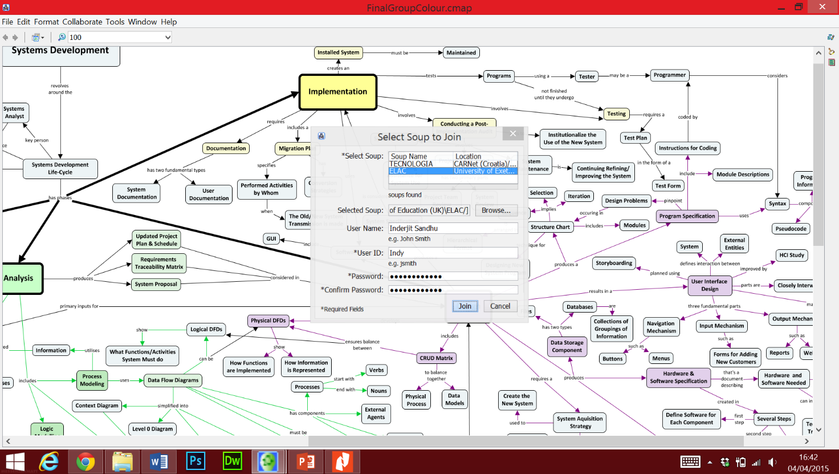

2.3 - Sharing our Concept Map online
We also attempted to share our Concept Map online, joining the University of Exeter’s ‘Soup’. This is an advanced feature of CmapTools that allows people to view other’s concept maps to help educate them.

3. Project Schedule & Risk Assessment

3.1 - Work Breakdown Structure
We constructed a work breakdown structure that includes a list of tasks and activities regarding our project.
Task ID | Task Name | Assigned to | Duration | Start Date | Finish Date | Dependency | Status
1 | Planning Phase
1.1 | Intro to Team and Methodology
1.1.1 | Complete Belbin Test | ALL | 2 days | 16/01/2015 | 17/01/2015 |  | OPEN
1.1.2 | Summarise members strengths | ALL | 3 days | 17/01/2015 | 19/01/2015 |  | OPEN
1.1.3 | Choose and Justify Methodology | ALL | 8 days | 20/01/2015 | 27/01/2015 |  | OPEN
1.1.4 | Describe Problem Solving Technique | Inderjit | 10 days | 25/01/2015 | 03/02/2015 |  | OPEN
1.2 | Concept Map
1.2.1 | Complete Initial Concept Map | Inderjit, Mehvish | 16 days | 21/01/2015 | 05/02/2015 |  | OPEN
1.3 | Project Schedule & Risk Assessment
1.3.1 | Complete Work Breakdown Structure | Mehvish | 2 days | 05/02/2015 | 06/02/2015 |  | OPEN
1.3.2 | Gantt Chart | Mehvish | 3 days | 09/02/2015 | 11/02/2015 | 1.3.1 | OPEN
1.3.3 | Pert Chart | Mehvish | 3 days | 09/02/2015 | 11/02/2015 | 1.3.1 | OPEN
1.3.4 | Risk assessment Table | Akorede | 5 days | 07/02/2015 | 11/02/2015 |  | OPEN
2 | Analysis/Design Phase
2.1 | Systems Proposal
2.1.1 | Define Name & Motivation of Game | ALL | 8 days | 06/02/2015 | 13/02/2015 |  | OPEN
2.1.2 | Define Game Objective | ALL | 5 days | 16/02/2015 | 20/02/2015 | 2.1.1 | OPEN
2.1.3 | Narrate How Game Teaches Methodology | ALL | 4 days | 23/02/2015 | 26/02/2015 | 2.1.2 | OPEN
2.1.4 | Create Game Manual | ALL | 7 days | 27/02/2015 | 05/03/2015 | 2.1.3 | OPEN
2.1.5 | Draw Design Of Game | ALL | 7 days | 10/03/2015 | 16/03/2015 | 2.1.4 | OPEN
2.1.6 | Table Of Use Cases | Inderjit | 3 days | 17/03/2015 | 19/03/2015 |  | OPEN
2.1.7 | Functional/Non-Functional requirements | ALL | 2 days | 20/03/2015 | 21/03/2015 | 2.1.6 | OPEN
2.1.8 | Process Models (DFDs) | Inderjit | 2 days | 20/03/2015 | 23/03/2015 | 2.1.6 | OPEN
2.1.9 | Logic Models (Structured English) | Akorede | 3 days | 24/03/2015 | 26/03/2015 | 2.1.8 | OPEN
2.1.10 | Normalization and 3NF ERD | Mehvish | 5 days | 27/03/2015 | 31/03/2015 | 2.1.9 | OPEN
2.1.11 | Complete Final Concept Map | Inderjit | 64 days | 05/03/2015 | 10/04/2015 | 1.2.1 | OPEN
2.2 | Evaluation
2.2.1 | Evaluate Planning and Software | ALL | 5 days | 01/04/2015 | 05/04/2015 |  | OPEN
2.2.2 | Evaluate use of Concept Map | Inderjit | 5 days | 02/04/2015 | 06/04/2015 |  | OPEN

3.2. – Project Gantt Chart
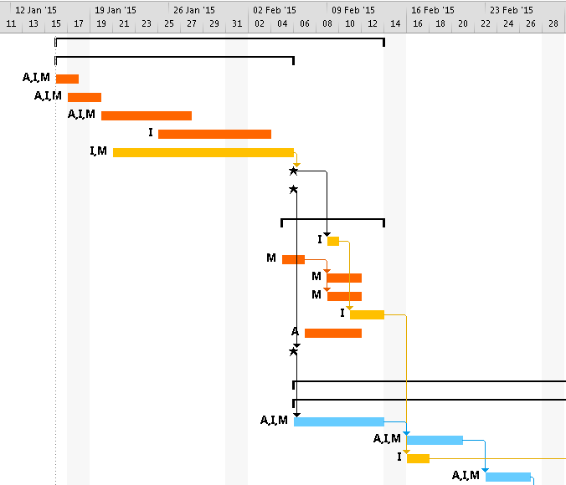
The following is the Gantt chart that we constructed for our project. The second image carries on from the first.
Key:
A = Akorede Ajiroba
I = Inderjit Sandhu
M = Mehvish Zaidi
Orange bar = Planning phase task
Blue bar = Analysis phase task
Green bar = Design phase task
Red bar = Evaluation
Yellow bar = Concept map task
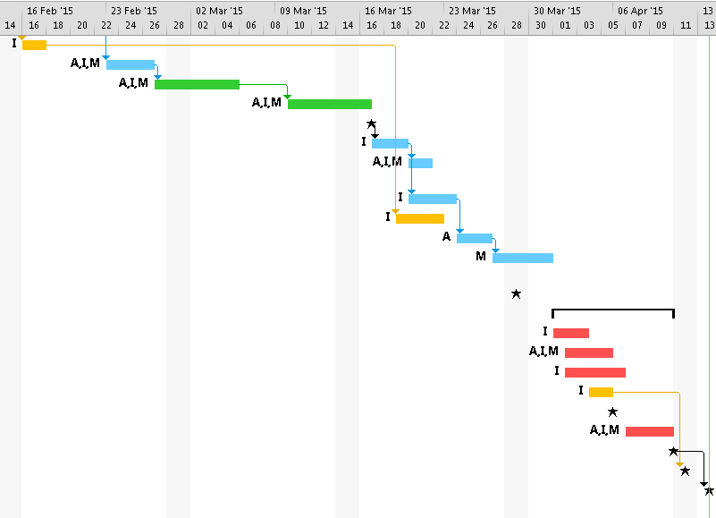
Star = Milestone

3.3. – Pert Chart
We created a pert chart for our project using Microsoft Excel. The pert chart continues on from where it left off from the previous image.
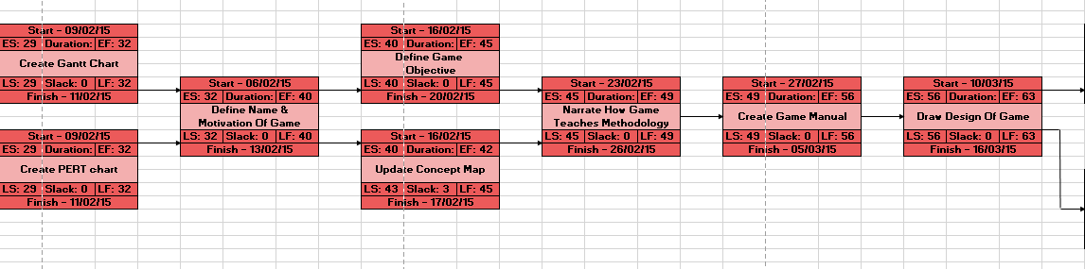
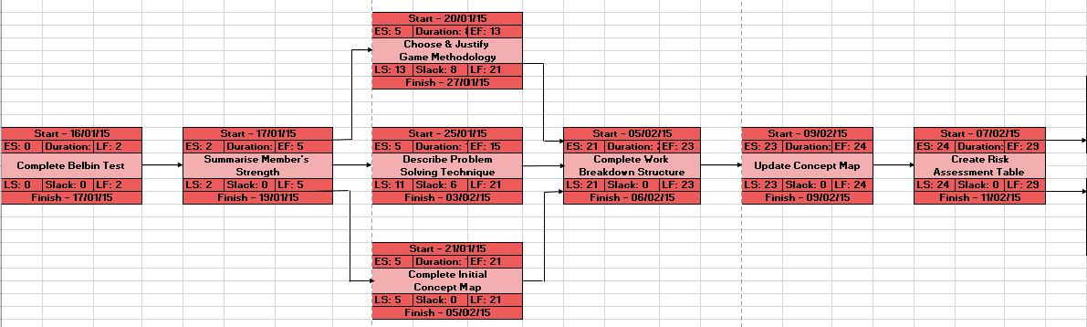

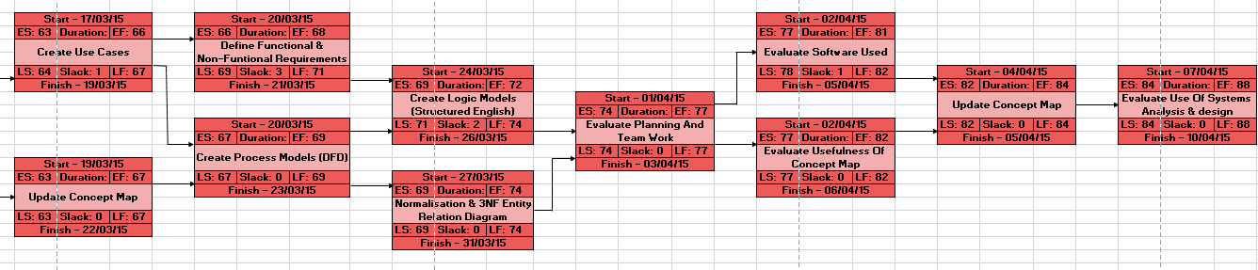

3.4. – Risk Assessment Table
We created a risk assessment table including possible risks during for project.
Description of Risk | Probability of Risk | Severity of Risk | Overall Risk | Contingency Plan
Lack of Commitment/ Enthusiasm | Medium | Medium | Medium | Ensure all group members are allocated tasks that they understand. Constantly remind each other why we came to university, and that this module is important. Take breaks and take part in other activities to boost group chemistry and enthusiasm.
Software Unfamiliarity | Medium | High | Medium | Ensure the group members attempt and complete the lab exercises to gain an understanding of software and become more confident using it for the project.
Group Disagreement | Medium | Medium | Medium | If the group has a disagreement then we will analyse each option, looking at the positives and negatives of each and then deciding as a group the best option to take.
Loss of Work | Low | High | Medium | Ensure that the work is backed up as soon as it’s been complete on an external disk or software such as dropbox.
Illness to Group Member | Low | Medium | Low | If the illness comes at a vital time, a group member will deputise for the ill member, temporarily completing their tasks. In other circumstances, the group will ensure that the ill member is informed of any important information that they may have missed. The group member will then catch up with the work that they are behind on.
Group Member Misses Important Meeting | Low | Low | Low | To reduce the chance of this happening, the date of the next meeting is confirmed at the end of every meeting. If a group member does miss a meeting, then the other members will explain the missed information during the next meeting if it is detailed, or through ‘WhatsApp’ if the missed information can be easily explained.
Falling Behind Deadlines | Low | High | Medium | If a group member falls behind, they will inform the others and receive support if necessary, before setting the work as a priority to complete as soon as possible.
Procrastination | Medium | Medium | Medium | Ensure that we set objectives for each group meeting, giving us something to aim for. Make sure that we have occasional breaks to avoid exhaustion that may lead to procrastination.
Task Uncertainty | Medium | High | Medium | Ensure that we communicate with our lab tutor in labs or through email if any unclear tasks occur. Always ask each other before asking the lab tutor, as others may know the answer.

4. System Proposal
To view the Game manual and information stored by the game, visit the Appendices.

4.1. - Name of the game
Decided name: ‘Stack Your Wealth!’
This title explains the main aim of our game, in which players must stack up their salary and attempt to finish with the highest figure.

4.1.2. - Motivation or inspiration of the game
As a group, we have decided that we will plan and design a game from scratch, ensuring that it is imaginative and hopefully unique. We’ve decided that we want the game business related, and have therefore based it in an office, forming a sort of psychological relationship between playing the game and the world of business. The finishing positions also correlate with business job roles.
Though our game has no direct inspiration, certain aspects can be compared to existing games, such as:
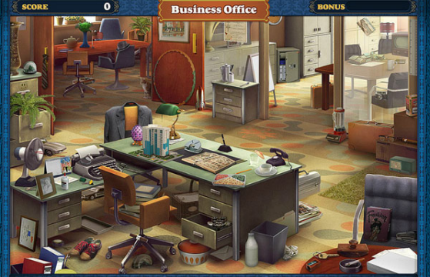
- ‘Who wants to be a Millionaire?’ – in terms of answering questions correctly to earn money
- ‘Hidden Chronicles Business Office’ – in terms of what our game’s interface would look like, viewing an office with different sections from a first person view (image to the right)
- ‘Crush the Castle’ – in terms of completing each section on a floor before advancing the floor (image below)
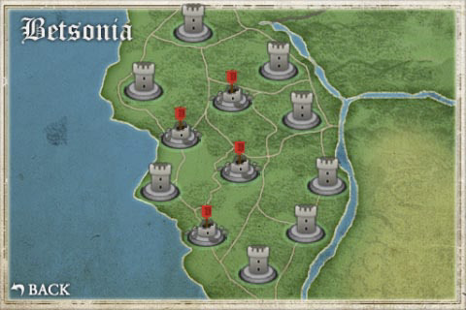
Whilst including concepts similar to these games, we also plan to add many original aspects of the game to make it complex, fun to play and educational.

Screen designs
We have design some screen design to show roughly how our game interface would display.
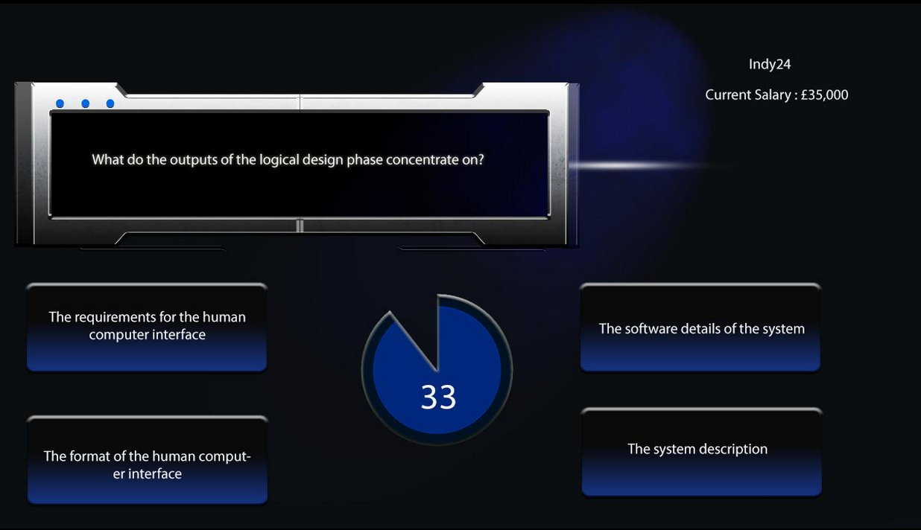
The image on the right shows an answering a question screen for a player. It was created on Photoshop.

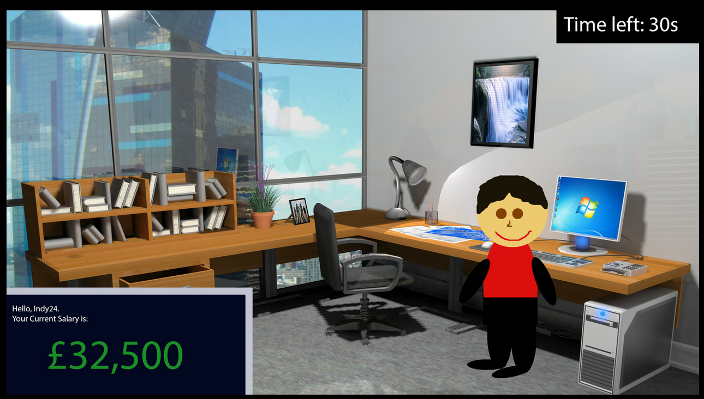
The image on the left shows a screen that is displayed before a player answers a question. It shows the player’s main stats, details and avatar.

4.3. - Game objective and brief narrative indicating how the game play mimics and/or teaches the systems development methodology
(Our game manual, explaining in more detail how the game is played, can be found here)
‘Stack Your Wealth!’ Has been planned and designed as a fun game that teaches Structured Systems Analysis and Design Methodology (SSADM) through the answering of questions and completion of activities. The concept of the game allows it to be competitive and finishing positions typically represent each player’s general knowledge of SSADM, making it a useful tool for identifying employees’ strengths and weakness regarding the methodology.

Objective (from our game manual)
Taking it in turns, players make their way through four office floors (each representing the four phases of the SDLC), answering questions (choosing their difficulty and hence rewards amounts) to build their salary as high as possible before the chosen game length expires. Player’s salaries are ranked (high to low), determining their final position.

How the game play mimics the methodology
SSADM uses the Waterfall method, in which each phase must be completed before the next phase can begin. Our game mimics this same concept, as players must complete the phase/floor they are currently on before they can begin the next. In the Waterfall method, progress is seen as flowing steadily downwards. Again, this is similar to our game as players steadily complete the phases, section by section, to progress floors.
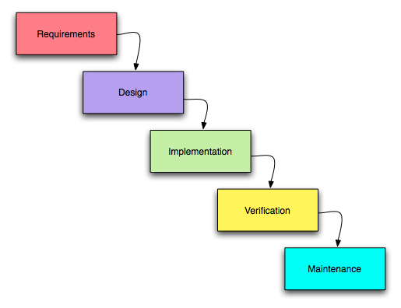
The images below show that the Waterfall method and our game work in similar ways.
A typical example of how the Waterfall method is displayed
How ‘Stack Your Wealth!’ mimics the Waterfall method
Planning/Floor 4
Analysis/Floor 3
Design/Floor 2
Implementation/Floor 1

How the game teaches the methodology
‘Stack Your Wealth!’ teaches the methodology by asking players to answer questions or complete activities. These questions/activities will be displayed on screen as well as being asked by a speaker (on a DVD or available to download online) that synchronises with the game. The speaker then comments on whether the answer/solution given was correct or not, and then speaks the correct answer, allowing all players to learn.
We have decided that this speaker feature is a very useful tool in terms of education as research has found that receiving auditory signals from speech is an integral part of cognitive resources involved in perception including focused attention, learning, and working memory (Heald, 2014). Therefore, with this speaker addition, players will receive auditory information through speech, thus involving the cognitive process of speech recognition in the brain. As well as this, speech aids players with disabilities or visual difficulties.

Below are some examples of questions for different phases/floors with different difficulties.
- Planning Question – Easy – Draw lines to match the feasibility type to its area of consideration
Will the new system be compatible with existing practices?
Technical
Is the impact of the new system socially acceptable?
Financial
Can the business afford to carry out the project?
Organisation
Is the project technically possible?
Ethical

- Analysis question – Medium – How many Business System Options (BSO) are chosen during the BSO section of the analysis phase of SSADM?
  - 4
  - 2
  - 1 (answer)
  - All
- Design question – Hard – What do the outputs of the logical design phase concentrate on?
  - The requirements for the human computer interface (answer)
  - The software details of the system
  - The format of the human computer interface
  - The system description
- Implementation Question – Easy – What is a product of the physical design phase?
  - A data catalogue
  - A logical data model
  - A complete physical design
  - The final physical system

4.4. – Functional Requirements
The following table includes all of the functional requirements for our game.
Functional Requirements
FR1 - Initialise the game
FR1.1 | The system will allow the player to input length of the game
FR1.2 | The system will allow the player to enter in a username
FR1.3 | The system will allow the player to choose avatar
FR1.4 | The system will generate the amount of sections on each floor
FR1.5 | The system will record player username and avatar into database
FR1.6 | The system will give the player a starting salary of £20,000
FR1.7 | The system will start the game timer when user details have been
FR2 - Attempt a question
FR2.1 | The system will allow the user to choose the difficulty of the question
FR2.2 | The system will generate a question for the player
FR2.3 | The system will let the user choose an answer to the given question
FR2.4 | The system will record the answer and if it is correct or incorrect
FR2.5 | The system will record the new salary in regards to how much they have lots/earned from the answer
FR3 - Advance to next floor
FR3.1 | The system will then allow the player to move their avatar
FR3.2 | The system will ensure that the user gets the correct answer before advancing
FR3.3 | The system will increase the players salary by £1,000
FR3.4 | The system will update the players position
FR4 - Finish the game
FR4.1 | The system will allow the player to see what their final salary
FR4.2 | The system will allow the player to see the total incorrect and correct answer count

4.5. – Non-Functional Requirements
The following table includes all of the non-functional requirements for our game.
Non-Functional Requirements
NFR1 - Accessibility
NFR1.1 | The system must make it easy for the user to move their avatar around the game
NFR1.2 | The system must make it clear how a question should be answered
NFR2 - Performance
NFR2.1 | The system should support the use of up to 6 players
NFR2.2 | The system should update player salary after each turn
NFR2.3 | The system should update game details after each turn
NFR3 - Efficiency
NFR3.1 | The system should go from one question to another smoothly
NFR3.2 | The system should allow the player to answer a questions successfully with just one click
NFR4 - Quality
NFR4.1 | The system should make sure the players are able to see questions and answers clearly
NFR4.2 | The system should make sure that all sections are clear
NFR5 - Timing
NFR5.1 | The system should make sure that game is only as long the player wants it to
NFR5.2 | The system should make sure that the game ends once a player has reached the end before the timer runs out OR when the time runs out

4.6. – Use Case Summary Table
The following table summarises our game’s use cases. The actual use cases can be found in the Appendices.

Process (UC) Number | Name | Purpose (s) | Input | Source of Input | Output | Output Recipient (s)
1 | Initialise the Game | - Sets the game up so it is ready for players to play | - Game length  - Player details | - Player  - Player | - Sections per floor  - Initialised player details  - Player salary  - Game details  - Game length | - ‘Sections’ datastore  - ‘Player details’ datastore  - ‘Individual statistics’ datastore  - ‘Game’ datastore  - ‘Game’ datastore
2 | Attempt a Question | - Allows players to progress through the game  - Educate players about the methodology  - Update the game details and interface | - Old player section number  - Player difficulty choice  - Question choice  - Player answer | - ‘Sections’ datastore  - Player  - ‘Turn’ datastore  - Player | - Player question  - Correct answers count  - Incorrect answers count  - Earned Player salary  - Player section  - £200 salary decrease  - Player turn salary  - Player turn result  - Question answer  - Updated question choice  - Updated player position | - Player  - ‘Individual statistics’ datastore  - ‘Individual statistics datastore  - ‘Individual statistics’ datastore  - ‘Individual statistics’ datastore  - ‘Individual statistics’ datastore  - Player  - Player  - Player  - ‘Turn’ datastore  - ‘Individual statistics’ datastore
3 | Advance to Next Floor/ Phase | - Allows players to advance to the next floor to answer questions about the next phase in the SDLC | - Correct final section answer  - Player floor number | - Player  - ‘Individual statistics’ datastore | - Updated player floor number  - Question choice  - Sections per floor  - £1,000 salary increase  - Updated player position | - ‘Individual statistics’ datastore  - ‘Turn’ datastore  - ‘Sections’ datastore  - ‘Individual statistics’ datastore  - ‘Individual statistics’ datastore
4 | Finish the Game | - Summarises the game and player details so that players can review their performance and receive their final position/job role | - Individual statistics  - Player details  - Player position  - Game details | - ‘Individual statistics’ datastore  - ‘Player details’ datastore  - ‘Position’ datastore  - ‘Game’ datastore | - Game over message  - Summary screen | - Player  - Player

4.7. – ‘Stack Your Wealth!’ Context level DFD
The following is our context level DFD. All DFDs were created using WinA&D using the skills learnt during lab sessions.
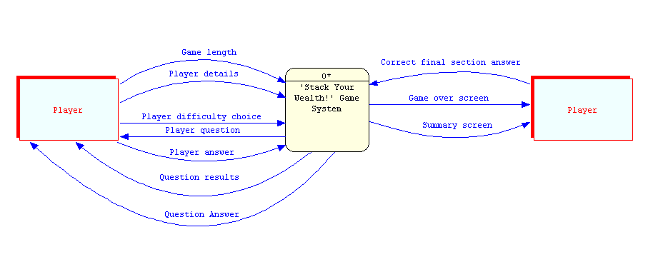

4.7.2. – Level 0 DFD
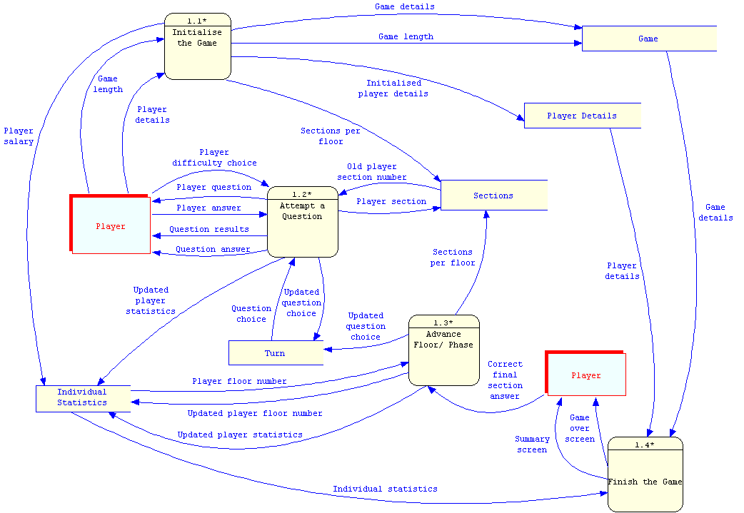
The following is our level 0 DFD that shows the high level events (Initialise the game, Attempt a Question, Advance floor & Finish the game) in our game.

4.7.3. – Level 1 DFD
The following level 1 DFD is based on process 2 (Attempt a Question).
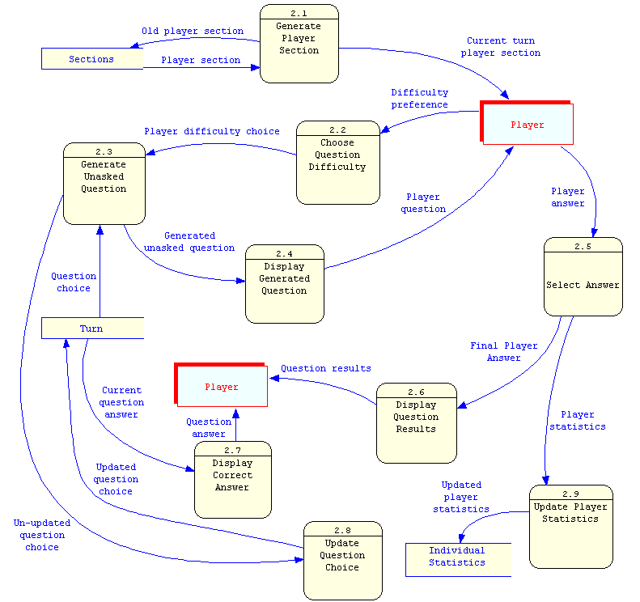

4.8. – Logic Model (Structured English)
The following is a logic model in the form of Structured English showing primitive processing for process 2 - attempting a question.
DO WHILE [Current player’s turn]
Identify the section the player is on
Prompt player for question difficulty
IF [Player chooses easy difficulty]
THEN Generate easy unasked question
ELSE IF [Player chooses medium difficulty]
THEN Generate medium unasked question
ELSE
Generate hard unasked question
END IF
Display unasked question to player
Prompt player for answer
IF [Player answer is correct]
THEN
Increment player’s correct answers count
Add earned money to player’s salary
Increment player’s selection number
ELSE
Increment player’s incorrect answers count
Remove £200 from player’s salary
END IF
Display player’s earnings/loss
Display whether player’s answer was correct or incorrect
Display correct question answer
Update question choice by removing the question just asked
Update player’s position
END DO

4.9. – Logic Data Model – UND, 1NF, 2NF & 3NF Data in table
The following tables show our game’s data going through the stages of normalisation. * Game player and player turn tables have been added due to many- to-many relationships.
UNF |  |  | 1NF |  |  | 2NF |  |  | 3NF |  |  | Table Names
PK | Game ID |  | PK | Game ID |  | PK | Game ID |  | PK | Game ID |  | Game
 | Number of players |  |  | Number of players |  |  | Number of players |  |  | Number of players |  | Game
 | Game winner |  |  | Game winner |  |  | Game winner |  |  | Game winner |  | Game
 | Game length |  |  | Game length |  |  | Game length |  |  | Date played |  | Game
 | Sections per floor |  |  | Sections per floor |  |  | Sections per floor |  | FK | Game length |  | Game
 | Date played |  |  | Date played |  |  | Date played
 | Player ID |  |  |  |  |  |  |  | PK | Game length |  | Sections
 | Username |  | PK | Game ID |  | PK | Player ID |  |  | Sections per floor |  | Sections
 | Avatar number |  | PK | Player ID |  |  | Username
 | Player salary |  |  | Username |  |  | Avatar number |  | PK | Player ID |  | Player Details
 | Player position |  |  | Avatar number |  |  | Player salary |  |  | Username |  | Player Details
 | Correct answers count |  |  | Player salary |  |  | Correct answers count |  |  | Avatar number |  | Player Details
 | Incorrect answers count |  |  | Player position |  |  | Incorrect answers count |  | FK | Player salary |  | Player Details
 | Job role |  |  | Correct answers count |  |  | Player position
 | Turn ID |  |  | Incorrect answers count |  |  |  |  | PK | Player salary |  | Individual Statistics
 | Question choice |  |  | Job role |  | PK | Game ID |  |  | Correct answers count |  | Individual Statistics
 | Question answer |  |  |  |  | PK | Player ID |  |  | Incorrect answers count |  | Individual Statistics
 | Player section |  | PK | Player ID |  |  | Job role |  |  | Player position
 | Player question |  | PK | Turn ID |  |  |  |  |  |  |  | Game Player
 | Player answer |  |  | Question choice |  |  | Turn ID |  | PK | Game ID |  | Game Player
 | Player difficulty choice |  |  | Question answer |  |  | Question choice |  | PK | Player ID |  | Game Player
 | Old player section number |  |  | Player section |  |  | Question answer |  |  | Job role |  | Game Player
 | Player turn salary |  |  | Player question |  |  | Player section
 | Player turn result |  |  | Player answer |  |  | Player question |  | PK | Turn ID |  | Turn
 | Player floor number |  |  | Player difficulty choice |  |  | Player answer |  |  | Question choice |  | Turn
 |  |  |  | Old player section number |  |  | Player difficulty choice |  |  | Question answer |  | Turn
 |  |  |  | Player turn salary |  |  | Player turn salary |  |  | Player section |  | Turn
 |  |  |  | Player turn result |  |  | Player turn result |  |  | Player question |  | Turn
 |  |  |  | Player floor number |  |  | Player floor number |  |  | Player answer |  | Turn
 |  |  |  |  |  |  |  |  |  | Player difficulty choice |  | Turn
 |  |  |  |  |  | PK | Player ID |  |  | Player turn salary |  | Turn
 |  |  |  |  |  | PK | Turn ID |  |  | Player turn result |  | Turn
 |  |  |  |  |  |  | Player section |  |  | Player floor number |  | Turn
 |  |  |  |  |  |  | Old player section number
 |  |  |  |  |  |  |  |  | PK | Player ID |  | Player turn
 |  |  |  |  |  |  |  |  | PK | Turn ID |  | Player turn
 |  |  |  |  |  |  |  |  |  | Player section |  | Player turn
 |  |  |  |  |  |  |  |  |  | Old player section number |  | Player turn

4.9.2 – ERD for 3NF table
The following is an ERD for the 3NF data in our game.
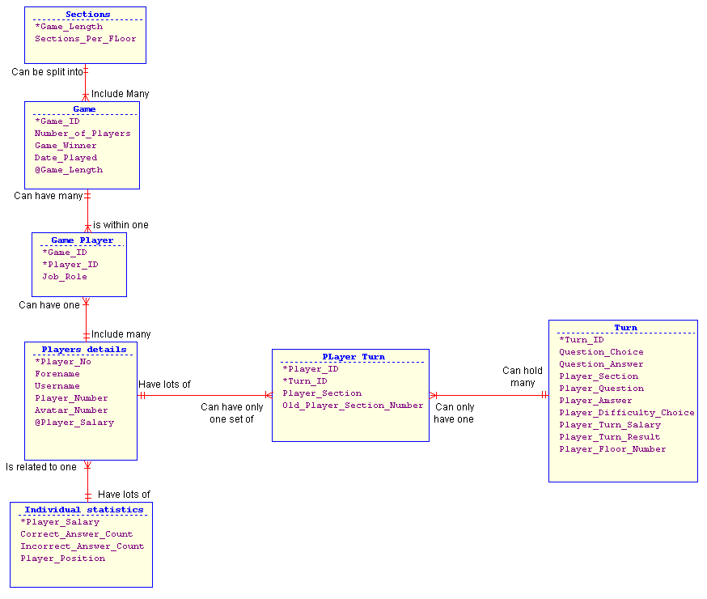

5. Evaluation
This section of the report includes a reflection and critical evaluation of our experience, as a group, of the systems development process.

How successful was the planning and risk management of the project?
We ensured that the planning and risk assessment of our project was completed to a good standard, as we knew that these parts build the foundation of our report - if we plan strongly, our project will be strong and vice versa.
Our planning and risk management was very successful as we spent a lengthy amount of time doing these, which later came to use during the project. For example, one of the potential risks that we identified as a group was that work could potentially get lost. We implemented a contingency plan of creating a group dropbox folder from the very first week, ensuring that each group member has access the work in real-time and that the work is backed up should it be lost.

How could the team working and planning have been improved?
Due to a rather right schedule towards the end of the report, leading to some stress, we agree that we should have completed the earlier tasks in the report in a smaller duration of time than we did. This would have allowed us to spend more time on the more challenged parts of the report that came towards the end, such as the ERDs.
We also agree that the team work could have been improved by working on more parts of the project as a group, rather than splitting so many tasks up to individuals. Due to our planned task distribution, some tasks required only one or two people, when we could have used the support of the whole group, adding a potentially useful third opinion. By completing more tasks as a whole group, the entire group would have more of a balanced knowledge of the project, and less difficulties would have occurred. Due to this weakness, we now know that deploying work schedule is a part of a report that is more important than we realised.

How did the use of MS Project and WinA&D help with the project? What other features might be useful in such tools?
MS Project and WinA&D helped massively with the project’s progression as they were fundamental in constructing the Gantt chart, DFDs and ERDs, which were perhaps the most important parts of the project.
MS Project allowed us to create a Gantt chart that graphically displaying team member tasks and deadlines. This helped with the project as a simple glance of the Gantt chart was all that was necessary to identify what each member was required to do by when.
WinA&D allowed us to create DFDs and a 3NF ERD that were easily readable and professional looking. The simplicity of the software helped us understand the concepts of how to create DFDs and ERDs.
The feature of being able to change the colour of certain data was useful as it helped distinguish different tasks. For example, in our Gantt chart, each phase has a different colour bar, making the chart easier to read.
A feature that would be very useful in WinA&D could be an option that helped smooth our data flows in DFDS. There is currently a feature that attempts to do this, but it doesn’t do it very effectively. This would be a useful feature as a DFD should look clear and tidy to allow the reader to understand it easily.

How useful was concept mapping for helping you to understand what you had learnt?
Concept mapping was an extremely effective and important method of helping all group members understand what we had learnt during the project. Concept mapping ensured that we recalled what we had learnt, helping us to learn and remember the different concepts in the SDLC.
By creating a concept map, we were able to understand a lot more about the module and how systems are developed in the real world of business, including how different aspects of the SDLC relate to each other.
Our concept maps allowed us to review the content that we had learnt during the project with a simple glance, as the information in a concept map is effectively summarised.
In our concept map, we included concepts beyond those taught. This was difficult but also rewarding, as our group now had an enhanced understanding of how systems development works and we can now put each phase into context of the SDLC.
Our group agrees that we will considering using concept maps in the future for different purposes, including revising, as they are simple to make but effective in learning.

How successful was the assessment in helping you to learn the principles of systems analysis and design?
In terms of understanding the fundamentals and learning the main principles of systems analysis and design, this project has been quite successful. We agree that the practical experience we have gained from taking part in this project has been valuable, as we now not only know what must be done during systems analysis, but we also know how it is executed.
Though we have learnt a lot about systems analysis and design, we feel that our knowledge has been hindered due to the general concept of carrying out the project on a PC game rather than a business system. Some confusion and difficulty that we faced due to carrying out the project on a game include:
- Use Cases – We struggled to understand the need of producing so many use cases when three would be a suitable number (start the game, make a move and end the game). This caused some confusion and uncertainty as it meant that we felt we had to reconsider the level of detail that we had to go into not only during the use cases, but during other aspects of the project.
- DFDs – We have been used to producing DFDs with many different external entities, but for most games there would be only one type – a player. Though another type, such as a ‘banker’ could have been used, this would mean that the game wouldn’t teach the methodology effectively and consistently to all players
Despite this, we accept that the game element has made the project more interesting and enjoyable, and agree that carrying out the project on a system may have been very complex considering it is our first attempt.
Overall, this project has been challenging at times and has required us to carry out a lot of independent research to understand how certain aspects work. We agree that this challenge has helped us become better system analysts and we are much more confident about systems analysis and design than before.

References
Belbin, R. M. 2003) Management Teams: Why They Succeed or Fail, Butterworth Heineman, ISBN: 0750659106
Vangie Beal. (2009). SSADM - Structured Systems Analysis and Design Method. Available: http://www.webopedia.com/TERM/S/SSADM.html. Last accessed 29th Jan 2015.
Peterson, K. (2009). The Waterfall Model in Large-Scale Development. Available: http://btu.se/fou/forskinfo.nsf/17e96a0dab8ab6a1c1257457004d59ab/fc0d54aeea5cb8d7c12575c8005fc9d6/$file/00320386.pdf. Last accessed 3rd Feb 2015.
Kinchin, I.M., Hay, D.B. and Adams, A (2000) How a qualitative approach to concept map analysis can be used to aid learning by illustrating patterns of conceptual development.
Olivier, D. (2009). The Five Whys Technique. Available: http://www.adb.org/publications/five-whys-technique. Last accessed 6th Feb 2015.
Dennis Et Al (2012). Systems Analysis and Design. 5th ed. Indiana: John Wiley & Sons. 1-594.
S, Heald. (2014). Speech perception as an active cognitive process. Available: http://www.ncbi.nlm.nih.gov/pmc/articles/PMC3956139/. Last accessed 5th March.

Bibliography
http://www.ogcio.gov.hk/en/infrastructure/methodology/ssadm/doc/s3a_pub.pdf
http://www.grin.com/en/e-book/106034/the-use-of-ssadm-structured-systems-analysis-and-design-methodology-as
http://www.webopedia.com/TERM/S/SSADM.html
http://www.selectbs.com/analysis-and-design/what-is-ssadm
http://www.ehow.co.uk/list_7485401_stages-ssadm.html
http://www.veracode.com/security/software-development-lifecycle
https://www.mrs.org.uk/careers/what_is_systems_development
http://goo.gl/E7Jyke
http://goo.gl/3ralYV
http://www.tutorialspoint.com/sdlc/sdlc_waterfall_model.htm
http://goo.gl/wPi1pV

Appendices

Appendix 1 - Game Manual & Data stored by the game

Appendix 2 - ‘Stack Your Wealth!’ Game Manual (Rules)
Players: 2-6 (at least 4 recommended for competitiveness and a reflection of knowledge of SSADM).
Brief Description/Aim: Taking it in turns, players make their way through four office floors (each representing the four phases of the SDLC), answering questions (choosing their difficulty and hence rewards amounts) to build their salary as high as possible before the chosen game length expires. Player’s salaries are ranked (high to low), determining their final position. Who earns the crowned role of Chairman? Who finishes just short as a CEO? Who finishes as an assistant?
Minimum System Requirements: A PC running Java 6 with at least 512 MB RAM.
2.1 - Playing the Game (Detailed description)

Step 1 – Setting up the game
- When the ‘Begin Game’ option is chosen, the game requests details (explained in 2.2) from players. These details enable to game to separate and identify players for future use
- The players then choose a game length (between 1 – 100 minutes) and the game is ready to launch. We recommend choosing a longer game if players want to learn more about SSADM and/or if there are a larger numbers of players.
- The length of the game decides how many sections (question/activities) there are on each floor. For example, a 100 minute game has five sections per floor.
- Each player starts the game on a £20,000 salary.

Step 2 – Playing the game (starting the game and completing questions/activities)
- When the ‘Play’ option is selected, a quick summary screen appears with the game and player details, the game timer begins and the game starts. Players take turns in the same order that they entered their details.
- All players start off on the fourth floor of a business office. When it’s a player’s turn, they view the office from the view of their selected avatar and can view several sections, which all consist of one question each (same concept for all floors/phases).
- Players must progress through the sections (starting from the first, then advancing to the next - 1, 2, 3 etc…), choosing a difficulty (easy, medium or hard) and answering the question from that section. A unique, single question is randomly generated by the game for each section
- Only when the question from a section is answered correctly is that section cleared, and players must clear all sections of the floor before being able moving on to the next (also meaning the next phase).
- The table below explains the money earned for each phase/floor depending on the difficulty chosen. Answering a question incorrectly results in a £200 salary decrease for the player.

 | Easy | Medium | Hard
Planning | £500 | £750 | £1,000
Analysis | £750 | £1,000 | £1,250
Design | £1,000 | £1,250 | £1,500
Implementation | £1,250 | £1,500 | £1,750

Step 3 - Advancing floors/phases
- In order to advance to the next floor/phase, each section from the previous floor must be cleared.
- When a player advances a floor, they receive a bonus £1,000
- Only the planning, analysis and design floors can be advanced, as the implementation floor is the final floor in the game.

Step 4.1 - A player completing the game
- On the final floor, the question is a ‘Golden Question’. This is a more complex question that must be answered correctly to complete the game and secure a golden prize - a salary increase of 10% and finishes the game.
- The boost is a huge incentive to finish the game. If answered incorrectly, the player must wait until their next turn so long as enough game time remains.

Step 4.2 - Finishing the game
- The game finishes immediately once the game timer reaches 0.
- The game details and player details are then summarised and shown to the players, so that players can see a summary of their game
- The table below shows how finishing positions (ranked by highest-lowest final salary) relate to respective job roles. The job roles therefore typically represent each player’s knowledge of SSADM. The higher their role, the more the player has impressed through the game and impressed with their knowledge of SSADM.
Finishing Position | Job Role
1 | Chairman
2 | Chief Executive Owner (CEO)
3 | Vice-President
4 | Manager
5 | Vice Manager
6 | Vice Manager’s Assistant

Extra Information/Rules
- Each question and answer is spoken by a speaker (on the included DVD or downloaded online), boosting learning effectiveness and supporting players that may have disabilities or visual difficulties
- Whether a question is answered correctly or incorrectly, the answer is displayed clearly so that all players learn about SSADM
- All players may answer the ‘Golden Question’. Players that struggle to progress in the game to make it this far may be severely disadvantaged in terms of winning the game, as the 10% bonus is a huge amount
- There is no turn timer, allowing the group to choose how long they will allow individuals to answer

2.2 - Information stored by the game
‘Stack Your Wealth!’ stores the following information during games:
- Game - Game ID, Game Length, Number of Players, Game Winner, Data Player, Game Length
- Sections - Sections per Floor, player section, Old player section number
- Player Details- Player ID, Username, Avatar number, Job role
- Individual (player) Statistics - Player Salary, Correct Answers Count, Incorrect Answers Count, Player answer, Player difficulty choice, Player floor number, Player position
- Turn - Question Choice, Question Answer, Player Question, Player Turn Salary, Player Turn Result

Appendix 2 – Use Case tables
Use case 1 – Initialise the Game
Use Case Name: Initialise the Game |  |  | ID: 1 |  | Priority: High
Description:
This Use Case describes how the game is set up and made ready for the players.

Trigger:
Management want to educate themselves about SSADM in an entertaining way by playing a game.

Type: External/Temporal

Pre-conditions:
1. Management have agreed to play the game and have available players (2-6).

Summary Inputs:  - Game length  - Player details | Source:  - Player  - Player | Summary Outputs:  - Sections per floor  - Initialised player details  - Player salary  - Game details  - Game length |  | Destination:  - ‘Sections’ datastore  - ‘Player details’ datastore  - ‘Individual statistics’ datastore  - ‘Game’ datastore  - ‘Game’ datastore
Major Steps Performed:  (1.0 initialising the game)  - The player enters a game length  - The system generates the amounts of sections per floor  - The player enters player details  - The system stores the player details into the ‘player’ datastore  - The system stores £20,000 starting salary into the ‘individual statistics’ datastore  - The game details are stored into the ‘game’ datastore  - The system launches the game and the game timer begins counting  down from the entered game length |  |  | Information Required:  Game length  Sections per floor  Player details  Initialised player details  Player salary  Game details  Game length
Post-conditions:
1. Player’s details are stored into ‘Player’ datastore.
2. Starting salary (£20,000) is stored into ‘Individual statistics’ datastore.
3. Game Interface is displayed for next player (Player 1 – who entered their details first).
4. Game timer begins counting down

Use case 2 – Attempt a question
Use Case Name: Attempt a Question |  |  | ID: 2 |  |  | Priority: High
Description:
This Use Case describes how a player makes a game move (attempting a question).

Trigger:
It is the next player’s turn in the sequence (taken in turns).

Type: External/Temporal

Pre-conditions:
1. The game has been initialised (for first turn).
2. The last player (if there was one) has finished attempting their question/activity.
3. The appropriate datastores have been updated.
4. The Game Interface is displayed for the current player.

Summary Inputs:  - Old player section number  - Player difficulty choice  - Question choice  - Player answer | Source:  - ‘Sections’ datastore  - Player  - ‘Turn’ datastore  - Player | Summary Outputs:  - Player question  - Correct answers count  - Incorrect answers count  - Earned Player salary  - Player section  - £200 salary decrease  - Player turn salary  - Player turn result  - Question answer  - Updated question choice  - Updated player position |  |  | Destination:  - Player  - ‘Individual statistics’ datastore  - ‘Individual statistics datastore  - ‘Individual statistics’ datastore  - ‘Individual statistics’ datastore  - ‘Individual statistics’ datastore  - Player  - Player  - Player  - ‘Turn’ datastore  - ‘Individual statistics’ datastore
Major Steps Performed:  (1.0 the player attempts a question/activity)  - The system generates which section the player is on  - The player chooses a question difficulty  - The system generates a question that hasn’t been asked  - The system displays the generated question to the player  - The player chooses an answer  If the answer is correct,  a. The system increments the player’s correct answers count  b. The system updates the player’s salary, with the earned money  c. The system increments the player section number  Otherwise (if the answer is incorrect)  a. The system increments the player’s incorrect answers count  b. The system removes £200 from the player’s salary  - The system displays how much the player has earned/lost  - The system displays whether the player was correct or incorrect  - The system displays the correct answer  - The system updates the question choice, removing the question  that was just asked  - The system updates the player’s position |  |  |  | Information Required:  Old player section number  Player difficulty choice  Question choice  Player question  Player answer  Correct answers count  Earned player salary  Player section  Incorrect answers count  £200 salary decrease  Player turn salary  Player turn result  Question answer  Updated question choice  Updated player position
Post-conditions:
1. The appropriate datastore are updated
2. Game Interface is displayed for the next player.

Use case 3 – Advance Floor/Phase
Use Case Name: Advance to Next Floor/Phase |  |  | ID: 3 |  | Priority: Medium
Description:
This Use Case describes how the system advances a player on to the next level floor (based on the next phase in the SDLC).

Trigger:
The player has cleared all of the sections on any of the first three floors

Type: External/Temporal

Pre-conditions:
1. The appropriate datastore have been updated
2. The player has cleared all sections on their current floor but one

Summary Inputs:  - Correct final section answer  - Player floor number | Source:  - Player  - ‘Individual statistics’ datastore | Summary Outputs:  - Updated player floor number  - Question choice  - Sections per floor  - £1,000 salary increase  - Updated player position |  | Destination:  - ‘Individual statistics’ datastore  - ‘Turn’ datastore  - ‘Sections’ datastore  - ‘Individual statistics’ datastore  - ‘Individual statistics’ datastore
Normal Major Steps Performed:  (1.0 the player advances floor)  - The player answers the final section question correctly  - The system obtains the player’s floor number  - The system updates the player’s floor number to the  next floor  - The system updates the question choice to only ask questions in the next phase in the SDLC  - The system generates the sections for the player  - The system increases the player’s salary by £1,000  - The system updates the player’s position |  |  | Information Required:  - Correct final section answer  - Player floor number  - Updated player floor number  - Question choice  - Sections per floor  - £1,000 salary increase  - Updated player position
Post-conditions:
1. The appropriate datastores are updated
2. The player had advanced on to the next floor/phase of the game
3. The player receive a £1,000 salary bonus

Use case 4 – Finish the game
Use Case Name: Finish the Game |  |  | ID: 4 |  |  | Priority: High
Description:
This Use Case describes how a game is finished.

Trigger:
The game timer has expired.

Type: External/Temporal

Pre-conditions:
1. The game timer has expired.
2. The appropriate datastores have been updated.

Summary Inputs:  - Individual statistics  - Player details  - Player position  - Game details | Source:  - ‘Individual statistics’ datastore  - ‘Player details’ datastore  - ‘Position’ datastore  - ‘Game’ datastore | Summary Outputs:  - Game over message  - Summary screen |  |  | Destination:  - Player  - Player
Major Steps Performed:  (1.0 the game timer expires)  - The system displays a game-over screen,  - The system retrieves each player’s individual statistics  - The system retrieves each player’s details  - The system retrieves the game details  - The system displays a summary of the game using the retrieves  details |  |  |  | Information Required:  - Game over message  - Individual statistics  - Player details  - Game details  - Summary screen
Post-conditions:
1. The game had ended and no more players can attempt a question

Appendix 3 – Group Minutes

Date: | 14TH January 2015
Attendance: | All present
Agenda: | - We firstly introduced each other and decide to have our Belbin’s Test completed for the next meeting and to summarise our strengths so it can be added to our report  - As a group we decided to each think of a game idea for our report by next week and to discuss which is best for the Group Report.
Time start: | 2:00PM
Time finish: | 3:00PM
Constructed by | Akorede

Date: | 21th January 2015
Attendance: | All present
Agenda: | - It was resolved that the methodology of Structured Systems Analysis and Design Method was best for our game as we researched it uses both the waterfall to develop (existing and new) information systems, mainly focusing on the analysis and design of the system  - Inderjit was assigned to describe the problem solving technique  - Mevhish and Inderjit were assigned to Complete the initial Concept Map
Time start: | 2:00PM
Time finish: | 4:00PM
Constructed by | Akorede

Date: | 1st January 2015
Attendance: | All present
Agenda: | - Inderjit motioned that we make an interface for our game and the motion was carried  - Akorede was assigned to design the interface and to start working on it. It was decided that Photoshop be used to design the game interface.  - The initial concept map was about complete and we as group approved of the it to the state it was at  - We worked on our individual task for the rest of the meeting
Time start: | 3:00PM
Time finish: | 6:00PM
Constructed by | Akorede

Date: | 7th February 2015
Attendance: | All present
Agenda: | - Each member was given there allocated tasks and decided when the start and end date for this would be. Mehvish was assigned to put all this into a work breakdown structure  - After discussion, the group decided that Akorede should do the Risk Assessment Table  - We have now decided to meet up twice a week now rather than once as the work load is picking up  - Our Planning Phase is to be completed by our next meeting which is being held on Wednesday 11th February 2015
Time start: | 3:00PM
Time finish: | 5:00PM
Constructed by | Akorede

Date: | 11th February 2015
Attendance: | All present
Agenda: | - Our agenda for this meeting was to decide on the games name and plan the game from scratch  - We decided to go with a game that had certain aspects that can be compared to games such as ‘Who wants to be a Millionaire’ and ‘Crush the Castle’  - The motivation and full description of the game to be completed by the 16th Of February latest by the 18th
Time start: | 12:00PM
Time finish: | 3:00PM
Constructed by | Akorede

Date: | 23rd February 2015
Attendance: | All present
Agenda: | - We are starting as group on how our game teaches our methodology we’ve agreed to have it completed within 2-4 days  - The drawing of the games interface needs to be started as it hasn’t  - Inderjit is have the table of use case completed by next the 5th of February  - Discussion on how the interface should look like between the group
Time start: | 2:00PM
Time finish: | 6:00PM
Constructed by | Akorede

Date: | 20th March 2015
Attendance: | All present
Agenda: | - Inderjit has informed us of the completion of the use case and also of the DFD’s  - Mevhish is to complete on the Normalization by 27th March  - Akorede must start on Logic Models, the group decided that structured English would be the best one to use
Time start: | 5:00PM
Time finish: | 8:00PM
Constructed by | Akorede

Date: | 9thApril 2015
Attendance: | All present
Agenda: | - Completion of final Concept Map to be completed tomorrow by Inderjit  - Mehvish to have Normalization and 3NF ERD completed by 12th Of April  - Akorede to complete the interface of the game by 12th Of April
Time start: | 4:00PM
Time finish: | 6:30PM
Constructed by | Akorede

Date: | 12th April 2015
Attendance: | All present
Agenda: | - Inderjit and Mehvish to adjust tweaks to the Process Models by the end of today’s meeting  - General Overview of report to be done on 14th Of April before submissions
Time start: | 7:00PM
Time finish: | 9:00PM
Constructed by | Akorede

