Multimedia Website Report
Word count (excluding references): 1354.

1) Explain the layout of your homepage making reference to your use of HTML and CSS to organise your media and text.
The layout of my homepage is very simple, but also effective as it includes a navigation bar and images that both allow the viewer to navigate through the site. As well as this, a simple paragraph is used to describe the purpose of the website.
On my home page (and other pages) I used simple HTML heading 1, 2, 3 and 4 tags to give that section a unique heading. I then used the simple paragraph tag to insert the content for that section.
My homepage (and all other pages) also use <div> tags to divide each page, helping create good structure, organisation and presentation. The <div> tags helped me position certain parts of my content exactly where I wanted them to be positioned. For example, I was able to use the <div> tags to separate my left content from my right content from my footer. Sometimes I was required to use elements such as ‘float: left’ and ‘position: relative’ to ensure certain sections remained positioned the way I wanted them to be.
As the use of CSS has helping me organise my media and text, I’ve been able to set properties for particular elements of my website. This has also ensured that my pages are consistently presented and displayed.
Using CSS, I reset the margin and padding of everything in the body of my web pages to 0 pixels. This allowed me to manually assign the values I wanted to each container. If I hadn’t reset these values to 0, I would have probably got into some confusion with the padding and margin of containers that I created.
Behind the content of my website, I have a light blue background, which has a slightly visible sound wave effect. I used Photoshop to create this effect, and CSS to set and repeat the background on each of my pages. The other sections of my website all also have different colours. This colour scheme layout helps identify the different sections of my website.
I created a template file on Dreamweaver for my website, so that I could use it for my other pages, and that they would maintain a consistent layout. I found that using a template is very useful to do and it also prevents any important but irrelevant (to the current page) code being modified.
Towards the top of all of my pages is my banner, which also includes my logo. These both help distinguish to the viewer what the website is about (using the made up name of ‘AboutSound.Com’.

2) Identify any accessibility features included as part of your website and explain why these features are important.
I’ve considered many accessibility features when creating my website which allows my website to be used easily and effectively.
My navigation bar allows the viewer to access any parts of the website, from any page. The background colour changes on hover helps the viewer establish where their cursor is, and which page they are about to visit. I have also used opacity effect on some other images (such as the social media icons and home page images) in a similar way to have the same effect.
I’ve used alternative text for my images, sound clips and video to explain the text-based alternatives of what the media is about. This means that users with visual impairments are assisted.
Another accessibility feature I’ve considered is making sure that my content is understandable. I’ve done this by ensuring my content is clearly expressed (and user friendly for 13-15 year olds). I’ve also made the structure of each page understandable through the use of headings to categories different sections of information.
My website includes many eye-catching images (all created or modified by me - screenshots at the bottom of the report) to help keep the attention of 13-15 year olds, and supporting their learning in interesting ways. A video, gifs and audio files (such as my piano octave created on audacity) also help maintain the interest of the viewer while aiding their education in a fun way.
I’ve ensured that my website has good readability by choosing text and background colours that contrast with each other. The colours chosen mean that the text is easy to read and colourful, again helping maintain the attention of the viewer.
I’ve considered accessibility in terms of the browser that viewers use to view my website. I’ve used HTML 5, to make sure that my content is successfully displayed to viewers that use the main internet browsers - Firefox, Chrome, Safari and IE (9).
To ensure that my website is accessible in terms of coding that I may have got wrong, I’ve used validators for my HTML 5 and CSS. The validator supported me in making sure that my code conforms to conventional code, meaning that my website shouldn’t have any major troubles when being visited.
I’ve used a conventional layout for my website so that viewers are used to its structure and other features, and aren’t left confused. For example, I have two centre content sections, with the left one containing the more important information. Hopefully, viewers will be used to this style and therefore have no trouble reading the content on my website. I’ve also made my links clear (using the conventional blue font and underline), so that the viewer knows that when clicking on that text, they will visit a new page. My opacity effects on other images also share this purpose.

3) Discuss any considerations made for the appearance of your website across different screen sizes, resolutions and platforms.
I’ve considered that mainly because my website has many images (I chose to do this to attract the target audience), it would be better to use a fixed layout. Using a fixed layout means that the content of my website doesn’t depend on other factors, meaning that the size of the viewer’s browser won’t result in text or images being made smaller, and potentially unreadable. The main content of my website is only about 650px wide, meaning that it will be comfortably displayed on most devices, but even if this width is too large, the viewer can scroll the page due to my use of a fixed layout.
Another consideration I made for the appearance of my website is the quality of my images. As some devices may not display content with a quality as high as others, I’ve acknowledged that my images should be of high as quality as possible. I’ve kept my images high quality by using the Bi-Cubic interpolation scheme when resizing the images, meaning that the newly re-sized images retain their quality.
For viewers who may be using platforms or browsers that don’t support my media, my alternative text lets them know what they would be viewing, so they at least have an idea of what they would be viewing.

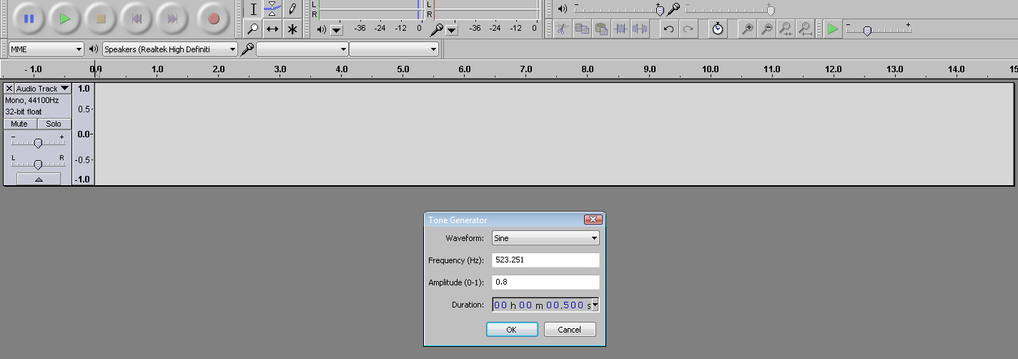
Screenshots of the creation of my website
The above screenshot shows me creating a piano octave, from C to C, with sine sounds on Audacity. I included each of these notes on my website, with the key they are equivalent to, on my website so that the viewer could almost play a keyboard on my website. I used my experience from the labs and researched online website to find the precise frequency of each note.
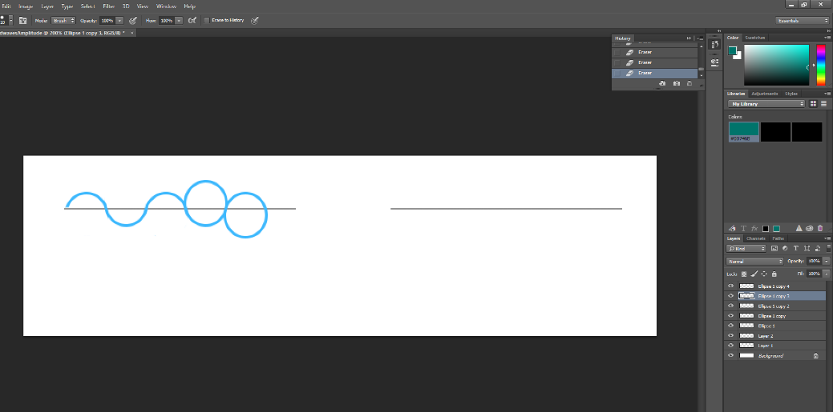
The screenshot to the left shows me creating sound waves for my website. I drew circles and erased parts of them to get an even curve effect.

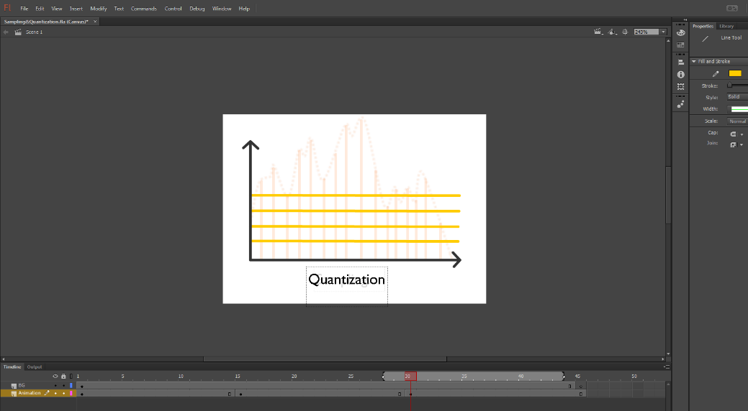
The screenshot to the left shows me using Flash to create an animated image that shows the processes of sampling and quantization.
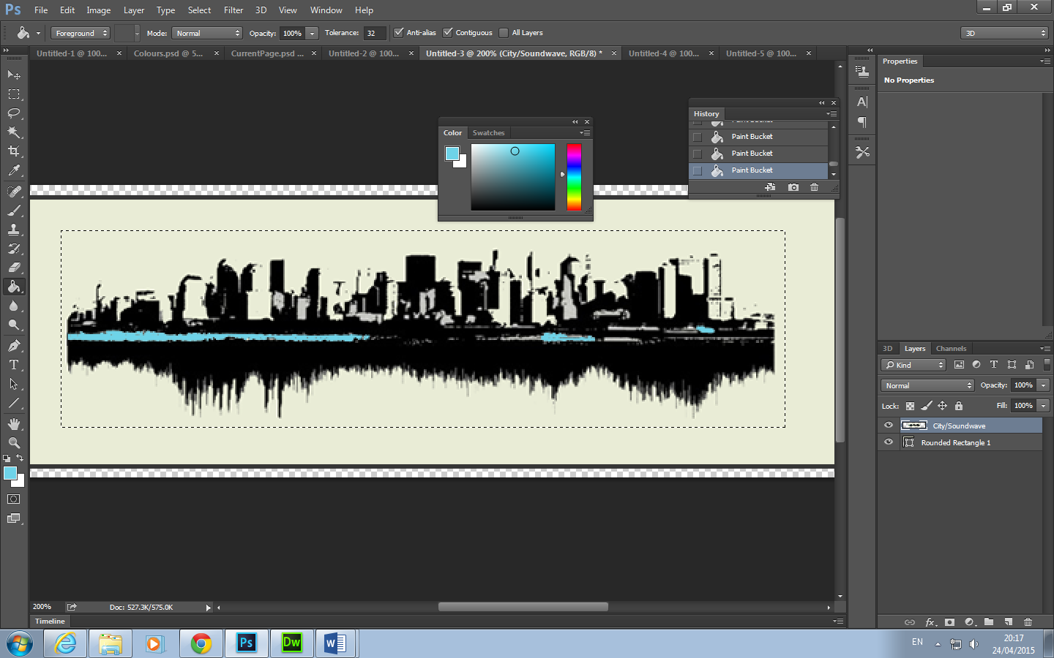

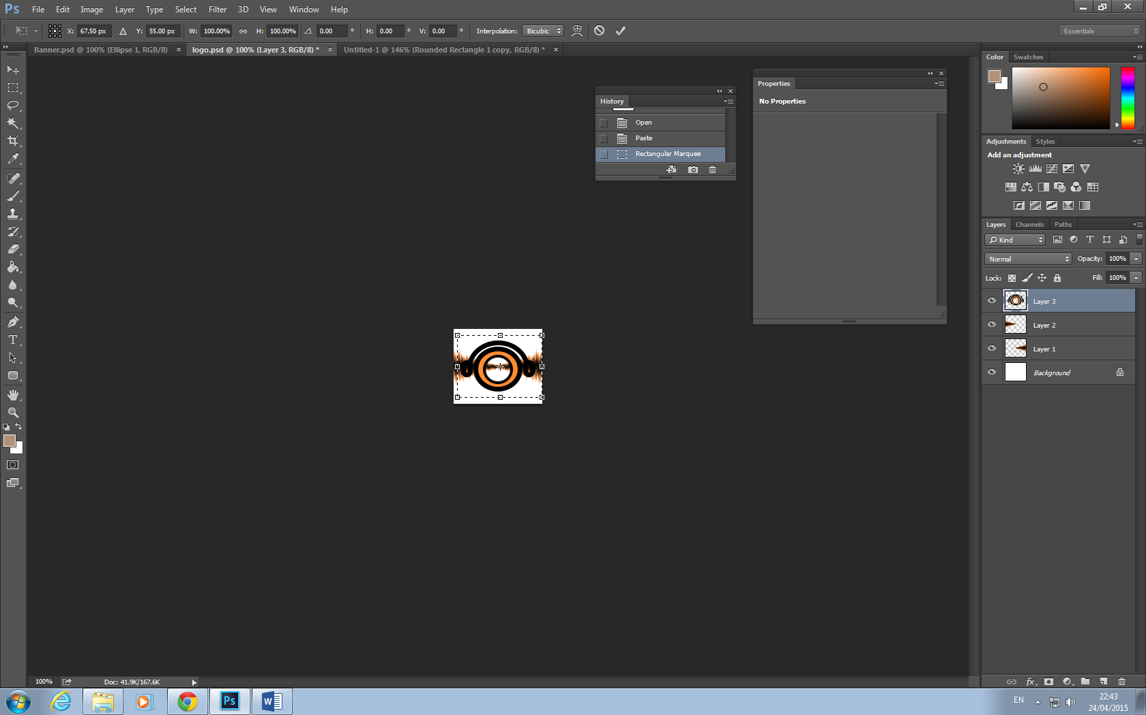

The images above show me creating my banner and logo. I used a couple of images that I obtained online, and added various effects, colours and other images to create these.
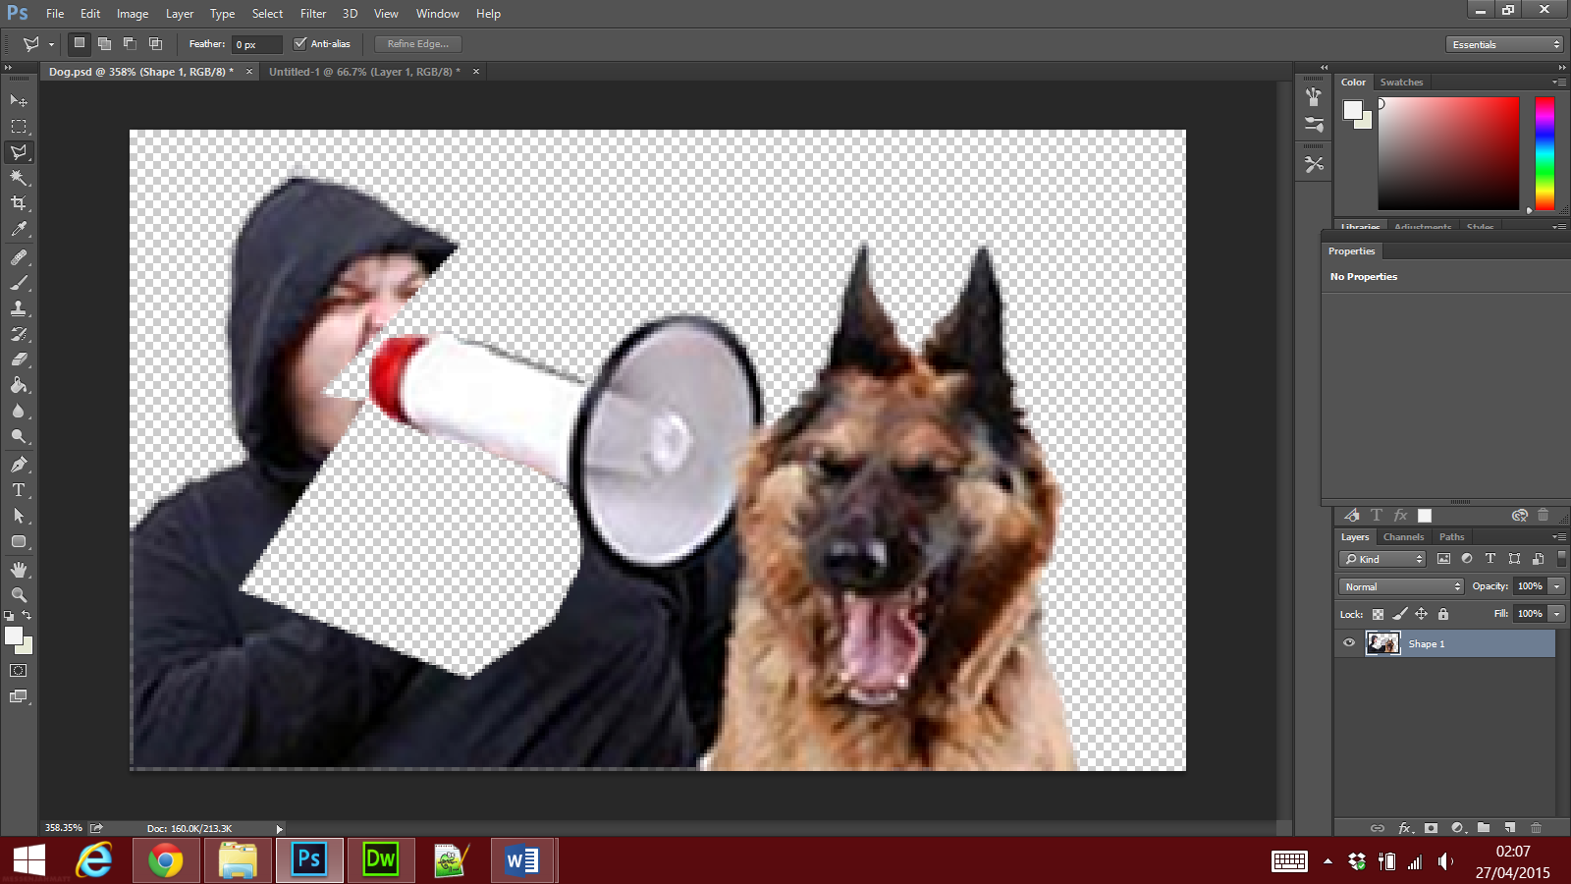
The screenshot above shows me using the polygonal lasso tool to crop out the man from the original image. I then added another image of another dog so that it appeared the other dog was shouting through the megaphone.

References
N and J Chapman (2009). Digital Multimedia. 3rd ed. West Sussex: Wiley. 1-320.
Hopper, T. (2009). How Tuning Forks Work. Available: http://science.howstuffworks.com/tuning-fork1.htm. Last accessed 20th March 2015.
Unknown. (2006). Amplitude and Frequency. Available: http://www.howmusicworks.org/103/Sound-and-Music/Amplitude-and-Frequency. Last accessed 20th March 2015.
Wolfe, J. (2005). What is a Sound Spectrum? Available: http://newt.phys.unsw.edu.au/jw/sound.spectrum.html. Last accessed 25th March 2015.
Unknown. (2015). Sound Facts. Available: http://www.sciencekids.co.nz/sciencefacts/sound.html. Last accessed 25th March 2015.
Unknown. (2006). How do we measure sound waves?. Available: http://www.dangerousdecibels.org/virtualexhibit/6measuringsound.html. Last accessed 25th March 2015.
Carol, G. (2007). Decibel (Loudness) Comparison Chart. Available: http://www.gcaudio.com/resources/howtos/loudness.html. Last accessed 28th March 2015.
Pan, D. (2003). Digital Audio Compression. Available: http://www4.ncsu.edu/~rhee/export/papers/DigitalAudioCompression.pdf. Last accessed 28th March 2015.
Unknown. (2010). MP3 File Compression - What is MP3 Compression. Available: http://www.hometechanswers.com/mp3/mp3-audio-compression.html. Last accessed 4th April 2015.
Plus, P. (2011). How MP3 compression works. Available: http://www.techradar.com/news/audio/how-mp3-compression-works-916093/2. Last accessed 4th April 2015.

Multimedia (image, sound and video) links used:
https://www.youtube.com/watch?hl=en-GB&v=VCERs0v1OoI&gl=GB)
https://s-media-cache-ak0.pinimg.com/originals/e0/ab/53/e0ab5380d984bdeb9101a2234454be16.jpg
http://blogs.fruitportschools.net/ksix/files/2012/02/sound-waves2.jpg
https://expertbeacon.com/sites/default/files/strategies_for_coping_with_hearing_loss_or_deafness.jpg
http://media.mercola.com/imageserver/public/2011/February/man-shouting-pet-dog.jpg
http://clog.dailycal.org/wp-content/uploads/2008/09/image00002-2.jpg
http://s3.gomedia.us/wp-content/uploads/2013/07/GoMediaArsenal_WireframeSoundwaves_07.jpg

