Programming assignment
Inderjit Sandhu (N0578334)

Nottingham Trent University
Computing (Tech2i)
Declaration of Ownership
I, Inderjit Sandhu (N0578334) hereby declare that I am the sole author of the associated report and software apart from the software declared below.
I am aware of the University’s rules on plagiarism and collusion and I understand that, if I am found to have broken these rules, it will be treated as Academic Misconduct and dealt with accordingly.
I understand that I must submit this coursework by the time and date published.
I understand that it is entirely my responsibility to ensure that I submit my full and complete coursework and that any missing elements submitted after the deadline will be disregarded.
I understand that the above rules apply even in the eventuality of computer or other information technology failures.
Software Used (Sources)
I have used the following from these sources:
Art generator website - http://www.network-science.de/ascii/
Python textbook – Python Programming for the Absolute Beginner - http://site.ebrary.com/lib/nottinghamtrent/reader.action?docID=10370091
Flowchart shapes - http://www.rff.com/flowchart_shapes.htm
I can also confirm that none of my work has been directly copied and pasted from any other source, with the exception of my ASCII Art welcome message, that has been created from a generator.
Inderjit Sandhu

Contents
Brief description of the aims of my program 2
Analysis of the requirements of my program (1-2 pages) 3
Clear layout and structure 3
Program that functions faultlessly 3
Beneficial to user 3
Variety of options 3
Customisable 4
Log of scores 4
Multiple users 4
Design – may be documented by flowcharts, class diagrams etc. (2-4 pages) 5
Pseudocode for my program – ‘Create Your Quiz’ 5
Flowchart 6
Testing – table of tests to prove that my program achieves its goals 9
Critique – what worked, what didn’t work, and what could have been improved 11
What worked 11
Each option in my program worked as intended 11
The layout and structure of my program made it easy to understand 11
My program ensured that the user learned repetitively 11
What didn’t work 11
What could have been improved 11
I could have removed the question after a user guessed it correctly 11
I could have used indexing so that the user could select a question number to edit or delete rather than having to type it all out 11
Save entered questions and answers when user closes the program 11
Sources 12

Brief description of the aims of my program
I am aiming to create a revision tool, which can be for any amount of people of any age, which is also beneficial to the user or users. Instead of creating a pointless game or program that tests the user on the same questions repetitively, I want to create a program that provides variety.
This will be done through making my program customisable. I aim to do this by allowing the user or users to set their own revision questions and answers and then test themselves on these to see how much they can remember. As well as this I would like my program to be able to print instructions and save the scores of a user so they can view and measure their progress.
While I want my program to be conceptually impressive, I also want it to have a clear layout and structure. In doing this, I will have created a program that is easy to use and visually attractive. Due to the concept of my program, I expect to create a program that can have multiple users, giving it more use than a program that is designed for just one person.
My Program will be called ‘Create Your Quiz’. This title is pretty self-explanatory, and explains the notion of my program.

Analysis of the requirements of my program
In order to create a program that a user would find worthwhile, I’ve had to analyse the requirements of the needs of a user. The main requirements I’ve found are:
- A clear layout and structure
- A program that functions faultlessly
- A program that is beneficial to the user
- A variety of options for the user
- Ability to customise the program
- Ability to see a saved log of scores
- Option for multiple users
Within this section, I will constantly refer to what makes good revision, as this is what my program aims to do.

Clear layout and structure
One of the most important requirements of a program is for it to have a clear layout and structure, as this ensures the program is easy to read and function. I will not create a program with text and options that are clogged up as this would make it look messy, would mean it’s hard to read and would cause confusion. Instead, I will make use of triple quotes, the newline and tab features and generally make sure that my program has a clear layout and a logical structure.

Program that functions faultlessly
If any errors occur whilst a program is being run, the program could shut down, meaning the user loses their progress and becomes frustrated. Due to this, I have realised that the user of a program wants the program to run in a way that if they type a valid input, the program will correspond accordingly, or if they type something that shouldn’t have been typed, the program will ask again, rather than just closing.
Apart from errors, the program in general should do what it says, for example, if a menu explains that you must type ‘L’ to list scores, listing scores should be the only thing that happens.
In order to ensure my program functions faultlessly, I must test it thoroughly. This will be done after I’ve created my program, in the ‘Testing’ section.

Beneficial to user
Depending on the type of user, a program that is beneficial may be a user requirement. This is what I have in mind when creating my program, as I want to make one that will make the user feel like they have learned something.
Though being beneficial could be one side of a program, making a program that is interesting and challenging ensures that the user is more entertained, and is likely to take part again. This is why I will create a program that takes the form of a quiz, so the user will feel like they are playing a challenging game whilst they are also revising.

Variety of options
In order to create a program that isn’t boring and repetitive, the user must be provided with a variety of different options. A program that repeatedly asks ‘What is 5 x 10?’ would quickly become boring and useless. Due to this, I must create a program that has a variety of options, in which the user can interact with the program, customise the program and have other options available.
The different options of my program will be created in functions, which will make the program have a logical and simple structure.

Customisable
One effective method of ensuring a program remains interesting is by making it customisable. As an interesting program is a user need, and customisation contributes to this, customisation may be seen as a requirement.
Customisation within a program makes the user feel more engaged, as it lets them influence how the program runs.
Whilst customisation may result in a more interesting program, it can also result in a more useful one. For example, a user will be able to customise my program so that they can choose their own revision questions and answers, creating an effective method of revision.

Log of scores
Considering that my program will be a revision program, the ability to view progress may be considered as a user need. Displaying a log of scores is extremely important to somebody using the program that wants to measure their progress – they can simply see whether their score is getting worse, better or not changing, and from then, they can figure out why and take action.

Multiple users
Although offering the ability of multiple users isn’t a necessity, if several people want to revise together using my program, it may well be one. Revising in groups can be an effective way of learning, which is why I will make this possible in my program. This will be done simply by asking the name of the user when somebody chooses to take part in the quiz, and saving this user’s score. The results can be displayed in a statistics section so that multiple users can compare their results if need be.

Design – may be documented by flowcharts, class diagrams etc. (2-4 pages)
In order to design my program, I’ve used two methods of design - pseudocode and a flowchart. I learned how to use pseudocode in the textbook, Python Programming for the Absolute Beginner, and I’ve learned that it is a very effective way of planning your program.

Pseudocode for my program – ‘Create Your Quiz’
Display welcome message
Display menu with options
Set dictionary with questions/answers in
While user doesn’t choose to exit
If user wants to view guide
Read guide from file
Otherwise start the quiz
Get user’s name
While user doesn’t choose no for selecting another quiz
Set score to 0
Get number of questions user wants to answer
Set loop start
Get random question from dictionary with its answer
Loop through number of questions user wants to answer
Get user’s answer
Break loop if user wants to quit
Print correct/incorrect and add one to score if guess is right
Convert score to percentage and display score and percentage
Append these details to a file
Ask user if they want another quiz
Otherwise view/edit questions
While user doesn’t choose to return to previous menu
Display new view/edit questions menu
If user wants to view questions and answers list
List questions and answers
Otherwise if user wants to add question
Get new question and answer
If question doesn’t exist, add to dictionary If question does exist, tell user
Otherwise if user wants to edit question
Get question user wants to edit
If question is in dictionary, get new answer
If question isn’t in dictionary, tell user
Otherwise if user wants to delete question
Get question user wants to delete
If question is in dictionary, delete it
Otherwise tell user
Otherwise if user wants to return to previous menu
Break loop & return to previous menu
Otherwise View stats
Read stats from file
Otherwise close the program

*As my pseudocode is long, I’ve used alternating colours to help distinguish the different sections

Flowchart
My second method of design was using flowcharts. For creating and reading flowcharts, it is important to understand what each shape means:
Shape | Meaning
Process | Process – shows something that has to be done or an action that has to be taken
Flow Direction | Lines with arrows determine the direction of flow through a flowchart
Decision | Decision – Asks a question. The answer of which determines which arrow to follow
Terminator | Terminator – A terminator states where a program starts or ends
Manual Input | Manual input – represents entering data into a computer
Stored Data | Stored data – data could be stored on a hard drive/magnetic disk etc…
Display | Display – used to show that the information is being displayed to the user

My flowchart can be found on the following page.

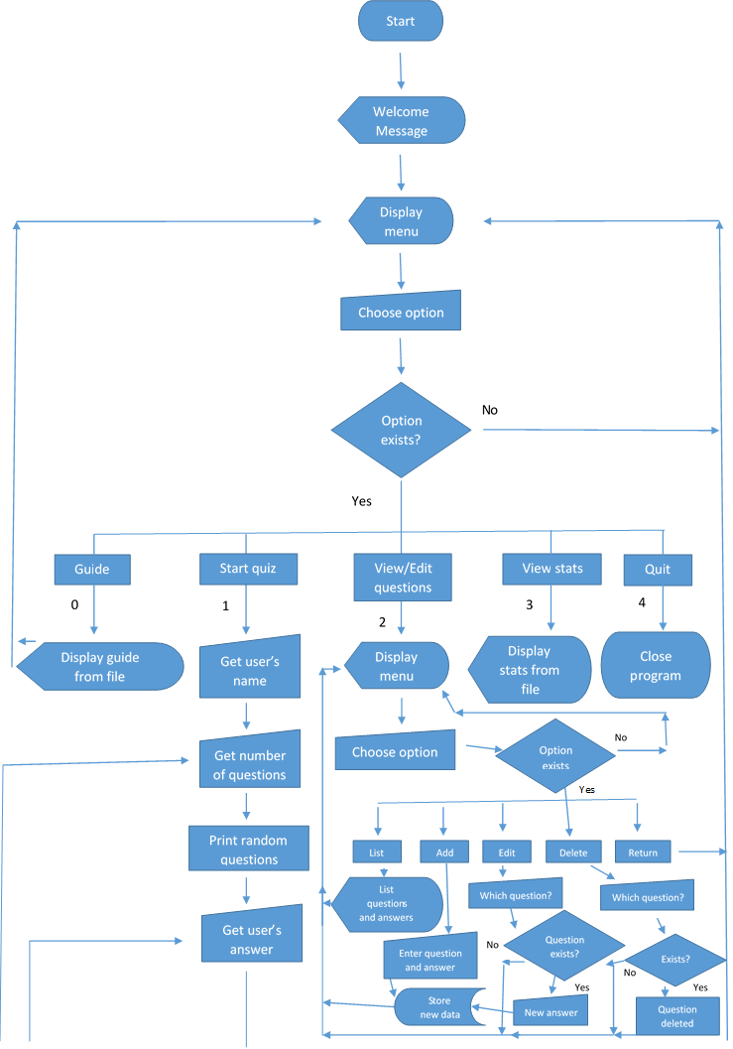

No
Yes
No
Yes
Any questions left?
Generate another random question
Workout & print score
Stores name & score to stats
Another quiz?

*Due to formatting difficulties, I had to re-create my flowchart, which resulted in it becoming disproportionate and unclear in some areas

Testing – table of tests to prove that my program achieves its goals
The following table proves that my program achieves what I wanted it to.
Test type | What I enter (input) | Result (output) | Explanation
Program starts with welcome message & menu comes up | Run program and press ‘enter’ key | 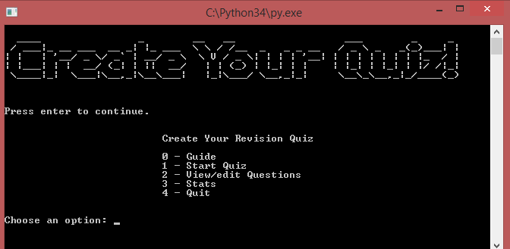 | My program has successfully started, printed the welcome message and displayed the menu
Displaying the guide | The ‘0’ key, as indicated by the program | 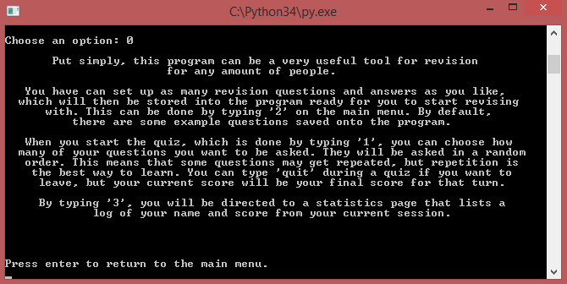 | After typing ‘0’, the guide successfully opens
Starting and finishing the quiz with printed results and updated stats | ‘1’, to start the quiz, my name and the number of questions | 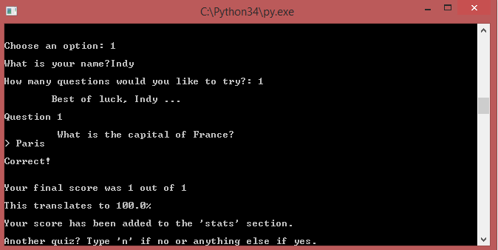 | After typing my name and the number of questions to answer, and answering my question, my results were displayed back to me.  (updated stats will be shown later in table)
Testing to see if ‘n’ works when choosing not to take part in another quiz | ‘n’ to choose not to take part in another quiz | 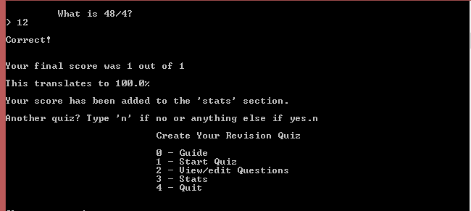 | After typing ‘n’, my program successfully returns me to the main menu, rather than closing the program or repeating a quiz
Editing questions – viewing the current question | ‘2’ to get onto the edit screen, and then ‘l’ to list the questions | 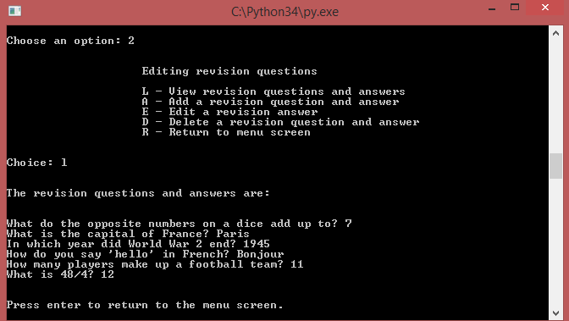 | The program does what it should do, as when I type ‘l’, the current questions are displayed
Editing questions – Adding a new question and answer | ‘a’ to add a new question and answer, then the new question and answer | 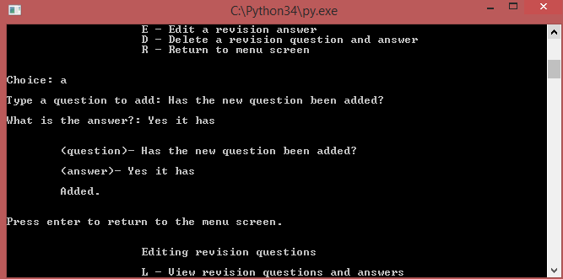 | The first screenshot shows me typing the new question and answer (continue on column below)
Editing questions – Adding a new question and answer |  | 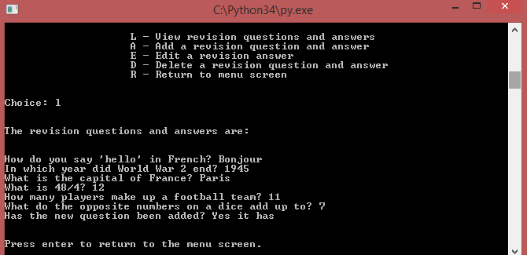 | This second screen shot shows the new list of questions, it is one entry bigger and has the new question and answer included
^ | ^
Editing questions – editing an existing answer | ‘e’ to select the edit option, then the question I want to edit along with its new answer, and finally ‘l’ to view the new updated questions | 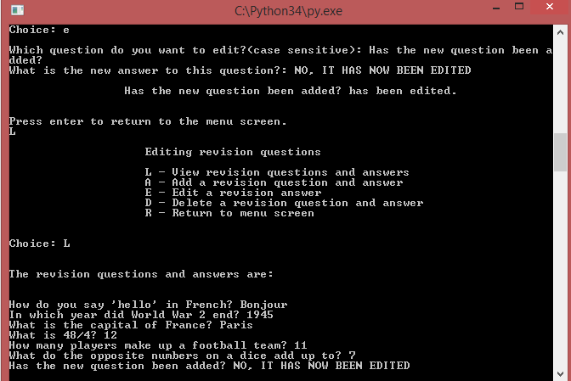 | After typing the question to edit and the new answer, the new list now includes this entry, after I changed the answer to ‘NO, IT HAS NOW BEEN EDITED’ (as can be seen at the bottom of the screenshot
Editing questions – Deleting a question | ‘d’ to select delete, then the question I wanted to delete, and finally l to view the new updated questions | 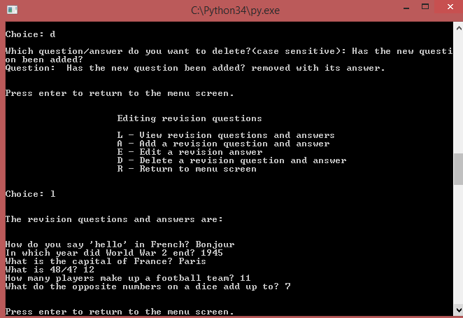 | This screenshot shows me typing a question to remove and then choosing to view the questions. Clearly, the question I typed has now been removed
Returning to main menu and viewing stats | ‘r’ to return to the main menu, and then ‘3’ to view the stats | 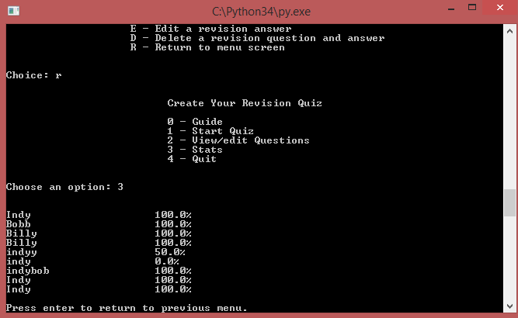 | After typing ‘r’, I was successfully returned to the main menu. After typing ‘3’, the stats are displayed, with the updated entry from earlier (row 3)

Critique – what worked, what didn’t work, and what could have been improved
I’ve performed a critique of my program, through testing it myself and getting feedback from other students. I’ve summed up what worked, what didn’t work and what could have been improved.

What worked

Each option in my program worked as intended
Every option worked just as I wanted it to, for example appending and opening files, editing dictionaries, running my quiz and everything else did what I wanted them to do. I’ve demonstrated that I can use functions, while loops, branching, file handling, dictionaries and other features effectively and with purpose.

The layout and structure of my program made it easy to understand
I planned to create a program with a good and logical structure and clear design, and I did this successfully. As this worked, my program is now easy to function and read.

My program ensured that the user learned repetitively
I had an educational aim of creating an effective revision tool. My program does this as it asks revision questions repeatedly as intended, resulting in a good revision work out. To demonstrate this, by default my program comes with random questions, all of which I will probably never forget the answer to now, due to the repetition of my program.

What didn’t work

I wanted to add audio and images
I decided to try to add audio files and images after I had finished my program to make it more interactive and look more attractive. However, I spent a lot of time trying to learn how to do this and due to other work that had to be completed, I decided to leave my program as it is. Though audio and images may have improved my program, my program remains fairly simple but effective.

What could have been improved

I could have removed the question after a user guessed it correctly
I got feedback from fellow students that I could remove a question after the user had answered it correctly, and this might have been an improvement for my program. However, I decided to take a different approach and repeat correctly answered questions. This was intentional as it ensured that the user consistently remembers the answers. I added an option to delete questions, so this can be done when the user is confident enough to so.

I could have used indexing so that the user could select a question number to edit or delete rather than having to type it all out
One of the most important parts of my program is when it comes to editing questions. I could have improved my program by using indexing to let the user choose a number of the question, set by indexing, to remove or delete, rather than having to type it all out.

Save entered questions and answers when user closes the program
When a user quits my program, the edited revision questions get reverted to the default ones. I could have improved my program by ensuring that these changes get saved, so that the user could practice the same questions as they did last time without having to make the changes again manually.

Sources
The following sources have assisted me in completing my programming assignment. None of my work has been directly copied from any source, other than my welcome message that has been created by an ASCII Art generator.
- Art generator website - http://www.network-science.de/ascii/
- Python textbook – Python Programming for the Absolute Beginner - http://site.ebrary.com/lib/nottinghamtrent/reader.action?docID=10370091
- Flowchart shapes - http://www.rff.com/flowchart_shapes.htm

