Web-Based Programming Report

(7 pages excluding appendix & references)
This report has been written to submit alongside my game, and outlines the specification/ requirements, design, implementation and testing of my code. I have also included an appendix, which I will refer to, and a list of sources that I have used during the game, along with their purpose.

Game name: (‘Don’t Forget the Celeb!’)
The name of my game explains the concept of it, the user simply must try to remember the celebrities that appear.

Specification/requirements of my game

Overview of how my game will be played
My game will has a very simple concept. The player will firstly choose a difficulty (easy, medium or hard), which will determine a number of factors of the game. The difficulty will determine the amount of celebrities to remember, the length of time the player has to remember the celebrities and the amount of time the player has to select the celebrities that appeared.
After choosing a difficulty, the player will start the game when they are ready, and the program will then loop through a shuffled selection of generated images of celebrities. Once the program has looped through all of these, it will then display all of the possible celebrities for a set amount of time, in which the player must click on the celebrities they remember that appeared during the loop. The program will finally display a feedback screen to the player, displaying their score, correct answers count and incorrect answers count.

Breakdown of key features / requirements

A different type of memory game
Though I’ve created a memory game, I decided not to create a game that is similar to the typical ‘match the pair’ style game. Instead creating a game that I find more interesting, which means the player will want to play the game repeatedly.
I’ve made my game more interesting by firstly looping through images of a randomly generated selection of celebrities, and then providing options of images that the player must choose. Another way that this style makes my game more interesting and challenging is because of the fact that once a player plays the game once, it will only get more difficult, as the celebrities from the last time they played the game will still be lingering around in their mind - causing confusion.

Interesting (use of images)
An obvious requirement that I identified was making my game interesting. I have decided to use images to achieve this. I could have chosen to create a game that didn’t use image, but I felt as though images add interest and also expand the scope of what can be achieved within a game.

Interactivity
I acknowledged before creating my game that an important requirement is ensuring that my game includes interactivity with the player. I have ensured I include interactivity in a couple of ways - firstly by requesting the player’s name (which is used to display an introductory and game summary message), and then by letting the player choose a difficulty of their choice.
I believe that allowing the player to choose a different difficulty not only adds a challenge aspect to the game, but also lets the player feel as though they have an influence on their game, like many successful games.

Different difficulty = different types of players
Another reason I wanted to have several difficulty levels was so that my game could be useful for different target audiences, rather than just one. For example, I could have made my game loop through 8 celebrities, and not give any other options, but younger players (or most people to be honest), probably wouldn’t be capable of remembering all 8 images. Instead, my game means that children can play using an easier difficulty option, and people who want to be more challenged can also choose a hard difficulty.

Readability & user-friendliness
With my experience I have observed that the best computer programs and games are ones that explain what the user must do clearly, in a way that leave no confusion. Due to this, I have ensured that my program explains what the player must do in sufficient, but not excessive detail.
Initially, I include an instruction paragraph that explains to the user how to play. When user clicks on the buttons they are told what to do next. When choosing a difficulty, the user will see all of the settings of their game before they begin to play. Finally, when the user has played the game, they are told that they should refresh the screen if they wish to play again. Though a simple concept, creating a user-friendly program improved the appearance of it greatly.
Another way I’ve added some user friendly aspects to my game is by including comments such as ‘Don’t forget to remember’ and ‘Think you can do better? Play again’. These small comments aim to gain the attention of the user, and attempt to challenge them to play again.

Design of my game

Pseudocode
I constructed a pseudocode to help me create my program. Creating this helped create a clearer picture in my mind about how the game will be programmed. I opted for using the pseudocode design method rather than the flow diagram methods because I find it more detailed and therefore more useful.

Create an array that filled with images of all the possible celebrities that will be used in the game
Create an empty array that will later be filled with the generated celebrities to be used in game
Create a variable that will later store the player’s answer
Create a variable that will later store the player’s difficulty choice
Create a variable that will later store the number of celebrities to be generated in the game
Create a variable that will later store the amount of time that the player has to select the images
Create a variable that will later store the amount of time each images flashes to the user
Create a variable that will later be used to store the user’s name
Create a variable that will be used to store the user’s score
Create a variable that will be used to store the user’s correct answer count
Create a variable that will be used to store the user’s incorrect answer count
Create a button that will ask the user for their name
Create buttons for easy, medium and hard difficulties
Create a button for starting the game
Display a heading with the name of the game
Tell the user how to play the game and what they must do next
Display the button that asks the user for their name
If the user clicks the button (and enters their name)
Store their name into the name variable
Display a hello message to the user including their name, and tell them to click a difficulty button
Display the easy, medium and hard difficulty buttons
Display a blank image that will be used as a flasher for the looping celebrities
If the user clicks the easy difficulty button:
Set the difficulty variable to easy
Set the number of celebrities variable to 4
Set the selection time variable to 10000 (milliseconds)
Set the image flash time variable to 3000 (milliseconds)
Otherwise, if the user clicks the medium difficulty button:
Set the difficulty variable to medium
Set the number of celebrities variable to 6
Set the selection time variable to 8500 (milliseconds)
Set the image flash time variable to 2000 (milliseconds)
Otherwise, if the user clicks the hard difficulty button:
Set the difficulty variable to hard
Set the number of celebrities variable to 8
Set the selection time variable to 7000 (milliseconds)
Set the image flash time variable to 1500 (milliseconds)
Display all of the difficulty settings to the user, so they can see the settings of their game

Display a start game button so the user can click it when ready
Shuffle the array filled with images of all the celebrities
Initialise a for loop that stores an amount of celebrities (equal to the number of celebrities variable) into the empty array that stores the images to be used in the game
Shuffle the array filled with images of all the celebrities again, so it’s displayed in a mixed order later on

Initialise a set interval to will loop through the selected celebrities with a time interval equal to the image flash variable time
Initialise a variable to be used as a loop counter and set it to 0
Change the blank image to the array item from the selected celebrities at the position equal to the counter
Increment the loop counter
Create an ‘if’ condition - if the counter becomes the size of the amount of selected celebrities:
Stop the interval

Remove image that the images looped through
Initialise a for loop that runs until equal to the length of all of the items in all possible celebrities array
Display an image at the position of I within the for loop from the array containing all the celebrities
If the player clicks on an image:
Set the player answer variable to the image they clicked
Initialise a counter variable
Initialise a while loop, running while counter is lower than length of selected celebrities array
If the player’s answer is in the selected celebrities array at the counter position:
Add 50 to the score variable
Increment the correct answers variable
Otherwise:
Decrease the score variable by 20
Increment the incorrect answers variable
Increment the counter variable
Increment I in the for loop
Initialise a set timeout that will remove the displayed images in a time equal to the selection time variable
Create a counter variable and set to 0 to use in a for loop
Begin a while loop that runs while the counter is less than the length of the array including all the celebrities
Remove the displayed image at the position of the counter
Increment the counter

Remove all element on the page except the game title heading
Display a well done message along with the value of the name variable
Display a score message along with the value of the score variable
Display a total correct answers message along with the value of the total correct answers count variable
Display a total incorrect answers message along with the value of the total incorrect answers count variable
Display a message to the user, explaining that they must refresh the page to play again

Diagrams
I have created some diagrams on paint to show a basic idea of how I want my game to look.
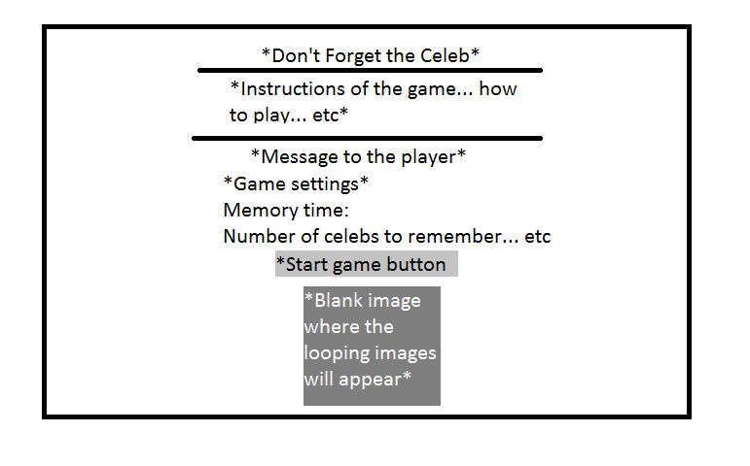
The first version of the game page, before the images are displayed:
The game page while the images are displayed:
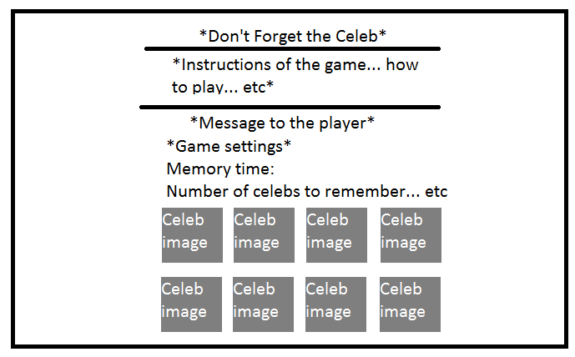

Implementation of my game
During the implementation stage of my game, I used a variety of techniques and methods.

Breaking code into functions / separation of concerns
When coding, I have split the main parts of the game into different functions. This can be seen as separating the concerns. I have the following functions in my game:
- enterName
- easyDifficuly
- mediumDifficulty
- hardDifficulty
- displaySettings
- shuffle
- generate
- loopImages
- placeImages
- updateStats
- removeImages
- displaySummary
- startGame
Though I have quite a lot of functions, they are all logical and have assisted me in focusing on specific parts of my game. Using this style helps make the code more readable and helps me identify an error easier than if my code was just a massive single block of code.

Styling (using CSS)
I decided that I wanted to add some styling to my game, and I have done this using CSS. I’ve stuck with basic ideas of CSS, and styled only a few elements of my page, including the background, headings, paragraphs, and images. The main styles that helped my page look more interesting include changing the background colour to a light blue, changing the font style, and adding borders to the images.

Button/image interactions
I have used many button and image interactions within my game, in-fact, my game relies on them heavily. I’ve used buttons to change the settings of the game and to begin the game, while I’ve added interactions to the images so that the user can click the images that they remember and their score can be updated. Button and image interactions have helped make my game interesting and interactive.

Used pointer cursor style
I researched how to use a pointer cursor style when the user hovers over an image. This is particularly useful for my game as the user must click on the image that they remember, and the pointer cursor helps the user identify which image they are clicking on.

Using logical variable, array and function names
I have used logical variable, array and function names to support readability of my code and to help me when constructing the game. For example, ‘numOfCelebs’ and ‘playerAnswers’ make it obvious what the variables store.

Shuffling Images using Fisher-Yates method
In order for my game to be effective and avoid repetition, I realised that I must shuffle my array containing all of the celebrity images, so I learnt how to use the Fisher-Yates shuffle method. This method effectively shuffle each item in the array with the others, creating an overall convincing shuffle. Shuffling was necessary in my game as I had to add variation in the celebrities that the player must remember, as well as the order that they were displayed.

Problems that occurred and how I solved them

Figuring out how add images/text to the page later on during the game
When I initially started coding using HTML and JavaScript, it took me time to understand how to use them together, and one of my main concerns was being able to add content to the page later on in the game. However, I researched online and asked some friend and learnt how to do this. I learnt that one method of doing it was giving a HTML tag an id, but not giving it a value. For example - <p id=”testing”> </p>. Then, later on when I wanted to add something to the paragraph tag, I would use document.getElementById.innerHTML.

Knowing when to create and call functions
During the creation of my game, I noticed that some code wouldn’t execute as I wanted, even though there was no obvious syntax error. After asking my tutor, I learnt that the order of which I define and call functions is very important, as some parts of code require another part of code to be defined first. To fix the problem, I defined the functions that needed to be defined in logical order, and then called the functions that required a previous function afterwards.

Testing my code
I have carried out several tests to show the functionality of my code. The images of the tests are shown in the appendix. The following table summarises the tests.
Appendix/ test # | Test | Input | Output | Successful or not?
1 | - Testing difficulty buttons - do they produce output & is this output correct? | - Clicking the difficulty button | - Text was successfully displayed  - The correct information was successfully displayed | Yes - I clicked each different difficulty button and the output displayed as appropriate.
2 | - Testing whether difficulty buttons actually influence the game settings during gameplay | - Clicking the difficulty & start game button | - The game successfully started  - The game settings successfully were influenced | Yes - the game started successfully and the different difficulties resulted in the different settings - e.g. difficult difficulty resulted in the game flashing each celebrity for 1.5 seconds
3 | - Testing to see whether the images of the celebrities successfully displayed & shuffled during a different game | - The game was started and I looked out for the images of the celebrities  - I refreshed the page to see whether the images shuffled | - The game displayed all of the necessary images at the right time  - The images were shuffled when the game was run the next time | Yes - As the screenshot shows, all of the images were displayed at the right times.  Appendix 3.2 also shows that the images successfully shuffled.
4 | Testing to see whether the score, correct answers and incorrect answers variables updated successfully based on the player’s answer | - I played my game and clicked on the celebrities that appeared during the looping part of my game | - The variables outputted number that weren’t as expected  - The output was -400 score, 0 correct answer and 20 incorrect answers. | No - My game outputted numbers that it wasn’t meant to. I believe I understood why this was the case, but unfortunately I didn’t have the time to learn how to fix the problem.

Reflecting on Design & Implementation

Did the design/implementation meet my requirements?
The design aspect of my game successfully met my requirements. The colours, images and style used was exactly how I planned.
Despite most of the implementation meeting my requirements, my game didn’t successfully update the score, correct answers and incorrect answers count. I know that the problem was within my ‘updateStats’ function, as I was trying to assign a variable the same value as an image with a source that had been added to an array. Despite knowing the problem, I didn’t have enough time to figure out how to fix the problem, and unfortunately this created a big flaw in my program.
However, every other aspect of my game met my requirements. Each function (except the updateStats function) ran as expected. The correct images were displayed at the correct times for the correct amount of times, and the correct page elements appeared when I wanted them to.

What would I do differently?
Obviously, I would have tried to complete my game early, so that I had more time to fix the main problem that I couldn’t fix.
Other than this, I would possible have created a different style game. I realised that many people chose memory games (in some form or another) whereas I had other ideas, but it was too late to choose these. I have learnt to consider my options more before jumping into choosing an idea.
Another thing I would do differently would be creating several sections of my page, in which would include a leader boards section, an instruction section and a play again section. This would add another dimension to my page.

Key points that I learnt
During this project, the main thing I learnt was how important planning is. During creating my pseudocode for my game, I came across countless areas that I had no idea I would encounter. I’ve learnt why writing pseudocode and planning beforehand are so valued in the computing world.
The other major thing I’ve learnt during this project is how to combine HTML with JavaScript. I now know how to use JavaScript for interaction on a HTML page, which is obviously extremity useful in creating an interactive page or game.

Did the testing show any gaps?
As mentioned above, the testing of my game showed that my scored system didn’t update correctly.

Appendices

Appendix 1 - Testing difficulty buttons - do they produce output & is this output correct?
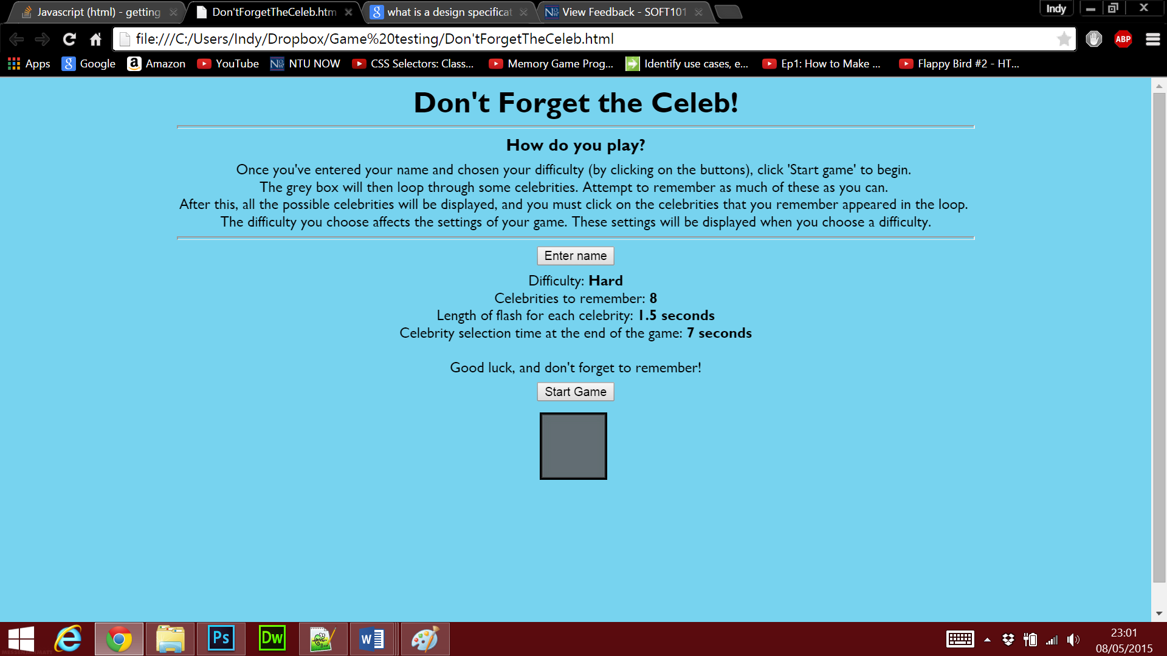

Appendix 2 - Testing whether difficulty buttons actually influence the game settings during gameplay
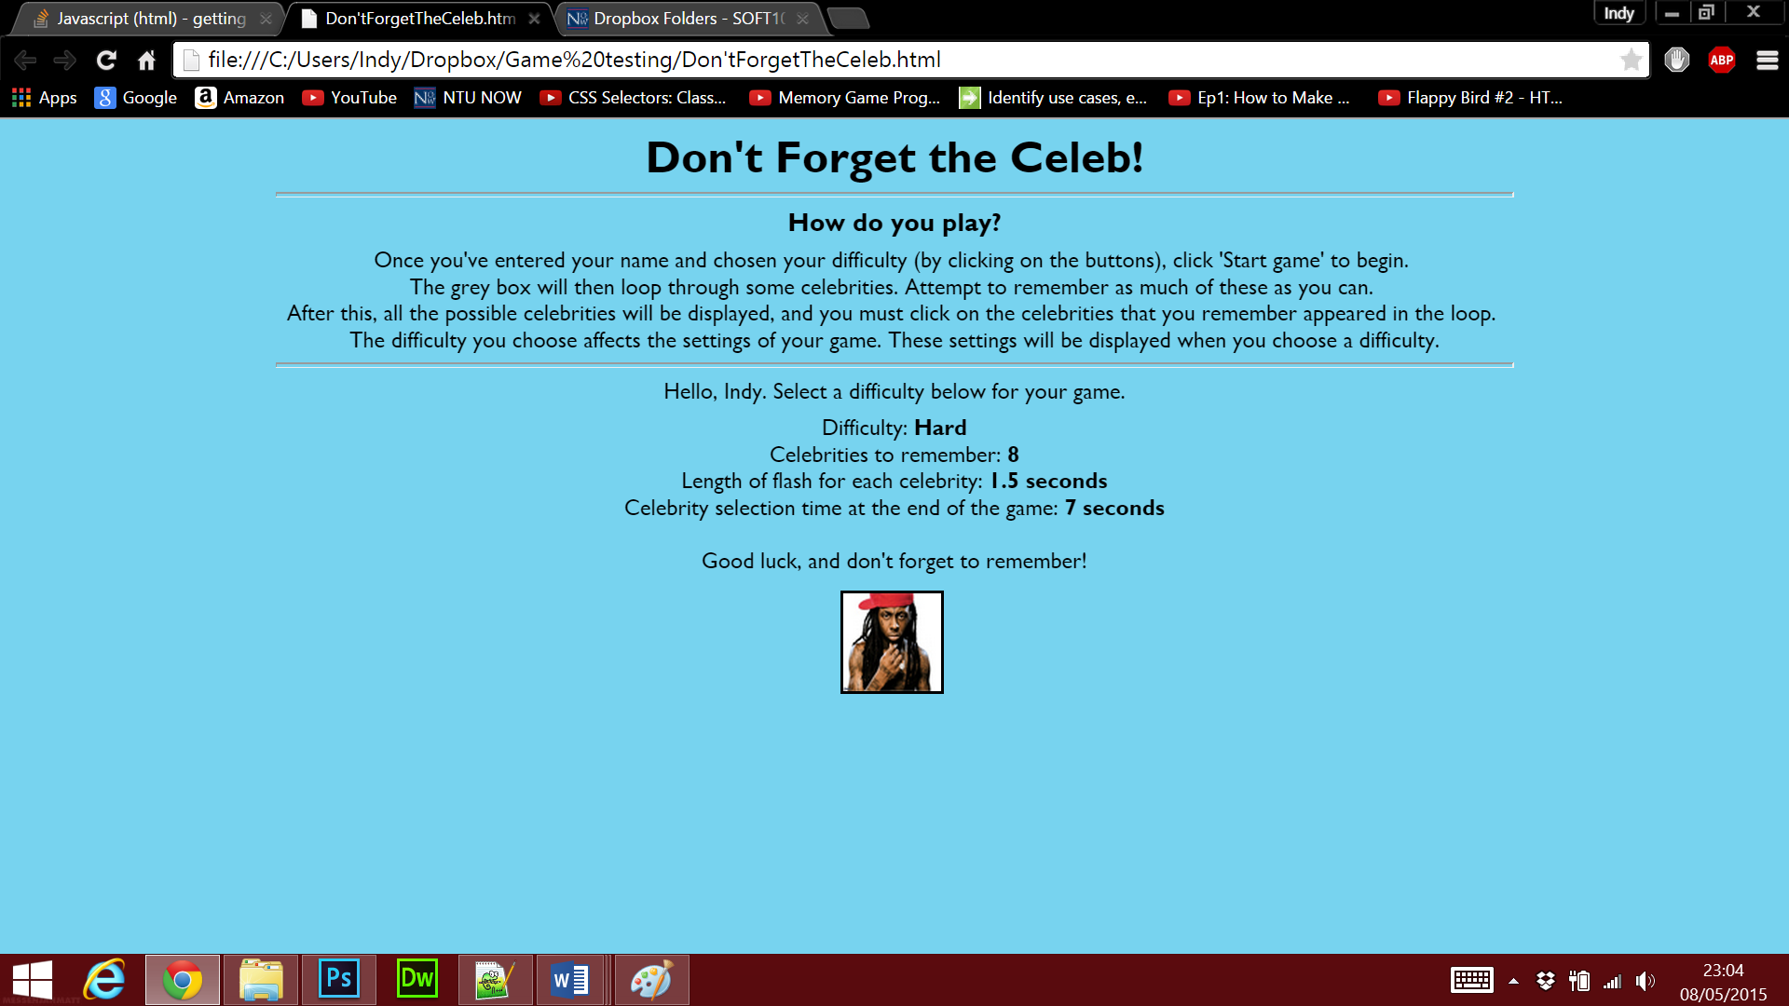

Appendix 3.1 - Testing to see whether the images of the celebrities successfully displayed & shuffled during a different game
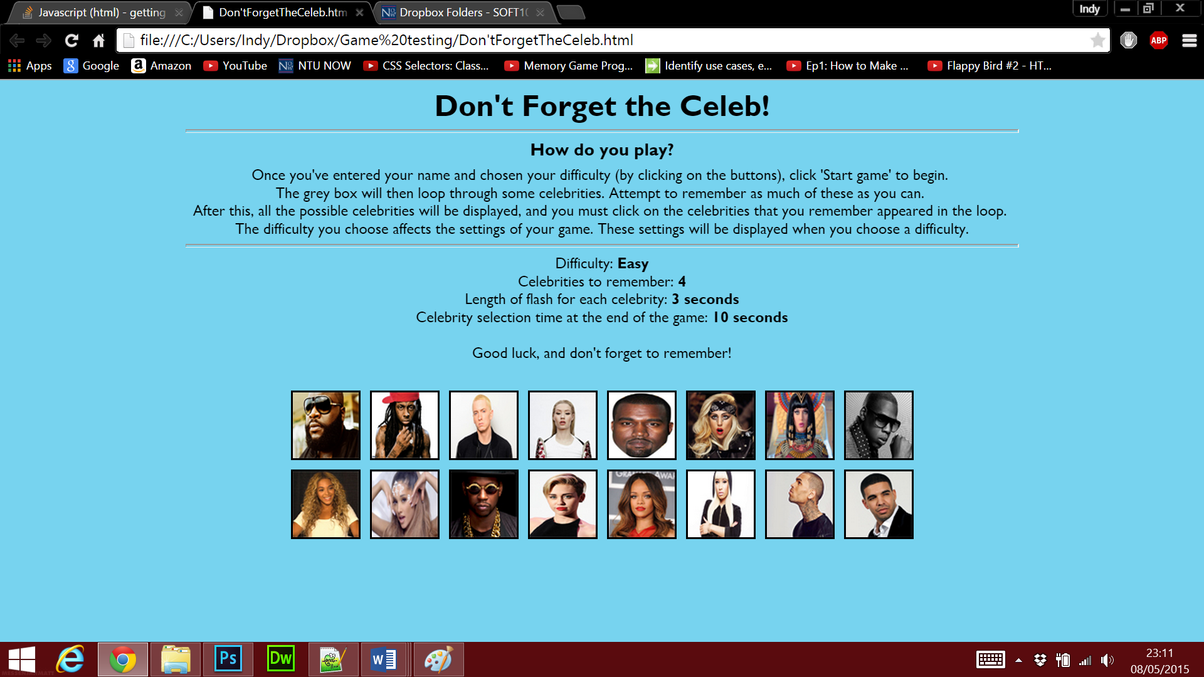

Appendix 3.2 - Checking if the images shuffled - clearly they did
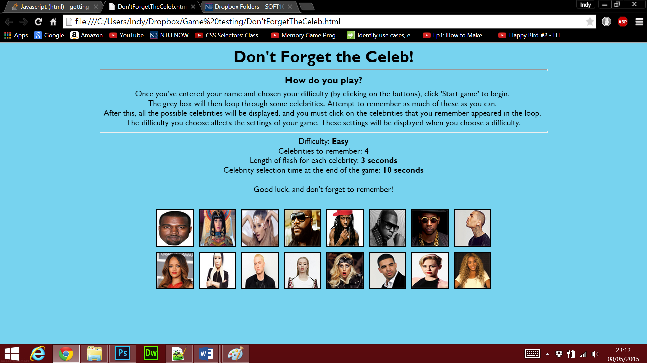

Appendix 4 - Testing to see whether the score, correct answers and incorrect answers variables updated successfully based on the player’s answer
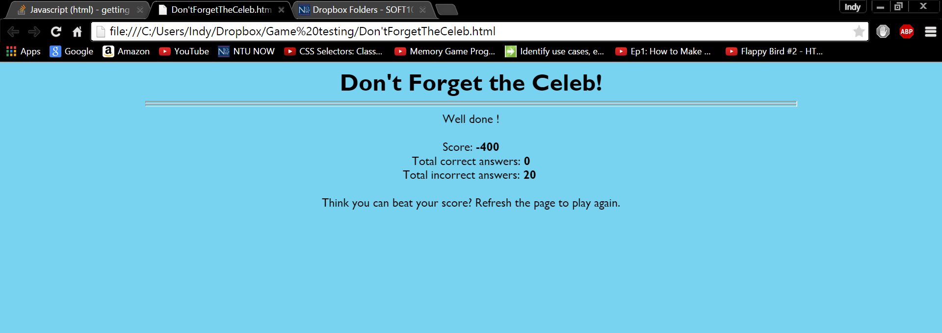

References
Links to all 16 of the images of the celebrities I used to display in my game:
Jay Z - http://artnectar.com/wp-content/uploads/2010/11/jay_z.png
Kanye West - https://www.cheap-flyer-printer.com/shop/product_images/p/kanye%20west__52846.jpg
2 Chainz - http://assets.rollingstone.com/assets/images/story/q-a-suddenly-2-chainz-is-everywhere-20120813/square.jpg
Eminem - http://assets-s3.usmagazine.com/uploads/assets/articles/74828-eminems-daughter-hailie-graduates-from-high-school-details/1403900539_187596325_eminem-zoom.jpg
Rihanna - http://www.technologytell.com/entertainment/files/2015/03/Rihanna.jpg
Beyonce - http://assets.rollingstone.com/assets/images/video/beyonce-answers-tough-adorable-questions-from-kid-president-20130820/beyonce-306-1377006730.jpg
Nicki - http://www.billboard.com/files/media/nicki-minaj-press-2014-650.jpg
Katy - http://www.independent.co.uk/incoming/article9153990.ece/alternates/w620/katy-perry-dark-horse-v2.jpg
Iggy - https://pbs.twimg.com/profile_images/456995177819676672/U3oviu0E_400x400.jpeg
Ariana - http://www.ryanseacrest.com/wp-content/uploads/2014/08/ariana-grande-2.jpeg
Drake - http://1vze7o2h8a2b2tyahl3i0t68.wpengine.netdna-cdn.com/wp-content/uploads/2015/03/Drake-Leads-Much-Music-Awards-With-Six-Nominations.jpg
Chris - http://cdn.hiphoplead.com/static/2014/02/Chris-Brown-2014-pic.jpg
Wayne - http://static.comicvine.com/uploads/original/9/93477/4170060-8831283607-LIl-W.jpg
Miley - http://img2.timeinc.net/people/i/2014/database/140831/miley-cyrus-300.jpg
Gaga - http://thatgrapejuice.net/wp-content/uploads/2015/04/lady-gaga-icon-thatgrapejuice.jpg
Rick - http://www.gorillaconvict.com/wp-content/uploads/2013/03/rick-ross-rapper-1.jpg

Links to code that I’ve used/ taken ideas from online (also referenced in comments of code):
Fisher-Yates shuffle array method - https://www.youtube.com/watch?v=tLxBwSL3lPQ&list=PLE7nwk02vLAAkki3p75jTYDvvCfMnqSon
Using a pointer style cursor for images - http://www.w3schools.com/cssref/pr_class_cursor.asp

