Project Report
ISYS20181: Practical Project Management
Group B1:
Kelly Sykes N0591518
Meghan Brown-Kane N0570301
Marcin Slawecki N0581166
Philip Rock N0607921
Inderjit Sandhu N0578334

Abstract

The assignment was to conceive, design and develop a software product, using any software development tools required, as long as they are relevant to the groups course and cluster. The Project Proposal document was approved by the group supervisor, who is acting as the product client.
The approved project was the creation of a money management system for a support service for people with learning disabilities, to aid the safeguarding of tenants against financial abuse. The software conceived would enable a more efficient and effective recording system for the service’s tenants personal money and bank accounts. The system was designed to be used by staff on a daily basis and by service managers for auditing purposes. It was also essential that the software was inclusive and accessible, as the service presumes that all service users have some competency and ability to manage their own finances.
The primary functionality of the software is that it will allow users to record transactions and review the expenditures against the projected transactions, detailed in a tenant’s risk assessments and support plans. The user will be able to record bank or personal transactions by completing details about date, location, budget category and amount. The aim is to remove the time consumption and inconsistency assessed in the current procedure.
The company required that all steps were taken to protect the data of the people they support. The program itself will be for a desktop computer located at the service, with the potential expansion to the company’s secured intranet across multiple services.
The program has been designed on NetBeans IDE using Java as the primary programming language, with SQL integration to manage the information database. NetBeans provided a development tool that allowed the graphical user interface to be designed to best suit all users of the software.
The program has been thoroughly tested to check the functionality is correct and meets the requirements defined by the user. The program has also been tested by both technical and non-technical users to ensure that the program is useable. With some further development to meet all the needs of the client, the application would be a viable solution to the company.

Contents
1 Introduction 5
1.1 Background 5
1.1.1 The Current System 5
1.1.2 Why the Current System Exists 5
1.1.3 Issues with the Current System 5
1.2 Aims and Objectives 6
2 Survey of Existing Solutions 6
2.1 Market Research Results 6
2.1.1 Survey Analysis 6
2.1.2 Functional and non-functional requirement Analysis 6
2.2 Software Required 6
2.3 Discussion of Existing Solutions and Decisions Made 7
3 New Ideas – functional and non-functional requirements with justification 8
3.1 User Requirement Investigation. 8
3.1.1 Functional Requirements 8
3.1.2 Non Functional Requirements 9
4 Design and Development 10
4.1 Software Development Lifecycle choice and implementation. 10
4.1.1 ‘Welcome changing requirements, even late in development’ 10
4.1.2 ‘Business People and developers must work together daily throughout the project’ 10
4.1.3 ‘Build projects around motivated individuals. Give them the support they need, and trust them to get the job done’ 10
4.1.4 ‘The most efficient and effective method of conveying information to and within a development team is face-to-face conversation’ 10
4.1.5 ‘Continuous attention to technical excellence and good design enhances agility’ 10
4.1.6 ‘At regular intervals, the team reflects on how to become more effective, then tunes and adjusts its behaviour accordingly’ 10
4.2 Data integrity in the cloud 10
4.3 SQL 12
4.4 Menu Design 12
4.5 Graphical Design 12
4.5.1 How the GUI was created 12
4.5.2 Design decisions 13
5 Evaluation of Product 13
5.1 Testing 13
6 Professional, Social and Legal Issues 14
7 Conclusion 15
8 References 16
10 Bibliography 17
11 Appendices 19
11.1 Client Explanation of Current System and Desired Change 19
11.2 Research of Existing Solutions 19
11.2.1 Current Support System 19
11.2.2 Mint Budgeting Application 20
11.2.3 YNAB (You Need a Budget) 21
11.2.4 Budget Simple 21
11.2.5 WalletHub 22
11.3 Use Cases 24
11.4 Paper Based Record – old system 33
11.5 Computerised Money System – Old System, Monthly Example 34
11.6 Computerised Money System – Old System, Budget report 35
11.7 Survey of Existing Solution 36
11.8 DFD and ERD explanations 40
11.8.1 Context level DFD 40
11.8.2 Level 0 DFD 40
11.8.3 Level 1 DFD - Add new tenant 42
Level 1 DFD – Add user 42
11.8.4 Level 1 DFD – log on 42
11.8.5 3NF ERD 43
11.9 Testing 44
11.10 User Manual for Staff and Managers 51
11.11 Team Meeting Minutes 54
11.11.1 Meeting 1 54
11.11.2 Meeting 2 54
11.11.3 Meeting 3 54
11.11.4 Meeting 4 55
11.11.5 Meeting 5 55
11.11.6 Meeting 6 55
11.11.7 Meeting 7 55
11.11.8 Meeting 8 56
11.11.9 Meeting 9 56
11.11.10 Meeting 10 56
11.11.11 Meeting 11 56
11.11.12 Meeting 12 57
11.11.13 Meeting 13 57
11.11.14 Meeting 14 57
11.11.15 Meeting 15 57
11.11.16 Meeting 16 58
11.11.17 Meeting 17 58
11.11.18 Meeting 18 58
11.11.19 Meeting 19 58
11.12 SQL Statements 59

Introduction

Background

The Current System
A team of support workers record the financial transactions of the people with learning disabilities that they support in order to safeguard them from financial abuse. The current system is both paper based and computerised and requires support workers to complete many steps. Currently staff are required to detail the location, amount, date and sign off all monetary spending or withdrawal for each resident. This information is initially recorded on a paper based document and all receipts are retained for proof of purchase. Any money transferred from the bank to the person whom is being supported is also recorded so that an accurate current balance is known at all times. To confirm the current balance a night count is completed daily; this involves all receipts and cash onsite being counted for each tenant in residential support. The paper based document is then transferred to a money spreadsheet on Microsoft Excel which involves inputting all the information on each receipt. The spending is further categorised for budget comparison purposes, to help monitor regular spending of each residence to safeguard against financial abuse. Bank statement reconciliation must happen on the money sheet to confirm each transaction and monitor the balance of each person who is being supported.

Why the Current System Exists
The Mental Capacity Act (2005) brought in legislation to safeguard vulnerable adults in England and Wales. Safeguarding is about protecting those at risk from abuse or neglect. The support workers have developed this system to protect against financial abuse and create an audit trail that can be reviewed and investigated. Financial abuse can come under many different forms, in the No Secrets (1998) document published by the department of health it is described as “including theft, fraud, exploitation, pressure in connection with wills, property or inheritance or financial transactions, or the misuse or misappropriation of property, possessions or benefits”.

The support team work to policies and procedures put in place by the company they work for that has incorporated both the legal duties and their own safeguarding considerations. The computerisation of money sheets was introduced due to a case of abuse where an individual with severe mobility issues had paid for entertainment equipment they could not use themselves. Policies and procedures were adjusted to ensure budgets and spending categories were introduced to help identify any suspect activity.

Issues with the Current System
As there is both a paper based document and Microsoft Excel money spreadsheet, it necessitates the replication of information on to both locations which is a time consuming task. Some information is only recorded on the paper based document and some only on the Microsoft Excel money spreadsheet, making it difficult to accurately trace the transaction details of each person who is being supported. If a member of staff wishes to query a transaction, it is likely both the paper based document and Microsoft Excel money spreadsheet will need investigating.

The paper based document is open to human error as calculations are completed by staff; entering the details on the computer will provide a second check but if there are any errors, the sheet will need correcting from the point of error to the current position. It is also worth noting however, that whilst computer transactions can be easily corrected, this can also lead to some human errors with inputs. The current system also lacks the sufficient amount of traceability to safeguard the person who is being supported against financial abuse.

Aims and Objectives
To design and create an application that allows users to input details on transactions for the people they support. The application will be user friendly, easy to use and have a clear layout. The service provided will be a professional and efficient safeguard tool to be used by support workers and tenants. This project will be completed before the end of the academic year and supporting documentation will be produced. To ensure there will be a finished product, the project has been split into two phases; Phase I will produce a desktop application and Phase II will also allow this application to be used on mobile devices.

Survey of Existing Solutions

Market Research Results

Survey Analysis
A survey was completed by all staff at the service for which the money management system would be implemented. Whilst all members of the team found the paper based form simple to fill out and knew how to access the supporting documentation for filling in the form, not all members of the team were confident with completing the computerised money record. The paper record was completed daily by members of staff, with involvement of the tenants. The only problem the team found was when another member of staff had made an error, that correcting this error was often difficult and messy if the error was not spotted immediately. The computerised records were filled out less frequently, on the completion of the paper based sheets. The questionnaire highlighted that the task was being handed over to the more computer confident staff members, who perceived themselves to have a greater understanding and could complete it quicker. The task was described as “time-consuming” and when deciding on a category, there were staff who stated that the list of category examples was not being interpreted and used in the same way. The manager of the service also noted that the categories were “a useful tool to help protect tenants from financial abuse but only if the staff understood how to categorise the spending and recorded all the correct details”.

Functional and non-functional requirement Analysis
A member of the group conducted an interview with the service manager and analysed the “Finance: Supported Living Services operational guidance” document and finance procedures. The previous requirements were of the highest importance for any software but additional functionality would improve the usability and impact of new software.

Software Required
As an application that requires lots of data to be stored and accessed, the decision was made to use both Oracle SQL and Java languages. The database has been designed to store information relevant to the client based on their requests and feedback given throughout the development process. Oracle SQL was chosen due to the database language being better understood by team members, who have been taught it in other modules. There was also a distinct advantage with this choice as both Oracle SQL and Java (the programming language chosen for this project) were created by Oracle making them compatible and easy to use together. The program used to code the Java was NetBeans; a free open source IDE. For Java, NetBeans GUI builder can be used to design the application quickly and smoothly by using the GUI editors and drag-and-drop tools. NetBeans also enabled the application to be Cross Platform supported, and although the specification from the client did not require this, it would allow for expansion and reuse elsewhere.

Discussion of Existing Solutions and Decisions Made
Conducting research into both the current system used by support workers, and commercial applications which are similar to the proposed idea helped to identify key features that must be included in the system.
The current support system does not require the storing of personal details; this is a key aspect of the current system that must be incorporated due to the company wishing to increase the financial procedures after a tenant had suffered abuse. All transactions must be categorised to identify key areas of spend and for each category a monthly and yearly figures can be produced.
The current system highlighted areas that need to be improved in the new system, for example the new system will be able to produce real time reports on bank balances, detail the expenditure in a consistent manner and has the flexibility to add budget categories. These key features identified by the research into the current system will be focused on throughout the new system.
The real time bank balance in an important feature due to the need to keep up to date details on all tenant expenditures to help safeguard against financial abuse. Inputting the expenditure details in a more consistent manner allows the transactions to be directly compared and allow the user of the program to compare costs per budget category. The flexibility to add a budget category is important due to each tenant having different areas to spend their money.
Research in to currently existing applications that have similar functionality to the proposed idea helped to identify key features that would make the application more user friendly. The key areas identified from current applications to include are: a user must have a unique username and password to access to system; the budget must be broken down into months to allow a clearer view of the tenant’s financial situation; no personally identifiable information will be stored in the system.
Through the groups research, weaknesses in the commercially used applications were highlighted; these weaknesses are addressed in the new system design. The design has ensured that “cash in tins” in addition to bank accounts can be tracked. The system must be quick and easy to set up and all transactions must be dated and stored to have the flexibility to search transactions by a given criteria.
Tracking all financial expenditures is a contractual requirement of all supported living services and therefore this system has been designed to not only track bank accounts but to track money in the service. A night count on the application should also increase traceability of any discrepancies and enable managers to address problems quickly when they arrive. The system must be quick and easy to set up as the system is aimed to be used by non-technical people who may have little knowledge of how to use a computer.
The setup of the system must be quick and easy due to the user having an unknown level of technical knowledge, so no technical knowledge must be assumed. This feature has also been highlighted from surveys taken by the users of the current system.

New Ideas – functional and non-functional requirements with justification

User Requirement Investigation.
To understand the requirements of the system, the group carried out research. As there was an existing solution, the details of the survey are above in section 2.1 Market Research Results. The group also looked at the company’s existing documentation; the supported living finance operational guidance, finance procedures, paper based and computer based system components, and annual spending plan. A discussion was also conducted with a support worker, who developed the previous system to fix some of the previous problems faced when the first version of the computer based system was developed. The requirements were of varying levels of importance and were implemented accordingly in the development cycles. The scope of the project could quickly exceed the time frame available so it was essential to manage this limitation.

Functional Requirements
- A tenants name should be written in full and stored.
- All tenants are presumed to have capacity and have the right to access and manage their own finances. “The service presumes that all service users have some competency and ability to manage their own finances. The right to manage and control your own financial affairs is an important right; that right is not diminished because an individual needs assistance to discharge their financial obligation or support to manage their financial affairs. Staff should provide minimal support to enable people we support to achieve maximum independence when managing their money. “
- Where a pooled money agreement is in place, the money spent should be recorded in the same way as for a tenant. The amounts in the category should be divided and recorded in the tenants budget spend.
- The records must be able to be audited effectively. There must be effective ways to extract and investigate all transactions.
- The staff and manager should be able, in the event of an error, to delete a transaction or force a new balance. These functions should be recorded for the manager to be able to view as an incident form may need completing. Ideally the manager would be notified if a deletion happened.
- All expenditure made from the tenant’s cash should be entered and signed by the tenant and the support worker to agree expenditure. If the tenant has been risk assessed as unable to sign, a second support worker should sign.
- On no account should the PIN number be recorded within the financial records, an on no account should staff know the PIN numbers of tenants.
- Record details of any loyalty cards held by the tenant – this should include the number on the card.
- Gift Vouchers and store card points should be traceable.
- The system will be an application that is able to run on desktop platforms.
- There must be three user levels; Manager, staff and tenant with different access capabilities.
A tenant should not insert their own data but should be able to approve their transactions.
- All users should only be able to access the software using their verified username and password to keep data secure.
- A manager must be able to add new staff, services and tenants. Managers and staff can add locations as sources of expenditure or money receipt.
- The application must allow the user to report amount, location, date and budget category details on spending and update the bank balances.
- The application must allow the user to report details on money received and update bank balances.
- The application must allow the user to add a budget category. This should only happen at the start of the financial year.
- The application must allow the user to report details on staff member details and activity.
- The application should prompt a nightly count record. The daily night counts should be checked for differences, with differences being flagged to service manager and staff member prompted to fill out the appropriate form.
- The application must produce yearly budget reports which displays total spends for each category, with monthly breakdowns and total spends.

Non Functional Requirements
- A key part of the check performed by the budget report is ensuring that the expenditure is in line with the wishes of the tenant. It compares the type of actual expenditure with the type of expenditure anticipated by the tenants risk assessment and support plan.
- The language used should be accessible to all using the application.
- The application should look clean, simple and professional.
- The application should be accessible to people who are colour blind.
- The application should comply with the Disability Discrimination act (2010).
- The application should not breach the Data Protection act (1998).
- Ease of access should be considered for people with disabilities (Web Content Accessibility Guidelines 2.0).
- The application should load within a reasonable time.
- The program should only be available for the service computers so as to protect tenants’ data.
- Data should be permanent and exist when the computer is switched off.
- The application should be quick and easy to setup.
- The application should be runnable from a Windows operating system released after 2001(XP, Vista, 7, 8, and 10).
- The application should be optimised for lower end machines.
- The application should use reference codes on errors so that software errors can be reported, traced and corrected.
- The application should maintain a log which can be sent to the technician.
- The application common resolution should be able to resize for different screen resolutions.

Design and Development

Software Development Lifecycle choice and implementation.
In order to ensure that the project and team is managed effectively, the group has mutually agreed to use the agile approach. This section outlines some of the principles of the agile approach, explained by Beck et al (2001), and explains how the approach relates to the group’s project.

‘Welcome changing requirements, even late in development’
The group will consider changing requirements, even if in late development stages, supposing that there is enough time to implement these changes. The group acknowledges that requirements may change, and wants to be able to make these changes.

‘Business People and developers must work together daily throughout the project’
The group will be working together, daily whenever possible, throughout the entire project to ensure that teamwork is utilised to its full potential. Working together daily as a team will ensure that a variety of ideas are suggested and considered, and appropriate feedback and advice is given.

‘Build projects around motivated individuals. Give them the support they need, and trust them to get the job done’
The group contains five members that are all motivated to do well in the project. Wherever possible, support will be provided to one another but each group member will be trusted to complete a piece of work to a good standard.

‘The most efficient and effective method of conveying information to and within a development team is face-to-face conversation’
Though the group will use WhatsApp to communicate, the group will regularly meet to ensure face-to-face communication is ever-present. The group realises that face-to-face communication is a much more effective method of conveying information, suggestions and feedback to other group members.

‘Continuous attention to technical excellence and good design enhances agility’
The group will aim to develop an application that is constructed excellently in terms of technical and design side of the project. An application is to be created that is useful, efficient, looks professional and is easy for a user to use.

‘At regular intervals, the team reflects on how to become more effective, then tunes and adjusts its behaviour accordingly’
The group will regularly hold meetings to discuss and reflect on past performance, and figure out how to become more effective. The group will then adjust its behaviour according to this, to ensure that the team is more effective, and the project is completed in the most effective manner possible.

Data integrity in the cloud
The money management system stores data used within the app in the cloud, which has both its advantages and disadvantages. As Salesforce UK (2015) explains, cloud computing can allow for an easy form of disaster recovery - should anything happen to data, it is easy recover this data from the cloud. The cloud also offers free storage, the ability to use the data from anywhere and a form of security, in the sense that there is no physical object that can be lost or stolen.
Though cloud computing has its advantages, it is important to consider the threats that cloud computing offers. As Al-Saiyd and Sail (2013) point out, data loss/leakage is a high possibility with cloud computing, as there are many ways to compromise data because of insufficient authentication, authorization and audit controls, such as deletion or alteration of records without an original backup. The pair also emphasise the point that account or service hijacking is a big threat. Various attack methods can be used such as phishing, fraud and exploitation of software vulnerabilities. If an attacker simply gains access to credentials, they can eavesdrop on user activities or transactions. They can also manipulate data, falsify information and redirect the users to illegal sites. Al-Saiyd and Sail (2013) also explain that hackers can exploit browser vulnerabilities by attacking browsers and gaining access to documents that are saved on the cloud.
The data used by the money management system should obviously be kept secure, as it is confidential and important. Therefore, it is important that users consider the threats of cloud computing and take the following actions to minimise potential risks:
- Ensure that antivirus software is used, and browsers are up to date, to minimise the risks of hackers attacking browsers
- Ensure that only administrators have the ability to access and modify the data, rather than everybody or anybody, to minimise the risk of somebody losing or leaking data. The administrator should be a trustworthy individual who understands how the app and system works
- Consider general safeguarding principles to avoid the risk of facing hackers, such as being suspicious of emails, not opening attachments unless confident it is safe and using secure passwords.

SQL
The tables themselves have undergone a lot of change since the initial prototype created from the normalised table data created in the analysis stage. This was due to further communication with the client (additional features needing more data to be stored, as well as removing some no longer relevant data from removed features) as well as discussions among the team about making the database tables and the program as efficient as possible.
Using Oracle SQL has some drawbacks. One example is the lack of an automatic increment feature, used to increment the value of a field whenever a new row is added to the table. The original design was to use this to automatically allocate an ID value to newly created tenants, staff, management, and transactions, however sequences were used to carry out this task. The drawback of this approach is that a sequence does not decrement when a row is removed from the relevant table, since they are not linked. When a new row is added, it will use the highest ID value, and not the newly freed up one. In a large database that performs a lot of insert and delete operations this could result in large amounts of ID numbers being unused. However, given the size and scope of the program, this shouldn’t pose too much of a problem, as deleting records should be a very rare operation.

Menu Design
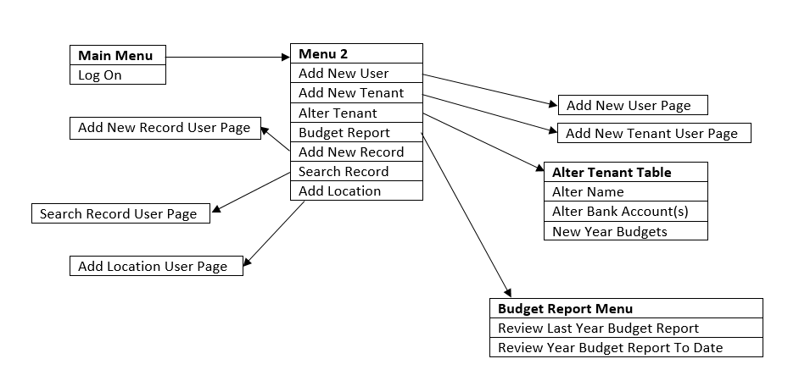

Graphical Design

How the GUI was created
Once the initial screens were created with the standard NetBeans interface, Photoshop was then used to improve the appearance of the GUI. This includes using various shapes to create a simple but professional looking logo and using a light grey and white gradient background with dark text and screen elements.
After creating a more attractive GUI background on Photoshop for each interface, a background label containing the corresponding GUI image was then added to each interface.

Design decisions

Font
The money management app uses the sans serif font Trebuchet, because, as Angelova (2014) explains, sans serif fonts work best for screen designs as they are easier to read than serif fonts (which include many curls at the end of letters). Largish fonts have been used (at least 14px) at all times so that content is easily readable.

Colours / colour scheme
The best way to ensure that screens are readable is by following the contrast rule: dark text on light backgrounds and light text on dark backgrounds, as Ambler (2014) suggests. Following this principle, the money management system uses a light grey/white background for the main content while darker colours are used for the text, other content and other interface elements. This contrast of colours ensures that text is easily readable for the user.

Consistent layout
The app uses a consistent layout, which allows users to develop usage patterns as Fadeyev (2009) points out. Consistency in an app also allows the user to become familiar with the app so that they can use it again in the future with ease and without confusion.

‘Less is more’
W3schools (2013) explains that ‘less is more’ on an interface and screens should keep text as minimal as possible while using a lot of white space. The money management system acknowledges this, as its interface is kept as simple as possible, avoiding unnecessary confusion and over complication.

Convenient navigation
Ambler (2014) explains that users will become frustrated and give up if they struggle to get to one screen from another. Due to this, the money management system provides convenient navigation for users, so that they can access important and relevant parts of the app at the most convenient times.

Logo
The app also includes a logo on each screen, giving the money management system its own unique identity whilst also ensuring the interfaces look professional.

Evaluation of Product

Testing
The application has been tested against the specifications and the testing framework is detailed in the appendix.

Professional, Social and Legal Issues
Within this project, there were professional, social and legal issues that had to be considered for both the functional and non-functional requirements and the group work. It was important that all members of the group felt able to speak openly about the project and give and receive any criticisms or ideas freely and professionally.
When conducting research with the members of the company team, it was equally as important to remain professional and record the information given accurately. It was important that in order to get a better opinion on the money management system, the staff must have felt free to give any criticisms and praise to get accurate and therefore useful specifications.
The application was developed with the intention of safeguarding adults with learning disabilities from financial abuse. The current operational guidance in place had carefully considered and developed the system to put into place the safeguarding and data protection measures therefore it was important to implement those requirements whilst making the process as simple and accessible as possible. It is important to ensure that the project looks on how the software can protect vulnerable adults and enable them to be as involved with their finances as possible. “Tenant” was used for the people in the supported living service as this was a non-discriminatory term, something on discussion with people living at the service, they had said would be preferable and that they actually quite liked.
Whilst it would be unfeasible to make the software accessible to all tenants, it was important to make the software as inclusive as possible. This resulted in the non-functional requirement 5, “Ease of access should be considered for people with disabilities (Web Content Accessibility Guidelines 2.0)”. Language should be accessible to all users and visuals should be simple and clear enough as to make it easy for anyone to navigate menus and understand what is going on. Non-functional requirement 6 is “The application should comply with the Disability Discrimination act (2010)”. Again, this is something hopefully covered by the operational guidance requirements but the group also considered how this application would be used and how to ensure as much independence and dignity as possible for all tenants.
As stated previously, the application should not breach the Data Protection act (1998). The design of the application has considered how to take all reasonable measures to ensure this act is not breached. The application is password protected so that only members of staff and managers of the service can view the tenants’ data. The tenants are also only able to view their own data. Account creation is also only possible through a manager’s account. It may also be possible to have this application on the company’s intranet which is hosted by Citrix Access Gateway. Citrix.com describes one of the key benefits as “Users are authenticated against various authentication systems to protect secured applications and data. Endpoint analysis scans client devices and determines the validity of the mandatory security programs.”

Conclusion
Analysis of the current system in place identified many requirements for the project, using the current system identified how slow and what issues arise through using the system. Consulting with support workers confirmed these issues and produced more requirements for the new system. For example the system must be quick and easy to set up due to accommodating for non-technical users.
The design of the system using DFDs and ERDs identified how the system would interact with both the user and the Oracle database. This formed the basis of the approach taken to breaking down the project to manageable tasks for different members to complete. The team used the agile methodology to develop the project, this allowed the team to consult with users throughout the project to suggest any added features.
Certain professional, social and legal issues, in particular the Disability Discrimination act (2010) and the Data Protection act (1998). The Disability Discrimination act ensures that a tenant has as much dignity and independence possible. This is combatted by referring to people in supported living as tenants and allowing the tenants to view any details stored by the system about themselves. Tenants also have the option to approve transactions to confirm they are correct.
The data integrity of the cloud used by Oracle had to be addressed due to the storage of personal information, although not personally identifiable. Oracle was found to have highly developed security features that allow the activity on the database to be closely monitored. The support workers currently use Citrix virtual desktop to access Windows applications, this allows the application to be available on many desktops through the virtual desktop. Citrix employs several mechanisms that ensure the safety of the application including; the centralisation of data to a data centre and policy-based access control. Also the application produced does not allow access unless the user has a username and password that has been added to the database by a manager.
Creating and implementing the GUI for the money management app came with several challenges. The first challenge faced was ensuring that the GUI created looked professional, attractive and was as accessible as possible. This was revolved by using principles learnt from another module, which taught how to create effective user interfaces. Aspects from this module were used to ensure that the money management app GUI looked professional, attracted the user and was easily usable for various users, such as users with dyslexia.
Another issue faced with the GUI of the app was finding a way to add the background, created on Photoshop, to the actual screens. As NetBeans offered no method of adding an image to each interface, an alternative had to be discovered. This alternative was to add a label to each interface, set the layout of the frame to ‘no layout’, so the label wouldn’t move other screen elements around, and set the label background to an image of the corresponding screen created on Photoshop.
With a larger timescale photos would be added to help the tenants navigate the system. For example, some tenants may not be able to read but have the capability to use a computer. The use of pictures would help these tenants to identify the functionality of certain buttons and therefore help them to use the system correctly.

References
Dmitry Fadeyev, 2009. 8 Characteristics of Successful User Interfaces [online]. Available at: http://usabilitypost.com/2009/04/15/8-characteristics-of-successful-user-interfaces/ (Accessed: 9 February 2016)

Dr. Nedhal A. Al-Saiyd and Nada Sail, 2013. DATA INTEGRITY IN CLOUD COMPUTING SECURITY [online]. Available at: http://www.jatit.org/volumes/Vol58No3/12Vol58No3.pdf (Accessed: 3 March 2016)

Key benefits application and data security and endpoint analysis (2011) Available at: https://www.citrix.com/content/dam/citrix/en_us/documents/downloads/netscaler-access-gateway/Citrix_Access_Gateway_VPX.pdf (Accessed: 4 May 2016).

Salesforce UK, 2015. Why Move To The Cloud? 10 Benefits of Cloud Computing [online]. Available at: https://www.salesforce.com/uk/blog/2015/11/why-move-to-the-cloud-10-benefits-of-cloud-computing.html (Accessed: 29 March 2016)

Scott W. Ambler, 2014. User Interface Design Tips, Techniques, and Principles [online]. Available at: http://www.ambysoft.com/essays/userInterfaceDesign.html (Accessed: 8 February 2016)

Velly Angelova, 2014. 3 Tips to Make Your Website More User-Friendly [online]. Available at: http://www.websitemagazine.com/content/blogs/posts/archive/2014/02/06/3-tips-to-make-your-website-more-user-friendly.aspx (Accessed: 8 February 2016)

W3schools, 2013. Web Design [online]. Available at: http://www.w3schools.com/website/web_design.asp (Accessed: 9 February 2016)

Bibliography
Actual BudgetSimple user (no date) Available at: https://www.budgetsimple.com/ (Accessed: 14 February 2016).

Am I making myself clear? Mencap’s guidelines for accessible writing(2000) Available at: http://www.accessibleinfo.co.uk/pdfs/Making-Myself-Clear.pdf (Accessed: 14 March 2016).

Davis, K. and Collins, M. (2015) BudgetSimple reviews - real customer reviews. Available at: https://bestcompany.com/personal-finance-management/company/budgetsimple/ (Accessed: 14 February 2016).

Duffy, J. (2016a) WalletHub. Available at: http://uk.pcmag.com/wallethub/74400/review/wallethub (Accessed: 14 February 2016).

Dmitry Fadeyev, 2009. 8 Characteristics of Successful User Interfaces [online]. Available at: http://usabilitypost.com/2009/04/15/8-characteristics-of-successful-user-interfaces/ (Accessed: 9 February 2016)

Dr. Nedhal A. Al-Saiyd and Nada Sail, 2013. DATA INTEGRITY IN CLOUD COMPUTING SECURITY [online]. Available at: http://www.jatit.org/volumes/Vol58No3/12Vol58No3.pdf (Accessed: 3 March 2016)

Enabling the information society accessible technology A guide for IT professionals (2009) Available at: http://www.bcs.org/upload/pdf/accessible-technology.pdf (Accessed: 14 March 2016).

JavaZOOM (no date) MP3 library for the java platform. Available at: http://www.javazoom.net/javalayer/javalayer.html (Accessed: 11 April 2016).

Key benefits application and data security and endpoint analysis (2011) Available at: https://www.citrix.com/content/dam/citrix/en_us/documents/downloads/netscaler-access-gateway/Citrix_Access_Gateway_VPX.pdf (Accessed: 4 May 2016).

Mercadante, K. (2016) ‘Educate’, Personal Finance Software, 14 January. Available at: https://investorjunkie.com/15562/ynab-you-need-a-budget-review/ (Accessed: 14 February 2016).

Mint: Money, bill pay, credit score & investing (2016) Available at: https://www.mint.com/ (Accessed: 14 February 2016).

Salesforce UK, 2015. Why Move To The Cloud? 10 Benefits of Cloud Computing [online]. Available at: https://www.salesforce.com/uk/blog/2015/11/why-move-to-the-cloud-10-benefits-of-cloud-computing.html (Accessed: 29 March 2016)

Scott W. Ambler, 2014. User Interface Design Tips, Techniques, and Principles [online]. Available at: http://www.ambysoft.com/essays/userInterfaceDesign.html (Accessed: 8 February 2016)

Velly Angelova, 2014. 3 Tips to Make Your Website More User-Friendly [online]. Available at: http://www.websitemagazine.com/content/blogs/posts/archive/2014/02/06/3-tips-to-make-your-website-more-user-friendly.aspx (Accessed: 8 February 2016)

WalletHub – join our community & find the best rates! (no date) Available at: https://wallethub.com/ (Accessed: 14 February 2016).

W3schools, 2013. Web Design [online]. Available at: http://www.w3schools.com/website/web_design.asp (Accessed: 9 February 2016)

YNAB. Personal finance software to take total control of your money(no date) Available at: http://www.youneedabudget.com/ (Accessed: 14 February 2016).

Appendices

Client Explanation of Current System and Desired Change
“The support service has had money management systems in place to ensure the safeguarding of individuals with learning disabilities. The system has evolved to have the addition of computer records and budgets following a review which prompted the new computer system, financial procedures and support statements. This system has been in place for a couple of years but staff have reported some errors or issues with the system.
The system can be time consuming, having to complete the paper based record as soon as possible after an expenditure then copying all records over to the computer system and categorising them in to the right section. The members of staff who are less confident or have less computer skills, will often hand these tasks over to other staff.
There is plenty of documentation for the old paper records as these have been developed over time but not so much for the computer. Any new members of staff have to be guided through with other staff on top of the work placed observations carried out by managers. It would be beneficial to have a guide on how to use a new system.
The computer based record also did not have enough categories in the first year and the Excel spread sheet needed expanding for improved traceability and accuracy. This was a timely process and still results in some problems. The system is also not tailorable to individual tenants. “ Kelly Sykes, support worker.

Research of Existing Solutions

Current Support System
Pros | Cons
Does not require the storing of personal details. | Requires the user to enter each transaction manually
All transactions are stored. Real Time balance of “cash in tin” is known for night counts. | Real time bank balances are not available.
Tenants do not need to input their bank details and are protected against financial abuse. | Transferring from paper record to computerised system.
All transactions can be categorised. | Categories are user assigned and potentially inconsistent or inaccurate.
Produces monthly, yearly and category specific totals. | Lack of flexibility in categories.
Computer records accessible only through a password protected, single computer. | Each time a location or details of expenditure is entered, it may be entered differently. This means that the transaction is harder to search for.
 | The current system has restricted access as it is only available at a single location access.
 | Requires manual back up of data
 | Correcting an error must cascade to all following transactions for paper based record.

Mint Budgeting Application
The Mint budgeting application connects to your bank and the application uses the person’s details to help create a personalized budget. Mint is available on iPhone, iPad, android and desktop.
Mint gathers all financial information about a person into one place, allowing the person to track spending patterns, investments and what money is owed where. Mint will send alerts based on unusual charges. Mint automatically updates and categorizes your information in real time, so an accurate financial status is provided on the person. Mint shows exactly how your spending decisions affect how much you have left at the end of each month or year.
Mint helps to identify tips customized to the person’s spending that can help reduce the money spent on fees and other bills. Mint will make recommendations that will save the person the most based on the person’s lifestyle and goals.
Mint uses the same security as banks and the team behind this service also makes TurboTax and Quicken. Mint is free and easy to get started. Mint connects to almost every US financial institution that is connected to the internet to allow the user to see money transactions. The person’s credit score is also included.
Mint is safeguarded with an individual 4-digit PIN and if the device is ever lost or stolen then the account information can be remotely deleted. Login details to bank accounts are stored securely in a separate database with multi layered hardware and software encryption. Mint uses the same 128-bit encryption and physical security that banks use.
Mint only stores information needed to save you the trouble of updating manually, it does not require any personally identifiable information for the person to create an account so the person is not at risk of identity fraud.
Pros | Cons
Mint monitors all financial accounts, right down to individual account transactions. So current balance is updated in real time. | Mint only takes into account financial accounts, so cash transactions will only be tracked but as account withdrawals. Individual cash transaction cannot be recorded.
Mint is available on a range of devices: iPhone, iPad, android and desktop. Allowing access to the person’s budget anywhere. | Mint set up may take a long time as it is required that the person signs into each financial account individually. Tenants may be unable to do so and financial information such as passwords and PINs should not be shared with support workers.
Mint has budgeting tools, which categorise spending and allows the person to track spending patterns. | Mint does not allow the user to select the sort of recommendations and offers displayed to the person.
Mint free to set up and does not ask for personally identifiable information.
Mint is safeguarded with individual 4-digit PIN and uses the same 128-bit encryption and physical security that banks use.

YNAB (You Need a Budget)
The YNAB is available on iPhone, iPad and android while also syncing with the desktop application. YNAB charges $5 a month or $50 if the person signs up for the full year. YNAB is entirely web based so when changes are made to the person’s account on one device the changes will automatically carry over to other devices.
YNAB offers a blog that addresses the changes in habits and behaviours required for the person to stick to the budget. YNAB also offers a forum for the person to gain help and support from people with similar circumstances. Topics include the various mechanics of using the YNAB platform, as well as specific budgeting strategies.
YNAB has weak customer contact, a live chat feature is offered but no indication of either phone support or direct email contact.
YNAB allows the person to import transactions from the person’s bank to account in real-time, allowing the person to track spending patterns. YNAB will automatically update and categorize your information so an accurate financial status is provided on the person.
YNAB helps to identify tips customized to the person’s spending that can help reduce the money spent on fees and other bills. YNAB will make recommendations that will save the person the most based on the person’s lifestyle and goals.
YNAB staff do not access customer data unless requested by the person or required by law. Passwords are one-way salted and hashed, using multiple iterations of a key derivate function for passwords, making it difficult for hackers to determine the exact sequence. Secure data is encrypted and when the person’s account is terminated the account and data is wiped clean from the database.
Pros | Cons
YNAB is available on a range of devices: iPhone, iPad, android and desktop. Allowing access to the person’s budget anywhere. | YNAB does not take all financial accounts, so not all financial expenditures are tracked.
YNAB continues to improve as new versions of YNAB are produced regularly. | YNAB does not offer phone or email support.
YNAB tracks monthly expenses and identifies spending patterns.
YNAB connects to banks and credit cards so the person does not have to manually input all transactions.

Budget Simple
The Budget Simple application is a web-based financial planning and budgeting software program. Budget Simple has two plans, the basic plan and the plus plan.
Budget Simple views one of the biggest aspects of becoming financially secure is to become educated about finances in general. To support this Budget Simple offers a blog that addresses basic financial questions and issues. The aim of the blog is to allow the person to gain a better understanding of money.
Budget Simple’s basic plan creates a budget and generates reports. The basic plan will generate reports that analyse the person’s finances and produce a budget planner. The budget planner will identify tips customised to the person’s spending that can help reduce the money spent each month.
Budget Simple’s plus plan is $4.99 a month and offers additional features to the basic plan. Plus plan allows Budget Simple to be available on iPhone, iPad and android devices. Plus plan also allows bank accounts to be linked to the budget. The plus plan also includes the features of the basic plan.
Budget Simple uses industry leading 256-bit encryption algorithms to transfer information securely. The person’s information is stored on servers which are securely housed in a space that is monitored by authenticated personnel. Access to the servers requires multiple levels of authentication, therefore providing a high level of physical security.
Budget Simple does not allow the deletion of an account from a device remotely so the risk of identity fraud is high if a device is lost or stolen.
Pros | Cons
Budget Simple allows bank accounts to be linked to the budget with the plus plan. | Lack of features on mobile app.
Budget Simple is available on iPhone, iPad, android and desktop with the plus plan. | No option to prompt the user when a condition is met.
Budget Simple uses industry leading 256-bit encryption algorithms and physical security to ensure the security of information. | Budget Simple does not date any transactions, which makes the analysis on spending patterns difficult.
Budget Simple tracks monthly expenses and identifies spending patterns. | Lack of flexibility in tasks and limited categories for spending.
Budget Simple produces graphs to display information to the user.

WalletHub
The WalletHub application connects to your bank and the application uses the person’s details to help create a personalized budget. WalletHub is only available on desktop.
WalletHub uses personal details provided to gather information about the person’s loans and credit cards. WalletHub provides a credit analysis so the person’s credit score is shown and explained. Credit analysis focuses on explaining and analysing different factors that could affect a person’s credit score; payment history, account age and hard credit inquiry.
WalletHub requires the person being monitored to enter personal information. These details include address, date of birth and the last four digits of the person’s social security number, which means that personally identifiable information must be provided.
WalletHub displays a lot of detail about the person’s account, however account numbers are not displayed so money cannot be moved or stolen from within WalletHub. WalletHub uses the same 128-bit encryption and physical security that banks use. Personal data collected is also anonymized once stored.
WalletHub identifies tips that can help reduce the money spent on fees and other bills. WalletHub allows the person to explore selected categories of tips.
WalletHub offers a forum for the person to ask specific questions about a problem. A community of financial experts provide the answers and the community votes for the best answers.
Pros | Cons
WalletHub is free to set up and automatically adds financial accounts so the set up time is minimal. | Does not provide budgeting tools to categorise spending and allow the person to track spending patterns.
WalletHub monitors most financial accounts. So current balance is updated automatically and in real time. | WalletHub is not available on iPhone, iPad or android so a person’s budget cannot be accessed anywhere.
WalletHub uses 128-bit encryption and anonymizes personal information when stored. | WalletHub only takes into account financial accounts, so cash transactions will only be tracked as account withdrawals.
WalletHub allows the user to select the sort of recommendations and offers displayed to the person.

Use Cases
Use case Name: Enter Transaction |  | ID Number: 1
Short Description:
A tenant makes a purchase. Details of the purchase is entered into the system
Trigger:
A tenant spends money.
Type: External
Major Inputs: |  |  | Major Outputs:
Description :  Tenants Name  Receipt details: Location, category  Receipt details: Amount, date  Confirm balance | Source :  User, select from DB  User, select from DB  User, date default as current date  User |  | Description :  Tenants balance  Discrepancy form |  | Source :  DB  Software
Major Steps Performed:  - The tenant who is being supported is selected from options.  - New transaction option is selected  - The receipt or petty cash voucher information is entered on to the new transaction form including the date and amount. The category of expenditure and location is selected from drop down menus. New locations can be added.  - The details are confirmed and saved by primary user and the tenants balance is updated.  - If all receipts have been entered, User counts tenants money and confirms if balance is correct or raises discrepancy notice. Balance is saved.  - If another receipt needs entering, the user clicks next and loop back to step 3. |  |  |  | Information required:  Tenant Name  Receipt total, date, location, and category.

Use case Name: Bank records |  |  |  | ID Number: 2
Short Description:
After a transaction at the bank, or on receiving a bank statement, details are recorded and reconciled.
Trigger:
User selection
Type: External
Major Inputs: |  |  | Major Outputs:
Description :  Bank transfer/withdrawal/deposit amount  Details of Payee or recipient | Source :  User  User |  | Description :  Bank balance |  | Source :  System
Major Steps Performed:  - User selects bank input option.  - Details and amount of transaction is added – including date – dates do not need to be concurrent, the system will adjust records appropriately |  | Information required:  Tenant details  User details  Date of transaction  To/ from whom  Amount

Use case Name: Night Count |  | ID Number: 3
Short Description:
A daily night count of the tenant’s daily balance is undertaken. Support worker confirms that the expected and actual balance are the same else reason for discrepancy must be recorded and user is prompted to fill in risk assessment form.
Trigger:
Daily/time or log on
Type: External
Major Inputs: |  |  | Major Outputs:
Description :  Actual Balance  Reason for discrepancy | Source :  User  User |  | Description :  Expected Balance |  | Source :  System
Major Steps Performed:  - When a User is logged on, either on log on if after, or on a daily timed schedule, a prompt to fill in night count balances is generated by system.  - The expected balance is displayed to user.  - The user counts the money and enters the actual balance.  - If equal, the system checks count as complete and finishes.  - If not, the user must record reason for discrepancy and is prompted to fill in the records as per the code of practice. |  |  |  | Information required:  Tenant details  User details

Use case Name: Log on to System |  | ID Number: 4
Short Description:
User logs on to the system with their own details.
Trigger:
Manual system boot up
Type: External
Major Inputs: |  |  | Major Outputs:
Description :  Username and password | Source :  User |  | Description :  Log on confirmation or error |  | Source :  System
Major Steps Performed:  - Program is run.  - User asked to log on. Enters unique username and password.  - Program checks whether details correct.  - If correct, user is taken to main menu.  - If incorrect, asked to retry. Up to 3 times, after which the user is redirected to password reset page. |  |  |  | Information required:  User Name and password

Use case Name: New tenant |  |  |  | ID Number: 5
Short Description:
A new tenant is added to the system
Trigger:
User selection
Type: External
Major Inputs: |  |  | Major Outputs:
Description :  Tenant Name  Number of bank accounts  Budget estimates  Current Balances | Source :  User  User  User  User |  | Description :  Unique tenant ID |  | Source :  System
Major Steps Performed:  - User clicks Create New Tenant Records  - The system prompts for the inputs above.  - All records are needed for creation, if incomplete, the User can save a partial input until able to create. |  | Information required:  Tenant Name  Number of bank accounts  Names of bank accounts  Types of account  Budget estimates  Current Balances  Night count selection.

Use case Name: New User Added |  | ID Number: 6
Short Description:
Managers create a new User
Trigger:
Manager selects New User
Type: External
Major Inputs: |  |  | Major Outputs:
Description :  New User Username  New User unique identifier (Staff ID)  New User name | Source :  User  User  User |  | Description :  New User creates |  | Source :  System
Major Steps Performed:  - On main screen, administrator clicks New user.  - New Users details are entered and confirmed.  - The system generates new user and initial password. New User prompted to change password on first log on |  |  |  | Information required:  Administrator details  New user details  New user name  New user level of access

Use case Name: Altering Details of tenant |  |  |  | ID Number: 7
Short Description:
A tenants details need altering
Trigger:
User selection
Type: External
Major Inputs: |  |  | Major Outputs:
Description :  Tenant Name  Number of bank accounts  Budget estimates  Current Balances | Source :  User  User  User  User |  | Description :  New tenant record with stored previous info. |  | Source :  System
Major Steps Performed:  - User clicks Alter Tenant Records  - The system prompts for User to change records.  - Confirmed update by User.  - System stores altered records as primary but retains previous account information. |  | Information required:  Previous details  User who updated  Change of information.

Use case Name: New Location added |  | ID Number: 8
Short Description:
User adds a new location when inputting a transaction
Trigger:
User selection
Type: External
Major Inputs: |  |  | Major Outputs:
Description :  New Location Name | Source :  User |  | Description :  Location added to list |  | Source :  System
Major Steps Performed:  - When a user is adding transaction records, the location is from a drop down menu, if not currently added, a new one can be created  - Name of location is inputted by the User.  - System checks that it’s not already present.  - Adds if not there.  - Returns message if already in list |  |  |  | Information required:  New location name.  Current list of locations.

Use case Name: Budget generation |  |  |  | ID Number: 9
Short Description:
A yearly budget report is calculated by comparing the spends of a tenant with the expected figures
Trigger:
User selection
Type: External
Major Inputs: |  |  | Major Outputs:
Description :  Current or previous Year | Source :  User |  | Description :  Budget Report |  | Source :  System
Major Steps Performed:  - User requests a budget report.  - System generates a report based on expected and actual spends.  - Uses system data to calculate a budget report for the current financial year or uses last year’s complete figures.  - Report is created.  - User can choose to save or discard report. |  | Information required:  How far into the year.  Budget categories and spends, year to date.  Expected Budget.

Paper Based Record – old system
Month | December
Tenant Name | A Person
Address | 42 Wallaby Way, Notts
Key Worker | User Name
CASH Personal Money Record for Tenants in Supported Living

Sheet Number | 12a
Signed as checked by
Manager
Area Manager

Date | Receipt No. | Amount | Money In | Details | Balance | Signed by Tenant | Signed by Staff
Money Transferred from Previous Sheet |  |  |  |  | £104.67
11.12.15 | 1 | 0.63 |  | Tesco | 104.04
11.12.15 | 2 | 60.00 |  | Kitty w/c 15.12.15 | 44.04
12.12.15 |  |  | 200 | Money from Book acc | 244.04
12.12.15 | 3 | 9.70 |  | Sainsbury’s | 234.34
14.12.15 | 5 | 4.96 |  | Tesco milk, magazine | 229.38
14.12.15 | 6 | 2.50 |  | Money spent at Day centre | 226.88
15.12.15 | 7 | 32.00 |  | Hairdressers, 28 barbers | 194.88
15.12.15 | 8 | 10.67 |  | Whetherspoons | 184.21
16.12.15 | 9 | 23.00 |  | Next - present | 161.21
18.12.15 | 10 | 60 |  | Kitty wc 22.12.15 | 101.21
19.12.15 |  |  | 250.00 | Money From bank | 351.21
20.12.15 | 11 | 76.58 |  | Presents – John Lewis | 274.63
20.12.15 | 12 | 20.00 |  | Feet First | 254.63
20.12.15 | 13 | 2.50 |  | Money spent at day centre | 252.13
21.12.15 | 14 | 8.87 |  | Tree tops | 243.26
21.12.15 | 15 | 12.11 |  | Tesco | 231.15
21.12.15 | 16 | 3.62 |  | Costa | 227.53
22.12 | 17 | 67.90 |  | John Lewis – secret santa | 159.63
22.12.15 | 18 | 75 |  | WH Smiths - Secret Santa | 84.63
23.12.15 | 19 | 4.00 |  | Admission | 80.63
23.12.15 |  |  | 300 | Money from Book acc | 380.63
23.12.15 | 20 | 8.90 |  | Cineworld – Star Wars | 371.73

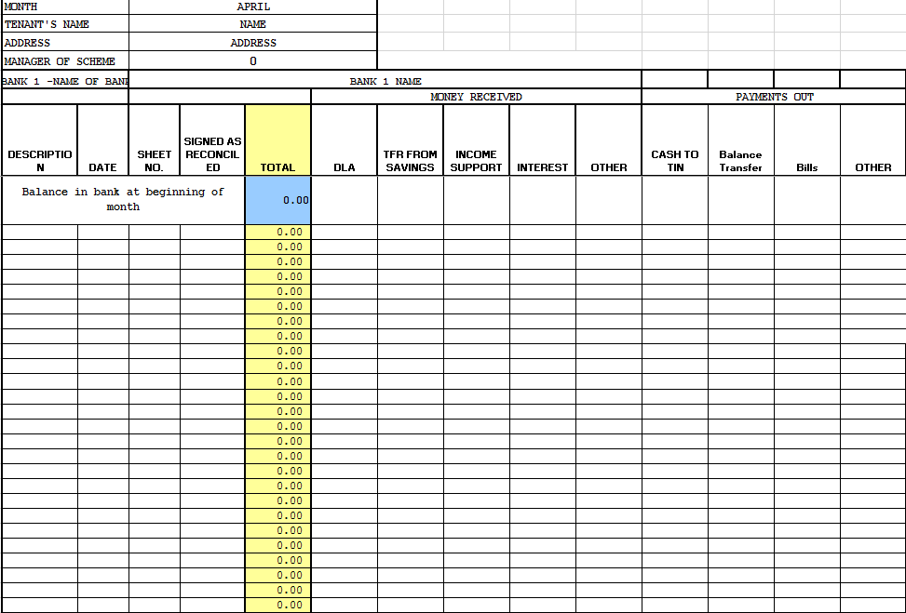
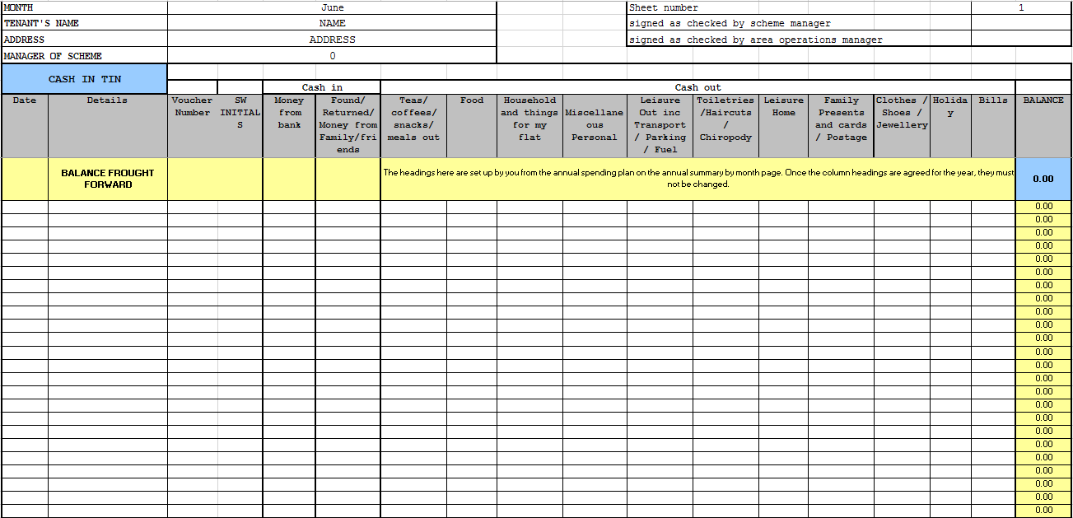
Computerised Money System – Old System, Monthly Example
Figure 2 CMR - For Bank Account
Figure 1 CMR - For Cash in Tin

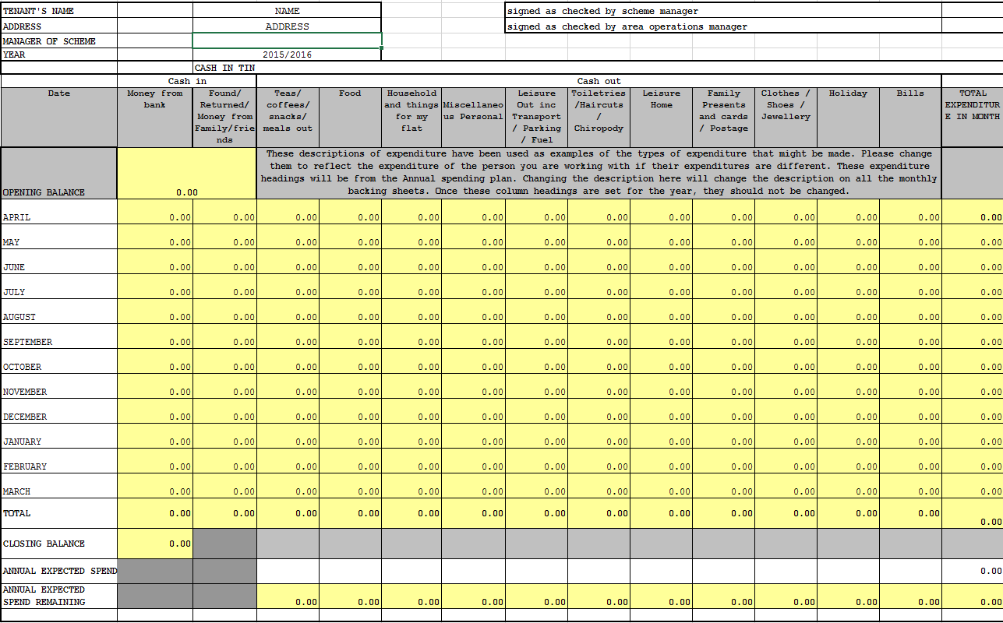
Computerised Money System – Old System, Budget report
Figure 3 CMR – Yearly Cash Budget Report

Survey of Existing Solution
Money Management System Investigation.
The purpose of this questionnaire is to gather an understanding of the implementation and problems with the current money management system to determine functional and non-functional requirements of a new system.

Current System
How often do you enter transactions in to the paper based money records?
Every time I am at work.

Do you find this form simple to use?
Yes

What problems do you encounter?
No problems, unless somebody has made a mistake and not realised it which sometimes leads to me having to make changes which doesn't look great.

Would you say that it is simple to correct an error?
Depends on how big the error is and how long ago it was made.

How often do you enter transactions in to the computerised money records?
Probably weekly.

How often do you reconcile bank statements?
Never.

How do you decide which category a transaction goes under?
Mostly by using supporting documentation, sometimes by using own judgement

What problems do you encounter?
None, apart from the fact that the process is really time consuming.

How do you find the software appearance?
Could be more compressed so that the whole form fits on the screen and you don't have to keep scrolling left and right.

Confidence and Documents
How confident are you using this current system?
Very confident.

How much supporting documentation is available?
Explanation of categories and where to enter transactions.

What additional support would you find beneficial?
Not really sure.

Do you find the system useful?
I'd find it much more useful if we only had the computerised system as that would save us a lot of time.

What additional features would you like?
Not really sure

Anything else you would like us to know?
No
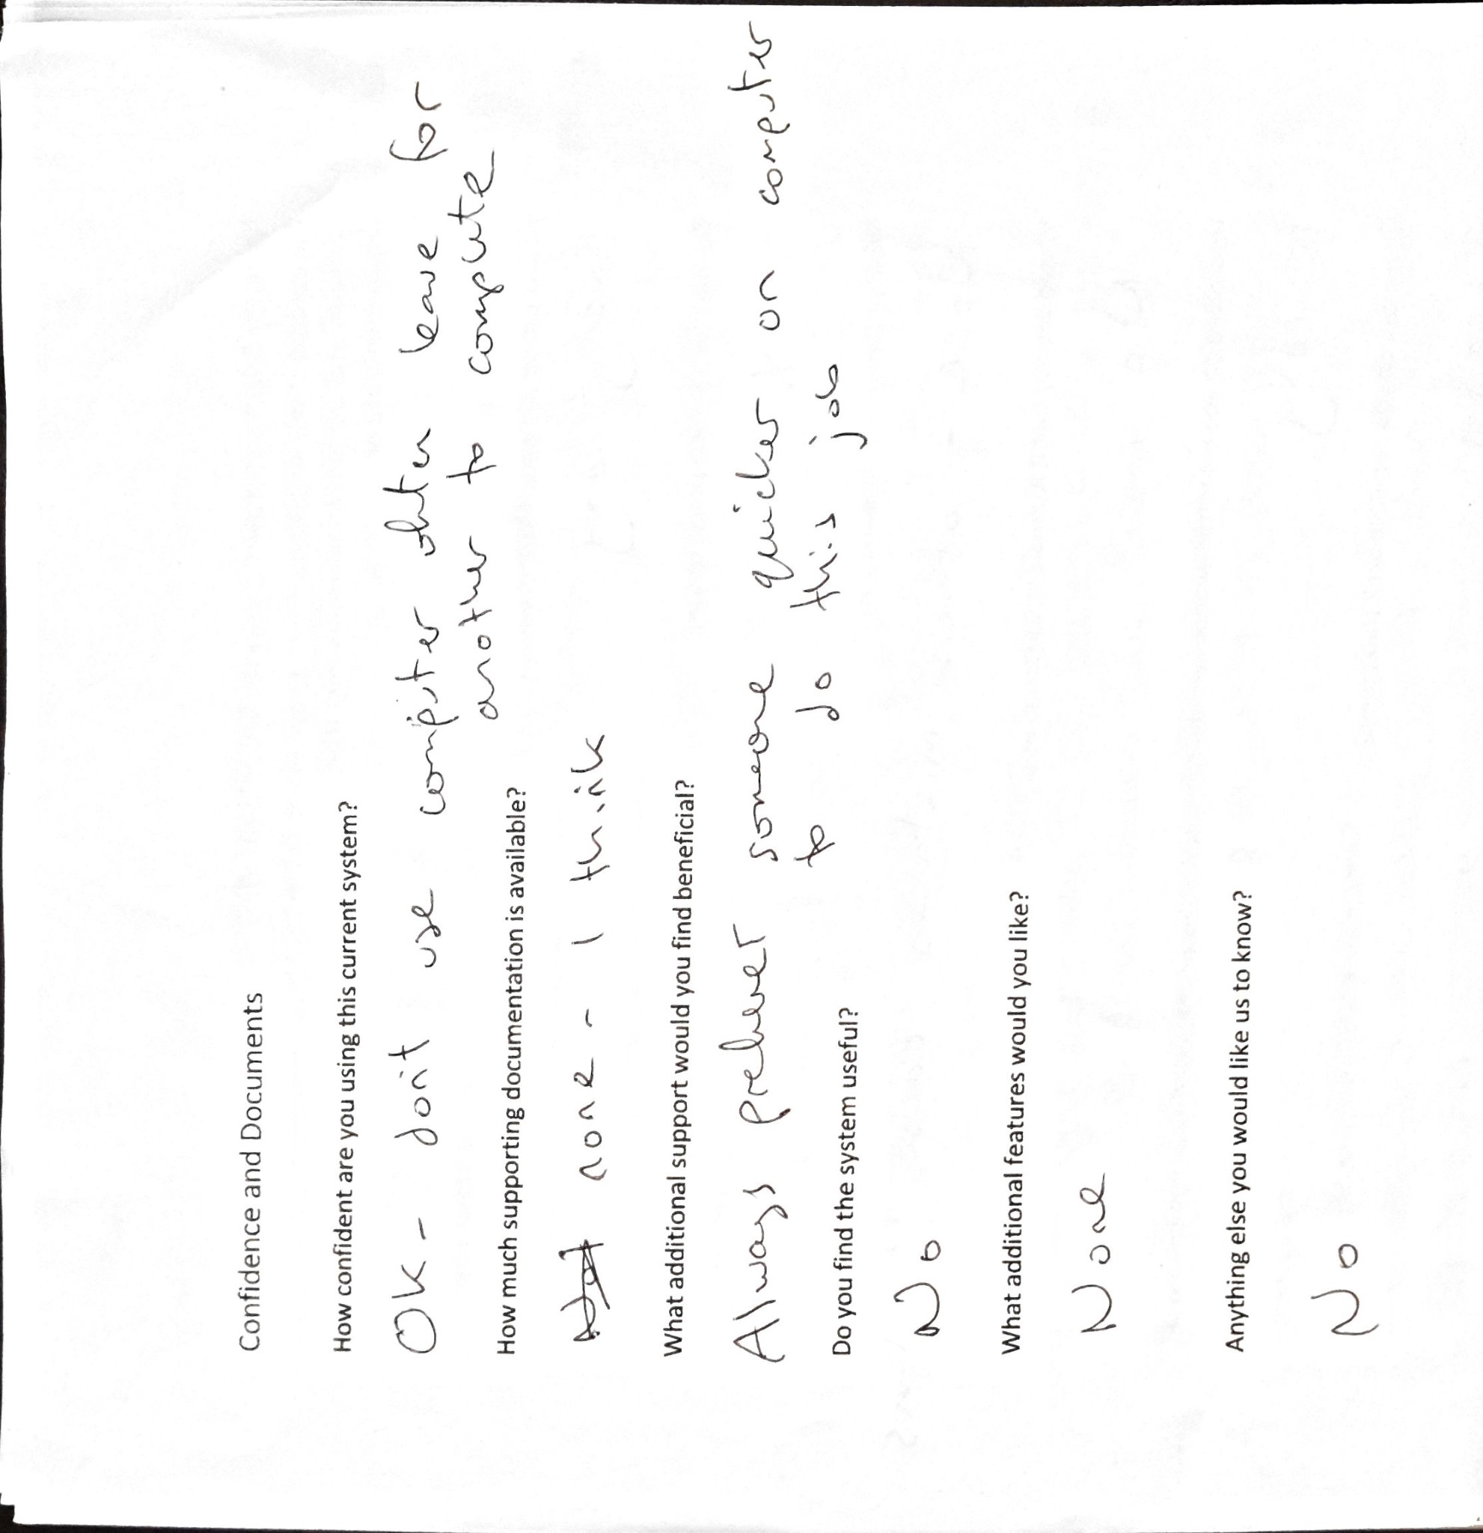
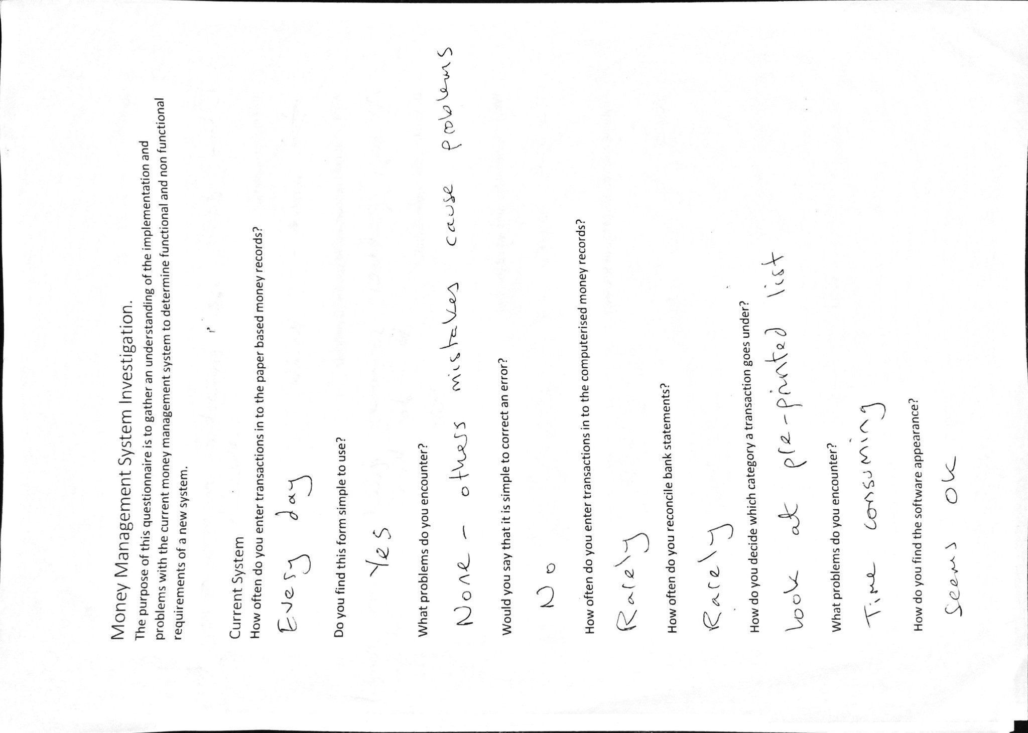

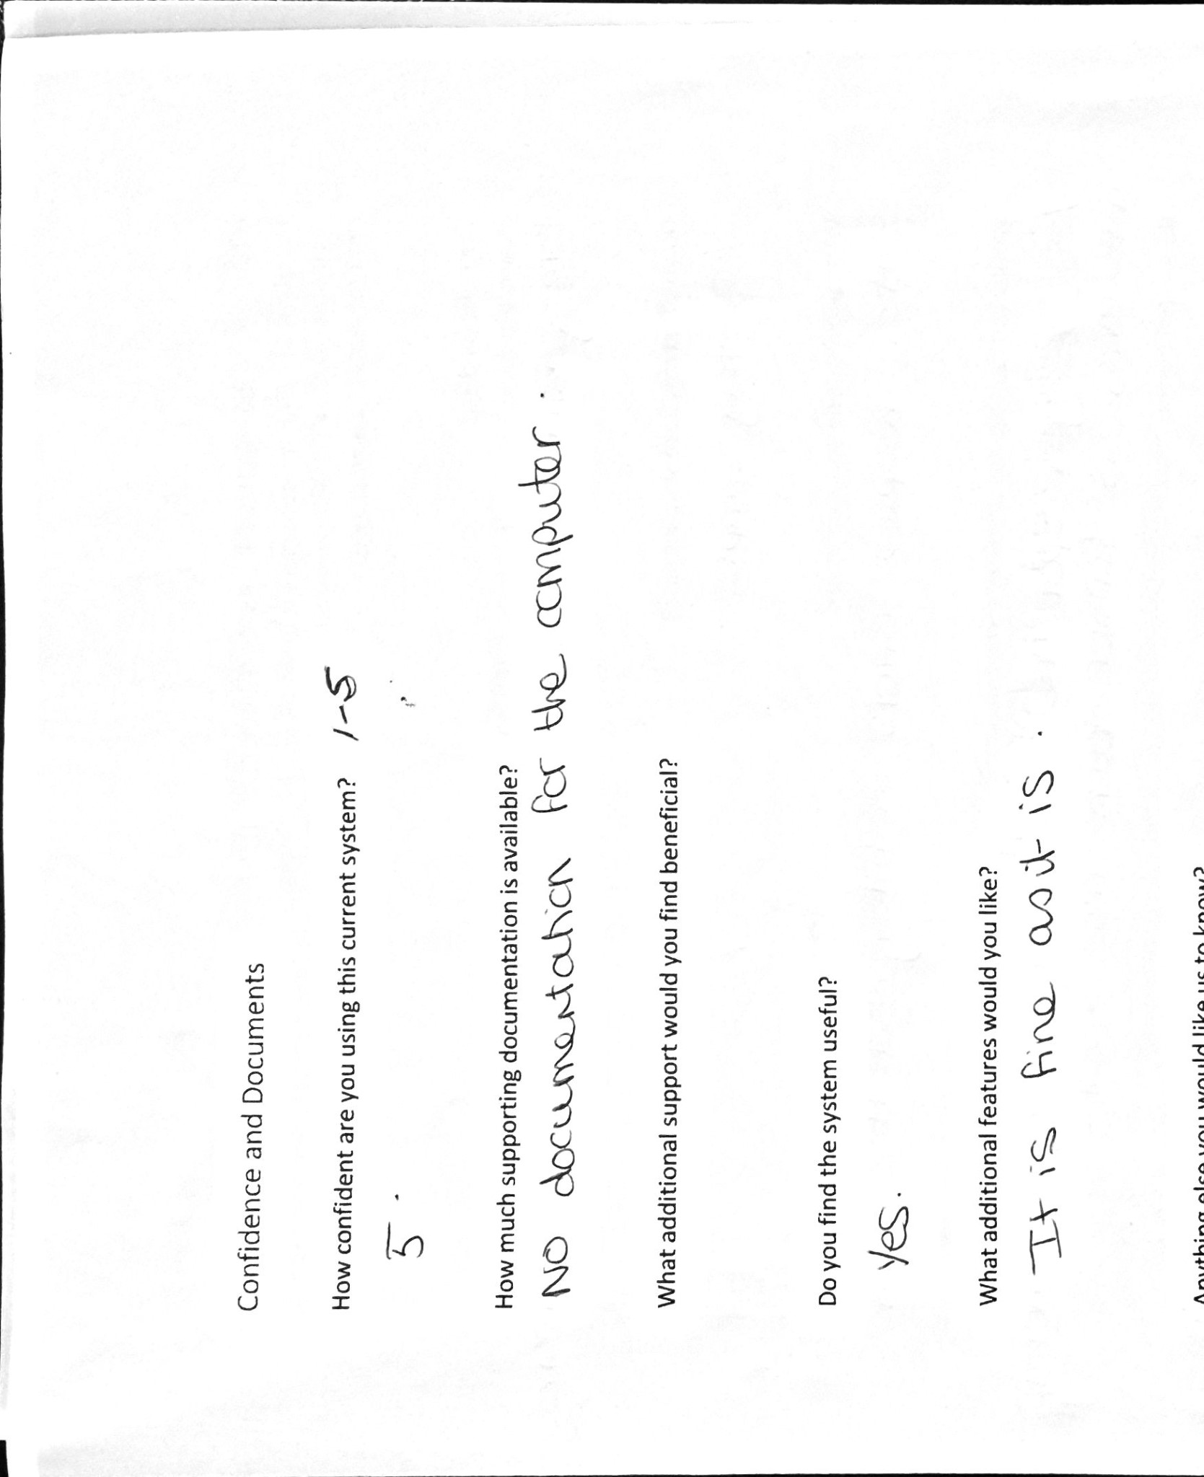
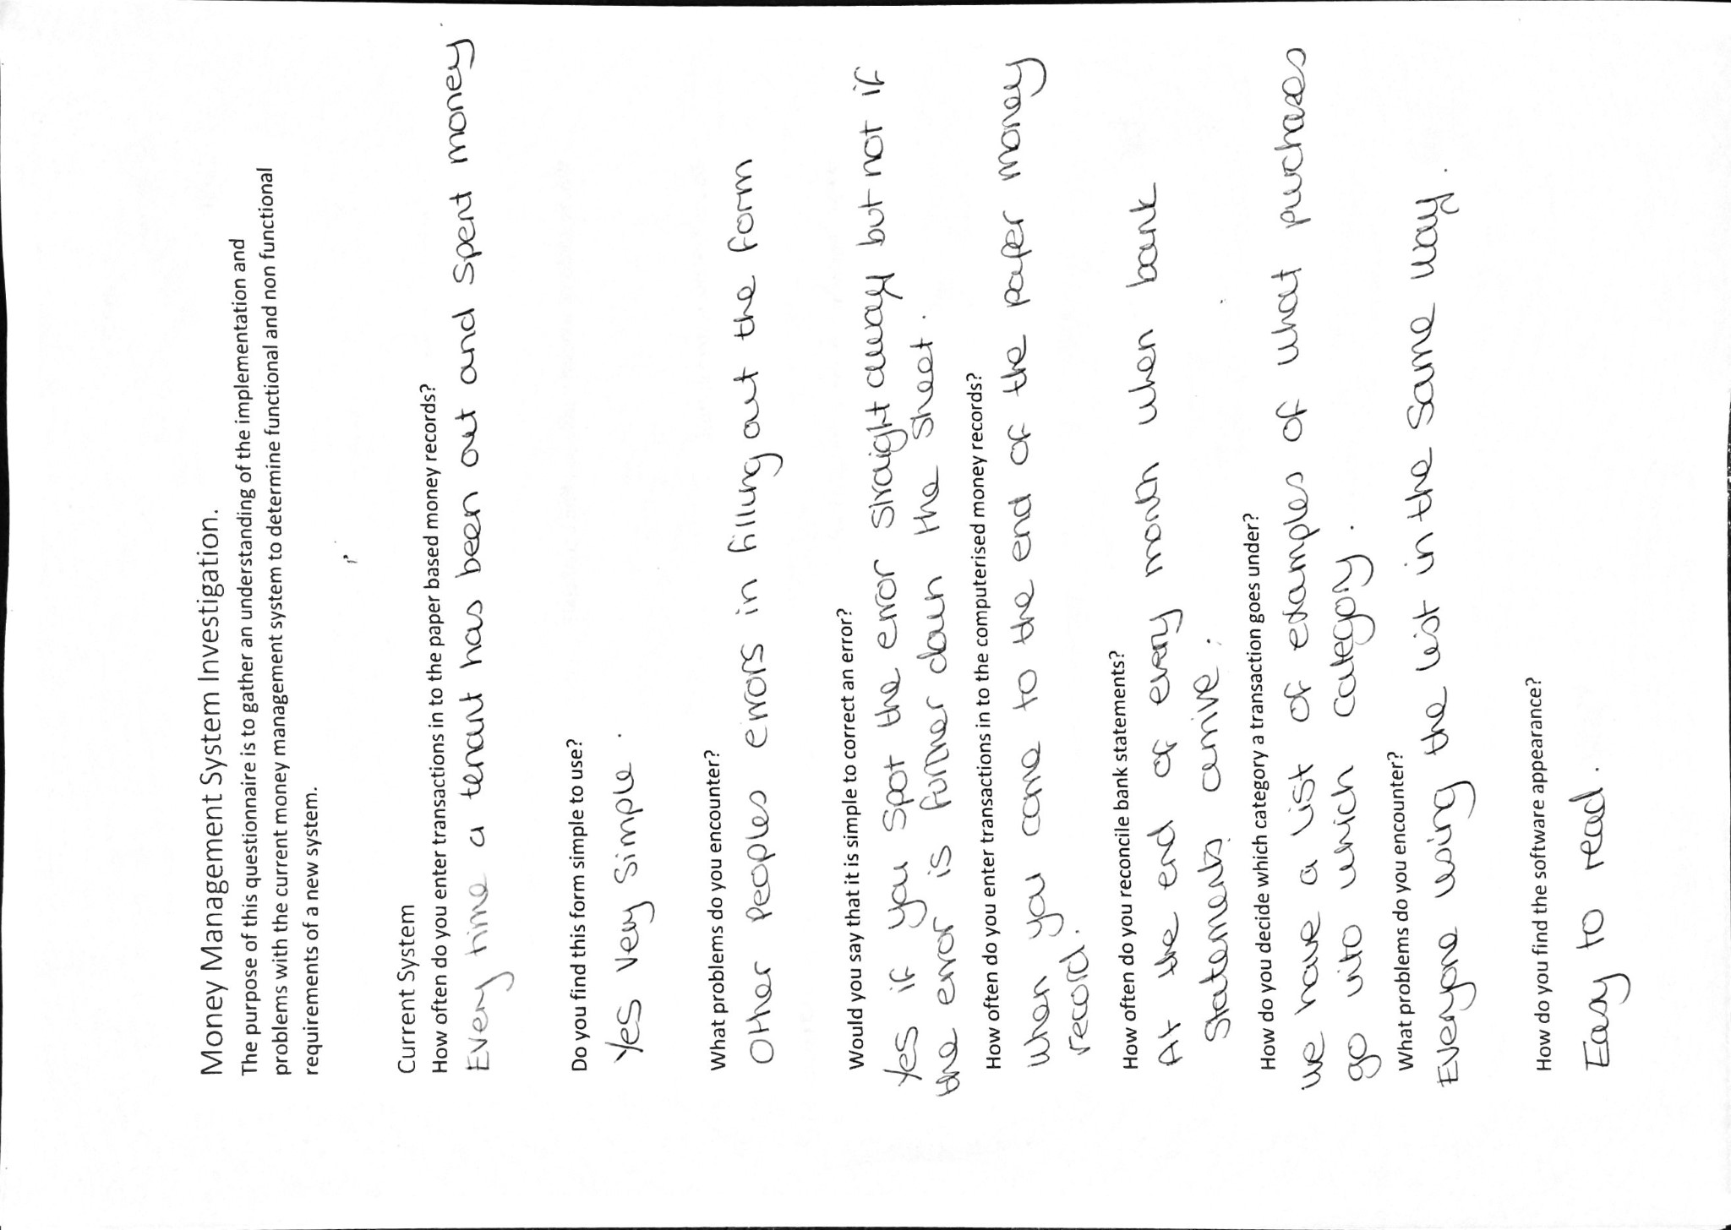
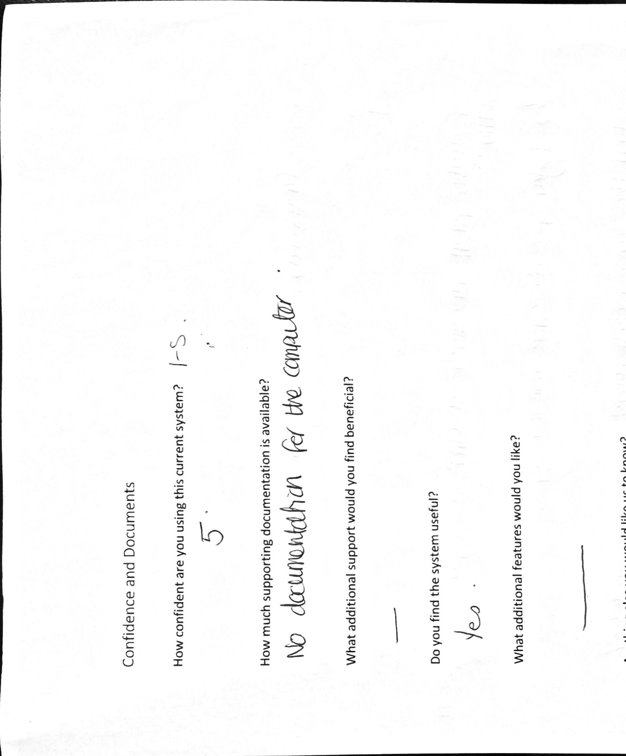
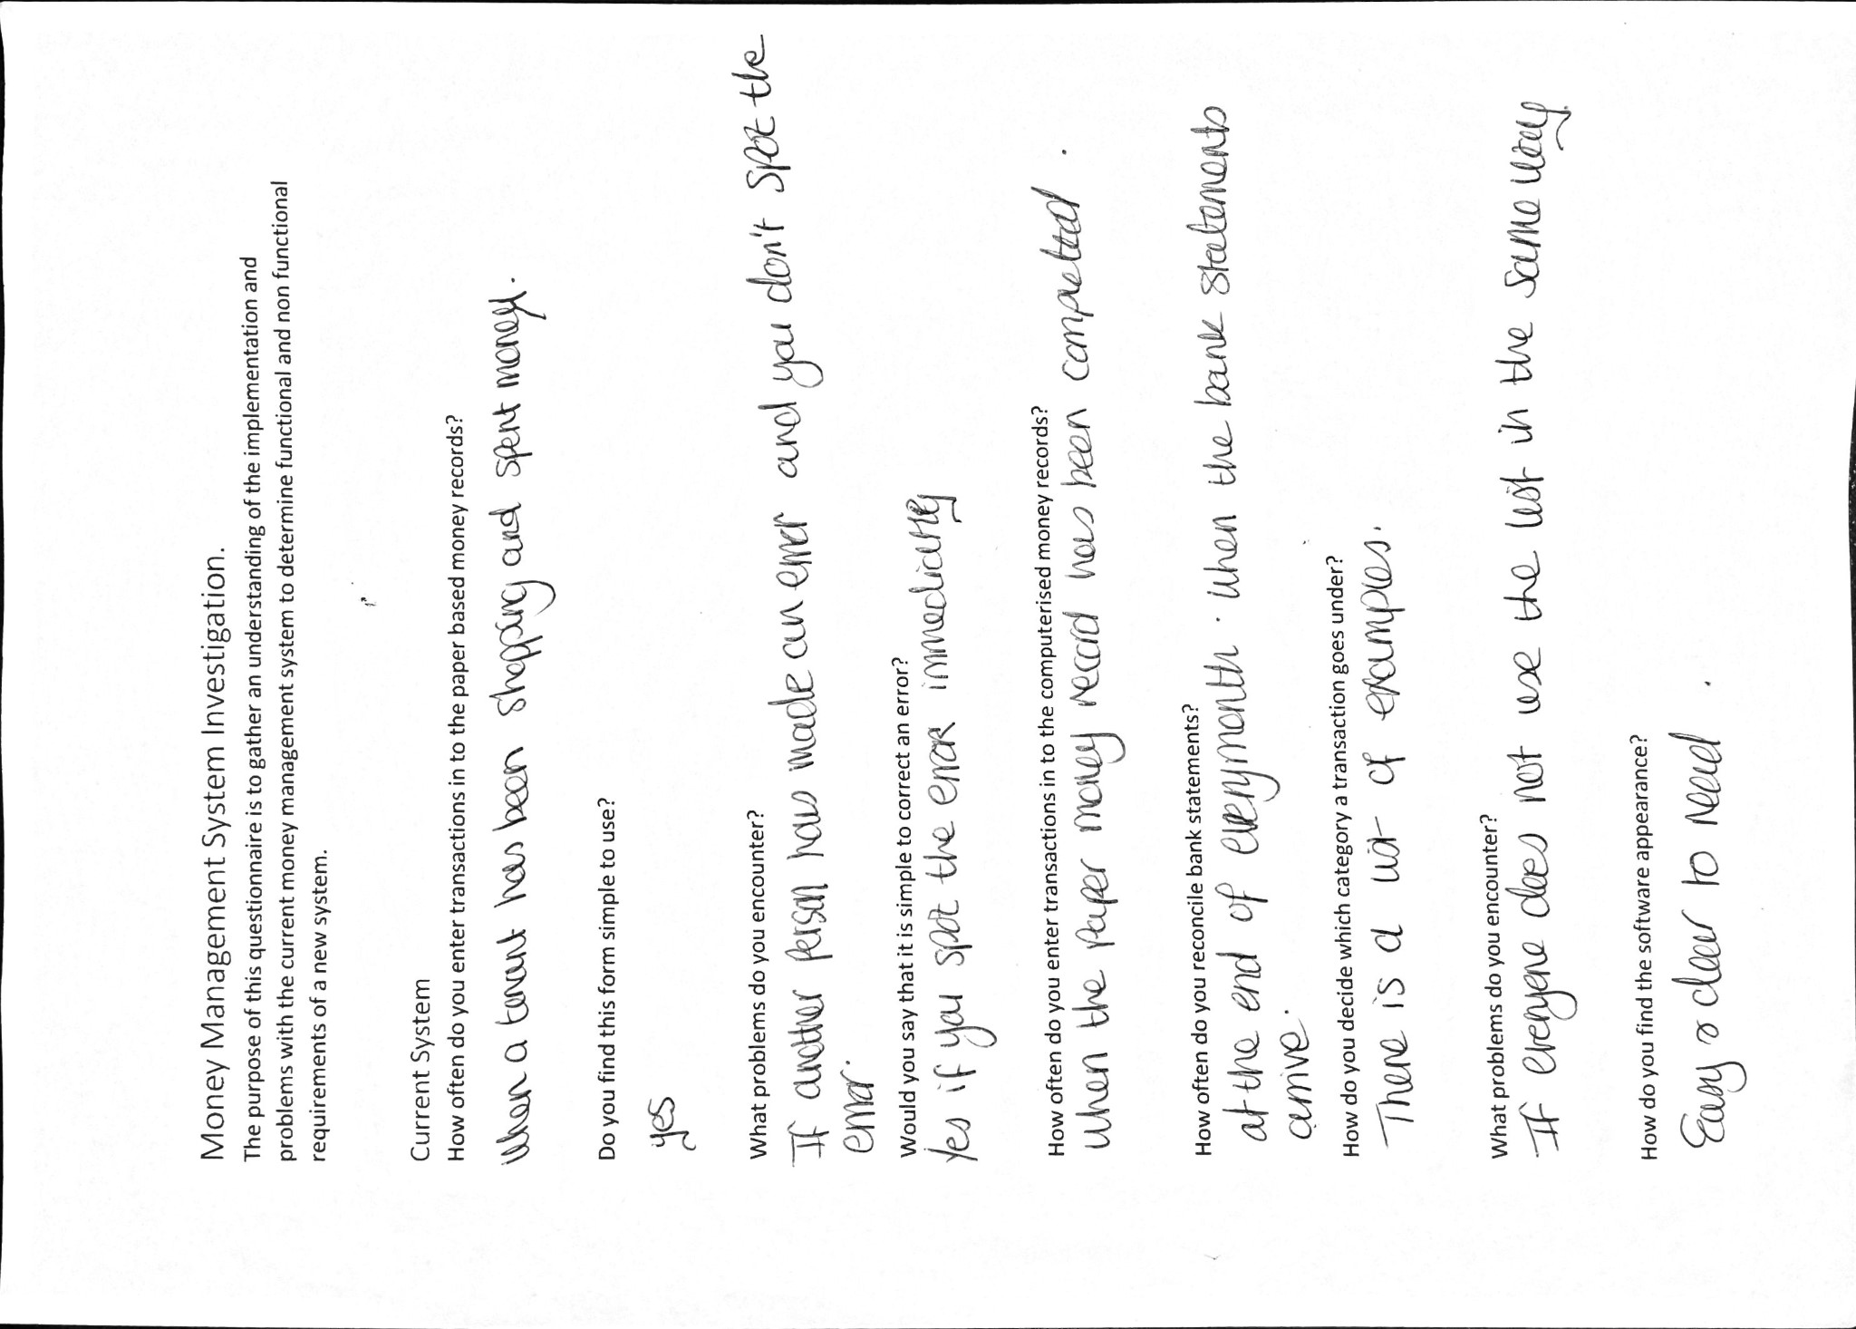

DFD and ERD explanations

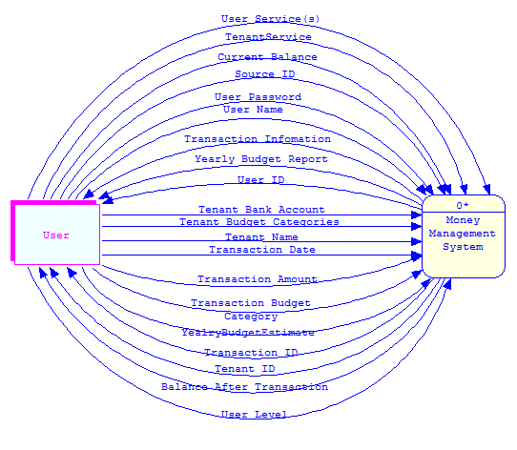
Context level DFD
The following is the context level DFD for the money management system. The context diagram shows the money management system as a single high level process as well as the relationship that the system has with the user.

Level 0 DFD
The following is the level 0 DFD for the money management system. The diagram shows the high level processes in brief and their relationships with external entities and data stores.
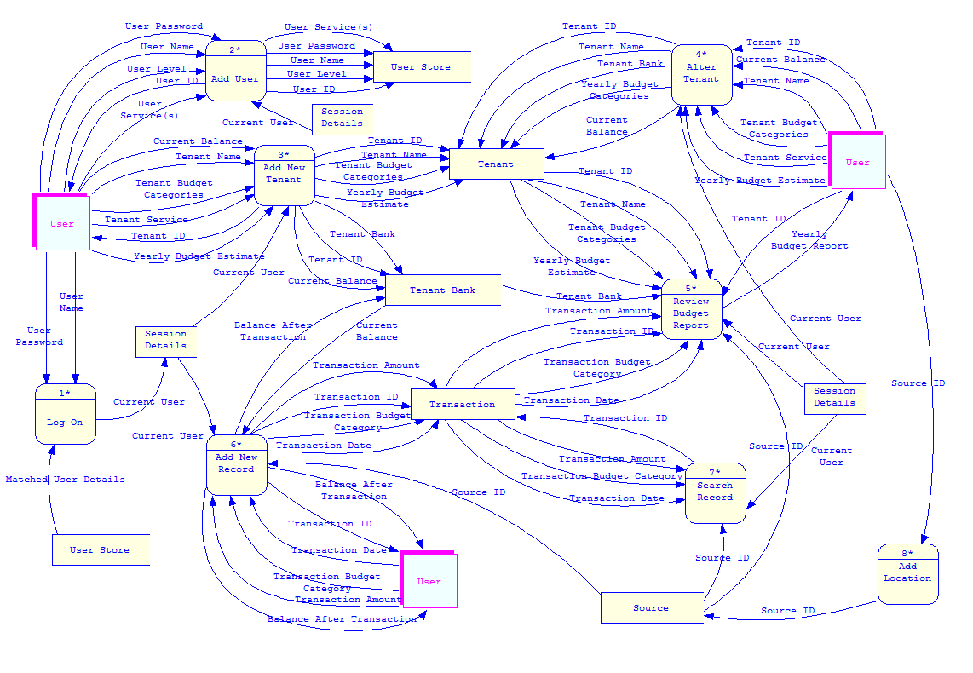

Level 1 DFD - Add new tenant
The following DFD is based on process 3 of the level 0 DFD – Add new tenant.
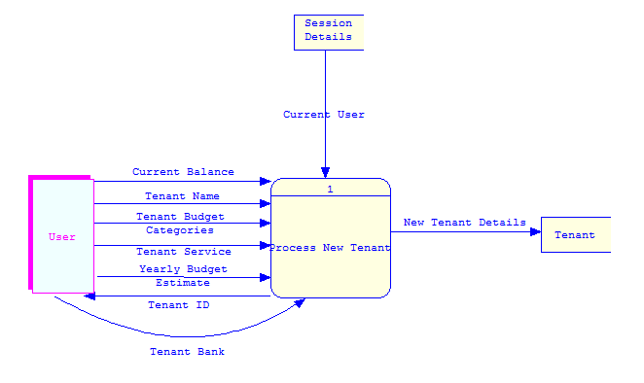

Level 1 DFD – Add user
The following DFD is based on process 2 of the level 0 DFD – Add user.
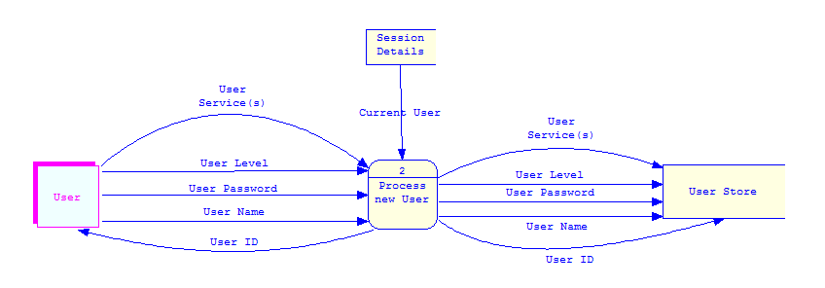

Level 1 DFD – log on
The following DFD is based on process 1 of the level 0 DFD – log on.
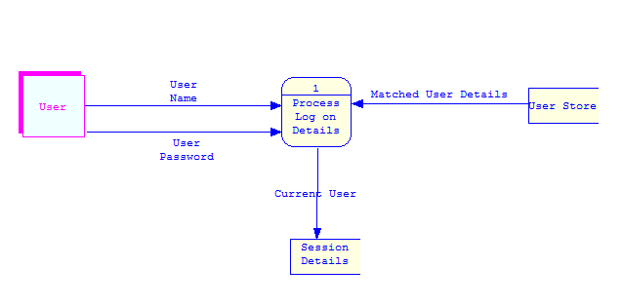

3NF ERD
The following is the 3rd normal form Entity Relationship Diagram for the money management system. It shows the relationships between the entities within the money management system.
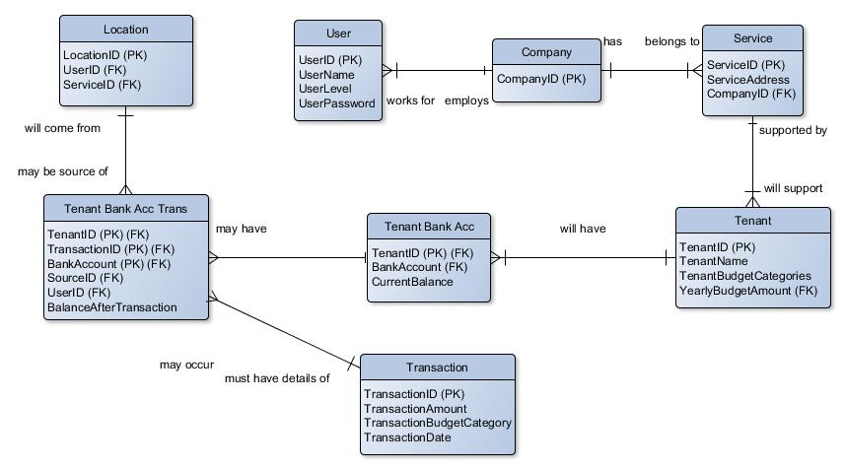

Testing
ID | Test | Expected Result | Actual Result
1 | SQL Handler – perform update query using executeUpdate function, the full update query must be the parameter of the function that will be changed. | The table in the database will be updated to show the data from the update query. | As expected
2 | SQL Handler – perform a count on the columns in a specific table using the GetColumnCount function. | The table in the database will contain the number of columns equal to the result returned by the function. | As expected
3 | SQL Handler – perform a select statement using the executeQuery function. The query will be the parameter of the function that will be changed. | The returned value will be the correct value of the select statement. | As expected
4 | SQL Handler – get a specific row of elements from a table using the getRowElements function. | The row values returned will be equal to the values in the table in the database. | As expected
5 | SQL Handler – produce a SQL update query from the parameters, it will then be passed to the executeUpdate function from within the updateData function. | The update statement will contain the correct values and in the correct order. The update statement must be passed to the executeUpdate function in string form. | As expected
6 | SQL Handler – perform the action of inserting a user to the table using the insertUser function. The user name, password, level and service ID will be the parameters of the function that will be changed. | The user will be added to the user table with the associated password, level and service ID. | As expected
7 | SQL Handler – perform the action of adding a user service using the insertService function. The user ID and service will be the parameters of the function that will be tested. | The service will be added to the service table with the associated user ID. | As expected
8 | SQL Handler – perform the action of retrieving a tenant ID from the tenant table using the getTenantID function. | The tenant ID is the associated tenant ID for the tenant name selected from the tenant name combo box. | As expected
9 | Add Location – review the service names displayed from the drop down menu. | The service names displayed will be all the service names in the service table in oracle. | As expected
10 | Add Location – review the location name to be added to the location table. | The location name will be taken from the text field labelled location name. | As expected
11 | Add Location – the add location button will be pressed. | The location and service name will be added to the location table. A message displaying ‘location added’ will be displayed to the user. | As expected
12 | Add Location – the back to main menu button will be pressed. | The GUI will switch to the appropriate main menu depending on what level user is currently using the system. | As expected
13 | Add New Category – the add new category text field will be filled with the category name. | The add new category text field will be the text that is used as the category name. | As expected
14 | Add New Category – add category button will be pressed. | The add new category text field contents will be added to the category table as the category name. | As expected
15 | Add New Category – the back to main menu button will be pressed. | The GUI will switch to the appropriate main menu depending on what level user is currently using the system. | As expected
16 | Add New Tenant – the tenant first name will be entered to the text field labelled tenant first name. | The tenant first name text field contents will be used as the tenant first name. | As expected
17 | Add New Tenant – the tenant second name will be entered to the text field labelled tenant second name. | The tenant second name text field contents will be used as the tenant second name. | As expected
18 | Add New Tenant – the tenant service name combo box will be displayed. | The tenant service combo box will contain all the service names from the service table. | As expected
19 | Add New Tenant – the add new tenant button will be pressed. | The tenant first name, tenant second name and service ID will be added to the tenant table. | As expected
20 | Add New Tenant – the back to main menu button will be pressed. | The GUI will switch to the appropriate main menu depending on what level user is currently using the system. | As expected
21 | Add New Transaction In – the sender name will be entered to the text field labelled sender. | The sender text field contents will be used as the sender name. | As expected
22 | Add New Transaction In – the bank account combo box will be displayed. | All the bank accounts associated with the tenant are displayed in the combo box. | As expected
23 | Add New Transaction In – the amount of the transaction will be entered in to the text field labelled amount. | The amount text field contents will be used as the amount of the transaction. | As expected
24 | Add New Transaction In – the add button will be pressed. | The sender, bank account and amount will be added to the transaction table. | As expected
25 | Add New Transaction In – the back to the main menu button will be pressed. | The GUI will switch to the appropriate main menu depending on what level user is currently using the system. | As expected
26 | Add New Transaction Out – the budget category combo box will be displayed. | The budget categories in category table will match the categories displayed in the combo box. | As expected
27 | Add New Transaction Out – the bank account combo box will be displayed. | All the associated bank accounts for the tenant will be displayed in the combo box. | As expected
28 | Add New Transaction Out – the location combo box will be displayed. | The locations in the location table will match the locations displayed in the combo box. | As expected
29 | Add New Transaction Out – the amount of the transaction will be entered in the text field labelled amount. | The amount text field contents will be used as the amount of the transaction. | As expected
30 | Add New Transaction Out – the add button will be pressed. | The budget category, bank account, location and amount will be added to the transaction table. | As expected
31 | Add New Transaction Out – the back to the main menu button will be pressed. | The GUI will switch to the appropriate main menu depending on what level user is currently using the system. | As expected
32 | Add New User – the name of the user will be entered to the text field labelled user name. | The user name text field contents will be used as the user name. | As expected
33 | Add New User – the password of the user will be entered to the text field labelled password. | The password text field contents will be used as the user password. | As expected
34 | Add New User – the user level combo box will be displayed. | The user level combo box will display manager, staff and tenant. | As expected
35 | Add New User – the service name combo box will be displayed. | The service names from the service table will match the service names in the combo box. | As expected
36 | Add New User – the tenant name combo box will be displayed. | The tenant names from the tenant table will match the tenant names in the combo box. | As expected
37 | Add New User – the add button will be pressed. | The user name, password, level and service name will be added to the user table. | As expected
38 | Add New User – the back to the main menu button will be pressed. | The GUI will switch to the appropriate main menu depending on what level user is currently using the system. | As expected
39 | Add Service – the service name will be entered in to the service name text field. | The service name text field contents will be used as the service name. | As expected
40 | Add Service – the service address will be entered in to the service address text field. | The service address text field contents will be used as the service name. | As expected
41 | Add Service – the add button will be pressed. | The service name and service address will be added to the service table. | As expected
42 | Add service – the back to main menu button will be pressed. | The GUI will switch to the appropriate main menu depending on what level user is currently using the system. | As expected
43 | Alter Tenant –the tenant first name will be entered in to the tenant first name text field. | The tenant first name text field contents will be used as the tenant first name. | As expected
44 | Alter Tenant – the tenant second name will be entered in to the tenant second name text field. | The tenant second name text field contents will be used as the tenant second name. | As expected
45 | Alter Tenant – the service name combo box will be displayed. | The service names in the service table will match the service names displayed in the combo box. | As expected
46 | Alter Tenant – the budget category combo box will be displayed. | The budget categories in the categories table will match the budget categories displayed in the combo box. | As expected
47 | Alter Tenant – the estimated annual spend will be entered in to the estimated annual spend text field. | The estimated annual spend text field contents will be used as the estimated annual spend. | As expected
48 | Alter Tenant – the budget category add button will be pressed. | The budget category and the estimated annual spend will be added to the text areas below. | As expected
49 | Alter Tenant – the budget category will be selected and the remove button will be pressed. | The selected budget category and corresponding estimated annual spend value will be removed from the text area. | As expected
50 | Alter Tenant – the bank account name will be entered in to the tenant bank account text field. | The bank account text field contents will be used as the bank account name. | As expected
51 | Alter Tenant – the bank balance will be entered in to the bank balance text field. | The bank balance text field contents will be used as the bank balance. | As expected
52 | Alter Tenant – the bank account add button will be pressed. | The bank account name and the bank balance will be added to the text area below. | As expected
53 | Alter Tenant – the bank account will be selected and the remove button will be pressed. | The selected bank account and corresponding estimated annual spend value will be removed from the text area. | As expected
54 | Alter Tenant – the alter button will be pressed. | Any changes made to the tenant details will be changed in the appropriate tables. | As expected
55 | Alter Tenant – the back to main menu button will be pressed. | The GUI will switch to the appropriate main menu depending on what level user is currently using the system. | As expected
56 | Approve Transaction In – display all transactions in text area. | All transactions in will be displayed in the text area. Transactions will be able to be selected. | As expected
57 | Approve Transaction In – a transaction in will be selected and the approve button will be pressed. | The transaction will become approved and will be removed from the text area. | As expected
58 | Approve Transaction In – the back to main menu button will be pressed. | The GUI will switch to the appropriate main menu depending on what level user is currently using the system. | As expected
59 | Approve Transaction Out – display all transactions out text area. | All transactions out will be displayed in the text area. Transactions will be able to be selected. | As expected
60 | Approve Transaction Out – a transaction out will be selected and the approve button will be pressed. | The transaction will become approved and will be removed from the text area. | As expected
61 | Approve Transaction Out – the back to main menu button will be pressed. | The GUI will switch to the appropriate main menu depending on what level user is currently using the system. | As expected
62 | Budget Report – transactions will have taken place. | The values associated with the transactions will be placed in to the correct place in the table. | As expected
63 | Budget Report – the back to main menu button will be pressed. | The GUI will switch to the appropriate main menu depending on what level user is currently using the system. | As expected
64 | Log On – the user name will be entered in to the user name text field. | The user name text field contents will be used as the user name. | As expected
65 | Log On – the password will be entered in to the password text field. | The password text field contents will be used as the password. | As expected
66 | Log On – log on button | The user name and password will be verified against the user table. If the log on is successful then the GUI will switch to the appropriate main menu depending on the level of the user. | As expected
67 | Manager Main Menu – the add new user button will be pressed. | The GUI will switch to the add new user GUI. | As expected
68 | Manager Main Menu – the add new tenant button will be pressed. | The GUI will switch to the add new tenant GUI. | As expected
69 | Manager Main Menu – the add location button will be pressed. | The GUI will switch to the add location GUI. | As expected
70 | Manager Main Menu – the search tenant button will be pressed. | The GUI will switch to the search tenant GUI. | As expected
71 | Manager Main Menu – the add service button will be pressed. | The GUI will switch to the add service GUI. | As expected
72 | Manager Main Menu – the log out button will be pressed. | The GUI will switch to the log on GUI. | As expected
73 | Search Tenant – the tenant name will be entered in to the text field labelled tenant name. | The tenant name text field contents will be used as the tenant name. | As expected
74 | Search Tenant – the alter tenant button will be pressed. | The GUI will switch to the alter tenant GUI. | As expected
75 | Search Tenant –the add new transaction out button will be pressed. | The GUI will switch to the add new transaction out GUI. | As expected
76 | Search Tenant – the add new transaction in button will be pressed. | The GUI will switch to the add new transaction in GUI. | As expected
77 | Search Tenant – the search transactions button will be pressed. | The GUI will switch to the search transactions GUI. | As expected
78 | Search Tenant – the budget report button will be pressed. | The GUI will switch to the budget report GUI. | As expected
79 | Search Tenant – the back to main menu button will be pressed. | The GUI will switch to the appropriate main menu depending on what level user is currently using the system. | As expected
80 | Search Transactions – the search by combo box will be displayed. | The budget category names will match the budget category names in the category table. | As expected
81 | Search Transactions – the search criteria will be entered in to the text field labelled search. | The search text field contents will be used as the search criteria. | As expected
82 | Search Transactions – the search button will be pressed. | The GUI will switch to the transactions GUI. The search by and search criteria will be used to display selected transactions that meet the search criteria in the transactions GUI. | As expected
83 | Search Transactions – the back to main menu button will be pressed. | The GUI will switch to the appropriate main menu depending on what level user is currently using the system. | As expected
84 | Staff Main Menu – the add new tenant button will be pressed. | The GUI will switch to the add new tenant GUI. | As expected
85 | Staff Main Menu – the add locations button will be pressed. | The GUI will switch to the add location GUI. | As expected
86 | Staff Main Menu – the search tenant button will be pressed. | The GUI will switch to the search tenant GUI. | As expected
87 | Staff Main Menu – the log out button will be pressed. | The GUI will switch to the log on GUI. | As expected
88 | Tenant Main Menu – the search transactions button will be pressed. | The GUI will switch to the search transactions GUI. | As expected
89 | Tenant Main Menu – the budget report button will be pressed. | The GUI will switch to the budget report GUI. | As expected
90 | Tenant Main Menu – the transaction out for approval button will be pressed. | The GUI will switch to the transactions out GUI. | As expected
91 | Tenant Main Menu – the transaction in for approval button will be pressed. | The GUI will switch to the transactions in GUI. | As expected
92 | Tenant Main Menu – the log out button will be pressed. | The GUI will switch to the log on GUI. | As expected
93 | Transactions – transactions will have taken place. | The values associated with the transactions will be placed in to the correct place in the table. | As expected
94 | Transactions – the back to main menu button will be pressed. | The GUI will switch to the appropriate main menu depending on what level user is currently using the system. | As expected
95 | Add New Tenant Next – the budget category combo box will be displayed. | The budget categories in the categories table will match the budget categories displayed in the combo box. | As expected
96 | Add New Tenant Next – the estimated annual spend will be entered in to the text field labelled estimated annual spend. | The estimated annual spend text field contents will be used as the estimated annual spend. | As expected
97 | Add New Tenant Next – the add button next to estimated annual spend will be pressed. | The budget category and the estimated annual spend will be added to the text areas below. | As expected
98 | Add New Tenant Next – the add category button will be pressed. | The GUI will switch to the add category GUI. | As expected
99 | Add New Tenant Next – the bank account will be entered in to the text field labelled bank account. | The bank account text field contents will be used as the bank account name. | As expected
100 | Add New Tenant Next – the current balance will be entered to the text field labelled current balance. | The bank balance text field contents will be used as the current balance. | As expected
101 | Add New Tenant Next – the add button next to current balance will be pressed. | The bank account name and the bank balance will be added to the text area below. | As expected
102 | Add New Tenant Next – add new tenant button | The tenant details will be added to the appropriate tables. | As expected
103 | Add New Tenant Next – the back to main menu button will be pressed. | The GUI will switch to the appropriate main menu depending on what level user is currently using the system. | As expected

Technical User Test
ID | Test | Expected Result | Actual Result
1 | The user will log on. | The user will be able to log on with their password and user name. | As expected
2 | The user will add a new user. | The user will be able to add a new user. | As expected
3 | The user will search a tenant. | The user will be able to search a tenant. | As expected
4 | The user will add a transaction in for a tenant. | The user will add a transaction in. | As expected
5 | The user will approve a transaction in. | The user will be able to approve a transaction in. | As expected
6 | The user will add a transaction out. | The user will be able to add a transaction out. | As expected
7 | The user will add a transaction out. | The user will be able to approve a transaction out. | As expected
8 | The user will view the budget report for a tenant. | The user will be able to view the budget report. | As expected
9 | The user will search transactions for a tenant. | The user will be able to search transactions. | As expected

Non-Technical User Test
ID | Test | Expected Result | Actual Result
1 | The user will log on. | The user will be able to log on with their password and user name. | As expected
2 | The user will add a new user. | The user will be able to add a new user. | As expected
3 | The user will search a tenant. | The user will be able to search a tenant. | As expected
4 | The user will add a transaction in for a tenant. | The user will add a transaction in. | As expected
5 | The user will approve a transaction in. | The user will be able to approve a transaction in. | As expected
6 | The user will add a transaction out. | The user will be able to add a transaction out. | As expected
7 | The user will add a transaction out. | The user will be able to approve a transaction out. | As expected
8 | The user will view the budget report for a tenant. | The user will be able to view the budget report. | As expected
9 | The user will search transactions for a tenant. | The user will be able to search transactions. | As expected

User Manual for Staff and Managers
Step 1: Logging In
Enter your username and password to log in. Passwords should not be written down unless needed and should be kept safe.
Step 2: Main menu
After logging in, you will be presented with 6 different options:
- Add New User – add a new user account to the system. These accounts are used for logging into and using the system. (Only available to Managers)
- Add New Tenant – add a new Tenant to the system. This does not create a user account for the tenant. (Only available to Managers)
- Add Location – add a new location into the system. These are associated with a service, and are used to specify where money was spent by a tenant, e.g. Shop or Cinema.
- Search Tenant – search for, and find a single tenant record. New options will become available once a tenant is selected.
- Add Service – add a new service into the system.

Add New User (Only available to Managers)
Fill in all the required fields in order to create a new user account, then click the “Add New User” button.
- User Name – the name of the account. This will be used on the login screen to access the account.
- Password – the password for the account. A password must be at least 6 and at most 24 characters long.
- User Level – select the type of account from the drop down menu. This will affect what the account is allowed to do.
  - A Manager account has all permissions – they can add and alter tenant and user accounts, as well as add new services.
  - A Staff account can add and alter tenant records, but it cannot add new user accounts or new services.
  - A Tenant account can view their own transactions or budget report, as well as approving transactions added by a staff member. They cannot alter any information.
- Service Name – select the service that the user works for using the drop down menu.
- Tenant Name – if the new account is a Tenant-level account a Tenant Name needs to be provided, in order to allow the account to have access to the right records. Select the appropriate name from the drop down menu.
Add New Tenant (Only available to Managers)
Fill in the required fields in order to add a new tenant record into the system
- Tenant First Name – enter the tenant’s first name.
- Tenant Surname – enter the tenant’s surname.
- Service Name – select the service that the tenant is associated with from the dropdown menu.
Clicking the add tenant button will take you to the next screen, which will allow you to add budget categories and their estimated yearly budget for the newly created tenant
- Tenant Budget Category – select the appropriate category from the drop down menu, and enter the estimated annual spending in the text box on the right, then click the Add button. The record will be added to the text boxes below, and you may add another category.
- Tenant Bank Account – enter the name of a bank account into the text box on the left, and enter the current balance of the account on the right, then click the Add button. This record will be added to the text boxes below, and you may add another bank account.
- Add Category – click this button to add a new budget category, if you cannot find an appropriate one in the drop down menu. Clicking the button will open a window. Enter the name of the category and click the Add button to add the category to the database.
Once all of the information is filled in, click the submit button to finalize adding a new tenant into the system.
Add Location
Locations are anywhere where money can come from or be spent. This includes cash withdrawals, balance transfers and bills.
Fill in the required fields to add a new location into the system.
- Service Name – select the appropriate service from the dropdown menu. The location will only be available to tenants that are associated with this service.
- Location name – enter the name of the location.
Once the information is filled in, click the Add Location button to add the location to the system.
Search Tenant
This menu allows you to search for and access a single tenants records to view or alter them, as well as add new transactions for a single tenant.
- Tenant - select the appropriate tenant from the drop down menu. This is the tenant that you wish to alter or add new records for.
- Alter Tenant – click this button to change the details of the tenant. These include:
  - Tenant First Name – enter a new first name for the tenant. The default value is the current first name.
  - Tenant Surname – enter a new surname for the tenant. The default value is the current surname.
  - Service Name – change the service that the tenant is associated with. Select the new service from the drop down menu. The default value is the current service.
  - Tenant Budget Category – Add or remove budget categories for the tenant, following the same procedure as when adding a new tenant. This should ONLY be done at the start of the financial year. These should be what was decided in the Annual Spending Plan
  - Bank account – Add or remove bank accounts for the tenant, following the same procedure as when adding a new tenant. Keep all bank statements and bank books for 7 years.
  - Add New Category – Add a new budget category to the system, if the appropriate one cannot be found in the drop down menu.
- Add New Transaction Out
  - Budget Category – select the appropriate category from the drop down menu.
  - Bank Account – select the appropriate bank account from the drop down menu.
  - Location – select the appropriate location from the drop down menu.
  - Amount – enter the total cost for the transaction.
  - Add New Transaction – once the above information is entered, press this button to add the transaction to the database.
- Add New Transaction In
  - Location – select the appropriate location from the drop down menu.
  - Bank Account – select the appropriate bank account from the drop down menu.
  - Amount – enter the total income from the transaction.
  - Submit – once the above information is entered, press this button to add the transaction to the database.
- Search Transaction
  - Search By – select the appropriate category from the drop down menu.
- Budget Report
  - Displays the budget report for the tenant. This report shows the expenditures and incomes for the tenant, for each category, for each month, as well as the estimated annual spending and the difference between the actual and estimated expenditures.
Add Service (Only available to Managers)
Fill in the required fields to add a new service into the system.
- Service Name – enter the name of the service.
- Service Address – enter the main office address of the service.
Click the Add Service button to add the service to the system.

Team Meeting Minutes

Meeting 1
Attending: KS, MBK, IS, MS, PR
Date: 23/11/15
Time: 1pm
Location: MAE
Agenda:
To discuss project ideas and create proposal for group tutor.
Outcome:
2 ideas have been put forward for the project and a brief overview of these have been emailed to Paul Bowden. Awaiting feedback to the proposals. Group communication platforms have been established and will be used for group discussions. A drive has been created to upload all work.

Meeting 2
Attending: KS, MBK, IS, MS, PR
Date: 30/11/15
Time: 1pm
Location: MAE
Agenda:
To investigate the Product Definition document and determine group roles.
Outcome:
Kelly has put herself forward as project manager and Meghan is happy to assist her. Kelly has been having some trouble with her hand so will work together to produce the first 3 elements of the Project Definition Document.
Project Management and Team Members and Responsibilities have been assigned to Marcin.
Sources of Information and Resources and the Risk Assessment have been assigned to Philip.
Professional, Social and Legal Issues and the Project Plan sections have been assigned to Inderjit.
The primary deadline for this work is the 12th of December so that the group can review this work and feedback. As this is in the university holiday, the work will be uploaded to the group’s drive.

Meeting 3
Attending: KS, MBK, IS, MS, PR
Date: 07/12/15
Time: 1pm
Location: MAE
Agenda:
Do work on the assigned sections and get any feedback.
Outcome:
Work on all sections took place in this meeting. This was mostly a meeting to make sure everyone was confident with the work they were doing and could ask any questions. The group all uploaded their Belbin figures for the team members section so they could be reflected upon. Kelly will put all the work together in to 1 document ready for the hand in.

Meeting 4
Attending: KS, MBK, IS,
Date: 08/12/15
Time: 1pm
Location: MAE
Agenda:
Meeting with Paul Bowden for feedback on the group idea and to ensure the group was on track.
Outcome:
Relayed information of the choices that have been made and Paul is happy that the project is on track.

Meeting 5
Attending: KS, MBK, (IS, MS, PR on whatsapp)
Date: 11/01/16
Time: 5pm
Location: MAE
Agenda:
Check over document and make the necessary improvements.
Outcome:
Some work needed adjusting due to being written with We/I etc. Some adjustments made to gantt chart due to unreachable target in programming timing and extra detail added. All the group was then happy to submit this to Paul Bowden the next day.

Meeting 6
Attending: KS, MBK, IS, MS, PR
Date: 18/01/16
Time: 1pm
Location: MAE
Agenda:
Assign tasks as detailed in Gantt chart.
Outcome:
Marcin and Philip will investigate how to integrate C++ and SQL
Kelly is writing the Use Cases.
Meghan and Indy will be looking at the existing solutions. Indy has suggested a questionnaire for the current users of the system.
These will be available for the next team meeting 1/2/16.

Meeting 7
Attending: KS, MBK, IS, MS, PR
Date: 25/01/16
Time: 1pm
Location: whatsapp – group messaging
Agenda:
Ensured assigned tasks were being completed.
Outcome:
Philip and Marcin worked on integrating the software and ran some initial testing.
Indy and Kelly planned and designed a survey of the existing solution to be carried out with the clients.

Meeting 8
Attending: KS, MBK, MS, PR
Date: 08/02/16
Time: 1pm
Location: MAE
Agenda:
Ensure design phase complete. Begin program development.
Outcome:
Kelly and Meghan completed normalisation and began the DFD and ERD designs, created the DFD’s on Win A&D.
Philip and Marcin continued with software implementation.

Meeting 9
Attending: KS, MBK, MS, PR
Date: 15/02/16
Time: 2pm
Location: MAE
Agenda:
Discuss existing solution with paper based and computerised records examples.
Outcome:
The group discussed the current system and uploaded to group dropbox for reference. Discussed the downfalls and benefits of this system. Research of existing solutions was also complete and Kelly detailed the functional and non-functional requirements of the system. This led to some updates of normalisation. Marcin designed the SQL tables, Phil continued with software.

Meeting 10
Attending: KS, MBK, MS, IS
Date: 22/02/16
Time: 1pm
Location: MAE
Agenda:
Complete Design documentation. Prepare for interim presentation.
Outcome:
DFD’s, ERD’s, normalisation complete. SQL initial stage of design completed by Marcin. Some notes on further development and questions were clarified.

Meeting 11
Attending: KS, MBK, MS, PR
Date: 29/02/16
Time: 1pm
Location: MAE
Agenda:
Considerations in to GUI design. Begin Construction of report. Continue software code. Add to GUI.
Outcome:
The group integrated GUI with existing code. Began construction of report.
Next meeting suspended due to other module commitments.

Meeting 12
Attending: KS, MBK, IS, MS, PR
Date: 14/03/16
Time: 1pm
Location: MAE
Agenda:
GUI design documentation. Continue with software.
Outcome:
Indy to complete GUI documentation. Important to consider accessibility. Log in page and switching between windows now complete.

Meeting 13
Attending: MBK, IS, MS, PR
Date: 22/02/16
Time: 1pm
Location: MAE
Agenda:
Discuss jobs for over Easter.
Outcome:
Updates to GUI made.

Meeting 14
Attending: KS, MBK, IS, MS, PR
Date: 13/04/16
Time: 12pm
Location: MAE
Agenda:
Further work on software.
Outcome:
Initial version of program complete, discussed what features needed to be added and any adjustments that needed to be made.

Meeting 15
Attending: KS, MBK, IS, MS, PR
Date: 18/04/16
Time: 1pm
Location: MAE
Agenda:
Divide report and continue work on application. Develop GUI to add.
Outcome:
The group was given sections of the report to complete and tasks to do with code.

Meeting 16
Attending: KS, MBK, IS, MS, PR
Date: 25/04/16
Time: 1pm
Location: MAE
Agenda:
Check progress on the report, give feedback to improve each part. Add GUI to program.
Outcome:
Feedback given for members to work on.

Meeting 17
Attending: KS, MBK, IS, MS, PR
Date: 02/05/16
Time: 1pm
Location: MAE
Agenda:
Finish report, review GUI design and test the program works.
Outcome:
Finish report and finish program.

Meeting 18
Attending: KS, MBK, IS, MS, PR
Date: 25/04/16
Time: 1pm
Location: MAE
Agenda:
Proof read report, produce presentation.
Outcome:
Produce presentation and add parts to report.

Meeting 19
Attending: KS, MBK, IS, MS, PR
Date: 05/05/16
Time: 1pm
Location: MAE
Agenda:
Proof read report, practice presentation.
Outcome:
Final proof read of report and practiced presentation in front of team.

SQL Statements
---------------------
LogOnUI
---------------------
"INSERT INTO users VALUES (seqUserID.nextval, '"+username+"', '"+userlevel+"', '"+pass+"')";
"SELECT userid from users where username = '"+username+"'";
"INSERT INTO serviceworkers VALUES ("+userid+", '"+serviceid+"')";
"Insert into usertenant Values ('"+userid+"',' "+tID+"')";

---------------------
AddDailyCountUI
---------------------
"Insert into dailynightcount values (seqDNCID.nextval,"+LogOnUI.tenID+",SYSDATE, "+actual+","+expectedBal+","+LogOnUI.userID+",NULL)";
"Insert into dailynightcount values (seqDNCID.nextval,"+LogOnUI.tenID+",SYSDATE, "+actual+","+expectedBal+","+LogOnUI.userID+",'"+details+"')";
"select * from tenantbankaccount where tenantid ="+LogOnUI.tenID+" and bankaccount = 'Cash in Tin'";

---------------------
AddLocationUI
---------------------
"INSERT INTO Location VALUES ('"+ locationName +"','"+serviceName+"')";
"select servicename from service";

---------------------
AddNewCategoryUI
---------------------
"insert into budgetcategories values ('"+category+"')";

---------------------
AddNewTenantUI
---------------------
"select servicename from service";
"INSERT INTO Tenant VALUES (seqTenID.nextval, '"+TenantFirstName+"','"+TenantSurname+"', '"+ServiceID+"')";

---------------------
AddNewTenantNextUI
---------------------
"INSERT INTO TenantBudgetCategories VALUES ("+tenID+",'"+category+"',"+spend+")";
"INSERT INTO TenantBankAccount VALUES ("+tenID+",'"+bank+"',"+bal+")";
"INSERT INTO TenantBankAccount VALUES ("+tenID+",'Cash in Tin',"+bal+")";
"select categoryname from budgetcategories";
"select tenantID from tenant where firstname ='"+firstname+"' AND surname = '"+surname+"'";

---------------------
AddNewTransactionInUI
---------------------
"select currentbalance from tenantbankaccount where tenantID ="+LogOnUI.tenID+" AND bankaccount = '"+bank+"'";
"insert into moneyin values(seqMoneyID.nextval, "+tenID+",'"+send+"','"+cat+"',"+amount+",'"+bank+"',"+balanceBefore+","+balanceAfter+", SYSDATE, 'no')";
"update tenantbankaccount set currentbalance = "+balanceAfter+" where tenantID ="+LogOnUI.tenID+" AND bankaccount = '"+bank+"'";
"Select categoryname from budgetcategories";
"Select * from location";
"select tenantID from tenant where firstname ='"+firstname+"' AND surname = '"+surname+"'";
"Select bankaccount from tenantbankaccount where tenantID = "+ TenantID;

---------------------
AddNewTransactionOutUI
---------------------
"select tenantID from tenant where firstname ='"+firstname+"' AND surname = '"+surname+"'";
"select servicename from tenant where firstname ='"+firstname+"' AND surname = '"+surname+"'";
"Select categoryname from budgetcategories";
"Select bankaccount from tenantbankaccount where tenantID = "+ TenantID;
"Select locationname from location where servicename ='"+service+"'";
"select currentbalance from tenantbankaccount where tenantID ="+tenID+" AND bankaccount = '"+Bank+"'";
"Insert into transaction values (seqTranID.nextval, "+amount+ ", '"+Category+"','"+location+"', '" +Bank +"', SYSDATE,"+ tenID +","+balanceBefore+","+balanceAfter+",'no')";
"update tenantbankaccount set currentbalance = "+balanceAfter+" where tenantid= "+tenID+" And bankaccount = '"+Bank+"'";

---------------------
AddNewUserUI
---------------------
"SELECT userid from users where username = '"+username+"'";
"select firstname, surname from tenant";
"select servicename from service";

---------------------
AddServiceUI
---------------------
"insert into service values ('"+name+"', '"+address+"')";

---------------------
AlterTenantUI
---------------------
"update tenant set firstname = '"+name+"', surname = '"+sur+"', servicename = '"+serv+"' where tenantid ="+ID;
"INSERT INTO TenantBudgetCategories VALUES ("+ID+",'"+category+"',"+spend+")";
"INSERT INTO TenantBankAccount VALUES ("+ID+",'"+Bank+"',"+bal+")";
"delete from tenantbudgetcategories where category = '"+categoryRem+"'";
"delete from tenantbankaccount where bankaccount = '"+bankRem+"'";
"select tenantID from tenant where firstname ='"+firstname+"' AND surname = '"+surname+"'";
"Select * from tenant where tenantID = "+ ID;
"Select * from tenantbudgetcategories where tenantID = "+ ID;
"Select * from tenantbankaccount where tenantID = "+ ID;
"select servicename from service";

---------------------
ApproveTransactionInUI
---------------------
"update moneyin set approved = 'yes' where moneyid = "+moneyID;
"select * from moneyin where tenantid ="+LogOnUI.tenID+"AND approved = 'no'";

---------------------
ApproveTransactionOutUI
---------------------
"update transaction set approved = 'yes' where transactionid = "+tranID;
"select * from transaction where tenantid ="+LogOnUI.tenID+" AND approved = 'no'";

---------------------
BudgetReportUI
---------------------
"Select * from budgetcategories";
"Select EstimatedAnnualSpending from tenantbudgetcategories where tenantid = "+tenid+" AND categoryname = '"+catList.get(x)+"'";
"Select SUM(transactionamount) as Total from transaction where extract(month from transactiondate) = "+y+" AND extract(year from transactiondate) = "+yr+" AND TransactionCategory = '"+catList.get(x)+"' AND tenantid ="+tenid;
"Select SUM(amount) as Total from moneyin where extract(month from indate) = "+y+" AND extract(year from indate) = "+yr+" AND category = '"+catList.get(x)+"' AND tenantid ="+tenid;
"select * from tenant where tenantid ="+LogOnUI.tenID;
"Select * from service where servicename ='"+serviceName+"'";

---------------------
DailyCountUI
---------------------
"update dailynightcount set details = NULL where dncid = "+dncid;
"select * from dailynightcount where details IS NOT NULL";

---------------------
TransactionsUI
---------------------
"select * from transaction where tenantID = "+LogOnUI.tenID+ " AND transactioncategory = '"+SearchTransactionssUI.search+"'";

---------------------
SearchTenantUI
---------------------
"select tenantID from tenant where firstname ='"+firstname+"' AND surname = '"+surname+"'";
"select tenantID, firstname, surname from tenant";

---------------------
SearchTransactionsUI
---------------------
"select * from transaction where tenantID = "+LogOnUI.tenID+ " AND transactioncategory = '"+SearchTransactionssUI.search+"'";
"Select categoryname from budgetcategories";

---------------------
StaffMainMenuUI
---------------------
No SQL Statements needed

---------------------
TenantMainMenuUI
---------------------
No SQL Statements needed

---------------------
MainMenuUI
---------------------
No SQL Statements needed

