The rise of social media: What are the effects of social media on businesses?
ITEC20081 (Social Media’s Impact on Businesses)
Assignment 2

For: Dr Pauline Smith
By: Inderjit Sandhu (N0578334)
Date: 18 April 2016

ABSTRACT
This era is the information age, the age of technology. Social media’s rapid growth is a natural part of the growth of technology - people want to communicate with each other and both social media and IT are making this easier than ever. This report examines the growth of social media in the last few years, before considering what this growth has meant for businesses, as businesses have began using social media themselves. The effect of social media on businesses are analysed by considering both positive and negative effects. The report concludes that social media can benefit businesses by assisting with their marketing activities, providing better cost efficiency and improving customer relationships. Negative effects are found to be the damaging of business reputation, the threat to smaller businesses and the headache caused by policies. The report recommends that all businesses should utilise social media if possible, but they should carry out enough research before doing so to ensure that no problems are faced such as ruining business reputation or damaging customer relationships.

Contents
ABSTRACT 1
Introduction 3
Main report body 3
The rise of social media 3
A wide audience for businesses 3
How social media positively effects businesses 4
Marketing Benefits 4
Better cost efficiency 4
Improved customer relationships 5
Negative effects of social media on businesses 5
Damaging business reputation 5
Threatening small businesses 5
Creating business user policies 6
Conclusion 6
References 7
Appendices 9
Appendix 1 - Number of monthly active Twitter users worldwide from 1st quarter 2010 to 4th quarter 2015 (in millions) 9
Appendix 2 - Number of monthly active Instagram users from January 2013 to September 2015 (in millions) 9

Introduction
This report has been constructed as required for the second assignment of the module ‘Social Media’s Impact on Businesses’. Whilst the first assignment took place in the form of a presentation using online research, this assignment is a scientific research based report. An area of the IT industry has been researched that is fairly new and offers scope for depth of research - social media. In order to maintain a specific focus, this report focusses on the effects of social media on businesses. Created for module leader, Dr Pauline Smith, this report has been completed within just under two and a half months to meet the assignment deadline of Monday 18th April 2016.

Main report body
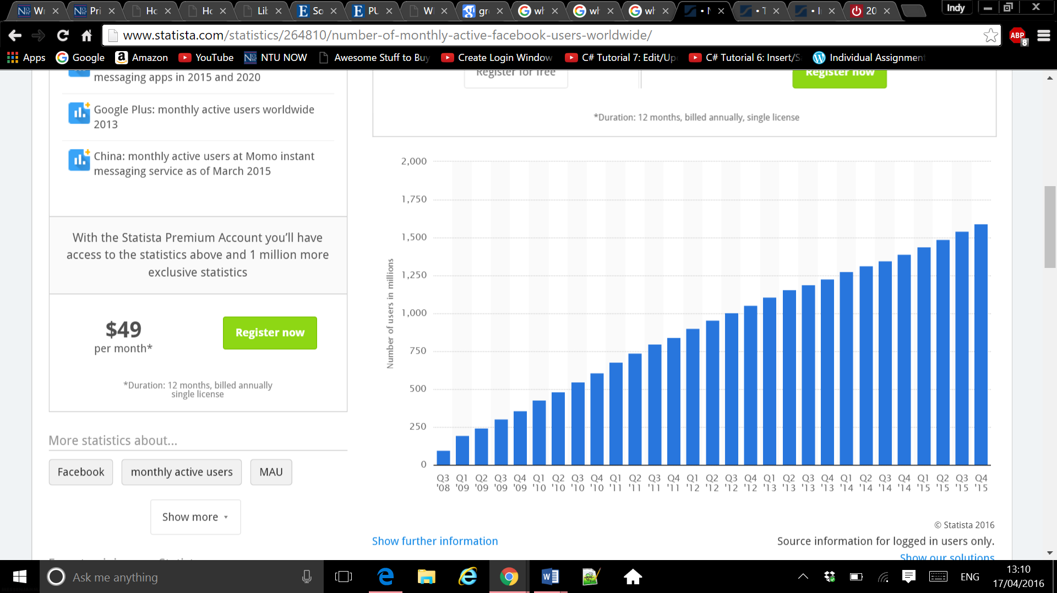
Whilst there are many definitions of social media, this report considers Ward’s (2016) definition, describing social media as being “online media that expedites conversation as opposed to traditional media, which delivers content but doesn't allow readers/viewers/listeners to participate in the creation or development of the content”. This definition expresses the fact that social media, such as Facebook, Twitter and Pinterest, differ from traditional media by allowing people to share opinions and communicate with one another knowing that their voice will be heard, which, as Ward (2016) explains, is the main reason people use social media. As Hensel and Deis (2010) explain, businesses from all over the world have taken an approach to use social media themselves - figuring out the most effective ways of improving business performance.
Users (millions)
Quarter and year
Bellini (2016) - Statista.com
Active monthly Facebook users (2008 - 2015)

The rise of social media
Within the last decade, social media has grown into one of the most used forms of IT. Since 2009, which Gaudin (2009) describes as the “Year social media networking went mainstream”, social media websites, such as Facebook and Twitter, have seen a consistent and rapid growth in monthly users.
The chart on the right, constructed by Bellini (2016) for Statista.com, shows the consistent constant increase in Facebook users per quarter. Facebook had just 100 million users in 2008, growing to a phenomenal 1.5 billion users in 2015. Bellini (2016) also summarised the rapid rise of social media usage for other social media, such as Twitter (see appendix 1), and Instagram (see appendix 2). The number of Twitter users has grown from around 30 million in 2010 to over 300 million users just 5 years later. Instagram users have also rapidly increased, more than quadrupling from 90 million users in 2013 to 400 million users in 2015. It is obvious that social media has rose and shone since 2009, providing the opportunity for them to have an effect on businesses.

A wide audience for businesses
With so many people using social media, businesses have a huge potential target audience. Considering over 1.5 billion people have a monthly active Facebook account, businesses can reach out to over a fifth of the world’s entire population, through Facebook alone. Hensel and Deis (2010) point out that social media users also have a wide variety of demographics, meaning that businesses will always have different type of customers to target. This provides businesses with tremendous opportunities, as Patton (2009) points out, supposing businesses incorporate social media correctly.
Businesses have identified the potential of using social media, as according to Flynn (2014), 8 out of 10 businesses now use them with the intention of improving business performance. The next sections analyse the positive and negative effects that social media has on businesses.

How social media positively effects businesses
This section analyses how social media can effect businesses in positive ways.

Marketing Benefits
Askool and Nakata (2011) point out that the most widely recognised business benefits from social media revolve around marketing. Some of these benefits include growing a business, reaching out to customers and increasing website traffic.

Growing businesses through other customers
Whilst in the past, customers might have only received opinions from a few friends regarding a product, Swedowsky (2009) emphasises that the use of social media can increase the number of those opinions to thousands. When users search a word or phrase on social media, all posts that other users have created that include that same word or phrase will appear. For example, a user could search a phone model on a social media website and subsequently read what other others have said about it. Qualman (2010) highlights that this system provides social media users with a reliable method of deciding whether or not to purchase a product by considering other people’s experiences. This system can benefit businesses, as if a business releases a satisfying product, satisfied users will share their experience on social media, effectively resulting in these users marketing business products to each other and potentially increasing business sales. Businesses must acknowledge however, that a poor product could generate complaints on social media, ultimately leading to an unconvinced audience and therefore fewer sales.

Reaching out to customers
Social media allows businesses to easily locate potential customers by searching for in demand products, as Eddy (2014) points out. For example, Apple could search ‘MacBook’ into Facebook’s search engine, and view users that have posted stating they are ‘thinking of purchasing a MacBook’, or something similar. Apple could then reach out to this user and potentially interest them in a sale, which wouldn’t have been made as easy if it wasn’t for social media.
Businesses also use adverts to reach out to customers through social media. These adverts are becoming increasingly common on social media such as Twitter and YouTube, and as Kaplan and Haenlein (2010) point out, users become attracted to advertisements, making avoidable purchases.

Increasing website traffic
Social media has the power to increase website traffic of businesses. As Kaplan and Haenlein (2010) explain, businesses can use social media to direct people to their websites, with the use of advertisements or through partnerships with users promoting their products, increasing the amount of website visitors and potentially earning more sales.

Better cost efficiency
Another advantageous effect of social media on businesses is the fact that social media usage can improve the cost efficiency of a business, due to the minimal costs associated with setting social media. Using social media rather than classic media means that businesses don’t require experts and special machines to create and deliver content, as Logofatu and Alexandru (2012) conclude, they just need to figure out how to implement social media effectively. Nagle and Pope (2013) list the main costs of using social networking as paying for staff training and hardware, but as Logofatu and Alexandru (2012) point out, users no longue require a strong IT background to use platforms such as Facebook and Instagram, as they are become increasingly easy and intuitive to use. Schaupp and Belanger (2013) explain that the main financial cost of using social media is the time it takes to realise the benefits of social media marketing. Once a business does realise the benefits, it can proceed with using social media to better overall business cost efficiency.

Improved customer relationships
As Schaupp and Belanger (2013) explain, social media provides a perfect platform for creating and improving customer relationships. Businesses can use social media, for example, Twitter, to tweet customers, answering any questions or offering advice in an almost informal, but still purposeful manner. An example of this was when David (2014) responded from Sainsbury’s official Twitter account to a customer query regarding fish. The customer used a pun in their query, to which Sainsbury’s replied “If I'm herring you right, you're looking to eel our relationship. I'll tell the store to find the shelf & fillet”. Not only did Sainsbury’s respond to the customer’s query in a humorous way using puns, but the tweet also received 44 retweets, meaning that many other users viewed the tweet. As Kaplan and Haenlein (2010) explain, when business tweets gains popularity, more people will know about the business, increasing the likelihood of receiving more customers.
Businesses can improve relationships with customers by offering a fast, free and personal method of communicating with them. As Swedowsky (2009) expresses, one is more likely to respect a business that responds to messages on social media and provides that personal touch rather than a business that has no simple form of communication.

Negative effects of social media on businesses
As Taneja and Toombs (2014) explain, implementing social media isn’t easy, as they require dedication and commitment to learn how to utilise effectively. This section outlines the potential negative effects of social media on businesses.

Damaging business reputation
Though businesses can make use of social media to help customers and provide humour, they face risks that can damage reputation, which is the biggest hindrance of using social media according to Flynn (2014).
One instance of a business damaging its reputation was when Microsoft released an AI Twitter chat bot that tweeted other users. The Microsoft AI bot learnt its vocabulary from the users tweeting it, and within days the bot used racist and inappropriate words, as Weinberger (2016) reports. Due to this mistake with the use of social media, Microsoft received many complaints and had damaged its reputation. Business mistakes using social media like these, can harm business reputation, ruining the image of a business and possibly putting customers off.

Threatening small businesses
While larger businesses face no problem incorporating social media, Logofatu and Alexandru (2012) express that smaller businesses may struggle to afford running social media. This can be a threat to smaller businesses in terms of losing out on customers. A big businesses can afford to set up social media and pay staff to run an account, advertise the businesses and respond to customer queries, providing potential customers with more reasons to join them. Smaller businesses on the other hand, may struggle to advertise and communicate with customers due to the inability of affording incorporating social media. Social media can be a huge asset for larger businesses, but a threat to smaller businesses.
It is important to consider that small businesses aren’t always losing out from not using social media, as some small businesses may just be too narrowly defined by sector, product or region to benefit from the global nature of online social networking as a marketing strategy, as Kaplan and Haenlein (2014) explain. Smaller businesses must therefore decide whether or not they should use resources to employ social media.

Creating business user policies
Belanger (2013) details that in order for businesses to use social media, they must develop proper social media policies for the business account user. This comes with extra complications in the sense that it may take a business a long time to produce the policy and the business must decide what would happen to an employee should they not follow the policy or incorrectly use the social media, as mistakes using social media could potentially damage the reputation of a business.

Conclusion
Social media’s colossal rise since 2009 has undoubtedly affected the world of business. The most evident effect of social media on businesses is how they have revolutionised business attitude towards marketing. Businesses are no longer required to hire large amounts of marketing experts or machines, or carry out physical marketing campaigns costing substantial amounts of time and money. At little to no cost, social media provides a platform for businesses to grow bigger and enhance customer relationships, while attracting more customers along the way.
Though the positive effects are merry for businesses, the negative effects can be exasperating. A damaged reputation can be hard to fix, small businesses may face difficulty trying to make worthwhile use of social media and policies can become unnecessary headaches.
The rise of social media shows no signs of stopping and the benefits of using this technology are priceless, which is why businesses should focus on using social media if they don’t already. Businesses must however, ensure they have carried out enough research on utilising social media effectively to avoid the chance of an error that may ruin reputation or damage a customer relationship.

Word count: 1997.

References
Askool, S. and K. Nakata. 2011. A conceptual model for acceptance of social CRM systems based on a scoping study. 26 (3), 205. Accessible via: Business Source Complete [Accessed 20 March 2016].
Bellini, J., 2016. Number of monthly active Facebook users worldwide as of 4th quarter 2015 (in millions) [online]. Statista. Available at: http://www.statista.com/statistics/264810/number-of-monthly-active-facebook-users-worldwide/ [Accessed 17 March 2016].
David, M., 2014. @Sainsbury’s - If I'm herring you right, you're looking to eel our relationship. I'll tell the store to find the shelf & fillet [Twitter]. 10 Jan. Available at: https://twitter.com/sainsburys/status/421596862429556736?ref_src=twsrc%5Etfw [Accessed 23 March 2016].
Eddy, N., 2014. Social Media Offers Financial Benefits for Small Businesses [online]. (June), 14. Available via: Business Source Complete [Accessed 23 March 2016].
Flynn, M.K., 2014. How to Leverage Social Media in Deal making [online]. 49 (9) (September), 44-46. Available via: Business Source Complete [Accessed 22 March 2016].
Gaudin, S., 2009. 2009: Year of the Social Network [online]. Available at: http://www.pcworld.com/article/185205/2009_year_of_the_social_network.html [Accessed 20 March 2016].
Hensel, K. and Deis, M.H., 2010. Using Social Media to Increase Advertising and Improve Marketing [online]. 15, 87-97. Available via: Business Source Complete [Accessed 17 March 2016].
Kaplan, A.M., and Haenlein, M., 2010. Users of the world, unite! The challenges and opportunities of Social Media [online]. 53 (1) (February), 59-68. Available via: Science direct [Accessed 22 March 2016].
Logofatu, C., and Alexandru, M., 2012. The Social Media Impact on Small and Medium Sized Businesses [online]. 9 (18) (April), 214-218. Available via: Business Source Complete [Accessed 21 March 2016].
Nagle, T. and Pope, A., 2013. Understanding social media business value, a prerequisite for social media selection [online]. 22 (4) (October), 283-297. Available via: Compendex [Accessed 20 March 2016].
Patton, C., 2009. The Social Networking Express - Professional Safety [online]. 5 (1), 5. Available via: Business Source Complete [Accessed 16 March 2016].
Qualman, E., 2012. Socialnomics: How Social Media Transforms the Way We Live and Do Business [online]. (November), 124 - 174. Available via: Google Scholar [Accessed 21 March].
Schaupp, L.C. and Belanger, F., 2013. The Value of Social Media for Small Businesses [online]. 28 (1) (December), 187-207. Available via: Business Source Complete [Accessed 20 March 2016].
Swedowsky, M., 2009. Improving Customer Experience by Listening and Responding to Social Media. Swedblog [online blog]. 7 July. Available at: http://blog.nielsen.com/nielsenwire/consumer/improving-customer-experienceby-listening-and-responding-to-social-media/ [Accessed 18 March 2016].
Taneja, S. and Toombs, L., 2014. Putting a Face on Small Businesses: Visibility, Viability, and Sustainability - The Impact of Social Media on Small Business Marketing [online]. 18 (1) (November), 249-260. Available via: Business Source Complete [Accessed 16 March 2016].
Walters, S., 2013. Social intelligence: Beyond listening [online]. 18 (1), 13-17. Available via: Business Source Complete. [Accessed 22 March 2016].
Ward, S., 2016. Social Media Marketing [online]. Available at: http://sbinfocanada.about.com/od/socialmedia/g/socmedmarketing.htm [Accessed 17 March 2016].
Weinberger, M., 2016. Microsoft apologizes for its racist chat bot's 'wildly inappropriate and reprehensible words' [online]. Available at: http://uk.businessinsider.com/microsoft-apologizes-for-tay-twitter-meltdown-2016-3?r=US&IR=T [Accessed 26 March 2016].

Appendices

Appendix 1 - Number of monthly active Twitter users worldwide from 1st quarter 2010 to 4th quarter 2015 (in millions)
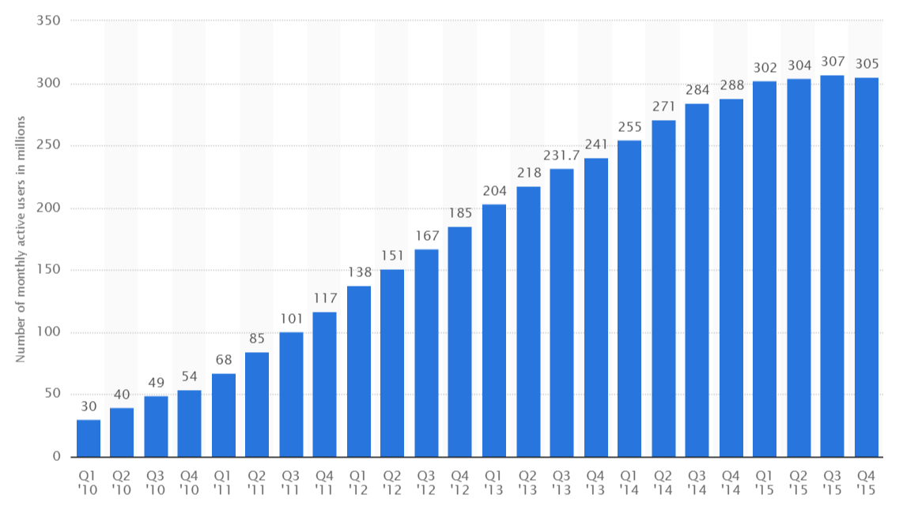

Appendix 2 - Number of monthly active Instagram users from January 2013 to September 2015 (in millions)
