Nottingham Trent University
School of Science and Technology

by

in

Project report in part fulfilment
of the requirements for the degree of
Bachelor of Science with Honours
in

I hereby declare that I am the sole author of this report. I authorize the Nottingham Trent University to lend this report to other institutions or individuals for the purpose of scholarly research.
I also authorize the Nottingham Trent University to reproduce this report by photocopying or by other means, in total or in part, at the request of other institutions or individuals for the purpose of scholarly research.


- Inderjit Singh Sandhu.

Abstract
With a recent rise in the number of high profile terror related attacks occurring in popular locations around the world, it can be argued that more concerns are being raised concerning the safety of travelling on holiday than ever before. The impact of terror attacks can leave people feeling a sense of helplessness matched by few other events. One such event however, is the occurrence of a lethal natural disaster. While humans can be checked for weapons, there is no way of preventing a tsunami from sweeping up homes. While one has a lack of options when immediately faced with a terror attack or natural disaster, the best chance of staying away from the ruins, and potential after-effect of these threats comes from being informed of the threat as soon as possible.
This report looks at the effectiveness of existing terror-alerting applications which aim to inform and alert people of terror attacks and natural disasters occurring over the world. As well as this, the use of Web scraping techniques and regular expressions are explored before they are used to develop a threat alerting application targeting the weakness of current state of the art.
The work carried out throughout this project found that while current terror alerting applications exist, they come with many limitations and areas for improvement. The development of the system carried out in the report addresses the current limitations, delivering a useful, effective and successful threat alerting application.

Acknowledgements
I would like to show my gratitude to my supervisor, Dr Joanna Hartley (Nottingham Trent University), for supporting me throughout the entirety of this project.

Table of Contents
Abstract ii
Acknowledgements iii
Table of Contents iv
List of Figures viii
List of Tables x
CHAPTER 1 1
Introduction 1
1.1 Introduction to the project 1
1.1 Subject area and background 1
1.3 Aim and objectives 3
CHAPTER 2 5
CONTEXT 5
2.1 Product review 5
2.1.1 Facebook Safety Check 5
2.1.2 Disaster Alert (DA) 7
2.1.3 Public Alert and Information System (SAIP) 8
2.1.4 EVAC Cardiff 9
2.1.5 Apple Siri Spotlight Search Suggestions (SSS) 10
2.1.6 Trivago.com 12
2.2 Testing current state of the art 13
2.3 The current gap 16
2.4 Areas for improvement 17
2.5 Other points of consideration 19
CHAPTER 3 20
New Ideas 20
3.1 New proposed idea – TAT (Terror Alert Tracker) 20
3.1.1 How TAT will identify terror or natural disaster threats 22
3.2 Project management methodology – Waterfall 23
3.3 List of requirements 24
3.3.1 Functional requirements 25
3.3.2 Non-functional requirements 29
3.4 User analysis 34
3.5 Use case analysis 35
3.6 Project planning 37
3.7 Development of separate regular expression console application 37
CHAPTER 4 39
IMPLEMENTATION 39
4.1 Design - Data-flow diagrams (DFDs) 39
4.2 Database system 41
4.2.1 Database design 41
4.2.2 Database implementation and challenges 43
4.2.3 Development of regular expression application 44
4.3 Software design and implementation 45
4.3.1 Threat scraper service 45
4.3.2 User interface (UI) Web application 55
4.3.3 Incident identifying and alerting service 65
CHAPTER 5 69
RESULTS 69
5.1 Testing the system vs products reviewed 69
5.2 Testing the system vs the FRs and NFRs 72
5.2.1 System vs FRs 72
5.2.2 System vs NFRs 76
5.3 User testing session 82
5.4 System testing conclusion 83
CHAPTER 6 84
CONCLUSIONS / FUTURE WORK 84
6.1 Conclusion 84
6.2 Critique and future work 85
6.2.1 Use of AI 85
6.2.2 Sending SMS notifications 85
6.2.3 Using user’s location services 85
6.2.4 Modifying the system for business use 86
6.3 Discussion of Professional, Social, Ethical and Legal (PSEL) issues 86
6.3.1 Professional Issues 86
6.3.2 Social Issues 87
6.3.3 Ethical Issues 87
6.3.4 Legal Issues 88
ReferenceS 89
Appendices 92
Appendix A – Use cases produced for the system 92
Appendix B – Breakdown of the project’s main tasks and milestones 102
Appendix C – Project Gantt chart 104
Appendix D – List of sources and resources required to complete the project 105
Appendix E – Project risk analysis 107
Appendix F – Data-flow diagrams produced for the system 109
Appendix G – Normalization of data used by the system 116
Appendix H – Entity relationship produced for the system 119
Appendix I – Testing screenshots of the system vs FRs 120
Appendix J – Testing screenshots of the system vs NFRs 123
Appendix K – User testing questionnaire 125

List of Figures
Figure 1: An article within the BBC World RSS news feed 23
Figure 2: Diagram showing how the waterfall method will be used throughout the development of the project 24
Figure 3: 2NF data used by the system 42
Figure 4: Regular expression application 45
Figure 5: DFD showing how the system’ scrapes for threats 47
Figure 6: Pseudocode for the threat scraper 47
Figure 7: For each loop, looping through the RSS feed’s Xml structure 50
Figure 8: List of several regular expressions constructed 51
Figure 9: Insertion of an identified threat into the Threat table 52
Figure 10: Extract of function used to convert date format 53
Figure 11: Function to fix formatting issues 54
Figure 7: Site map for the UI Web application 56
Figure 13: Method used to encrypt user’s password 61
Figure 14: Session used to display certain navigation bar items 62
Figure 15: Error handling jQuery calendar widget 63
Figure 16: Error handling jQuery calendar widget code 63
Figure 17: System UI following HCI guidelines 64
Figure 18: Pseudocode for the incident identifying and alerting service 66
Figure 19: Code for the service’s timer 68
Figure 20: Code for the service’s timer 68

List of Tables
Table 1: Test of the functionality and features offered by current state of the art 13
Table 2: List of functional requirements for the proposed system. 25
Table 3: List of non-functional requirements for the proposed system. 29
Table 4: Use case summary table. 36
Table 5: Table of HCI principles to be considered. 58
Table 6: Testing the functionality and features offered by the system 69
Table 7: Testing the system vs FRs 73
Table 8: Testing the system vs NFRs 77

Introduction

1.1 Introduction to the project
This report has been constructed as part of the Final Year Project module, involving the development of a terror alerting system. The purpose of this report is to provide a record of the processes involved throughout the development of the project and system. In doing this, the report is split into six chapters.
This chapter contains the introduction of the project, outlining the subject area, and the project’s aims and objectives. Chapter two includes a product review to identify the position of state of the art in the field, before chapter three outlines the newly proposed idea in response to the current position of the relevant technology. The implementation of the system is detailed in chapter four, with the results, in the form of testing, being discussed in chapter five. Chapter six concludes the project by explain how successful the project was, outlining areas of improvement and discussing the professional, social, legal and ethical issues involved.

1.1 Subject area and background
With the recent rise in the number of high profile terror related attacks in popular locations throughout the world, it is widely believed that there is a case for concern. As the Guardian (2016) explains, a survey carried out in 2016 by TravelZoo, a travel deals site, found that 30% of UK travellers now rate general safety and security of a location as their most important holiday destination factor. This is unsurprising, and perhaps even lower than one may have thought, considering that the UK’s terror threat level has been raised to ‘critical’, the highest level, twice in 2017 (after the survey was carried out). One occasion was after the Manchester bombings, which left 23 people killed and 250 injured, and the threat level was again raised to the highest level possible in September, after a bomb attack in London’s Parsons Green.
Terror related incidents aren’t just problematic and deadly in the UK. Johnston (2017) has compiled a list of worldwide terror related incidents, noting recent attacks as deadly as the Las Vegas shooting, in which 59 people were killed and 527 injured, as far away as the Kenyan college campus shooting, leaving 152 people killed, and as close to the UK as France’s attacks in Paris and Nice, each with over 400 victims.
While terror related incidents have been so devastating and lethal in recent times, natural disasters have consistently wreaked havoc on mankind for many years. Statista (2016) reports that from 2000 to 2016, over 1.2 million lives have been lost due to natural disasters. Though natural disasters can be predicted in advance, they are near impossible to prepare for when they are at their most fierce, and they, like terror attacks, can be serious threats to life.
Though no application or software could prevent a terror attack or natural disaster, an application which identifies a threat and alerts the public of this threat, soon after it happens, could be extremely beneficial. For instance, if somebody is on holiday, and is informed of a terror related incident or natural disaster that has occurred near them, they can take caution on their travels and be sure to double check whether or not it is safe to leave their hotel or travel to their next planned destination. A threat alerting application would also allow users to share news of an attack or natural disaster, helping spread awareness quickly, resulting in the public providing support to those who need it as quickly as possible.
As part of this project, a threat alerting application, like the one mentioned above, will be designed and developed. The recent rise in the number of high profile terror related incidents, and the benefit that a terror alerting application could provide in such incidents, are the motivating factors for completing this project.
As well as benefitting the users of the system to be developed, this project intends to raise awareness regarding the development of threat alerting applications to be used on holiday.

1.3 Aim and objectives
The aim of the project is to develop a user-friendly threat alerting Web-based application that offers more features to users than current state of the art.
To achieve the aim, the project fill focus on six objectives:
- To develop an application that will identify threats, such as terror related incidents or natural disasters, by using a predefined list of regular expressions (such as ’50 killed in terrorist attack’) to Web scrape through RSS feeds of reliable news websites and storing these as threats into a ‘threats’ database table
- To successfully identify the country of a threat by using a list of countries and cities, and scanning this list through articles which have been judged to mention an incident
- To develop a system which allows users to enter a journey, and alerts users of threats occurring in the country of that journey between the journeys start and end dates
- To ensure that effective design principles are researched and have been applied to the application, resulting in a user-friendly application
- To provide a page which allows users to see a list of recent terror attacks and natural disasters that have occurred around the world

CONTEXT

2.1 Product review
This chapter includes reviews of existing products in the fields of terror identifying, terror alerting and Web scraping systems, as these systems will be considered in the design of the proposed system (defined in chapter 3). As well as providing a description of the product and its relevance to the proposed system, this section also identifies the positives and limitations of the products. Upon reviewing the products, several tests will be carried out regarding their functionality, and a list of mini-conclusions will then be constructed, summarising the position of current state-of-the-art and identifying areas for improvement.

2.1.1 Facebook Safety Check
Facebook (2014) released Safety Check as a Facebook feature which activates during times of terror incidents. The feature allows users to post that they are safe on Facebook in the event of an incident so that loved ones and friends are aware of their well-being.

2.1.1.1 How Safety Check relates to the project
Safety Check’s ability to identify terror incidents and alert the appropriate users will be considered as a core focus of the project.

2.1.1.2 Positives of Safety Check
- Safety Check is very simple for users to use. The feature alerts users of the incident and then allows them to post that they are safe. The entire process is completed within seconds.
- Safety Check uses the user’s location services, meaning that users are not required to manually enter their location to use the feature.
- Safety Check uses manual workforce to identify a threat, rather than AI or a Web scraper, meaning that the feature is reliably accurate when identifying a threat.

2.1.1.3 Limitations of Safety Check
- Upon being alerted of an incident, users are not provided with more information about the incident, as the main aim of Safety Check is for users to update their friends and family of their wellbeing. This means that users must go out of their way to research more about the incident. Furthermore, users cannot see a list of previous incidents.
- There have been reports of Safety Check mistakenly alerting users far away from incidents. Seetharaman (2016) reports on the feature alerting users in New York and Washington, D.C. after an incident in Pakistan. This could worry users, who may unexpectedly be alerted of incidents that do not affect them.
- The feature may result in the family and friends of the user receiving spam or becoming worried as a result of the user unnecessarily marking themselves as safe when they may not actually be involved.
- Safety Check relies on the user having access to a mobile device with location services to work. This therefore requires users to own a device with location services and be comfortable with leaving their location services on.
- As users are marked as ‘unsafe’ until they mark themselves as ‘safe’, their friends and family may worry about their wellbeing until they state that they are safe. This could mean that if users have no internet connection or are busy when an incident occurs, their Facebook friends may begin panicking.

2.1.2 Disaster Alert (DA)
Pacific Disaster Center (2011) released Disaster Alert as an application for android users. The application allows users to see, on a map, where natural disasters have recently occurred around the world. Each disaster displays its own icon and is placed over a city in which the disaster has occurred.

2.1.2.1 How Disaster Alert relates to the project
Disaster Alert accurately identifies natural disasters that have occurred around the world and allows users to see a list of previous disasters. The project will also focus on identifying natural disasters that may affect users around the world.

2.1.2.2 Positives of Disaster Alert
- The application provides users with an option of viewing a list of recent natural disasters, rather than just one disaster than may affect them.
- Users are able to tap on and see more information about the disasters if they are interested or concerned.
- Users can see a visual representation of disasters around the world, as they are plotted on a map.

2.1.2.3 Limitations of Disaster Alert
- Disaster Alert does not send alerts to users regarding disasters that may have occurred near them.
- Only users with Android enabled devices may download and use the application.
- The application focusses solely on natural disasters and not terror incidents.
- Reviews from the Google Play store have mentioned that the application sometimes incorrectly marks events (such as heavy rain) as disasters.
- The interface looks outdated as the application uses old styled graphics. Text, buttons and icons overlap on certain screens.
- The list of recent threats only displays 10 threats, meaning the user is not able to view older disasters.

2.1.3 Public Alert and Information System (SAIP)
Ministry of the Interior France (2016) released SAIP as an alert-based application that provides users with push notifications when major crises, such as a terror attack or bombings, occur in France.

2.1.3.1 How SAIP relates to the project
SAIP alerts users of incidents so that they can take precaution if necessary. This event led alert-based system will also be considered as part of the project.

2.1.3.2 Positives of SAIP
- SAIP provides users with a choice of either using their location to determine incident alerts or selecting up to eight geographical areas.
- The application allows users to share alerts on social networks, making it easier to inform friends and family of recent incidents.
- SAIP provides users with a reasonable amount of information regarding a crisis, as users are able to view a summary of the incident and the source from which the incident arose.

2.1.3.3 Limitations of SAIP
- SAIP can only be used in France and has not been updated to work globally, significantly limiting the number of potential users.
- Reviewers on the Google Play store have reported that they sometimes fail to receive an alert when reports of threats have occurred. This suggests that the application’s method of identifying a crisis required improvement.
- Reviewers have also mentioned that the application has taken as long as two hours to alert users after a crisis has occurred. Taking two hours to alert users is not effective as an alerting application, users should instead be alerted within a matter of minutes.

2.1.4 EVAC Cardiff
Cardiff Council (2017) developed EVAC Cardiff as a mobile application to alert the residents and visitors of Cardiff of terror attacks in the city via push notifications.

2.1.4.1 How EVAC Cardiff relates to the project
EVAC Cardiff’s aim is to inform users of terror attacks and the application allows users to register and receive push notifications. This project will consider a similar organised terror alerting system.

2.1.4.2 Positives of EVAC Cardiff
- Users receive notifications of attacks, rather than being left to check the application for attacks themselves.
- EVAC Cardiff is more than just a terror alerting application. It also provides maps, news, links and advice about the city. These extra features provide extra value to the application.
- Though the application has many pages and features, its user interface is user-friendly. The buttons are big, text is readable, and it looks attractive and modern.

2.1.4.3 Limitations of EVAC Cardiff
- The application is only useful for users in Cardiff. This limits the potential number of users as people in other cities in Wales, and the rest of the world are unable to receive updates of terror attacks.
- Several users have left reviews on the Google Play Store stating that they have not received any notifications, even though they have been told notifications have been sent.
- As the application has many features and many pages, it may be complicated for users that are less technical to use.

2.1.5 Apple Siri Spotlight Search Suggestions (SSS)
SSS is a recommendation-based search service, provided by Apple (2015), that suggests content to users, such as news articles, which is similar to previously browsed content.

2.1.5.1 How SSS relates to the project
Spotlight Suggestions uses Apple Bot Web crawler. This crawler takes phrases a user has previously searched (regular expressions) for in Spotlight (a system wide and Web searching service), searches the Web for these phrases and then displays similar content back to the user. As this content is found by using previous searches, it should be of interest to the user. The project will consider similar technology - using regular expressions to search the Web for threats occurring around the world and sharing this information with appropriate users.

2.1.5.2 Positives of SSS
- Spotlight Suggestions automatically provides similar content to users without the user having to go out of their way, spending time choosing preferences entering interests.
- Spotlight Suggestions always displays the latest recommendations to the user, rather than content that is outdated. This is because the system uses recent user searches and searches the Web for the latest news articles.

2.1.5.3 Limitations of SSS
- Spotlight Suggestions may suggest articles to the users that they may not want to see. There is no guarantee of displaying articles that a user is interested in.
- As SSS uses a Web crawler, content is picked out by a program, rather than a human, meaning that suggestions may be inaccurate or irrelevant. Despite this, it is up to the developers to develop a bot that is successful at producing accurate, relevant and exciting content for its users.
- The feature has requirements such as internet connection and at least iOS 9, meaning that only particular iPhone users can use the feature. This considerably limits the number of users of the service.

2.1.6 Trivago.com
Trivago (2015) is a hotel price comparison website that allows users to compare prices from over 1.3 million hotels in over 190 countries all over the world.

2.1.6.1 How Trivago.com relates to the project
Trivago uses a Web scraping system to obtain prices of hotels from their websites before displaying all these prices, from all the hotels, back to the user. The project will also consider this concept of scraping data and displaying certain information back to the user.

2.1.6.2 Positives of Trivago.com
- Trivago requires minimal effort and input, saving the user a lot of time. Within minutes a user can see prices from hundreds of hotels by simply entering a few details of their planned journey.
- Information that Trivago scrapes on hotels is always up to date as the scraper only functions when a search is made, and the scraper uses the latest results available on the web.
- Trivago’s Web scraping is carried out by a program rather than a human. This eliminates human error and saves the company money.

2.1.6.3 Limitations of Trivago.com
- As Trivago uses a program rather than a human, program errors could occur. For example, a website that Trivago scrapes from may change its URL, possibly resulting in Trivago not displaying that website. This may mislead users.
- Prices listed on Trivago may not include hidden fees that can only been seen when the user visits that specific hotel’s website. This may frustrate users and waste their time as the price they see on Trivago may not be the final price.

2.2 Testing current state of the art
After an initial review of the products, their positives and limitations, their functionality and features are tested in this section (table 1), helping summarise and visually demonstrate the position and offering of current state of the art. The testing criteria used is inspired by the various areas of interest regarding the subject matter of this report. This testing criteria will help identify how current state of the art can be improved and will be used in chapter 5 to compare current systems with the finished system. Apple SSS and Trivago has been disregarded, as these products are not focussed on alerting/informing users of threats.
Table 1: Test of the functionality and features offered by current state of the art
Test Id | Does the system provide the following? | Safety Check | DA | SAIP | EVAC
1 | A registration system, allowing the user to create and use an account
2 | The ability for users to add a journey from which they would like to receive alerts of threats from
3 | A Web scraper that scrapes the Web for terror-related or natural disaster-based threats that occur all over the world
4 | The inclusion of a system which aims to send an alert to a user when a threat occurs near them
5 | An alerting system that consistently alerts users within a matter of a couple of minutes of an incident being reported |  | N/A
6 | A threat alert containing considerable amounts of information that may be of importance to the threat (such as title, summary, country, type, date, time, source and URL) |  | N/A
7 | A system which can be used on a computer and a mobile device
8 | An alerting system which does not require the use the user’s location services
9 | A system that reports on, or sends alerts regarding incidents occurring across the entire world
10 | An area dedicated to displaying a list of recent terror incidents or natural disasters that have occurred around the world
11 | A system dedicated to alerting users on holiday of incidents that occur that may affect them

2.3 The current gap
The testing carried out above, and the product reviews, identify that each product focuses on its intended purpose and provides functionality for that purpose. While Safety Check allows users to check in, informing others that they are safe, Disaster Alert allows users to view disasters on a map. While these systems each focus on their specific purposes, none of them provide a solution dedicated to alerting a user wanting to receive alerts of incidents related to a holiday they will be attending. As explained in the introduction, 30% of UK travellers rate the safety and security of a destination as their most important holiday destination, several deadly terror incidents have occurred in popular destinations around the world in recent years and over 1.2 million lives have been lost due to natural disasters. Considering this, an argument can be made that more systems should exist to alert the users interested in using this technology of the many potential threats that may affect users whilst on holiday. Due to this gap, these users are the ones that the proposed system will target. This is explained more in chapter 3.
The testing also identified that current threat alerting solutions generally lack many features and functionality, including:
- The inclusion of a registration system for users
- The option for users to add a journey from which they want to receive alerts from
- The use of Web scraping to identify threats
- A threat alert containing a significant amount of information about the threat
- A system which can be used on a computer or a mobile device
- A system which does not rely on using the user’s location services to send an alert
- A system which alerts users, and allows users to see a list of recent incidents that have occurred around the world
The features and functionality mentioned above will be discussed more in the next section, with the resulting discussions influencing the new idea explained in chapter 3.

2.4 Areas for improvement
Considering the findings of the reviewed products in the sections above, several areas of improvement regarding current state of the art have been identified. These have been listed below as conclusions (C1 – C7):
- C1: Current alerting systems are focussed on involving the user as little as possible, with the aim of using the user’s location services to alert them of incidents which may affect them at all times. These systems lack sophistication and security and fail to provide a more customised experience for the users. Users do not currently have the option of officially registering with a dedicated threat alerting system which, which only alerts them if a threat occurs within the country they have entered as part of that journey, within the time frame specified.
- C2: Many existing solutions limit the number of potential users of the technology in various ways. SSS requires users to have an iOS9 enabled device, while Disaster Alert is only available to users with Android. Furthermore, many of the current solutions function on only mobile applications. Current alerting solutions lack the ability to be used on various mobile devices and computers. The creators of these systems could choose to develop native alternative, ensuring both iOS and Android users can use the app, or Web based applications, to ensure the system is accessible by all users with an internet enabled device.
- C3: Several alerting systems have been known to take hours to alert users of terror attacks or natural disasters, with some even failing to alert users at all. These systems must improve on their reliability and speed of alerting, as their users expect much quicker alerts. There should be no excuses regarding alerting users quickly as attacks and incidents are reported on within a matter of minutes of them occurring in the modern day.
- C4: Many existing alerting systems only provide a brief description of incidents, meaning that users are not able to read more information if they are interested in doing so. Though some systems do provide considerably more information on incidents, they do not provide users with a list of incidents that have occurred around the world. Users do not currently have access to an alerting system that allows them to read more about an incident as well as see a list of reported recent threats that have occurred around the world.
- C5: Though some systems aim to alert uses of worldwide incidents, others, such as EVAC Cardiff and SAIP, only alert users that are within a certain area. This means that users wanting to be alerted of incidents occurring around the world must find an alternative. These systems could be improved by making them usable worldwide, utilising the technology involved to benefit people all over the world.
- C6: Some current systems have a poorly designed user interface, potentially making it difficult for users to navigation through the system and use the system with ease. These systems could improve this aspect by considering interface design principles in their design.
- C7: Current state of the art has been known to send sent spam alerts, or incorrect alerts, to its users that aren’t near an affected area. The accuracy of these systems regarding identifying the threats and alerting the appropriate users must be worked on, as spam alerts may frustrate a user, waste their time and potentially force them to use an alternative system.

2.5 Other points of consideration
Following on from the previous list of conclusions, more conclusions are listed below (C8 – C9) that consider other important points to take away from the product reviews.
- C8: Web scraping methods are effective at obtaining information that is up-to-date, as discovered through reviewing SSS and Trivago.com. These systems both scrape the Web for the latest data that are relevant for their purposes and display this information back to the user. SSS also shows that the use of regular expressions can aid in creating an effective scraper – as the system uses regular expressions to search the Web and display relevant data.
- C9: Some systems currently rely on human workforce to identify incidents and alert users. This means that the possibility of human error can occur, and a human is always required to be working else the system cannot function.

New Ideas
As identified in chapter 2, current state of the art focuses on specific purposes, such as displaying incidents on a map, allowing users to ‘check in’ to update friends and family of their wellbeing and alerting users in a specific area. While these terror informing/alerting systems exist, they do not provide an organised method to users wanting to receive alerts of incidents occurring that may concern their holidays or travels. Since a system of this nature has not been identified, this is the type of system that will be focussed, designed and developed during this project. Furthermore, the new idea proposed in this chapter will consider the current state of the art’s missing features and functionality as identified in the testing section of chapter 2.
This chapter outlines the newly proposed system and project to be completed by outlining the newly proposed idea, listing and justifying the functional and non-functional requirements of the system, detailing the project management methodology and finally carrying out a user and use case analysis.

3.1 New proposed idea – TAT (Terror Alert Tracker)
Terror Alert Tracker will be a terror alerting application that will send an Email alert to registered users of disruptive terror related incidents or natural disasters which may affect or concern the user’s holiday or travels. TAT will require users to enter a journey into the Web-based application (ensuring it can be used on a computer or any mobile device with an internet browser), by providing details of the journeys country, start date and end date. If a terror related incident or natural disaster then occurs in the country of a user’s journey, between the dates of that journey, the user will receive an Email alert providing many details of the threat. While the system will be developed to target users wanting to receive alerts of threats that may concern a holiday or journey they are on, it will also be usable by those who may not interested in travelling. Other instances of use include a user wanting to simply receive Email alerts of incidents in the country they are living in, or those wanting to receive alerts of a family member or friend who is travelling on holiday.
As well as allowing users to sign up to the application, TAT will allow users to change their account details, modify their journey details and view a page containing a list of threats that have occurred around the world. The sophistication that TAS will offer is something that is not currently offered by existing terror alerting applications, which, as mentioned in x, focus on specific aspects of threat informing/alerting. While TAT will offer a new modern useful tool focused on those wanting to receive alerts of terror incidents, its development will also potentially open new possibilities regarding the future research into the field of holiday focused terror alerting applications. Chapter 6 discusses future work in this field by considering the success of the development of TAT.
Nb. While the proposed Web application will result in the production of a user interface, this interface is not the most important or complicated part of the system. More emphasis will be placed on creating an effective threat scraper and alerting system. This means that while the user interface design will be considered and professionally designed and developed, majority of the time spent developing the system will be allocated to back-end programs (the threat scraper and alerting system). The complexity of the system therefore cannot be identified through simply using and exploring the user interface. This will be evident and emphasised on in chapter 4.

3.1.1 How TAT will identify terror or natural disaster threats
The most important aspect of TAT’s system, and one of the most important areas of concern in this project, is how the system will identify terror alerts of natural disasters that occur around the world. This will be achieved by using Web scraping, summarised by Glez-Pena et al. (2013) as the extraction of contents interest from the Web in a systematic way, and regular expressions (a user-constructed list of phrases). These methods have been chosen as they have been proven, as identified in in chapter 2 (C8), to being effective methods of obtaining up to date and relevant data.
Web scraping systems such as SSS and Trivago.com are successful in providing effective methods of obtaining up to date data and displaying this information back to users. TAT will therefore constantly and frequently scrape the RSS feeds (containing the latest news articles around the world) of reliable news websites, for articles that report on terror incidents or natural disasters. Whether or not an article is a threat will be determined through the compilation of a set of regular expressions which will be run through the article’s title and summary.
For example, the BBC (2018) RSS feed below (figure 1) shows an article, within an item tag, which discusses a suicide attack. TAT may use the regular expression ‘suicide attack kills’ to scrape through the item and store it as a threat, as the title contains this phrase. Complications will arise through Web scraping however, with one example being that some articles may report on historic events. Furthermore, a method to obtain the country of attack is required. These complications, and a more detailed explanation of the implementation of TAT will be discussed in more detail in chapter 4.

Figure 1: An article within the BBC World RSS news feed
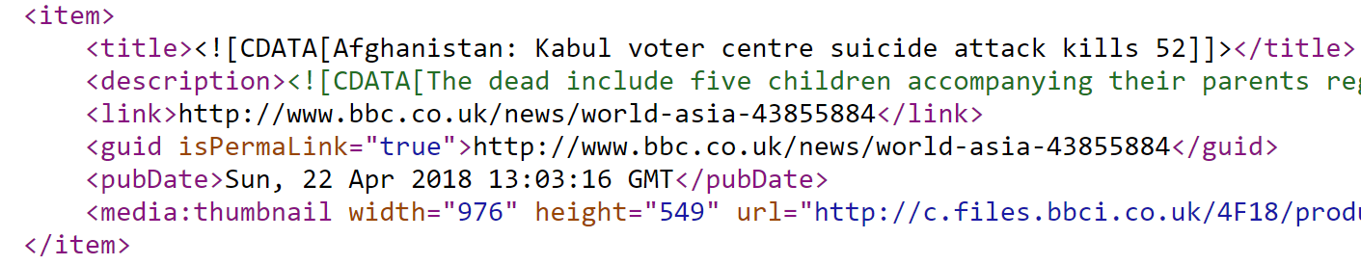

3.2 Project management methodology – Waterfall
The waterfall methodology has been chosen as the project management methodology as this method focuses on extensive planning and follows linear development, only delivering working software at the end of the project, as Curtis (2017) describes. These characteristics are relevant to how the project will develop, as importance and emphasis will be placed on planning the project and the project will be broken down into several stages. As the project will progress in a linear nature, a list of requirements will be set and completed before the next stage begins. Iteration is therefore not required, making the waterfall methodology more effective and fit for purpose than an agile approach.
William et al. (1998) breaks down the waterfall method into the following stages:
- Step 1 – Requirements analysis
- Step 2 – Design
- Step 3 – Implementation
- Step 4 – Testing
Inspired by this structure, figure 2 has been created to demonstrate the system development life cycle of the project, breaking down the tasks involved and stating which chapters each stage is to be completed in. The design and implementation stages have been merged together to provide for a more logical and fluent chapter 4.

Figure 2: Diagram showing how the waterfall method will be used throughout the development of the project
Testing
(Chapter 5)
Requirements analysis
(Chapter 3)
- Software testing

Design & Implementation
(Chapter 4)
- Functional requirements
- Non-functional requirements
- User analysis
- Use case analysis
- Data flow diagrams
- Database design and implementation
- Normalisation & Entity relationship diagram
- Software design and implementation

As the diagram shows, this chapter (chapter 3) analyses the requirements of the system. Once the requirements of the system are analysed, following the linear waterfall method, chapter 4 details the design and implementation of the system. Finally, once the requirements have been analysed, and the design and implementation have been carried out, chapter 5 tests the final system.

3.3 List of requirements
To breakdown the requirements of the TAT, a list of functional requirements (FR) and a list of non-functional requirements (NFR) have been produced. The FRs, as Heckel and Engels (2002) describe, detail the main services the system will provide to its users. NFRs will be produced to define the attributes of the system and to ensure system quality. As Mahmoud and Williams (2016) explains, a failure to identify NFRs early in the process will negatively impact the overall quality of the system.
Many of the FRs and NFs have been chosen in consideration of the findings from chapter 2. As a result of this, many of the justifications for selection mentioned beside each requirement will refer to C1 – C9, as listed in chapter 2.
Nb. The lists of FRs and NFRs have been carefully constructed to ensure that the system functions in a variety of useful ways. This ensures that the testing session (chapter 5) tests a variety of aspects regarding the functionality of the system.

3.3.1 Functional requirements
Table 2 outlines the list of FRs (and justifications for inclusion) produced for the proposed system.
Table 2: List of functional requirements for the proposed system.
FR Id | Functional requirement | Justification for inclusion
FR01 | The user shall be able to register to, log in to and log out of the system. | As mentioned in C1, many current terror-alerting application lack sophistication and are not dedicated to alerting registered users while on holiday. Rather than providing a registration system for users, many current solutions are usable instantly upon download and not secure. This FR has been included to ensure the development of a system that is organised, professional and secure for its users.
FR02 | The system shall send the registered user a registration confirmation Email upon registration to confirm that the system can successfully communicate with the user via Email. | The inclusion of this requirement is based on the fact that the system’s method of alerting users is through sending Emails. By confirming registration through Email, a successful communication between the user and system will be confirmed.
FR03 | The system shall ensure user’s personal information is kept secure and not shared, with passwords being encrypted for additional security. | This requirement has been included to ensure the system complies with laws regarding the safety of user’s data, as users will be required to submit personal information. Passwords will be encrypted to ensure that in the case of unauthorised access to the database of users, they cannot be stolen.
FR04 | An ‘Add Journey’ page shall be included that allows users to quickly add a journey to the system. | This requirement allows the functionality of one of the core aspects of the system. It allows users to submit a journey to the system, ensuring the system can compare the submitted journey details with details of potential threats.
FR05 | The system shall use Web scraping to scrape several news website’s RSS feeds, using regular expressions, to identify terror-related or natural disaster-based events that occur around the world. | As identified in C8, Web scraping can be an effective method for obtaining up to date and relevant information. C8 also discusses how regular expressions can aid in creating an effective scraper. Due to these reasons, the system will make use of Web scraping and regular expressions to identify potential threats occurring around the world.
FR06 | The system shall scrape the country and city (if available) of the identified terror or natural disaster threat. | This requirement has been included as it is another core feature of the system. Without the country of the identified threat, no users can be alerted.
FR07 | The system shall calculate whether an incident (a threat occurring in the country of a user’s journey whilst they are there) has occurred by comparing details of threats and user’s journeys. | This is another core requirement of the system. The system must be able to calculate whether an incident has occurred, else it will not be able to carry out its main purpose.
FR08 | The system shall send the relevant user(s) a threat alert email in the case of an incident, containing details (title, summary, country, type, date, time, source and URL) of the article that has been identified as a threat. | As well as this requirement ensuring another key aspect of the system is successful (the threat alerting Email to the user), it has also been inspired by the point made in C4. In this conclusion, it was acknowledged that many existing threat alerting systems only provide brief details of the threat. The proposed system however, will provide more details to the user, as well as providing the URL of the article, in the case that the user wants to learn more about the threat.
FR09 | A ‘Home’ page shall be included that welcomes users and explains the purpose of the application. | This requirement has been included in consideration of C1, which, as mentioned in FR01’s justification, relates to providing and organised and professional solution for users.
FR10 | A ‘My account’ page be included that allows users to view and edit their account details. | Similar to FR09’s justification above, this requirement has been included to provide an organised and professional system to users. As user account will be used, it is important that users are able to update their information as a restriction on this may be frustrating.
FR11 | A ‘My Journeys’ page shall be included that allows users to add, view, edit and delete their journeys. | This requirement has been included for the purpose of ensuring the system is user friendly and offers customisation to the user, as expressed in C1. Allowing users to view, edit and delete their journeys can save them time ad provide them with convenience when changing their mind about a journey.
FR12 | A ‘View Threats’ page shall be included that allows users to view a list of all the threats scraped by the application. | C1 explains that users do not currently have access to a threat alerting application which also lists reported recent threats around the world. This requirement will ensure that the proposed system can be used as a threat tracker of threats around the world, as well as an alerting system.
FR13 | A ‘How to use’ page shall be included that breaks down to users how they use the application. | This requirement ensures that the system explains to the user how the system is to be used. This is important as users may be left clueless without a user guide, hence potentially deciding against using the system.

3.3.2 Non-functional requirements
Table 3 lists the NFRs with justification for inclusion for the proposed solution.
Table 3: List of non-functional requirements for the proposed system.
NFR Id | Non-functional requirement | Justification for inclusion
NFR01 | The system’s UI shall follow design principles to ensure that it is user-friendly and accessible for people that may experience various disabilities (such as colour blindness or dyslexia). | As discussed in C6, many systems have a poorly designed user interface, meaning that users may struggle to user the system with ease and fluency. The consideration of this requirement will ensure that the system is user-friendly.
NFR02 | The system’s UI shall run operate successfully on Google Chrome, Mozilla Firefox, Internet Explorer, Microsoft Edge and any mobile device’s internet browser. | This requirement has been included to ensure that the number of users of the system are not limited based on their choice of internet browser. C2 has been considered in the inclusion of this requirement, as it discusses limiting the number of users.
NFR03 | The system’s UI shall be delivered in the form of a Web application. | This requirement ensures that, as discussed in C2 and the section above, the number of users are not limited based on whether they prefer to use a mobile device or a computer. C2 identified that current systems limit users based on operating system, device type and device version. The use of a Web-based application ensures that users will be able to access the proposed system through their computer and/or mobile device, rather than just one of the other.
NFR04 | The system shall scrape for threats every 60 seconds. | C3 discusses the fact that current alerting applications have been reported to take hours to respond. This requirement has been included to ensure that the system avoids this, and instead identifies threats within a matter of one minute.
NFR05 | The system shall check to identify if an incident has occurred every 60 seconds and send out the relevant threat alerting Emails within 30 seconds of the incident being identified. | As explained in the justification for the inclusion of NFR04 above, this requirement has been included to ensure that the system functions with speed, and successfully alerts users within a matter of a couple of minutes of a threat being identified. This avoids users receiving alerts after a couple of hours, as C3 discusses, takes the effectiveness of being an alerting application away.
NFR06 | The system shall not send spam Emails, or multiple Emails regarding the same alert to users. | Spam Emails will annoy, and potentially worry users, as identified in C6, which explains that some alerting applications have incorrectly alerted users of threats occurring in different continents. The system will therefore not send unnecessary Emails to users, and effectively locate the correct country of a threat, ensuring incorrect users are not alerted.
NFR07 | Users shall be able to enter as many journeys as they wish to. | This requirement has been included to ensure that users, who may wish to enter journeys for purposes other than holidays, are free to use the system as often as they like, without limitation.
NFR08 | The list of RSS feed news sources used to scrape threats from shall be straight forward to modify. | The inclusion of this requirement is based on the consideration of the maintenance of the application in the long run. Certain RSS feeds may begin to report incorrectly, or with a long delay, on news articles, or more reliable alternatives may be found. It is therefore important that a new RSS feed source can be added with ease.
NFR09 | The system shall run as a Windows service (in the background of a PC). | By complying with this requirement, the system will not be required to be manually controller by a human. C9 discusses how human error can occur when humans are in charge of systems. Human error can therefore be avoided by running the system as a service. Furthermore, if running as a service, as opposed to through the development program, the system will consume less computer processing power.
NFR10 | The system shall make use of databases to store, retrieve and manage its information. | Due to the variety and volume of data required by the system (for both storing and retrieving), the inclusion of database implementation is necessary.
NFR11 | The system shall be more successful than not in alerting registered users of threat alerts occurring that match the details of their journey. | As discussed in C7, current state of the art has been reported to have incorrectly alerting users of potential threats. This could cause worry, hence as much time possible will be spent on ensuring the system is accurate at alerting the relevant users of threats that may affect them.  Nb. This project prioritises proof of concept and consideration of the overall project over the production of a largely accurate alerting application, meaning that the final version of the system may not be as accurate as intended.
NFR12 | The system shall be free for users to use and not entail any costs. | This system will not be developed with the consideration of commercial gain.

3.4 User analysis
The nature of the system makes it difficult to considerably segment the target audience, as users of the system may well have varying characteristics and demographics. Due to this, many of the characteristics identified may be generic.
The users expected to use the system are men and women, with experience of or an interest in technology, between the ages of 18 and 65. People generally do not have the opportunity to travel abroad until the age of at least 18, and in the modern day, people above the age of 65 tend to share a declining interest in utilising technology compared to those that are younger. As the system will identify threats from all over the world and will not need to consider time zones (as users will be alerted instantly), it will target users all over the world. Despite this, the system will not provide language alternatives due to time constraints, meaning that it will be targeted at English speaking users.
The user analysis carried out in this section will be considered in chapter 4, in which the interface of the system is designed and implemented, to ensure the system is designed suitably for its target audience.

3.5 Use case analysis
After discussing all the system’s requirements in section 3.5, five use cases have been created, expressing the main five processes of the proposed system. Table 4 below displays a table summarising the use cases – see Appendix A for the full use cases. As Dennis et al. (2012) describes, these use cases help understand the user requirements by detailing the interactions required between the user and the system to complete the user’s goals. As well as expressing the user’s requirements, the use case analysis also breaks down the system, ensuring that the correct data and steps required are identified and ready to be used in the design phase of the project.
Nb. Several words/phrases used in the use cases have been broken down below, to ensure and understanding of the terminology mentioned in each use case. This terminology also applies to the data-flow diagrams mentioned listed in chapter 4:
- Article – An article consists of the details scraped by the application from an RSS feed. Articles include information such as the Article title, summary etc.
- Threat – A threat is an article that has been identified by the application as a dangerous attack or natural disaster. Threats may potentially affect a user, in which case they are then stored as an incident.
- Incident – An incident is effectively when a user is to be alerted of a threat. Incidents occur when the details of a scraped threat match the details of a journey entered by a user. A match is made when the country of a threat matches with the country the user entered as a journey, and when the date of the threat falls within start and end dates entered by the user.
- Threat alert – A threat alert is an alert that a user receives containing the details of a threat that matches with their trip. A threat alert is sent to a user when an incident occurs.

Table 4: Use case summary table.
Use case Id | Use case name | Use case description
1 | Register to the application | Describes how a user registers to the application.
2 | Add a journey | Describes how a user enters a journey into the system.
3 | Scrape for threats | Describes how the system scrapes articles to identify which articles are to be considered as threats and which country the threat is related to.
4 | Identify an incident | Describes how the system identifies an incident (when a user’s journey details match with a threats details, meaning that the user is to be alerted of a threat that is relevant to their journey).
5 | Alert user of a threat | describes how the system alerts the user of a threat that has occurred in the country they are visiting.

3.6 Project planning
Following the waterfall method, extensive project planning has been carried out, ensuring the project is managed effectively. This project planning resulted in several deliverables, including:
- A breakdown of the main tasks to be completed throughout the project and the project’s milestones. (see Appendix B)
- The production of a project timetable including the contents from the main tasks and milestones mentioned in the breakdown. This timetable has been developed in the form of a Gantt chart, which was created using Microsoft Project (2016). (see Appendix C)
- The compilation of a list of sources of information and resources that will be required to complete the project. (see Appendix D)
- A project risk analysis of the project, detailing mitigation methods in the event of a risk occurring. (see Appendix E)

3.7 Development of separate regular expression console application
As well as the development of the threat alerting system, a separate console application will be developed to allow for a quick and user-friendly method of inserting, editing and deleting the regular expressions used to identify threats by the main application. This secondary application will negate the need to manually construct and execute the numerous database queries relating to the threat identifying regular expressions. Instead, this console application will provide text fields (for inserting and editing regular expressions), buttons (carrying out insert/update/delete database queries) and display a table of the regular expressions currently stored in the database.
As well as providing convenience for adding to and modifying the list of regular expressions, the console application will also ensure that the main application can be maintained with ease in the future, as it will allow the regular expression data to be modified in a quick, simple and user-friendly manner. The management of the regular expressions is also important as the list will inevitably be required to be modified to increase the accuracy of identifying threats.

IMPLEMENTATION
Considering the list of requirements created and the analysis carried out in the chapter 3, this chapter details the design and implementation stages of the project, as well as the challenges faced throughout. Firstly, the use of data-flow diagrams used to design the system is discussed, before the system’s database design and implementation is focused on. Finally, the design and implementation of the system’s software components are discussed. These components make up the entire system, and consist of:
- The threat scraper service
- The user interface Web application
- The Incident identifying and alerting service
For the database and software sections, a brief description of the aspect is provided, before the design process involved is discussed. Challenges regarding the implementation are then described. The sections referring to the aspects of the system in this chapter were carried out in the order they occur in this chapter, following the use of the waterfall methodology. For instance, the database system was only implemented after the system’s design was complete, and the development of the system’s components began only after the implementation of the database.

4.1 Design - Data-flow diagrams (DFDs)
Following the waterfall methodology, the design of the system was carried out after completion of the requirements analysis in chapter 3. As Dennis et al. (2012) recommend, requirements analysis and uses cases can be further clarified through process modelling. Due to this, Dennis et al.’s (2012) book on System Analysis and Design was followed as the use cases and requirements defined in chapter 3 were used as a basis to create process models, in the form of data-flow diagrams (see Appendix F), using Microsoft Visio (2016). The data-flow diagrams produced diagram the processes involved with the system, and the data that are used throughout, as Dennis et al. explain.
Nb. As explained in chapter 3 (section 3.5), certain words/phrases are used in the DFDs which may be unclear. Before reading the DFDs, refer to section 3.5 to view a breakdown and explanation of these phrases.
The following data-flow diagrams were produced:
- Context level DFD (Appendix F1) – Shows, at a glance, how the system interacts with external entities
- Level 0 DFD (Appendix F2) – Shows the system as a whole (showing the main processes involved)
- Level 1 DFDs – Breaks down the system’s main processes into sub-processes:
  - 1.1 Register account (Appendix F3)
  - 1.2 Add journey (Appendix F4)
  - 1.3 Scrape for threats (Appendix F5)
  - 1.4 Identify incident (Appendix F6)
  - 1.5 Alert user of threat (Appendix F7)

4.2 Database system
The use of a database was necessary for the system, as it relies on handling various data. The design and implementation of the system’s database are discussed below.

4.2.1 Database design
This section describes the processes involved in designing the system’s database – the normalization of the data used by the system and the creation of an entity-relationship diagram.

4.2.1.1 Normalization
Using the data from the DFDs, a final list of data (table columns) required by the system was constructed. With this list of data, the process of normalization was carried out to reduce redundancy occurring in the database and ensuring that the system’s database structure would be free of insertion, update and deletion anomalies or errors. Carrying out normalization also helped identify the primary and foreign key constraints required when implementing the database. Dennis et al.’s book was used to carry out the process of normalization.
Nb. Due to the lack of complexity regarding the relationship between the system’s data, normalization was carried out to 2NF. 3NF normalization was not required as the data could not be simplified any further.
Figure 3 shows a list of the data, in its final normal form (2NF) used by the system. Appendix G shows the system’s data through all the stages of normalization (un-normalized form, 1NF and 2NF).

Figure 3: 2NF data used by the system
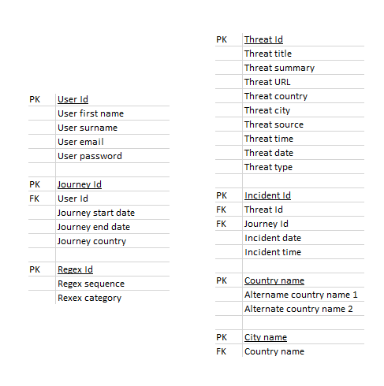
tbl_City
tbl_Country
tbl_Threat
tbl_Incidents
tbl_Regex
tbl_User
tbl_Journey
With the data above being in its final form, the table columns names were then ready to be used in the implementation of the database. As seen in figure 3, following the normalisation process, the following table names were given to each of the sets of data:
- Tbl_User – Stores data of the users of the system
- Tbl_Journey – Stores data of the journeys entered by the system’s users
- Tbl_Regex – Stores data of the regular expressions the system will use
- Tbl_Threat – Stores data of the threats identified by the system
- Tbl_Incident – Stores data of the incidents identified by the system
- Tbl_Country – Stores country names used to identify a threat’s country
- Tbl_City – Stores city names used to identify a threat’s city

4.2.1.2 Entity Relationship Diagram (ERD)
As the DFDs were created to model the processes involved in the system, an ERD was created to model the data involved. Dennis et al.’s book was again used as a guide to create the ERD. This form of data modelling was carried out to diagram the organisation of the system’s data without the inclusion of where the data are stored, created or manipulated. To view the ERD created for the system, see Appendix H.

4.2.2 Database implementation and challenges
With the system’s database already designed, the database was ready to be created. Microsoft SQL Server (2014) was downloaded to use as a database management server, while Microsoft SQL Server Management Studio (2014) was downloaded to connect with SQL Server to design, query and manage the system’s databases. A local server, ‘IndyPC\SQL2014EXPRESS’, was set up and a new database (TaDb) was created. Using ‘CREATE TABLE’ SQL statements, the tables mentioned in the normalization (using 2NF table columns) section were created.

4.2.2.1 Challenge – Inserting world countries and cities
While creating and setting up the database was generally simple, the project’s first lengthy challenge occurred. Upon the creation of the country and city tables, lists of all the countries and the major cities in the world were required to be used to identify the country and city of threats by the system. A free list of the world’s countries and major cities in the correct format (CVS – allowing modification of data columns) was eventually found, using Datahub (2012).
Once downloaded, the data required a lengthy process of modification. Firstly, around 600 of the 21,000 or so city names were duplicated, meaning that the lesser known of these duplicated cities were removed, to ensure that the city name could successfully link to one country. Furthermore, many of the country names linked to the list of cities did not have the same name as the country names in the list of cities. This meant that, as the country names differed, the data could not be entered into the database due to the foreign key constraint requiring the same column name. After modifying the list of city country names, ensuring they matched the list of country names from the country list, the lists of countries and cities were then successfully imported into SQL Server Management Studio (SSMS).

4.2.3 Development of regular expression application
The use of regular expression data is pivotal to the success of the system identifying threats and threat types. A list of ‘detection’ regular expressions such as ‘killed in attack’ are used to scrape through an RSS feed article to identify a threat. However, regular expressions get more complicated, as more detailed regular expressions are required to identify threats more successfully and ignore phrases must be considered to ignore certain article which may be confused as threats. Due to this reason, it is likely that the list of regular expressions would constantly require modifying throughout the project.
After the implementation of the system’s database, a console application was created using Visual Studio (2017), as explained in chapter 3 (section 3.7), to allow for a quick and user-friendly method of inserting, editing and deleting the regular expressions used to identify threats by the main application. Though this application, named (RegExcellent), took two days to develop, it saves a considerable amount of time carrying out repetitive SQL SELECT, INSERT, UPDATE and DELETE statements, which are required to view and modify the regular expressions used by the system to identify threats. Figure 4 shows the application.

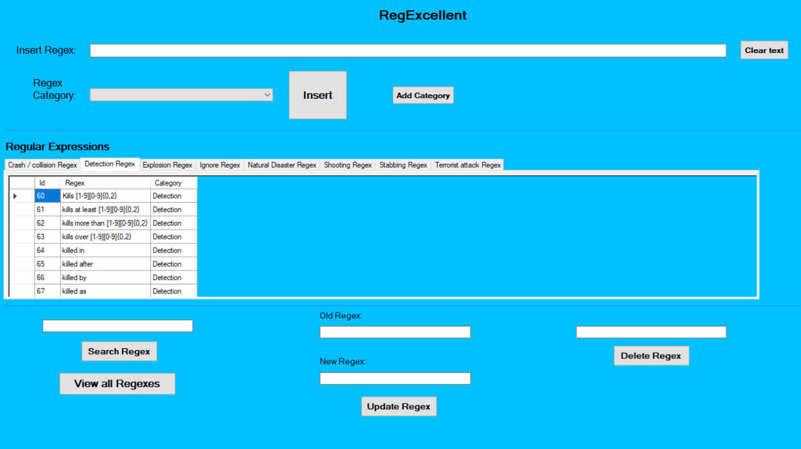
Figure 4: Regular expression application
Nb. The focus of this application was to provide convenience regarding modifying the system’s regular expressions. Great attention has therefore not been paid to interface design principles, or ensuring the application looks attractive, as it is effectively an admin tool, and will never be seen by a user. The application is not a component of the final system.

4.3 Software design and implementation
This section describes the design and implementation stages, and challenges, involved in the development of the system’s three components – the threat scraper service, the user interface Web application and the incident identifying alerting service.

4.3.1 Threat scraper service
Upon implementation of the system’s database and the development of the regular expression application, design and implementation of the threat scraper service began. The threat scraper service is the component of the system which uses regular expressions to scrape RSS feed articles of news websites for threats. If the threat scraper identifies a threat, it stored it in the database ready for future use by the system. The threat scraper has been created as a service, allowing it to run in the background of a computer. The development of the threat scraper service targets FR05, FR06, NFR04, NFR08, NFR09, NFR10, NFR11 and NFR12.

4.3.1.1 Threat scraper service design
The design of the threat scraper begins with the creation of the level 1 DFD, as seen in figure 5 below. As the DFD shows, the threat scraper will first retrieve an RSS feed item from a list of pre-defined news websites. Secondly, the scraper will use the regular expressions stored to identify threats, as the regular expressions will run through the RSS feed item. Upon identifying a threat, the system will scrape the threat for its country, by scanning the list of countries from the countries table through the RSS feed item. If the country is found, the RSS feed item will then be stored into the system’s threat table.
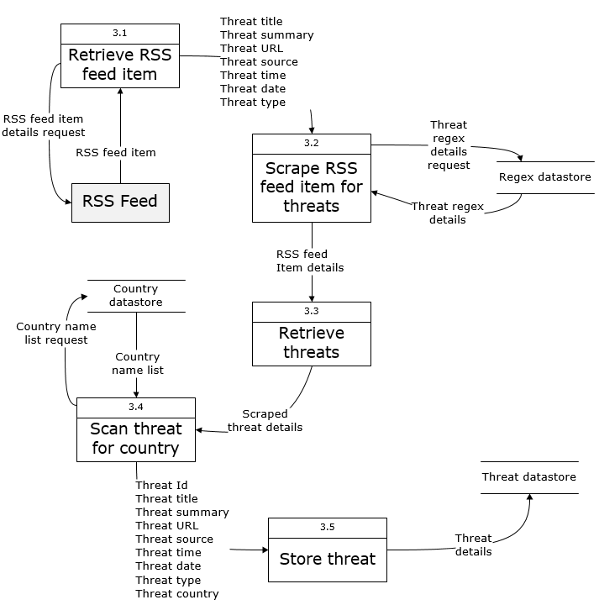
Figure 5: DFD showing how the system’ scrapes for threats

Before the implementation of the threat scraper, pseudocode has been created to create an outline and plan of the scraper. The creation of the pseudocode helps break down how the system would work and be developed. Figure 6 shows the pseudocode created for the threat scraper.

Figure 6: Pseudocode for the threat scraper
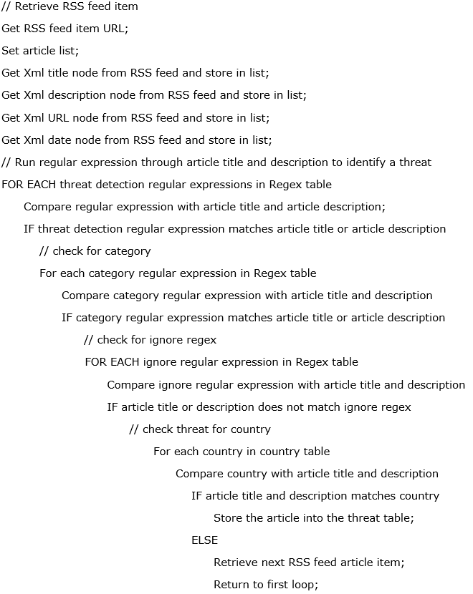

4.3.1.2 Threat scraper service implementation and challenges
After planning the design of the threat scraper service, the scraper was then implemented. A brief summary of the steps involved include:
- Creating a new Windows service-based project on Visual Studio
- Importing the Threat, Regex, Country and City database model into the project, ensuring a connection between the application and the appropriate database tables, and creating a connection string in the App.config file
- Obtaining the Xml pages of three RSS feeds (BBC News, Reuters and Sky News), and storing these as keys in the App.config file, allowing them to be called from the application whenever required
- Entering regular expressions into the Regex table (such as ‘killed in attack’), to ensure the system had some data to use to scrape for threats
- Carrying out the programming based on the pseudocode in figure 6
- Setting up and installing the service once the application was complete

Challenge A – Using a Web scraper to scrape the RSS feeds
Creating the system’s web scraper was the first major challenge faced when implementing the system. This challenge helps meet FR05 (the system using Web scraping to identify threats).
The first step required obtaining the URLs of the RSS feeds, in Xml format, and storing these URLs in keys in the App.config file, ready to be assessed by the system. A function was then created which looped through the Xml nodes of each item in the RSS feed, identifying the title, summary, link, date and time of each article in the document. These nodes were stored in a temporary variable, ready to be analysed by the system at future stages. Figure 7 shows the creation of the function which obtained the nodes from the RSS feed using Xml nodes.
Figure 7: For each loop, looping through the RSS feed’s Xml structure
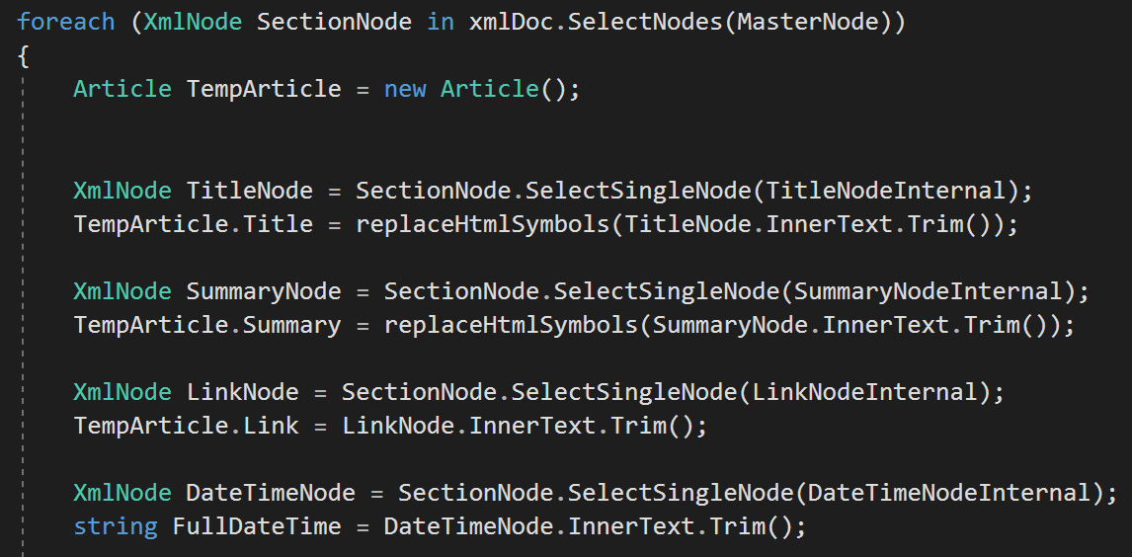

Challenge B – Learning to use regular expressions to identify threats
This challenge concerns FR05 (the system using Web scraping and regular expressions to identify threats).
Before the data obtained from the RSS feed could be scraped for threats, a list of regular expressions was required, containing the expressions used to identify threats. This required learning how to use regular expressions. While some expressions were simple, such as the phrase ‘people have died’, matter got more complicated. News websites sometimes report on articles that contain a phrase associated with killing, but not discussing recent human deaths. For instance, if just the phrase ‘killed after’ was used to scrape for articles reporting on threats, the system could have scraped a threat, when the full title may have been ‘dog killed after owner leaves it’. Due to this type of complication, and many others, a list of carefully constructed regular expressions was created, along with a list of ignore expressions, which would disregard an article as a threat. Several initial categories of regular expressions were created:
- Detection – used to identify an article discussing a report on a recent threat, e.g. ‘50 killed in’
- Ignore – used to ignore article that discussed historic articles or articles discussing the killing of animals, such as ’50 people died last year’, or ’50 sheep died’
- Other threat typed categories – such as ‘Natural disaster’, ‘Explosion’ and ‘Terrorist Attack’. If regular expressions under these categories were found in an article, the type of threat could be identified and described to the user in an alert.
Figure 8 shows some of the regular expression stored in the Regex table to be used to identify threats and threat types.
Figure 8: List of several regular expressions constructed
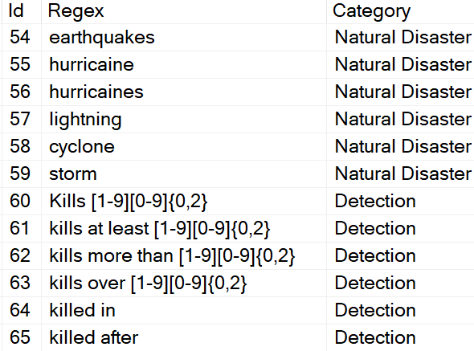
Considerable time was spent creating a list of regular expressions that would be clever enough to identify which article was a threat and which article was not.

Challenge C – Identifying a threat
With the list of regular expressions created, and the scraper scraping articles from RSS feeds, the next challenge was to create a function which would use the regular expressions and run it through the article to identify a threat.
A function was created which looped through each regular expression in the Regex table and scanned this through the title and summary of each RSS feed item. If a detection regex was found in the title or summary of an RSS feed, the system would store this article into the table of threats with an SQL query, as shown in figure 9.
Figure 9: Insertion of an identified threat into the Threat table
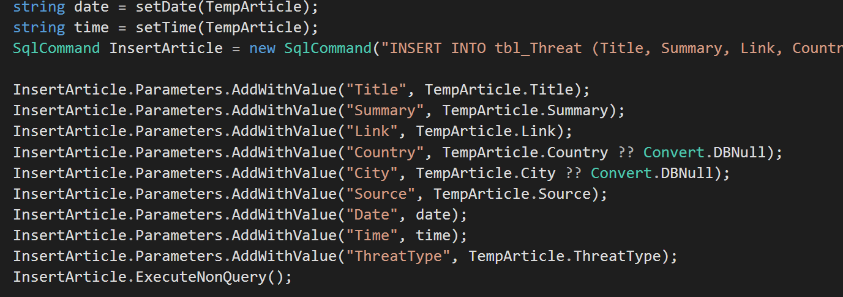

Challenge D – Difficulty identifying country
Challenge C described the process of inserting a threat into the Threat table (FR06), but before this was completed, several other challenging processes were required.
The system would only store a threat if the article included the name of a country in its title or summary, else the threat could not be used to alert users. While a function was created to simply scan the list of country names from the Country table through the RSS feed, it was observed that some articles would only mention city names.
As a result of this, another function was created, which scanned the list of city names from the City table through the RSS feed. The function would then use the foreign key constraint in the city table to link the name of the city to the associated country. This function effectively helps make the scraper more reliable by ensuring the city name can be used to identify the country of a threat.

Challenge E - Converting articles date format to format understood by the system
Another challenge faced before a threat could be inserted into the database was the formatting of the date supplied by the RSS feeds. While the RSS feeds provided the date in a format such as ‘Sun, 02 April 2018’, the format of ‘YYYY-MM-DD’ was required. A function was therefore created to convert the standard RSS feed date format into the format required. Figure 10 shows an extract of this format, showing the use of cases, which would convert the month ‘Jan’ into 1.
Figure 10: Extract of function used to convert date format
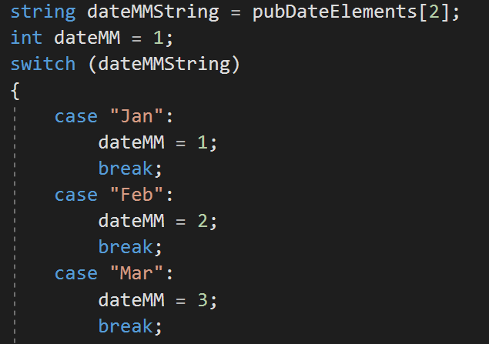

Challenge F – Formatting issues with articles
Occasionally, the formatting of the text within the RSS feed item would contain seemingly random symbols, ruining the title of the threat as it was stored in the database. As a result of this, a function was created (Figure 11), which checked the article for the symbols, and removed them. This ensured the article was inserted, with the correct formatting, into the threat table.
Figure 11: Function to fix formatting issues
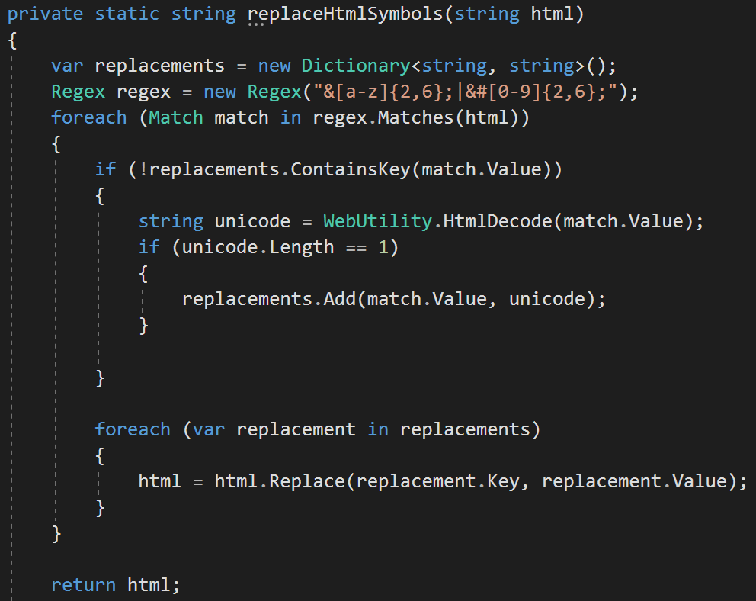

Challenge G – Maintaining the regular expressions
A challenge throughout the development of the threat scraper was the maintenance of the list of regular expressions used to identify threats. As more ‘threats’ were added to the database, it was clear than many of the articles were not actually threats. These threats had been inserted when they should not have been, requiring constant modifications to the regular expressions as time went by.

Challenge H – Creating and installing the service
After creating the threat scraper, the service was ready to be installed. A discussion of the challenge faced when installing the service will be explained in the next section, which discusses the system’s other service – the incident identifying and Emailing service.

4.3.2 User interface (UI) Web application
After successfully creating the threat scraper, the next component to be developed was the UI Web application. The UI Web application allows users to register to the system, add journeys and view a list of threats around the world.
While the UI application is the only component of the system which the user interacts with, it is less complex than the threat scraping service. As a result of this, more time had been spent on developing the threat scraper, as this was the main priority of the system. Furthermore, the UI application intends to be fairly simple – as the users only significant interaction with it is the adding of a journey. Though simple, considerable time has been spent designing and implementing a user-friendly UI application that satisfies the FRs and NFRs. The development of the threat scraper service targets FR01, FR02, FR03, FR04, FR09, FR10, FR11, FR12, FR13, NFR04, NFR01, NFR02, NFR03, NFR07, NFR10 and NFR12.

4.3.2.1 UI Web application design
To ensure the design of the UI application has been adequately considered, five design areas will be focussed on – DFDs, Web app sitemap, requirements analysis, HCI design principles and other design guidelines.
No screen designs have been included as the Web application will be created using the ASP.NET MVC Bootstrap (model-view-controller) framework in Visual Studio. In using ASP.NET MVC and Bootstrap, a standard and simple already designed user interface layout is provided for each page. While the layout of the pages will be not be changed, certain design elements will be modified to comply with certain principles. This will be discussed later in the section.

4.3.2.1.1 DFDs
Level 1 DFDs have been created for the system diagramming the two-main process regarding the user’s interaction with the system - Register Account (Appendix F3) and Add Journey (Appendix F4).
The Register Account DFD shows that the system will first receive and validate the user’s registration details, before generating the user’s account and adding it to the user table. Finally, a confirmation Email will be sent to confirm that the system communicates with the user.
The Add Journey DFD shows that the system will firstly obtain the user’s journey details was they are entered, before validating these details and storing them in the journey table.

4.3.2.1.2 Web application sitemap
A sitemap, shown in figure 12, has been created to show the planned design of the proposed system’s navigation.

Figure 12: Site map for the UI Web application
Home
View Threats
Add a Journey
Register/ Log in
My Journeys
Logout
More Threat details
Add Journey
Edit Journey
Delete Journey
How to use
My Account
Change Details

Looking at the sitemap, it is easy to see how simple the user interface is, reflecting the fact that the user’s involvement with the system will generally be simple and quick.

4.3.2.1.3 Requirements analysis – designing for the target user
As identified in chapter 3 (section 3.4), the target users of the system are men and women, who may have experience of, or an interest in technology, between the ages of 18 and 65.
As users of the system are expected to be above the age of 18, and may be elderly, the interface design will be kept simple. While there is no need to attract younger people with the use of bright colours and images, a simple interface will ensure that those who are older, and potentially technologically naïve, face no complications when using the software.

4.3.2.1.4 HCI design principles
The UI Web Application will follow a variety of HCI design principles to ensure a successful interaction with users. Tognazzini’s (2014) provides a set of HCI principles, explaining that they are fundamental to the design of effective interfaces, whether they be computer or mobile based devices. As the principles provided by are extensive and apply to both computer and mobile device, they will be used. Table 5 lists the principle area and design decision made in consideration of the HCI principle described by Tognazzini.
Table 5: Table of HCI principles to be considered.
HCI Principle area | Design decision considering HCI principle
Navigation | - The users will be prevented from making mistakes, with the inclusion of validation techniques used wherever the user must provide input.  - Feedback will be provided to the user wherever possible and appropriate. This will include provide informative validation, confirmation and error messages.  - A menu bar will be used, allowing the user to navigate to various parts of the application whichever page they are currently on.  - Icons will be used on the application’s navigation menu, to visually inform users of the page the navigation menu item points to
Anticipation | - The instructional information and tools will be present and visible on all pages to ensure that users do not need to search for information or instructions.
Colour | - Colours that are difficult to read (typically green) for people who are colour-blind will be avoided in the UI.  - The UI’s primary colour will be white, and its secondary colour will be dark blue. Blue will be used as it is associated with trust, as Batsou (2017) explains. Using blue will hopefully build trust with the user of the system.
Consistency | - The colours used, and layout of the UI will be kept consistent, ensuring that users are able to learn to use the system quickly.
Discoverability and simplicity | - The UI will not be designed in a complex way. Instead it will be simple, ensuring that users are easily able to discover the contents of the interface they require.
Readability | - Text will have a high contrast to ensure it is easily readable. Black text on white backgrounds will be used, as well as white text on dark blue backgrounds.  - A font size that is large enough to read (at least 16pt) will be used.  - A sans serif font (such as Verdana) will be used as it is easier for users to read (particularly with dyslexia) than serif fonts.
Content awareness | - Users will always be aware of where they are in the system, as a heading of the page they are on will be displayed.
White space | - The UI will carefully consider not using too much or too little white space.
Minimise user effort | - As previously mentioned, the interface will be simple to use, and users will be able to complete most actions with just a few clicks.
Responsiveness | - The UI will be designed in a way that is responsive, ensuring that the application can be used on varying screen device sizes without graphical errors occurring.

4.3.2.2 UI Web application implementation and challenges
As the main and most complicated components of the system are the threat scraper and incident identifier, less time was spent on developing the system’s UI. The system’s UI is also fairly simple, as the only user interactions involved are registering, adding a journey and changing details. Due to these reasons, and the simplicity of the UI, only basic challenges were faced. Visual Studio 2017 was used to create the UI application, and the ASP.NET MVC (Model-View-Controller) framework was used.
The processes involved in the implementation of the UI Web application included:
- Creating the registration system, which allowed users to create an account to use whilst using the application. This also involved creating the ‘Edit details’ and ‘Forgot password’ pages
- Creating the ‘Home’ and ‘How to Use’ pages, which simply displayed data regarding the application
- Creating the ‘View Threats’ page, which called data from the Threat table and displayed it on the page
- Creating the ‘Add Journey’ and ‘My Journeys’ pages, which allowed the user to add and edit their journey by selecting their journey country from a dropdown list of all the countries, and start and end dates from a calendar widget

Challenge A – Learning to use the ASP.NET MVC framework
The decision to use MVC (using C#) was made to enhance programming skills and learn a new method of programming. With little experience of using MVC, getting to grips with it was difficult, particularly at the beginning. After following a tutorial by Chadwich (2016) on how to use the technology, the framework began to make more sense. After learning the ropes, the structure of MVC became familiar. The Model (M), deals with the database connection, the View (V) focusses on the interface and the Controller (C) deals with the programming logic of the system. Learning to use MVC was challenging, but hugely beneficial.

Challenge B – Registration system with password encryption
To meet FR03, a password encryption system was included in the system’s registration. This was accomplished through the use of a Crypto.Hash method offered by Visual Studio, as shown in figure 13.
Figure 13: Method used to encrypt user’s password
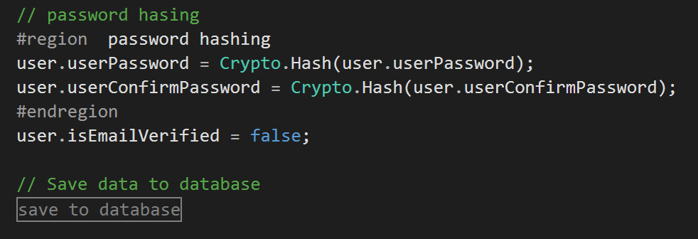

Challenge C – User sessions
To ensure that certain pages were only displayed when a user was logged in, and the data displayed was associated to the user, Session Ids were used. These session Ids worked by storing a session Id when the user logged in and using this Id for various processed until the user logged out. Figure 14 shows an example of the session Id being used. It shows code implemented that displays the ‘Add Journey’ navigation menu item if the user is logged in.
Figure 14: Session used to display certain navigation bar items
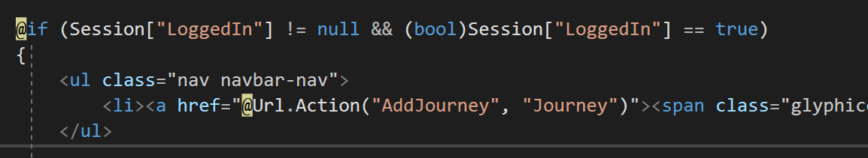

Challenge D – Error handling using jQuery calendar widget
Another challenge regarding the implementation of the UI was the use of jQuery calendar widgets. This challenge helped meet FR04 (the Add Journey page).
Using jQuery, a widget was added to the interface, allowing the user to click and choose their journey dates rather than manually typing them in. This is shown in figure 15.

Figure 15: Error handling jQuery calendar widget

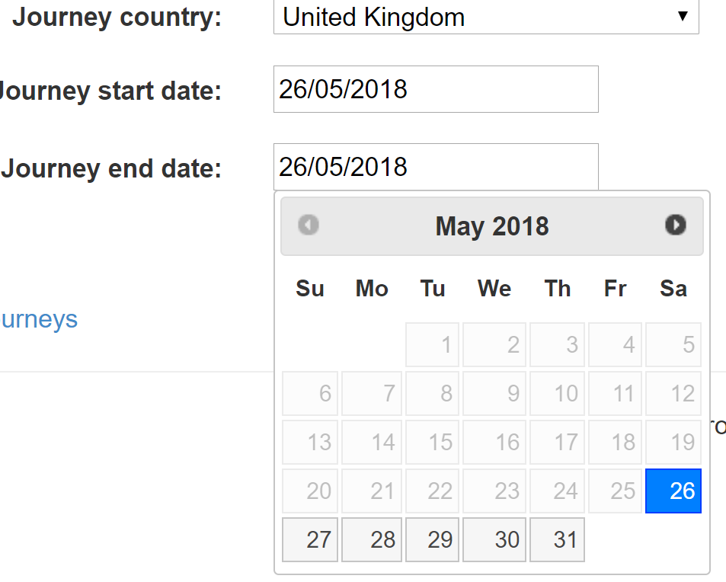
As seen in the figure above, the error handling applied to the calendar meant that the user could not choose an end date that was later than the selected start date. Figure 16 below shows the code used to apply the error handling.
Figure 16: Error handling jQuery calendar widget code
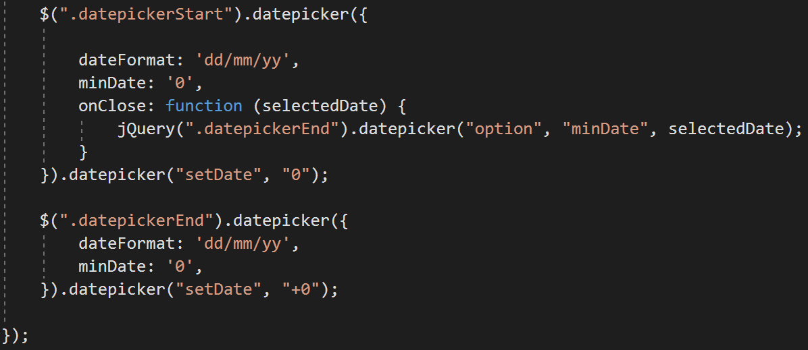

Challenge E – Designing the UI following the guidelines
Considerable time was spent in considering the HCI principles in the design of the system (meeting NFR01). With past CSS experience, modifying the design to meet the HCI principles was not challenging. The challenge involved was the unexpected length of time taken to implement the changes. Figure 17 shows a screen of the UI with a description below of how the screen follows several principles described below.
Figure 17: System UI following HCI guidelines
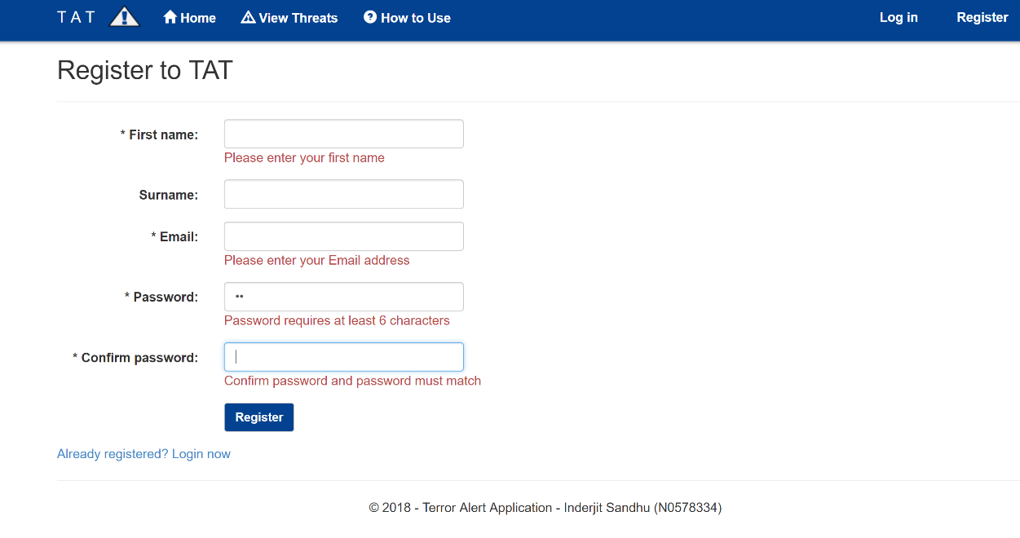
As evident in the screenshot above, the system uses a high contrast between text colour and background colour, displays text in a sans serif font and displays text in at least font size 16, ensuring the text is easy to read. Various validation messages are shown, ensuring the user is informed of any incorrectly entered date, and icons are used as a visual cue.

4.3.3 Incident identifying and alerting service
After implementing the threat scraper and creating the user interface application, design and implementation on the incident identifying and alerting service began. This service is the component of the system which compares the details of a threat with the details of a user’s journey to identify an incident. If an incident is found, it is stored in the database and sends an Email alert to the associated user. The development of the incident identifying and alerting service targets FR07, FR08, NFR05, NFR06, NFR09, NFR10, NFR11 and NFR12.

4.3.3.1 Incident identifying and alerting service design
As with the threat scraper, the design of the incident identifying and alerting service begins with the creation of two level 1 DFDs (see Appendix F6 and F7).
The first DFD details the system identifying an alert. The diagram shows that the system will first retrieves a user’s journey details, including the country, start date and end date. Then, the system will retrieve the threat details, including the threat date and country. Next, the system will compare the details of the journey with the details of a threat and processes an incident if a match is found.
The second DFD shows how the system will alert a user of an incident. The system will first obtain the details of the incident, including the incident’s journey Id and threat Id, before processing a threat alert. At this stage, the details of the journey, including the user’s Id, and the details of the threat will then be obtained by the system. Once the system has all the required information, a threat alert is sent to the appropriate user, containing details of the threat.
Figure 18: Pseudocode for the incident identifying and alerting service
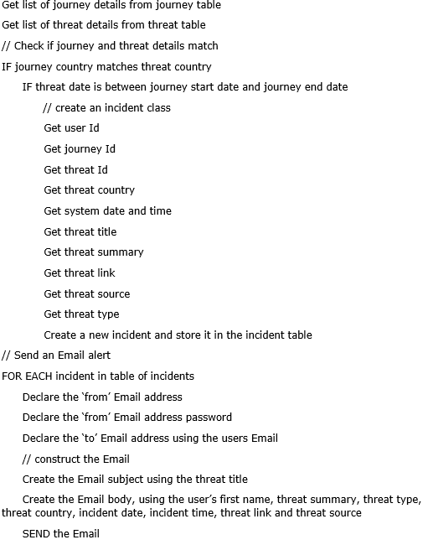
Figure 18 above shows the pseudocode created for the incident identifying and alerting component of the system. This pseudocode will then be used to guide the implementation of the component.

4.3.2.2 Incident identifying and alerting service implementation and challenges
Following the design of the incident identifying and alerting service, the service was then implemented. Due to learning how to construct and send Emails in the UI application, and previous experience of comparing data (making storing an incident simple), this component was implemented without any troublesome challenges. A brief summary of the steps involved include:
- Creating a new Windows service-based project on Visual Studio
- Importing the Journey, Threat and Incident database model into the project, ensuring a connection between the application and the appropriate database tables, and creating a connection string in the App.config file
- Importing the System.Net.Mail property into Visual studio
- Importing the Email API into Visual Studio
- Carrying out the programming based on the pseudocode in figure 18
- Setting up and installing the service once the application was complete

Challenge – Creating and installing the service
To meet NFR09, the creation and installation of Windows services were required for the incident identifier and the threat scraper.
To make the application run in the form of a service, A Visual Studio Windows Service project was created, and a timer was declared for the service, as shown in figure 19.

Figure 19: Code for the service’s timer
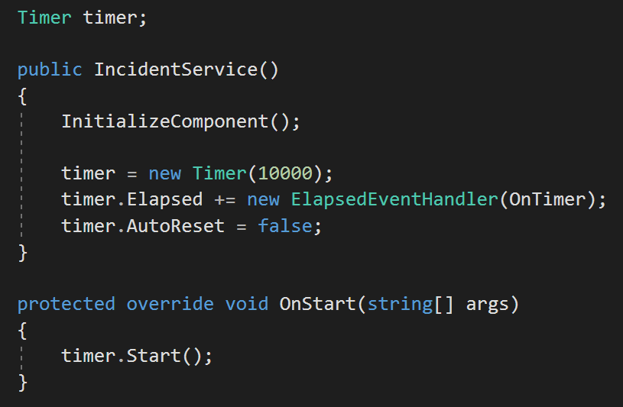
The timer ensured that the service run every set number of seconds (every 10 seconds in the code above).
After the service was create, it was then required to be installed on the device. An ‘install-util’ command was carried out in the command prompt to install the service. The service did not initially run, until the log on setting were changed (shown in figure 20), and an admin account was used. This fixed the problem and ensured that the threat scraper and incident identifying services ran in the background of the computer.
Figure 20: Code for the service’s timer
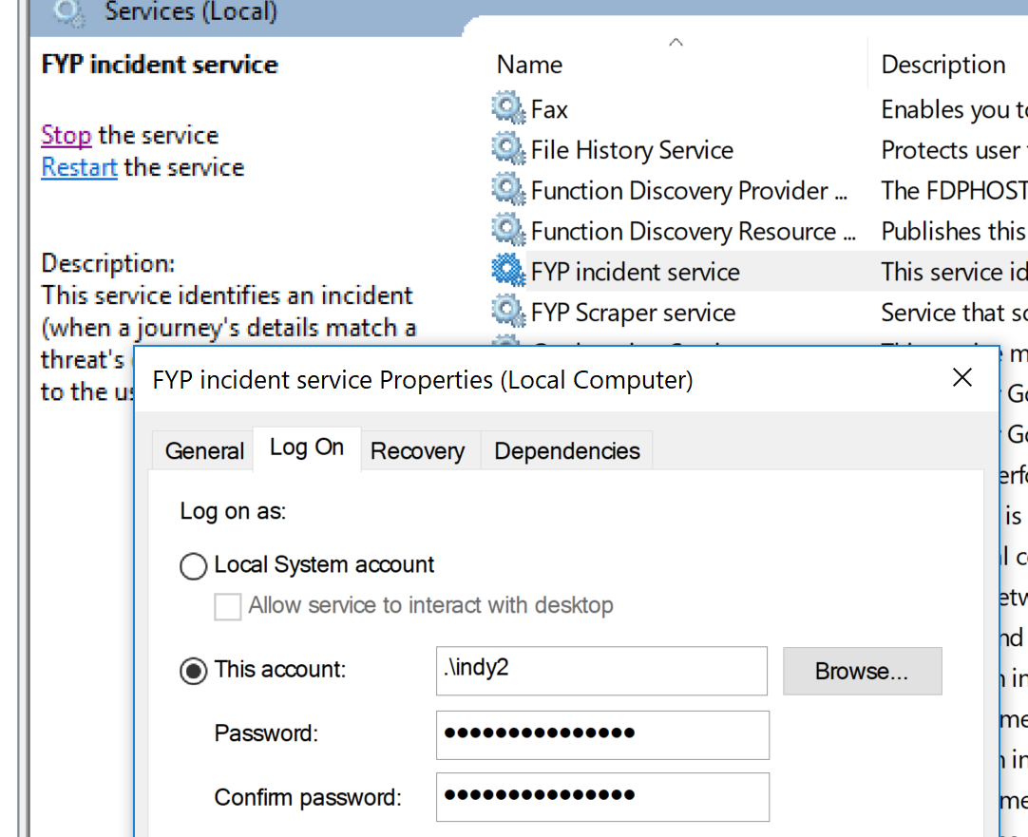

RESULTS
This section discusses the results of the system developed – the final stage of the project’s waterfall methodology. The results are discussed through several testing sessions:
- Testing the system against the products reviewed in chapter 2
- Testing the system against the FRs and NFRs defined in chapter 3
- A User testing session

5.1 Testing the system vs products reviewed
The system was developed to demonstrate an improvement on previous techniques. To measure this, table 6 carries out the same tests on the system as carried out on the products reviewed in section 2.2, which tested the functionality and features offered by current state of the art.
Table 6: Testing the functionality and features offered by the system
Test Id | Does the system (TAT) provide the following? | Pass or fail
1 | A registration system, allowing the user to create and use an account
2 | The ability for users to add a journey from which they would like to receive alerts of threats from
3 | A Web scraper that scrapes the Web for terror-related or natural disaster-based threats that occur all over the world
4 | The inclusion of a system which aims to send an alert to a user when a threat occurs near them
5 | An alerting system that consistently alerts users within a matter of a couple of minutes of an incident being reported
6 | A threat alert containing considerable amounts of information that may be of importance to the threat (such as title, summary, country, type, date, time, source and URL)
7 | A system which can be used on a computer and a mobile device
8 | An alerting system which does not require the use the user’s location services
9 | A system that reports on, or sends alerts regarding incidents occurring across the entire world
10 | An area dedicated to displaying a list of recent terror incidents or natural disasters that have occurred around the world
11 | A system dedicated to alerting users on holiday of incidents that occur that may affect them

As the table shows, the system passed 10 of the 11 tests. This shows a considerable improvement on previous state of the art, which passed on average 3 of the 10 tests. In passing the above tests, it is clear that the system offers more functionality and features than Safety Check, Disaster Alert, EVAC Cardiff and SAIP.

5.1.1 Failed test – 7
Though the majority of the tests were passed, the system failed test 7 – the offering of a system which functions on computers and mobile devices. While functioning perfectly on the computer the system was developed on, no access could be made to the localhost used to develop the system. This resulted in the inability to run the application on a mobile device, even though the application is capable of doing so. This is evident as the system uses bootstrap and a responsive design. Despite the application’s ability to respond to different screen sizes, the test was still failed. The system would have passed this test if it was published, but this also could not be achieved. If the system was published, it would not rely on running on a localhost, meaning that it could be accessed by any device.
Despite the system failing this test, it is still important to consider that the system still sends Email alerts, which are successfully received on mobile devices. This means that in its current state, users would be required to enter a journey through a PC, but they could still receive alerts on their mobile device. This maintains the effectiveness of the alerting side of the application.

5.2 Testing the system vs the FRs and NFRs
This testing session tests the system against the FRs and NFRs defined in chapter 3, helping identify how successful the system is in achieving its planned goals. As explained in chapter 3, the lists of FRs and NFs were constructed carefully, ensuring that the testing carried out in this section tests a variety of aspects regarding the functionality of the system.

5.2.1 System vs FRs
Table 7 summarises the testing of the system against the FRs defined in chapter 3. The expected result is defined, along with the aspect of functionality tested and whether the requirement has been met or not.
Where appropriate, screenshots will be provided, although this is not always the case. As it is not possible for a screenshot to prove whether some tests are passed or failed, these screenshots are not included. The demo of the system will help better demonstrate the passing of failure of these tests.
Nb. The screenshots included in the table may be small or cropped. To see larger images of the screenshots, along with all the other FR testing screenshots, see Appendix I.
Table 7: Testing the system vs FRs
FR Id | Expected result | Screenshot evidence | Requirement met?  Discussion of functionality tested
FR01 | Ability to register to, log in to and log out of system | Better demonstrated in demo | YES  In meeting this requirement, the system demonstrates its ability to use databases to create a registration system, manager managing the user’s information.
FR02 | Successful delivery of a registration verification Email | 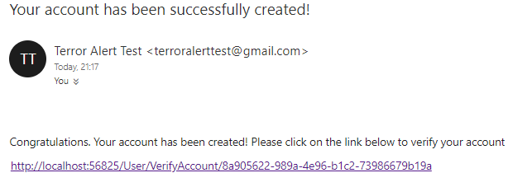  See Appendix I1 for full screenshot | Yes  The functionality successfully tested was the system’s ability to send an Email to the correct user.
FR03 | User’s information kept secure and encryption of passwords | 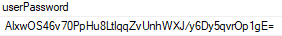  See Appendix I2 for full screenshot | Yes  The system’s ability to encrypt a user’s password was successful. This provides extra user security.
FR04 | An ‘Add journey’ page allowing a journey to be added | 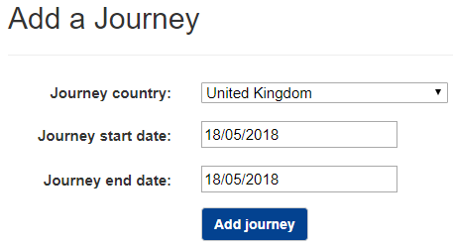  See Appendix I3 for full screenshot | Yes  In meeting this requirement, the system demonstrates its ability to store user input, from a dropdown list and a calendar, into a database.
FR05 | Use of Web scraping and regular expressions to scrape threats | 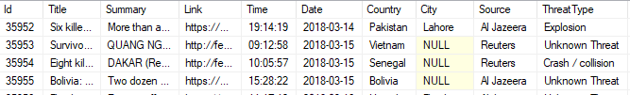  See Appendix I4 for full screenshot | Yes  Meeting this requirement was important as it is the most complex and important part of the system. It was successfully implemented and shows that the system successfully combined the use of regular expressions with Web scraping to identify threats.
FR06 | Identification or threat’s country/city | See shown in screenshot above | Yes  The system successfully scraped for the country (and city if available) of a threat.
FR07 | Successful calculation of an incident | 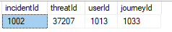  See Appendix I5 for full screenshot | Yes  This was another requirement that was important to meet. The system successfully compared two sets of data (users journey details with threat details) to create an incident and store it in the database.
FR08 | Successful delivery of a threat alert Email | 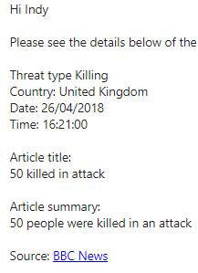  See Appendix I6 for full screenshot | Yes  In meeting this also important requirement, the system successfully delivered a threat alert Email, showing its ability to query data and send an email.
FR09 | A home page | As the home page is basic, it will be shown during the demo | Yes  The system successfully included a home page, demonstrating its ability to display data.
FR10 | A ‘My Account’ page, allowing the user to edit their account details | 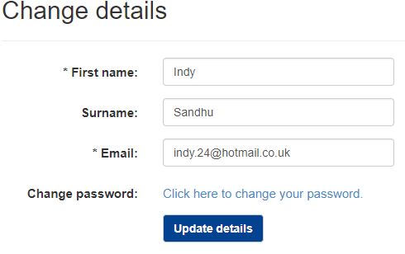  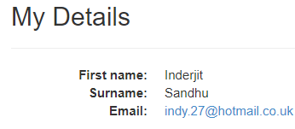  See Appendix I7 for full screenshot | Yes  This requirement was met, demonstrating that the system is able to successfully allow users, using the UI, to modify their data from the database.
FR11 | A ‘My Journey’s page allowing users to add, edit and view their journeys | No screenshot provided as the functionality is effectively the same as the ‘My Account’ page  System works in a similar way to the screenshot above. Will be demonstrated during demo | Yes  As mentioned in the row above, the system successfully allows users to modify their data.
FR12 | A ‘View Threats’ page displaying the threats identified by the system | 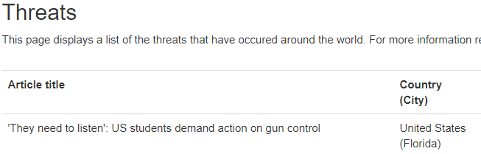  See Appendix I8 for full screenshot | Yes  The completion of this requirement shows that the system successfully displayed important data to the user.
FR13 | A how to use page explaining how to use the system | As the how to use page is basic, it will be shown during the demo | Yes  The system successfully included a how to use page, in the case of user’s requiring instructions.

The results of this test show that the system successfully meets all of its functional requirements, meaning that it carries out the main functionality that was intended.

5.2.2 System vs NFRs
Table 8 summarises the testing of the system against the NFRs defined in chapter 3. The layout of the table is similar to the table used in the previous section, in the testing of the system against the FRs.
Screenshots are again provided where appropriate, though this is not always the case as it is not possible for a screenshot to prove whether some tests are passed or failed. The demo of the system will help better demonstrate the passing of failure of these tests.
Nb. The screenshots included in the table may be small or cropped. To see larger images of the screenshots, along with all the other NFR testing screenshots, see Appendix J.
Table 8: Testing the system vs NFRs
NFR Id | Expected result | Screenshot evidence | Requirement met?  Discussion of functionality tested
NFR01 | The system should successfully comply with the HCI principles listed in chapter 4, ensuring it is user-friendly. | See Appendix J1 for full screenshot  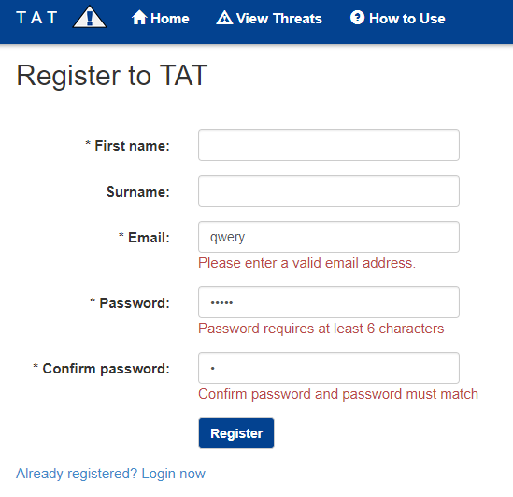 | Yes  The system successfully complies with the HCI principles listed in chapter 4.  Considerable time has been spent on making the UI user-friendly, as the demo will demonstrate.  Some HCI principles followed, as evident by looking at the screenshot, include:  - Use of validation throughout to help prevent user mistakes  - Use of icons as visual cues  - Used contrasting colours, sans serif font and large enough text, ensuring the text is readable  - Ensured consistency throughout the UI  - Kept pages simple
NFR02 | The system running on Chrome, Firefox, IE, Edge and any mobile device’s browser. | Screenshot not beneficial | No  While the UI works on all the computer-based web browsers, it does not function on mobile devices. This has been explained in section 5.1.1.
NFR03 | Delivered in the form of a Web-based application. | Screenshot not beneficial | Yes  The system was successfully delivered in the form of a Web-based application, using MVC.
NFR04 | Scraping for threats carried out every 60 seconds. | Screenshot not beneficial. | Yes  The system successfully scrapes for threats every 60 seconds. It has been measured that upon scraping a threat, the system stores this threat within 2 seconds.
NFR05 | Checking for incidents every 60 seconds and sending Email within 30 seconds. | Screenshot not beneficial. | Yes  The system meets this requirement as it successfully scrapes for threats every 60 seconds. The time taken to send an Email was measured to be just 4 seconds. The ability for the system to process data quickly ensures it is an effective alerting tool.
NFR06 | System should not send spam Emails or multiple Emails regarding an alert. | Screenshot not beneficial. | Yes  The system does not send any spam Emailers to users. A function was created to stop Email alerts being sent from multiple sources reporting on the same threat.
NFR07 | Users should be able to add many journeys as required. | Screenshot not required. | Yes  This requirement has been met, allowing the users to receive alerts from as many countries and journeys as they like.
NFR08 | List of RSS feeds used to scrape for threats should be easily modifiable. | Screenshot not beneficial. | Yes  A function has been created that loops through the defined list of sources. All an admin would be required to do is add a source key to the application’s Web.config including the URL of the RSS feed.
NFR09 | System should run as a Windows service. | See Appendix J2 for the full screenshot  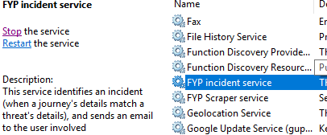 | Yes  The system successfully runs as a Windows service. This allows the threat scraper and incident identifier to run in the background of a computer.
NFR10 | System should successfully use databases for the management of information. | See Appendix J3 for the full screenshot  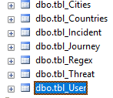 | Yes  The system uses SSMS as a database querying software and use SQL and EF queries to query data.
NFR11 | System should be more successful than not when regarding alerting users. | Screenshot not beneficial. | Yes  Though alerts are not common for the system, due to the rarity of threats occurring, the system always successfully alerts the users when an incident is identified.
NFR12 | System should entail no costs. | Screenshot not appropriate. | Yes  No costs are involved in using the system.

The results from testing the system against the NFRs identified in chapter 3 show that the system meets 12 or the 13 NFRs. Though not perfect, the system still functions in most ways planned.

5.3 User testing session
The system’s UI Web application was tested by four people (aged between 21 and 25), providing feedback on its suitability for the intended purpose. As the system’s main components are the threat scraper and Emailing system, the UI is simple, meaning the user testing sessions were brief.
A questionnaire was created (see Appendix K), inspired by Slegg (2007), which focused on the UI’s usability. The questionnaire was completed by the four testers after using the system for five minutes.
The feedback from the questionnaire was positive as the UI design was generally perceived as user-friendly and easy to use.
All four of the testers stated that they were able to identify the purpose of the application and carry out the required tasks with no problems. The testers all agreed that the UI’s validation error messages were useful and informative. While one of the testers explained that the home page was slightly too obtrusive, the testers all agreed that the text was easy to read.
The testers all agreed that they were able to navigate their way around the UI with ease, and that it functioned at a good speed. While the four testes believed the application’s UI design was simple, two of the testers thought that the design could do with being a little more attractive.
The general feedback was that while minor changes could have improved the visual appearance of the UI, the interface was user-friendly and allowed users to carry out their tasks with ease.

5.4 System testing conclusion
After carrying out the testing sessions in this chapter, it has been identified that the system carries out its major functionality as expected, with the inability of the system working on mobile device the only downfall. Despite this, the system provides many more features than the products reviewed in chapter 2 and met all but one of its functional and non-functional requirements. Taking less than 10 seconds to store a threat and send an Email, it can be concluded that the threat-scraping and incident identifying/alerting systems are quick and effective.

CONCLUSIONS / FUTURE WORK

6.1 Conclusion
As identified in the results section, the development of the system produced in this project has been very successful. Despite the fact that one requirement was not met (the UI application functioning on mobile devices) the system successfully met all other criteria defined in chapter three.
The review of state of the art in the field carried out in chapter three found that currently, terror alerting applications face many limitations. Some of these limitations include providing a dedicated application to alerting users on holiday, making use of Web scraping technology and regular expressions to create a fully automated alerting system and providing users with alerts containing a considerable amount of information regarding the alert. Out of the 11 tests, testing features of the systems, carried out on the products, the average number of features included by each system was three.
The system developed, TAT, addressed 10 of the 11 tests, offering many more features to users than current solutions. The success of the system provides a framework for exploring the idea of developing threat alerting systems targeted at users on holiday.

6.2 Critique and future work
Despite the fact that the project has been successful, future action can be taken to improve the produced system, making it more beneficial and effective regarding its concept of being a threat alerting application that is used whilst travelling.

6.2.1 Use of AI
While the system is accurate at identifying threats with the use of regular expressions, this accuracy could be further improved with the use of artificial intelligence. As well as providing accuracy, the use of AI would reject the need to maintain the list of regular expressions. A drawback of using AI however, is that its complicated nature would make it difficult to implement. The AI would need to read thousands of articles of threats to identify a threat accurately.

6.2.2 Sending SMS notifications
Another improvement to the system could be the use of SMS notifications rather than Email notifications. The use of SMS notifications, rather than Email notifications would provide an alerting system which is more effective, as SMS notifications tend to be more obvious than Email notifications. While SMS notifications could incur complexions regarding data roaming, it would also reject the need for the system to rely on having an internet connection as it currently does.

6.2.3 Using user’s location services
Using the user’s location services could provide a much more accurate alerting system. Whereas currently a user could be on the east coast of America and receive an alert of a threat that occurs hundreds of miles away in the west coast, the use of location services could provide the option of only alerting a user within a set radius. Using the user’s location services could also allow the possibility of providing the user with nearby SOS locations in the event that they are in trouble.

6.2.4 Modifying the system for business use
A drastic improvement of the product could include the modification of the system to allow it to be used by businesses.
The system could be modified to include a response service, allowing employees to respond to the business if they receive a threat alert. This could benefit businesses by being a tool that helps monitor staff.
The system could then be made more and more advance, with another level of complexity potentially including a system which updates HR and line managers of the safety of employees that may be involved in an incident.

6.3 Discussion of Professional, Social, Ethical and Legal (PSEL) issues
Various PSEL issues have impacted the product and will do so in the future

6.3.1 Professional Issues
Professional Issues have had a high impact on the work carried out throughout the project, as the project has aimed to be an extremely professional piece of work. Following the British Computing Society Code of Conduct (2015), professional knowledge, skills and competence have been developed as the project has advanced. New knowledge, skills and competence, such as creating a Web scraper, designing a user-friendly application and using an Email alerting system has been developed throughout the project.
Another professional standard mentioned by the BCS is that alternative viewpoints should be respected and valued, and that honest criticism of work should be accepted. This standard has also been complied with, as feedback from the project supervisor has been considered throughout the project, resulting in an improvement in the the quality of the project. After the initial features were declared and described to the project supervisor, advice from the supervisor, such as new feature ideas, or product improvement, has been considered.

6.3.2 Social Issues
Social Issues will potentially have a high impact on the project depending on how successful the system is at performing its main task of alerting a user of a threat in a country they are in. The application could cause panic among the society if it incorrectly reports a threat, such as a terrorist attack, to users.
On the other hand, when the application successfully alerts a user of a threat, it will benefit society greatly by making the public aware of an attack soon after it happens, meaning that the news could be spread quickly, and people could take any required action to remain safe and support the affected society.

6.3.3 Ethical Issues
Privacy is the main ethical issue regarding this project. Privacy has a high impact on the project as important and sensitive data will be requested by the application from the user, such as personal details and details of journeys which they will be attending. To provide the user privacy, and ensure their personal details will remain safe, the application includes a registration and log-in system, meaning that users must require a password to add a journey. As a further layer of security, passwords have been encrypted, making stealing passwords difficult. The application will never be shared elsewhere.

6.3.4 Legal Issues
As the system stores data from news websites and presents this back to the user, legal issues have had a high impact on the project. Many news websites do not permit the use of their content for personal non-commercial use, and block web scrapers or bots from scraping their data. To comply with this legal issue, the system scrapes from the RSS feeds of websites, rather than from the actual websites. RSS feeds permit bots or web scrapers to scrape their content and allow websites to use their data on the condition that the news website is credited. Hence, when alerting a user of a summary of a threat, the application states the news source and provides a link to the original new article.
The application complies with the relevant principles mentioned in the Data Protection Act 1998 (Gov.co.uk, 2017). Due to this, when dealing with the personal data of users, data is used only for the application’s purpose (alerting users of incidents), and nothing more. Personal data is deleted from the database when deleted by the user, ensuring data is not kept longer than necessary. User’s data is also kept safe and secure as it is stored in a database that is used only by the creator of the application. To comply with the Disability Discrimination Act 1995, HCI and accessibility guidelines have been considered when designing the application.

ReferenceS
Apple, 2015. Siri Spotlight Search Suggestions. iOS feature. Available from iOS enabled devices. [Accessed 28 March].
Batsou, E., 2017. Colour Psychology in Web Design [online]. Available at: https://blog.prototypr.io/color-psychology-in-web-design-bf974293beb [Accessed 20 December 2017].
BBC (2018). BBC News – World [RSS] 22 April. Available at: http://feeds.bbci.co.uk/news/world/rss.xml?edition=uk [Accessed 22 April 2018].
British Computing Society. (2015). British Computing Society Code of Conduct. [online]. Available at: http://www.bcs.org/upload/pdf/conduct.pdf [Accessed 20 April 2018].
Cardiff Council, 2017. EVAC Cardiff. Mobile app. Available from: Apple App Store and Google Play Store. [Accessed 28 March 2018].
Chadwich, J., 2016. Learning ASP.NET Core MVC [online]. Available at: https://www.lynda.com/ASP-NET-tutorials/Learn-ASP-NET-Core-MVC-Basics/512728-2.html [Accessed 20 December 2018].
Curtis, J. (2017). Agile vs waterfall. London: Dennis Publishing Ltd.
Datahub.io, 2012. List of all countries with their 2 digit codes [online]. Available at: https://datahub.io/core/country-list#data [Accessed 26 November 2017].
Datahub.io, 2012. Major cities of the world [online]. Available at: https://datahub.io/core/world-cities [Accessed 26 November 2017].
Dennis, A, et al., 2012. System Analysis and Design. 5th ed. Unite States of America: John Wiley & Sons, Inc.
Facebook, 2014. Safety Check. Mobile app feature. Available from: Facebook mobile app. [Accessed 28 March 2018].
Glez-Pena, D. et al, 2013. Web scraping technologies in an API world. Briefings in Bioinformatics, 15 (5), 788 – 797.
Heckel, R. and Engels, G., 2002. Relating functional requirements and software architecture: separation and consistency of concerns. Journal of software maintenance and evolution, 14 (5), 371-388.
Johnstone, R. (2017). Worst terrorist strikes—worldwide. [online]. Available at: http://www.johnstonsarchive.net/terrorism/wrjp255i.html [Accessed 4 December 2018].
Mahmoud, A. and Williams, G., 2016. Detecting, classifying and tracing non-functional software requirements. Requirements Engineering, 23 (3), 357-381.
Microsoft, 2014. Microsoft Sql Server 2014 [software], 2014. S.l.: Microsoft. Available at: https://www.microsoft.com/en-gb/download/details.aspx?id=42299 [Accessed 26 November 2017].
Microsoft, 2014. Microsoft Sql Server Management Studio 2014 [software], 2014. S.l.: Microsoft. Available at: https://www.sqlshack.com/how-to-install-sql-server-2014-management-studio/ [Accessed 26 November 2017].
Microsoft, 2016. Microsoft Project 2016 [software], 2016. S.l.: Microsoft. Available at: https://products.office.com/en-gb/project/compare-microsoft-project-management-software?tab=1 [Accessed 4 November 2017].
Microsoft, 2016. Microsoft Visio 2016 [software], 2016. S.l.: Microsoft. Available at: https://products.office.com/en-gb/visio/flowchart-software?tab=tabs-1 [Accessed 2 January 2018].
Microsoft, 2017. Microsoft Visual Studio 2017 [software], 2017. S.l.: Microsoft. Available at: https://imagine.microsoft.com/en-us/Catalog/Product/530 [Accessed 26 November 2018].
Ministry of the Interior France, 2016. Public Alert and Information System. Mobile app. Available from: Apple App Store and Google Play Store. [Accessed 28 March 2018].
Pacific Disaster Center, 2011. Disaster Alert. Mobile app. Available from: Apple App Store and Google Play Store. [Accessed 28 March 2018].
Seetharaman, D., 2016. After Pakistan Attack, Facebook's 'Safety Check' Asks Users Far Away if They're Safe [online]. Available at: https://ntuanywhere.ntu.ac.uk/docview/,DanaInfo=.asfcugmFwzx05q57Os54,SSL+2019990216?accountid=14693&rfr_id=info%3Axri%2Fsid%3Aprimo [Accessed 7 February 2018].
Slegg, J.,2007. List of questions to ask website usability testers [online]. Available at: http://www.jenniferslegg.com/2007/09/24/list-of-questions-to-ask-website-usability-testers/ [Accessed 20 March 2018].
Statista. (2016). Number of deaths from natural disaster events globally from 2000 to 2016. [online]. Available at: https://www.statista.com/statistics/510952/number-of-deaths-from-natural-disasters-globally/ [Accessed 4 December 2017].
The Guardian. (2016). Terrorism fears see UK tourists opting for 'safer' holiday destinations. [online]. Available at: https://www.theguardian.com/travel/2016/jan/27/terrorism-fears-see-uk-tourists-opting-for-safer-holiday-destinations [Accessed 4 December 2017].
Tognazzini, B., 2014. First Principles of Interaction Design [online]. Available at: https://asktog.com/atc/principles-of-interaction-design/ [Accessed 30 November 2017].
Trivago, 2005. Trivago.com [online]. Website. Düsseldorf: Trivago. Available at: https://www.trivago.co.uk/ [Accessed 28 March 2018].
William, S. et al., 1998. The Information System Consultant’s Handbook: Systems Analysis and Design [online]. United States America: CRC Press. Available at: https://goo.gl/BMQWoD [Accessed 15 January 2018].

Appendices

Appendix A – Use cases produced for the system

Appendix A1 – Use case 1 – Register account
Use case name: Register to the application |  |  | Use case Id: 1 | Priority: High
Description:
This use case describes how a user registers to the application.
Trigger:
A user has decided to register to the application.
Type:
External / temporal
Pre-conditions:
- The application has been accessed by a user
- The application’s ‘register’ page has been navigated to, requiring the registration form to be completed by the user
Summary inputs:  - User first name  - User surname  - User Email  - User password  - Registration confirmation | Source:  - User  - User  - User  - User  - System | Summary outputs:  - User Id  - User first name  - User surname  - User Email  - User password  - Registration confirmation link Email  - Registration confirmation Email |  |  | Destination:  - User table  - User table  - User table  - User table  - User table  - User  - User
Main course - major steps performed:
(The user registers to the application)
- User completes first and surname name fields
- User completes email and confirm email fields
- User completes password and confirm password fields
- User clicks ‘register’ button
- System checks information is valid (meets validation criteria)
- System generates user account (AC 1)
- System sends registration confirmation link (URL) to user via Email
- User sends confirmation by clicking registration confirmation link
- System sends registration confirmation Email
Alternate course(s):
AC 1 (6b) - User’s details do not comply with validation criteria
- System informs user which field(s) need correcting and how
- User completes the required fields again, attempting to correct previous errors
- Return to main course – step 4
Post conditions:
- The system stores the user’s account information into the User database table
- The system logs the user in and directs them to the application’s home screen
- The user is ready to use the application

Appendix A2 – Use case 2 – Add journey
Use case name: Add a journey |  |  | Use case Id: 2 |  | Priority: High
Description:
This use case describes how a user enters a journey into the system.
Trigger:
The user wants to receive threat alerts from a country they are travelling to.
Type:
External / temporal
Pre-conditions:
- The application has been logged into by the user
- The application’s ‘add a journey’ page has been navigated to by the user, requiring an ‘add a journey’ form to be completed by the user
Summary inputs:  - Journey start date  - Journey end date  - Journey country  - User Id | Source:  - User  - User  - User  - User table | Summary outputs:  - Journey Id  - Journey start date  - Journey end date  - Journey country  - User Id  - Journey added confirmation Email |  | Destination:  - Journey table  - Journey table  - Journey table  - Journey table  - Journey table  - User
Main course - major steps performed:
(The user adds a journey to the application)
- User completes journey start date field
- User completes journey end date field
- User completes journey country field
- User clicks ‘add journey’ button
- System checks information is valid
- System stores the journey and informs the user that their journey has been added (AC 1)
Alternate course(s):
AC 1 (6b) - User’s journey details do not comply with validation criteria
- System informs user which field(s) need correcting and how
- User completes the required fields again, attempting to correct previous errors
- Return to main course – step 4

Post conditions:
1. The system stores the user’s journey information into the Journey database table
2. The user is ready to receive alerts

Appendix A3 – Use case 3 – Scrape for threats
Use case name: Scrape for threats |  |  | Use case Id: 3 | Priority: High
Description:
This use case describes how the system scrapes articles to identify which are to be considered as threats and which country the threat is related to.
Trigger:
The entire threat alerting application has been developed and is ready for use.
Type:
External / temporal – The scraper runs every 60 seconds
Pre-conditions:
- The threat scraper has been developed and is ready to run
- The threat scraper is running, either through Visual Studio or as a Windows service
Summary inputs:  - Threat title  - Threat summary  - Threat URL  - Threat source  - Threat time  - Threat date  - Threat type  - Country name  - City name | Source:  - RSS feed item  - RSS feed item  - RSS feed item  - RSS feed item  - RSS feed item  - RSS feed item  - RSS feed item  - Country table  - City table | Summary outputs:  - Threat Id  - Threat title  - Threat summary  - Threat URL  - Threat source  - Threat time  - Threat date  - Threat type  - Threat country |  |  | Destination:  - Threat table  - Threat table  - Threat table  - Threat table  - Threat table  - Threat table  - Threat table  - Threat table  - Threat table
Main course - major steps performed:
(The scraper has begun scraping for threats)
- System scrapes details of the RSS feed item (an article)
- System stores details of the RSS feed item as a temporary variable
- System scans the threat-detecting regular expressions through the RSS feed item and identifies that it is a threat (AC 1)
- System scans the list of country names from the Country database through the article to identify the country of the threat (AC 2 / AC 3)
- System stores the threat with its full details
Alternate course(s):
AC 1 (3b) – The scanned RSS feed item is not identified as a threat
- System ignores the RSS feed item
- Return to main course – step 1
AC 2 (4b) – The country name is not found
- System scans the list of city names from the City database through the article
- System identifies the city name mentioned in the article (AC 3)
- System uses foreign key of country name from City table to Country table to identify the country of the threat
- Return to main course – step 5
AC 3 (AC 2 – 2b) – The city name is not found
- System ignores the threat
- Return to main course – step 1
Post conditions:
- The system stores the full threat details into the Threat database table
- The system is ready to scrape the next article

Appendix A4 – Use case 4 – Identify incident
Use case name: Identifying an incident |  |  | Use case Id: 4 | Priority: High
Description:
This use case describes how the system identifies an incident (when a user’s journey details match with a threats details, meaning that the user is to be alerted of a threat that is relevant to their journey)
Trigger:
A threat has been identified in the country of the user’s journey, within the dates of the user’s journey.
Type:
External / temporal – An incident is identified when a user’s journey details match a threat’s details
Pre-conditions:
- The application is in use by the user - they have registered and entered a journey
- The application has begun scraping details of threats
Summary inputs:  - Journey Id  - User Id (FK)  - Journey start date  - Journey end date  - Journey country  - Threat Id  - Threat country  - Threat date | Source:  - Journey table  - Journey table  - Journey table  - Journey table  - Journey table  - Threat table  - Threat table  - Threat table | Summary outputs:  - Incident Id  - Journey Id  - Threat Id  - Incident date  - Incident time |  | Destination:  - Incident table  - Incident table  - Incident table  - Incident table  - Incident table
Main course - major steps performed:
(The system identifies an incident)
- System retrieves the journey details
- System retrieves the details of the threat
- System compares the journey details with the details of the threat and finds that the details match (the country of the journey matches the country of the threat and the date of the threat’s occurrence is within the range of the user’s journey) (AC 1)
- System processes an incident
Alternate course(s):
AC 1 (3b) – The journey details and threat details do not match
- System cancels the processing and moves on to the next journey and threat
- Return to main course – step 1

Post conditions:
- The system stores the detail of the incident into the incident database table
- The system alerts the user of the incident (UC5)
- System moves on to the next journey details and the next threat to identify the next incident

Appendix A5 – Use case 5 – Alert user of threat
Use case name: Alert user of a threat |  |  | Use case Id: 5 | Priority: High
Description:
This use case describes how the system alerts the user of a threat that has occurred in the country they are visiting.
Trigger:
A threat has occurred in the country of the user’s journey.
Type:
External / temporal – This use case triggers when an incident (UC4) occurs
Pre-conditions:
- The application is in use by the user - they have registered and entered a journey
- The application has begun scraping details of threats
- The application has found a match between the details of the user’s journey and a threat (also called an ‘incident’)
Summary inputs:  - Incident Id  - Journey Id  - Threat Id  - Incident date  - Incident time  - Journey Id  - User Id (FK)  - Threat Id  - Threat title  - Threat summary  - Threat URL  - Threat country  - Threat source  - Threat type | Source:  - Incident table  - Incident table  - Incident table  - Incident table  - Incident table  - Journey table  - Journey table  - Threat table  - Threat table  - Threat table  - Threat table  - Threat table  - Threat table  - Threat table | Summary outputs:  - Threat alert email  - Threat title  - Threat summary  - Threat URL  - Threat source  - Threat type  - Threat country  - Incident date  - Incident time |  | Destination:  - User  - User  - User  - User  - User  - User  - User  - User  - User
Main course - major steps performed:
(The user is alerted of a threat)
- System obtains the incident details
- System obtains the journey details (which include the user’s details)
- System obtains the threat details
- System creates an ‘incident’ and stores it
- System sends a threat alert Email to the user detailing information of the threat
Post conditions:
1. The system stores the detail of the incident into the incident database table
2. The user has been alerted, via email, of a threat

Appendix B – Breakdown of the project’s main tasks and milestones
Main tasks:
- Chapter 1 – Introduction – 1 week
- Chapter 2 – Context (Product review) – 1 week
- Chapter 3 – New Ideas – dependency: Context (Ch. 2)
  - Project overview – 1 day
  - Functional requirements – 3 days
  - Non-functional requirements – 3 days
  - Project methodology explanation – 1 days
  - User analysis – 2 days
  - Use case analysis – 2 days
  - Project planning – 3 days
- Chapter 4 – Implementation – dependency: New Ideas (Ch. 3)
  - Planning/creating database structure – 1 day
  - Development of regular expression application – 1 day
  - Screen designs / application planning – 2 days
  - Registration and login system – 1 week
  - Account details page – 2 days
  - Threat scraper – dependency: Registration system
    - Creating regular expressions to scrape RSS feeds – 2 weeks
    - Creating regular expressions to ignore – 1 weeks
    - Refining the regular expressions – 1 week
    - Creating the threat scraper – 2 weeks
  - Entering a journey – 4 days
  - Selecting countries to receive threat alerts from – 4 days
  - Threat alerting system – dependency: threat scraper
    - Scraping RSS feeds with regular expressions – 2 weeks
    - Sending an Email alert to the user – 2 weeks
  - Account settings page – 4 days
  - Effective interface design – 1 week
  - Running the application as a service – 3 days
  - Application refinement – 1 week
  - Application testing – 3 days
- Chapter 5 – Results – dependency: Implementation (Ch. 4) – 1 week
- Chapter 6 – Conclusion – dependency: Results (Ch. 5) – 1 week
- Acknowledgements & Abstract – 1day
- Report proof reading – 2 days

Project milestones:
- Project start date: - 3/10/17
- PPD end date (deadline): - 27/10/17 (5:00pm)
- Project review form 1: - 27/10/17 (2:00pm)
- Project review form 2: - 9/02/18 (2:00pm)
- Project end date (deadline): - 27/04/18 (2:00pm)
- Project demonstration: - 4/05/18

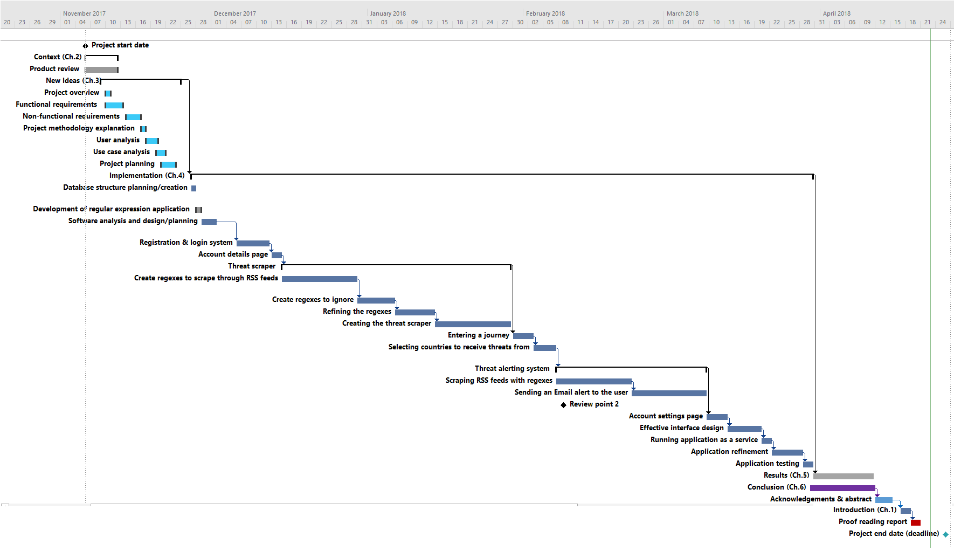
Appendix C – Project Gantt chart

Appendix D – List of sources and resources required to complete the project
List of resources required:
Software:
- Microsoft Visual Studio will be used as the integrated development environment (IDE) for the application. This IDE will be used as it supports ASP.NET MVC (Model, View, Controller), which will be used as the application framework. Visual Studio also supports C#, will be used as the programming language for the application
- Microsoft SQL Server will be used as the project’s database server. SQL server has been chosen because it is compatible with Visual Studio and is able to store and retrieve data – a key requirement of the application
- Microsoft SQL Server Management Studio (SSMS) will be used to configure, manage and administer SQL Server components. SSMS allows for a quick and efficient way of testing SQL statements, ensuring they are correct
- Microsoft Word will be used to produce the project report. The simplicity, effectiveness of Word will ensure the report is professional and easy to read
- Adobe Photoshop will be used to create the application’s graphics
Hardware:
- A Microsoft Surface Book will be used as the device on which the entire project will be completed on. This laptop has an i5 processor with SSD memory, ensuring it is powerful, quick and convenient to use for the project
- A USB memory stick will be used to store backups of the project and application
Companies:
- Nottingham Trent University will be used as the primary workspace for completing the project. The university also includes links to professionals that can assist with programming advice, personal problems or any other general support
People:
- Dr Joanna Hartley will be the project supervisor, providing project support and advice when necessary or required
List of sources of information required:
- Documents on the ‘Project’ learning room on NTU NOW, such as Lecture notes, module specification, project guide and marking scheme (project marking grid) will be used for guidance, ensuring the project is completed in-line with NTU’s standards
- Various RSS Feeds will be used from reliable news websites, such as BBC News and Sky News, as sources of threat identification
- ASP.NET MVC 5 by Galloway et al. (2014) will be used to aid learning of MVC
- Designing Interfaces by Tidwell (2011) will be used to identify interface design principles that the application will use
- Understanding terrorism by Martin (2016) will be used to assess the effects of terrorism and explore how beneficial a terror alert application could be
- Perspectives on terrorism (Lowell, Mass.) is a journal which will be used to further explore terrorism
- Studies in conflict and terrorism (Russak) is another journal which will be used to understand more about terrorism

Appendix E – Project risk analysis
Risk description | Trigger | Likelihood (impact) | Mitigation method
Lack of communication with the project supervisor, potentially resulting in issues mounting up and/or work being completed to a poorer level than expected | The supervisor or student missing weekly meetings. | Low  Medium | Weekly meetings will be organised between supervisor and student to discuss issues and/or progress. If one cannot attend, an alternative day will be agreed.
Misjudgement of project scope, resulting in an application that either consists of too little or too much work required to complete a substantive, but not too substantive, piece of work. | Not researching project aims and objectives in sufficient detail before beginning. | Medium  High | Extensive research will be carried out pre-project, including identifying how various system features are completed, and whether they can be completed within the available time frame.
Falling behind initial project plan due to unseen circumstances. | Not following plan or maintaining work ethic. | Low  High | A realistic plan, considering all deadlines, will be produced. Weekly supervisor meetings will inspire consistent progress.
Producing a product that is not user-friendly and has a poor interface, resulting in a difficult to use application. | Not paying attention to the design aspect of the application. | Low  Medium | Interface design principles will be researched to ensure the application is user friendly and attractive.
Producing a final product that is of poor quality. For example, an application which is slow, contains bugs, is difficult to use or does not achieve what it has set out to. | Not allocating time to test the application. | Low  High | The application will be tested to ensure that it is bug free, usable and achieves what it intends to.
Loss of work, resulting in all or part of the project being be completed again. | Losing a memory storage device or lacking a backup. | Low  High | Dropbox will be used to ensure a cloud copy exists, and regular backups will be taken.

Appendix F – Data-flow diagrams produced for the system

Appendix F1 – System Context-level DFD
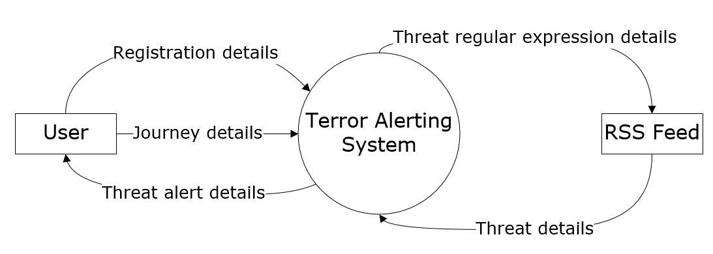

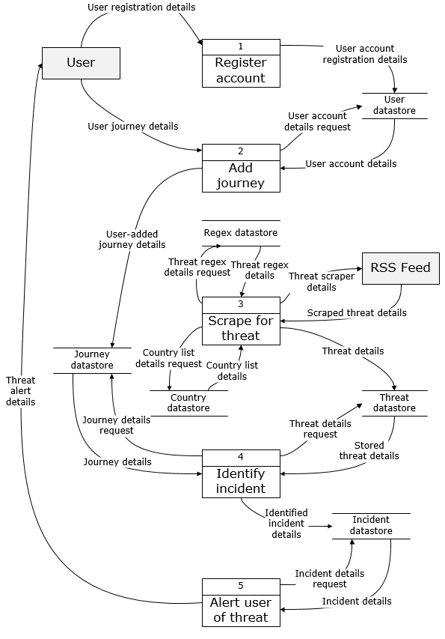
Appendix F2 – System level 0 DFD

Appendix F3 – Level 1 DFD – 1.1 Register account
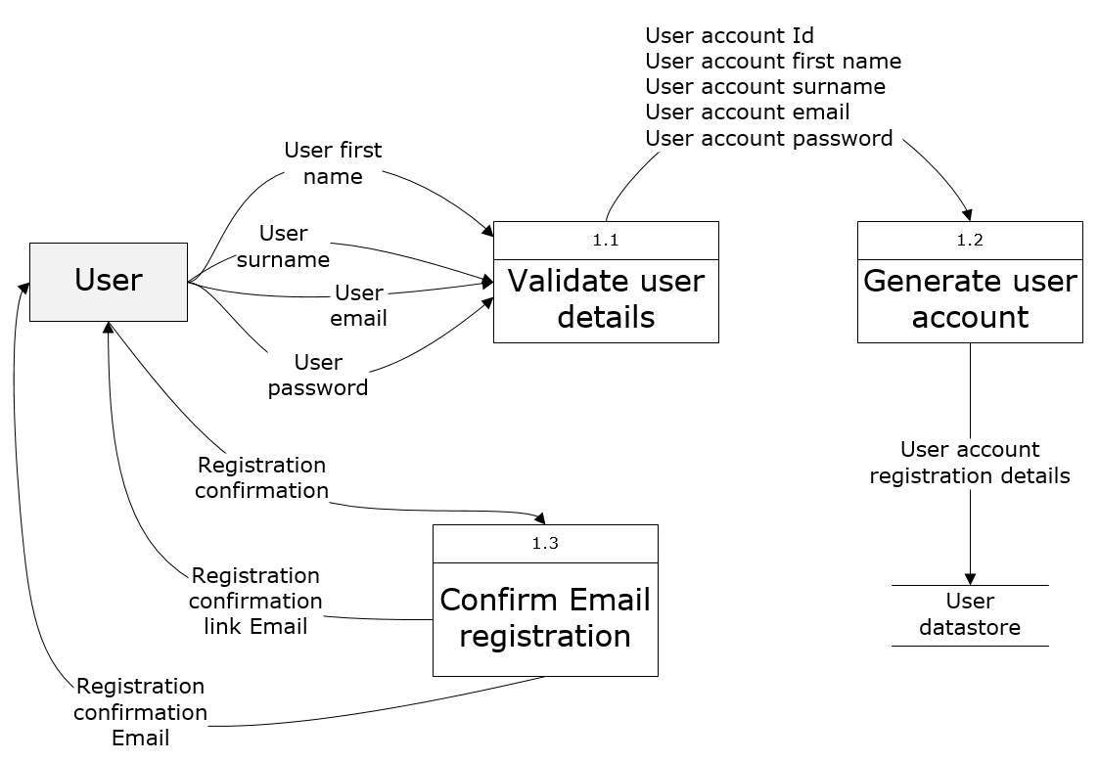

Appendix F4 – Level 1 DFD – 1.2 Add journey
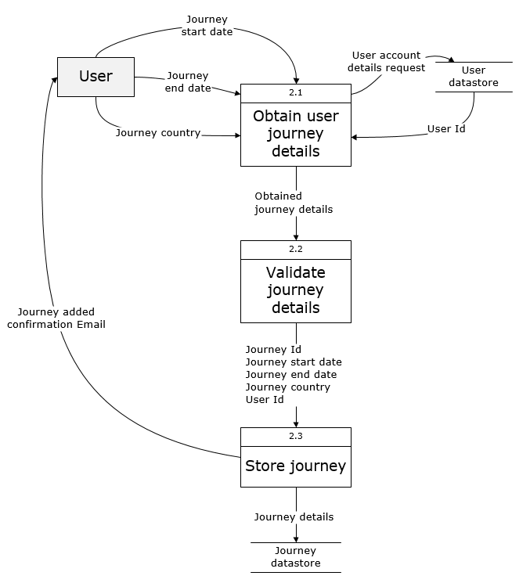

Appendix F5 – Level 1 DFD – 1.3 Scrape for threats

Appendix F6 – Level 1 DFD – 1.4 Identify incident
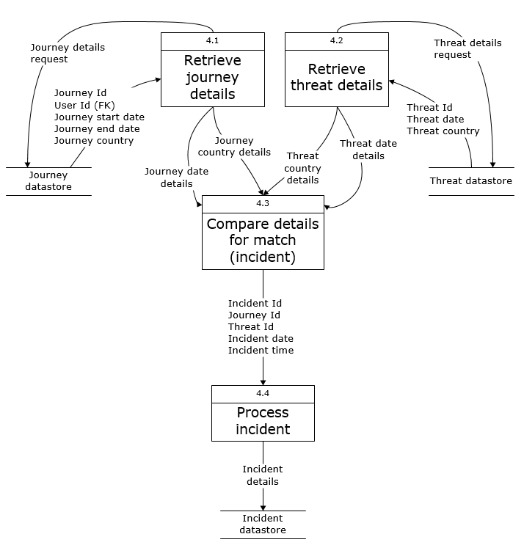

Appendix F7 – Level 1 DFD – 1.5 Alert user of threat
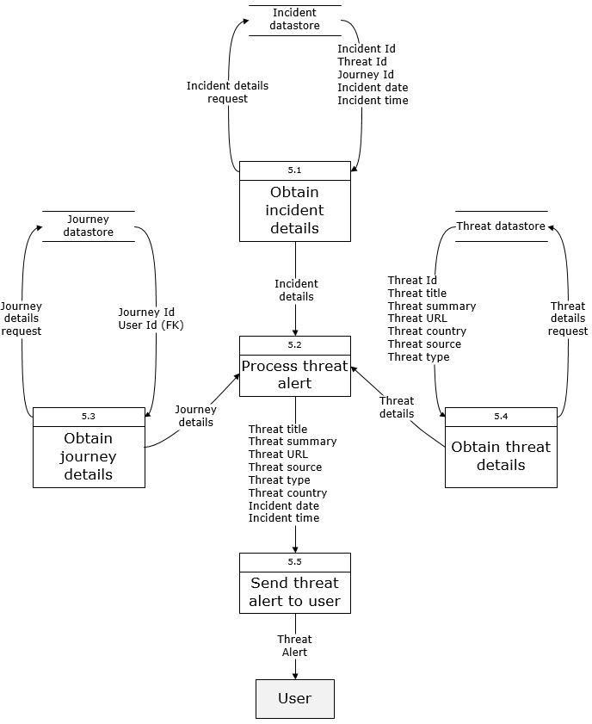

Appendix G – Normalization of data used by the system

Appendix G1 – System’s data in un-normalized form (UNF)
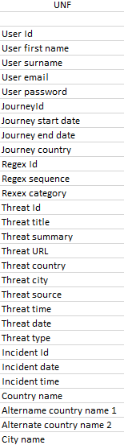

Appendix G2 – System’s data in 1st normal form (1NF)
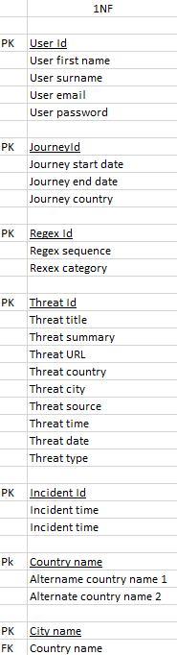

Appendix G3 – System’s data in 2nd normal form (2NF)
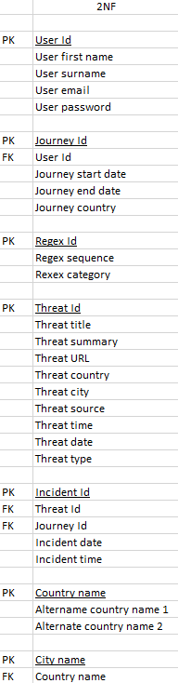

Appendix H – Entity relationship produced for the system
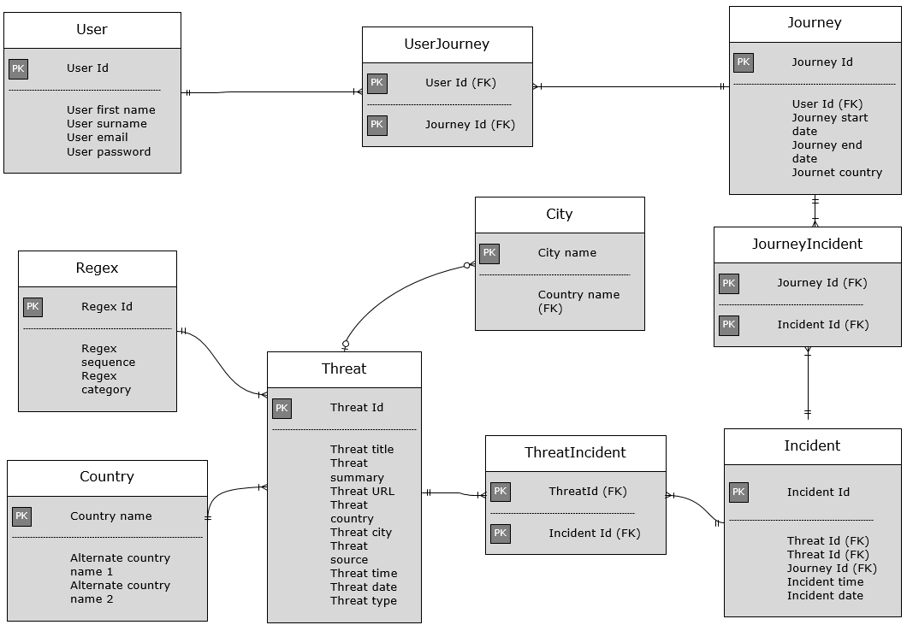

Appendix I – Testing screenshots of the system vs FRs

I1 – FR02 testing screenshot

I2 – FR03 testing screenshot

I3 – FR04 testing screenshot
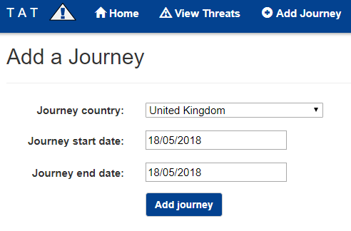

I4 – FR05 testing screenshot
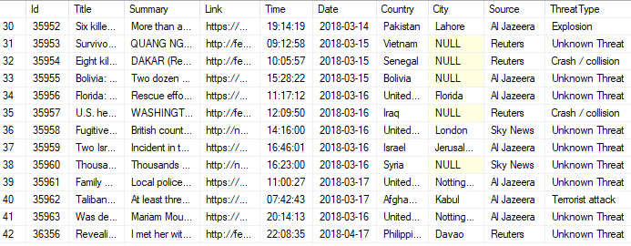

I5 – FR07 testing screenshot
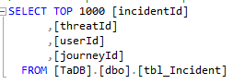
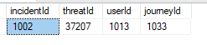

I6 – FR08 testing screenshot
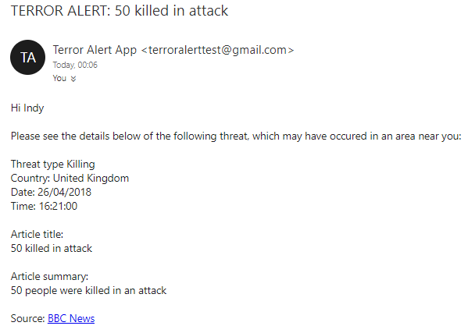

I7 – FR10 testing screenshot
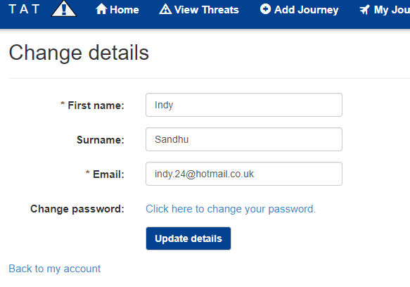

I8 – FR12 testing screenshot
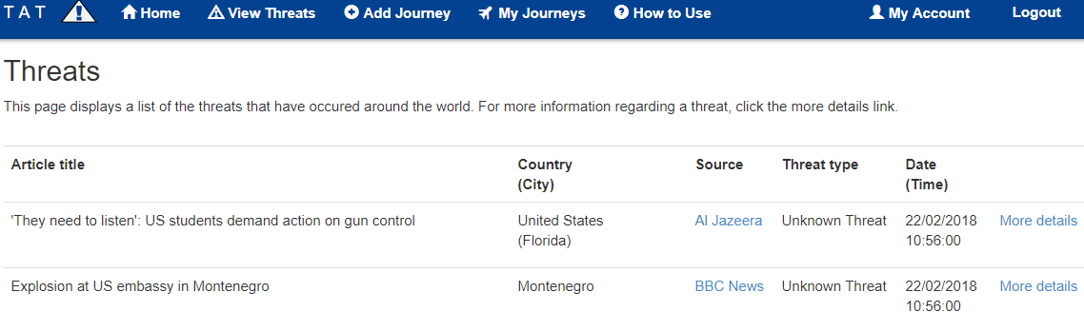

Appendix J – Testing screenshots of the system vs NFRs

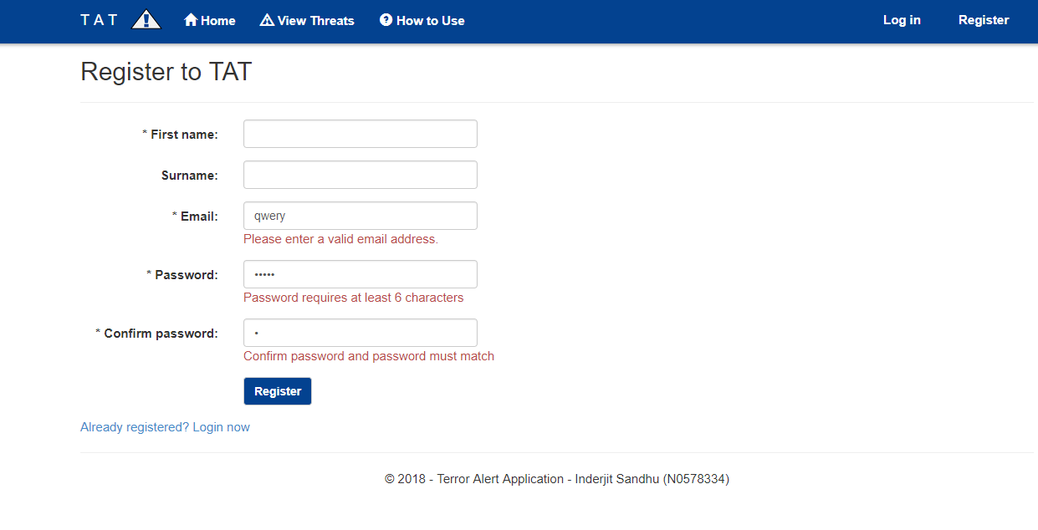
J1 – NFR01 testing screenshot

J2 – NFR09 testing screenshot
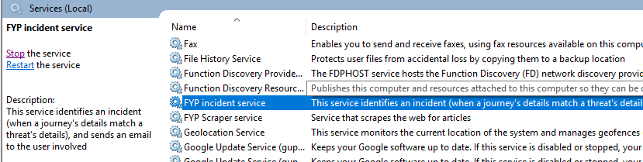

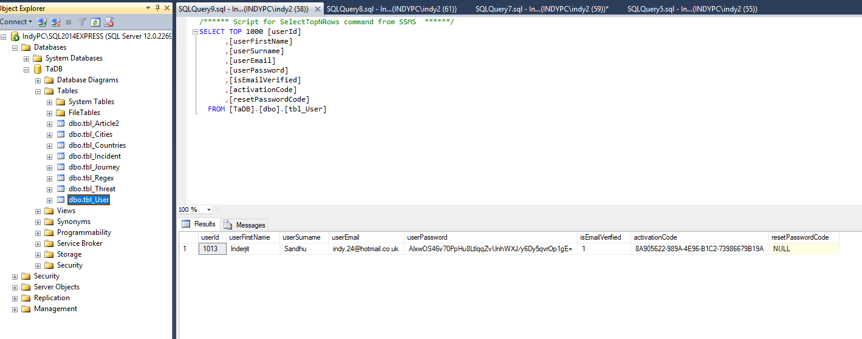
J3 – NFR10 testing screenshot

Appendix K – User testing questionnaire
- Could you identify the purpose of the application with ease?
- Was anything too obtrusive?
- Was the colour scheme positively effective?
- Was the text easy to read?
- Was anything too obtrusive?
- Could you navigate to different parts of the application with ease?
- Was the application quick enough to use?
- Were informative validation errors useful?
- Did you have any problems with validation, or were you allowed to enter incorrect data?
- Was the application simple?
- Was the design of the application attractive?

