
‘Take a Seat’ Application Proposal
Inderjit Sandhu (N0578334)


This document contains assignment 1 of the Mobile Platform Development module.
It consists of a project proposal and paper prototype that is in the form of an executive summary.
Mobile Platform Development
ITEC30041
Assignment 1
Contents
1. Introduction 2
2. Problem statement – the business and its problems 2
3. Assumptions 3
3.1 Business assumptions 3
3.2 User assumptions 4
3.3 Assumptions prioritization 4
4. Hypotheses 5
4.1 Business assumptions hypothesis statements 5
4.2 User assumptions hypothesis statements 6
4.3 Hypotheses prioritization 7
4.4 Business outcomes 7
4.5 Personas 8
4.6 Features 9
5. Device hardware and features 11
6. Development options 12
6.1 Recommended options 14
6.2 Development choices (conclusions) & recommended platform 15
7. Technology requirements 15
7.1 Global Positioning System (GPS) 15
7.2 Google maps Android API 16
7.3 3G/4G mobile data 16
7.1 Infrastructure 16
8. Style guide 17
Colours 17
Icons 17
Typography 17
Separating content and structure 18
Writing 18
9. Minimum Viable Product (MVP) prototyping (app/system design) 19
10. Limitations 23
References 24
Appendix 25
Appendix A – The problem statement template used for creating the problem statement 25
Appendix B – Completed assumptions worksheet which inspired final business and user assumptions (answers in bold) 25
Appendix C – Gothelf and Seiden’s recommended hypothesis statement format 26
Appendix D – Persona creation template 26
Appendix E – Created personas 27
Appendix F – Brainstorming of feature ideas 29
Appendix G – Features template used to create features list 29

1. Introduction
This executive summary includes a project proposal and paper prototype of an application that will later be developed for the Mobile Platform Development module (ITEC30041) – the ‘Take a Seat’ application. This proposal will explain why the chosen business should invest in the application and how the application will solve the problem faced by the business in a suitable way.
The Lean UX methodology will be used in creating this proposal, following principles from Gothelf and Seiden’s (2016) book - Lean UX: designing great products with agile teams. In following Lean UX, this proposal moves away from focusing on deliverables and other documents that may be unnecessary, and focuses more on finding the fastest way to achieve end goals. This will be achieved by following the main concepts of Lean UX, including a problem statement, assumptions, hypotheses, personas, features paper prototyping and design guidelines, as well as some other principles mentioned in Gothelf and Seiden’s book. Lecture notes by Kanjo and Cook (2017) will be referred to and used as guidance in producing this Lean UX based report.

2. Problem statement – the business and its problems
Using Kanjo and Cook’s problem statement template (Appendix A), the problem statement, below, has been created for Nottingham City Council. The statement describes the purpose of Nottingham City Council’s (2016) ‘Take a Seat’ (TAS) service, its goals, the reasons the service isn’t meeting these goals, the effect this failure is having on the business, improvements that can be made to the service and the measurable success criteria for solving the problems. The statement provides a clear focus for the work to be carried out and identifies constraints and impacts of the application on the business and customers.
“Our ‘Take a Seat’ service kindly offers older people a chance to sit down, relax and catch a breath when they are out and about in the streets of Nottingham. The service aims to tackle social isolation, loneliness and fatigue amongst older people by encouraging them to feel confident about leaving their homes. Older people can feel reassured that there are many locations in which they can take a seat, catch their breath and socialise with others.
We have observed that while the concept of our service is positive and beneficial to the elderly, it is currently difficult for people to find ‘Take a Seat’ locations near them. As well as this, people will sometimes arrive at a location that has no chairs available or that does not appeal to them.
The difficulty the elderly face in finding a seat location near them, arriving at a location with no chairs or arriving at a location that does not appeal to them results has resulted in fewer people taking part in the ‘Take a Seat’ initiative than expected. This means that higher numbers of older people are more socially isolated, lonely and fatigued than we would like.
To improve our service and address these problems, we have a plan. We would like to release a mobile application for the elderly to use that will show them ‘Take a Seat’ locations near them on a map. The will also allow users to state whether or not a location is busy, so that other users can see this update on the application and do not waste their time and energy walking to a location with no seats available. As well as this, the application will allow users to review each location and post pictures, so that other they can identify whether or not that location appeals to them.
The application will have an effect on the business and provide support for customers. If more people use the application, more people will be involved in the ‘Take a Seat’ initiative and this will raise awareness of the initiative. Effectively, using the application will make it much easier for people to find a location near them, which will increase the likelihood of an increase in the number of older people wanting to step outside, find a seat, rest and socialise. This will create a healthier, happier community amongst the elderly.
As the ‘Take a Seat’ service becomes more popular, so will the number of locations of the seats. This means that the application must provide a simple method of adding more locations and maintaining the application. This must be considered when developing the application – it must be easy to maintain and update.
A main constraint in developing the application is the fact that users will be elderly. This means that they may not be mobile device literate, have physical impairments, such as sight loss, hand tremors and they may have a loss of dexterity. Due to these constraints, it is important that the application is developed in a user-friendly manner considering the target users. “

3. Assumptions
A set of business and user assumptions has been compiled to learn more about the target audience of the proposed application by considering assumptions from several viewpoints. These assumption statements have been inspired by the completion of an assumptions worksheet (see Appendix B) relating to business and user assumptions.

3.1 Business assumptions
- It is assumed that our customers have a need to easily locate nearby ‘Take a Seat’ (TAS) locations that allow them to sit down and rest
- Our customers can fulfil this need by using a mobile application that allows them to identify nearby TAS locations, marked on a map
- Our initial customers will be older citizens that have heard about or downloaded our application and are interested in finding a seat near them
- The number one value our customers will get out of our service is the ability to locate nearby TAS locations in a quick and simple manner
- Our customers will also get the following additional benefits:
  - The ability to see how busy a TAS location is near them
  - The ability to view photos of TAS locations posted by other users
  - The ability to read reviews of TAS locations posted by other users
- We will acquire the majority of our customers through advertising our application. Advertisement will be carried out on radio stations, street signs and on social media
- Our primary competition in the market will be the Google maps application. On Google maps, users are able to use street view to locate benches around them, though this is complicated and takes quite a long time
- We will beat our competition due to the fact that we will develop a quick and easy to use application which directs users to good quality resting locations. Using our application, users will also have the advantage of seeing feedback/photos of locations that other users have shared
- Our biggest product risk is the fact that users may struggle to use it due to the potential lack of mobile device literacy and physical impairments, such as sight loss, hand tremors and loss of dexterity, of the elderly users of the application
- We will mitigate this risk by developing an application that is straight forward to use and easily readable

3.2 User assumptions
- Our users are elderly males and females, that are around 65 years of age plus, and are looking for a TAS location to rest at
- Our product fits in the user’s everyday life as it can be easily accessed on their mobile device whilst they are out and walking around Nottingham city centre
- Our product solves the difficulty the elderly face in finding TAS locations near them. As well as this, our product helps with the problems of not knowing whether a seat location is busy or not and not knowing whether the location is suitable or appealing for them
- Our product will be used when users are looking to identify a TAS location whilst they are walking around Nottingham city centre when they are tired or just want to take a seat. The product is used by opening our application on their mobile device and viewing a map which shows the TAS locations near them
- The important features of our application are:
  - A map which includes accurate location markers of TAS locations near the user
  - The ability for users to see if any other users have stated whether a location is busy or not, so that users can decide whether or not walking to a location is worth it
  - The ability for users to upload, and see pictures that other users have uploaded, of TAS locations
  - The ability for users to leave and view feedback regarding TAS locations
  - Ensuring that the application is easy to read, and that users can increase font size if required
  - Ensuring the application is easy to use and intuitive to navigate
- Our product should look professional and simple. It should be intuitive, meaning that navigation to different parts of the application should be straight forward and obvious, and specific colours should be used to ensure users can read contents as easily as possible. The product should behave the expected manner of a modern-day application – it should work successfully, accurately and quickly

3.3 Assumptions prioritization
The business assumptions (letters A-J) and user assumptions (numbers 1-6) have been prioritized on the prioritization matrix below.
Figure 3-1. Prioritization matrix for the business and user assumptions
1
C
E
4
B
2
3
Low risk
High risk
Known
Unknown
A
H
I
J
F
D
G
5

6

The prioritization matrix above shows which business and user assumptions are high risk, low risk, known and unknown. By plotting the assumptions onto a matrix, it’s clear to see to riskier and unknown assumptions as opposed to the less risky and known ones.

4. Hypotheses
This section outlines a list of hypothesis statements. The statements have been constructed by transforming the assumptions from the previous sections into a format that is easier to test. By transforming the assumptions into hypothesis statements, the subjective and political arguments are taken out the scenario and focus can be shifted towards the application’s users. The hypothesis statements have been produced by following Gothelf and Seiden’s recommended format (see Appendix C) for each assumption.

4.1 Business assumptions hypothesis statements
- We believe that our customers would like to easily locate nearby TAS locations that allow them to rest. We will know we are right when market feedback expresses their need for an application that helps them find a TAS location
- We believe that we can fulfil customer needs by developing a mobile application that will allow them to locate a TAS location near them. We will know we are right when we release our application and market feedback tells us that our application is fulfilling their needs and helping them easily locate a TAS location
- We believe that our initial customers will be older citizens that have heard about or have downloaded our application and are interested in finding a seat near them. We will know we are right when we survey our first users and the results show that they are older and have heard about the application and then decided to download it
- We believe that our customer’s number one value is to locate nearby TAS locations in a simple and quick manner. We will know we are right when market feedback shows that users state that their number one value is to be able to simply and quickly use the application to locate nearby TAS locations. Alternatively, we will know we are wrong when customers’ feedback suggests that their number one value is something different
- We believe that our customers will also benefit by using our application as they will have the ability to see how busy a TAS location is that is near them and to view photos and read reviews of TAS locations posted by other users. We will know we are right when we see that users start to post that locations are busy, post photos and share feedback of locations
- We believe that we will acquire the majority of our customers through advertising our application. We will know we are right when we survey our users and they explain that they have heard about the application through our advertising methods
- We believe that Google maps will be our primary competitor. We will know we are right when users tell us that they use, or have used, Google maps to locate resting locations. We will know we are wrong when users tell us that they use other applications
- We believe that we will beat our competition by developing an application that is quick and easy to use when locating a TAS spot. We will know we are right when we carry out research that tells us more than 50% of people use our application as opposed to others
- We believe that our biggest risk is the fact that users may struggle using our application due to the potential lack of mobile device literacy or physical impairments. We will know we are right when market feedback states that users do indeed struggle to use our application due to mobile device illiteracy or physical impairments
- We believe that we will mitigate our main risk of users struggling to use our application by developing an application that is straight forward to use and easily readable. We will know we are right when we test our application and market feedback suggests that people can successfully use our application

4.2 User assumptions hypothesis statements
- We believe that our customers are elderly males and females, aged around 65 years and older and are looking for a TAS location to rest at. We will know we are right when our market feedback survey results show that the majority of our users are 65 years or older, are a mix between male and female and are people looking for a TAS location
- We believe that our product can be easily accessed on users’ mobile devices in their everyday life. We will know that we are right when we release our application for a mobile device and it is available for download. Seeing as most people currently own mobile devices, our application will be easily accessible supposing it’s released and available to download
- We believe that our product solves the problems of identifying a TAS location, not knowing whether a TAS location is busy or not and not knowing whether a TAS is suitable or appealing for a user. We will know that we are right when users tell us that our application has successfully solved the above problems
- We believe that our product will be used when users are looking for a TAS location. We will know that we are right when users tell us when they tend to use our application. We believe that our product will be used by opening the application and viewing a map showing nearby TAS locations. We will know that we are right when our market feedback tells us that users use our application after it has been released, in the same manner as mentioned above
- We believe that our product has many important features, such as:
  - A map which includes accurate location markets of TAS locations near the user
  - The ability for users to see if any other users have stated whether a location is busy or not, so that users can decide whether or not walking to a location is worth it
  - The ability for users to upload, and see pictures that other users have uploaded, of TAS locations
  - The ability for users to leave and view feedback regarding TAS locations
  - Ensuring that the application is easy to read, and that users can increase font size if required
  - Ensuring the application is easy to use and intuitive to navigate
We will know that we are right when our market feedback regarding each of the above features tells us that each feature is important and useful
- We believe that our product should look professional and simple and should be intuitive. We will know that we are right when the market tells us that they want an application that looks good and is easy to use

4.3 Hypotheses prioritization
The business hypothesis (letters A-J) and user hypothesis (numbers 1-6) have been prioritized on the prioritization matrix below.

Figure 4-1. Prioritization matrix for the business and user hypotheses
1
E
4
Low risk
High risk
Low value
High value
A
H
I
J
F
D
G
2
3
B
C
5
6

The prioritization matrix above shows which business and user hypothesis statements are high risk, low risk, high value and low value. The matrix helps identify which statements should be the priority when testing. Statements A, B, D, I, J, 3, 5 and 6 are all high risk and high value, so during testing, these will be prioritised.

4.4 Business outcomes
A table of business outcomes has been produced (below) to show the results that our business seeks and the measuring stick for success. The table follows the ‘Start-up Metrics for Pirates’ framework as rows 1,2,3, 4 and 5 focuses on customer acquisition, activation, retention, referral and revenue. The table focuses less on outputs and more on the outcomes that these outputs create.
Figure 4-2. Business outcomes table
Id | Business outcome | Description
1 | A consistently increasing number of application downloads each month | If there is a consistently increasing number of users downloading our application each month, it means we are successfully getting more people using our application
2 | An increase in the number of people locating TAS spots through our application | By identifying that there is an increasing number of users have locating a TAS spot through our application, we can see that users are indeed using our application
3 | An increase in using other features of the application and low numbers of uninstalls | If we identify that users are using other features of our application, we can see that we are retaining our customers, and they are repeatedly using our application. A low number of uninstalls also suggests that people are using our application again and again
4 | An increase in the number of users of our application through referrals | If users are referring our application, it will raise awareness of the project and give us more customers. We can identify this by asking people how they have heard about the application
5 | Generating revenue from our application | Though our application will be free for users, by reaching advertisement agreements with companies, we can generate a substantial revenue through advertisements

4.5 Personas
Three personas have been created to consider some of the different types of our target audience. These personas are our best guess as to who will use our product and why. A template (Appendix D) has been used to create these personas. The top-left quadrant contains a sketch of the user with their name and role. The top-right quadrant describes the user’s basic behavioural and demographic information. The bottom-left quadrant describes the user’s pain points and needs. The bottom right quadrant describes the potential solutions.
Due to poor visibility of the original personas, an electronic version has been provided below. See Appendix E for the original personas.
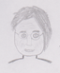  Joanna  - 88 years old  - Likes to spend time with her family | Behavioural/demographic information:  - Retired – former nurse  - Married  - 5 children  - Has always had an interest in travelling and exploring
Pain point and needs:  - Would like to be able to locate seats around Nottingham town centre to rest at  - Struggles to read as her vision is deteriorating  - Not very mobile device literate | We will aim to address these by:  - Developing an application which helps people locate TAS locations around Nottingham town  - Ensuring the application text is easily readable and can be increased in size  - Including a tutorial video/page explaining how to use the application
Figure 4-3. Persona 1 – Joanna

  Bethany  - 66 years old  - Enjoys sewing at home | Behavioural/demographic information:  - Unemployed  - Widowed  - No kids  - Tends to stay at home
Pain point and needs:  - Likes to know about her surroundings before she visits somewhere  - Has a smartphone but gets frustrated when an application is complicated and difficult to use  - Always expresses her opinion or feedback whenever possible | We will aim to address these by:  - Allowing users to see feedback of each TAS location that has been posted by others  - Ensuring the application is straight forward and easy to use  - Offering a feedback page for users to send us feedback regarding our application
Figure 4-4. Persona 2 – Bethany
Figure 4-5. Persona 3 – Akash
  Akash  - 72 years old  - Spiritual and religious | Behavioural/demographic information:  - Property developer  - Married  - 2 kids  - Often visits town with family
Pain point and needs:  - Struggles to walk for long periods as arthritis affects his fatigue at random intervals  - Hesitant when sitting down in public - doesn’t like sitting down in unappealing places  - Expects a seat to be available in public places - gets annoyed when seats are all taken | We will aim to address these by:  - Allow users to see the TAS locations nearest to them wherever they are, by using their GPS location  - Allowing users to view photos of TAS locations posted by other users so they can see which locations appeal to them  - Including a feature on the application which allows users to post whether or not a location is busy, so that other users won’t waste their time and energy walking to a location with no chairs available

4.6 Features
This section considers information from the assumptions, hypotheses, business outcomes and personas sections to create a list of features that will be included in the application. The features chosen are appropriate for addressing the key problem areas that have been identified. Appendix F shows the brainstorming of features that have been thought of for the application. The table below, stating the features of the application, was created using a features template (Appendix G).
Figure 4-6. Table showing the features of the ‘Take a Seat’ application
Feature (we will) | For | In order to
Include an interactive map (zoomable and scrollable) which shows all of the TAS locations in the form of pin marker. This map will help users locate the TAS locations they could visit. | Joanna – who wants to locate seats in Nottingham to rest at | Make it much easier for people using the application to see the possible locations at which they can take a seat. This will solve the problem that there currently isn’t a map showing all TAS locations.
Use a user’s GPS on their mobile device to show which TAS locations are nearest to them, and navigate them towards their chosen location. | Akash – who randomly becomes fatigued | Allow users to quickly navigate to TAS locations near them. This is particularly useful as users will regularly move around the city, and may suddenly feel the need to rest.
Allow users to post how busy a TAS location is. Users can state that a TAS location is busy, and this update will pop up on a live feed for that location for other users to see. | Akash – who needs a seat to rest at randomly | Allow users to see how busy a TAS location is. This feature will help users decide whether or not they should spend their energy and time walking there.
Include a feedback section in which users can leave us feedback regarding our application. | Bethany – who like helping by providing feedback | Listen to our users and identify any problems or positive feedback they wish to share with us. This will help us build a relationship with our users and ensure our application is as good as our users want it to be
Allow users to upload photos of TAS locations for other users to see. | Akash – who likes to see places he visits before he visits them | Allow users to see what a TAS location looks like before they visit it. Users may find some locations unappealing, or they may want to visit a location with a distinct environment. This feature allows users to see which locations appeal to them, so they can make the visit if necessary.
Allow users to post feedback and reviews of TAS locations. | Bethany – who likes to know her surroundings before she visits somewhere | Allow users to read what other users have posted about TAS locations. Other users’ feedback may help a user decide whether or not they want to travel to a TAS location.
A tutorial/FAQ screen which explains to users how to use the Take a Seat application. This screen will include a video showing a demonstration of how to use the application. | Joanna – who is not very mobile device literate | Show users how to use the application. Though the application will be easy to use, some people, particularly the older generation, struggle with carrying out basic tasks on modern mobile phones. This feature will allow users to feel more confident in using the application.
Ensure our application is easy, straight forward and intuitive to use. | Bethany – who gets frustrated when applications are complicated or difficult to use | Allow users to have a smooth and simple experience when using our application. This will not leave users feeling frustrated.
Ensure all text on the application is easy to read, and that the user can make it bigger if required. | Joanna – who’s vision is poor | Ensure that users are able to read, and hence use the application as easily as possible. This is particularly a problem with older people, as their vision tends to deteriorate.
Allow users to search locations or postcodes on the map. Users can use their voice to search for these. | Joanna – who has an interest in exploring | Allow users to explore new areas or find TAS locations near a location or post code that they are interested in visiting. By allowing users to voice search, our application will save them time.

5. Device hardware and features
This section analyses hardware and features that exist of current mobile devices. It explains how they can be used to enhance our application to support the business and users.
Though many of the devices listed aren’t owned by everybody, the main concept behind each feature is prevalent in most modern mobile devices. This means that all features mentioned exist for many alternative devices and these devices support the use of our application.
Figure 5-1. Table analysing hardware and features of current mobile devices
Device | Feature | How it could be used to enhance our application
iPhone (all) | Touch screen | Touch screens greatly enhance our application as they allow users to navigate around our application in a quick and simple manner. A touch screen benefits our users in many ways, such as allowing them to quickly touch to select a different screen, and allowing them to scroll around the map to see different TAS locations.
iPhone (all) | On-screen keyboard | Like a touch screen, an on-screen keyboard will make using our application much easier for our users. If users want to search for a location or enter a post code to find TAS locations, using an on-screen keyboard will be quick and effective. On-screen keyboards are quicker and easier to use and are more readable than physical mobile device keyboards. This is particularly important considering our customers, who may have poor vision and mobile device literacy.
Samsung S8 | 12-megapixel optical image stabilisation camera | Our application will make use of the camera that comes with any mobile device, as a camera will allow our users to take and upload photos of TAS locations for others to see. Cameras with optical image stabilisation, like the S8, will help our users that may struggle with a steady hand. This may be a fairly common problem considering many of our users will be elderly. As well as this, a high-quality camera will provide more detail for users to see what TAS locations look like more clearly.
Lenovo P2 | 3-day battery life | Mobile devices with reasonable or longer battery lives will enhance our application as they will give users confidence that their phone will not run out of power when using our application. Longer battery life supports both us as a business, and users, as our application will use GPS, meaning it will drain battery life quicker than other basic applications.
Samsung Galaxy Note 8 | 6.3-inch display | Any application is easier to use and clearer on larger mobile device screens. This is particularly the case with our application, which will display a map to the user. A large screen will make navigating using the map easier for users. As well as this, font is bigger on devices with large displays, making it easier for our elderly users to read, as they tend to suffer with vision. Though the Note 8 has a 6.3-inch display, most modern smart phones with a 5+ inch display will still be effective when using our application.
Samsung S8 | Water resistance | Our application will be used by people when they are walking around Nottingham city centre, meaning that rain can begin at any time. Users may want to use our application to quickly locate a TAS when it begins raining, and if a mobile device is water resistant, like the S8, they can continue using their device and locating a seat. A water-resistant phone enables users to use our application, which is primarily used when walking around outside, in any weather conditions.
iPhone X | Face ID | Using a facial recognition system to unlock mobile devices makes using a mobile device quicker than manually unlocking it. The simplicity and speed of unlocking one’s phone with this feature will allow our users to quickly unlock their phone and begin using our application. Our users don’t want to be standing around typing a password whilst out in the city centre.

The hardware and features mentioned in this section will all enhance the usability of our application, and will assist in our application carrying out its own features. To see a list of these features, see section 4.6.

6. Development options
This section analyses all the potential development options for the application (native applications, mobile websites and cross-platform mobile development), and how they relate to our proposed application, before justifying which option will be used. The tables below explain each development option and their advantages and disadvantages.
Figure 6-1. Table analysing native applications
Explanation | Advantages | Disadvantages
(Native applications)  A native application, as Rouse (2013) explains, is an application that has been created for use on a particular platform or device. Native applications are usually mobile applications as mobile applications are typically written to work on a specific platform or device. iPhone and Android are the biggest competitors in the native application field | - As native applications have the ability to use device-specific hardware and software, they can take advantage of the latest technology available on mobile devices, such as global positioning system (GPS) and a mobile phone’s camera. This is important to our application as the use of GPS and a camera is necessary | - Native applications tend to be more expensive to develop and maintain, as Vishwanthan (2017) concludes. This is due to the fact that multiple mobile devices and versions must be considered when developing and maintaining them. This could be an issue for us as we are not expecting to make profit from users, and we are considering our budget wisely
 | - Native applications, as Bisht (2016) teaches, allow for a better aspect ratio. Native applications give developers more control over screen resolution, size and orientation. This means that they look smoother and more natural than other types of applications, such as web applications, when displayed on a mobile device. This is important for our application as readability is an important consideration for the users | - Native applications must be approved before they can be placed on their applications stores, which is potentially a tedious process for the developer. Applications may also get rejected if they are not approved
 | - As native applications work with the device’s own built in features, they are easier to work with, development wise, and also perform quicker on the device than other options. This is important to consider as we don’t want to struggle developing this application, and we want it to be quick for users | - Users must allocate their device’s own memory and go out of their way when downloading a native application. This could be an issue for us as it may cause inconvenience and put people off downloading the application

Figure 6-2. Table analysing mobile websites
Explanation | Advantages | Disadvantages
(Mobile websites)  Sutherland (2011) explains that a mobile website is simply a website that has been optimised for mobile browsing. A user can access a mobile website through using a phone’s web browsers. | - Mobile websites can work on any mobile platform that includes a browser, as Sutherland explains. This means that mobile websites are more accessible for the general public than native applications. This could result in us gaining more users | - The main disadvantage of mobile websites is that it is not possible to access all of the features of a mobile device. This could mean that we would struggle to include our main features, which rely on using GPS and the device’s camera
 | - Mobile websites are faster and cheaper to develop than native applications. This is due to the fact that developers do not have to worry about developing for different platforms and devices. This could save us money | - Mobile websites may not be convenient for users to use, as it can take users time finding the website. This could frustrate users as they may struggle to find our website on their bookmarks
 | - Users do not have to spend their time and device memory downloading a website application. This could be an attractive proposition, which could attract more customers | - Mobile websites sometimes have issues with formatting, and do not look as smooth or natural as native applications. This could cause issues with our users as they want an easy to use and read and intuitive application

Figure 6-3. Table analysing cross-platform mobile development
Explanation | Advantages | Disadvantages
(Cross-platform)  Cross platform mobile development is the creation of mobile applications that are compatible with multiple operating systems, as Rouse (15) states. Some different platforms include iPhone, Android and Windows. | - As Rouse explains, developing for multiple platforms results in a greater reach. This means that we could get more users, as more people could use our application | - Developing for multiple platforms means that you must use the commonalities between them. This loss of flexibility could limit the development options of our application  - Cross platform applications limit the user experience. This is because iPhone, Android and other platforms have different screen layouts and functions. This could cause problems for us if customers have different phones, as the application may not look or work as smoothly as they would like it to
 | - Developing a cross platform application may be quicker than developing an application for Android and iOS. This could be useful if we were not a time limit, which we are not
 | - Cross platform applications can be developed and maintained with a sense of simplicity. This could make things easier for us as it would be easier to sync updates across all platforms and devices

6.1 Recommended options
Mobile devices running Android and iOS operating systems are the most popular and commonly used, according to IDC (2017), so we will choose one of these options for developing our application.

6.1.1 Android
IDC reports that from 2016, Android has comfortably owned 80% of the mobile phone operating system market share, meaning that the public mostly uses devices running Android. This huge market share is one of the advantages of using Android, as we, as a business, would have lots of people to target. We want our application to be used by as many people as possible, and clearly Android is very popular, making it a good choice. Another main advantage of using Android is that it is open source. This allows users to view and modify the source code of their application if they require. As well as this, Android device are much more customisable than iOS device. Android users can download different launchers, keyboard, change the positioning of features on the screen and generally customise their device more than iOS users can. This customisation aspect may appeal to some users, and it may be the reason they prefer using Android over other iOS, which is closed source, and other operating systems.

6.1.2 iOS
Though iOS devices have only about 15% of the market share, according to IDC, this is still many millions of people. This means that even if we were to create an iOS application, we would still have a potentially large target audience, and we could still improve the lives of many older people. An advantage of developing an iOS application is that Apple’s devices have better protection against malware, as they control the device’s firmware and hardware, unlike Android. This sense of security may be one of the reasons that users buy iOS products, and it may encourage people to download our application, with extra confidence that they will be protected well by Apple. Another advantage of iOS devices is that people commonly believe that they are more user-friendly than Android devices. iOS devices usually have a simple interface and offer limited customisation, while Android can be rather complicated allow a large amount of customisation. This is important to consider, as older people may prefer a simpler device, like an iOS enabled one, due to them having limited mobile device literacy. People with limited mobile device literacy would find using iOS device easier than using Android devices. A disadvantage of iOS devices however, is the fact that they do not allow for expandable storage, unlike many Android enabled. This means that iOS users may be more reluctant to download our application, as they may not want to use their device’s memory, or they may simple not have enough memory to do so.

6.2 Development choices (conclusions) & recommended platform
Upon weighing out the advantages and negatives of each development option and platform, we have decided that we will develop a native application for Android.
We have decided to develop a native application because of the following reasons:
- Native applications allow the use of the device’s technology, including GPS and the camera. This is extremely important for us, as some of the most important features of our application (using a user’s GPS to find TAS locations near them and uploading photos of TAS locations) rely on this technology. If we were to create a mobile website, we would not be able to implement these features.
- Native applications allow for a better aspect ratio. This will play a huge part in the usability of our application, considering the fact that many of our elder users may struggle with poor vision and will just want a simple interface. By developing a native application, we can make the application look how we want it to, and this look will be guaranteed on each user’s device. If we were to create a mobile website, the size and layout of our application would vary greatly, potentially making it unusable for users.
- By using a native application, users have their own personal application dedicated to helping them find TAS locations around Nottingham. They do not have to spend time finding our website on a web browser – they can instead simply open up our application and use it.
We have chosen to use Android as a mobile platform because of the fact that Android has many more users than iOS/other platforms. With a market share that has consistently remained over 80% over the last few years, we have the reassurance that developing an application for Android would give us a large target audience. As Android has much more users than other devices, we have also considered that by developing an application for Android, we will be helping out the largest number of elderly people as possible. As well as this, most Android devices allow for expandable storage, meaning that most Android users will tend not to worry about downloading our application in terms of using up their phone’s memory.

7. Technology requirements
This section explains and justifies the technology that will be used in our application. It will compare technology options to alternatives and also discuss the application’s infrastructure.

7.1 Global Positioning System (GPS)
Our application will use GPS to locate where a user is and help them identify where the nearest TAS location is to them. GPS is particularly useful for our application because users will be moving around various parts of Nottingham city centre, and their location will constantly change. Because of this, our application must fetch the user’s location in order to show the nearest TAS locations to them.
An alternative to using GPS could be to use beacons instead. Beacons use Bluetooth to send out a signal so that mobile devices can connect to them. We have decided not to use beacons due to their main limitation – the fact that they only allow devices to locate them from a maximum of 70 meters away. This distance is simply not big enough in order for our application to work effectively, as users may be hundreds of meters away from the nearest TAS location.

7.2 Google maps Android API
In order to show our users the nearest TAS locations, we will include Google maps within our application by using the Google maps Android API. With Google maps integrated into our application, we can set a marker pin for each location, and users can scroll around the map to interact with it. As well as this, users can use street view and 3D view to help with navigation around Nottingham city centre.
An alternative to using Google maps within our application could be to use BackCountry Navigator. This essentially carries out the same function as Google maps, but costs money to use, is known to drain an excessive amount of battery life, and doesn’t have a simple and smooth interface like Google maps does.

7.3 3G/4G mobile data
We have decided that our application will allow the use of 3G or 4G mobile data to allow users to load the map, upload photos, post feedback and post how busy a location is. This technology is important as it allows users to carry out these functions on the go in a quick and convenient manner.
An alternative to using 3G or 4G internet could be only allowing the users to use features requiring the internet if they had a Wi-Fi connection. We decided against this as Wi-Fi spots are limited and this would not be convenient for our users as our application would be much more useful if they could use our application wherever and whenever they wanted to.

7.1 Infrastructure

7.1.1 Android studio
We have decided to use Android studio as a development environment for our application. We have decided to use this environment as it is free to use, and it exists specifically for the development of Android applications, meaning that it will be more reliable and tailored for the creation of our Android application. As well as this the user interface on Android is known to be more user friendly than many other alternatives.
The other main alternative to Android studio that we could have chosen to use was Eclipse. We have chosen not to use Eclipse is because it lacks a graphical user interface, which will be useful for us as our application focuses on providing an effective interface. With Android Studio, our developers can customise the interface more freely and quickly, and they can drag and drop.

7.1.2 SQLite
We have decided to use SQLite as the database management system to be used within our application. SQLite allows our application to store data in a structured manner, meaning that data is easy for us to analyse and use for other application purposes. SQLite is known to be quick at retrieving data through SQL queries. This will help ensure that our application runs quickly. As well as this, SQLite is a light weight database system, meaning that it doesn’t deal with huge amounts of large data, which is not what we are going to be dealing with.
The main database to be used will be a TAS locations database. This will store information on the TAS location, address, rating, feedback details, photos uploaded and how busy the location is. When adding new TAS location, administrators must simple add a new location and address to the database.
An alternative to using SQLite could be to store data in user’s internal device storage. While this would simplify things a lot in terms of developing our application, it would mean that we can not use the data that users have sent to us, such as feedback of locations, as the data would only be stored in their device. By using SQLite we are able to access data from users and use it ourselves.

8. Style guide
This style guide sets out the standards for the design of our application. Guidelines from Material.io (2017) have been used in producing this guide, which considers the needs of our target audience (men and women 65 years of age and older).

Colours
Coleman (2017) explains that as the elderly tend to have difficulty differentiating similar colours, due to a loss of visual acuity, contrasting colours should be used for backgrounds, texts and separate elements.
Considering this, a white colour is to be used as the application’s primary colour, and a dark grey will be used as the secondary colour. The white will be used most frequently across the application. It will also be used to accent elements. The dark grey will mainly be used to accent selected parts of the application, the navigation bar and for buttons.
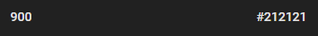
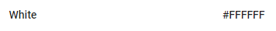
Primary colour - white
Secondary colour – dark grey

Dark grey and white colours from Material.io

Icons

Simple icons, followed by captions, are to be used across the application to visually represent ideas, capabilities and topics. A product icon will be created and used to represent the application. This icon will be simple, and it will communicate the core idea of the application. System icons will be used to represent a command or common actions. Nottingham city council’s logo (right) will be prevalent on the navigation bar on each screen.

An example of a system icon taken from Material.io. This icon represents the application using the user’s GPS location to show the user where they are on the map.

Typography
Roboto font is to be used throughout the application, as it is the standard typeface on Android and is sans serif. As it is sans serif, it is easier to read for users with visual impairments than serif fonts, which include curls around letters.
As Campbell (2015) recommends for elderly people, a font size of at least 16 pixels is to be used throughout the application, as people with visual impairments will struggle to read text smaller than this. Users will have the option of increasing this font size should it not be big enough for them to read.
Each button is to include a label, clearly describing which page the users will be taken to, or which action will be completed should they touch it. This will ensure that users have an idea of the task they are carrying out before clicking on a button.

Separating content and structure
There is to be a touch target of at least 44 pixels x 44 pixels for each element on the application. This ensures that when touching an option, the users, who may have unsteady hands, can accurately tap the right target with their finger, rather than tapping a target they didn’t mean to touch. A space of 44 pixels is enough to mitigate this risk. The square on the left demonstrates 44 pixels by 44 pixels. This will be the minimum touch target for users when pressing options on the application.
44 pixels

Writing
All text in the application will be clear, accurate and concise. This will build the user’s trust and will make the application more usable. As the image below, taken from Material.io, shows, application text should be in small, scannable segments, allowing users to simply understand the message being put across. Concise information will also mean that users with reading difficulties are not strained massively, and can quickly understand the information presented by the application.
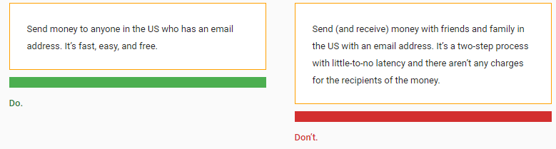
Users will be addressed in the second person. For example, words like “you” and “your” will be used to make the user feel as though the application is talking to them. This form of addressing the user will make the application feel more personal to them and hopefully make them want to use it more in the future. As well as this, the present tense will be used when communicating with the user, so that they feel as though they are in the moment

9. Minimum Viable Product (MVP) prototyping (app/system design)
This section looks at the application’s design by paper prototyping the experience to create the application’s MVP. This prototyping shows how the workflow coalesces around the application’s interface. It also looks at infrastructure of the system. Prototypes have been created on Samsung S8 templates found at Cssauthor.com. Prototypes have been created for the main processes of the application, which includes finding a TAS location, and the processes which branch out from this.
Currently selected option has an obvious trim around it

Nottingham city council logo - on each page

Navigation bar expanded
Home screen
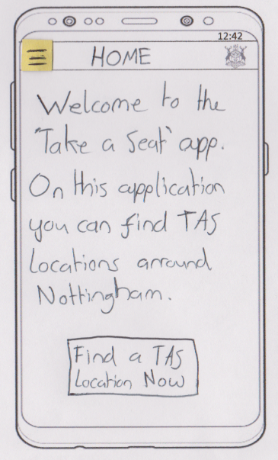
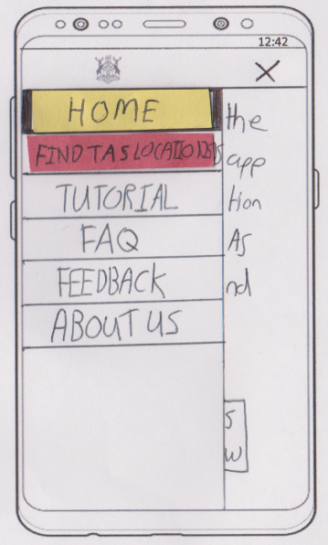
Navigation bar
When the navigation icon in the upper left area is touched, the bar expands, as seen by the image on the right. The remaining content on the right will have a dark overlay when the navigation bar is open

Short cut to the Find TAS Location screen

Clicking on the X, or an area off the navigation bar will close it

TAS map screen shows TAS locations on a map

FAS map screen – location tapped
FAS map screen
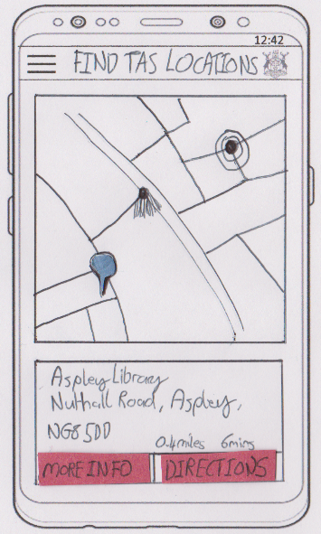
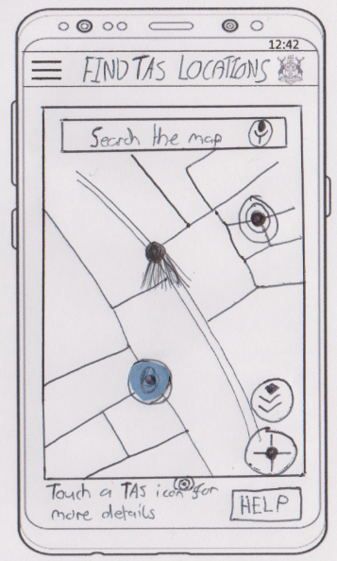

GPS button shows user’s GPS location on the map

Button for users to select terrain or satellite map option

When user touches a TAS location, more details expand (right) and a marker appears

Links to tutorial screen

More info button links to reviews screen by default.
This screen shows reviews and allows users to leave a review by touching a star

More info screen – Reviews screen
Navigating to location screen
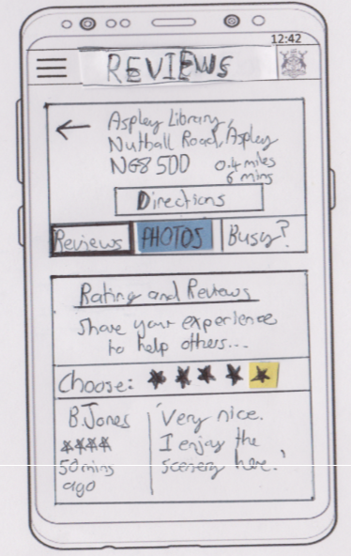
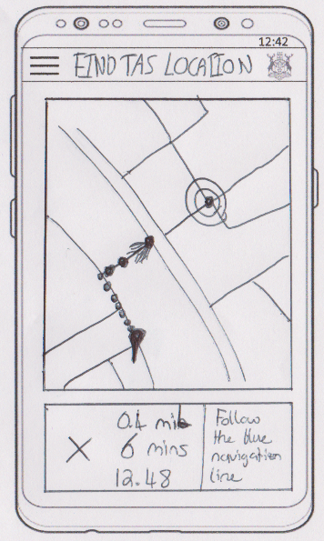
Back Button which takes user to previous screen

Navigation screen – a blue and dotted pathway appears on the map, so the user can navigate to the location

Links to photos screen

User can close navigation and return to previous screen by touching the X

Users can leave a review, using the on-screen keyboard, which pops up. They click the post button to post this review

More info - Photos screen
Leaving a review screen
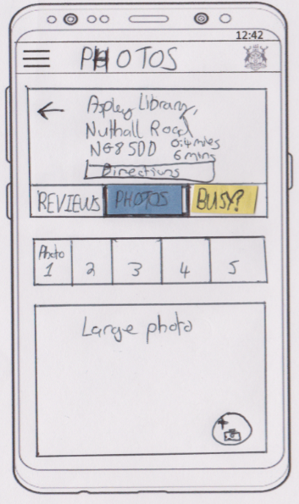
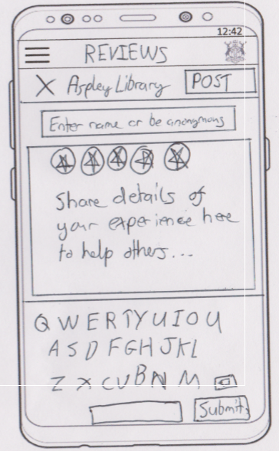

Takes user to ‘busy?’ screen

Reviews, photos and updates on how busy a location is all stored in a database for that location.

Users can see photos on this screen. They can scroll through the small thumbnails, and when they touch a photo, it enlarges.
Users can upload their own photo by touching the camera icon. This requests their permission to use their camera

More info – Busy screen
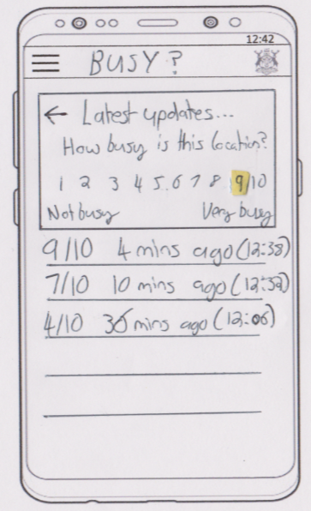

Users can rate, out of 10, by clicking on one of the rating numbers, how busy this TAS location is.
A live feed is provided for users to see the latest update

10. Limitations
After considering each section of this report and analysing our proposed application, we have identified some limitations regarding our application, its features and our users:
- Not all elderly people have modern day mobile devices, as our application requires to function. Furthermore, not all people with mobile devices have a device running Android, meaning that realistically, we can only support a limited number of people. Though this is a limitation, we are still proud to be supporting the elderly and if the application is successful, we could consider releasing modified versions of our application for different devices, such as iOS devices, to support more people.
- Our application requires the use of mobile data to view and post photos or feedback of TAS locations. A lack of internet connection could really limit the use of features that our application includes. Despite this, there are an ever-increasing number of Wi-Fi zones in public, and if a user does connect to Wi-Fi, they can then use the features that require an internet connection.
- Anybody and everybody can post images or feedback onto our application. This could mean that people may post inaccurate, inappropriate or spam content. Even with a registration system, this can’t be prevented. In order to counter this however, administrators will remove incorrect or spam content, ensuring that users don’t see any unnecessary data on our application.
- As our application uses GPS to identify a user’s location, it will drain their mobile device’s battery at a considerable rate. For users with mobile devices with a poor battery life, this could cause some problems. On the other hand, many modern-day smartphones offer reasonable battery lives, and power banks can be purchased to extend the battery life of a mobile device.
- Due to the fact that our users will be elderly, there will be a good chance that they may have serious physical impairments (such as very poor vision and poor mobile device literacy). This could mean that even though we develop our application considering physical impairments, our application may still be impossible to use, if the impairment is serious. We will do as much as we can to ensure our application is as usable by as many people as possible.
- The nature of our application brings about some security issues. Some users, particularly the elderly, who may be more vulnerable, might not like the idea of using our application in public. They may fear that by exposing their device, criminals may attempt to snatch their device and steal it. Furthermore, users may be worried about using GPS, and fear that people may be able to locate where they are.

References
Bisht, K, 2016. Advantages of native apps [online]. Available at: http://www.oodlestechnologies.com/blogs/Advantages-of-Native-Apps [Accessed 16 November 2017].
Campbell, O, 2015. Designing for the Elderly: Ways Older People Use Digital Technology Differently [online]. Available at: https://www.smashingmagazine.com/2015/02/designing-digital-technology-for-the-elderly/ [Accessed 18 November 2017].
Coleman, B., R, 2017. The best colours for the elderly [online]. Available at: https://healthfully.com/colors-elderly-8551183.html [Accessed 17 November 2017].
Gothelf, J. and Seiden, J., 2016. Lean UX: designing great products with Agile teams. 2nd ed. Sebastopol: O’Reilly Media, Inc.
Idc.com, 2017. Smartphones OS market share, 2017 q1 [online]. Available at: https://www.idc.com/promo/smartphone-market-share/os [Accessed 17 November 2017].
Kanjo, E. and Cook, B., 2017. ITEC30041: Mobile Platform Development 201718 Full Year [online]. Available at: https://now.ntu.ac.uk/d2l/le/content/483527/Home [Accessed 15 November 2017].
Material, 2017. Material design [online]. Available at: https://material.io/guidelines/style/icons.html [Accessed 18 November 2017].
Nottingham City Council, 2016. Take a Seat [online]. Available at: https://www.nottinghamcity.gov.uk/health-and-social-care/adult-social-care/take-a-seat/ [Accessed 15 November 2017].
Rouse, M, 2013. Native app [online]. Available at: http://searchsoftwarequality.techtarget.com/definition/native-application-native-app [Accessed 16 November 2017].
Rouse, M, 2015. Cross platform mobile development [online]. Available at: http://searchmobilecomputing.techtarget.com/definition/cross-platform-mobile-development [Accessed 16 November 2017].
Sutherland, J, 2011. The Difference Between Apps and Mobile Websites [online]. Available at: https://www.newmediacampaigns.com/blog/the-difference-between-apps-and-mobile-websites [Accessed 16 November].
Vishwanthan, P, 2017. The Pros and Cons of Native Apps and Mobile Web Apps [online]. [Accessed 16 November 2017].

Appendix

Appendix A – The problem statement template used for creating the problem statement
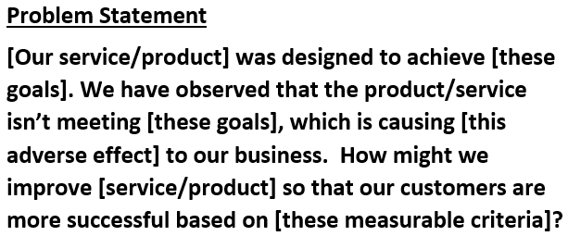

Appendix B – Completed assumptions worksheet which inspired final business and user assumptions (answers in bold)
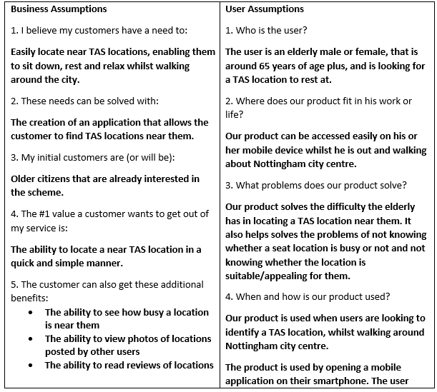
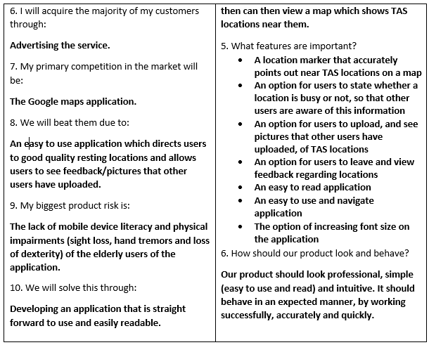

Appendix C – Gothelf and Seiden’s recommended hypothesis statement format
We believe [this statement is true].
We will know when we’re [right/wrong] when we see the following feedback from the market:
[qualitative feedback] and/or [quantitative feedback] and/or [key performance indicator change].

Appendix D – Persona creation template
1  Sketch & Name | 2  Behavioural demographic information
3  Pain points & needs | 4  Potential solutions

Appendix E – Created personas
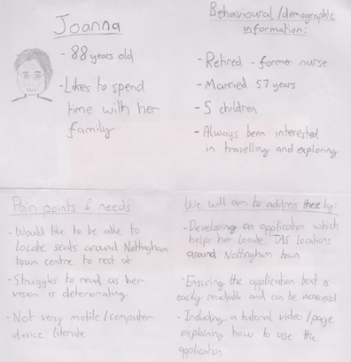

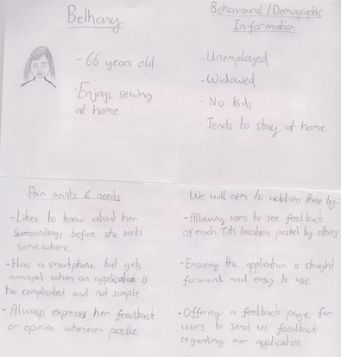

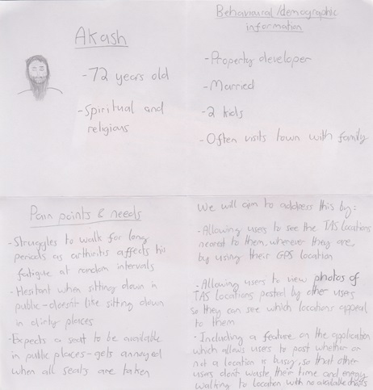

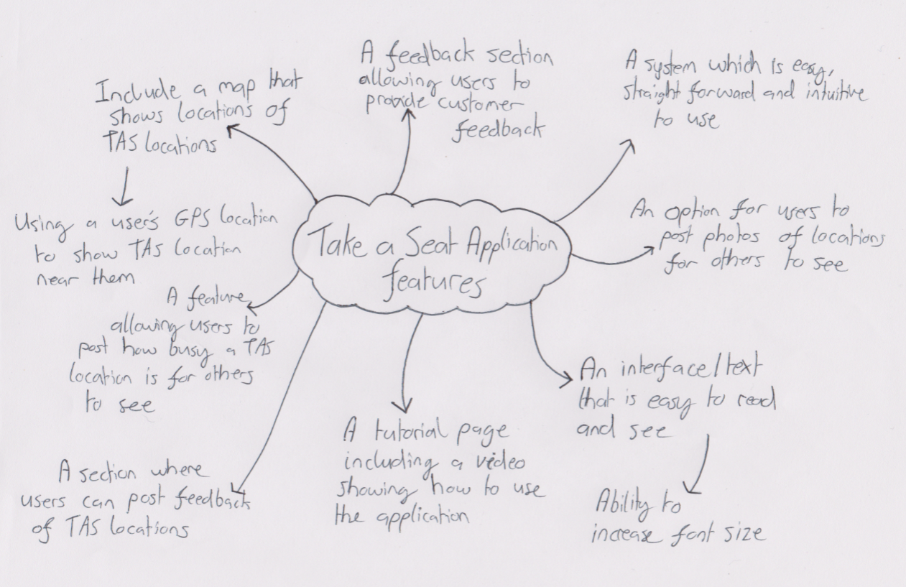
Appendix F – Brainstorming of feature ideas

Appendix G – Features template used to create features list
We will | For | In order to achieve
[create this feature] | [this persona] | [this outcome]

