
Mobile Platform Development (ITEC30041)
Assignment 2


Application name: TAS (Take a Seat) Locator
Inderjit Sandhu (N0578334)
Dr Beverley Cook
Contents
Introduction 2
Problem the application addresses 2
Introduction to/overview of the application 2
Features implemented and how they address the problem 3
Use of design guidelines and principles 6
Usability & accessibility 6
User interface & navigation 8
Data storage 10
Use of components 10
Adaptability to devices & displays 11
(See next page for testing sessions) 11
User Testing Sessions 12
User Testing methodology 12
User Testing Session 1 13
User Testing session 2 17
User Testing Session 3 20
Testing Session 4 - Android core app quality testing 24
Testing session 5 – App Quality Alliance (AQuA) Testing Criteria for Android Applications (final draft) 28
Connectivity 28
User interface 29
Menu 31
Stability 31
Coding Diary 32
Use of Google maps 32
Customising Google Maps to fit the purpose of the application: 32
User interface 35
Data storage 36
Video 37
References 38

Introduction
This section firstly provides context, by describing the problem that the application (TAS Locator) addresses, then provides an overview of the application, before finally explaining how the features implemented address the problem (with screenshots).

Problem the application addresses
The Centre for Ageing Better’s (2014) have partnered with Nottingham City Council (2015) to the ‘Take a Seat’ (TAS) service. This service attempts to create a more age-friendly Nottingham by tackling fatigue, social isolation and loneliness faced by the elderly people travelling around Nottingham. The TAS service currently provides access to seating for older people, allowing these people to catch their breath and socialise with others while travelling around the city.
While the elderly now has access to these seats, they do not have a method of locating these TAS premises, and with over 300 locations, and potentially memory problems occurring with old age, these people may struggle to remember where nearby TAS locations are. Furthermore, the elderly may be walking around various parts of Nottingham for the first time, meaning that they are likely to be unaware of the TAS nearest to them.
TAS (Take a Seat) Locator supports the Age Friendly campaign and addresses the problem that the elderly face – having no method of locating the TAS seats throughout Nottingham or nearest to them.

Introduction to/overview of the application
TAS Locator is a mobile application that supports the elderly travelling around Nottingham in finding TAS seats around the city or near to them. In assisting the elderly, the application supports the Age Friendly campaign and makes use of mobile development technology to better the community.
Users of TAS Locator view, on a map, precise markers of the TAS premises currently available in Nottingham. Users also have the option of using their device’s location to view the TAS locations nearest to them. By touching a marker, users can view more details about the selected TAS location, and then have the option of navigating themselves to that location if required.
TAS Locator’s design is based around its target audience, the elderly. Older people are currently generally mobile device illiterate, are likely to have physical impairments, such as sight loss or hand tremors, and may have a loss of dexterity. Considering this, TAS Locator has been designed in a simple and user-friendly manner, with this simplicity ensuring that the application is suitable for its users. If the application was more complicated, it would likely frustrate its users and make it difficult to use.

Features implemented and how they address the problem
This section describes the features included within TAS Locator by shows screenshots of the features and discussing how they address the problem. Mostly, the main features of the application are discussed, while the video (https://youtu.be/P30rX4acLhA) goes further into detail, addressing smaller features and explaining how the application is fit for purpose. The coding diary discusses the implementation of the features and technology involved.
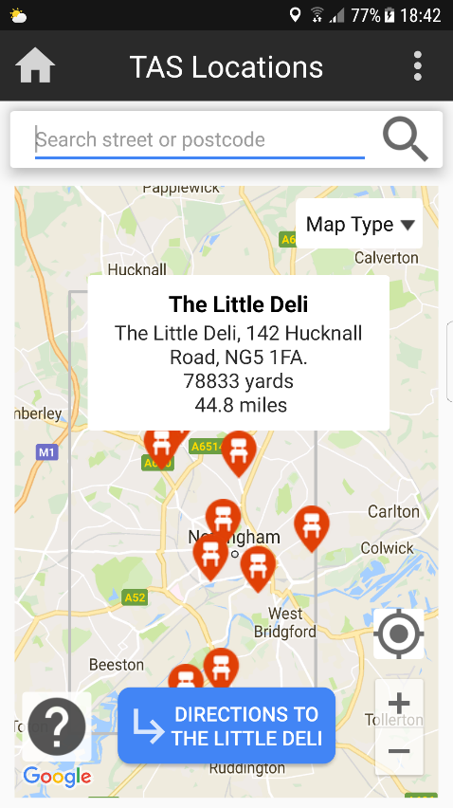
Feature 1 - Displays the TAS locations as markers on Google Maps (using Google Maps API). The application syncs with a Firebase Realtime database to plot the markers, ensuring the locations are up to date (they’re frequently updated) each time the user loads the map.
How it addresses the problem - Users can easily see, plotted on a map, the various TAS locations that are around them, or the city of Nottingham. The use of Google Maps allows users to zoom in and out of the map and move around it, as well as carry out other actions, which will be discussed soon throughout this report.

Feature 2 – Shows a customised selected marker information screen, displaying useful information about the application. Custom marker logos (chairs in markers) are used, the modified info box looks more readable/clear than the standard info box, and important information such as the title and address are displayed. As well as this, a function has been created to calculate the distance from the user’s current location to the selected location.
How it addresses the problem – As the customised information box is clearer to read the standard one, the users, who may suffer from poor vision, can now read this information with ease. The information displayed could be influential in a user’s decision of whether they want to travel to a selected location.

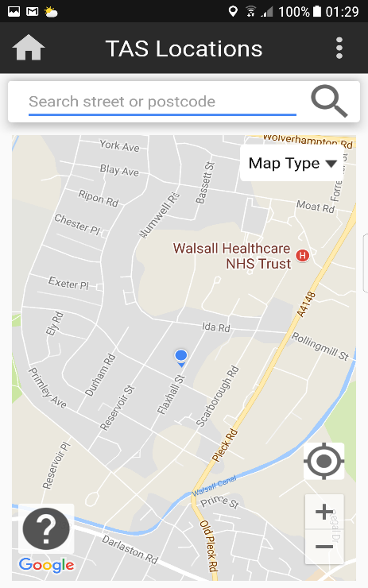
Feature 3 – Automatically obtains the user’s location, displaying it on the map and moves the map forwards this location. Also offers the ability to press the location button to manually find the current location.
How it addresses the problem – By automatically moving the camera to the user’s location, the user can see, within a short amount of time, the TAS near them. They can then choose locations to explore based on locations they can visually see are nearby.

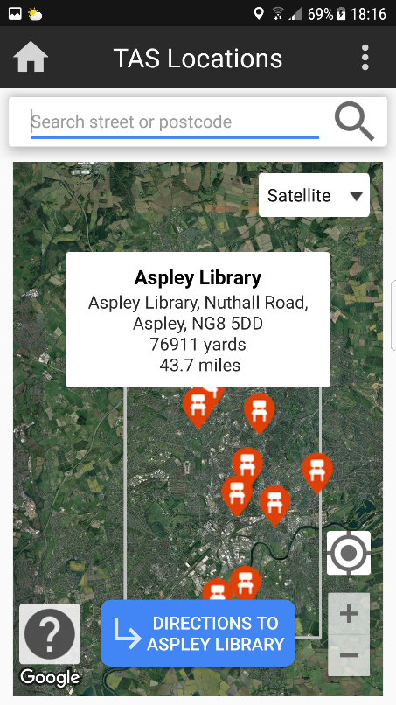
Feature 4 – The option to interact with the maps similarly to the Google Maps App. TAS Locator offers the ability to change map type (using the spinner), press the zoom buttons (or pinch) to zoom, move the map around, and change the dimensions of the map by using two fingers and pulling up/down.
How it addresses the problem – The ability to interact with the map and adapt it to one’s needs or preferences means that the application can be used by people with various preferences. Each function makes interacting with the map quicker and more convenient by assisting users in navigating their way around and finding TAS locations with ease.

Feature 5 – Customised direction button and navigation to a location. This directions button (and function) has been added, and appears when a user touches a marker, providing them with an option of navigating to a TAS location from their current location through Google Maps. The button is bigger than the standard direction button that appears on a marker selection and confirms which location the user is navigating to.
How it addresses the problem – The development of a new directions button ensures that users now have a larger, easier to press, more noticeable and more informative directions button. The button has been programmed to take the user to a Google Maps Navigation route, from their current location to the location of the marker they selected.
This interoperability with Google maps means that users can choose to open another application to view, within a matter of seconds, a detailed navigation of their route, and view other options such as estimated travel time, transport options etc.

Feature 6 – Advanced search function. This search function is programmed to ensure that searching for a location only returns locations within the radius of TAS locations around Nottingham.
The screenshot below to the left shows a search for a street outside the polygon (represents the TAS location area radius) drawn on the map. The user is informed that the location is not within Nottingham. Below to the right is a screenshot of the user searching for a location within Nottingham, successfully returning a result.

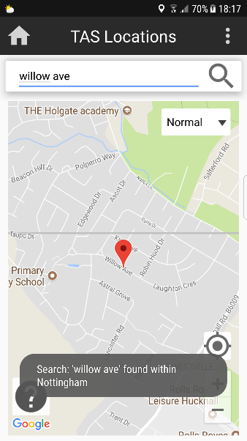
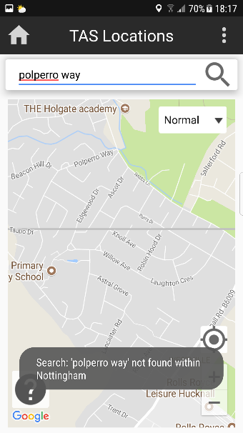
How it addresses the problem – By returning results only within Nottingham, the application saves users time by ensuring they don’t receive a result in another city or country, which they obviously don’t require.
The search feature allows users who aren’t from Nottingham, or who aren’t familiar with certain areas, to search for a location before or during travels. This allows the user to plan and search for new locations to locate new TAS locations.
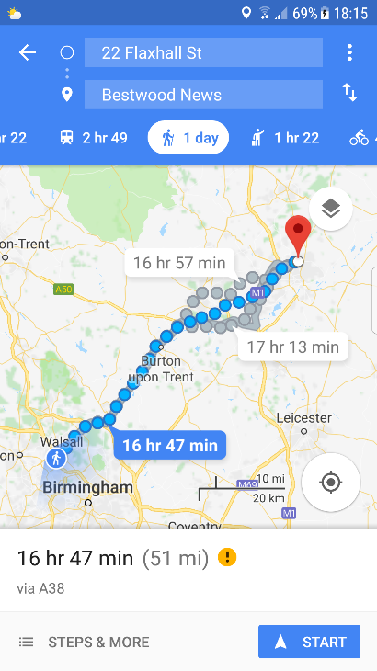
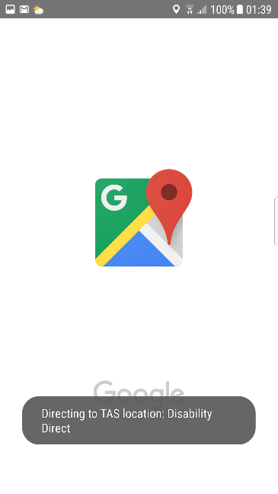

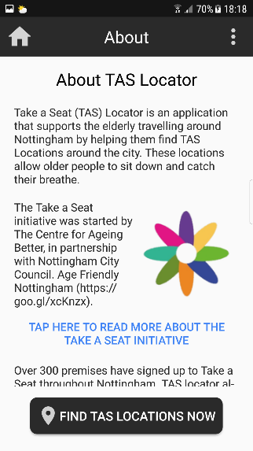
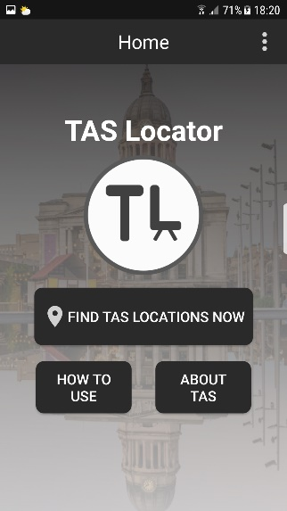
Feature 7 – Inclusion of Home / About / Contact / Help screens. These pages have been included to ensure the application offers expected screens and performs as a standard Android application. Each screen uses a scroll view, ensuring that varying screen device sizes and landscape orientation is supported. The about screen describes the story behind the application, the contact screen offers users the chance to leave feedback or ask questions, and the help screen explains to the user how to use the application.
How it addresses the problem – The inclusion of these pages means that users know support, advice and help is available when using the application. The user, who will typically be an old person, may be interested in learning more about the Take a Seat initiative, contacting the creator of the application for any queries, or receiving instructions on how to use the application. The help page aims to simply break down how to use the application, ensuring that users don’t struggle.

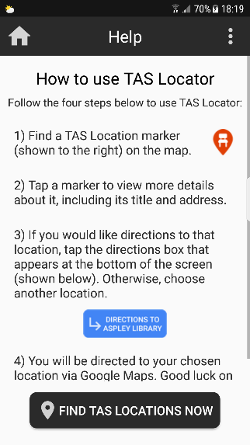
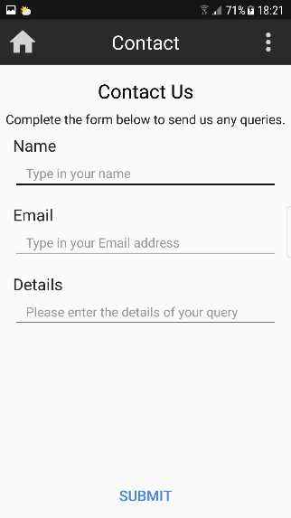

Feature 8 (and how it addresses the problem) – User-centred application design. Considerable time has been spent on designing an application that is user friendly, particularly for the older users. Some aspects that have been considered include:
- Simplicity of design – the application only has few pages, and has no navigation bar, ensuring that users can navigate their way around the application with ease. Extra features, such as a registration system, have been avoided particularly to keep the application design simple and ensure that the elder users don’t struggle or become frustrated. The elderly would simply appreciate an application that takes a few seconds to load, display locations and navigate to a location, and that’s what TAS aims to provide.
- Readability – high contrast and large font sizes (at least 16 +) are used throughout the application to ensure that the application’s older users can easily read content.
- Large button tapping areas – most buttons within the application are much larger than the recommended minimum of 40px by 40px. This ensures that users become aware of buttons and find them easy to press.
- Simple toolbar – a simple toolbar has been implemented which includes a home button, a page title and an options menu. This allows users to navigate to the home screen at any time, identify where they are in the application and access further support or options at all times.

Use of design guidelines and principles
This section demonstrates how the relevant guidelines, principles and recommendations have been used in the design of TAS Locator. The following guidelines/ principles/ recommendations have been considered throughout, and will be referred to:
- Android (2018) Developer Design Guidelines - https://goo.gl/dHzsdf
- Android (2018) Material Design - https://goo.gl/n3fqBj
- Cook (2018) – Lecture on Persistent Data 2 - https://goo.gl/xnBy4Y
- Cook (2018) – Lecture on Design Principles and Patterns - https://goo.gl/7fTjjo
- Campbell (2015) – Designing for the Elderly - https://goo.gl/kwtiVG

Usability & accessibility
Guidelines and principles have been used to ensure the application is accessible to as many people as possible - particularly people with low vision, colour blindness and restricted motor skills.
Android’s Material.io guidelines (https://goo.gl/w7HBWs) place accessibility within the usability category and were used whilst designing the application.
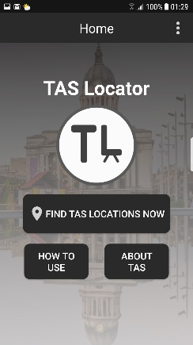
Colour and contrast
- The Material guidelines suggest using colours with sufficient contrast (at least 4:5:1) throughout the application, as they help users see and interpret content
- Due to this, text and icons contrast with the use of white and dark grey (primary and secondary colours) throughout the application, as the screenshot to the right shows
Text
- As the Material guidelines suggest, a sans serif font is used throughout the application as it is easier to read due to it not having curls at the end of letters
- Furthermore, as Campbell recommends for elderly people, a font size of at least 16 pixels is used throughout the application, as people with visual impairments struggle to read text smaller than this
Touch targets
- Each touch target is a minimum of 40dp by 40dp (about 9mm), as the Material guidelines recommend. This enables users who aren’t able to see the screen, or have motor-dexterity problems (likely the target audience), to tap elements in the application with ease
Icons
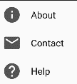
- The Material guidelines suggest using icons across the application to visually represent ideas, capabilities and topics. Icons are therefore added wherever relevant. See the screenshot to the right, demonstrating the use of info, message and help icons
Writing
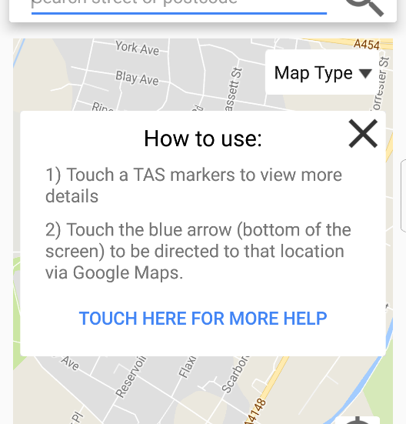
- As recommended by the guidelines, writing within TAS Locator is kept short and concise, building the user’s trust and making the application more usable. See the screenshot to the right, which shows the help popup activity, as an example of this
Feedback and awareness of app position
- The application provides feedback to the user wherever required and informs the user of their current application position. The Material guidelines recommend including these to keep the user updated and let the user feel as though the application considers their status
- The screenshots below show a Toast, used to provide feedback, and the heading of the toolbar, used to inform the user which screen they are currently on
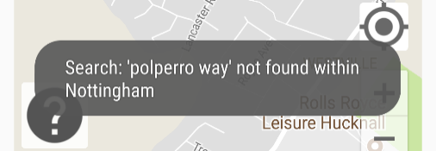
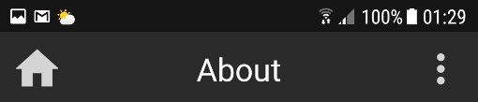

Label visual UI elements

- As the Material guidelines recommend, descriptive labels are provided to explain the purpose of elements
- See the screenshot to the right, which shows a hint in the search bar on the Map screen
Include help, about and support/contact page
- Cook and the Android Developer Design guidelines recommend including help, about and support/contact screens within an application as some users will come into questions of problems in the way of using the application
- The Developer guidelines also explain the help screen option should be placed at the bottom of a menu, and an in-app help screen should be included rather than a link to a page on the web. This means the user doesn’t need to leave the app to get. Furthermore, users should be able to contact the app creator with questions
- TAS Locator will complies with these guideline - see the screenshots below of the contact, about and help pages
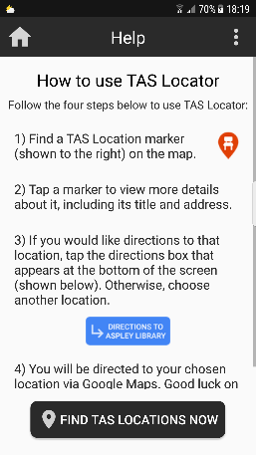
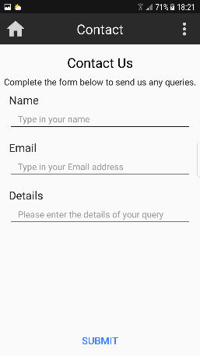
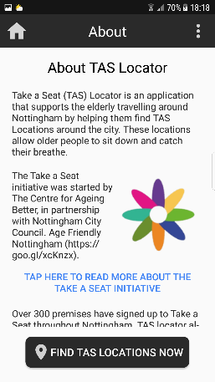
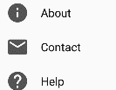

^Help at bottom of list

Map zoom level
- TAS Locator sets the default map zoom level at a level so that relevant information is shown automatically, and the user isn’t required to zoom immediately. See the screenshot to the right to see how TAS complies with this guideline, as recommended by Cook. The map displays the marker, and is at a level that it zoomed in enough to read nearby road names, and zoomed out enough to see many roads nearby
Intuitive
- Cook recommends ensuring an application is intuitive. TAS Locator, as the demo shows, is design intuitively. It is obvious which buttons carry out certain functionality and how the user gets to another location on the app

User interface & navigation
Layouts
- The Android Developers guidelines suggests designing an application that can display screens across different device sizes. TAS Locator does this, by using scroll views to ensure no content is missed, and layouts that do not overlap elements with each other or over the edge of the screen. See the demo for an example of the scroll views within TAS Locator and the landscape view of the screens
Navigating between apps
- The Android Developers guidelines describe navigating between applications as useful because they allow an application to utilise the code of another application to benefit the user. As the demo showa, TAS Locator navigates to Google Maps when directing the user to a location, benefiting the developer, who saves time writing code, and the user, who receives more journey options
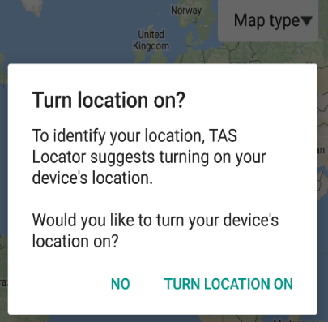
Navigating with intents using Dialogs
- TAS Locator takes on board the Android Developer’s recommendations of using a dialog box to make a decision. Users receive a dialog box prompting them to turn on their location.
- If the user chooses to agree, an intent is used to navigate from the app to their device’s location settings. This saves the user times and makes their experience using the application smooth. See the screenshot to the right to see the location setting dialog box, which results in an intent to device location settings
Spinners
- The Android Developer guidelines suggest using spinners as a quick way for the user to select a value from a set. TAS Locator used a spinner to allow the user to quickly change the map type. See the demo for a demonstration of this
App bar
- TAS Locator considers the Android Developers guidelines recommendations of using an app bar to provide a visual structure to the application and allow the user to interact with elements that are familiar
- The app bar also allows the user to identify where they are in the application, and provides easy access to the Home, About, Contact and Help screens
Status bar
- TAS Locator’s status bar is slightly darker than the application’s app bar, as recommended by the Android Developer Guidelines
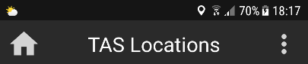
- This makes the interface look professional and tidy. See the screenshot to the right to see TAS Locator’s status bar, which has taken the recommendation on board and is darker than the app bar
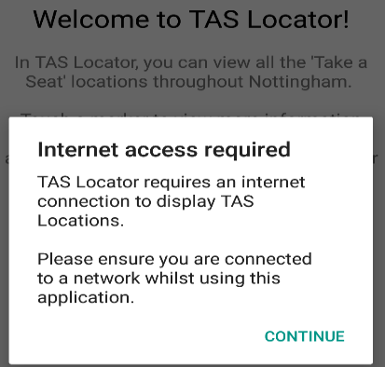
Confirming and acknowledging:
- As the Android Developer guidelines recommend, confirming and acknowledging is used by TAS Locator to help alleviate uncertainty about things that have happened or will happen. This prevents users from making mistakes they might regret
- As shown earlier, TAS Locator uses toasts in various circumstances to confirm an action. See the screenshot to the right to see an acknowledgement dialog box

Data storage
TAS Locator will use an external database – a Firebase Realtime database.
Only a relatively small amount of data is involved with the application, as it is purposely simple. A registration system could be included but this would unnecessarily complicate the application. The data to be involved in the application is data about each TAS location – its title, address, latitude and longitude. TAS Locator simply pulls this data from the Firebase database. Firebase database syncs data in real-time, as Cook’s lecture on Persistent Data 2 described, meaning that it is perfect for the purpose of the application.
This method of data storage is fit for purpose as there are over 300 current TAS premises, with many being added, edited, or removed frequently. It is extremely important that whilst using TAS Locator, users see locations that are up to date and live. If the marker information is not up-to-date, somebody may spend time and energy travelling to a location, only for it to be no longer available, all due to the method of data storage used by the application.
While the user requires a network connection to view TAS locations with this data storage method, it ensures that the user is not required to update their application regularly, to update information about the TAS locations, as would be the case if internal/external file storage was used to hold the information.
The Android Developer’s guide (https://developer.android.com/studio/write/firebase.html) to connecting an application with Firebase was followed to establish the connection between TAS Locator and the Firebase Realtime database.

Use of components
TAS Locator makes use of several components, as recommended by the Material guidelines.
Buttons
- Buttons are used to communicate the action that occurs when the user touches them. Flat buttons are used in dialogs boxes, while raised buttons are used in other circumstances
- As previous screenshots show, buttons in dialogs are aligned to the right, with the affirmative button on the right and the dismissive button on the life (as recommended by the Material guidelines)
- Button text is all capitalised and has at least a 2dp corner radius
Dialogs
- As mentioned previously, TAS Locator uses dialog boxes to inform the user that their network connectivity or location connectivity is non-existent. This information is critical, which, as the Material guidelines recommend, is why it is placed in dialog boxes
- Dialog boxes are only used on these rare occasions, and not more frequently as they would be interruptive

Text fields
- While TAS Locator only uses one text field, the search bar, the Material guidelines make some recommendations on how they should be used and displayed
- Following this advice, the search text field is identifiable (indicating that users can enter information) and easily findable (located above the map)
- The guidelines also recommend using input lines, to indicate where text should be entered, and cursors, to indicate where the user’s current input position is
- See the screenshot below to see the search text field, with its input line. The cursor is visible in the demo


Adaptability to devices & displays
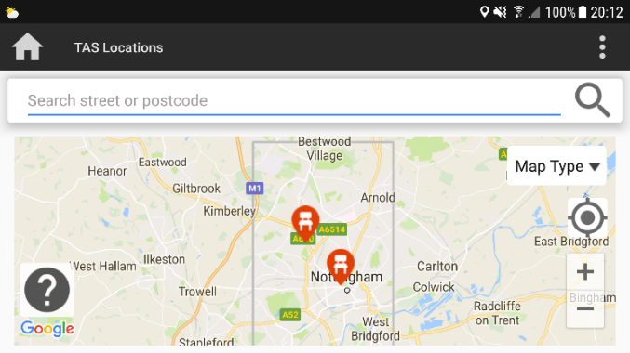
Using Material’s advice on application structure, TAS Locator is designed in a way that allows it to adapt to different devices and displays. The map page uses a constraint layout, ensuring that screen elements are all in line with one another if the device size or orientation is changed. See the screenshot below to the right to see how despite being landscape, the map still displays in a usable way.
The About, Contact and Help pages all use linear layout, which use scroll views to scroll through elements on the screen. This ensures that no content is missed when the device screen size, or the orientation, is changed. See the demo for these views

(See next page for testing sessions)

User Testing Sessions
This table below summarises the four testing sessions involved, at various stages, in the development of TAS Locator.
Testing session | Description
Testing session 1 -User testing session 1 | Explains the results of user testing of the paper prototypes produced in the application proposal (assignment 1). This testing session is brief as there is no physical product for users to test.
Testing session 2 - User testing session 2 | Explains the results of user testing of the minimum viable product (draft 1) of TAS Locator. The minimum viable product will still be a distance off being the finished product, but it will still be at a stage which solves the problem, in a basic manner.
Testing session 3 - User testing session 3 | Explains the results of user testing of the second draft of TAS Locator.
Testing session 4 - Android core app quality testing | Tests the application against Android’s core app quality testing guidelines.
Testing session 5 - App Quality Alliance (AQuA) testing criteria for Android Applications (final draft testing) | Tests the final version of the application against the App Quality Alliance testing criteria. No changes will be made after this testing session, which helps summarise how successful the application is. Future improvements are mentioned.

User Testing methodology
The user testing carried out in sessions 1,2 and 3 has been carried out in scheduled university labs with fellow peers acting as though they share the characteristic of the personas of the appropriate target audience (the elderly – 65 years of age plus). Furthermore, two adults (60 years old +) have tested the application, meaning that their input may provide feedback more suited to the target audience. Self-feedback has also been included at times, when problems have been observed while testing.
The purpose of the application was explained to the testers, who were then asked to use the application and provide feedback. This feedback is then noted, and the appropriate changes made. To keep things simple, all feedback is collated rather than providing each tester’s individual feedback.
FBX, FBX Response and FBX Change all refer to the same piece of feedback. Numbers are used in this instance to maintain a tracking system for response and feedback.

User Testing Session 1
Application paper prototype (from assignment one) with user feedback - before testing (FBX) | Response to feedback and additional tester comments | Prototype after changes made considering user feedback and justification - after testing (FBX Change)
Home screen & menu expanded screen  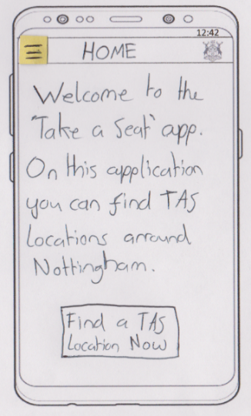  FB1 – Include less text as this is a home screen for an app – doesn’t need to explain its purpose  FB2 – Add a logo to give the app an identity  FB3 – Add a marker icon to the button  FB4 – Include an about and how to use button  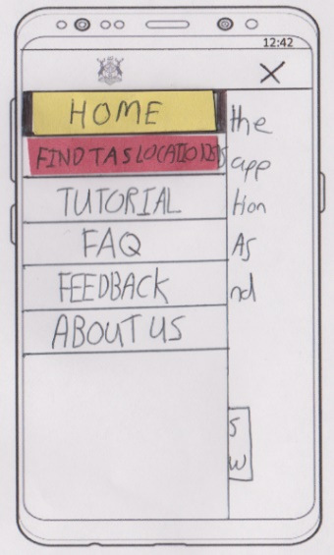  FB5 – Change from a navigation bar to an options menu  FB6 – Change the options. Only need a few – About, Contact and Help  FB7 – Add icons to the menu icons | General response:  Many changes have rightly been considered for the home screen and navigation option of the app. The feedback received will help transform the home screen to look more professional and be more intuitive and useful.  The change in navigation system (from navigation menu to options menu) will make the application simpler to use for the target audience, who may have little experience with mobile applications. The additional pages required do not need to be in a navigation bar.  Additional comments:  - Be sure to keep the home screen simple as users may not want to read the information each time the start the application | FB1 Change – Less text is included on the application. This keeps the screen simple and allows the user to navigate to where they choose to.  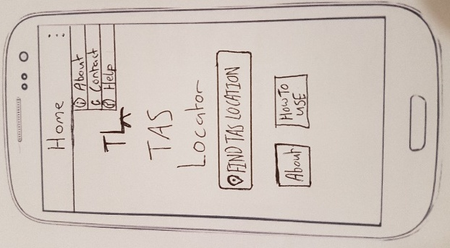  FB2 Change – A logo has been added, a little sketch for now.  FB3 Change – An icon has been added to the image to visually communicate its purpose.  FB4 Change – About and how to use buttons have been added.  FB5&6 Change – The navigation bar has been scrapped, instead the ‘options’ option (three dots) is now available to the user  FB7 Change – Icons have been added, these icons also assist in visually communicating
Map screen  FB8 – Separate the search bar from the map, so the user can distinguish the difference more obviously – preferably place above the map  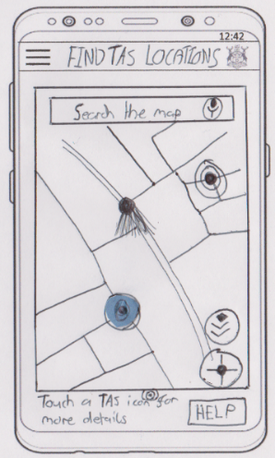  FB9 – Provide a help option that produces a popup box describing to the user briefly how to use the application. This can save time as opposed to navigating to a new, detailed screen with lots of writing  FB10 – Change the TAS markers from a blue dot to an actual marker, as they represent locations more  FB11 – Change the map types icon to a spinner so the user can see the options in writing and is clear of what the button does  FB12 – Add zoom buttons to the map, as the may be unfamiliar with the pinch to zoom mechanism, and may prefer simple buttons | General response:  The feedback focuses on making the map page more user-friendly. This will all be considered as the application should be as user-friendly as possible considering the target audience.  Additional comments:  - Looks as though the map could be a useful tool for people trying to find the TAS locations, as it uses the user’s location  - There seems to be a lot of buttons and features on this screen. Be sure to not overcrowd the screen with buttons and confuse the user | FB8 Change – The search bas has now been separated from the map, making it look more visible and making the map look cleaner.  FB9 Change – A help button has been added, which, when touched will bring a pop up, briefly explaining how the use the application. If, however, the user is still unsure, they can click the button to be redirected to the actual help screen  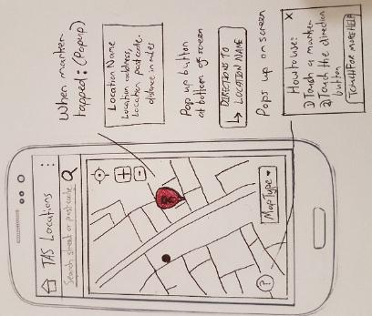  FB10 Change – The circular blue markers have now been replaced with red location markers with chairs on them, symbolising TAS locations  FB11 Change – A spinner is now used to change map types  FB12 Change – Zoom buttons have now been added to the map, providing the user with an alternative to pinching to zoom
Map marker selected pop up screen  FB13 – Set the pop-up information when a marker is selected as an information window popup within the map, rather than resizing the map and changing the entire structure of the screen  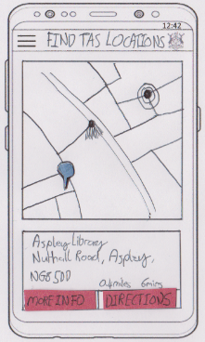  FB14 – Remove the more info button, as this makes the application more complicated, and the main information is already displayed  FB15 – Consider removing the walking time suggestion as older people may walk slower than the average person. This information may be misleading the user, which could frustrate them | General response:  This page seems as though it will require a fair amount of re-working. The feedback again revolves around keeping the application simple and not overloading the user with too much information.  Additional tester comments:  - The concept of providing more information when the user taps a marker is good – if this information can be generated dynamically, for each location, the user could receive some important details which may make them choose one location rather than another | 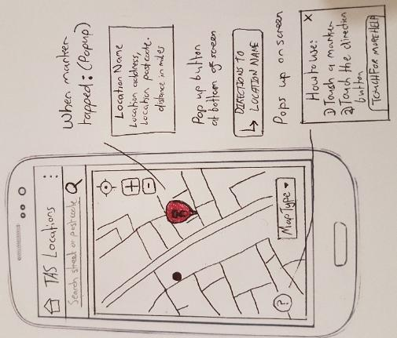  FB13 Change – Instead of resizing the screen, a pop-up information window will appear, providing the user with details of the chosen location.  FB15 Change – The walking time suggestion has now been removed. The user will instead be told how far away they are from the selected TAS location  FB14 Change – The more info window button has been removed as it is no longer required
Other screen/general application feedback  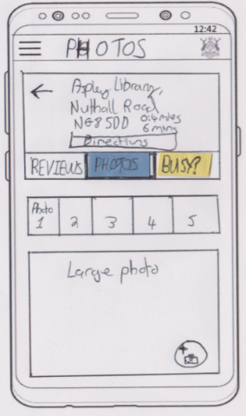  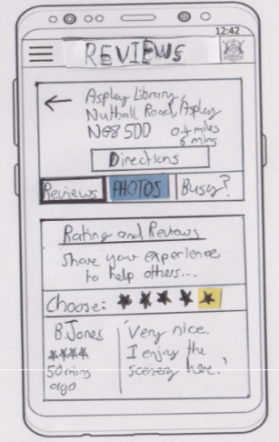  FB16 – These two screens may make the application too complicated for the target users. Many older people struggle performing basic functions on mobile devices, so they are unlikely to use this feature  FB17 – Use Google Maps to direct the user to a location rather than calculating the journey within the application itself  FB18 – Add About, contact and help screens | General response:  The reviewing system and uploading a photo system will be left out of the application. These features are complex and may confuse the target audience. They could potentially be included in a later release of the application or included as part of the application with more development time.  Response to feedback 17 – Google Maps will be used, to avoid repeating programming in TAS Locator that already exists in Google maps, and to provide the user with more travelling options.  Additional tester comments:  - The application idea seems beneficial overall, and without the complicated features, it could really benefit the older people travelling around Nottingham if implemented correctly  - Ensure that time is spend on making the design of the application look attractive and user-friendly | FB16 Change – The reviewing system and photos screen will not be included in TAS Locator  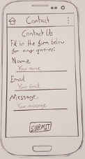  FB17 Change – Google maps will be used to direct the user to the location, rather than the application itself. By using the actual Google Maps app, users can receive more route options, such as traffic time information, transport options etc  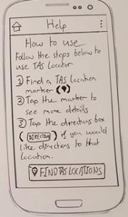  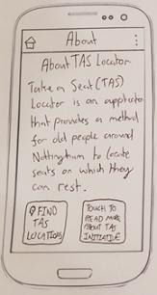  FB18 Change – About, contact and help screens have now been designed. These make the application more professional and can benefit the users should they want to know more about the scheme, ask a question, or receive more instructions on how to use the application

User Testing session 2
Application screenshot (if required) with user feedback - before testing (FBX) | Responses (FBX Response) and additional tester comments | Application screenshot after changes made considering user feedback and justification - after testing - (FBX Change)
Home screen – loads on application launch  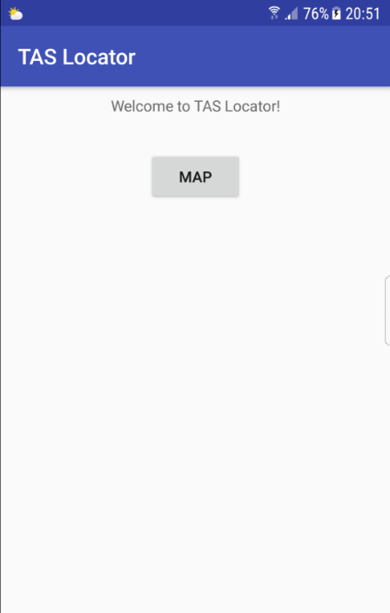  FB1 – The application looks dull – it could be made to look more attractive. See Response1.  FB2 – A navigation bar could be added to allow the user to navigate between screens. See Response2.  FB3 – This screen should describe the purpose of the application. It could also be more descriptive and tell the user what the button will do. This will make the screen more user-friendly.  FB4 – The text could be made larger as elderly users may struggle to read it. The button text could also be bigger and more descriptive. | FB1 Response – While the application does currently look dull, the current priority is developing the application’s functionality. Styling will be applied at a later stage. The demo will show the final interface  FB2 Response – Considering the target audience, a options menu will be used rather than a navigation bar, ensuring the application is simple and intuitive. This will also not be implemented until the main map functionality is complete.  Additional tester comments:  - The application loads quickly  - Screen is simple and not complicated, it is obvious where the user must navigate to next  - This screen is currently simple, which is expected at this stage of development | 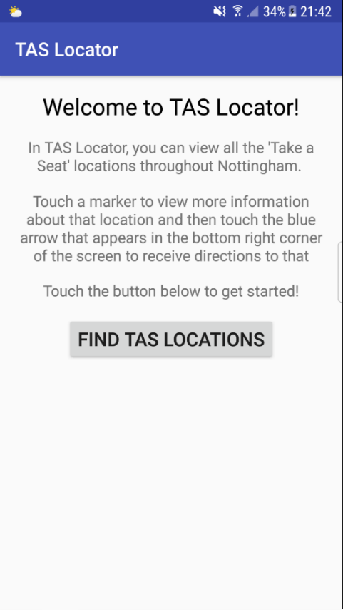  Minimal changes have been made at this stage as much of the user feedback focussed on the design of the application rather than the functionality. To see improvement to design changes, see the demo.  FB3 Change - a brief description has been added to describe the purpose of the application. User’s now know what they can do in the application and how.  FB4 Change – The font has been increased from 14 SP to 16 SP minimum for all text. This font increase makes the text much more readable.
Map screen – displays TAS Locations  FB5 – Include instructions, or an option for help, so the user is informed about what they should do.  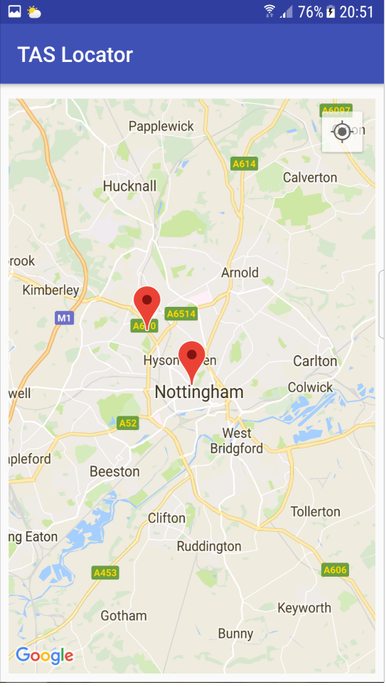  FB6 – Zoom the default zoom in a little more as users may have to waste time zooming into the city centre.  FB7 – A search feature could be added as users may want to search for a new area with a TAS seat.  FB8 –  Provide zoom in and zoom out buttons as elderly users may struggle to ‘pinch’ to zoom.  FB9 – An option could be added to allow the user to add more TAS locations. See Response9. | General response to feedback:  All this feedback seems beneficial and useful. It will all improve the application and therefore be considered.  FB9 Response – This feedback will be disregarded, as the application is to be developed for the user, rather than administrators.  Additional tester comments:  - The option to centre your location with the GPS icon is useful  - The markers are big and clearly visible  - It is logical that the application loads the map to Nottingham as the default location  - The application successfully shows the TAS Locations | FB5 Change – an info icon has been added which brings up a box describing how to use this application.  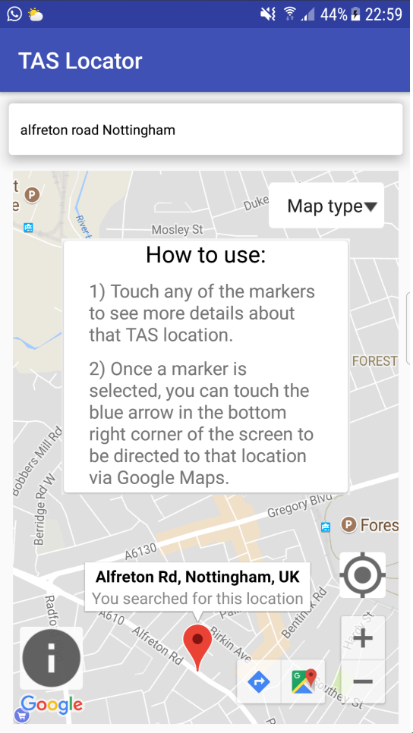  FB6 Change – the default zoom has been zoomed in more. The zoom in the screenshot at the same level the zoom is at when the application loads. This provides more detail and makes using the map easier for the user.  FB7 Change – a search feature has been added. This allows users to search for locations for TAS seats. When a user searches, the map pans to that latitude and longitude, and a marker appears.
Map screen with marker selected  FB10 – The user’s location should be shown on the map, so they can see where exactly they are.  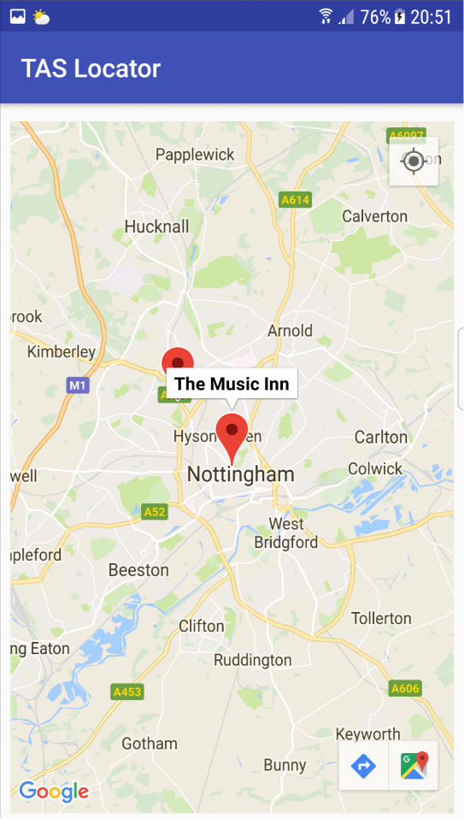  FB11 - Add alternate map types option e.g. satellite, as different users may have preferences.  FB12 - Include the full address of a location with the marker info window. This could be useful for users.  FB13 – There is no method of returning to the welcome screen or other screens once the user is on this screen. See Response13. | FB13 Response – As mentioned previously, navigation to other screens will be worked on at a later stage.  Additional tester comments:  - It is useful that touching on a marker displays the name of the TAS premises  - When a marker is selected, map options appear in the bottom right corner. These allow users to direct themselves to the location using Google Maps. This is very useful for the user  - Users are not prompted with a big pop up for directing to a location, rather a smooth little box appear in the bottom corner. This ensures the user doesn’t feel forced to direct to a location, more it is an option, and it allows users to continue using the application without delay | FB10 Change – The user’s current position now appears on the map. This provides the user with an indication of where they are, making it easier to spot nearby locations.  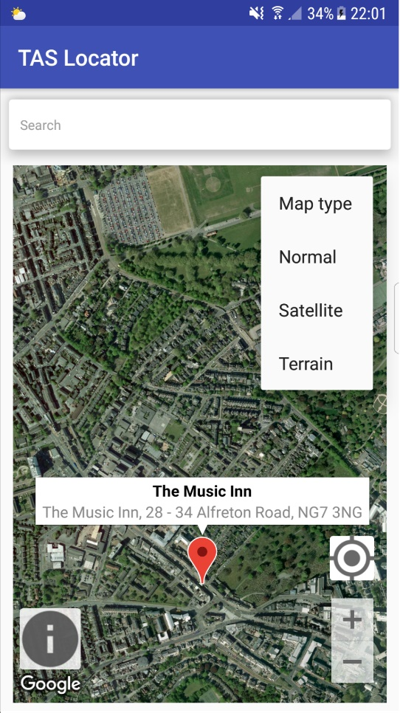  FB11 Change – Alternative map types are now available via the use of a spinner. This ensures that the application caters for users with different map preferences when travelling. The map type has been set to satellite on this screenshot.  FB12 Change – The address is now shown when a user touches a location. This provides the user with more, potentially useful, information about the TAS location.

User Testing Session 3
Application screenshot (if required) with user feedback - before testing (FBX) | Responses (FBX Response) and additional tester comments | Application screenshot after changes made considering user feedback and justification - after testing - (FBX Change)
Map screen – default app launch  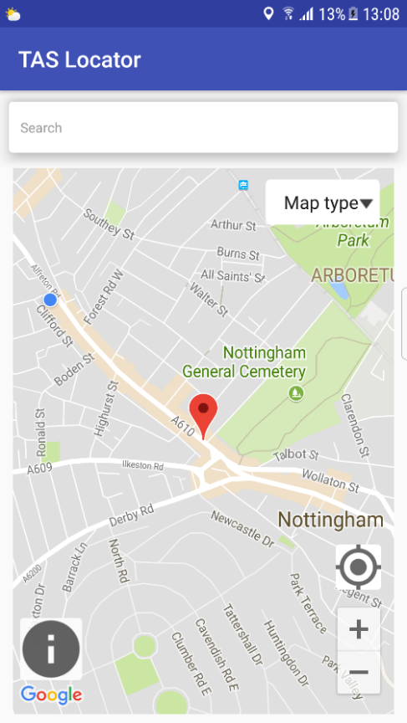  FB1 – A search button could be added on the search bar.  FB2 – The hint could be more informative.  FB3 – Search bar text could be bigger as elder users may struggle to read.  FB4 – Customer markers could be used rather than the standard Google Maps markers. This would help give the application its own identity.  FB5 – The default location could be changed to the user’s location to save users time. | Additional tester comments:  - The application is accurate in determining the user’s location. The dot updates frequently  - The TAS locations have been plotted accurately  - With some work, the application can be very user friendly and simple, ensuring that the elderly target audience will be able to use it with a fair amount of ease | FB1 Change – A magnifying glass button has been added, allowing users to search with an alternative method to pressing done on the keyboard.  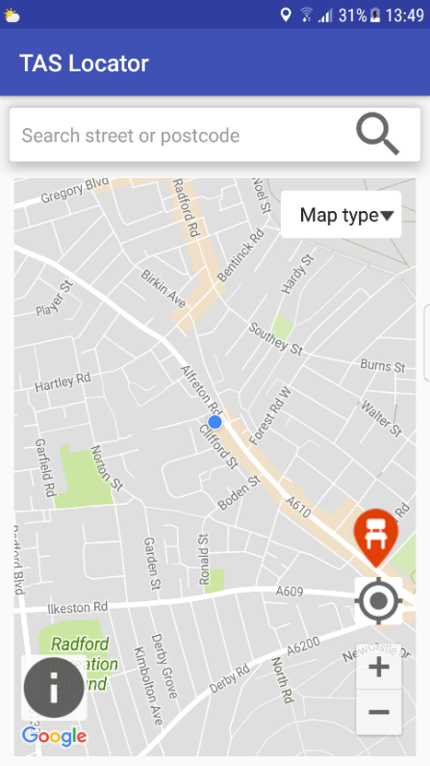  FB2 Change – The hint is now more descriptive, meaning the user knows precisely what to type into the bar.  FB3 Change – Text has been increased to 16SP, ensuring it is easier for the user to read.  FB4 Change – A customer marker (created on Photoshop) is now used to represent TAS locations. This marker makes the application more personal and clearly symbolises a TAS location.  FB5 Change – The application now loads at the user’s location. This allows users to instantly find TAS locations near them.
Searching screen – after a location has already been searched for and during the process of searching for another  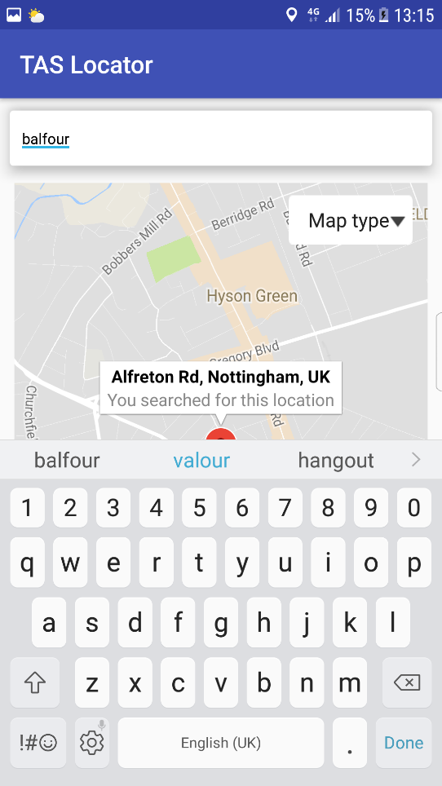  FB6 – The search function uses autocorrect, this is frustrating when searching for streets.  FB7 – The ‘done’ could be changed to ‘search’ so the user knows it will search.  FB8 – After searching for a location, the keyboard remains on screen. This frustrates users as the user must then press the back button to remove it. | Additional tester comments:  - The inclusion of the search feature is useful, but a few changes need to be made to make it less frustrating for the user | 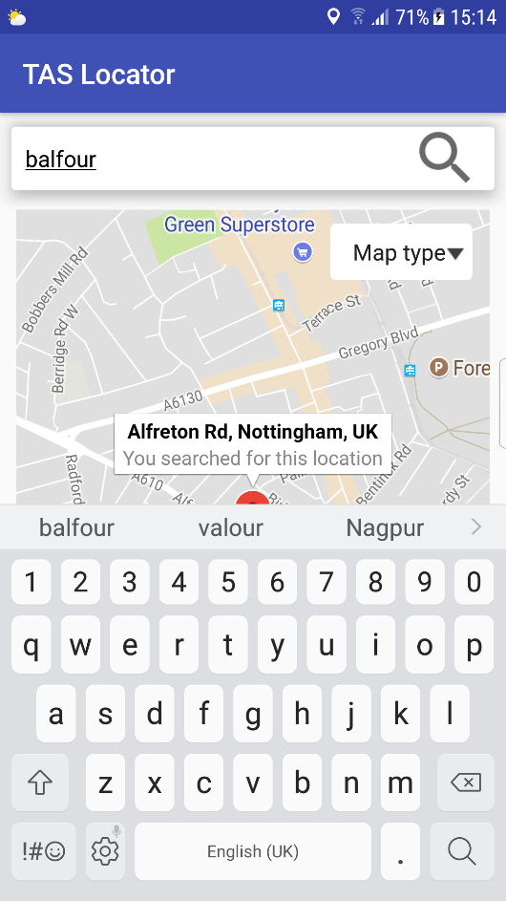  FB6 Change – The autocorrect feature has now been turned off, as seen by the suggested correction in blue no longer being visible. Suggestions have been kept on the screen however, as many street names are suggested correctly.  FB7 Change – ‘Done’ has now been changed to a magnifying glass. This clearly informs the user that this button will search for a location.  FB8 Change – Though not visible on this screenshot, when pressing the search button, the keyboard now automatically closes. This stops the user from being frustrated. See the video for evidence of this.
Starting the application with internet and location off  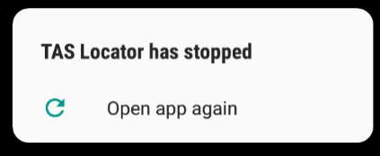  FB9 – When starting the application with internet turned off, the application just runs, without warning the user that the application requires the internet to carry out its purpose.  FB10 – When starting the application without location turned on, it crashes. It should inform the user that their location is required.  FB11 – The application should also ask the user if they would like to turn on their location services.  Selecting a marker with address information  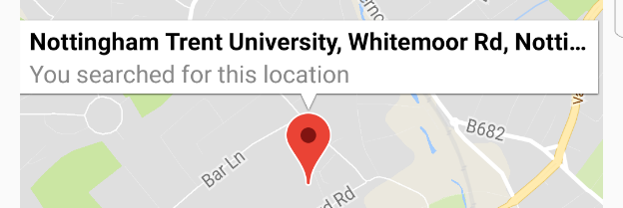  FB12 – The content in the marker info box has been cut off. The content also looks small and is not very structured. | General response to feedback:  The application’s purpose is carried out by its ability to user internet and the user’s location. This validation feedback is important as it is key that the user knows their location and a connection is required to run the application.  Additional tester comments:  - By providing pop-up boxes explaining that the application requires the location and internet, the application will be much more user friendly  - It is important that the application never freezes, so this will be addressed  - The marker info box does its job, but customisation could allow it to be more user friendly | FB9 Change – On launch, the application now informs the user that internet is required if they have no internet connection.  FB10 Change –  If the user’s location is off when starting the application, a dialog box now pops up, informing them that the application recommends allowing location permission.  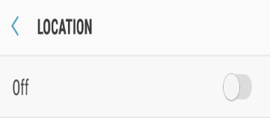  FB11 Change – The application also provides an option for the user to turn their location on. This intent saves the user time.  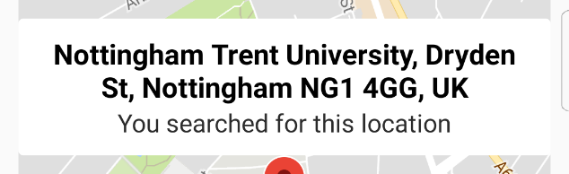  FB12 Change – The info window box now displays all required information and is more readable. It is now more user-friendly.
Searching for a location  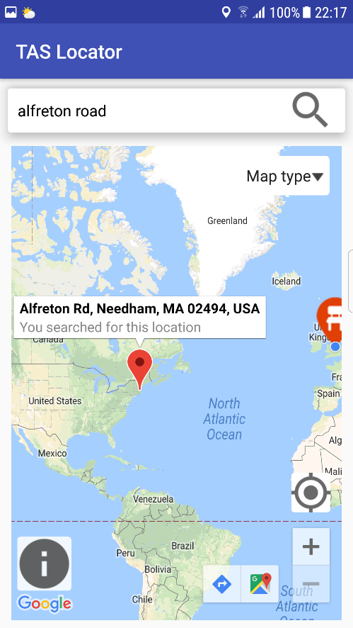  FB13 – Searching for a location often returns results outside Nottingham, in other countries.  FB14 – If limiting search results, a border could be added.  FB15 – Could add a registration system, allowing users to sign in. See FB15 Response.  FB16 – Could add some more screens to the application, mainly a screen to show the user how to use the application. Could add home icon too.  FB17 – Add more locations. See FB17 Response.  FB18 – The directions button looks small, standard and could be confused with the map button. | FB14 Response - A registration will not be used as it will make the application more complicated to use. Particularly for its elderly users, the application is designed in a way that is simple.  FB15 Response – Several screens will be created, but the content will not be finalised until the next testing session. See the demo to view these screens. This ensures the priority remains on the main functionality of the application for the time being.  FB17 Response – More TAS locations will be added by the final version – see the demo. | 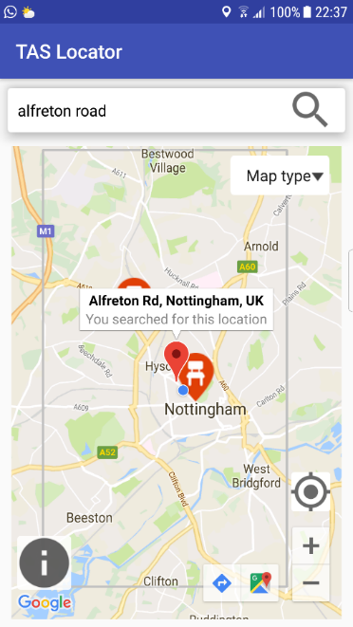  FB13 Change – The word ‘Nottingham’ is now used as well as the user’s search input, ensuring that results are gathered from Nottingham rather than other random places throughout the world. As seen in the screenshot, ‘Alfreton road’ now find a street in Nottingham rather then in the USA.  FB15 Change – A border has been added to show the rough area in which TAS areas are based within Nottingham. Search results are now limited to being within this radius.  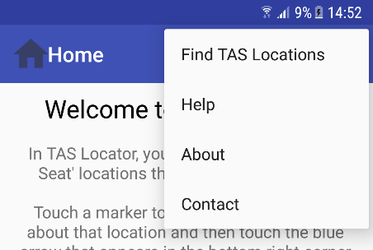  FB16 Change – New screens and a navigation bar have been added. More will be added for completion of the final version.  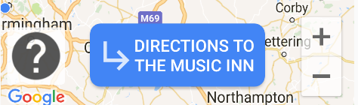  FB18 Change – a new directions button has been added. This is bigger and dynamically generates the location name, ensuring a more user-friendly experience.

Testing Session 4 - Android core app quality testing
This section tests TAS Locator using the Android Developer’s (2018) core app quality checklist. This test helps assess the core aspects of quality in areas such as the application’s visual design and user interface, functionality, compatibility, performance and stability and security. A description of all the tests, with pass criteria, are available at https://goo.gl/jkHjv7. Only the relevant and reasonable (within resources) tests have been carried out.
The website states that all android apps should pass all the criteria. While it is impossible to show the test results through screenshots, a description is provided, considering the pass criteria from the website, and the demo shows many results.
Type | Test Id | Test Description | Test Result (PASS / FAIL) with criteria and screenshot if appropriate
Core suite | CR-0 | Navigate to all parts of the app — all screens, dialogs, settings, and all user flows.  - If the application allows for editing or content creation, game play, or media playback, make sure to enter those flows to create or modify content.  - While exercising the app, introduce transient changes in network connectivity, battery function, GPS or location availability, system load, and so on. | PASS    All areas of the application, including screens, dialogs, user flows and searching, function correctly.  This Photo by Unknown Author is licensed under CC BY-SA  Transient changes, such as a change in network connection, network settings being turned off, location settings turned off and low battery do not affect the performance of the application. The application continues but just does not display the latest data.
Core suite | CR-1 | From each app screen, press the device's Home key, then re-launch the app from the All Apps screen | PASS  This Photo by Unknown Author is licensed under CC BY-SA  The application successfully re-launches, from where it left off, when pressing the device home key on each screen.
Core suite | CR-2 | From each app screen, switch to another running app and then return to the app under test using the Recent app switcher. | PASS  The application successfully resumes with the use of the recent app switcher after switching to other running applications.  This Photo by Unknown Author is licensed under CC BY-SA
Core suite | CR-3 | From each app screen (and dialogs), press the Back button. | PASS  The back button works as expected on each screen. When pressing the button, previous screens are returned to, dialogue/popup boxes close and the keyboard disappears.  This Photo by Unknown Author is licensed under CC BY-SA
Core suite | CR-5 | From each app screen, rotate the device between landscape and portrait orientation at least three times. | PASS  The application is successful in rotating on all screens when the device is rotated least three times. The screenshot shows the main screen rotated landscape. Content is still displayed correctly and functionally remains unaffected.  This Photo by Unknown Author is licensed under CC BY-SA  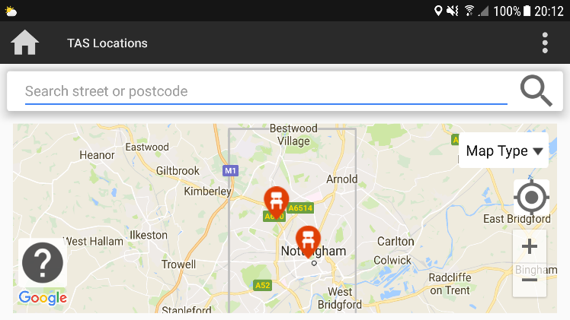
Core suite | CR-6 | Switch to another app to send the test app into the background. Go to Settings and check whether the test app has any services running while in the background. In Android 4.0 and higher, go to the Apps screen and find the app in the "Running" tab. | 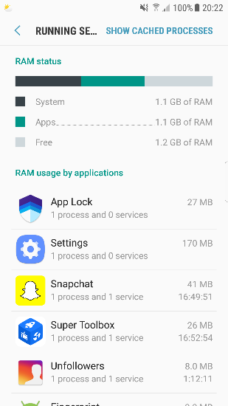  PASS  The application does not leave any services running when in the background.  This Photo by Unknown Author is licensed under CC BY-SA  Scrolling further down the list shows no sign of TAS Locator.
Performance and stability | SP-1 | Review the Android manifest file and build configuration to ensure that the application is built against the latest available SDK (targetSdk and compileSdk). | 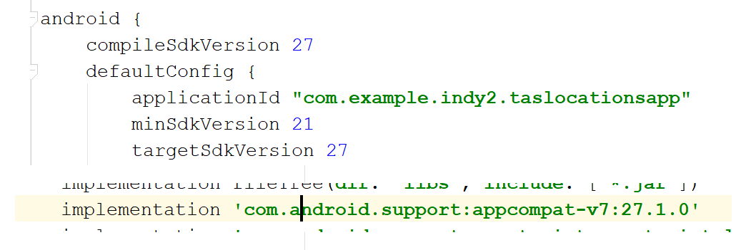  PASS  The application targets the latest available SDK (27), minimising the use of any platform provided compatibility fall-backs.  This Photo by Unknown Author is licensed under CC BY-SA
Security | SC-4 | Review all permissions that your app requires, in the manifest file, at runtime and in the app settings (Settings > App Info) on the device. | 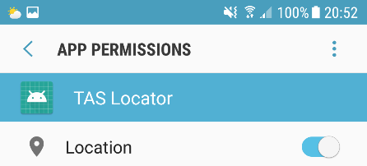  PASS  The application requests only the minimum permissions (location and internet) that it needs to support core functionality.  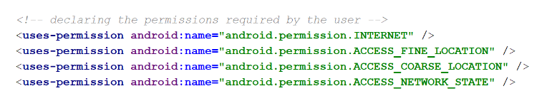
Security | SC-10 | Run the application and exercise all core functionality, while observing the device log. No private user information should be logged. | PASS  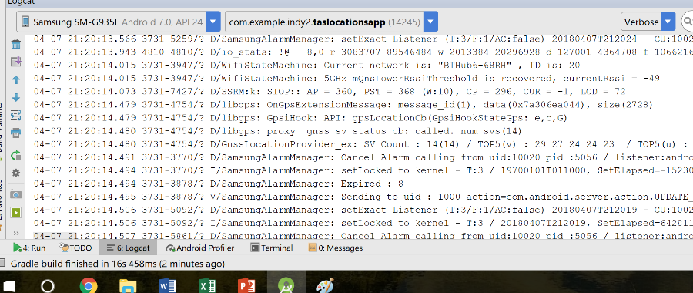  After using the application, no personal or sensitive information is observed on the Logcat.

Testing session 5 – App Quality Alliance (AQuA) Testing Criteria for Android Applications (final draft)
This testing session tests the final draft of TAS Locator using the App Quality Alliance (AQuA, 2012) Android application testing criteria. See https://goo.gl/SFu8yH for the fully detailed criteria and testing steps. This testing session helps gain an understanding of the quality of the final version of TAS Locator, and describes potential improvements, should more time be made available. The testing is split into different sections.

Connectivity
Test (Id, title and description) | Test result (with screenshot if appropriate) | Future improvement
C1 - Send/receive data  Where the application uses a different application to perform the data transfer, it must successfully send/receive data. | 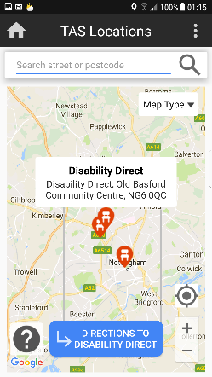  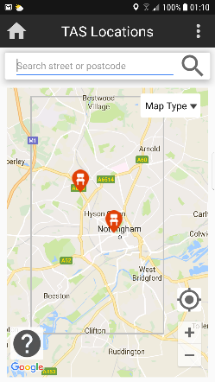  PASS – As the screenshots show, adding a location into the Firebase database successfully updates the map. The ‘Disability Direct’ location and marker has been added.  Before  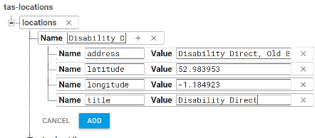  After
C2 - Network delays and loss of connection  Where the application uses network capabilities, it must be able to handle network delays and any loss of connection. | PASS – Connection loss, whether it be internet or location, can be handled by the application. The application does not freeze, it waits for the connection to return, and then proceeds to function as normal. | Could add a message alerting the user of a loss of connection if it occurs, and how it will affect functionality

User interface
Test | Test result (with screenshot if appropriate) | Future improvement
UI1 – Readability  Ensure that the content is readable. This means not crowding content, using readable font, a large enough font and a readably contrasted font. | PASS – As the demo shows, all content on the application is clearly readable. All font is at least font size 16, on a contrasted background and uncluttered. Extra care has gone into ensuring the application is user-friendly and suitable for its target audience. | Though not directly related to readability, future improvements could include the use of audio alternatives.
UI2 – Read time  Each screen must be visible for the time necessary to comfortably read all its information. | PASS – No screen disappears or changes after a set amount of time (each screen displays for as long as the user stays on it).
UI3 – Screen repainting  Application screens must be correctly repainted. There must be no blinking of moving objects. | PASS – Transitions between applications are smooth and include no blinking. | Some animations could be added to the application while screens change.
UI4 – Consistency  The application UI should be consistent and understandable throughout. | 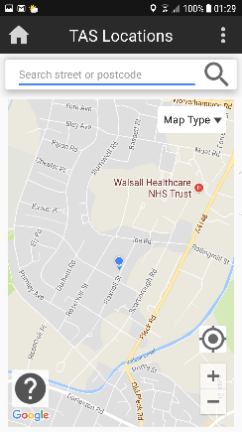  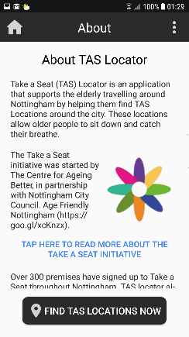  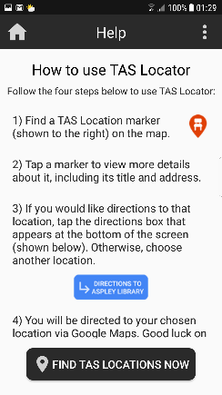  PASS – As the screenshots below shoe, the UI across the application is consistent. Screens all use similar colours, font sizes and other UI elements.
UI5 – Application speed  The speed of the application is acceptable to the purpose of the application. | PASS – The application loads up, switches screens, and directs to locations quickly. | Code could be made to be more efficient with more time.
UI6 – Error messages  Any error messages must be clearly understandable. | PASS – Though not many error messages are possible in the application, the screenshot below shows a user searching for an area outside of Nottingham. This error message is clear.  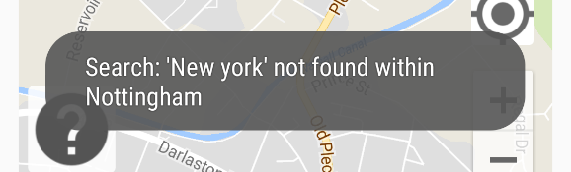
UI7 – Function progress  Any function should start within 5 seconds, and there should be some visual indication that the function is being performed. | 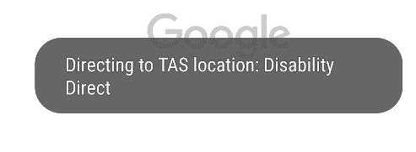  PASS – All functions, including the main function, load within less than 5 seconds. The screenshot to the right shows indicating that a function is being performed.
UI8 – Spell errors  The application must be free of spelling errors. | PASS – As evident in the demo, the application is free of spelling errors.
UI9 – Technical text errors  The application must be free of technical text errors such as text cutting off or overlapping | PASS – This was an issue in a previous testing session but has now been resolved. As the above screenshots and the demo shows, no technical text errors exist within the application.

Menu
Test (Id, title and description) | Test result (with screenshot if appropriate) | Future improvement
M1 – Help and About  The application should contain the standard menu items Help and About. These items are found easily on the screen. | 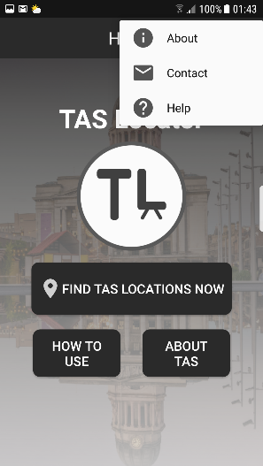  PASS – As the screenshot to the right shows, the Help and About items are available to the user. These are available on all pages, with ease. These pages are also available from the home screen.

Stability
Test (Id, title and description) | Test result (with screenshot if appropriate) | Future improvement
ST1 – Application stability  The application must not cash or freeze at any time while running on the device. | PASS – The application does not crash or freeze at any time whilst in use. See the demo for proof of this.
ST2 – Application behaviour after forced close  When the application is exercised (closed / device turned off / battery removed), the application must continue to function as before. | PASS – After restarting the device, the application functions as normal.

Coding Diary
This section shows a log of the development of the application.

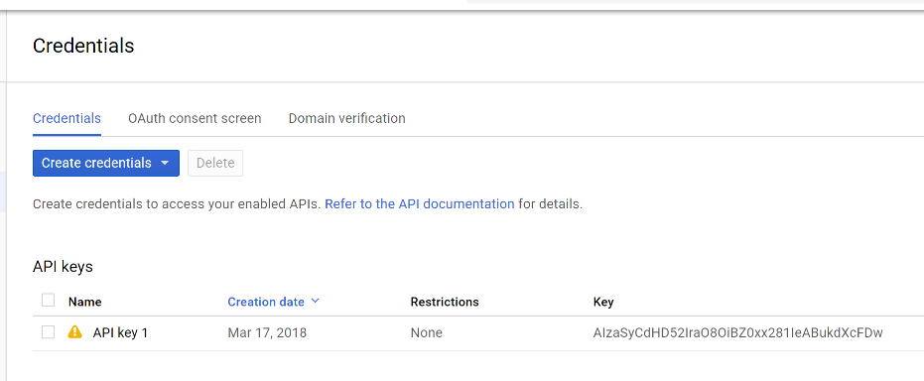
Use of Google maps
- Used Google Maps Layout Activity to save time doing extra, repeated coding
- Incorporated Google maps API, by creating a project, obtaining and API Key and inserting it into the application to establish a connection with Google Maps

Customising Google Maps to fit the purpose of the application:
- Obtained the user’s location and requesting location permission:
  - Used mFusedLocationProviderClient to obtain the user’s latest location using their latitude and longitude
  - Created a function (below) to check whether the user’s location settings were on or not. Locations settings aren’t on, a dialog box will pop up, asking the user if they would like to turn it on
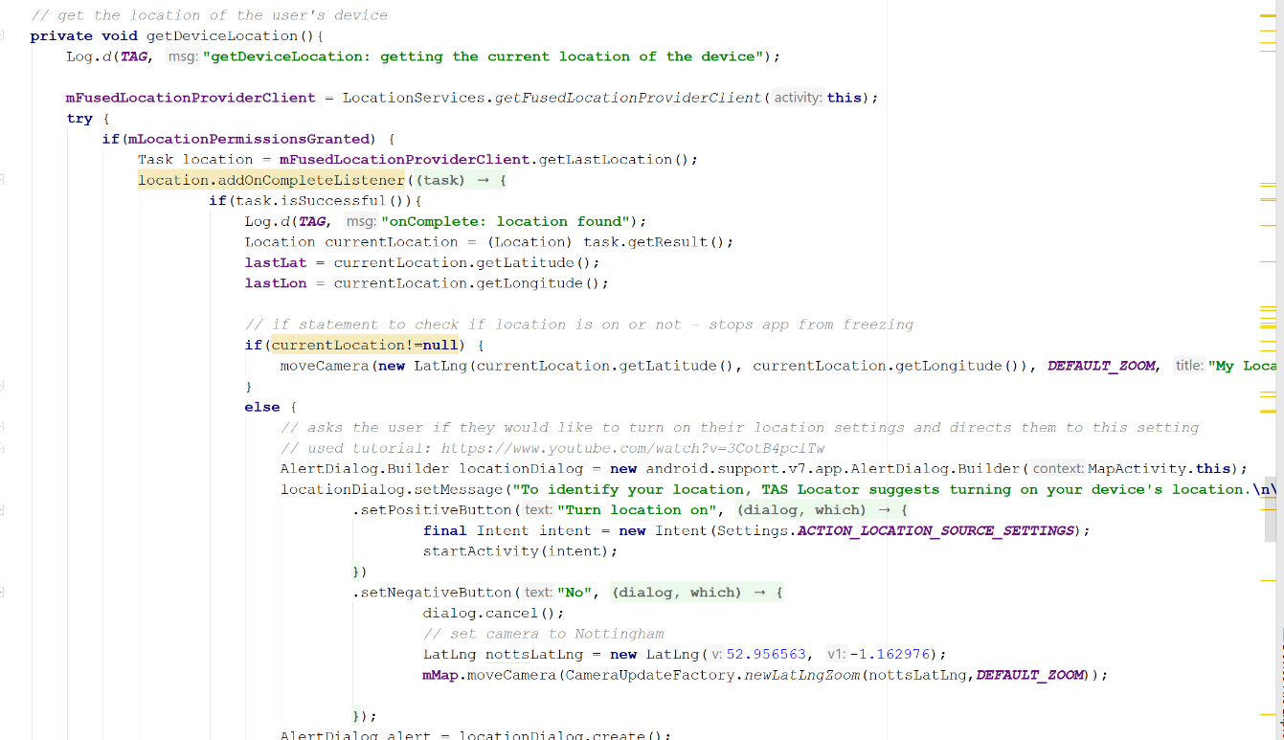
  - If the user turns their location on, the application moves the camera to this location (plotting a blue dot as the location), if not, the application positions the camera to Nottingham city centre

- Checking the user’s internet connection
  - As the application loads the home screen, it checks to see whether the user is connected to an internet network, and if not, recommends that they turn it on. A function was created (below) to carry this out
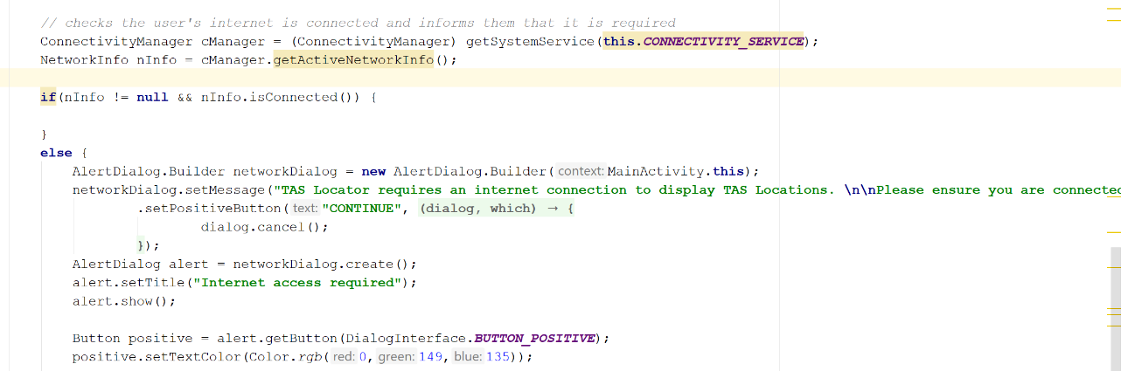
- Creating an advanced search function
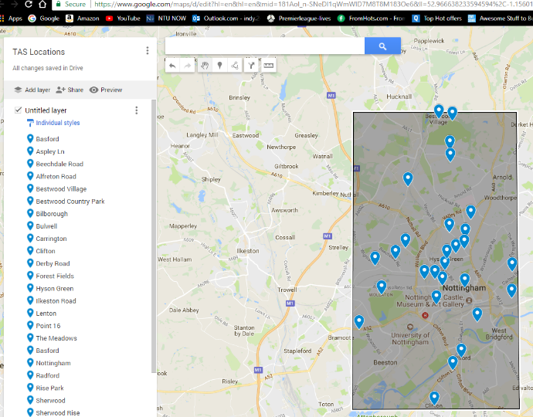
  - Created a search function which searches a certain radius – a radius that is based around Nottingham in which the TAS areas are located
  - The is beneficial as it allows users to only search within Nottingham, and not return results in other cities or countries. This saves time being wasted. For example, when searching for Alfreton Road, a location in USA is found normally, but with this function, Nottingham’s Alfreton road shows
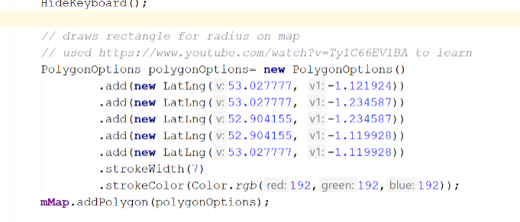
  - As the screenshot to the left shows, each of the 28 Take a Seat locations were plotted on Google maps using MyPlaces, and a rough radius was drawn around:
    - Left side longitude: -1.235227
    - Right side longitude: -1.120180
    - Top side latitude: 53.027801
    - Bottom side latitude: 52.904241
  - These longitudes and latitude were then drawn on the map, to create a polygon to represent the radius
  - A function was created to check whether the user’s search was within this radius (in between the latitude and longitude ranges), with the use of an if statement (below), and if the search was within the range, the location would be plotted. If the search was outside Nottingham, the user is informed that no location within the range was found
  - ‘Nottingham’ was also added to the user’s search, ensuring the application searches for locations based in Nottingham
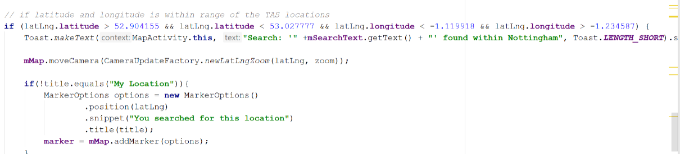

- Customised the standard Google Maps marker information window (more user-friendly and shows distance from a location)
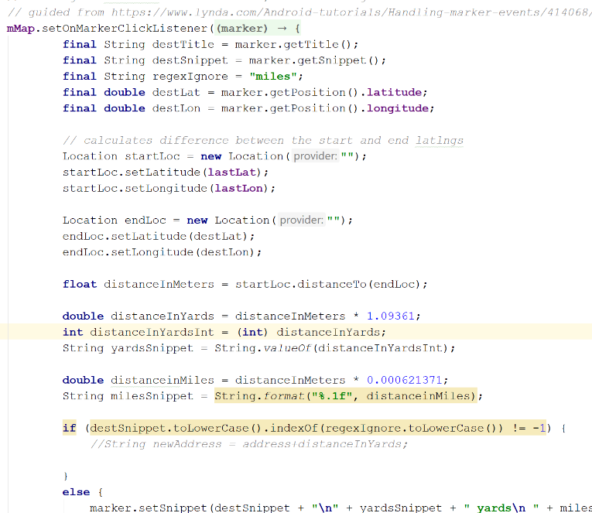
  - Created a new xml document to create a new custom information marker. The font in this custom marker is easier to read than the standard marker
  - To plot the marker, the marker options function was used. This plotted a custom marker (image created on photoshop) of a marker with a chair in, the title and the address
  - As well as displaying the title and address, a function was created to display the distance from the user’s current location to the chosen marker
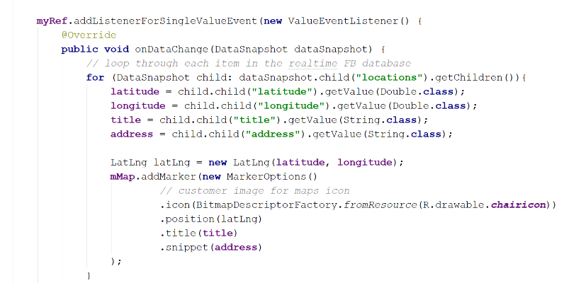
  - The screenshot to the right shows the function, which calculates the distance in metres, and converts this to yards and miles

- Created a spinner to allow the user to choose different map types
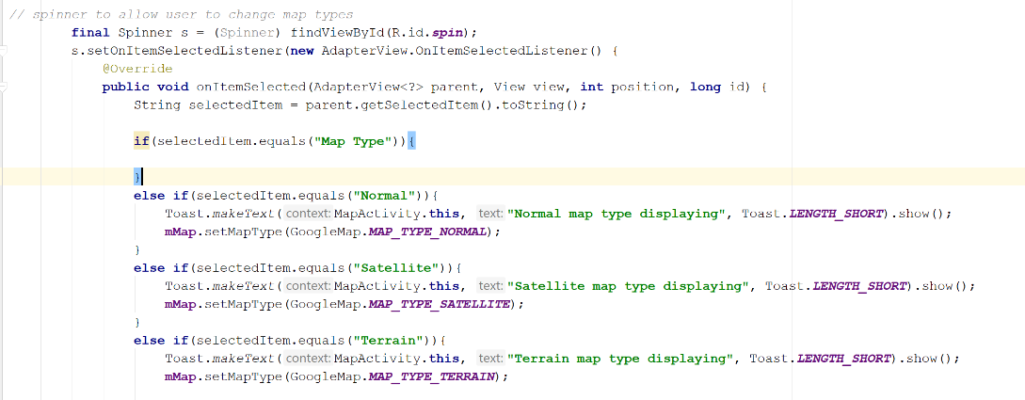
  - Depending on the option chosen, the application changes the Google Map type, as the screenshot below shows

- Added a help button, which brings a pop-up help activity
  - This button, when touched, brings up an activity, created with an extra xml file, which only takes up a part of the screen. On the popup, the user can click a button to access the more detailed help page

- Displaying a directions button on marker touch
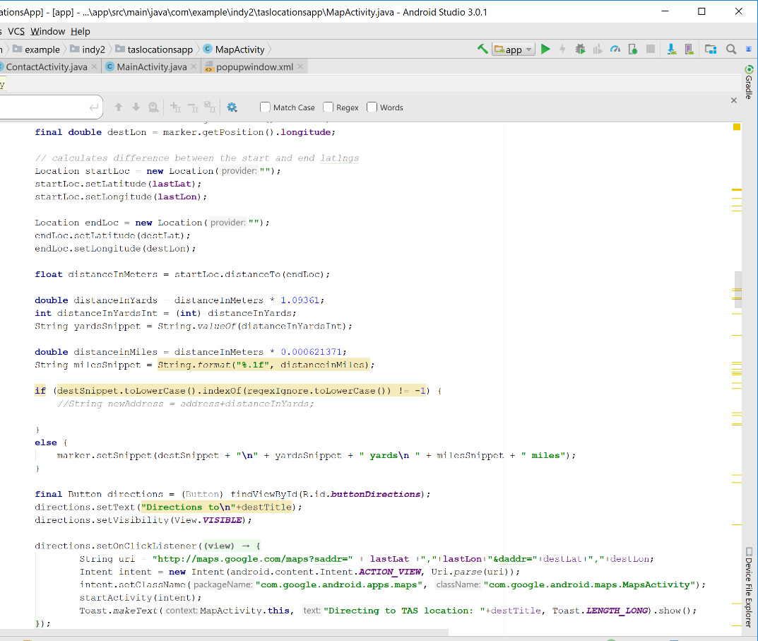
  - As the default directions button was small and next to another button, a new one was created that is more obvious
  - A new function was created, which takes the user’s current latitude and longitude, and the latitude and longitude of the selected marker, and feeds this into Google Maps for directions
  - See the screenshot to the left

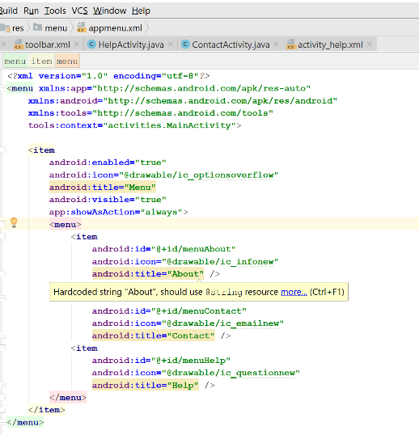

User interface
- Toolbar customisation
  - A custom toolbar was created, which allows for east navigation through the application
  - Instead of a navigation bar, a home button is used, and settings are also included to allow the user to view About, Contact and Help pages
  - This toolbar is dynamically titled through each Activity


- Customised xml documents for styling:
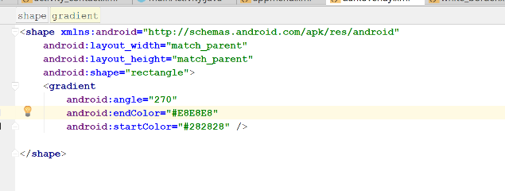
  - Several xml styling documents were created to style various application objects (examples below – right)
  - Styled a dark overlay to use on the home screen
  - Styled buttons, search box and other elements to make them rounded

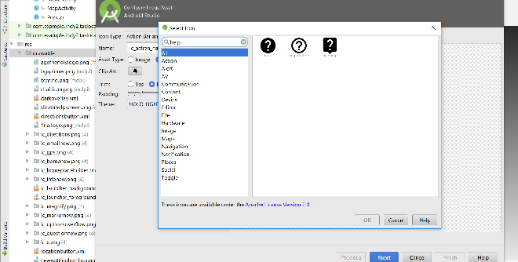
- Use of Android icons as Image Assets:
  - Various icons were added to the application to make it more user-friendly
  - These were added from the Image Assets option and the colour was changed to match the application’s colour scheme
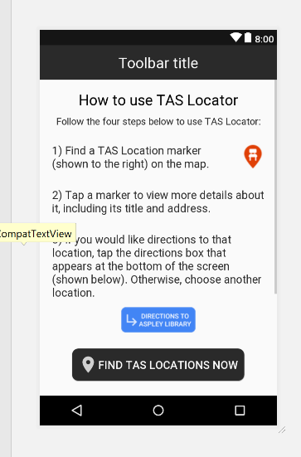
- About, help and contact page (scroll views)
  - These screens were created to comply with several guidelines
  - The help page explains in detail how to use the application
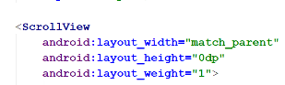
  - Scroll views were used to ensure that when displaying the application on a smaller device, or in landscape mode, all the information would still be displayed

Data storage
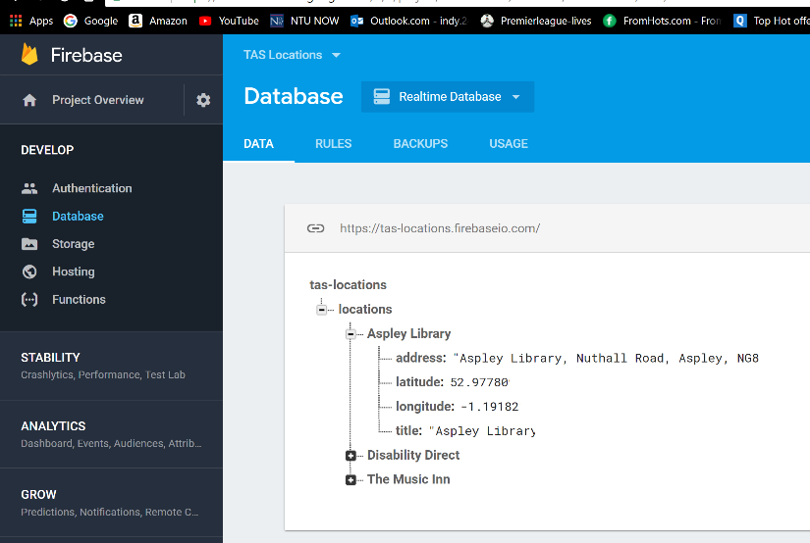
- The application uses a Firebase Realtime database to handle data.
- As the application is simple, data storage is also kept simple – the only data involved is data received by the application through Firebase
- Most suitable data storage method, as TAS Locations are frequently updated. By checking the internet for updated data, users can always be sure the locations are up to date
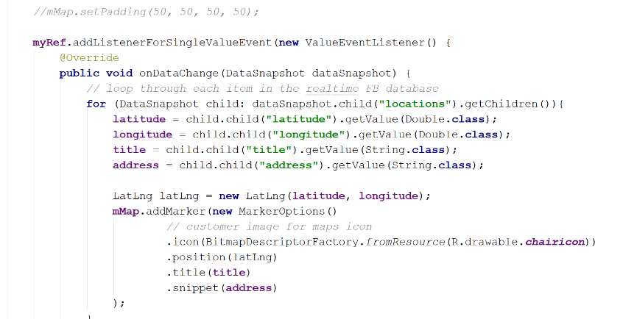
- This also means that users do not need to update their application for new TAS location updates
- A Firebase database was created and connected to through the application
- The application then searches the address, latitude, longitude and title of each location, and plots it on the map
- As testing shows, when a location is added to the database, this change is reflected in the application, with the addition of an extra marker being plotted using the latitude and longitude of the database entry

Video
To see the video demonstration of TAS Locator, click the URL below:
https://youtu.be/P30rX4acLhA
The video has been trimmed and sped up slightly to stick within the 10-minute time limit.
The video was recorded using the screen recording app DU Recorder on a Samsung Galaxy S7 Edge.

References
Android Developers., 2018. Core app quality [online]. Available at: https://goo.gl/Lvq8oD [Accessed 08 March 2018].
Android Developers., 2018. Android Design Guidelines [online]. Available at: https://goo.gl/dHzsdf [Accessed 07 March 2018].
Android Developers., 2018. Material Design [online]. Available at: https://goo.gl/n3fqBj [Accessed 07 March 2018].
App Quality Alliance., 2012. Testing Criteria for Android Applications [online]. Available at: https://goo.gl/SFu8yH [Accessed 08 March 2018].
Campbell, O, 2015. Designing for the Elderly: Ways Older People Use Digital Technology Differently [online]. Available at: https://www.smashingmagazine.com/2015/02/designing-digital-technology-for-the-elderly/ [Accessed 06 March 2018].
Centre for Aging Better, 2014. Take a Seat [online]. Available at: https://www.ageing-better.org.uk/take-seat [Accessed 15 January 2018].
Cook, B., 2018. Beverley Cook’s Lecture on Design Principles and Patterns [online]. Available at: https://goo.gl/7fTjjo [Accessed 07 March 2018].
Cook, B., 2018. Beverley Cook’s Lecture on Persistent Data 2 [online]. Available at: https://goo.gl/xnBy4Y [Accessed 07 March 2018].
Nottingham City Council, 2015. Take a Seat [online]. Available at: https://www.nottinghamcity.gov.uk/health-and-social-care/adult-social-care/take-a-seat/ [Accessed 15 January 2018].

Nottingham city council logo - http://www.nimbusdisability.com/case-studies/nottingham-city-council-leisure/
Marker - https://www.iconsdb.com/soylent-red-icons/map-marker-2-icon.html
Chair - https://www.pinterest.com/pin/126593439498666619

