
Serious Games Report
N0578334 (Inderjit Sandhu)


Module title: Serious Games
Module code: ISYS30321



Table of Contents
1. Introduction 2
2. Research 2
2.1 Parallel product review 2
2.2 Design guidelines review 5
2.3 Literature review 17
3. Design 23
3.1 Design matrix 23
3.2 Design document 26
4. Evaluation 34
4.1 Evaluation proposal 34
4.2 Results and analysis 35
4.3 Scenario evaluation 37
4.4 Evaluating the game against the NLN’s accessibility guidelines 38
4.5 Copy of serious game 38
References 39
Appendices 42
Appendix A – Client notes 42
Appendix B – Further details of target audience / Alexandra house 43
Appendix C – Game scenarios with justification of inclusion 44
Appendix D – Comparing Rep your City with NLN’s guidelines 48

1. Introduction
This report has been constructed as part of the Serious Games module (ISYS30321), with the purpose of analysing the research, design implementation and evaluation stages involved in the production of a games-based learning solution which aims to tackle recidivism.
The report aims to do this by detailing the tasks carried out throughout the module, with these tasks split into three sections:

- Research (section 2): Containing a parallel product review, design guidelines review and literature review regarding the areas of serious games and recidivism
- Design (section 3): Including the completion of the design matrix, design document and storyboard associated with the serious game to be produced
- Evaluation (section 4): Carrying out an evaluation of the game through an evaluation proposal and an analysis of the results and analysis from the evaluation session

2. Research
This section discusses the research carried out regarding the topics of computer aided learning (CAL) serious games and recidivism. Emphasis has been placed on ensuring this section is detailed to provide a clear understanding of CAL serious games and recidivism.

2.1 Parallel product review
A parallel product review has been carried out on two games which have been used by teachers and trainers – SPENT (McKinney, 2011) and Imagine Earth (Serious Brothers, 2014). These two games have been chosen as their styles of game-play are different. While SPENT offers a text-only, simple experience, Imagine Earth includes a detailed game screen and a more complicated game style.
Despite their differences, each game is effective at teaching. By reviewing these games in parallel, rather than just one, an understanding is gained of how different types of CAL can be used to teach its users in several ways. Furthermore, other useful aspects of the games are identified, such as key features of the games and areas for improvement.

2.1.1 SPENT
Table 1 – Review of SPENT
Who made the game and who is it for? | SPENT is an online game developed by McKinney, an advertising agency based in North Carolina. The game was created for client Urban Ministries of Durham (UMD). UMD’s (n.d.) mission is to end homelessness and provide food, shelter and a future to those in need. It is for those people that SPENT is ultimately for, as players may donate money to them through the game.
What does the game teach? | SPENT teaches, educates and raises awareness of the difficulties of poverty and homelessness - a major problem around the world. It also teaches players how their decisions impact their future.
How does the game teach this? | SPENT teaches through its gameplay and social media integration. Players experience trying to survive a month on $1,000, by making difficult lifelike decisions, such as which food to buy. Through a game, players make sacrifices, experiencing the real-life difficulties faced by poor and homeless people. SPENT further educates by presenting facts regarding poverty and allowing players to use Facebook or Twitter to share their results or ask for help, informing new people of SPENT.
Why are the game’s teachings important? | Poverty and homelessness are a big issue worldwide. The World Bank (2013) estimated that in 2013, 10.7% of the world’s population (over 660 million people) lived on less than $1.90 a day. BBC News (2016) reported that charity Shelter claimed that in England, 1 in every 260 people (250,000 total) were homeless in 2016. SPENT aims to address these issues and make a difference.
What is the game’s domain? | SPENT’s domain is informal learning. As Ulicsak and Wright (2010) explain, these types of games aim to raise awareness of something outside the formal education system and tend to be non-preachy. SPENT raises awareness of poverty and homelessness to the player in a way that is not too excessive.
Positives/key features | - The interface looks sleek and gameplay is simple, making the game visually appealing and easy to play. Players simply choose options and read about the results, almost like a story.  - SPENT teaches players about the future impact of their decisions and the value of money through unforeseen realistic scenarios. The game is an effective eye-opener.  - By exposing realistic, difficult scenarios, informing players of facts and allowing donations, SPENT raises awareness of homelessness/poverty and allows players to make a difference.  - SPENT has a score-based system, in that players aim to save as much money as possible, giving players something to aim to improve on. This can lead to playing the game again.
Negatives/areas for improvement | - While SPENT’s simplicity makes it easy to play, it can also make the game monotonous. With more visual graphics, SPENT would feel more game-like, personal and retain player interest.  - SPENT lacks audio support – which is problematic for people with visual impairments. SPENT could include audio clips of in-game text, especially considering it is entirely text-based.  - The game’s storyline often feels impractical. To improve this, scenarios and their frequency should be more realistic, and players should be provided with more option choices.

2.1.2 Imagine Earth
Table 2 – Review of Imagine Earth
Who made the game and who is it for? | Imagine Earth is a futuristic real-time planet simulation strategy game developed by Serious Brothers in Germany. Initially a student project, Imagine Earth (IE) has evolved into an award-winning serious game. Though anyone can play, IE is ideally for those that are 16 years of age of older (due to its complexity) that enjoy simulation, strategy or space games.
What does the game teach? | IE teaches its players about, and raises awareness of, climate change. Players are taught how carbon emissions cause climate change, and the damaging effects of this on humans and the environment.
How does the game teach this? | IE teaches through its gameplay. Players take the role of colonising planets and must provide housing to grow the population, produce food to feed, factories to produce money and energy to power these creations. These activities are difficult to balance and manage and teach the player the impact activities have on carbon emissions. For example, if players incorrectly balance growing the population with expanding industries and growing forests, flooding and severe weather occurs.
Why are the game’s teachings important? | Climate change can have serious consequences on humans and the environment. The World Bank (2014) reported that since 1960, worldwide CO2 emissions have rapidly increased, with 2014 CO2 emissions at 36.1 million KT, compared to 33.4 million in 2010. If emissions aren’t controlled, global warming will increase, altering water supplies and changing the growing season for food crops.
What is the game’s domain? | IE’s domain is informal learning. As mentioned in the review of SPENT, these types of games raise awareness and are non-preachy. IE informally teaching about climate change through its enjoyable and educating gameplay.
Positives/key features | - The game’s interface is colourful, attractive and responsive, giving IE the feeling of fun game. This compares with SPENT, which lacks a real graphical appeal.  - IE introduces players to its complicated interface in a way that is easy to understand. The developers have clearly spent considerable effort on introducing players effectively.  - IE offers a large amount of diversity regarding player choices and in-game achievements. This helps make the game more entertaining and addictive for users.
Negatives/areas for improvement | - Though attractive and colourful, gameplay can look sterile. To improve on this, players’ inhabitants could be visible, as well as their cars, animals and many other lifelike features. Including these in-game will generate an actual sense of creating a colony.  - Some aspects of gameplay, such as having to navigate through the menus to individually build 5 buildings in a row, can be unpractical. This can frustrate users, especially considering IE is about maximising efficiency. A ‘build x’ option, or something similar would fix this.  - The control mechanism for IE can feel strange and inconvenient. Players click and drag with the left mouse button when two clicks would feel more natural. When hovering over a toolkit after zooming into planets, the popup box unnecessarily overtakes the screen.

2.2 Design guidelines review
This section investigates several sets of guidelines considering accessibility and usability regarding the design of educational multimedia.
After exploring the guidelines, 10 of these are then chosen to be focussed on in the design of the game to be produced. These 10 guidelines have been chosen in consideration of the client notes (appendix A) and a further breakdown of the target audience (appendix B - obtained from Professor David Brown, with connections to the house containing the target audience). While these chosen guidelines are explained after the investigation of the guidelines, they can be identified as being underlined and bold (in their tables’ left-most column which outlines the guideline).

2.2.1 National Learning Network guidelines review
Table 3 (below) reviews three CAL games, My Appearance (ISRG, n.d.), Cheese Factory (ISRG, n.d.) and SPENT (McKinney, 2011), against 48 of the National Learning Network guidelines (NLN, n.d.) for accessibility.
If the game complies with the guideline, a ‘Yes’ is noted, if the game fails to comply with the guideline, a ‘No’ is noted, and where the guideline is not applicable, an ‘N/A’ is noted. The right-most column then discusses/summarises the results, explaining each principle in accordance with each game. After the table, the games’ compliance with the guidelines are analysed.
Carrying out this activity helps identify the importance of applying guidelines to educational games as well as how they are applied and how much they can affect gameplay. This will be discussed later in the section.

Table 3 – Reviewing the NLN guidelines for accessibility against My Appearance (MA), Cheese Factory (CF) and SPENT
Accessibility - Navigation Issues | MA | CF | SPENT | Summary/explanation/notes
Negative feedback should not be in red. | Yes | Yes | Yes | All three games comply with this, providing feedback in colours other than red. Colour-blind players aren’t disadvantaged.
Avoid colour dependent navigation, instructions or references. For example, ‘choose the red pill’. | Yes | Yes | Yes | None of the games depend on colour for navigation, again meaning colour-blind players are able to play.
Progressive revealing of content for text or bullet type lists is not acceptable practice. | Yes | Yes | Yes | No progressive revealing of text or bullet points are used in any of the games, meaning that the relevant text is summarised on one screen and is easily readable.
The material must provide logical tabbing order. | No | Yes | NA | My Appearance’s (MA) use of tabbing skips some options. Cheese Factory’s (CF) tabbing order is logical, allowing users to navigate through options smoothly. SPENT does not use tabbing
All users must be able to access the materials using only a keyboard. | No | Yes | No | MA allows users to use the keyboard for a few options while CF allows users to access all material using their keyboard. SPENT does not allow users to use their keyboard.
Proprietary keyboard short cuts are not allowed within a content package. | Yes | Yes | Yes | None of the games use proprietary keyboard short cuts. This would cause confusion.
Accessibility - Graphical Issues
Underlined text may only be used for hyperlinks | Yes | Yes | Yes | Each game complies with this, as in-game text is not underlined. This ensures users don’t mistakenly click text.
Never use flashing or animated text. | Yes | Yes | Yes | MA and CF comply with this, but SPENT uses animated text for the game’s introduction and updating player’s balance. This could make the text difficult to read for some.
Use only web san serif-based fonts for body text within the content window. | Yes | Yes | Yes | All three games use san serif fonts, ensuring text is easy to read as they do not include serifs at the end of letter strokes.
Menu items must be at least 35 pixels square. Navigation items must be legible. | Yes | Yes | Yes | All menu items for all three games are at least 35 pixels square and legible, ensuring each item is easy to click and read.
Text must use both upper and lower-case letters. Do not use text in uppercase only. | Yes | Yes | No | MA and CF use both upper and lower-case letters, and don’t display text in only uppercase. Some of SPENT’s text is uppercase, meaning that it could be difficult to read for some people.
Text must be left justified with a ragged right edge for educational content. | Yes | No | No | While MA complies with this, CF and SPENT do not. Left justified and ragged edge text create white space and is easier to read.
Do not use any more than three text columns. | Yes | Yes | No | MA and CF never have more than three text columns, but SPENT sometimes has up to five, potentially confusing players.
A line of text must be no more than 14 words long. | Yes | Yes | Yes | No lines of text in all three games are more than 14 words long. Lines of text are therefore not excessive and are easy to read.
Overall information density must be less than 75 percent of the screen area. | Yes | Yes | Yes | All three games comply with this, ensuring players aren’t overloaded with information.
Use appropriate colours that consider colour blind people. | No | Yes | No | MA displays black on green backgrounds, and SPENT displays grey text on a green background, with both of these combinations causing difficulty for colour blind people. CF’s colour schemes consider colour blind people.
Use text heading formatting consistently. | Yes | Yes | Yes | All three games are consistent regarding their text heading formatting, making them look professional.
Patterned backgrounds must not be used behind text or graphics. | Yes | No | Yes | MA and SPENT successfully comply with this, making text easy to read, but CF displays text on a patterned background, potentially making it difficult to read for some players.
Do not loop the flashing element of the animation. It should run once to make the point. | No | Yes | NA | One animation in MA loops, though the rest don’t. CF’s animations don’t loop while SPENT doesn’t include animations.
Accessibility - Interoperability
The material must not interfere with any existing accessibility features of the operating system. | Yes | Yes | Yes | No parts of any of the games interfere with existing accessibility features of the OS.
The learner must control the starting, stopping and reviewing of animations and simulations. | Yes | Yes | NA | Players have control over the animations in MA and CF. SPENT doesn’t include any.
Animation must avoid strobe and flashing effects. | Yes | Yes | Yes | MA and CF avoid potentially damaging strobe and flashing effects, while SPENT doesn’t include animations.
A visual equivalent must be provided for all audio alerts. | Yes | N/A | NA | MA provides visual equivalent for all audio alerts, ensuring players with reading or visual impairments can play the game. CF and SPENT offer no audio support.
Accessibility - Assessment and Supplementary Documentation
If a timed response is required, the user/tutor should be able to modify the timing parameters. | Yes | N/A | NA | Users can modify the timing parameters in MA, allowing users to customise their experience. Thought not applicable in CF, users are able to change the difficulty and speed. Users have no control over game timing or difficulty in SPENT.
Editable documents must be available in .rtf or .doc. | N/A | N/A | NA | No editable documents are available for any of the games.
Downloadable documents must be available as PDF and RTF format. | Yes | N/A | NA | Players can download their game results in PDF format in MA. No documents are available to download in CF and SPENT.
Learning Model Guidelines
The learning objectives and outcomes must be clear, and learners should be given the opportunity to assess their own progress or performance against these objectives. | Yes | No | Yes | MA sets out objectives and allows users to view their performance after a game. CF explains objectives but doesn’t allow users to assess their performance. SPENT provides objectives and allows users to see their score when finishing a game.
Activities should relate theories and concepts to the learner’s current situation or experience. | Yes | Yes | Yes | In all three games, the game activities and theories are related to the player’s current situation. Each player action will result in a different scenario.
Learners must be able to pace themselves depending on their available time and ability. | Yes | No | Yes | In MA and SPENT, users can pace themselves as there is no game timer. The nature of CF makes it so that users only have limited time to make a move.
Learners should be able to bring other sources of information or enquiry into the learning and should be encouraged to solve problems. | No | No | No | Players of each game are not able to bring other sources of information into the learning. No hints are available.
Functionality Guidelines
The materials must provide appropriate help facilities for the learner. | Yes | Yes | No | In MA and CF, help options exist to assist the player if necessary. No such option exists in SPENT.
Where specialist or unusual terms, or terms unfamiliar to the target audience are used a glossary must be provided. | No | No | No | None of the games provide a glossary to explain unfamiliar or specialist terms.
Where summaries are provided, a print option must be available. | Yes | No | No | Only MA allows players to print a summary of their game results.
General Design Guidelines
The learning objectives must be clearly stated for the benefit of tutors and for independent learners. | Yes | No | Yes | Each game outlines its learning objectives, ensuring players know what they must do to complete the game.
The content should take the learner from the known to the new learning in appropriately sized stages. | Yes | Yes | Yes | Each game teaches new learning in appropriately sized stages, ensuring players aren’t overcrowded with information.
Electronic page turning must be avoided; each page must stimulate a response, action or interaction from the user. | Yes | Yes | Yes | Each games’ pages stimulate a response, action or interaction from the user, allowing smooth, organised gameplay and learning.
The content must help the learner to reflect on, review and digest new learning. | Yes | No | No | MA allows players to reflect on new learning, providing advice for the future. CF and SPENT do not do this.
The content must provide useful, constructive and supportive feedback. | Yes | No | No | MA offers useful, constructive and supportive feedback, showing players where they can improve. CF and SPENT do not.
Emphasis should be placed on creating activity or interaction and stimulating thought rather than the transmission of facts. | Yes | Yes | Yes | Each game places emphasis on creating activity, making players think about the consequences of their choices.
The content must include formative assessment of progress against learning objectives. This should comprise a range of activities and interactions. | Yes | No | No | MA offers a page dedicated to formative assessment progress. CF shows progress during a game, but not at the end. SPENT doesn’t provide any formative feedback.
All materials must provide audio support in English. | Yes | No | No | MA offers audio support in English for near enough all in-game text. CF and SPENT however, offer no audio support at all.
The user must be able to move through the materials at a pace determined by themselves at all times, even when audio is used. | Yes | Yes | Yes | All the games allow users to move through materials at their own pace, meaning players can take their time and enjoy their gaming experience.
The user must be able to switch any audio support on or off at will. | Yes | N/A | NA | MA includes a button for users to turn on or off audio support. Audio support doesn’t apply to CF or SPENT.
The content must demonstrate how new knowledge and skills can be applied to real problems and situations. | Yes | No | No | MA explains how new knowledge learnt from the game, such as how to get ready for work on time, applies to real life. CF and SPENT do not demonstrate this.
The materials must provide a variety of learning paths, interaction types and activities to accommodate different preferences in learning style. | Yes | Yes | Yes | Each game allows users to choose alternative game options and activities. This allows players to play with whichever learning or gameplay style they prefer.
The level of English language used must be appropriate for the target audience. | Yes | Yes | Yes | Each game uses simple English that is adequate for the target audience, meaning players are not left confused when they read.
The content must be accurate, valid, up-to-date and without errors. | Yes | Yes | Yes | Though MA and CF look outdated, their content, as well as SPENT’s, are accurate, valid and up-to-date and contain no error.
The content and design of the materials must reflect the many cultures of the UK. | No | No | No | No content within any of the games reflect UK culture. MA and CF could represent any country while SPENT’s is based in the US.

2.2.1.1 Analysing the compliance of the games against the NLN’s accessibility guidelines
Out of the 48 principles listed in table 3, 47 apply to My Appearance (MA). MA complies with 40 out of this 47, or 85% of them. 43 of the principles apply to Cheese Factory (CF), with this game complying with 29 of this 43, or 67%. 40 of the principles apply to SPENT, which complies with 25 of this 40, or 63%. As these percentages only represent the games considering the above guidelines, they do not fully represent the games in compliance with all principles available for CAL serious games. Despite this, using these same 48 guidelines for each game provides a simple way of comparing how these games comply with one set of guidelines.
When playing each of the games, their guideline compliance percentage is accurately reflected during gameplay. For example, when playing My Appearance, with a guideline compliance percentage of 85%, it is obvious that the developers have spent a lot of time and effort on making the game accessible and generally simple, intuitive and considerate of its players. When playing Cheese Factory, the lower principle compliance percentage of 67% is noticeable, as more principles are missing that would make the game feel more accessible. This is also the case with SPENT, which has a principle compliance percentage of 63%. When SPENT, though enjoyable and beneficial, it feels as though more time could have been spent on considering the users of the game by following more guidelines.
Section 4.4 evaluates the developed game against the NLN’s guidelines above.

2.2.2 Investigating more guidelines relevant to the development of CAL serious games
While the NLN guidelines are a comprehensive set of guidelines aimed at CAL games with a high degree of interactive multimedia elements, other sets of guidelines exist which are relevant to the development of CAL serious games. This section identifies these and investigates the importance of them.

GameAccessibilityGuidelines’ accessibility guidelines
GameAccessibilityGuidelines (2013) explains that accessibility is important as it means avoiding unnecessary barriers that prevent people with various impairments from accessing or enjoying content. Some of the accessibility guidelines, as listen on the website, that are relevant in the development of CAL serious games, are listed in table 4.

Table 4 – GameAccessibilityGuidelines relevant to CAL serious games and their importance
Guideline | Importance of guideline
‘Ensure controls are as simple as possible, or provide a simpler alternative’ | Controls on computer games should be kept as simple as possible because more complex control schemes require a higher degree of motor and cognitive skills. While some people may simply struggle to learn how to use complex controls, people with conditions, such as arthritis, may not even have a chance, due to joint pain that could be eradicated with simpler controls.
‘Allow the game to be started without the need to navigate through multiple levels of menus’ | Providing an unnecessarily high number of menus before starting a game can create a barrier of entry for people with certain conditions. One of these conditions is dyspraxia, which makes it difficult for people to visualise complex systems. People with an impaired short-term memory will also struggle to navigate through multiple menus before starting a game.
‘Use an easily readable default font size’ | For people with vision impairments, small text can cause a major struggle when trying to play a computer game. Furthermore, small font is more difficult for people with dyslexia to read. A reasonable font size should be used for all text within a computer game to ensure people with vision impairments can read the screen comfortably and play the game without headache.
‘Provide high contrast between text/UI and background’ | Contrast is important when designing a user interface, as, similarly to small font, people with vision impairments will struggle to read text if there is no contrast. A high contrast will also benefit users that are colour blind and that are playing in sunlight or on a poor-quality display.
‘Give a clear indication that interactive elements are interactive’ | People with cognitive or vision impairments may struggle to identify which in-game items are meant to be interactive. It is therefore important that interactive items are obvious and have a different style to other items. For example, interactive items could have a mouseover effect or glow.

Usability guidelines by Sanchez
As well as accessibility, usability is important in developing CAL serious games. As Sanchez (2013) explains, usability represents the possibility of using the game in a specified learning context. A game must be usable for it to be effective. Sanchez outlined several usability guidelines for a CAL game, as listed in table 5.
Table 5 – Sanchez’ usability guidelines and their importance
Guideline | Importance of guideline
‘The game runs on the devices offered within the environment’ | Users must be able to play the game on whichever device is available in that environment. For example, prisons may own basic computers and in order to create a serious game for this environment, the game must be able to run effectively on these computers. This may mean developing a game with simple graphics and that takes up a small amount of memory, depending on the device’s specification.
‘The time devoted to learning how to use the game is reasonable’ | It is easy for games to teach players how to play too quickly or spend too long on doing this. If too little time is spent learning how to play the game, players may struggle playing the game as they are not prepared enough, and if too much time is spent, players may get frustrated before even playing. A reasonable and considerate amount of time should be allocated to teaching players how to play.
‘The game provides clear and relevant feedback’ | This guideline is important in making a CAL serious game usable, as in order for the game to teach, and players to learn, they must be given clear and relevant feedback. This feedback may be during intervals, such as when a player has completed a level, or at the end of a game, by providing feedback of the player’s overall performance, or both.

Usability principles by Pinelle et al.
Pinelle et al. (2008) composed their own list of usability principles for video game design, considering a set of heuristics. These heuristics are intended for helping designers avoid common usability problems that have been seen in video games. Some of these principles are listed in table 6.
Table 6 – Pinelle et al.’s usability principles and their importance
Guideline | Importance of guideline
‘Provide consistent responses to the user’s actions’ | Pinelle at al defined this principle due to identifying issues with poor in-game physics and inconsistent responses to input from other games. If a game provides consistent responses to the user’s actions, users won’t be left frustrated and confused as to why an input has worked during one instance but not the other.
‘Provide controls that are easy to manage, and that have an appropriate level of sensitivity and responsiveness’ | Games often provide a control mechanism allowing players to move their in-game character, or change the positioning or form of an in-game object or screen. It is important that players can easily use these controls, and that controls have the right level of sensitivity and responsiveness, otherwise players will struggle. For example, if a player must move their character to avoid a collision, but the game does not respond, or the character moves too much, users will find playing the game difficult and annoying.
‘Provide users with information on game status’ | As users must make game decisions based on their current progress and situation in the game, it is important that they are able to see their current game status, which may include information such as lives left, percentage complete and game objectives. Not only does this help people generally when playing a game, but it also helps those with memory problems who may forget their progress.

2.2.3 Relevance of reviewing guidelines and impact on game design
In carrying out the above tasks, it is clear to see how important design guidelines are in developing games, particularly CAL serious games. This task has provided a clearer picture of the expectations and requirements of CAL serious games. There are numerous guidelines, some more important than others, that have varying levels of importance and affect different users in different ways. The guidelines help identify various challenges or conditions that users may face, such as vision impairments, cognitive difficulties and physical weaknesses.
Through playing the three games and acknowledging each guideline individually, the value of the guidelines is shown. My Appearance and Cheese Factory have clearly had a considerable amount of time and effort spent on considering guidelines, making the game user-friendly and accessible by many people. Other games, such as SPENT may not have considered guidelines, and this different shows. Games that do not consider guidelines do not consider how many users they could potentially be using. For example, as Colourblindawareness (2017) states, 4.5% of Britain’s population is colour blind, meaning that if a game is released that does not consider colour blind people, 5 out of 100 people will not be able to play. Not only may this be seen as discrimination, but it means that game developers could lose out on customers.
Researching into further guidelines and principles (other than the initial 48) has provided even more areas for consideration in developing CAL serious games. The more guidelines games developers consider, the more user-friendly their game will be, though the line must be drawn at some point, otherwise excessive time and effort will be spent on developing a game.

2.2.4 Chosen guidelines for the serious game to be developed
In consideration of the completion of the tasks above, including experiencing playing CAL games, researching into large numbers of guidelines and analysing the requirements of users, 10 guidelines have been selected to use in the development of the proposed CAL serious game. 9 have been chosen from the NLN, with one from Pinelle et al.’s list.
These 10 guidelines have been chosen based on the assessment scenario of developing a CAL serious game, considering the target audience. Details of the target audience have been provided via client notes (appendix A) and a further breakdown of the target audience (appendix B).
The chosen guideline, along with explanations for selection, are listed in table 7 (below).

Table 7 – 10 chosen guidelines for the serious game to be developed
Guideline | Explanation for selection
- The content must demonstrate how new knowledge and skills can be applied to real problems and situations. | As the client notes state, patients are used to blaming others, and must learn to take on responsibility themselves. This guideline has been selected as the game will aim to teach players to take on responsibility themselves through placing the player in real, lifelike scenarios in which they will face realistic problems and scenarios.  By relating in-game knowledge and skills to real life, players will hopefully apply what they have learnt in game to real life.
- The content must help the learner to reflect on, review and digest new learning. | This guideline has been chosen in consideration of the aim of tackling recidivism. By complying with this guideline and helping the player reflect on, review and digest new learning, players will be supported in learning how they should react or behave differently, increasing the likelihood of reducing recidivism.
- The learning objectives and outcomes must be clear, and learners should be given the opportunity to assess their own progress or performance against these objectives. | It is important that players have a clear idea of what the learning objectives and outcomes are, so that they know what they are aiming for and have a goal to reach. Players will also be given the opportunity to assess their progress against these objects so that they can see how they are doing and know whether they are on the right or wrong track in terms achieving their objectives.
- The content should take the learner from the known to the new learning in appropriately sized stages. | This guideline has been chosen in consideration of the fact that the target audience of the game tend to have poor memories, may have a lack of education and have poor cognitive abilities (as stated by the client notes and further breakdown of target audience). It is important that learners are not overloaded with information, or else they will not learn effectively. By breaking down new learning in appropriately sized stages, learners will be more likely to learn more from the game.
- Activities should relate theories and concepts to the learner’s current situation or experience. | By relating theories and concepts to the player’s current situation or experience, the game will teach players a variety of useful information in various ways, in a way that is personal and relatable to them. By providing this personal touch, recidivists will hopefully be more inclined to get engaged with the game, which is a safe environment for learning.
- Provide users with information on game status. | This guideline has been chosen as the client notes point out that the game’s target audience have poor memories. By providing players with information on the status of their game, such as time/lives left or what they must do next, players are constantly reminded of the position they are in, making having a poor memory less of problem.
- The content must provide useful, constructive and supportive feedback. | Complying with this guideline will mean that players are pulled into the game and seek to achieve outcomes, as the client notes request. It is important to be supportive of players and provide feedback to ensure they don’t feel as though they are being targeted and that they feel supported. Furthermore, by providing useful, constructive and supportive feedback to players, players may have a better chance of breaking habits, as they will learn how to improve.
- All materials must provide audio support in English. | This guideline has been chosen in consideration of the fact that, as stated by the client notes, the game’s target audience have limited, if any reading abilities, according to the client notes. Complying with this guideline will also ensure that those with conditions making it difficult for them to read, such as dyslexia, have an alternative method of reading in-game text.
- The level of English language used must be appropriate for the target audience. | This guideline has been chosen because communicating with players effectively is important in tackling recidivism. The level of English used must be considered, as the client notes state that the patients have poor reading abilities.  If players don’t understand the language in-game, they will get frustrated with the game and may not learn from it. As mentioned in the literature review, a study found that over a third of prisoners have a reading age lower than that of an 11-year-old. Due to this, basic English will be used in-game.
- The materials must provide appropriate help facilities for the learner. | This guideline will be followed due to the fact that the target audience will require help, for a variety of reasons, whilst they are playing the game. The target audience have poor memory, low literacy skills, poor reading abilities and limited cognitive abilities. Due to these disadvantages, it is important that appropriate help facilities, such as task reminders and tips, are provided as part of the game.

2.2.5 Additional guidelines to be included in game
Though the 10 guidelines above have been chosen by considering the target audience as a priority, the game will also comply with more guidelines, ensuring it is accessible and usability by as many people as possible. Section 4.4 discusses this, detailing how many more guidelines the game complies with. Appendix D shows the table comparing the developed game with NLN’s accessibility guidelines.

2.3 Literature review
To better understand the subject of recidivism, a literature review has been carried out. The literature review looks at the causes, impacts and intervention success of recidivism. It also looks at how games-based learning is currently being used to address recidivism. The findings of the literature review are all based in Europe and in the past 10 years whenever possible.
Nb. The literature review has been carried out as part of a group activity with James Arthur (N0600891), who focussed on section 2.3.4 (how successfully have interventions over the last 10 years addressed the problems). This section may therefore contain some similarities but has been re-constructed and completed again. The other sections of the literature review have been completed solely by the author of this report

2.3.1 What is recidivism?
Though there is no widespread definition of recidivism, the National Institute of Justice (2014) refers to it as the act of a person relapsing into criminal behaviour, usually after receiving sanctions for a prior crime. As recidivism focuses on convicted criminals, its concept has existed since prisons were introduced in the ancient times. Though recidivism has existed for many years, it was not until the 19th century that the act has been measured and reported, according to Radzinowicz (1945).

2.3.2 What are its causes?
Recidivism is believed to occur for several reasons, as discussed in the sections below. Emphasis is placed on this section as the causes of recidivism will influence the content of the serious game.

Drugs and alcohol misuse
Brunton-Smith and Hopkins’ (2013) UK research, identified that a higher risk of reconviction was evident amongst regular drug and alcohol misusers. The Ministry of Justice’s (MOJ) UK research (2012) confirms drug misuse being a problem for reoffenders, pointing out that 37% of the most prolific reoffenders misuse drugs. Drugs such as cocaine, cannabis and ecstasy can cause side effects, such as schizophrenia, overconfidence (risk taking) and anxiety, increasing the chances of crime committing. Misuse of drugs will result in these side effects reoccurring, resulting in recidivism.
The MOJ (2010) found that drinking alcohol was also significantly related to recidivism. The MOJ found that 22% of reoffenders had drunk alcohol every day in the four weeks prior to custody, and 78% had drunk alcohol in the 12 months prior. Careless alcohol consumption can cause unsteadiness and judgement impairment, increasing the likelihood of risky behaviour. Furthermore, alcohol withdrawal can cause anxiety, hallucinations and high blood pressure. These side effects, which repeatedly occur through alcohol addiction, evidently increase the probability of committing crime.

Mental health issues
The Social Exclusion Unit (SEU) report (2002) looked at reoffending causes in over 50 UK prisons and found that over 70% of prisoners suffer from at least two mental health disorders. Furthermore, the report suggests that prison sentences can prove counter-productive, as mental health could deteriorate further when in prison. Mental health conditions can alter the way the brain thinks and hence, how somebody behaves, sometimes resulting in somebody offending. For example, an individual with psychosis may think they are being attacked, when they aren’t. Reoffending as a result of mental health issues could arise due to offenders not thinking straight and learning from their mistakes, or not being treated, resulting in symptoms, and potentially recidivism, reoccurring.

Lack of education
The SEU report found that education has a big impact on reoffenders. The report refers to a study which found that those who had not participated in educational schemes while in prison were three times more likely to be reconvicted than those who had. The report also cites further research confirming that poor literacy and numeracy skills increase the risk of reoffending, showing a clear link between a lack of education and reoffending. This lack of education may originate from when reoffenders were young.
Music’s (2012) research suggests this could be the case, finding that 85% of all juveniles facing the juvenile justice system are functionally illiterate, and two thirds of students unable to proficiently read before the age of 10 end up in jail or welfare. Evidently, struggling to read at a young age increases the likelihood of committing a crime. This correlation of poor education and crime also transfers over to older criminals. Costelloe and Langelid’s (2011) UK research found that over half of prisoners have no qualifications and over a third have a lower reading age than an 11-year-old.
A poor education and reading skills lead to prisoners struggling to learn the right from the wrong, the moral from the immoral and leaves them uneducated about crime and its punishment. Furthermore, when locked in prison, prisoners may fall more behind regarding reading and education, meaning that upon leaving prison, they may be more likely to reoffend.

Lack of employment
Along with a criminal record, a poor education also makes getting a job, and earning money, more difficult, which may result in resorting to theft. The MOJ’s (2013) report found that employment status has been found to be closely linked to occurrences of recidivism.
The report found that, in 2008, 69% of offenders without a P45 employment spell re-offended after undertaking a custodial sentence of less than a year, and 43% re-offended without P45 employment undertaking a custodial sentence of more than a year. This compares with re-offending rates of just 32% and 18% respectively for offenders with a P45 employment spell undertaking a custodial sentence of less than one year and more than one year.

Difficult childhood
A difficult childhood can increase the likelihood of one offending and reoffending when they grow older. According to the MOJ’s report (2010), during childhood, factors such as being abused (emotionally, physically or sexually), observing violence at home and being taken into care are associated with higher reconviction rates. The report states that 70% of prisoners in the sample received their first conviction before turning 18. Considering many of these first convictions would only have incurred a fine or discharge, rather than a sentence, it is likely that as youngsters, criminals had not been punished in a manner that greatly affected them. Instead, knowing they would avoid jail, criminals may repeatedly offend and keep this bad habit as they grow older.

Prison violence and rape
People are commonly victims of violence and rape when locked up with other criminals, as Bailey (2006) explains. She describes how victims in jail are tricked by others into owning a favour, usually obtaining drugs or money, but when unable to offer provide this, the alternatives are providing sexual favours, or physical abuse. Bailey explains that many prisoners just want to do their time, not risk trouble and submit, but this victimisation has psychological effects. Victims often supress an intense amount of anger which may be taken out on society upon release. This shaming and emasculation, as Bailey continues, leads to depression and can leave victims wanting to reassert their masculinity through violent behaviour and rape on others outside of prison.

Focusing on punishment rather than rehabilitation
A more general cause of recidivism exists - the focussing of punishing prisoners. Deady’s (2014) research shows that in 2010, the UK and Wales had a recidivism rate of 46%, with Ireland’s at 62%. Norway’s recidivism, on the other hand, was at just 20%. Deadly explains that one of the main reasons for this massive difference is because Norway focuses rehabilitating prisoners, rather than punishing them. Some prisons in Norway, Deady continues, offer flat-screen TVs, mini fridges, long windows allowing sunlight and shared rooms and kitchens, creating a sense of family. Adams (2013) further discovered that Norway believes traditional regressive prisons, as used throughout Great Britain, do not work. By focusing on rehabilitation, and treating prisoners humanely, rather than regressive prisons, prisoners are more likely to reintegrate into society trouble-free. While Norway’s case suggests that focusing on rehabilitation guarantees a lower recidivism rate, complications must exist, otherwise, other countries would follow suit, but they choose not to.

Impulsivity
The MOJ’s (2014) report, which looked at causes of re-offending, found that high levels of impulsivity have been identified as a key factor that predicts both general and violent re-offending. Being impulsive, individuals act with little to no thought of the consequences they would face if they carried out an activity, such as committing a crime. This increases the likelihood of one re-offending.

Social networks with people with anti-social behaviour
Cobbina et al.’s (2012) report investigating the link between relational ties and recidivism states that peer networks can influence the behaviour of both males and females, with males being more susceptible to negative peer influence. The report continues, explaining that actors forging strong ties with those involved in crime are more likely to offend than those with few or no criminal associates. While anybody can be negatively influenced by peers carrying out anti-social behaviour, recidivists may be more vulnerable than others, as they may have experienced many of the life-changing experiences mentioned in this section.

Poor family relationships
A poor family relationship and lack of suitable accommodation are environmental factors relating to an individual’s likelihood of re-offending. As the MOJ’s (2014) report points out, those prisoners who receive family visits have been found to be less likely to re-offend than prisoners receiving no family visits. With poor family relationships, recidivists are not able to receive support from their family, potentially being the decisive factor in the individual re-offending.

2.3.3 What is the impact of recidivism?
Recidivism has various impacts, as described below.

Public safety fears
Recidivism inevitably results in public safety fears. The SEU Report (2002) explains that, in the UK, of those reconvicted, in the two years following their release, each person will receive three further convictions on average. This creates reasonable public concern about criminals that have been released. The report continues, stating that released prisoners are responsible for 1 million crimes a year, which is 18% of recorded crimes. While there’s certainly no guarantee that a released prisoner will commit a crime, these statistics create a public fear which is difficult to ignore.

Financial costs
Recidivism incurs staggering financial costs. The SEU report (2002) explains that the criminal justice system faces costs of at least £11 billion a year (averaging to around £65,000 for each offender) for recorded crime committed by ex-prisoners, with even more for unrecorded crime. As well as this, the report estimates that recorded crime only accounts for between a quarter and a tenth of total crime. Even more financial costs apply to the police, the criminal justice system, victims, other public agencies, the criminals themselves and their families. If the rate of recidivism was reduced, an incredible amount of money could be saved and spent addressing many other important issues.

Affecting prisoners and their families
Recidivism has a toll on prisoners and their families. As Deady (2014) expresses, recidivists’ loved ones can suffer from economic strain, emotional and psychological distress and social stigma. The process of seeing a loved one or a friend become convicted, released, only for it all to happen again is incredibly damaging. Prisoners themselves suffer from isolation from their families and the community. They are often placed in overcrowded and dangerous prisons which can lead to depression and anxiety. Deady importantly notes that inmates may leave prison in a worse state than when they arrived, which can be dangerous to themselves, their families and society.

2.3.4 How successfully have interventions (over the last 10 years) addressed the problem?
Various intervention techniques have attempted to address the problem of recidivism over the past 10 years. This section investigates intervention techniques, splitting them into several categories. Much of this section is based off the MOJ’s (2014) report which aims to summarise evidence of the effectiveness of existing interventions contributing to re-offending.

Addressing drug and alcohol misuse
The MOJ’s 2014 report explains that there is good evidence suggesting that various drug interventions, including methadone treatment, heroin treatment, therapeutic communities, psychological approaches, drug courts and prohibition and parole supervision, have had a positive effect on reducing recidivism. Sapouna et al.’s (2011) report confirms this, stating that on average, drug treatment programmes have a positive impact on re-offending, and offer value for money. As well as this, the report breaks down that the offenders whom enter treatment quickly, receive treatment for as long as requires and are provided with wider support are more likely to stop re-offending. Though the findings mentioned clearly suggest that drug misuse interventions have been successful, re-offending interventions regarding alcohol misuse are more complicated.
While the Home Office (2009) NOMS report claims that £9.50 is saved in crime and health costs for every £1 spent regarding early interventions regarding rugs and alcohol, McMurran (2013) argues that there is insufficient evidence relating alcohol misuse interventions with re-offending. Despite this, the MOJ’s 2014 report concludes that while limited evidence exists on the impact of alcohol interventions methods on offenders, good evidence exists, finding that various treatments in tackling alcohol misuse amongst the wider population can be effective.
Treatments such as cognitive behavioural, psycho-social interventions and self- and mutual-help programmers were reported to be particularly effective. These interventions may offer useful practice points – if they are effective amongst the wider population, they may be effective for offenders or re-offenders.

Addressing mental health issues
As the MOJ 2014 report summarises, overall, limited evidence exists regarding interventions targeted specifically at offenders with mental health issues. Morgan et al. (2012) agree with this, explaining that this evidence is often conclusive regarding criminal justice outcomes. Furthermore, the Offender Health Research Network (2011) looked into the treatment of offenders with mental illnesses, concluding that there is currently insufficient evidence to determine the impact of mental health intervention approaches on re-offenders.
Though there is limited evidence that exists regarding interventions targeted specifically at those with mental health issues, Morgan identified some positive effects for interventions targeted at both mental illness and criminal behaviour. The lack of evidence regarding successful interventions of offenders or reoffenders with mental health issues suggests that more research could be carried out on the topic.

Cognitive skills programmes
Evidence exists which suggests that the impact of cognitive skills programmes on reoffenders is beneficial. Studies in England, by Sadier (2010) and Wales, by Travers et al. (2013) estimated that cognitive skills programmes carried out in custody settings reduce reoffending by 6% and 8% over one and two-year periods respectively. Furthermore, the MOJ’s 2014 report found that these programmes work particularly well with offenders with a higher risk, and that they work well when delivered alongside other interventions such as anger management or individual therapy. By improving cognitive skills, offenders and reoffenders are able to carry out the core skills used by the brain better, reducing the likelihood of committing a crime.

2.3.5 How is games-based learning addressing recidivism across Europe?
Games-based learning can be an effective tool in addressing the issue of recidivism. Measures of using games-based learning to address recidivism have already begun.

The RealLife project
The RealLife project (n.d.), funded by the Erasmus+ programme, aims to reduce recidivism and promote employability for prisoners. The scheme plans to do this by developing the RealLife game, which will informally teach prisoners, increasing employability and hopefully reducing reoffending. The game will allow players to train skills in a safe and virtual reality, encouraging prisoners to function in real life and enhance their initiative, hopefully encouraging positive behaviour. The RealLife project certainly has the potential to reduce recidivism through gamification. Gamification provides a user-friendly platform that safely allows players to learn right from wrong. The intention is that players will take what they have learnt, and apply this to the real world, improving society and bringing positive, long-lasting effects on the European justice system. All being well, the RealLife project could kick-start a focus of using gamification to combat recidivism.

MindBytes’ SERES Prisoner Rehabilitation game
MindBytes (n.d.) is a team of scientists, creative designers and IT specialists that develop projects with the intention of improving the lives of patients and individuals. The group release their work in Belgium, where they are based, and aim to reach out to more countries. MindBytes believe that to reintegrate prisoners, prisoners must firstly gain an insight into how their choices and decisions in everyday life impact those around them, their integration and their future. As one of their European projects, in collaboration with local prisons adult education centres, the group have developed the SERES (Strategic Educational Reality Stimulation Tool) prisoner rehabilitation game, which aims to tackle recidivism. In the game, the player plays the role of a detainee, who faces a series of decisions regarding education, employment, housing, money, family and friends. These decisions are based on real life and integrating back into society and may be similar to the decisions that released prisoners may themselves face. MindBytes hope that the game will change the behaviour of detainees and enhance their coping strategies, ultimately reducing the chance of recidivism and ensuring a successful reintegration upon release.

Teresa Morrow’s study on using games to develop positive changes in offenders
Morrow (2008) carried out a study in a prison in London, using games as a teaching resource, to examine the possibility of improving social communication skills of male offenders through reflecting on their own practice. This allows individuals to become researchers and construct new theories where thinking and action are not separated, as Petty (2004) explains.
Morrow created two activities - a brain teaser and a problem-solving challenge. Individuals chose to complete the brain teaser alone. Though it had no solution, annoying the participants, it allowed them to acknowledge they were working in isolation, with one participant admitting he had developed negative feelings. For the next task, the participants chose to work as a group, showing progress in the willingness to work with others. Learners solved this problem quickly and enjoyed the task more. Morrow concluded that by the end of the course, all five learners had made positive developments in their social communication and interaction skills and had more confidence. The study challenged participants, and gave them an aim, which led to improving skills. Importantly, the majority of offenders explained that a deficit in skills resulted in their imprisonment.
Morrow’s study shows that games have potential to address recidivism and successfully rehabilitate offenders, through improving basic skills of an offender. In turn, this increases the likelihood of them wanting to be more social, rather than antisocial. Being more social allows people to understand one another more, whereas being antisocial increases the likelihood aggressiveness, as Shepherd and Farrington (2003) explain, ultimately increasing the likelihood of them being sent back to prison.

2.3.6 Summary of literature review
The literature review has resulted in a much greater understanding in the topic of recidivism. While one may consider recidivism simply somebody re-offending for no reason, the literature review has found many recidivists have logical reasons for the way they behave, some of which out of their control.
Discovering the serious games as part of the literature review has given an indication that in recent years, developers have realised the potential of serious games, and are now attempting using them to tackle recidivism. These games, and the logic behind their development and gameplay, have provided some extra ideas for thought regarding the concept of the game to be developed.
In exploring the causes of recidivism, this literature review has given an insight into game design ideas. The game will aim to focus on several of the causes of recidivism, by including scenarios which relate to the cause, and testing the player, teaching them the right from the wrong.

3. Design
This section details the design process involved with the development of the serious game.

3.1 Design matrix
Tale 8 below summarises the design matrix produced to analyse the design aspects of the proposed game. The design matrix considers the requirements of the target audience as it takes the client notes into account.
Table 8 – Design matrix for proposed game
Context of Use Data | Design Requirement | Design Feature
User Analysis  User has limited to no reading abilities and low literacy skills | The game must provide audio support  The game must not contain long paragraphs or advanced words/ terminology | The game will provide audio buttons for text in-game  Game content will be kept succinct and simple words will be used throughout
User has poor memory | The game must allow users to re-read information  The game must limit the amount of information the user is exposed to at one time  The game must remind the user of goals and their current in-game status | Users will have the option of re-visiting and re-reading scenarios  The game will only display a small amount information to the user, avoiding overloading them  The game will display the current score, a list of tasks yet to be done, and show their position on a mini-map
User often gets stressed | The game must include features which help reduce or prevent stress whilst playing the game | A pause menu will be included to allow the user to pause and take their time whenever required  There will be no time-limit in-game. The game will allow users to take as long as they require  Positive feedback will be used to ensure the user does not get too stressed out after receiving a response
User has an intellectual disability and limited cognitive abilities | The game must not be too complicated to play | The game will provide a simple multiple-choice option-based system to the user, keeping things simple  To keep the game interesting, but also user-friendly for users with intellectual disabilities, the user will be able to control a character while answering multiple choice questions  A how to play screen will be provided to teach the users, in a simplified way, what they must do within the game
User is 18-30-year with existing experience of playing computer games | A boring/simple game must not be developed | The game will allow the users to control a player and explore a city containing interaction areas
User is used to blaming others for problems | The game must aim to encourage the player to take responsibility | The game will place the user in several scenarios in which they can choose to take responsibility or not. Feedback will then be provided to help the user understand why they should take responsibility
User has low aspirations regarding working | The game must not focus on getting a complicated job, or revolve around having a job | The game will keep any references to working to a minimum. If mentioned at all, straight forward jobs may be discussed
Task Analysis  User will want to play a game that is not repetitive | The game must allow users to explore, and not simply be presented with screens displaying multiple-choice answer after multiple-choice answer  The game must not run in the same way each time it is played | The game will allow the user to move around and explore the map. This ensuring they are not faced with a repetitive task  The game will randomise scenarios, ensuring it isn’t played in the same way each time
Use may want to know how to play the game | The game must provide a method of teaching the user how to play | A ‘How to Play’ page will be included, detailing to the user how the play the game and the main objective of it
User will want to carry out several activities that do not relate to the game | The game must include other options, rather than just being a game | A main menu will be included, as well as a pause function and an end of game screen, allowing users to restart the game, return to the main menu or quit the game
Environment Analysis  Alexander House’s computer use environment is static | The game must be designed for desktop PCs | The game will be available as an executable (.exe) file, allowing it to be played on the static desktop computer
Windows 7 is used on the computers, which are old | The game must be compatible with Windows 7 and older computers | The game will not include an excessive amount of detail graphics or other elements which may slow the computer down
No access to the internet | The game must not require access to the internet to be played | The game will run on an executable that required no internet to run.
Design Guidelines  Text will be easily readable | The game must provide graphics and text which is easily readable to as many users as possible | The game will display large font which contrasts with its background, ensuring it is easy to read
Audio support will be provided in English for in-game text | The game must provide audio support for the user | The game will include audio buttons, which provide the user with the option of listening to an audio-transcript of the in-game text
The game will provide useful, constructive and supportive feedback | The game must provide feedback to help the players learn | The game will provide constructive feedback and advice that is relevant to the player’s scenario
Applying game concepts to real problems and situations | The game must attempt to help the player deal with real life situations better | The game will relate scenarios to real-life situations, making the user think about their choices and hopefully influencing the way they act in that situation if they are faced with it
Parallel Products  Games are learning mechanics – they can be effective at teaching | The game must provide an effective method of teaching its players while remaining interesting to play | The game will teach its users through the scenarios in-game. Each scenario will teach the user about a different topic
Score based systems to get users playing again | The game must keep players interested and provide motivation to tempt players to play again | The game will include a score-based system, prompting the user to play again when each game ends. Depending on the score, the user will receive personalised feedback
Simple control mechanism | The game must not be too challenging to play for the users, who have poor cognitive skills | The game will play using the up, right, down and left arrow keys to control the in-game character. Mouse clicks will be used to click on options

3.2 Design document
This section summarises the design decision made considering the previous sections of this report.

3.2.1 Title of Game:
‘Rep your city’ – The title of the game can be considered a pun, as the title tells the player what they are effectively doing in-game, as well as including the word ‘rep’ – standing for reputation (the user must try to gain as a reputation scope as possible).

3.2.2 Game overview:
‘Rep your City’ will be a top-down 2D platformer role-playing game in which the player will take control of a recently released prisoner. After time in prison, the prisoner is now faced with the challenge of integrating back into society to re-build their damaged reputation.
In playing ‘Rep your City’, players will explore a city with their in-game character through interacting with various other non-playable characters. Upon an interaction, the player will be faced with a question, or a scenario in which they must choose their response from three options. Generally, one response will be the correct response, increasing the player’s score, one response will decrease the score, and another response will be neither. Each response will provide customised feedback, ensuring the player learns from their mistakes or fully understands the good choice they made. The game will communicate with the user in the first person, to provide a personal touch.
After interacting with the 8 scenarios (12 will exist in total, resulting in randomisation each play to keep the game from being stale), the player’s game will end before they will be shown a feedback screen.

3.2.3 Core objective:
The player’s core objective will be to achieve as high a reputation score as possible, through choosing the most sensible responses.
This type of game has been chosen as it may reflect the life of a recidivist, who may have been in, may be in, or may one day be in, a similar situation of attempting to reintegrate back into society after serving a prison sentence. In placing the player in this specific circumstance in-game, the player will be encouraged to take what they learn from the game and apply this knowledge or experience to real life. Each scenario will be carefully chosen to pit the player in situations in which recidivists may struggle. For example, the player may be faced with the challenge of going out for drinks with a friend or going to the gym. See appendix C for a description and breakdown of the game scenarios and their reason for inclusion. The scenarios will be based on the causes of recidivism as identified in literature review.

3.2.4 Game play theme:
The theme of ‘Rep your City’ will be a personalised role-playing adventure/exploration experience that will focus on and encourage socialising and integration. Interaction points will be included on all corners of the map, and successful interactions are what result in achieving a good score. As the core objective of the game will be to reintegrate into society to re-build reputation, a motivation behind the game’s theme is to allow the player to experience the live of a recidivist, who must go out of his way to socialise.

3.2.5 Game structure:
‘Rep your City’ will consist of one map (in the form of a city), with eight different scenario areas. For example, the player may encounter a child outside a school, or may see somebody at a park. In splitting the game structure into different scenario areas, the game will help split the various tasks up for the target audience, who have poor cognitive and memory skills.
The player will be free to interact with any scenario area as pleased in any order. Upon visiting a scenario, the player will be able to close the scenario and revisit it later. While the difficult of the game will not increase, players will be faced with many scenarios which will challenge their decision making.

3.2.6 Distinctive features:
Distinctive features to be included as part of ‘Rep your City’ include:
- AI non-playable characters – These will move around the map creating the sense of being in a world in which the characters are alive and living their lives
- Randomised scenarios – This will provide a more interesting and varied experience, and ensure the game is not repetitive
- A mini-map - A mini-map will help the player see more of the map without having to walk to that point
- A progress list – A progress list, in the form of a checklist will be included to provide an organised method of informing the player of which scenarios must still be visited
- A how to use page – Including a how to use page will teach players how to play the game should they require it
- Audio alternatives – audio alternative will be used to allow players with poor reading skills, or players with vision problem, to hear the in-game text rather than read it
- Pause feature – A pause feature will be included should the user wish to, or be forced to abandon playing the game temporarily

3.2.7 Game Characters/Environment Features/Objects/Sounds:
The map will be creased using a sprite sheet made available for free by Kenney (n.d.). The sprite sheet includes various random objects and elements, such as grass and market stalls, which will be used to create a world map.
As well as the player’s character, the game will include other non-playable characters with which the player will interact with. A variety of characters will be included, such an old man, a young lady and a child. This variety of non-playable characters provides variety in the game. These characters will walk around the map, adding some realism to the game. When the player is interacting with a non-playable character, the movement will stop. Sithjester’s (n.d.) sprite characters will be used as they are free to use.
The game map will also include images of various buildings, available for free by Freepix (n.d.). Buildings such as hospitals, police stations schools etc. will be used to create the scenery of a city.
The above sources of graphical elements used in the game will be listed in a credits section within the game, as some may require this for legal purposes.

3.2.8 Scoring Mechanism:
‘Rep your City’ will include a points-based scoring mechanism. A slider will be provided at the corner of the screen, so the player can view their current score and progress. Depending on whether the player chooses an answer that is positive, such as choosing to help somebody, or an answer that is negative, the player will receive several score points.
At the end of the game, the player will be presented with their final score, and depending on their score, the player will receive a comment explaining how well they did. For example, a score between 0-7 (out of 24) will result in the game explaining that the user can improve, while a score of over 21 will congratulate the player.

3.2.9 Control Mechanisms:
The game will be controlled primarily through the use of the up, down, left and right keyboard keys. These will be used to move the player’s character around the map and interact with the game. Upon interaction, the user will then use their mouse to click the option they wish to choose.

3.2.10 Interface schematic and storyboard:
This section illustrates the planned design of the proposed game, labelling important items and features. It has been completed in the form of a storyboard to avoid repetition, as many of the features overlap and are similar.

Screen 1 - Home screen
This screen is launched when the game is run.

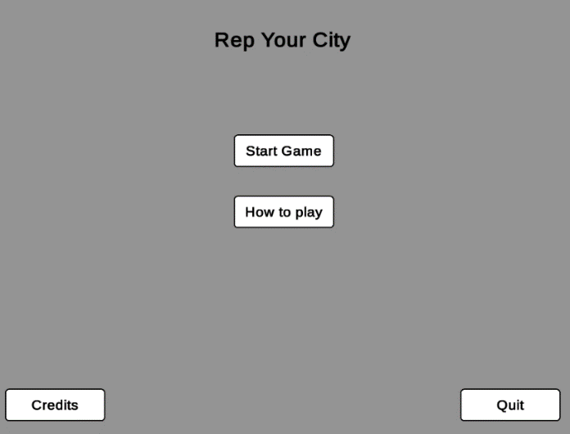
Option to view credits and see how to play
Very little text/options – keeping things simple for the user as they have poor reading skills and cognitive abilities

Screen 2 - Screen upon entering game
This screen is displayed to the user upon starting the game.
Reputation score – displayed with a slider text, ensuring the user is aware of their progress throughout
Mini-map feature – provides convenience to the user
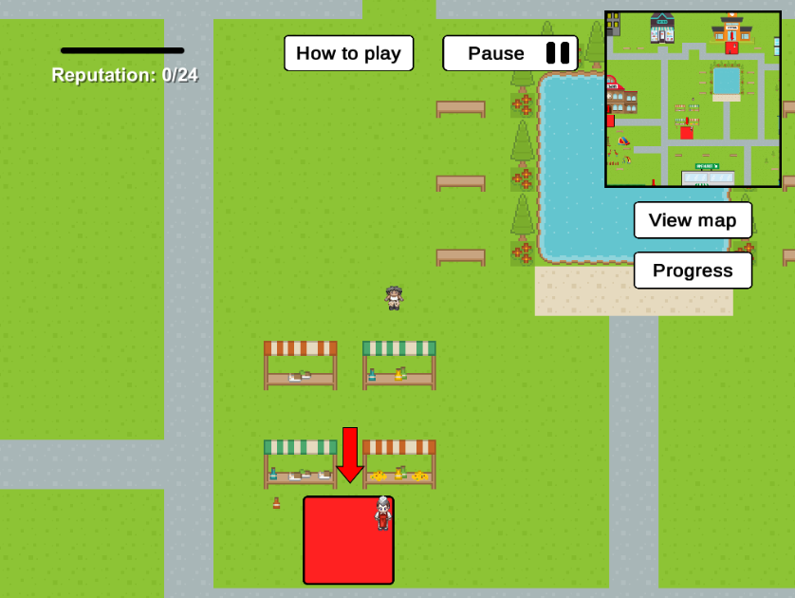

Example of an area that the user can interact with. Red and big to make it clear to the player that this is an interaction zone

Screen 3 - Pause screen
When the player clicks the pause button, the screen below appears. The pause feature allows the user to stop their session and resume the game later.

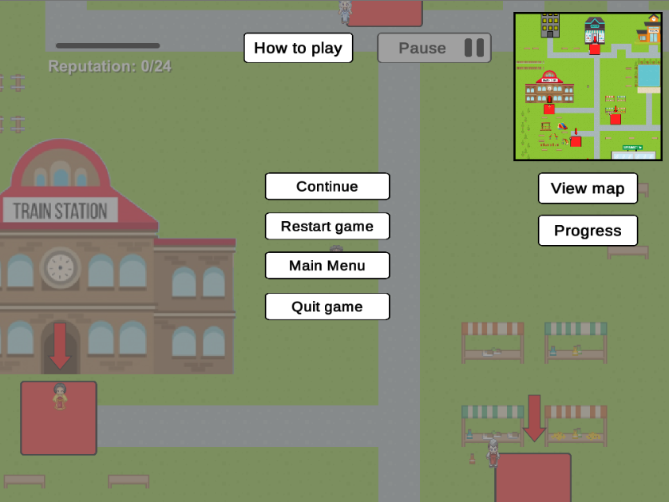
Light grey overlay to divert the focus to the pause options
Options to continue playing, restart game, return to main menu or quit game. Convenience for the user

Screen 4 - Screen upon interacting with a non-playable character
The screen below appears when the player interacts with a scenario area.
The name or title of the character the player is interacting with is shown. Makes the scenario and game feel more personal
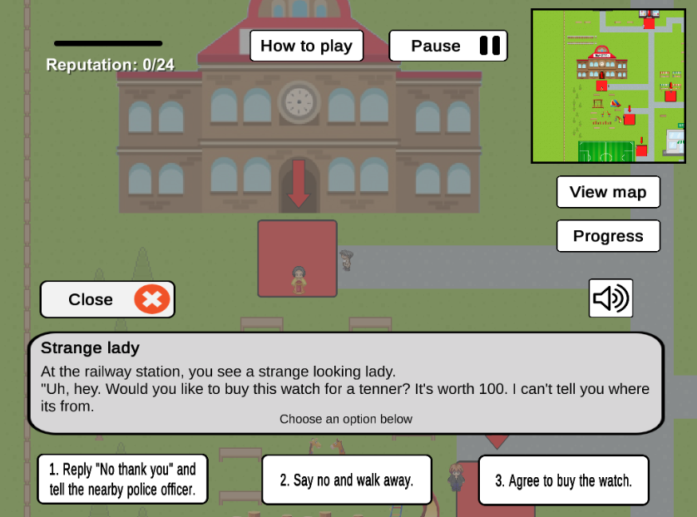
Simple terminology used as target audience have poor literacy skills

Contrast between text and background to allow for easier readability
Sound button, providing an audio alternative for those users who struggle to read / have poor reading skills

Targets chosen guideline 1 – puts the player in real, life-life situations so the player can relate

Screen 5 -Screen after choosing an option
The screenshot below shows the screen after a user has selected their answer. As you can see, feedback is provided based on the scenario.
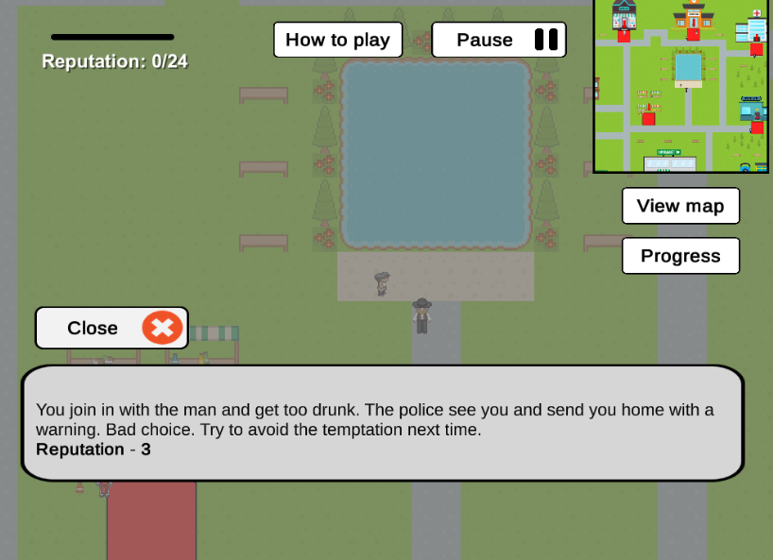
Targets chosen guideline 2 - Constructive feedback to the player based on their answer. Aims to teach the player the right from the wrong and digest new learning
Player’s movement is restricted whilst in the pause menu to maintain the focus on the current scenario

Screen 6 - Progress screen
The screen below shows the pop-up screen that appears when the user clicks the progress button.

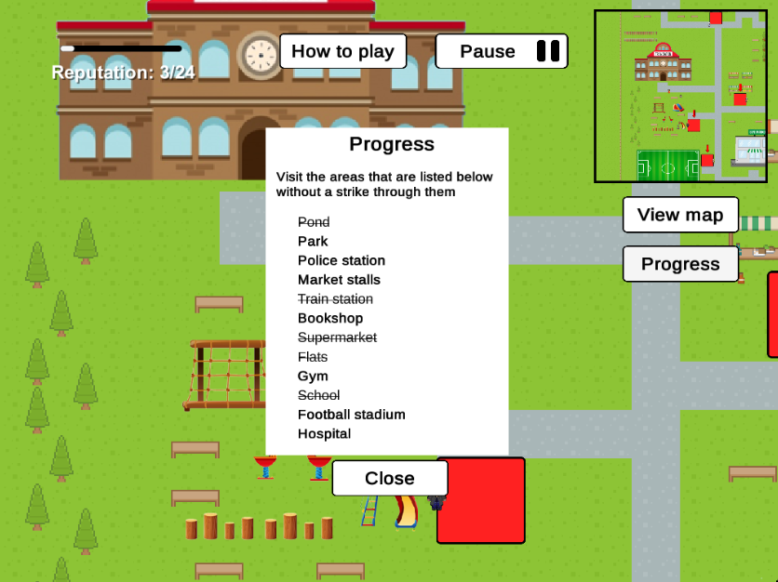
Added other map elements such as trees and benches to make the map look more realistic

Progress pop-up screen shows the user which scenario areas they have left to visit. As explain, the items with a strike through have already been visited

Screen 7 -How to play screen
The screen below shows the how to play pop-up screen which pops up when the user clicks the ‘How to play’ button.

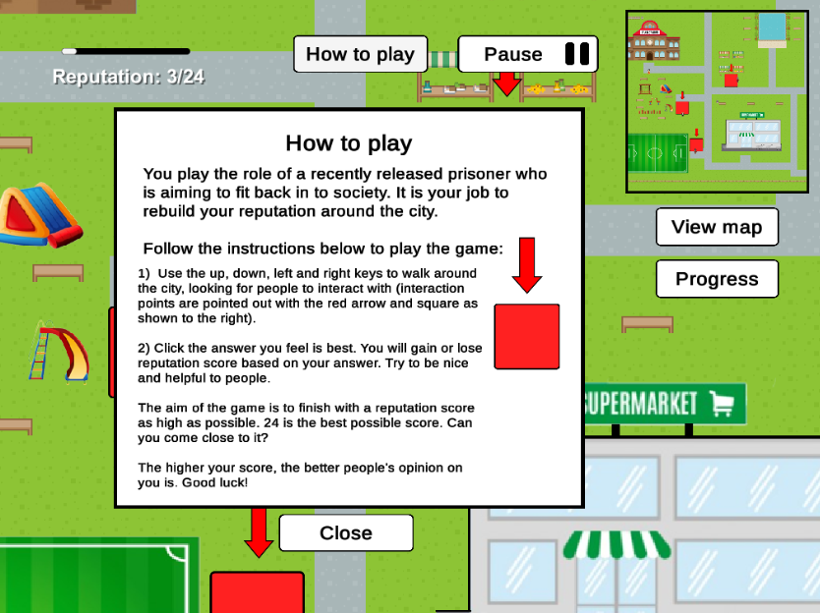
Targets chosen guideline 3 – explains the objectives clear and gives the users the opportunity to assess their performance
How to play pop-up screen. Useful for the users who may not understand the game and want more instructions
Describes the context as well as instructions and the aim of the game

Screen 8 - View large map screen
Screen 8 shows the screen that appears when the user clicks on the ‘View map’ button.
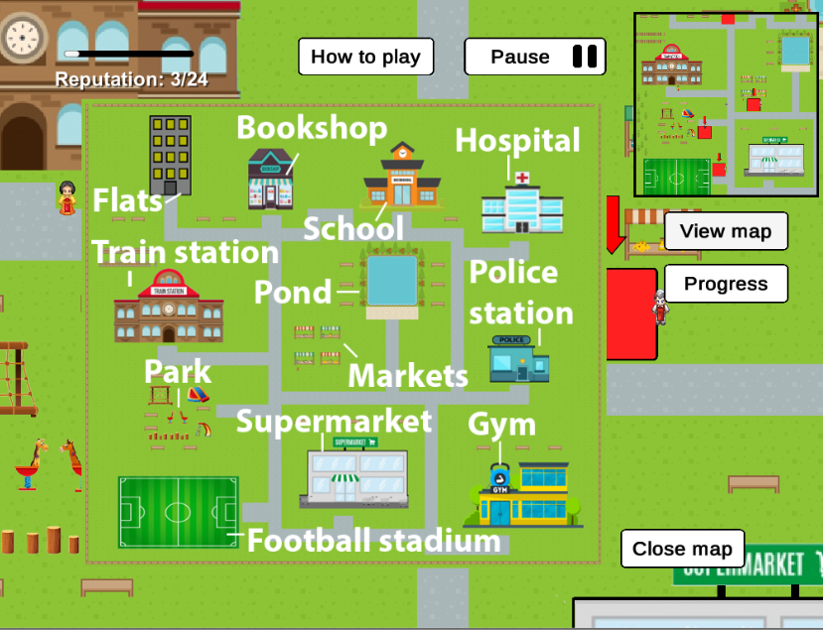
Pop-up map showing the full map and labelling each scenario area
Ensures the user can easily identify where the locations are

Screen 9 - Screen when ending game
This screen appears when the user has taken their last move.
Game over screen providing feedback on the user’s performance.

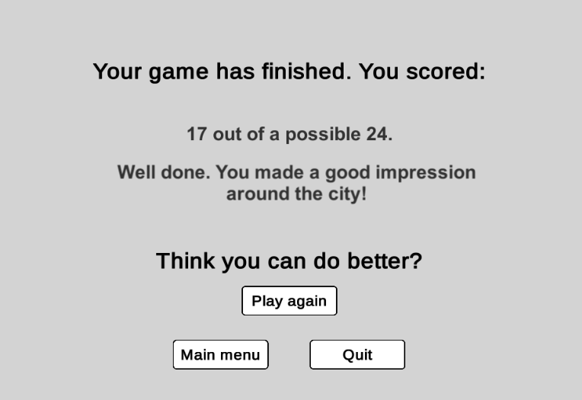
Displays the user’s score and provides a comment based on the score

Provides buttons for easy navigation to play again, return to the main menu or quit the game

Screen 10 - Credits screen
Screen 10 below shows the credits screen of the game.
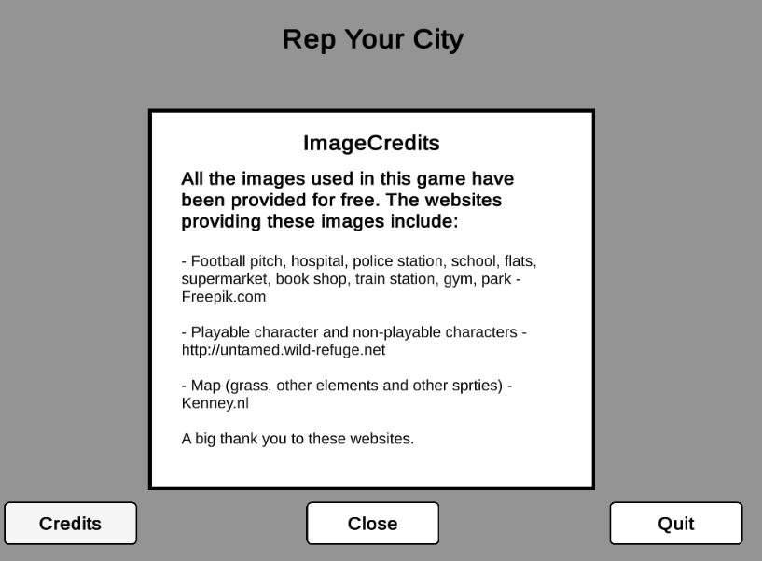
Image Credits screen crediting the websites used for the images within the game

4. Evaluation
After the completion of the design of the game, development got underway. This section discusses the evaluation methods involved in the stages before and during the development of the game.

4.1 Evaluation proposal
An evaluation proposal has been created in anticipation of the client, who will provide feedback on the current progress of the game (approximately 75% completed). The evaluation proposal lists various areas of evaluation that will be considered and planned to discuss with the client, with the aim of ensuring the final version of the game is as effective and fit for purpose as possible.
Many of the attributes being examined will involve asking the client for feedback. Furthermore, the client will be asked to briefly play the game and comment on its visual appearance. The conversation / informal interview with the client will be recorded so the transcript can be played back to re-visit feedback. Table 9 summarises the evaluation proposal.

Table 9 – Evaluation proposal for the serious game
Product | Rep your City
Learning objectives | To interact with various characters throughout with the aim of building reputation score up. The ultimate objective is to prepare the player for situations, similar to the ones in game, that they may well face one day. If a player is good at the game and understands it well, they know what the right thing to do in that situation in real life is. Many of these situations relate to the causes of recidivism, meaning that the game informally teaches the player the right from the wrong regarding situations that may relate to recidivists.
Attributes being examined | Planned type of evaluation | Details of plan
Usability and accessibility of the game | - Observation and analysis  - Informal interview with client | - The client will be asked to play the game briefly and comment on how usable/accessible the game seems to them. The following questions will be asked:  - Does the contrast between text and the background provide enough contrast to read the text without strain?  - Is the font size easily readable?  - Do any icons or text overlap, or look out of place in the game?  - Could more be done to make the game more accessible?  - The client’s ability to play the game will also be observed. For example, does the client seem to struggle to read, or not?
Functionality of the game | - Client playing the game  - Direct observation  - Informal interview with client | The client will be asked to play the game briefly, to test that all the included features function as expected. Particular aspects of functionality to be queried include:  - Do all buttons work as expected?  - Does the application freeze?  - Are there any other bugs?
Relevance of game to the scenario (requirements of clients) | - Informal interview with client  - Client observing the game | After observing the game and having the idea and logic of the game explained to them, the client will be asked for feedback on the following:  - Does the purpose of the game satisfy the requirements?  - Does the game seem as though it could potentially benefits recidivists?  - Do any aspects of the game need to be changed / modified?
How playable (enjoyable) the game is | - Direct observation  - Informal interview with client | The game must be enjoyable for its target audience for it to be effective. The client will therefore be asked to provide comments on whether, in their opinion, the target audience will enjoy the game.  The client will also be observed whilst playing the game so that it can be identified whether or not the game generally looks enjoyable or stands out.
Appropriateness of the game scenarios | - Client observing the game  - Observing the client playing the game | Another key aspect of the game is how appropriate the game scenarios are for its target audience. This is important as one wrong scenario may be the difference between one playing the game and not.  The client will be asked whether or not all, or some of, the scenarios are appropriate and fit for purpose.

4.2 Results and analysis
This section organises and discusses the results of the evaluation session as explained in the previous section. This section allows a consideration of feedback to improve and adjust the game to create a more effective and fit for purpose game.

Table 10 – discussing the evaluation results and analysis
# | Feedback/ observation | Type | Source | Relevance | Action
1 | Add audio alternatives | Accessibility | Client | High | Audio alternatives will be provided for each scenario the user faces. Audio buttons will be added, allowing the user to click the button to play the audio if required.
2 | Some dialogues are too long | Usability | Client / tutor | High | The longer dialogues will be cut down as much as possible, ensuring that the user is not left struggling to read the scenario.
3 | Some response options are too long | Usability | Client | High | As above. If the user spends too much time trying to read a large amount of text, they may forget the context.
4 | There are no options to start the game, pause the game of an end of game | Functionality | Client | Medium | A home screen, pause option and end game screen will be added in due course. As the priority is creating a game that aims to tackle recidivism, these extra features have not been focused on yet. Once added, these features will allow users to navigate their way through the game with ease.
5 | The freedom of walking around the map makes is slightly unclear as what the player’s main aim is | Usability | Client / tutor | Medium | More of an explanation will be provided in the how to play section. The section will provide the player with a brief summary as to why they are playing the game, information about the character they are controlling etc.  As well as this, a progress list will be added to list to the user which tasks/areas they are still to visit.
6 | The game’s objects look standard and not stylish, which doesn’t match with the stylish and attractive map | Visual design |  | Low | This will be addressed upon the completion of the development of the game, as it is a minor aspect. Considerable time will eventually be spent ensuring the interface looks stylish to make the game look more attractive.
7 | Map is zoomed in too much | Functionality |  | Medium | The map will be zoomed out. This is done easily enough with a zoom variable.
8 | Map is too large | Functionality |  | Low | While a large map could provide more fun to the user, it may also be frustrating. The size of the map will be reduced, ensuring the player does not waste too much time in unnecessary areas.  Furthermore, a mini-map will be added to visually display more of the map to the user, so they can see where they are headed. A view map button will also be added, that will display an annotated image of the entire map, showing the user where each scenario area is located.
9 | The player is not introduced to the scenario – doesn’t know the story behind the character | Storyline | Tutor | Low | Towards the later parts of development this issue will be resolved. The user will be told of the context.
10 | Feedback is not adequate and personalised to each scenario | Effectiveness |  | High | The feedback provided by each scenario will be revised and improved, ensuring that adequate feedback is provided to the user, which will have a chance of benefiting him or her. More advice will be made available to the player regarding future actions.

4.3 Scenario evaluation
Before implementing the scenarios straight into the game, a list of initial game scenarios were created. This list was sent to John Robertson (associated with the clients) for feedback on the suitability of the scenarios. The feedback was valuable, as it was pointed out that some scenarios created were not fit for purpose. The main points of consideration were:
- Not to make the correct answer of some scenarios too obvious. Some of the previously created scenarios pointed to an obvious question. Due to this, several scenarios were re-worded, making the game more challenging
- Not to relate the scenarios to family, as some of the ex-inmates have damaged relationships with their families. By discussing families, the game could potentially upset or anger the players
- Not to direct the player into a situation which required a very large amount of responsibility, as the ex-inmate would most likely want to stay out of jail. This was in response to a scenario which asked the player to choose who to kick out of a library for acting inappropriately
- Not to include violent answers
With the feedback from John, new scenarios were created, ensuring the game is as fit for purpose as possible regarding the game’s dialogue scenarios. Appendix C lists the new scenarios, as well as their reason for inclusion. They have been improved, ensuring they are fit for purpose. Some scenarios may change in before the final version of the game.

4.4 Evaluating the game against the NLN’s accessibility guidelines
To gain an understanding of how accessible ‘Rep your City’ is, and to compare this accessibility with My Appearance, Cheese Factory and SPENT, ‘Rep your City’ this section evaluates the compliance of the game with the NLN’s accessibility guidelines.
Of the 48 guidelines, 41 apply to ‘Rep your City’, with the game complying with 38 (92%) of these. This compares with a compliance percentage of 85% for My Appearance, 67% for Cheese Factory and 63% for SPENT. It is clear that the considerable effort put into making the game as user-friendly and accessible has paid off, and the game is accessible to many types of players.

4.5 Copy of serious game
The game has been submitted in the separate dropbox folder.
Due to display issues, the game will only run in 1024 pixels by 768 pixels.

References
Adams, W., 2012. Sentenced to Serving the Good Life in Norway [online]. Available at: http://content.time.com/time/magazine/article/0,9171,2000920,00.html [Accessed 17 December 2017].
Bailey, K., (2006). The Causes of Recidivism in the Criminal Justice System and why it is Worth the Cost to Address them [online]. Available at: https://www.bakerdonelson.com/files/The-Causes-of-Recidivism-in-the-Criminal-2007-1-30.pdf [Accessed 17 December 2017].
BBC News, 2016. More than 250,000 are homeless in England – Shelter [online]. Available at: http://www.bbc.co.uk/news/education-38157410 [Accessed 28 December 2017].
Brunton-Smith, I. and Hopkins, K., 2013. The factors associated with proven re-offending following release from prison: findings from Waves 1 to 3 of SPCR [online]. Available at: https://www.gov.uk/government/uploads/system/uploads/attachment_data/file/491119/re-offending-release-waves-1-3-spcr-findings.pdf [Accessed 24 December 2017].
Cobinna, J, et al. 2012. Men, Women, and Postrelease Offending: An Examination of the Nature of the Link Between Relational Ties and Recidivism. Crime and Delinquency, 58, (3), 331-361.
Costelloe, A. and Lengelid, T., 2011. Prison education and training in Europe - a review and commentary of existing literature, analysis and evaluation [online]. Available at: http://ec.europa.eu/justice/news/consulting_public/0012/Fullreport_en.pdf [Accessed 23 December 2017].
Deady, W, C., 2014. Incarceration and Recidivism: Lessons from Abroad [online]. Pell Center. Available at: http://www.salve.edu/sites/default/files/filesfield/documents/Incarceration_and_Recidivism.pdf [Accessed 22 December 2017].
Freepix, n.d. Graphic Resources for Everyones [online]. Available at: https://www.freepik.com/ [Accessed 18 January 2018].
GameAccessibilityGuidelines.com, 2013. Game Accessibility Guidelines [online]. Available at: http://gameaccessibilityguidelines.com/basic/ [Accessed 30 December 2017].
Home Office, 2009. The national reducing re-offending delivery plan. National Offender Management Service (NOMS). ISBN: 1-84473-756-X.
Interactive Systems Research Group, n.d. Cheese Factory [online game]. Available at: http://software.isrg.org.uk/flashgames/ [Accessed 30 December 2017].
Interactive Systems Research Group, n.d. My Appearance [online game]. Available at: http://software.isrg.org.uk/flashgames/ [Accessed 30 December 2017].
Kenney, n.d. Roguelike/RPG pack [online]. Available at: http://www.kenney.nl/assets/roguelike-rpg-pack [Accessed 16 January 2018].
McKinney, 2011. SPENT [online game]. Available at: http://playspent.org/html/# [Accessed 28 December 2017].
McMurran, M., 2013. Alcohol-Related Violence: Prevention and Treatment. West Sussex: John Wiley & Sons.
MindBytes, n.d. SERES Prisoner Rehabilitation [online]. Available at: http://mindbytes.be/project/seres-prisoner-rehabilitation/ [Accessed 25 December 2017].
Ministry of Justice, 2010. Compendium of reoffending statistics and analysis [online]. Available at: https://www.gov.uk/government/uploads/system/uploads/attachment_data/file/199224/compendium-of-reoffending-statistics-and-analysis.pdf [Accessed 24 December 2017].
Ministry of Justice, 2012. 2012 Compendium of re-offending statistics and analysis [online]. Available at: https://www.gov.uk/government/uploads/system/uploads/attachment_data/file/278126/2012-compendium-reoffending-stats-analysis.pdf [Accessed 24 December 2017].
Ministry of Justice, 2013. Analysis of the impact of employment on re-offending following release from custody, using Propensity Score Matching [online]. Available at: https://assets.publishing.service.gov.uk/government/uploads/system/uploads/attachment_data/file/217412/impact-employment-reoffending.pdf [Accessed 28 December 2017].
Ministry of Justice, 2014. Transforming rehabilitation: a summary of evidence on reducing reoffending (second edition) [online]. Available at: https://assets.publishing.service.gov.uk/government/uploads/system/uploads/attachment_data/file/305319/transforming-rehabilitation-evidence-summary-2nd-edition.pdf [Accessed 28 December 2017].
Morgan, D, et al., 2012. Treating Offenders with Mental Illness. A Research Synthesis’ in Law and Human Behaviour. 36, (1), 37-50.
Morrow, T., 2008. How effective is offender-reflective practice in their own learning when using games to develop positive changes in their social communication skills?, Reflective Practice, 9(3), 329-340.
Music, E., 2012. Chalk talks - teaching literacy in order to turn the page on recidivism, Journal of Law and Education, 41(4), 723–730.
National Institute of Justice, 2014. Recidivism [online]. Available at: https://www.nij.gov/topics/corrections/recidivism/Pages/welcome.aspx [Accessed 25 December 2017].
National Learning Network, n.d. National Learning Network Guidelines for Accessibility [online]. Available at: https://now.ntu.ac.uk/d2l/le/content/483635/viewContent/2385549/View [Accessed 31 December 2017].
Offender Health Research Network, 2011. Liaison and Diversion Services: Current Practices and future directions [online]. Available at: http://www.ohrn.nhs.uk [Accessed 29 December 2017].
Petty, G., 2004. Teaching today, (3rd ed.), Cheltenham, UK: Nelson Thornes.
Pinelle, D., et al., 2008. Heuristic Evaluation for Games: Usability Principles for Video Game Design [online]. Available at: https://pdfs.semanticscholar.org/60b1/063b7bec0a5a90213fcb4b17e0e855797a1c.pdf [Accessed 31 December 2017].
Radzinowicz, L., 1945. After-Conduct of Convicted Offenders in England. In L. Radzinowicz and J. W. C. Turner (Eds.): The Modern Approach to Criminal Law (Pp. 142–161). London: MacMillan and Co.
Sadier, G., 2010. Evaluation of the impact of the HM Prison Service Enhanced Thinking Skills programme on reoffending: Outcomes of the Surveying Prisoner Crime Reduction (SPCR) sample. Ministry of Justice Research Series 19/10, London. Available at: http://www.justice.gov.uk/downloads/publications/research-and-analysis/moj-research/eval-enhanced-thinking-skills-prog.pdf?type=Finjan-Download&slot=00000344&id=00000343&location=0A64020C [Accessed 29 December 2017].
Sanchez, E., 2013. Business game-based learning in management education [online]. Available at: https://books.google.co.uk/books?hl=en&lr=&id=UlKiBAAAQBAJ&oi=fnd&pg=PA79&dq=eric+sanchez+key+criteria+for+game+design&ots=g5rOJ5HiEl&sig=RnBal5uN_zkvgil6rY8HOj8mG20#v=onepage&q&f=false [Accessed 31 December 2017].
Sapouna, M, et al., 2011. What Works to Reduce Reoffending: A Summary of the Evidence [online]. Justice Analytical Services. Scottish Government. Available at: http://www.gov.scot/Resource/0038/00385880.pdf [Accessed 29 December 2017].
Serious Brothers, 2014. Imagine Earth [online]. Available at: http://store.steampowered.com/app/280720/Imagine_Earth/ [Accessed 29 December 2017].
Shepherd, J., Farrington, D.,2003. The impact of antisocial lifestyle on health: Family, school and police interventions can reduce health risks [online]. Available at: https://www.ncbi.nlm.nih.gov/pmc/articles/PMC1125758/ [Accessed 25 December 2017].
Sithjester, n.d. Sithjester’s RXMP Resources [online]. Available at: http://untamed.wild-refuge.net/rmxpresources.php?characters [Accessed 15 January 2018].
Social Exclusion Unit (SEU), 2002. Reducing re-offending by ex-prisoners. London: HMG Cabinet Office.
The RealLife Project, n.d. RealLife Project [online]. Available at: http://reallifeproject.eu/ [Accessed 23 December 2017].
The World Bank, 2013. Poverty [online]. Available at: http://www.worldbank.org/en/topic/poverty/overview [Accessed 28 December 2017].
The World Bank, 2014. Climate change [online]. Available at: https://data.worldbank.org/topic/climate-change [Accessed 29 December 2017].
Travers, R, et al., 2013. Reconviction following a cognitive skills intervention: An alternative quasi‐ experimental methodology. Legal and Criminological Psychology, 18, (1), 48-65.
Ulicsak, M. and Wright, M., 2010. Games in Education: serious games [online]. Available at: https://www.nfer.ac.uk/publications/FUTL60/FUTL60.pdf [Accessed 28 December 2017].
UMD, n.d. Mission & History [online]. Available at: http://www.umdurham.org/who-we-are/misson-values-history.html [Accessed 28 December 2017].

Appendices

Appendix A – Client notes

Notes from Client:
(John Robertson, Consultant Clinical Psychologist, Alexander House)
Notes re. Alexander House:
Alexander House is a locked rehabilitation unit for men with intellectual disabilities who are on a section of the mental health act. Alexander House staff help patients return to less restrictive community services.
Consider the following as part of your design ideas:
- Our patients have very limited, if any, reading abilities, so relying on text too heavily is unwise. Consider audio instructions wherever possible.

- Limit the amount of information someone is exposed to at any one moment and use repetition to help their poor memories to keep track of those instructions and to help them master the tasks in front of them.

- Motivation is a huge issue here: make tasks achievable without too much emphasis on failing and more emphasis, however small, on success, so that the patient/ offender is pulled into the task and seeks to achieve outcomes.

- Look at personal versus external responsibility-taking where possible, as our patients are very used to blaming others for problems and are having to learn to take on more responsibility for themselves.

- Stress is a huge issue, so think about how people might manage different demands, identify (and then manage) their feelings as they are not skilled at noting what feelings and thoughts they might be having.

- Offending can be a habit, so breaking habits will be necessary for a successful avoidance of re-offending. Think about how habits are broken – what is the incentive to break it? What will be the positive outcomes of doing so, versus the negatives of continuing the habit?

- Encourage the patient/ offender to think about what the future might look like if they continue acting recklessly – does the patient/offender have an idea of what being locked up in a more secure environment might look and feel like and what they would lose from their life at the moment that they would not want to lose?

- If thinking about employment, keep aspirations low, manual unskilled work is the most any of our men will be able to expect, such as gardening, cleaning, and kitchen assistant work. Education has been an unpleasant experience for them in the past, so if that is needed for them to get a chance to get a job, then make it exciting and relevant to them so they are more likely to stay interested and engaged with the educative tasks.

Appendix B – Further details of target audience / Alexandra house
- House located in Mansfield
- All males
- Intellectually disabled
- Have experience of contemporary computer games, they are not novice
  - May have a certain expectation of games - may not enjoy games that are too childish
- Have limited cognitive abilities
- In 18s/30s
- Low literacy skills
- Mild/moderate learning disability
- Physical cognitive impairments

Appendix C – Game scenarios with justification of inclusion
Id | (Game context) Scenario | Options  (Reputation effect) | Reason for inclusion
1 | (Drunk man drinking in the streets by the pond)  * You come across a man, who is very drunk, drinking in the streets... *  ‘Hey there, fancy drinking with me? It’s such a boring day!’ | - Reply ‘Yeah sure… just a couple of swigs!’  (reputation -3)  - Reply ‘No thank you. You should get going home.’  (reputation +3)  - Ignore the temptation and walk off  (reputation +2) | Various research shows that alcohol is strongly associated with recidivism. Furthermore, this scenario teaches the player that they should not choose to hang around with people with anti-social behaviour, as recidivists are more susceptible to behaving in a similar manner as somebody behaving like this.  (Cobbina et al. - 2012)
2 | (Player comes across an old school friend in the park)  * In the park, you see your old friend, Sam, from school. *  ‘Hi mate long time no see! I’ve got some drugs… cocaine, ecstasy, cannabis… any drugs you can name. Fancy doing them with me sometime?’ | - Reply ‘No thank you mate, I think I’ll give it a miss.’  (reputation +1)  - Reply ‘That sounds good mate, let’s do it!’  (reputation -2 )  - Reply ‘To be honest mate, we shouldn’t really do drugs. They’re not good for us.’  (reputation +3) | Various research shows that drug use is strongly associated with recidivism.
3 | (Player sees a police officer outside the police station)  *You see a police officer outside the police station.  “Hi sir! You haven’t been getting in any trouble lately have you? Hahaha.” | Choose your reply…  - Reply “Don’t talk to me, you wouldn’t help me if I needed it.” (reputation -3)  - Reply “Haha of course not! Have a good day officer!” (reputation +3)  - Ignore the officer and walk away (Reputation -1) | This scenario has been included to encourage the player to socialise with others in a positive, rather than negative way. It also aims to allow players to understand that police officers are there to help, rather than not, which some re-offenders may believe due to their criminal history.
4 | (Outside a stall in the markets)  * You see some a bottle of wine has fallen on the floor. You really want them. The store owner is looking away. What do you do? * | - Inform the store owner that the shoes have fell on the floor (reputation +3)  - Put the shoes in your bag and walk away  (reputation -3)  - Resist the urge to take the shoes and continue walking  (no reputation change) | Theft - Research on reoffenders in the UK found that offenders serving a sentence for an acquisitive crime (theft, robbery, prostitution, handling stolen goods, burglary) were more likely to be reconvicted on release.  (Brunton-Smith and Hopkins - 2013)
5 | (Outside the railway station)  *Outside the railway station, a strange looking lady speaks to you. *  ‘Hi. Would you like to buy this watch for only £10? It’s worth £100. I can’t tell you where it’s from. Tell your friends about me.’ | - Say yes and buy the stolen watch  (reputation -3 )  - Say no, and walk away  (no reputation change)  - Say no, and inform the policeman around the corner  (reputation +3)  - Say no, but inform your friends of the seller  (reputation -2) | Handling stolen goods - Research on reoffenders in the UK found that offenders serving a sentence for an acquisitive crime (theft, robbery, prostitution, handling stolen goods, burglary) were more likely to be reconvicted on release.  (Brunton-Smith and Hopkins - 2013)
6 | (Player sees their aunty outside the bookshop)  *You see your aunty, who approaches you*  “Hi how have you been? Would you like to work at my house doing some cleaning or gardening? 20 hours a week for £160. What do you say?” | - Reply ‘Yes, sure that sounds good!’  (reputation +3)  - Reply ‘Not at the moment, I feel too tired.’  (no reputation change)  - Reply ‘No, I don’t need to work!’  (reputation -2) | Various research shows a link between unemployment and recidivism. The client notes mention that aspirations should be kept low regarding skilled work, so unskilled work has been included.  The logic behind including this is that if a reoffender is offered any chance to do any work, it will benefit them to take it.
7 | (Outside the supermarket)  *A young teenager, looking about 14 approaches you*  “Hi there, could you buy me a bottle of vodka? I’ve lost my fake ID.” | - Reply “Alright then, give me they money and I’ll grab it for you” (Reputation -3) Child’s mum sees you.  - Reply “Sorry, I can’t help you. You shouldn’t be doing that until you’re 18. “(Reputation +3) Child’s mum praises you  - Reply “Find somebody else to do it, you silly child!” (Reputation +1) good didn’t do it, but don’t need to be violent | As well as this scenario teaching the player that alcohol consumption is wrong, particularly when consumed illegally, this scenario also teaches the player to take responsibility, as the client notes recommend.
8 | (Outside an old lady’s flat)  *You accidently knock over an old lady’s flowerpot. She approaches you. *  ‘Hi there. Did you see who knocked over my flower pot?’ | - Reply ‘Sorry, I don’t know’  (reputation -1)  - Reply ‘Oh, I’m terribly sorry, it was my mistake. Please forgive me’  (reputation +3)  - Reply ‘It wasn’t me! It was that kid over there!’  (reputation -3)  - Angrily go into her garden and break other items.  (reputation -3) | The client notes mention taking responsibility and not blaming others.
9 | (Outside the gym)  * Your friend Josh notices you look stressed *  ‘Hey, you looked pretty stressed out mate. Do you want to hang out some time?’ | - Reply ‘Yeah. We should go for a few drinks and forget about everything!’  (reputation -3)  - Reply ‘Yeah. How about joining the gym together?’  (reputation +3)  - Reply ‘No thanks mate. I’ll work on it don’t worry about me.’  (no reputation change) | Client notes mention stress is a huge issue. Being active will help reduce stress while the most unhelpful thing is turning to something unhealthy such as smoking or drinking
10 | (Outside the school)  * You see a group of kids outside the school bullying another kid, punching him and asking for his money. What do you do? * | - Ask what they are doing and explain that what they are doing is wrong. Tell the kid to tell his parents or a teacher.  (reputation +3)  - Attempt to get some of the money yourself.  (reputation -3)  - Walk away and don’t say anything.  (no reputation change)  - Walk past, telling the kids to stop  (reputation +1) | Violence and bullying is never wrong. It should be discouraged.
11 | (Player sees a man outside the football pitch)  You see a man swearing at people behind him and throwing his drink on the grass.  “Oi mate, want to hang out later? My friends are idiots.” He asks.  *A man approaches you after the football match, after swearing at a group of people around him and throwing his drink on the pavement*  “Oi mate, did you see the game? It was damn terrible! Want to hang out later? My friends are right idiots.” | - Reply “No thanks mate, hopefully the next game will be better” and walk away from the man (Reputation +3)  - Reply “Yeah sounds good, I’m not doing much anyway.” (Reputation – 2)  - Swear at the man and reply “No, go away you weirdo!” (Reputation -1) | Associating one’s self with people who behave in an anti-social manner may increase the likelihood that they may act more anti-social themselves. Research has shown that recidivists may be more vulnerable to this type of situation.
12 | (Outside the hospital, the player sees a doctor)  You see your doctor outside the hospital.  “Hey! You missed your check-up last week, you should book another appointment.” | - Reply “Oh, I forgot again, I don’t care about it that much, so I don’t need to book it again?” (Reputation -2)  - Reply “Oh I’m sorry! I’ll book another appointment again and be sure to turn up!” (Reputation +2)  - Reply “Yeah my bad, my friend wanted to go out and I couldn’t say no!” (Reputation -2) | Players need to take on responsibility as the client notes state

Appendix D – Comparing Rep your City with NLN’s guidelines
Accessibility - Navigation Issues | Rep your City
Negative feedback should not be in red. | Yes
Avoid colour dependent navigation, instructions or references. For example, ‘choose the red pill’. | Yes
Progressive revealing of content for text or bullet type lists is not acceptable practice. | Yes
The material must provide logical tabbing order. | NA
All users must be able to access the materials using only a keyboard. | No
Proprietary keyboard short cuts are not allowed within a content package. | Yes
Accessibility - Graphical Issues
Underlined text may only be used for hyperlinks | Yes
Never use flashing or animated text. | Yes
Use only web san serif-based fonts for body text within the content window. | Yes
Menu items must be at least 35 pixels square. Navigation items must be legible. | Yes
Text must use both upper and lower-case letters. Do not use text in uppercase only. | Yes
Text must be left justified with a ragged right edge for educational content. | Yes
Do not use any more than three text columns. | Yes
A line of text must be no more than 14 words long. | Yes
Overall information density must be less than 75 percent of the screen area. | Yes
Use appropriate colours that consider colour blind people. | Yes
Use text heading formatting consistently. | Yes
Patterned backgrounds must not be used behind text or graphics. | Yes
Do not loop the flashing element of the animation. It should run once to make the point. | NA
Accessibility - Interoperability
The material must not interfere with any existing accessibility features of the operating system. | Yes
The learner must control the starting, stopping and reviewing of animations and simulations. | Yes
Animation must avoid strobe and flashing effects. | NA
A visual equivalent must be provided for all audio alerts. | Yes
Accessibility - Assessment and Supplementary Documentation
If a timed response is required, the user/tutor should be able to modify the timing parameters. | NA
Editable documents must be available in .rtf or .doc. | N/A
Downloadable documents must be available as PDF and RTF format. | NA
Learning Model Guidelines
The learning objectives and outcomes must be clear, and learners should be given the opportunity to assess their own progress or performance against these objectives. | Yes
Activities should relate theories and concepts to the learner’s current situation or experience. | Yes
Learners must be able to pace themselves depending on their available time and ability. | Yes
Learners should be able to bring other sources of information or enquiry into the learning and should be encouraged to solve problems. | Yes
Functionality Guidelines
The materials must provide appropriate help facilities for the learner. | Yes
Where specialist or unusual terms, or terms unfamiliar to the target audience are used a glossary must be provided. | NA
Where summaries are provided, a print option must be available. | No
General Design Guidelines
The learning objectives must be clearly stated for the benefit of tutors and for independent learners. | Yes
The content should take the learner from the known to the new learning in appropriately sized stages. | Yes
Electronic page turning must be avoided; each page must stimulate a response, action or interaction from the user. | Yes
The content must help the learner to reflect on, review and digest new learning. | Yes
The content must provide useful, constructive and supportive feedback. | Yes
Emphasis should be placed on creating activity or interaction and stimulating thought rather than the transmission of facts. | Yes
The content must include formative assessment of progress against learning objectives. This should comprise a range of activities and interactions. | Yes
All materials must provide audio support in English. | Yes
The user must be able to move through the materials at a pace determined by themselves at all times, even when audio is used. | Yes
The user must be able to switch any audio support on or off at will. | Yes
The content must demonstrate how new knowledge and skills can be applied to real problems and situations. | Yes
The materials must provide a variety of learning paths, interaction types and activities to accommodate different preferences in learning style. | Yes
The level of English language used must be appropriate for the target audience. | Yes
The content must be accurate, valid, up-to-date and without errors. | Yes
The content and design of the materials must reflect the many cultures of the UK. | No

