

Safeguarding Incident Report Form
This form can also be completed online here: Safeguarding Report Form

Your Name:

Your Position:

Child’s Name

Child’s Address:

Parent/Carer/Guardian Name and Address:

Child’s School

Child’s Date of Birth

Date and Time of any Incident

Your Observations

Exactly What the Child Said and What You Said
(Record actual details. Continue on separate sheet if necessary)

Action Taken so far:

External Agencies Contacted (Date & Time)
Agency  Name and Contact Number | Details of Communication
Agency  Name and Contact Number | Details of Communication
Final Outcome:

Signature:

Print Name:

Date:

When completed, this form should be sent to Patrick Holden, the Conservatoire’s Executive Director and Designated Safeguarding Lead:
patrick.holden@conservatoire.org.uk

Disclosure Body Map

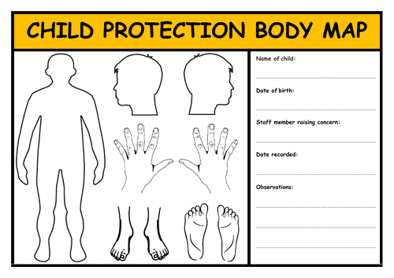

Contact Details

All incidents concerning child protection should be reported to the Designated Child Protection Policy Officer. If this person is unavailable you should report to the Deputies.

Please see contact details below:
Designated Safeguarding Lead
Patrick Holden, Executive Director
patrick.holden@conservatoire.org.uk
Tel: 020 8852 0234

Deputy Designated Safeguarding Lead
Mairéad Sheerin, Artistic Director
mairead.sheerin@conservatoire.org.uk
Tel: 020 8852 0234

Deputy Designated Safeguarding Lead
Dee De Bellotte, Operations Director
dee.debellotte@conservatoire.org.uk
Tel: 020 8852 0234

Conservatoire Trustees
Trustee Safeguarding Lead - Emma Smillie
emmaparkere14@gmail.com
Tel: 020 8852 0234

Support Services

POLICE

Police Station – Lewisham
Lewisham Police Station
43 Lewisham High Street
SE13 5JZ
Tel: 101
Tel: 0208 297 1212

Greenwich West Police Station (rarely manned)
Tel: 0208 649 3536
WestGreenwich.SNT@met.police.uk

LOCAL AUTHORITY CHIILD PROTECTION SERVICES

Greenwich Children’s Services – Child Protection team
Referral Team: 0208 921 3172
Tel: 020 8854 8888 Out of Hours Emergency Duty Team
Mash-referrals@royalgreenwich.gov.uk

Local Authority Safeguarding Contacts:
LADO, Caroline Aitken - Caroline.Aitken@lewisham.gov.uk.

Lewisham Multi-Agency Safeguarding Hub (MASH)
Tel 0208 314 6660
Out of Hours Emergency Team: 0208 314 6000

The Conservatoire is in Greenwich Borough and is deemed a school for safeguarding purposes and has had help and advice from Ken Palmer, Child Protection Co-ordinator – schools
Tel: 020 8921 4438
Ken.Palmer@royalgreenwich.gov.uk

Childline 0800 1111
NSPCC Child Protection Helpline: 0808 800 5000

