

C3-2000
  - MOBILE ECOLOGICAL COOKING STATION

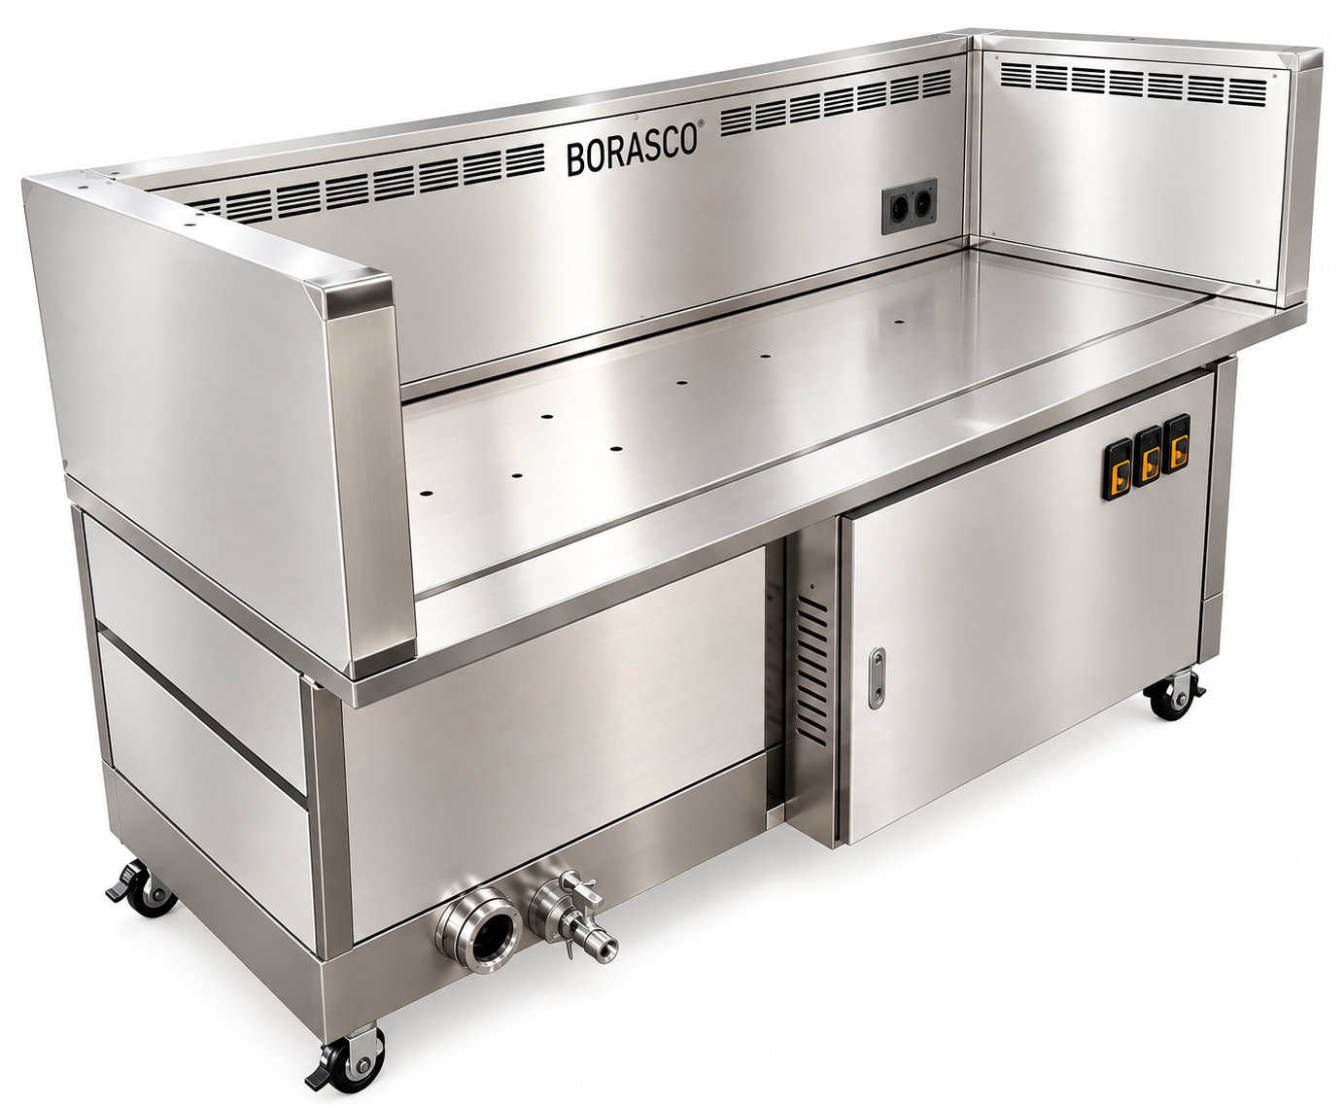

OPERATION, SAFETY, CLEANING AND PERIODIC MAINTENANCE MANUAL

BORASCO • English technical operating manual


1. SAFETY PRECAUTIONS AND WARNINGS

1.1 DANGER
- The C3-2000 incorporates a fan, electrostatic precipitator (ESP), dynamic oil separation system and recirculating Wet-Film water system. Installation, commissioning and technical maintenance must be carried out by trained and authorized personnel only.
- Do not open the electrical cabinet, ESP compartment or high-voltage power supply enclosures while the unit is operating. Do not operate the unit if protective earthing or electrical protection devices are defective.
- Before accessing the electrical or ESP compartments, disconnect the main supply and prevent reconnection. Dangerous voltage may remain in the ESP cells after power has been disconnected. Authorized personnel must verify safe discharge; users must not attempt discharge with a screwdriver. A fixed waiting period alone does not establish electrical safety.
- Do not spray water or pressurized water directly onto the electrical cabinet, fan motor or ESP power supplies. Do not operate the unit if leaking water reaches electrical components.
- Do not use the unit in explosive atmospheres, for extracting flammable or corrosive gases, or for non-cooking industrial processes. Do not obstruct air inlets. Do not operate with ESP cells or protective filters removed.
- Do not run the Wet-Film pump unless there is sufficient water in the tank. Do not continue cooking if the fan is not running or extraction is inadequate.
- If unusual noise, excessive vibration, a burning smell, smoke, flames or an electrical fault occurs, stop operation, safely disconnect the main power supply and contact authorized service personnel.
- Do not use the unit in explosive atmospheres, for industrial dust collection or for extraction from non-cooking processes.
1.2 WARNING
Operate the unit on a level, secure surface in a sufficiently ventilated area. Avoid excessive heat, humidity and corrosive environments. Do not install this product where ambient temperature exceeds 50°C.
Cooking surfaces and surrounding air ducts may be hot. Wear suitable heat-resistant gloves.
Clean stainless-steel surfaces using appropriate care products. Inspect pre-filters, oil collection sections, ESP cells and the water tank regularly; accumulated grease can increase fire risk.
Do not operate the unit until ESP cells are completely dry after cleaning. Dispose of contaminated water, grease and filter residues in accordance with applicable waste-management requirements.
Daily checks of surfaces, pre-filters, oil collection and water level, weekly ESP inspections and periodic general maintenance based on usage intensity are recommended. Final service intervals must be established in accordance with manufacturer approval and site conditions.
Allow sufficient clearance for opening covers, removing filters and performing service work.

1.3 PERSONAL PROTECTIVE EQUIPMENT
Operation | Protective equipment
Daily operation | Heat-resistant gloves
ESP cleaning | Safety goggles; suitable protective gloves
Electrical maintenance | Appropriate insulating PPE for qualified electrical personnel
Water system maintenance | Waterproof gloves; slip-resistant footwear

2. PRODUCT DESCRIPTION AND OPERATING PRINCIPLE
The BORASCO C3-2000 Ventless Ecological Cooking Station is a mobile cooking station developed to capture and filter greasy cooking fumes and airborne particles close to their source in professional kitchens.
The unit combines three-sided extraction, dynamic oil separation, a recirculating Wet-Film water curtain, oil-water separation, electrostatic precipitation (ESP) and a centrifugal fan. Filtered air is discharged into the surrounding space through an outlet in the lower section.
2.1 OPERATING PRINCIPLE
1. Three-sided air extraction system
Greasy fumes and particles generated during cooking are collected through extraction channels on the left, right and rear sides of the unit. The system is designed to capture fumes close to their source.
2. Dynamic oil separation system
Extracted air passes through the dynamic oil separation system. Some oil droplets are mechanically separated and directed to the collection section, reducing the oil load on subsequent filtration stages.
3. Wet-Film water curtain system
Air comes into contact with the recirculating water curtain. This stage helps capture some oil and particles in the water and cool the air. The system operates with an internal 75-litre tank and a circulation pump; make-up water must be added as required.
4. Oil-water separation system
This system helps separate oil accumulated in the water of the Wet-Film circuit. The water tank and oil collection sections must be inspected and cleaned regularly.
5. Electrostatic precipitation system (ESP)
Fine particles in the air passing through the pre-treatment stages are electrically charged and retained on collection surfaces. Two high-voltage power supplies are specified for the C3-2000. ESP cells must be cleaned regularly.
6. Centrifugal fan and air discharge
The centrifugal fan generates the required extraction airflow and directs filtered air to the outlet at the bottom of the unit. Extraction ducts and filters must be kept clean.
2.2 PRODUCT FEATURES
Integrated filtration: Dynamic oil separation, Wet-Film and ESP technologies are combined within one housing.
Three-sided extraction: Greasy cooking fumes are captured from extraction points at the left, right and rear.
Mobile operation: The wheeled unit can be positioned in suitable areas; wheel brakes must be locked during operation.
Recirculating water system: An internal 75-litre tank is used. The manufacturer indicates approximately 0.5 L/hour of evaporation-related make-up water; actual consumption may vary with operating conditions.
Electrostatic filtration: Helps capture fine oil aerosols and particles electrostatically.
Integrated design and service access: Extraction, filtration, water circulation and electrical controls are integrated in the same housing; maintenance access is provided through service doors.

2.3 ENVIRONMENTAL PARAMETERS AND CONDITIONS OF USE
Parameter | Operating condition
Application | Professional kitchens
Ambient temperature | Max. 50°C
Relative humidity | <80%
Electrical supply | 220 V / 50 Hz
Rated electrical power | 3.6 kW
Water tank capacity | 75 L
Water consumption | Approx. 0.5 L/hour (evaporation/make-up)
Gas-fired cooking equipment | Must not be used
Explosive atmosphere | Use prohibited
Corrosive chemical vapors | Use prohibited
IMPORTANT WARNING: Use the unit only with electric cooking equipment whose suitability has been confirmed by the manufacturer. Do not block air inlets or outlets. Do not operate the unit with filters removed or the water system disabled. Provide adequate ventilation in the operating area.

3. TECHNICAL SPECIFICATIONS
Parameter | Value / description
Dimensions (L×W×H) | 2000 × 780 × 1100 mm (manufacturer Rev.03)
Cooking area | 1800 × 700 mm
Net weight | Approx. 200 kg
Electrical supply | AC 220 V / 50 Hz
Manufacturer-declared total power | 3.6 kW
Manufacturer-declared current | 16 A
Supply cable | 3-core, 2.5 mm²
MCB | 16 A (manufacturer declaration; suitability to be verified on site)
Fan model / power | YWL4E-300QD (counterclockwise), 1.25 kW
Airflow | Nominal 3200 m³/h; design 2500 m³/h
Static pressure | 400 Pa
Noise level | <75 dB(A)
ESP | 600 W
ESP high-voltage power supply | 300 W
Water pump | 0.5 kW
Oil-water separator | 400 W
Water tank | 75 litres
Water consumption | Approx. 0.5 L/h (evaporation/make-up)
Internal water circulation | Approx. 4–6 m³/h
Clean-water connection | PPR outside diameter Ø20 mm
Drain connection | PPR outside diameter Ø20 mm
Electrical cabinet | IP65

4. INSTALLATION AND COMMISSIONING

4.1 PRE-INSTALLATION SAFETY AND INSPECTIONS
The BORASCO C3-2000 must be installed and initially commissioned by qualified personnel familiar with its technical specifications. Electrical connections must be made by authorized electrical personnel only.
Equipment inspection
- Inspect for transport damage and check the housing, service doors, filters and electrical cabinet.
- Verify that all accessories and components are complete; remove protective packaging and films.
Installation area
- Place the unit on a level, stable floor with adequate load-bearing capacity. Lock the caster brakes.
- Do not obstruct the left, right and rear air inlets or the lower air outlet.
- Allow adequate service clearance for maintenance and cleaning.
Electrical and water safety
- The supply must be 220 V AC / 50 Hz; protective earth continuity must be verified by measurement.
- Select overcurrent, short-circuit and residual-current protection according to the verified maximum operating current and applicable electrical installation regulations.
- Inspect the Wet-Film tank, pump, hoses and water connections and verify that there are no leaks.
- Do not energize the unit until installation and safety checks have been completed.

4.2 INSTALLATION REQUIREMENTS
Electrical connection: The supply circuit must comply with the rating plate and approved technical documents. Never operate without protective earthing. Because the manufacturer documents specify both 3.6 kW and 16 A, the 16 A protective device must not be regarded as a final verified rating; maximum operating current and suitable protection must be confirmed.
Air intake and discharge: Keep the integrated three-sided extraction system and lower outlet unobstructed. Verify adequate extraction and normal fan operation during the initial run.
Water system: Fill the internal 75 L tank to the correct level with clean water using the approved method. Never run the pump dry. Requirements for a permanent mains-water supply and fixed drain, as well as connection dimensions, must be confirmed against the manufacturer-approved plumbing diagram.

4.3 INITIAL COMMISSIONING PROCEDURE
- Position the unit and lock the caster brakes.
- Check supply voltage, protective earthing and protective devices.
- Fill the water tank to the correct level and check the connections for leaks.
- Verify correct ESP filter positioning and ensure all service doors are closed.
- Switch on the main electrical supply and test the pump, fan and ESP functions in accordance with the manufacturer-approved automation sequence.
- Check water circulation, fan extraction, ESP status indication and alarm status.
- Confirm that there is no unusual noise, vibration, odor or leakage.
- Measure and record the actual electrical current during normal operation.
NOTE: This procedure does not authorize bypassing automatic safety interlocks. The actual startup sequence must follow the approved control logic.

4.4 INITIAL COMMISSIONING CHECKLIST
Inspection item | Acceptance criterion / explanation
Unit position and casters | Level, stable; brakes locked
Supply voltage | 220 V AC / 50 Hz; verify by measurement
Protective earthing | Verified by measurement
Electrical protection devices | Suitable for verified maximum current
Electrical cabinet / covers | Closed and secure
Water tank | Filled to the correct level
Pump and water circulation | Steady flow; no leaks
Oil-water separator | Normal operation
Fan and air extraction | Normal extraction; no unusual vibration
ESP filters and indicator | Correct positioning; normal operation indicator
Lower air outlet | Unobstructed
Noise level | <75 dB(A)
Electrical current | Measured and recorded
Controls and alarms | Functions checked

4.5 INSTALLATION AND COMMISSIONING WARNINGS
- Unauthorized persons must not interfere with electrical connections.
- Do not operate without protective earthing or with the electrical cabinet or ESP compartment open.
- Do not operate the Wet-Film pump when the tank is empty.
- Do not block any air intake or discharge opening.
- Keep the caster brakes locked during operation.
- Do not commission the unit until all electrical, mechanical and water-system nonconformities have been corrected.
TECHNICAL APPROVAL NOTE: This section does not constitute final on-site installation approval until the manufacturer has confirmed electrical protection selection, water connection requirements and the drainage method.

5. CONTROL PANEL AND NORMAL OPERATION
Indicator / control | Function
POWER | Main power ON / OFF
PUMP | Wet-Film circulation pump ON / OFF
FAN | Fan ON / OFF and speed control
ESP | Electrostatic precipitator ON / OFF
ALARM | Fault status indicator

5.1 Startup sequence
- Check that the water level in the tank is adequate.
- Ensure all service doors and the ESP compartment are closed.
- Start the water pump using the PUMP button and verify water flow.
- Start the fan using the FAN button and select the appropriate speed.
- Activate the electrostatic filter using the ESP button and check the normal status indicator.
- Begin cooking only if no alarm is present.

5.2 Normal shutdown
- After cooking, continue operating the fan and ESP for a further 5–10 minutes.
- Switch off the pump.
- Switch off the ESP.
- Switch off the fan.
- If the unit will remain unused for an extended period, drain the water and clean the filters.

5.3 Emergency shutdown
In the event of an electrical fault, open flame, abnormal noise, heavy smoke or water leak, switch off the main power, safely isolate the supply and contact authorized service personnel. Do not restart until the fault has been corrected.

6. WATER SYSTEM: FILLING, DRAINING AND FREEZE PROTECTION

6.1 Filling with water
Open the water tank cover and fill with clean mains water up to the maximum level mark. Do not use seawater, wastewater or water containing corrosive chemicals.

6.2 Draining
Open the drain valve beneath the tank and discharge contaminated water to a suitable collection or disposal point. Then rinse the tank with clean water. Dispose of oily wastewater in accordance with local wastewater regulations.

6.3 Water-level inspection
According to the manufacturer manual, a round water-level sight glass is located in the lower section. Top up the water if the level falls below the minimum mark.

7. MAINTENANCE AND CLEANING

7.1 MAINTENANCE SAFETY
Regular maintenance and cleaning are required for safe, efficient and long-lasting operation of the BORASCO C3-2000. Before maintenance, stop the unit, disconnect the main power supply and prevent reconnection.
WARNING – HIGH VOLTAGE! ESP cells may retain a dangerous electrical charge after power is disconnected. Opening the ESP compartment, removing cells and working on electrical components are permitted only for authorized technical personnel after safe discharge has been verified.
Do not touch ESP electrodes with a screwdriver or other metal object. Do not spray water directly onto the electrical cabinet, high-voltage power supplies or fan motor. Wear gloves and eye protection appropriate to the task.
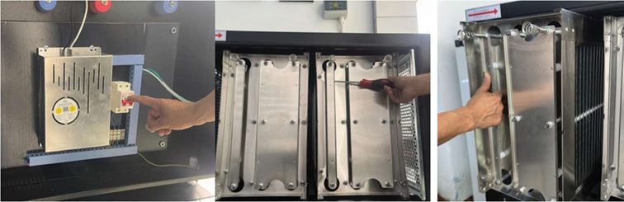

7.2 PERIODIC MAINTENANCE SCHEDULE
Maintenance task | Recommended frequency
Clean exterior stainless-steel surfaces | Daily
Inspect pre-oil separator and filters | Daily
Inspect oil collection tray | Daily
Check water level and contamination | Daily
Check Wet-Film water circulation | Daily
Inspect ESP filters for contamination | Weekly; authorized personnel
Clean ESP filters | According to contamination and approved method
Inspect oil-water separator | Weekly
Clean water tank | As required by contamination
Inspect water pump and connections | Monthly
Inspect fan and air duct | Monthly
Inspect electrical cabinet and connections | Periodically by authorized service
General technical maintenance | Every two months
Note: These intervals are recommendations. Increase frequency based on cooking intensity and operating hours; final maintenance intervals must be verified against the manufacturer-approved instructions.

7.3 PRE-OIL SEPARATOR AND FILTER CLEANING
- Switch off the unit and place it in a safe condition.
- Remove only those filters and oil collection parts that are approved for removal.
- Clean accumulated grease and dirt with a suitable degreaser compatible with the materials.
- Rinse only those parts for which rinsing is permitted by the manufacturer and dry them completely.
- Reinstall the parts in their correct positions.
WARNING: Do not use flammable solvents, corrosive chemicals or metal cleaning tools that could damage surfaces.

7.4 WET-FILM WATER SYSTEM MAINTENANCE
According to manufacturer data, the C3-2000 Wet-Film system recirculates water through an internal 75-litre tank.
- Check the water level and degree of contamination.
- Verify normal pump operation and ensure that the water distribution system is not blocked.
- Inspect hoses and connections for leakage.
- If the water is contaminated, drain it using the approved method; clean the tank and refill with clean water.
IMPORTANT: Never run the water pump dry. The manufacturer must separately confirm the mains-water supply and drainage arrangements.

7.5 OIL-WATER SEPARATOR MAINTENANCE
- Check the oil collection section for accumulated oil and transfer it to an appropriate waste container.
- Check the separator for blockages.
- Keep water away from electrical components during cleaning.
- Dispose of waste oil and contaminated water in accordance with applicable regulations.

7.6 ELECTROSTATIC PRECIPITATOR (ESP) MAINTENANCE
Grease and particles accumulated in ESP cells may reduce filtration performance and cause electrical faults. Removal and cleaning must be carried out by authorized technical personnel only.
- Disconnect the main power supply and prevent reconnection.
- Verify that high voltage has been safely discharged using the manufacturer-approved procedure.
- Remove the cells in accordance with the approved removal procedure.
- Soak the electrostatic collection assembly in detergent solution or washing-soda water for five minutes, then rinse away adhering dirt with water (as illustrated).
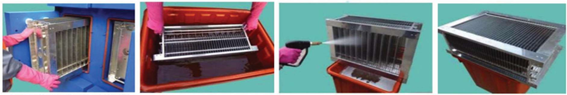
- Inspect for grease accumulation, electrode deformation and insulator damage.
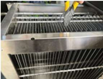
- Use only cleaning methods and chemicals approved by the manufacturer.
- Dry the cells completely; do not use damaged or deformed cells.
- Reinstall the cells correctly and close the service door.
PROHIBITED ACTIONS: Discharging with a screwdriver, using unapproved caustic soda/strong chemicals, pressure washing, straightening bent electrodes with pliers, or operating wet cells.

7.7 FAN AND AIR DUCT MAINTENANCE
- Check fan blades for grease and dirt buildup.
- Check for unusual noise or vibration.
- Keep air inlets and the lower outlet clean and unobstructed.
- Do not allow unauthorized work on fan-motor electrical connections.

7.8 POST-MAINTENANCE CHECKS
- Verify that all filters and components have been correctly reinstalled.
- Close all service doors.
- Check that the water level is correct and that no connections are leaking.
- Start the unit using the normal startup procedure.
- Check the fan, pump and ESP operating status and alarm indicators.

8. FAULTS AND TROUBLESHOOTING

8.1 GENERAL SAFETY WARNINGS
In the event of a fault, stop the unit safely. Only authorized technical personnel may access the electrical cabinet or ESP high-voltage system. Dangerous voltage may remain in ESP cells after power is disconnected. Never bypass protection or alarm systems.

8.2 POSSIBLE FAULTS AND REMEDIES
No. | Fault | Possible cause | Required action
1 | Unit will not start | No electrical supply | Check the external supply and accessible main switch.
2 | Unit will not start | Faulty circuit breaker or protective device | Contact a qualified electrician.
3 | Unit will not start | Control panel or connection fault | Arrange inspection by authorized service.
4 | Arcing or crackling from ESP | Dirty ESP cells | Stop the unit; have authorized personnel clean the cells.
5 | Arcing or crackling from ESP | Damp/wet ESP cells | Do not operate ESP; have authorized personnel inspect and dry cells completely.
6 | Arcing or crackling from ESP | Deformed electrode or foreign object | Authorized service inspection and replacement of parts as necessary.
7 | Arcing or crackling from ESP | Damaged insulator or high-voltage connection | Stop the unit and contact authorized service.
8 | ESP not operating | High-voltage power supply fault | Arrange inspection by authorized service.
9 | ESP not operating | Control signal or connection fault | Arrange inspection by authorized service.
10 | Insufficient air extraction | Dirty pre-oil separator or filters | Clean permitted filters according to maintenance instructions.
11 | Insufficient air extraction | Blocked extraction ducts | Stop the unit and check accessible openings.
12 | Insufficient air extraction | Reduced fan performance | Have authorized service inspect the fan.
13 | No air discharge | Fan not operating | Stop the unit and contact authorized service.
14 | No air discharge | Lower air outlet obstructed | With the unit stopped, check that the outlet is clear.
15 | Fan not operating | Motor, wiring or control fault | Arrange inspection by authorized service.
16 | Excessive noise or vibration | Dirty/damaged fan blades; loose connections | Stop the unit and call authorized service.
17 | Excessive noise or vibration | Unit not secured | Check floor stability and caster brakes.
18 | Dynamic oil separator not rotating | Motor or mechanical connection fault | Arrange inspection by authorized service.
19 | Dynamic oil separator rotating slowly | Grease buildup or mechanical resistance | Stop the unit and arrange maintenance.
20 | Wet-Film pump not operating | Insufficient water level | Check and top up water to the correct level.
21 | Wet-Film pump not operating | Pump motor or electrical fault | Arrange inspection by authorized service.
22 | Insufficient water circulation | Blocked distribution line or filter | Stop the unit and arrange maintenance.
23 | Insufficient water circulation | Reduced pump performance | Arrange inspection by authorized service.
24 | Water leakage | Loose hose or connection | Stop the unit and arrange a safe inspection.
25 | Water leakage | Damaged tank or connection component | Arrange inspection by authorized service.
26 | Oil-water separator not operating | Oil collection section full | Empty according to maintenance instructions.
27 | Oil-water separator not operating | Separator or drain line blocked | Arrange inspection by authorized service.
28 | Control panel alarm | Fan, ESP, pump or other system fault | Stop the unit safely; record the alarm and contact service.
Note: This table lists possible causes. Final diagnosis must be based on the manufacturer’s wiring diagram, control logic and service documentation.

8.3 SPECIAL WARNINGS FOR ESP FAULTS
Immediately stop the unit if persistent arcing, crackling or a burning smell occurs. Possible causes include grease buildup, wet cells, electrode deformation, damaged insulators, faulty high-voltage connections or power supply failure. Users must not adjust ESP high-voltage settings.

8.4 WET-FILM AND WATER SYSTEM FAULTS
Do not continue cooking if water circulation is insufficient. Stop the unit, check the water level and visible leaks, and record any control-panel alarm. Contact authorized service personnel if the problem persists. Never run the pump dry.

8.5 CONDITIONS REQUIRING AUTHORIZED SERVICE
Stop the unit and contact authorized service personnel in the event of electrical cabinet or ESP high-voltage faults, repeated circuit-breaker trips, arcing or burning smells, motor failures, automation problems, water leaks reaching electrical components or excessive vibration.
Symptom | Possible cause | First safe action
Unit does not operate | No power; protection tripped | Check supply and indicators; call authorized service
Fan does not rotate | Motor protection; mechanical blockage | Stop the unit; do not force a restart
ESP indicator off | Door interlock open; HV fault | Check covers; do not work on energized equipment
Poor fume capture | Clogged filter; insufficient fan airflow | After safe shutdown, clean filters and check fan
Crackling / arcing inside ESP | Dirty or damp cell; deformed electrode | Stop immediately; request authorized maintenance
Circuit breaker trips | Short circuit; insulation leakage | Do not repeatedly reset the breaker
Pump not operating | Low water level; pump blockage | Check water level; contact authorized service
Water leak | Loose seal or connection | Disconnect power; have leak corrected
Sharp ozone odor | ESP arcing / sealing problem | Stop unit, ventilate area and contact service
ALARM illuminated | Control system fault | Stop unit safely; request service assessment



GASTROTEK MÜHENDİSLİK HİZMETLERİ İNŞ. TAAH. TUR. TİC. LTD. ŞTİ.

Sales: +90 252 319 07 13-14
Greece: +30 22420-30060
Service: +90 542 740 66 33

SHOWROOM
Atatürk Bulvarı Protek İş Merkezi No 171-1 Konacık / Bodrum / Muğla

FACTORY
Atatürk Bulvarı Protek İş Merkezi No 173-2 Konacık / Bodrum / Muğla



info@borasco.net
www.borasco.net

