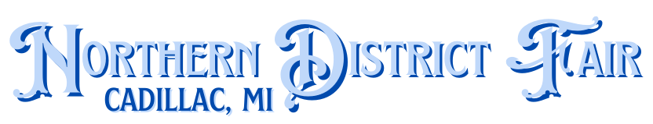
2026 MARKET TURKEY & CHICKEN ORDER FORM
NDF Youth Market Poultry Projects must be ordered through the Livestock Committee to be sold in the NDF livestock auction. Exhibitors may enter a pen of Three Broiler chickens with all selling at the auction. They may enter a pen of Four Cornish chickens with all selling at the auction. Turkey will be shown in a pen of Two with one selling at auction. It is recommended that you order and raise more than the minimum in case of sickness, faults, or fatalities. Having backup birds allows you to choose the best birds to exhibit.
PLEASE FILL OUT ALL OF THE FOLLOWING INFORMATION:
NAME OF YOUTH EXHIBITOR(s):
Due: Feb. 21st # of White Turkeys (min. 2): X $10.50 each =
# of Bronze Turkeys (min. 2): X $10.75 each =
Due: March 30th # of Freedom Ranger (min. 3): X $3.50 each =
Due: May 8th # of Broiler Chickens (min. 3): X $5.00 each =
# of Cornish Chickens (min. 4): X $5.00 each =
TOTAL DUE WITH ORDER:
By signing below, you acknowledge: You understand that chicks need to be given feed, water, and warmth as soon as possible. Also, you are solely responsible for picking up the birds by noon the day of arrival or risk forfeiting your ability to show birds at the NDF. The person picking up the birds will be contacted by phone or text when the birds arrive. Turkey pickup is expected March 30-April 03. Freedom Ranger pick up is expected June 1 - 5. Broiler pickup is expected June 12- 28. Cornish pick up is expected July 13-17.
Signature of Parent or Guardian: Person who will be picking up the order: Phone # for person picking up the birds:
Name of your organized club:
Name of club leader:
Payment: Checks Preferred. Make checks payable to Northern District Fair. Orders will not be placed until payment is made.
Mail completed forms with payment to: Northern District Fair, P.O. Box 131, Cadillac, MI 49601
Email forms: ndflivestock@gmail.com

