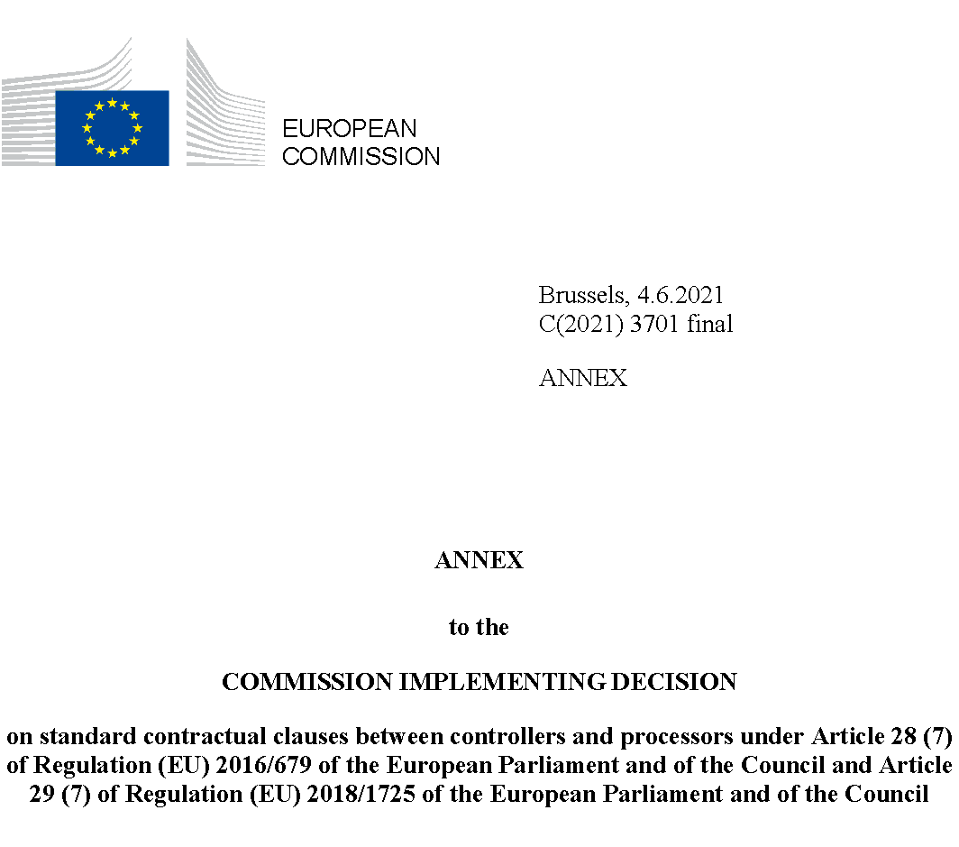
ANNEX

STANDARD CONTRACTUAL CLAUSES

SECTION I
Clause 1
Purpose and scope
(a) The purpose of these Standard Contractual Clauses (the Clauses) is to ensure compliance with [choose relevant option: OPTION 1: Article 28(3) and (4) of Regulation (EU) 2016/679 of the European Parliament and of the Council of 27 April 2016 on the protection of natural persons with regard to the processing of personal data and on the free movement of such data] / [OPTION 2: Article 29(3) and (4) of Regulation (EU) 2018/1725 of the European Parliament and of the Council of 23 October 2018 on the protection of natural persons with regard to the processing of personal data by the Union institutions, bodies, offices and agencies and on the free movement of such data].
(b) The controllers and processors listed in Annex I have agreed to these Clauses in order to ensure compliance with Article 28(3) and (4) of Regulation (EU) 2016/679 and/or Article 29 (3) and (4) Regulation (EU) 2018/1725.
(c) These Clauses apply to the processing of personal data as specified in Annex II.
(d) Annexes I to IV are an integral part of the Clauses.
(e) These Clauses are without prejudice to obligations to which the controller is subject by virtue of Regulation (EU) 2016/679 and/or Regulation (EU) 2018/1725.
(f) These Clauses do not by themselves ensure compliance with obligations related to international transfers in accordance with Chapter V of Regulation (EU) 2016/679 and/or Regulation (EU) 2018/1725.
Clause 2
Invariability of the Clauses
(a) The Parties undertake not to modify the Clauses, except for adding information to the Annexes or updating information in them.
(b) This does not prevent the Parties from including the standard contractual clauses laid down in these Clauses in a broader contract, or from adding other clauses or additional safeguards provided that they do not directly or indirectly contradict the Clauses or detract from the fundamental rights or freedoms of data subjects.
Clause 3
Interpretation
(a) Where these Clauses use the terms defined in Regulation (EU) 2016/679 or Regulation (EU) 2018/1725 respectively, those terms shall have the same meaning as in that Regulation.
(b) These Clauses shall be read and interpreted in the light of the provisions of Regulation (EU) 2016/679 or Regulation (EU) 2018/1725 respectively.
(c) These Clauses shall not be interpreted in a way that runs counter to the rights and obligations provided for in Regulation (EU) 2016/679 / Regulation (EU) 2018/1725 or in a way that prejudices the fundamental rights or freedoms of the data subjects.
Clause 4
Hierarchy
In the event of a contradiction between these Clauses and the provisions of related agreements between the Parties existing at the time when these Clauses are agreed or entered into thereafter, these Clauses shall prevail.
Clause 5 - Optional
Docking clause
(a) Any entity that is not a Party to these Clauses may, with the agreement of all the Parties, accede to these Clauses at any time as a controller or a processor by completing the Annexes and signing Annex I.
(b) Once the Annexes in (a) are completed and signed, the acceding entity shall be treated as a Party to these Clauses and have the rights and obligations of a controller or a processor, in accordance with its designation in Annex I.
(c) The acceding entity shall have no rights or obligations resulting from these Clauses from the period prior to becoming a Party.

SECTION II – OBLIGATIONS OF THE PARTIES
Clause 6
Description of processing(s)
The details of the processing operations, in particular the categories of personal data and the purposes of processing for which the personal data is processed on behalf of the controller, are specified in Annex II.
Clause7
Obligations of the Parties
7.1. Instructions
(a) The processor shall process personal data only on documented instructions from the controller, unless required to do so by Union or Member State law to which the processor is subject. In this case, the processor shall inform the controller of that legal requirement before processing, unless the law prohibits this on important grounds of public interest. Subsequent instructions may also be given by the controller throughout the duration of the processing of personal data. These instructions shall always be documented.
(b) The processor shall immediately inform the controller if, in the processor’s opinion, instructions given by the controller infringe Regulation (EU) 2016/679 / Regulation (EU) 2018/1725 or the applicable Union or Member State data protection provisions.

7.2. Purpose limitation
The processor shall process the personal data only for the specific purpose(s) of the processing, as set out in Annex II, unless it receives further instructions from the controller.

7.3. Duration of the processing of personal data
Processing by the processor shall only take place for the duration specified in Annex II.

7.4. Security of processing
(a) The processor shall at least implement the technical and organisational measures specified in Annex III to ensure the security of the personal data. This includes protecting the data against a breach of security leading to accidental or unlawful destruction, loss, alteration, unauthorised disclosure or access to the data (personal data breach). In assessing the appropriate level of security, the Parties shall take due account of the state of the art, the costs of implementation, the nature, scope, context and purposes of processing and the risks involved for the data subjects.
(b) The processor shall grant access to the personal data undergoing processing to members of its personnel only to the extent strictly necessary for implementing, managing and monitoring of the contract. The processor shall ensure that persons authorised to process the personal data received have committed themselves to confidentiality or are under an appropriate statutory obligation of confidentiality.

7.5. Sensitive data
If the processing involves personal data revealing racial or ethnic origin, political opinions, religious or philosophical beliefs, or trade union membership, genetic data or biometric data for the purpose of uniquely identifying a natural person, data concerning health or a person’s sex life or sexual orientation, or data relating to criminal convictions and offences (“sensitive data”), the processor shall apply specific restrictions and/or additional safeguards.

7.6 Documentation and compliance
(a) The Parties shall be able to demonstrate compliance with these Clauses.
(b) The processor shall deal promptly and adequately with inquiries from the controller about the processing of data in accordance with these Clauses.
(c) The processor shall make available to the controller all information necessary to demonstrate compliance with the obligations that are set out in these Clauses and stem directly from Regulation (EU) 2016/679 and/or Regulation (EU) 2018/1725. At the controller’s request, the processor shall also permit and contribute to audits of the processing activities covered by these Clauses, at reasonable intervals or if there are indications of non-compliance. In deciding on a review or an audit, the controller may take into account relevant certifications held by the processor.
(d) The controller may choose to conduct the audit by itself or mandate an independent auditor. Audits may also include inspections at the premises or physical facilities of the processor and shall, where appropriate, be carried out with reasonable notice.
(e) The Parties shall make the information referred to in this Clause, including the results of any audits, available to the competent supervisory authority/ies on request.

7.7. Use of sub-processors
(a) OPTION 1: PRIOR SPECIFIC AUTHORISATION: The processor shall not subcontract any of its processing operations performed on behalf of the controller in accordance with these Clauses to a sub-processor, without the controller’s prior specific written authorisation. The processor shall submit the request for specific authorisation at least [SPECIFY TIME PERIOD] prior to the engagement of the sub-processor in question, together with the information necessary to enable the controller to decide on the authorisation. The list of sub-processors authorised by the controller can be found in Annex IV. The Parties shall keep Annex IV up to date.
OPTION 2: GENERAL WRITTEN AUTHORISATION: The processor has the controller’s general authorisation for the engagement of sub-processors from an agreed list. The processor shall specifically inform in writing the controller of any intended changes of that list through the addition or replacement of sub-processors at least [SPECIFY TIME PERIOD] in advance, thereby giving the controller sufficient time to be able to object to such changes prior to the engagement of the concerned sub-processor(s). The processor shall provide the controller with the information necessary to enable the controller to exercise the right to object.
(b) Where the processor engages a sub-processor for carrying out specific processing activities (on behalf of the controller), it shall do so by way of a contract which imposes on the sub-processor, in substance, the same data protection obligations as the ones imposed on the data processor in accordance with these Clauses. The processor shall ensure that the sub-processor complies with the obligations to which the processor is subject pursuant to these Clauses and to Regulation (EU) 2016/679 and/or Regulation (EU) 2018/1725.
(c) At the controller’s request, the processor shall provide a copy of such a sub-processor agreement and any subsequent amendments to the controller. To the extent necessary to protect business secret or other confidential information, including personal data, the processor may redact the text of the agreement prior to sharing the copy.
(d) The processor shall remain fully responsible to the controller for the performance of the sub-processor’s obligations in accordance with its contract with the processor. The processor shall notify the controller of any failure by the sub-processor to fulfil its contractual obligations.
(e) The processor shall agree a third party beneficiary clause with the sub-processor whereby - in the event the processor has factually disappeared, ceased to exist in law or has become insolvent - the controller shall have the right to terminate the sub-processor contract and to instruct the sub-processor to erase or return the personal data.

7.8. International transfers
(a) Any transfer of data to a third country or an international organisation by the processor shall be done only on the basis of documented instructions from the controller or in order to fulfil a specific requirement under Union or Member State law to which the processor is subject and shall take place in compliance with Chapter V of Regulation (EU) 2016/679 or Regulation (EU) 2018/1725.
(b) The controller agrees that where the processor engages a sub-processor in accordance with Clause 7.7. for carrying out specific processing activities (on behalf of the controller) and those processing activities involve a transfer of personal data within the meaning of Chapter V of Regulation (EU) 2016/679, the processor and the sub-processor can ensure compliance with Chapter V of Regulation (EU) 2016/679 by using standard contractual clauses adopted by the Commission in accordance with of Article 46(2) of Regulation (EU) 2016/679, provided the conditions for the use of those standard contractual clauses are met.
Clause 8
Assistance to the controller
(a) The processor shall promptly notify the controller of any request it has received from the data subject. It shall not respond to the request itself, unless authorised to do so by the controller.
(b) The processor shall assist the controller in fulfilling its obligations to respond to data subjects’ requests to exercise their rights, taking into account the nature of the processing. In fulfilling its obligations in accordance with (a) and (b), the processor shall comply with the controller’s instructions
(c) In addition to the processor’s obligation to assist the controller pursuant to Clause 8(b), the processor shall furthermore assist the controller in ensuring compliance with the following obligations, taking into account the nature of the data processing and the information available to the processor:
(1) the obligation to carry out an assessment of the impact of the envisaged processing operations on the protection of personal data (a ‘data protection impact assessment’) where a type of processing is likely to result in a high risk to the rights and freedoms of natural persons;
(2) the obligation to consult the competent supervisory authority/ies prior to processing where a data protection impact assessment indicates that the processing would result in a high risk in the absence of measures taken by the controller to mitigate the risk;
(3) the obligation to ensure that personal data is accurate and up to date, by informing the controller without delay if the processor becomes aware that the personal data it is processing is inaccurate or has become outdated;
(4) the obligations in [OPTION 1] Article 32 Regulation (EU) 2016/679/ [OPTION 2] Articles 33, 36 to 38 Regulation (EU) 2018/1725.
(d) The Parties shall set out in Annex III the appropriate technical and organisational measures by which the processor is required to assist the controller in the application of this Clause as well as the scope and the extent of the assistance required.
Clause 9
Notification of personal data breach
In the event of a personal data breach, the processor shall cooperate with and assist the controller for the controller to comply with its obligations under Articles 33 and 34 Regulation (EU) 2016/679 or under Articles 34 and 35 Regulation (EU) 2018/1725, where applicable, taking into account the nature of processing and the information available to the processor.

9.1 Data breach concerning data processed by the controller
In the event of a personal data breach concerning data processed by the controller, the processor shall assist the controller:
(a) in notifying the personal data breach to the competent supervisory authority/ies, without undue delay after the controller has become aware of it, where relevant/(unless the personal data breach is unlikely to result in a risk to the rights and freedoms of natural persons);
(b) in obtaining the following information which, pursuant to [OPTION 1] Article 33(3) Regulation (EU) 2016/679/ [OPTION 2] Article 34(3) Regulation (EU) 2018/1725, shall be stated in the controller’s notification, and must at least include:
(1) the nature of the personal data including where possible, the categories and approximate number of data subjects concerned and the categories and approximate number of personal data records concerned;
(2) the likely consequences of the personal data breach;
(3) the measures taken or proposed to be taken by the controller to address the personal data breach, including, where appropriate, measures to mitigate its possible adverse effects.
Where, and insofar as, it is not possible to provide all this information at the same time, the initial notification shall contain the information then available and further information shall, as it becomes available, subsequently be provided without undue delay.
(c) in complying, pursuant to [OPTION 1] Article 34 Regulation (EU) 2016/679 / [OPTION 2] Article 35 Regulation (EU) 2018/1725, with the obligation to communicate without undue delay the personal data breach to the data subject, when the personal data breach is likely to result in a high risk to the rights and freedoms of natural persons.

9.2 Data breach concerning data processed by the processor
In the event of a personal data breach concerning data processed by the processor, the processor shall notify the controller without undue delay after the processor having become aware of the breach. Such notification shall contain, at least:
(a) a description of the nature of the breach (including, where possible, the categories and approximate number of data subjects and data records concerned);
(b) the details of a contact point where more information concerning the personal data breach can be obtained;
(c) its likely consequences and the measures taken or proposed to be taken to address the breach, including to mitigate its possible adverse effects.
Where, and insofar as, it is not possible to provide all this information at the same time, the initial notification shall contain the information then available and further information shall, as it becomes available, subsequently be provided without undue delay.
The Parties shall set out in Annex III all other elements to be provided by the processor when assisting the controller in the compliance with the controller’s obligations under [OPTION 1] Articles 33 and 34 of Regulation (EU) 2016/679 / [OPTION 2] Articles 34 and 35 of Regulation (EU) 2018/1725.

SECTION III – FINAL PROVISIONS
Clause 10
Non-compliance with the Clauses and termination
(a) Without prejudice to any provisions of Regulation (EU) 2016/679 and/or Regulation (EU) 2018/1725, in the event that the processor is in breach of its obligations under these Clauses, the controller may instruct the processor to suspend the processing of personal data until the latter complies with these Clauses or the contract is terminated. The processor shall promptly inform the controller in case it is unable to comply with these Clauses, for whatever reason.
(b) The controller shall be entitled to terminate the contract insofar as it concerns processing of personal data in accordance with these Clauses if:
(1) the processing of personal data by the processor has been suspended by the controller pursuant to point (a) and if compliance with these Clauses is not restored within a reasonable time and in any event within one month following suspension;
(2) the processor is in substantial or persistent breach of these Clauses or its obligations under Regulation (EU) 2016/679 and/or Regulation (EU) 2018/1725;
(3) the processor fails to comply with a binding decision of a competent court or the competent supervisory authority/ies regarding its obligations pursuant to these Clauses or to Regulation (EU) 2016/679 and/or Regulation (EU) 2018/1725.
(c) The processor shall be entitled to terminate the contract insofar as it concerns processing of personal data under these Clauses where, after having informed the controller that its instructions infringe applicable legal requirements in accordance with Clause 7.1 (b), the controller insists on compliance with the instructions.
(d) Following termination of the contract, the processor shall, at the choice of the controller, delete all personal data processed on behalf of the controller and certify to the controller that it has done so, or, return all the personal data to the controller and delete existing copies unless Union or Member State law requires storage of the personal data. Until the data is deleted or returned, the processor shall continue to ensure compliance with these Clauses.

ANNEX I LIST OF PARTIES

Controller(s): [Identity and contact details of the controller(s), and, where applicable, of the controller’s data protection officer]

1. Name: …
Address: …
Contact person’s name, position and contact details: …
Signature and accession date: …

2.
…

Processor(s): [Identity and contact details of the processor(s) and, where applicable, of the processor’s data protection officer]
1. Name: Atomic Jolt Inc.
Address: PO Box 4383, Logan, UT 84323
Contact person’s name, position and contact details: James Carbine, Security Officer, james.carbine@atomicjolt.com
Signature and accession date: [To be signed]

ANNEX II: DESCRIPTION OF THE PROCESSING

Categories of data subjects whose personal data is processed
- Students
- Instructors/Teachers

Categories of personal data processed
- Students/Instructors
  - Contact Information:
    - Atomic Search
      - LTI/LMS user ID
    - Atomic Assessments
      - LTI/LMS user ID
      - Full name
      - Scores
    - Atomic Polls
      - LTI/LMS user ID
      - Full name
    - Atomic Journals
      - LTI/LMS user ID
      - Full name
    - Atomic Discussions
      - LTI/LMS user ID
      - Full name
    - Atomic Curriculum Analysis Tool
      - LTI/LMS user ID
    - Atomic Reactor
      - LTI/LMS user ID
      - Full Name
    - Atomic Author
      - LTI/LMS user ID
    - Atomic Registrar
      - LTI/LMS user ID
    - Canvas LMS
      - Name, email address, phone number, address

Sensitive data processed (if applicable) and applied restrictions or safeguards that fully take into consideration the nature of the data and the risks involved, such as for instance strict purpose limitation, access restrictions (including access only for staff having followed specialised training), keeping a record of access to the data, restrictions for onward transfers or additional security measures.
None

The frequency of the transfer (e.g. whether the data is transferred on a one-off or continuous basis).
Data is continuously synced to servers within the same geographic region.

Nature of the processing
EU data is collected in the EU, and stored on Atomic Jolt servers with the physical geography of the EU. The data may also be accessed by individuals outside of the EU.
Australia data is collected in Australia, and stored on Atomic Jolt servers with the physical geography of Australia. The data may also be accessed by individuals outside of Australia.
US data is collected in the US, and stored on Atomic Jolt servers with the physical geography of the US.
Canada data is collected in Canada, and stored on Atomic Jolt servers with the physical geography of Canada. The data may also be accessed by individuals outside of Canada.

Purpose(s) of the data transfer and further processing
As an American company, Atomic Jolt’s principle operations are in the United States of America including customer support, development, and data hosting.

The period for which the personal data will be retained, or, if that is not possible, the criteria used to determine that period
The personal data is stored according to Atomic Jolt’s Retention Policy and Schedule. Data may also be removed on request by an individual in the European Union.

For transfers to (sub-) processors, also specify subject matter, nature and duration of the processing
The subprocessors used by Atomic Jolt extend to payment processing and cloud storage. These subprocessors retain only required data to perform the services needed.

Activities relevant to the data transferred under these Clauses:
Atomic Jolt provides
- Atomic Search
  - Allows easy keyword searches across content in an accessible way. Atomic Search is the first and only integrated LMS application with comprehensive search functionality. Search across all of your courses at once. Student search parameters can be configured to limit or expand search capabilities.
- Atomic Assessments
  - Measure learning better using Atomic Assessments over 40 interactive question types. Increase student engagement by embedding interactive activities in LMS pages. Generate assignments from item banks. Student accommodations can be created by overriding settings for specific students. Atomic Assessments is a full featured product that can be customized for publishers and schools by Atomic Jolt.
- Atomic Polls
  - Easily insert a poll in a discussion, page, assignment, syllabus, or even an announcement — anywhere that uses the Rich Content Editor. Polls allow teachers to select from a variety of advanced settings to facilitate flexible, dynamic class interactions.
- Atomic Journals
  - Atomic Journals allows teachers to effectively incorporate reflection into online learning by inserting writing prompts into course content where students can record their responses.
- Atomic Discussions
  - Increase student interaction around course content by inserting discussions into Canvas pages. Discussions help students connect with other students. Inserting discussions in pages allows students to interact with others around content similar to how they do on blogs and news websites.
- Atomic Curriculum Analysis Tool
  - Efficient and comprehensive searches across your Canvas, Brightspace, and Blackboard content.
- Atomic Reactor
  - Atomic Reactor is an AI-powered Learning Management System that transforms traditional education into engaging, TikTok-style content delivery with enterprise-grade features like LTI 1.3 integration and multi-tenant architecture.
- Atomic Author
  - Atomic Author helps you find and insert course content from multiple sources (Canvas Commons, Canvas Studio, your own Canvas courses) from a single search interface
- Atomic Registrar
  - Atomic Registrar is a tool for enabling public enrollment to Canvas courses, the capturing of demographic data, and the generation of custom reports for those courses
- Canvas LMS
  - Canvas is a modern, open-source Learning Management System (LMS) developed and maintained by Instructure Inc. It was established in 2010 and is used in many colleges, universities, and K-12 schools. It is released under the AGPLv3 license for use by anyone interested in learning more about or using learning management systems.

ANNEX III TECHNICAL AND ORGANISATIONAL MEASURES INCLUDING TECHNICAL AND ORGANISATIONAL MEASURES TO ENSURE THE SECURITY OF THE DATA
EXPLANATORY NOTE:
The technical and organisational measures need to be described concretely and not in a generic manner.

Description of the technical and organisational security measures implemented by the processor(s):

Security Standards

Atomic Jolt relies on guidance (and, as applicable, certification) from the technical security standards and frameworks below:

CIS Benchmarks (Centre for Internet Security)

NIST

ISO

SOC2

EDPB (European Data protection Board)

CSA CCM (Cloud Security Alliance Cloud Controls Matrix)

Data Management

Data is handled securely through the entire lifecycle including collection, access, transfer, analytics, retention and deletion.

Encryption standards – RSA 2048 or better for asymmetric key encryption and AES-256 or better for symmetric key encryption are followed.

All data is encrypted at rest (AES-256) and in transit (TLS 1.2 or 1.3).
- Data in transmission is protected via encryption when it leaves the private network (between the app server and the client browser).
- The data has been mapped and categorized. All data was reviewed as part of a PIA to ensure that only the minimum quantity of data is being collected. Additionally, sensitive data was reduced where possible.
- Data Retention is dictated by the Atomic Jolt Retention Policy and schedule.

Availability
- Disaster Recovery & Business Continuity are documented in the Atomic Jolt Contingency plan
- Back-ups - Account data is mirrored and regularly backed up off site.

Access Control
- User Identification and Authentication - With the exception of Canvas LMS, authentication is usually done using LTI. Canvas LMS can be configured to utilize SSO or password authentication. There is a logout based on inactivity.

Atomic Jolt’s corporate infrastructure relies on Google SSO to handle authentication management.

Application Security
- Atomic Jolt account passwords are hashed and salted.
- All login pages (from the website and mobile website) pass data via TLS.
- Atomic Jolt applications are encrypted with TLS.
- Login pages and logins via the Atomic Jolt API have brute force protection.
- Regular external penetration tests are performed throughout the year using different vendors. The tests include high-level server penetration tests, in-depth testing for vulnerabilities inside the application, and social engineering drills. Monthly external vulnerability scans. Continual image vulnerability scans. Continual code security scans.

Information Security

Atomic Jolt has Endpoint Detection and Response (EDR) solution for laptops.
- The Infrastructure team controls the provisioning of the servers using templates that have a default configuration based on the expected usage.

Atomic Jolt regularly patches its servers and performs vulnerability scanning on code during development as well as dynamic web scanning on the resulting applications.

Logging - Events are logged using AWS and other tools including Cloudtrail, Prometheus, Loki and Fluentbit.
- Our production network environment is segmented and centrally monitored.
- We have a dedicated internal security team that constantly monitors our environment for vulnerabilities. We engage with an independent third party to perform annual penetration testing exercises on our environment. Our security team includes OSCP and CISSP certified members.

Incident Response

Atomic Jolt has a robust Incident Response Plan and playbook that consists of a breadth of possible losses of integrity, confidentiality and availability. The plan is tested at least annually. In the event of a privacy breach, Atomic Jolt has a notification plan to ensure all parties receive the appropriate communication.

Governance
Information Security is governed by multiple policies and procedures including an overarching Information Security Policy.

Atomic Jolt continuously trains employees on best security practices, including how to identify social engineering, phishing scams, and hackers.
- Employees on teams that have access to customer data (such as tech support and our engineers) undergo criminal history and credit background checks prior to employment.
- All employees sign a Privacy Safeguard Agreement outlining their responsibility in protecting customer data.
- Annual third-party audits are performed against AICPA's Trust Service Criteria for Security, Confidentiality, Processing Integrity, Availability and Privacy.

Third Party Due Diligence
All third parties, or sub-processors, are assessed to meet or exceed the security standards set by Atomic Jolt. Sub-processors contracts and/or Terms and Conditions include privacy language which stipulate obligations for breach notification.

ANNEX IV: LIST OF SUB-PROCESSORS
EXPLANATORY NOTE:
For the purposes of Clause 7.7(a), the Parties confirm that the general written authorisation of sub-processors (Option 2) applies.
The controller grants the processor general authorisation to engage the sub-processors on the agreed list published at:
https://www.atomicjolt.com/legal/sub-processors

