Delp’s to Philadelphia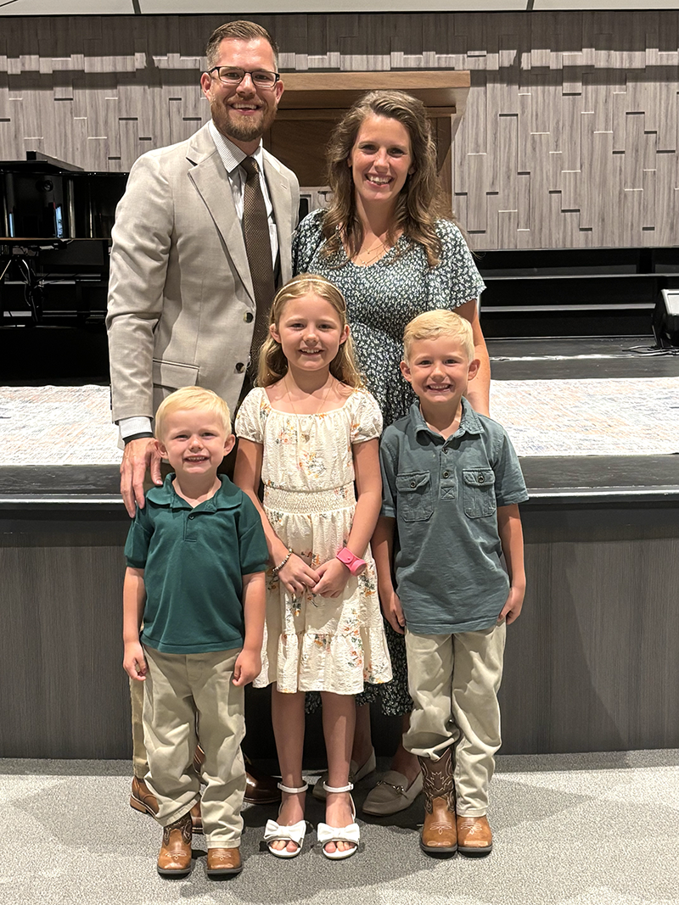

Dear Supporting Church,

God’s promises are true!

Our family began Deputation this past June. In these 3 months we have been in several churches throughout PA, NJ, VA and NC. We thank the Lord for His provision of good health and safety throughout our travels thus far, as well as His provision of several churches committing to take our family on for Support as part of their Missions Family.

Right now we are right around the 37% mark of our needed support. I have recently decreased my working hours at Chick-fil-A (King of Prussia, PA) to 30 hours per week (3 ten-hour days). The decrease in hours at CFA has helped with our travels and ministry work.

We are grateful to have the majority of September, October and November booked with Deputation Meetings. The Lord is faithful! His promises are true!

The plan is to begin a midweek Bible Study the first week of November 2025 and carry these midweek Bible Studies to when we have our Grand Opening—Sunday, March 1, 2026.

DIVINE APPOINTMENT FOR A BUILDING:

Some of you may know that we had been looking into renting a Methodist Church building right in the section of Philadelphia that we are planting the church in. Katie and I had stopped by this Methodist building a couple different times, but were unable to connect with anyone.

We stopped at another church building and found the pastor working in the backyard of the parsonage. After introducing ourselves and explaining our purpose in Church Planting, he asked us of any other buildings that we were interested in. We told him we were interested in the Methodist building. He then went on to tell us that he had the contact we needed and that he would introduce us via Group Text later that same day, and he did!

From that Group Text Intro we set up meetings. Each meeting has gone very well. The building is in great shape, it has exactly what we need and more. I even had the very unique opportunity of sharing with the Methodist Leadership my testimony and why I am a Baptist and not a Methodist. I thought this could be a deal-breaker, but the Lord blessed it…

We just heard back in regards to a Rental Agreement: We were blown away to hear that they are charging us ONLY $240 per month to rent their building for our midweek services from November through February. They plan to up the Rent to ONLY $1,000 per month in March when we begin Sunday services. TO GOD BE THE GLORY! His promises are true!

“Now unto Him that is able to do exceeding abundantly above all that we ask or think, according to the power that worketh in us, (21) Unto Him be glory in the church by Christ Jesus throughout all ages, world without end. Amen. (Ephesians 3:20-21)

GOSPEL PRAISE:

This past week I had the opportunity to preach for a Back-to-School Retreat at High Point Camp in PA. I attended this Christian Camp when I was a teenager in High School, but I was lost. Praise the Lord for 7 teens who responded to the Gospel for Salvation during the invitation! Jesus saves! His promises are true!

PRAYER REQUESTS:

\*Prayer for continual good health and safety over our family

\*Prayer for Katie’s Pregnancy with Baby #4 (Baby Girl Due Oct. 26th)

\*Prayer for more Monthly Support (currently at approximately 37%)

\*Prayer for God to put together a solid Church Plant Team for this work

\*Prayer for Door-to-Door Outreach, Mailers and Open-Air Gospel Meetings in Philly

\*Prayer for one-times financial gifts to come in to cover Rent, Gospel Literature, Outreach Materials, Signage, Billboard Rental, Sound Equipment and items for our Community Thanksgiving Dinner Outreach

Thank you so much for being one of our Supporting Churches! You are making a great impact for the cause of Christ, for the furtherance of the Gospel. He is worthy!

His promises are true!

Joe Delp

Acts 20:24

(267) 614-3834