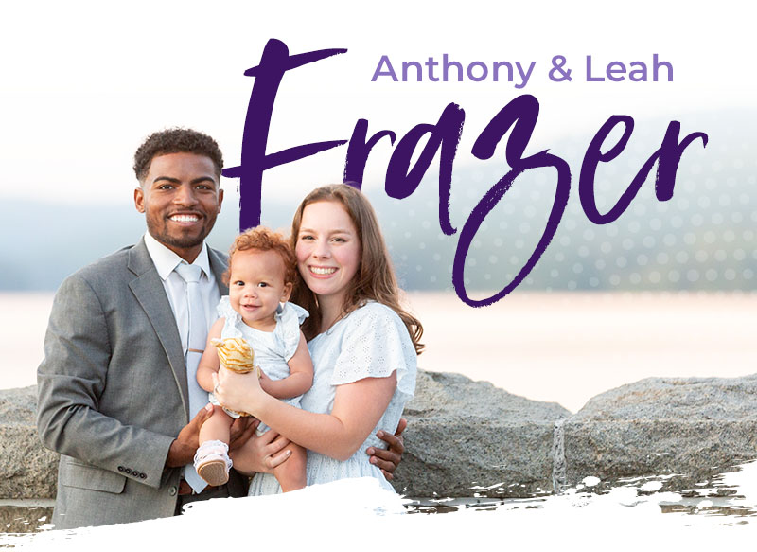

January / February Prayer Letter

Dear Praying Friends,

The first two months of the year have been full — full of travel, full of meetings, full of snow… and full of God’s faithfulness.

January Highlights

It has truly been a joy traveling. One of the unexpected blessings of deputation is not just visiting pastors and churches, but reconnecting with dear friends in the ministry. The fellowship along the way has strengthened our hearts more than we can say.

We were privileged to visit several wonderful churches throughout New England. Being close to home allowed me to go soul winning with a good friend, and we were able to see two individuals make professions of faith. There is nothing like watching God work in someone’s heart.

During the second week of January, I attended a church planting conference in Oklahoma. The Lord used that meeting to deeply encourage and steady my spirit. It was a timely reminder that the work we are called to is God’s work — and He is faithful to build His church.

The third week of January, our family traveled to North Carolina to present the ministry in a couple of churches there. We made it home just before the first major winter storm hit. Praise the Lord, none of our meetings were canceled! We were snowed in Monday and part of Tuesday, but it gave us unexpected family time together.

February Highlights

February kept us in New England the entire month, which allowed for a slightly slower pace and some much-needed rhythm for the kids’ sleep schedules.

We were especially grateful to be home for Valentine’s Day. Leah and I decided to make pasta from scratch — fettuccine Alfredo. Let’s just say… Leah was “in charge” and I was the enthusiastic assistant. (It is clear that church planting may be my calling — cooking is not!) It was sweet time together.

We were also able to connect with other families. I joined a few dads for fellowship while our wives enjoyed some kidless time together. It is a blessing to have meaningful fellowship so close to home during this season.

Another snowstorm came through, but once again the Lord protected our schedule. No meetings were canceled, and when we were snowed in, we were safely at home.

Later in the month, I attended a church planting conference in Memphis with a strong emphasis on reaching Black America. It was an incredible opportunity to meet pastors and leaders burdened for inner-city church planting. The connections made there will be invaluable as we prepare for Bridgeport.

A Special Provision

We also had to find a new doctor recently, and the Lord provided immediately. Leah found a practice run by believers that accepts our insurance. Adalee and Anthony had their first appointments, and we were so grateful for the care they received. Leah and I are even considering making them our primary care as well. God truly cares about the practical details of life.

Praises
- Pastor Stephen Rogers from Harvest Baptist Church in Hagerstown, MD, gifted us a bilingual Bible. We have been using it constantly as Leah and I continue working to learn Spanish. It has been an incredible help.
- Over the past two months, we have picked up four new supporting churches, bringing us to approximately 25% of our needed support. We are so thankful!
- The Hammonds (who will be joining us in planting City Baptist Church) have made a strong push in growing the Bible study they’ve started. It is exciting to see early groundwork being laid.

Prayer Requests
- A potential building opportunity in Bridgeport — pray for clear direction and open doors.
- I am going to be taking Pastor Pete Montoro’s inner-city church planting class in Astoria, Queens. Please pray the Lord would continue shaping and growing me through this training.
- Continued monthly financial support as we press toward full support.
- That the Holy Spirit would even now prepare hearts in Bridgeport for the gospel.
- Strength, unity, and wisdom for our family during this season of travel and preparation.

Thank you for standing with us. Your prayers, encouragement, and support mean more than you know. We are reminded constantly that we are not doing this alone — we are sent, and we are supported by faithful churches like yours.

Until all hear,
Anthony & Leah Frazer
Adalee (2) & Anthony III (6 months)
Church Planters to Bridgeport, CT
City Baptist Church
