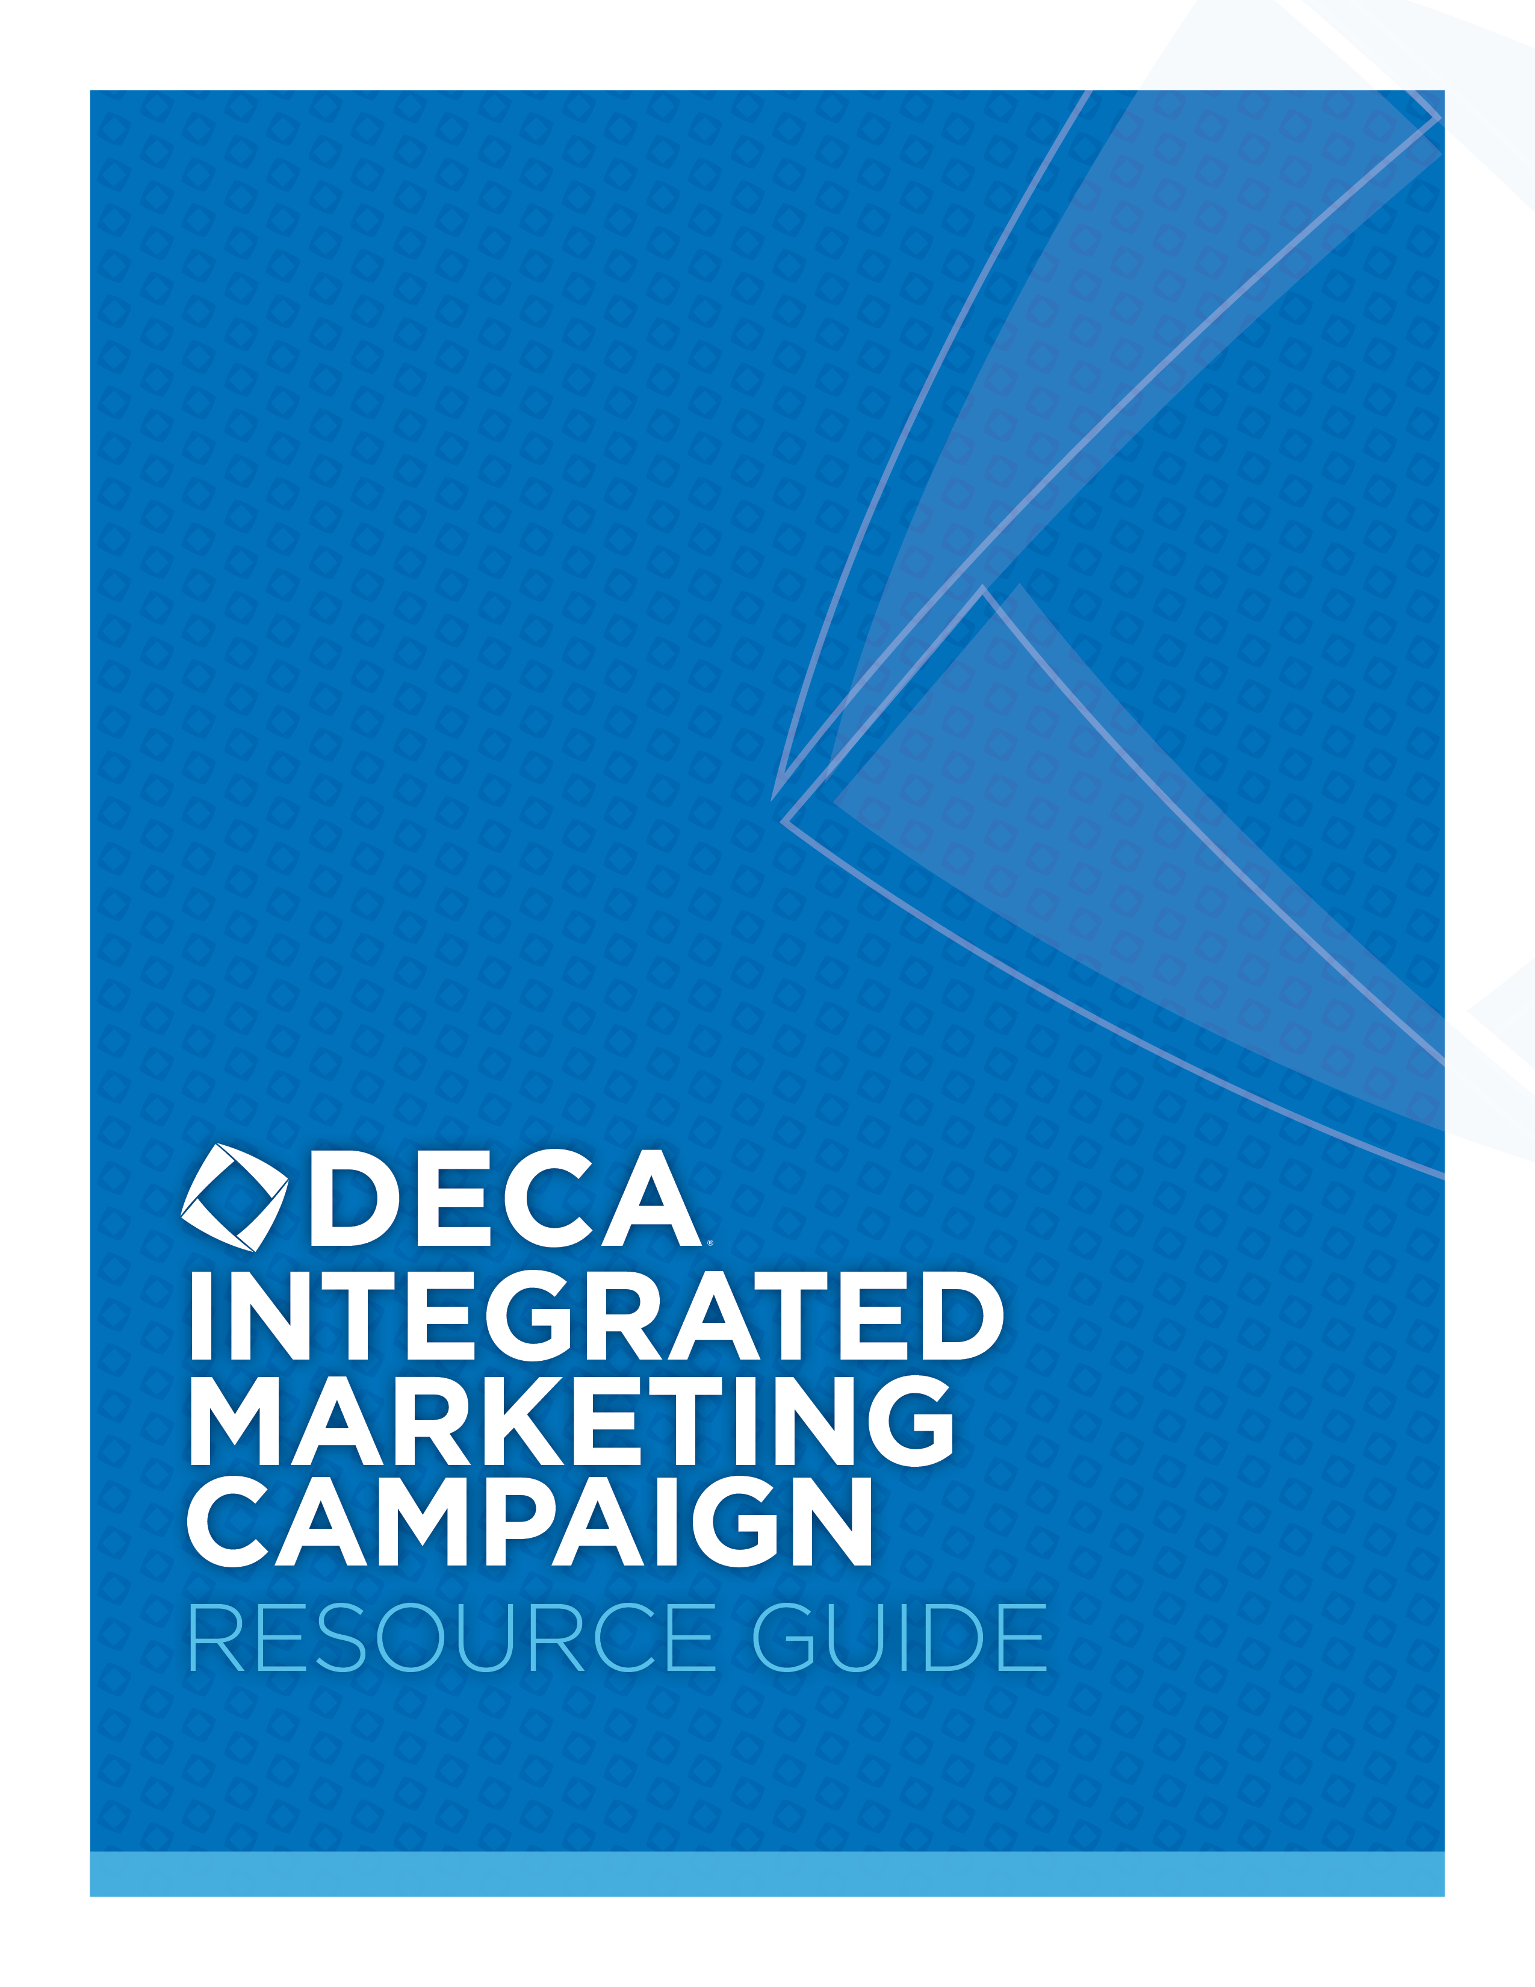
TABLE OF CONTENTS

INTRODUCTION 3

INSPIRATION 5

PROJECT KICK-OFF 6

RESEARCH 8

CAMPAIGN OBJECTIVES 9

CAMPAIGN TARGET MARKET 13

CAMPAIGN ACTIVITIES + SCHEDULE 16

BUDGET 20

KEY METRICS 21

EXECUTIVE SUMMARY 22

PRESENTATION 23

EVALUATION 24

BY KAREN BRETTINGEN
Contributing Industry Partners
- Jenna Krings Richardson, Senior Manager Campaign Strategy and Communications at Post Consumer Brands
- Ellen Brinn, Account Supervisor at Yamamoto
- Dominic Johnson, Media Supervisor at Nina Hale Performance Media
- Dillon Pomeroy, Digital Marketing Consultant
- Bernie Laur, Director of Digital Sales at Hubbard Interactive
Edited by Christopher Young, CAE, Chief Program Officer, DECA Inc.


1908 Association Drive
Reston, VA 20191

What is an Integrated Marketing Campaign?
Integrated Marketing is an approach to creating a unified and seamless experience for consumers to interact with the brand/enterprise; it attempts to meld all aspects of marketing communication such as advertising, sales promotion, public relations, direct marketing, and social media, through their respective mix of tactics, methods, channels, media, and activities, so that all work together as a unified force. It is a process designed to ensure that all messaging and communications strategies are consistent across all channels and are centered on the customer.

What are DECA’s Integrated Marketing Campaign Events?  The Integrated Marketing Campaign Events provide an opportunity for the participants to demonstrate promotional knowledge and skills needed by marketing personnel.  Participants in the Integrated Marketing Campaign Events will:  - develop an integrated marketing campaign of no more than 45 days in length for a real event, product, or service  - present the campaign in a role-play situation to a prospective client/advertiser  The guidelines for each of the Integrated Marketing Campaign Events are consolidated to facilitate coordination of participant activities in each of the campaign categories. This means the guidelines will be exactly the same for each campaign category. However, each campaign category will be treated separately as a competitive event.  - Integrated Marketing Campaign—Event includes a campaign that is related to any sports and entertainment event and/or company event. Examples include concerts, festivals, fairs, tournaments, pet adoption day, charity events, etc.  - Integrated Marketing Campaign—Product includes a campaign that is related to any hard/soft line retail products including e-commerce. Examples include apparel and accessories, retail products, etc.  - Integrated Marketing Campaign—Service includes a campaign that is related to any service or intangible product. Examples may include pet services, golf lessons, health care services, salons, restaurants, amusement parks, etc. |  | Knowledge and Skills Developed:  Participants will demonstrate knowledge and skills needed to address the components of the project as described in the content outline and evaluation forms.  Participants will also develop many 21st Century Skills, in the following categories, desired by today’s employers:  - Communication and Collaboration  - Creativity and Innovation  - Critical Thinking and Problem Solving  - Flexibility and Adaptability  - Information Literacy  - Initiative and Self-direction  - Leadership and Responsibility  - Media Literacy  - Productivity and Accountability  - Social and Cross-cultural Skills
Scoring Notes
This event consists of the written document, the cluster exam and the oral presentation. The maximum score for the written entry and presentation evaluation is 100 points. The combined written entry and presentation score will be weighted twice (2 times) the value of the exam score. The exam score carries forward into the final round of competition.

The Executive Summary is worth 10 points on the combined written entry and presentation score sheet. The purpose of the section titled Description of the Event, Product or Service is to help the judge understand what business/brand/organization he/she is representing. This is important as you are assuming the role of an agency that is presenting to the client so the judge needs to know the business before you present. In an actual agency presentation to a client, representatives often recap what they know of the business, including the business objectives and/or what they are trying to accomplish through marketing activities, the current business situation, and the brand’s/organization’s unique differentiator is in the marketplace. This lets the client know the agency understands their business situation and what the marketing activities will need to achieve to be successful.

Some people ask why the entire written proposal isn’t scored separately. A written proposal is often left with the client after a presentation. This allows the client to make reference to the proposal to clarify key points after the presentation is finished. The same is true with your written proposal. It is designed to be left with the judges (clients) to review points that may need further clarification after your presentation. From an educational perspective, it also allows you to organize and process your thoughts and ideas to deliver a dynamic presentation and impress your judge (client).
Consult the DECA Guide for the complete and most up-to-date guidelines.

“Don’t let what you know limit what you can imagine.” – Bill Taylor, Co-Founder of Fast Company
If you do what you’ve always done, you will get what you’ve always got! It’s important to spend time learning about how companies, organizations and brands are creatively marketing to engage and communicate with consumers to drive business results.
- What makes their marketing efforts stand out from their competition or how do they capture the attention of consumers?
- What makes them connect with consumers in a meaningful/relevant way?
- What is the clear message they are communicating?
- Do they communicate a consistent message across multiple platforms?

In addition to reviewing winning DECA Integrated Marketing Campaigns, you can read marketing periodicals such as AdAge and Marketing News, follow brand’s social media accounts, and pay attention to what’s happening in the marketplace to expand your learning and brainstorming capacity. Following are links to just a few places you can start looking.
- AdAge
- AdWeek
- Diaz, Ann-Christine. “The Best Digital, Integrated and Social Campaigns of 2018: A Countdown.” AdAge, 3 Jan. 2019.
- Marketing News
- Clio Award Winners The Clio Awards are an international awards competition for the creative business.
- Moat Pro As a non-member of this site you can enter a brand name and view many of their recent advertisements. It’s a great way to get a feel for brands that use a consistent theme (or not) in their advertising.

Performance Indicators:
- Plan project.
- Identify resources needed for project.
- Explain the use of advertising agencies.
- Foster client-agency relationship.

- Review the Event Guidelines
Review the DECA Guide for the most up-to-date guidelines for the Integrated Marketing Campaign Events. In addition, you should also refer to the Written Statement of Assurances and Penalty Point Checklist. Use these three documents to serve as your blueprint for this project.

- Staff Your Agency
DECA’s Integrated Marketing Campaign Events are composed of one to three members of the DECA chapter. In order to be successful, you’ll want to consider working individually or forming a team (up to three members) based on the following suggestions:
- Content Knowledge (exam is required for competition)
- Writing Skills
- Presentation Skills
- Communication
- Collaboration
- Creativity
- Critical Thinking
- Organizational Skills
You should also consider the need to schedule regular meetings to ensure your campaign is moving forward, so you will want to discuss meeting timelines, times and locations with your team to ensure a complete commitment from all.

- Select a Client
You’ll need to select a real event, product or service to develop a campaign. As you’re selecting a client here are a few items to consider:
  - Global Brand vs. Local Focus
  - Access to Information
  - Career Interests
  - Job Experience

- Specific Requirements
Review the Written Entry Guidelines and list any specific requirements that you feel important to highlight as you work throughout the project.

- Set Milestones
Based on your campaign due-date, you should work backwards to develop a schedule for when the components of the Integrated Marketing Campaign must be completed.

August
- Campaign Kick-Off

September

October

November

Final Due Date:

- Determine Roles/Responsibilities
You should research the roles of an agency and determine which team members will fulfill those major roles and responsibilities. You may also wish to identify additional resources, consultants and contacts with the client (if applicable).
Sample roles may include:
  - Account Executive
  - Account Manager
  - Account Planner
  - Media Planner
  - Creative Team

Team Member | Major Roles/Responsibilities

Additional Resources/Consultants/Client | Major Roles/Responsibilities

- Identify Resources Needed
You should also identify any additional resources needed to complete the project. This may include computer equipment, access to focus groups, online survey components, presentation materials, etc.
Performance Indicators:
- Gather brand information.
- Explain the nature of marketing research.
- Describe methods used to design marketing research studies.
- Describe data-collection methods.
Once you’ve selected the client you’d like to work with, it is important to conduct research on the business/brand to learn about their current business situation, what they’re trying to achieve through marketing activities, what they need to communicate and who they are trying to communicate with (who is their target consumer?). After you have conducted your initial client research, following are some sample questions you could use in a client interview to learn more.
Learn about the business/brand:
- What are three keywords you would use to describe your product/service/event?
- What is the history of the product/service/event? Do consumers have knowledge or connection with it, or is it new/not well known in the marketplace?
- Who do you believe to be your biggest competitors and how/why are you unique in comparison to the competition? What are your strengths and/or weaknesses in comparison to competitors? Why do your target consumers prefer you over your competition?
- What is your business objective? What are you trying to achieve to have a successful product/service/event?

Learn about the target consumer you need to reach with marketing activities:
- Describe your target market and/or the target consumer you would like to reach with your campaign? Demographics/psychographics? Who do you need to “talk” to and what do you need to say to them?
- How do you feel you have best communicated with your customers in the past?
- Where can you reach your consumer with a marketing message or connect with them--TV, radio, online/websites, social media, events, magazines, stores they shop at/where your product is available?
- Are consumers loyal to the brand? Or do consumers have and choose a variety of options?

Learn about the marketing challenge:
- What would you like to accomplish with this campaign? What are the goals? What does success look like?
- What campaigns have you done in the past? What’s worked well and why? What hasn’t worked well and why?
- What is your budget?

Performance Indicators:
- Compare business objectives with the expected use of the marketing-research outcomes.

AIDA is an acronym that marketers use to help them develop effective communication strategies and connect with customers in a way that better responds to their needs and desires. Credited to the American advertising and sales pioneer, Elias St. Elmo Lewis, the model originally applied mainly to advertising. AIDA describes a common list of events that occur when a consumer views an advertisement or other marketing communication. As marketing communication methods have evolved, the model has been used to encompass other marketing tools and channels as well.

The letters in the AIDA acronym stand for the following:
A represents attention or awareness, and the ability to attract the attention of the consumers.
I is interest and points to the ability to raise the interest of consumers by focusing on and demonstrating advantages and benefits (instead of focusing on features, as in traditional advertising).
D represents desire. The advertisement convinces consumers that they want and desire the product or service because it will satisfy their needs.
A is action. Consumers are led to take action by purchasing the product or service.
The system helps guide marketers to refine their objectives and clarify what they want to accomplish with a target segment. As campaign objectives become clearer, marketers gain insight into ways of refining their marketing messages and deciding which tools they can use to deliver these messages effectively.

The table below identifies typical campaign objectives associated with each stage of the AIDA model. Note that the largest group of prospective customers appears in the first stage of the model: Awareness. As the sales cycle progresses, a percentage of prospects is lost at each stage.
Awareness:  Build awareness to motivate further action | - Develop brand awareness and recognition  - Increase traffic to physical or virtual stores, Web sites, or other channels  - Remind customers about a brand, product, service or category
Interest:  Generate interest by informing about benefits; shaping perceptions | - Differentiate a product, stressing benefits and features not available from competitors  - Provide more information about the product or the service because information may be correlated with greater likelihood of purchase  - Increase demand for a specific product or a product category; generate enough interest to research further
Desire:  Create desire; move from “liking” to “wanting” | - Build brand equity by increasing customer perceptions of quality, desirability, and other brand attributes  - Stimulate trial, an important step in building new brands and rejuvenating stagnant brands  - Change or influence customer beliefs and attitudes about a brand, product, or category, ideally creating an emotional connection
Action:  Take action toward purchasing | - Reduce purchase risk to make prospective customers feel more comfortable buying a new or unfamiliar product or brand  - Encourage repeat purchases in the effort to increase usage and brand loyalty  - Increase sales and/or market share, with the goal of broadening reach within a time period, product category, or segment

It is best to always showcase/explain how you plan to achieve the specific objectives. So, share how you plan to develop brand awareness, change consumer beliefs, stimulate trial, etc. What marketing activities will help you achieve that objective?

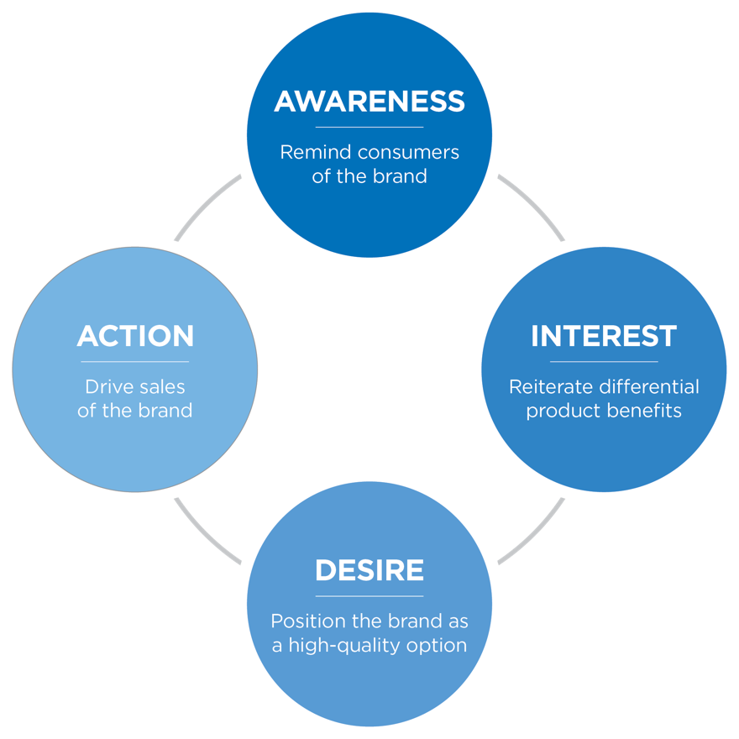

Industry Example
This example demonstrates specific campaign objectives a brand wishes to achieve through the marketing activities. First the brand needs to build brand awareness with their target consumer by reminding consumers of the brand. To accomplish this, the brand might advertise to reach their target consumer where their target consumer already spends time--watching TV, listening to the radio, magazines, social media, at sporting events, etc. with a message that brings the brand top-of-mind for the consumer.

Next, the brand needs to build interest by reiterating product benefits that are unique and different than competition. To do this, the brand might select one or two key benefits to communicate within the marketing messages/activities that are happening to build brand awareness.

Then the brand needs to generate desire by ensuring that the marketing activities and messages work to position the brand so it is perceived as a high quality option amongst competition. This can happen through selecting the right benefits to highlight in marketing communications, through public relations activity, and appearing in the right platforms that reiterate the position.

Finally, the brand needs to create action through activities that drive purchase of the brand/increase sales. The brand could accomplish this through providing incentives to drive sales (coupon, promotion, limited time offer, etc.).

USE THE AIDA MODEL WITH YOUR PRODUCT, SERVICE OR EVENT.

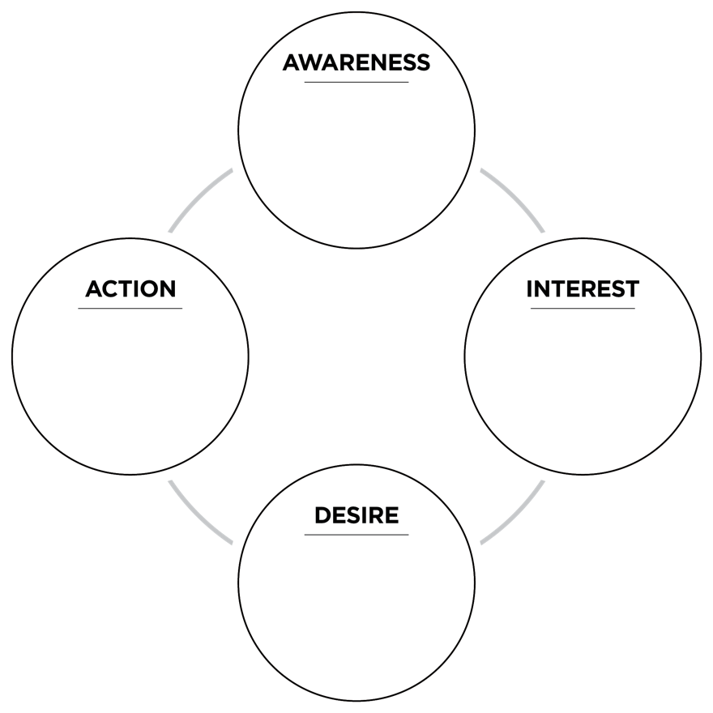
Performance Indicators:
- Explain the concept of market and market identification.
- Identify ways to segment markets for marketing communications.
- Describe the nature of target marketing in marketing communications.
This is the section of the project where you describe the consumer you are targeting with your campaign. It could be the organization’s entire target market, a specific market segment or a new market they are trying to capture.
PRIMARY TARGET MARKET: | SECONDARY TARGET MARKET:  (if applicable)
ADDITIONAL TARGET MARKETS:

Clients appreciate when an agency demonstrates an understanding of the target consumer before going into the creative process. While there are many ways to share the demographics and psychographics of the customers, agencies will often present them in the format of a customer profile.

INDUSTRY CUSTOMER PROFILE EXAMPLES

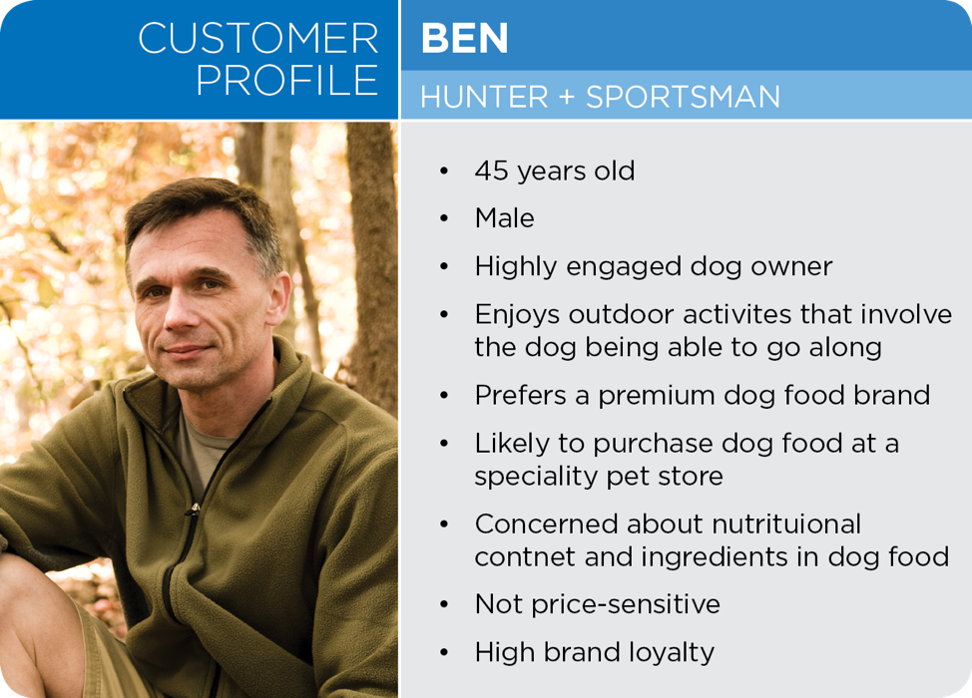

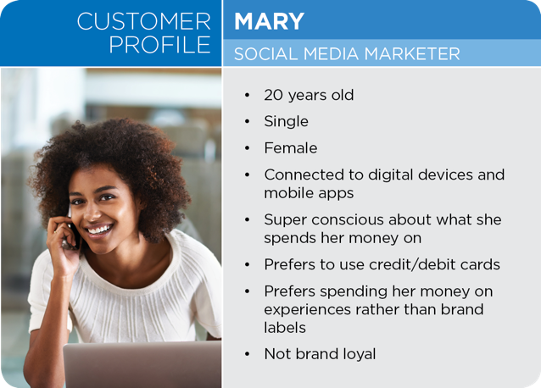

CREATE CUSTOMER PROFILES RELEVANT TO YOUR INTEGRATED MARKETING CAMPAIGN

[Insert PERSONA PHOTO] | [INSERT PERSONA NAME]
[Insert PERSONA PHOTO] | BACKGROUND:
[Insert PERSONA PHOTO] | DEMOGRAPHICS:
[Insert PERSONA PHOTO] | PSYCHOGRAPHICS:
[Insert PERSONA PHOTO] | LOYALTY:
[Insert PERSONA PHOTO] | PREFERRED COMMUNICATIONS:

[Insert PERSONA PHOTO] | [INSERT PERSONA NAME]
[Insert PERSONA PHOTO] | BACKGROUND:
[Insert PERSONA PHOTO] | DEMOGRAPHICS:
[Insert PERSONA PHOTO] | PSYCHOGRAPHICS:
[Insert PERSONA PHOTO] | LOYALTY:
[Insert PERSONA PHOTO] | PREFERRED COMMUNICATIONS:

Performance Indicators:
- Discuss the use of marketing/creative briefs.
- Employ communication styles appropriate to target audience.
- Understand promotional channels used to communicate with targeted audiences.
- Identify the elements of the promotional mix.

When developing your campaign activities, schedule and creative, consider your target market, and put the customer at the center using the customer personas you created.
- Where do they consume information?
- How do they want to consume information?
- How can you effectively use communication styles appropriate to your target audience?

ACTIVITIES
Determine your Campaign Theme: A campaign theme is designed to unify the look and feel of your campaign as well as the messaging. This might include items such as your design elements, slogan, and visuals. There are many iconic brands that have strong, well-known campaign themes. You can probably think of some off the top of your head! They’ve accomplished this through their marketing activities and having a holistic, cohesive message and campaign theme that comes to life in all their marketing activities. Take a look at a brand’s social media, websites, TV ads, billboards, etc. to identify the unifying campaign theme.

Developing a Creative Brief: Before you develop the campaign’s high-quality creative samples of key marketing pieces suggested, you should develop a creative brief for the campaign. The creative brief is a narrative that not only explains the theme but explains how the entire campaign should look and feel as well as the desired action. The creative brief should include key information to help the creative team develop their deliverables.

Creative Brief

Target Market
Objectives
Big Idea/Theme
Strategies
Budget

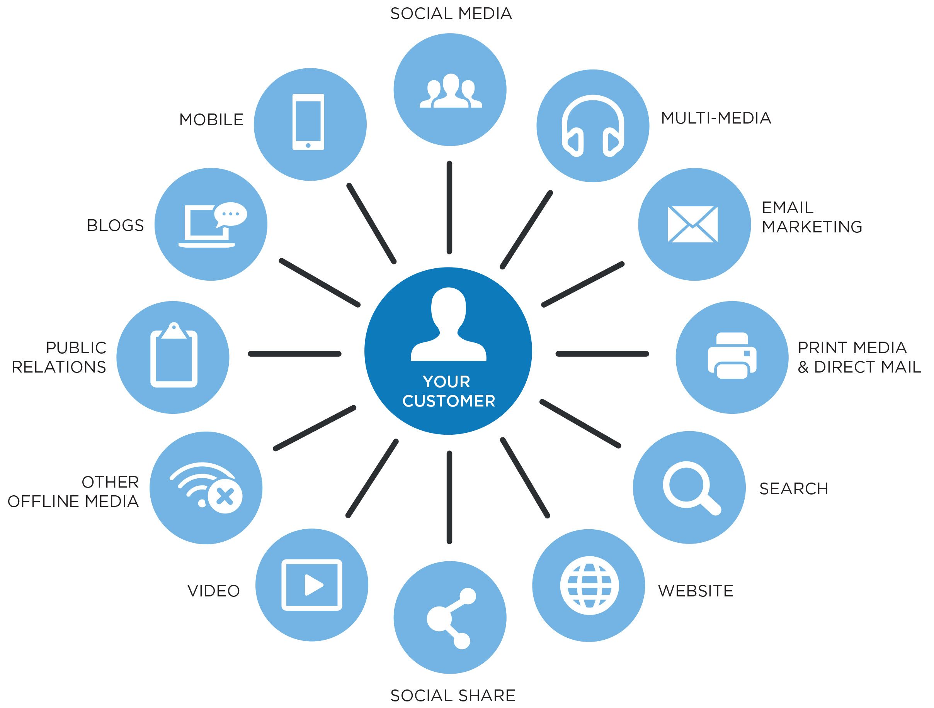

Develop your Promotional Mix: Consider all areas of the promotional mix including advertising, sales promotion, public relations, direct marketing and personal selling to determine the most effective way to capture the customer’s attention. Use current sources to learn about trends and methods. Following are a couple of source ideas to get you started.
- 11 Trends that will shape Marketing in 2019 by Forbes Agency Council
- The following presentations have been made available for your learning compliments of Hubbard Interactive, a full-service marketing agency in Minnesota.
- Facebook Advertising 101
- Facebook Basics for Business
- How to use Social Media to Help Market your Event
- Influencer Marketing
- Facebook for Business
- Twitter for Business
- Instagram for Business
SCHEDULE
Campaign schedules are typically displayed using some type of Gantt Chart methodology. While there are programs designed to create these charts to manage a timeline, they can easily be created using a spreadsheet or slide program. The campaign itself should be no longer than 45 days.

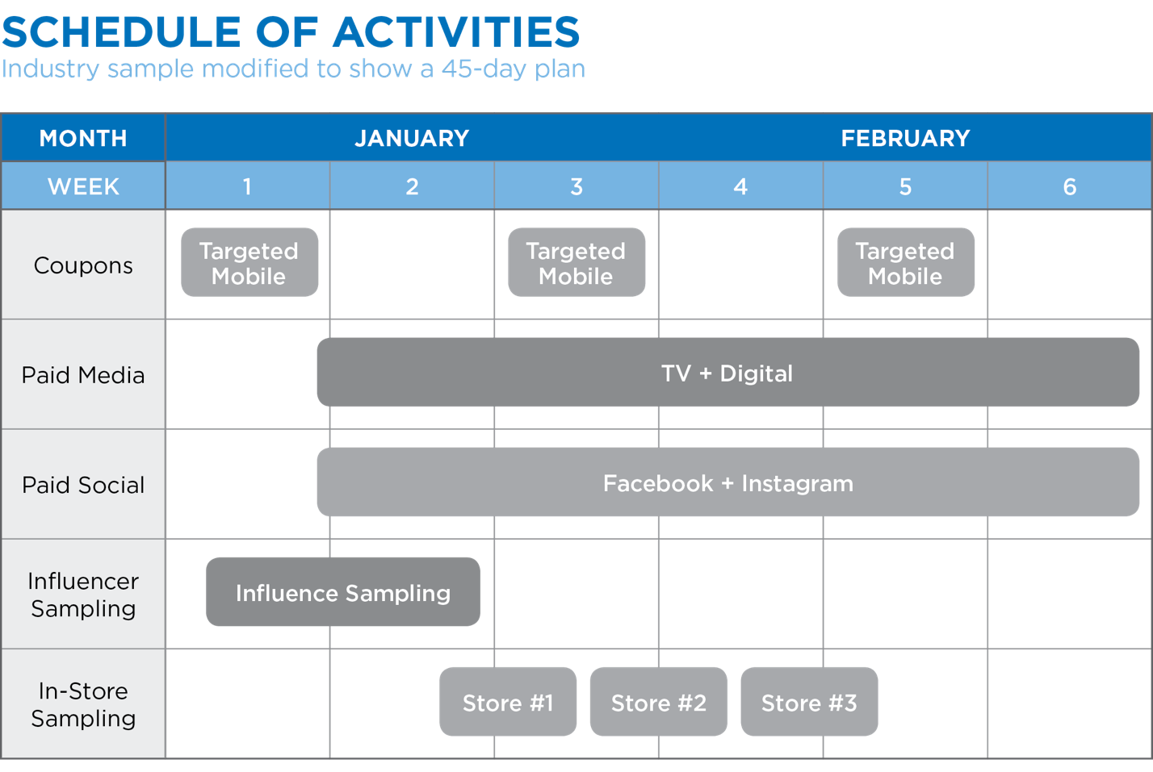

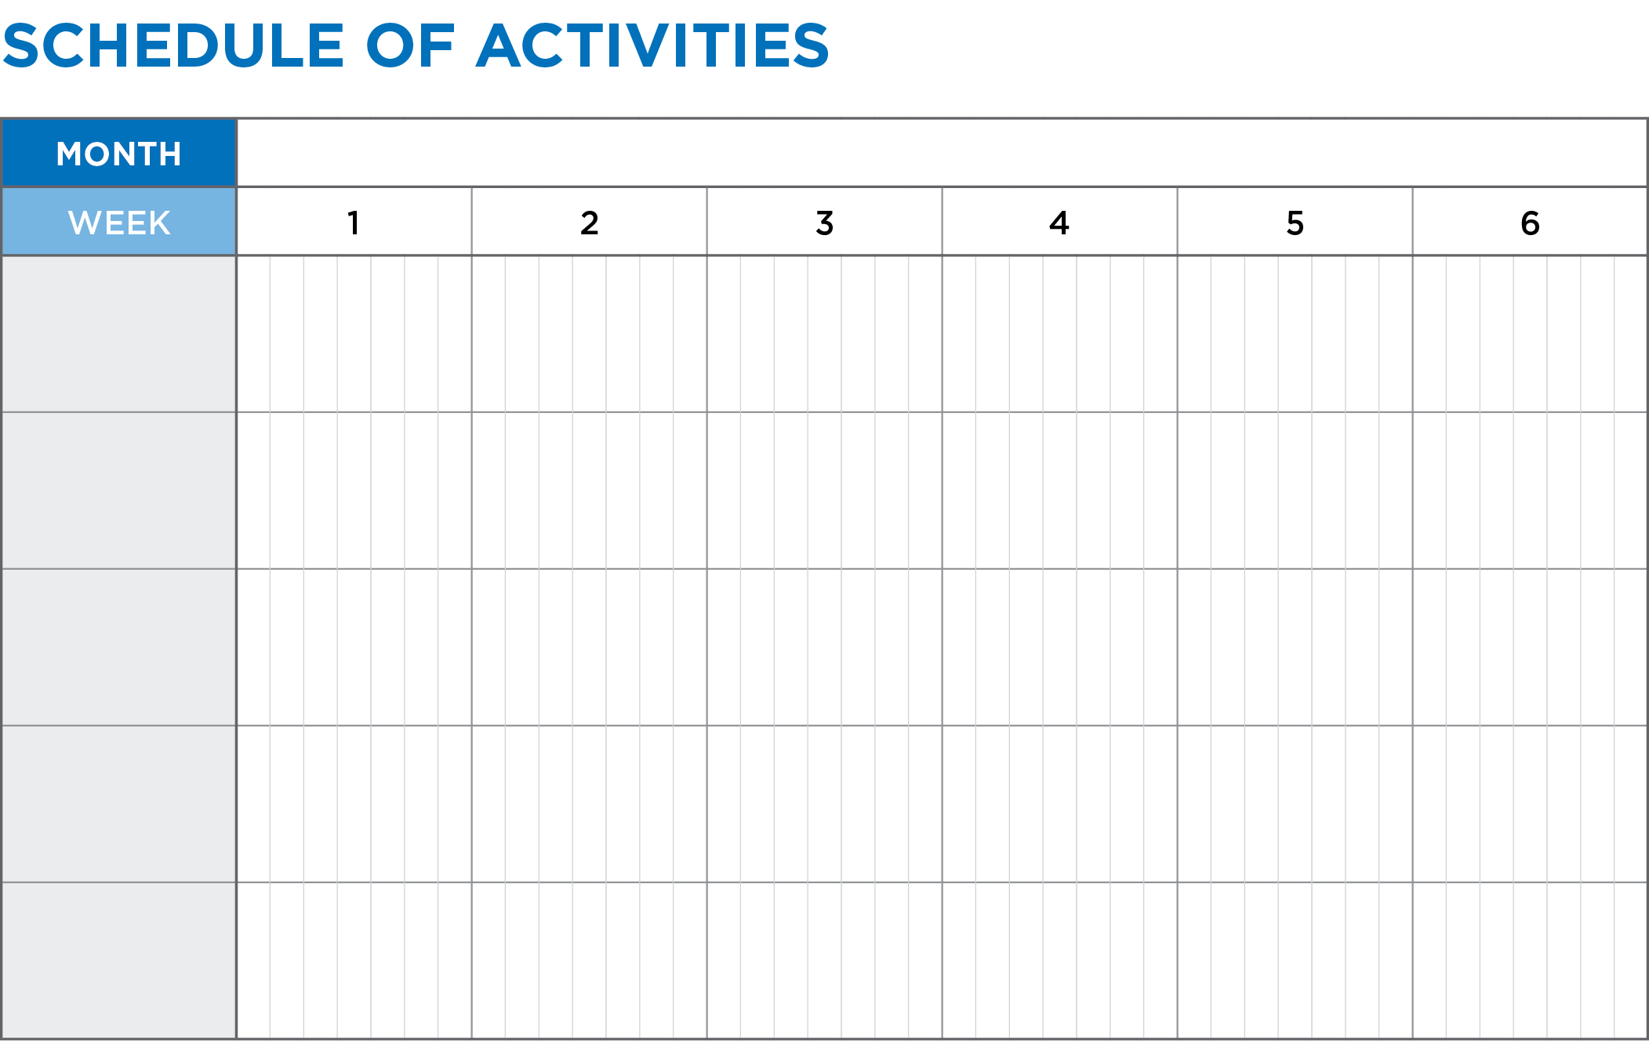

Performance Indicators:
- Describe the nature of budgets.
- Determine advertising reach of media.
- Choose appropriate media outlets.
- Calculate media costs.

After gathering all of the costs associated with your campaign, you can present the information using a simple spreadsheet. There are also free budget templates you can review and download to learn more about how to present this information in a professional manner. Smart Sheet has 12 Free Marketing Budget Templates you can download to learn and/or use.

Other budget calculations to consider for use as key metrics:
Return on Investment (ROI) is a basic calculation of the overall dollar value returned by the initiative.

ROI = Revenue - Marketing Spend

For example, if you spend $2500 on your campaign and earn $5000 in revenue, your ROI is $2500 or 100%

The simple ROI is easy to do, but it is loaded with a pretty big assumption. It assumes that the total month-over-month sales growth is directly attributable to the marketing campaign. For the marketing ROI to have any real meaning, it is vital to have comparisons. Monthly comparisons – particularly, the sales from the business line in the months prior to the campaign launching – can help show the impact more clearly.

Calculating Customer Lifetime Value
If your goal is to attract new customers, you may also want to measure what the new customer is worth. Customer lifetime value is the metric that indicates the total revenue a business can reasonably expect from a single customer account. It considers a customer's revenue value, and compares that number to the company's predicted customer lifespan. Businesses use this metric to identify significant customer segments that are the most valuable to the company.

Following are several sources to help you learn more:

Beattie, Andrew. “How to Calculate the Return on Investment (ROI) of a Marketing Campaign.” Investopedia, Investopedia, 12 Mar. 2019, www.investopedia.com/articles/personal-finance/053015/how-calculate-roi-marketing-campaign.asp.

Fontanella, Clint. “How to Calculate Customer Lifetime Value.” HubSpot Blog, http://blog.hubspot.com/service/how-to-calculate-customer-lifetime-value.

Performance Indicators:
- Describe the need for marketing data.
- Identify data monitored for marketing decision making.
- Track performance of promotional activities.
- Monitor/measure customer “buzz.”
- Track trends (e.g., social, buying, social media, advertising agency, etc.).
- Analyze customer behavior (e.g., media-consumption, buying, etc.).
- Data mine clickstream data using web analytics for marketing information.
- Monitor and mine sales data (by volume, product, territory, channel, time period, etc.).
- Identify transactional data through electronic means (e.g., bar coding, optical scanners, automatic replenishment systems, electronic data interchange [EDI], and reader-sorters).

Key Metrics, also known as Key Performance Indicators, are a quantifiable measure used to evaluate the success of an organization in meeting objectives for performance.

Common Key Metrics:
- Impressions: the number of times a consumer sees your message/content
- Reach: the number of unique people who see your content
- Engagement: the number of interactions people have with your posts such as likes, comments, shares, retweets, etc.
- Landing page views: the number of times your website is visited by driving consumers to the landing page (through digital banner ads, social media posts, etc.)
- Click through rates: measures the number of clicks that advertisers receive on their ads per number of impressions
- Trial (measured through sales of product)
- Ad recall (specific to television): Do consumers remember the ad, and more specifically, do they remember the brand featured in the advertisement
- Generating leads
- Number of new versus repeat site visits

Metrics Specific To Events:
- Ticket sales
- Event check-ins: the number of people who actually attended the event
- Social media engagement: the number of people who shared messages or images from your event or tagged your location on a picture
- Attendee or sponsor satisfaction: many event planners use a Net Promoter Score to measure this satisfaction
- Customer loyalty

Performance Indicators:
- Write executive summaries.

“The job of the executive summary is to sell, not to describe.” – Guy Kawasaki. The executive summary is your first impression with a judge, so you want to make sure the most important elements to pitching your campaign are included. Often, it is best to write the executive summary last so that you can identify the most relevant components to include. The executive summary should be persuasive and compelling enough to make the reader want to continue through the remaining written entry, but contain enough information to make an informed decision should the reader not.

Identify the most important components of your Integrated Marketing Campaign to include in your executive summary:

After you have drafted your executive summary, consider the following:
- If a person only read this section of the written entry, would s/he understand the premise of the paper and the recommendations that are included?
- Have you provided the appropriate data and metrics to support your campaign?
- Is the executive summary clear and coherent and free of any spelling and grammatical errors?
- Is the executive summary graphically appealing?
Performance Indicators:
- Make client presentations (includes strategies and research findings).

You have 15 minutes to make your pitch to your prospective client (judge), which includes time for any questions the prospective client (judge) may have.
- How will you organize your information?
- What information is the most important to share and what in your written entry can you reference to?
- What are the most compelling visuals to use?
- How will you end your presentation?

Storyboard

1 |  | 2 |  | 3
4 |  | 5 |  | 6
7 |  | 8 |  | 9

Anticipate Questions
What questions may your prospective client (judge) ask?

Overall Presentation
In addition to your content, you’ll be evaluated on these overall performance items: professional appearance, poise, confidence, presentation technique, effective use of visuals, professionalism of participants, participation by each participant.

What will set your presentation apart from the rest?
Performance Indicators:
- Edit and revise written work consistent with professional standards.

Once you have completed your written entry and your presentation, review the criteria below to ensure you have addressed each item. These items are part of the competitive events evaluation form, so if you believe items are missing or need improvement, revisit your written entry and presentation and improve those areas. You may also wish to ask consultants to read your written entry and/or listen to your presentation against the criteria and provide feedback. Often, that is the best way to determine if your written entry and presentation are clearly understood by someone other than you as the project creator(s).

In addition, you should edit and revise your written work so that it is well-organized, professional, logical and error free.

Executive Summary: One-page description provides a clear overview of the campaign | □ YES | □ NO
The description of the event, product or service, and business is clearly defined | □ YES | □ NO
Objectives are defined and referenced throughout the campaign.  The campaign activities are realistic, show evidence of marketing knowledge, and are research based | □ YES | □ NO
Unifying theme is evident in all campaign activities | □ YES | □ NO
Provides high-quality appropriate and creative samples of key marketing pieces suggested | □ YES | □ NO
Campaign schedule is cohesive and plan is no more than 45 days long | □ YES | □ NO
The budget is realistic for the campaign and all costs that would be incurred have been considered | □ YES | □ NO
Key metrics are well thought out and appropriate for the campaign | □ YES | □ NO
The campaign shows evidence of creativity and originality | □ YES | □ NO
The written entry is well-organized, professional, and presented in a logical manner | □ YES | □ NO

Checked the Written Entry against the Written Entry Guidelines | □ YES | □ NO
Checked the Written Entry against the Penalty Point Checklist | □ YES | □ NO
Reviewed, signed and included the Statement of Assurances | □ YES | □ NO

“Integrated Marketing Definitions - Definition of Integrated Marketing.” Thedma.org, thedma.org/integrated-marketing-community/integrated-marketing-definitions/.
Learning, Lumen. “Principles of Marketing [Deprecated].” Lumen, courses.lumenlearning.com/marketing-spring2016/chapter/reading-determining-imc-objectives-and-approach/.
Katz, Jess. “7 KPIs First Time Event Planners Should Be Measuring.” Convene, Convene - The Easiest Place to Meet and Work, 23 Apr. 2018, convene.com/catalyst/first-time-event-planners-kpis/.

