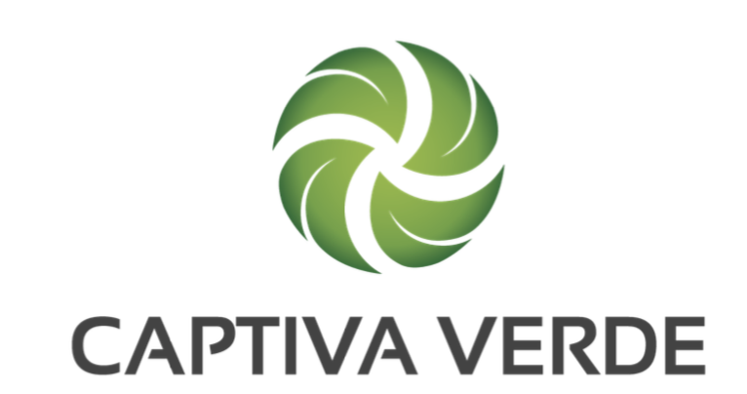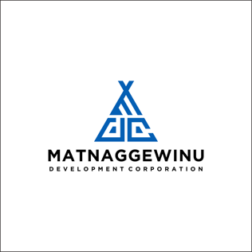

CAPTIVA VERDE AND MATNAGGEWINU DEVELOPMENT CORP (MDC) WELCOME TRAVIS NABAHE TO THE ADVISORY BOARD

Vancouver, British Columbia (March 18th, 2025) – Captiva Verde Wellness Corp. (CSE: PWR) (OTC: CPIVF) (“Captiva Verde”) a public company listed on the Canadian Securities Exchange under the trading symbol PWR and further listed on the US OTC Market under the trading symbol CPIVF announces that both Captiva Verde and Matnaggewinu Development Corp (MDC) welcome the appointment of Travis Nabahe, MBA, JD to the Advisory Board of Directors.
A seasoned business development executive, Mr. Nabahe brings over 25 years of experience across multiple industries, including real estate, retail, gaming, hospitality, art, manufacturing, food & beverage, construction, and energy. An enrolled member of the Lone Pine Paiute-Shoshone Tribe, with affiliations to the Shoshone, Paiute, and Navajo Nations, Mr. Nabahe has dedicated his career to Indigenous economic empowerment and strategic business growth. His vast expertise in corporate structuring, investment strategy, and high-value negotiations makes him a key addition to MDC’s leadership team. Mr. Nabahe holds both an MBA and a JD (law degree) from the University of Arizona, equipping him with a unique combination of business acumen and legal expertise.
Travis has held leadership positions across multiple Indigenous economic development organizations, including serving as General Manager for the Reno-Sparks Indian Tribe's Three Nations Management Corporation, Executive Director for the Pascua Yaqui Tribe, and CEO of Island Enterprises, Inc. Currently, he serves as Director of the Bishop Paiute Development Corporation (BPDC), where he oversees economic development initiatives, and sits on the Board of the Pueblo of Laguna Utility Authority, supporting infrastructure advancements. As an Advisory Board Member at Matnaggewinu Development Corporation (MDC), Mr. Nabahe will play a pivotal role in business development, investment strategy, and procurement partnerships. His leadership will ensure MDC advances Indigenous economic opportunities, expands into government and private-sector markets, and fosters sustainable growth. His expertise in mergers & acquisitions, due diligence, and corporate expansion will further MDC’s mission to drive innovation, sustainability, and Indigenous enterprise development. "We are honored to welcome Travis Nabahe to our board," said Nowlan Augustine. "His proven track record of leadership and deep commitment to Indigenous economic growth will be invaluable as we continue to strengthen our business strategy and expand MDC’s impact."
About Matnaggewinu Development Corp (MDC)
Matnaggewinu Development Corp (MDC) is a Mi’kmaq-led development corporation that focuses on advancing economic opportunities, fostering self-sufficiency, and supporting Mi’kmaq communities through initiatives in affordable housing, health and wellness, aerospace, defense, and sustainable infrastructure development. Founded by Nowlen Augustine, MDC is dedicated to creating long-term, sustainable economic growth for Indigenous communities. MDC is 49% owned by Captiva Verde.
About Captiva Verde Wellness Corp.
Captiva Verde Wellness Corp. (CSE: PWR) (OTC: CPIVF) is a publicly traded company listed on the Canadian Securities Exchange and the US OTC Market. The company focuses on sustainable housing, health, and wellness initiatives in Indigenous communities and is expanding into aerospace, defense, and space systems. Captiva Verde partners with organizations like MDC to promote economic reconciliation and self-sufficiency.
On Behalf of the Board of Directors
“Jeff Ciachurski”
Jeffrey Ciachurski
Chief Executive Officer and Director
Cell: (949) 903-5906
E-mail: westernwind@shaw.ca
Neither the Canadian Securities Exchange nor its regulation services provider accepts responsibility for the adequacy or accuracy of this release.
Cautionary Note Regarding Forward Looking Information
This news release includes “forward-looking statements” and “forward-looking information” within the meaning of Canadian securities laws and United States securities laws (together, “forward-looking statements”). All statements included in this news release, other than statements of historical fact, are forward-looking statements including, without limitation, statements with respect to the expansion of Captiva’s health and wellness platform.
Forward-looking statements include predictions, projections and forecasts and are often, but not always, identified by the use of words such as “anticipate”, “believe”, “plan”, “estimate”, “expect”, “potential”, “target”, “budget”, “propose” and “intend” and statements that an event or result “may”, “will”, “should”, “could” or “might” occur or be achieved and other similar expressions and includes the negatives thereof.
Forward-looking statements are based on a number of assumptions and estimates that, while considered reasonable by management based on the business and markets in which the Company operates, are inherently subject to significant operational, economic, and competitive uncertainties, risks and contingencies. These include assumptions regarding, among other things: general business and economic conditions. There can be no assurance that forward-looking statements will prove to be accurate and actual results, and future events could differ materially from those anticipated in such statements. Important factors that could cause actual results to differ materially from the Company’s expectations include those described under the heading “Risks and Uncertainties” in the Company's most recently filed MD&A (a copy of which is available under the Company’s SEDAR profile at www.sedar.com). The Company does not undertake to update or revise any forward-looking statements, except in accordance with applicable law.

