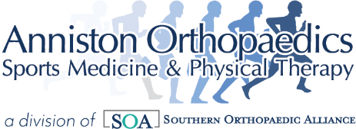

Dear Patient:
Thank you for contacting Anniston Orthopaedics Sports Medicine & Physical Therapy Medical
Records Department. To better serve you with your request for medical records, Anniston Orthopaedics Sports Medicine & Physical Therapy has partnered with Sharecare. Sharecare will fulfill your request for records in a safe, secure, and timely manner.

To receive a copy of your records, you will need to complete and return the attached
Authorization form. Please make sure you have specific instructions included as to what records you are requesting and where you are requesting records to be sent. You also have a choice of how you would like to have your records delivered. For records to be delivered directly to you, please choose mail or email. Please fax the completed Authorization form to Sharecare.

Please fax to (866)920-3647. Please include a copy of your Driver’s License.
For Records being sent to another Health Care Provider
Please provide as much contact information for your other Doctor, including the address, phone & fax.

You may also submit requests using our Online Patient Request Form by scanning the QR code below:


You can contact a Sharecare Health Data Services representative at any time by calling:

858-244-1811

Thank you,

Medical Records Supervisor
Anniston Orthopaedic Associates


