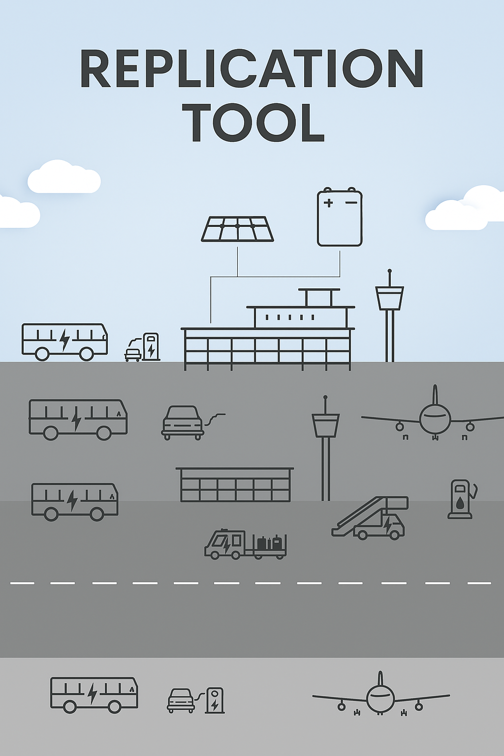

This project has received funding from the European Union’s Horizon 2020 research and innovation programme under grant agreement No 957824

SAF Readiness Level – Self assessment List

Tool 2.4

This section is dedicated to understanding the level of SAF readiness for airports, fuel suppliers, and aircraft operators. Using this self-assessment checklist, readers will be able to understand if they have all that is necessary to facilitate, supply, and use SAF at an airport aimed at optimizing the climate benefits through target use.
For airports, the following self-assessment checklist provides guidance on incorporating SAF into ground operations. Depending on the current infrastructure, an airport may be equipped to segregate different fuel grades and types, or it may need to handle SAF co-mingled with CAF. Airports that are equipped to segregate fuel will be ready to offer clients more options to minimize their climate impacts. Where segregation isn't possible, there are significant opportunities to improve LAQ.
For fuel suppliers, this self-assessment checklist provides guidance on incorporating SAF into airport fueling storage and handling operations. Depending on the current infrastructure of an airport, a fuel supplier may be equipped to segregate different fuel grades and types, or it may need to handle SAF co-mingled with CAF. Fuel suppliers that can accommodate the segregation of fuel will be ready to offer clients more options to minimize their non-CO2 climate impacts. Where segregation isn't possible, there are significant opportunities to offer clients improvement on LAQ levels.
For aircraft operators, this self-assessment checklist provides guidance on incorporating SAF usage to daily flight operations. Depending on the current infrastructure of an airport, a fuel supplier may be equipped to segregate different fuel grades and types, or it may need to handle SAF co-mingled with CAF. Where fuel segregation is feasible, aircraft operators will find the opportunity to optimize environmental benefits from SAF usage minimizing the non-CO2 climate impacts from contrails. Where segregation isn't possible, there are significant opportunities for aircraft operators to improve LAQ levels through the targeted use of SAF.
After completing the self-assessment, airports, fuel suppliers, and aircraft operators will have determined their positioning within the four SAF usage scenarios outlined in Section 4.1.1 of the handbook:
- Scenario 1 – Co-mingled.
- Scenario 2 – Dedicated Flights
- Scenario 3 – Dedicated Airports
- Scenario 4 – Non-Drop-In fuel
Ultimately, this self-assessment provides guidance to ensure compliance with applicable regulations while helping maximize non-CO₂ and LAQ benefits of SAF both in-flight and on the ground.

How to use this checklist
This checklist has been developed based on a skeleton of mazes that consider all possible options for SAF usage under the 4 established scenarios aimed at optimizing climate benefits and compliance with applicable regulations. The following illustration provides a glimpse of the extensive work performed:
Figure 44 - SAF Readiness Level Self-Assessment Checklist
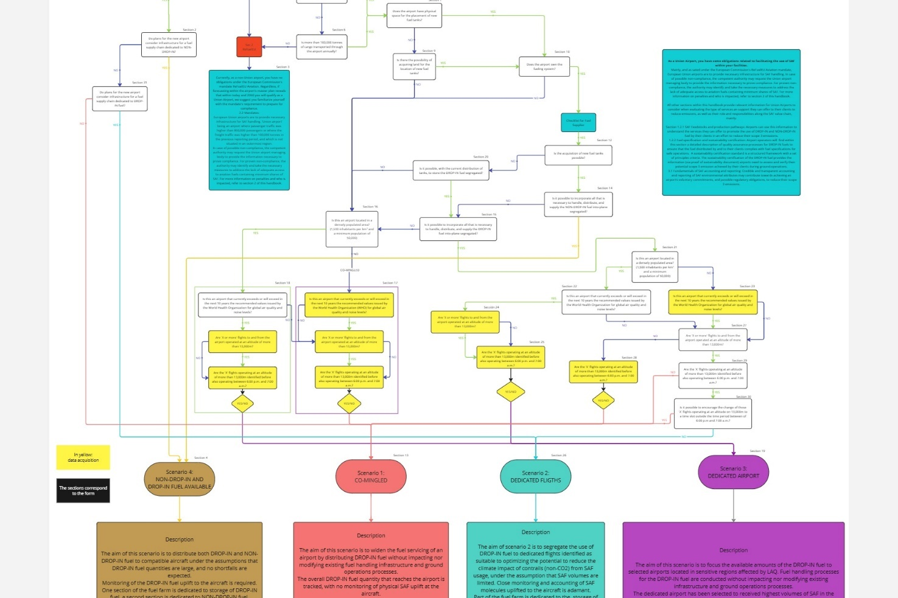
Following is a step-by-step guidance on how to use the self-assessment checklist:

Airports - Step-by-Step Instructions
Before you begin the self-assessment, there are several sets of valuable data we recommend you have handy:
To determine an airport’s suitability to optimize the use of SAF aimed at minimizing the impact of contrail formation, it is essential to first assess if the airport handles sufficient traffic of ‘dedicated flights.’ A dedicated flight is one that has been classified as having a greater potential to generate a contrail. While several parameters must be considered, and uncertainties remain regarding the accuracy of identifying these flights, two parameters are primarily associated with ‘dedicated flights:’ they operate at an altitude of over 13,000 meters and during nighttime hours, specifically between 6:00 p.m. and 7:00 a.m. for the purpose of this exercise.
Airports that can confirm that at least a certain number of flights arriving and departing operate at an altitude of over 13,000 meters and within the time range of 6:00 p.m. to 7:00 a.m. will be better positioned to understand if they can accommodate SAF usage scenario 2 – Dedicated flights.
Similarly, to understand if an airport is well suited to receive highest volumes of SAF aimed at improving LAQ, it is important to know the if it is located in a densely populate area (15,000 inhabitants per km2 and a minimum population of 50,000) and if the airport is currently exceeding or will exceed in the next 10 years the 2021 World Health Organization’s global air quality guidelines. For this assessment, those are the two parameters used that qualifies a ‘dedicated airport.’
If such data is not available, the self-assessment will still take you through the series of questions needed to determine your airport’s suitability among the remaining three scenarios.
You are now ready; follow the next steps to begin the checklist:
- Access:
- Use the following link to access the self-assessment checklist: https://forms.office.com/e/WuSd1fLtQv
- Enter your email address as user ID, chose and password, sign in, and follow the flow of the questions. You can navigate forward by answering the questions and clicking on the ‘next’ button. You can easily return to the previous screen if you want to edit your answer by clicking on the ‘back’ button. There is also an option to “save and exit” allowing you to come back to the self-assessment at your convenience from where you left off.
- Initial Identification:
Begin by determining whether your airport is new or already existing. This distinction will guide you through the subsequent questions tailored to your specific circumstances.
- Fuel Segregation Capability:
- Assess whether your airport's infrastructure supports the segregation of fuel grades and types. If feasible, segregating sustainable drop-in and non-drop in fuel from CAF can provide more options for reducing the climate impact of contrail formation.
- If segregation is not possible, focus on the opportunities to improve LAQ.
- Compliance with Regulations:
- Review the checklist to ensure your airport meets the necessary infrastructure requirements for fuel handling as well as obligations on SAF availability as stipulated by the European Commission's RFEUA mandate.
- Familiarize yourself with the definition of a "Union airport" and the relevant passenger and freight traffic thresholds that may apply.
- Infrastructure and Space Evaluation:
- Determine if your airport has the physical space required for new fuel tanks and related infrastructure.
- Assess whether the airport owns the fueling system and has the capability to acquire new fuel tanks if necessary.

- Scenario Identification:
Based on your responses, the checklist will guide you to identify your airport's positioning within the four SAF usage scenarios outlined in Section 4.1.1 of the handbook:
- Co-Mingled: For airports distributing drop-in fuel within existing infrastructure without modifications.
- Dedicated Flights: For specific flights identified to optimize the non-CO₂ benefits of SAF usage.
- Dedicated Airport: For airports selected to receive high volumes of drop-in fuel to improve LAQ in sensitive regions.
- Non-Drop-In SAF Available: For airports with dedicated infrastructure for both drop-in and non-drop-in fuels.
- Conclusion:
By thoroughly completing this self-assessment checklist, you would by the end have situated your airport within the recommended SAF usage scenario. This will help ensure compliance with regulations and allow the airport to offer its clients a variety of services and opportunities to enhance local air quality and maximize the environmental benefits of SAF both in-flight and on the ground.

Fuel Supplier - Step-by-Step Instructions
Before you begin the self-assessment, there are several sets of valuable data we recommend you have handy:
To determine a fuel supplier’s suitability to provide fueling services that can optimize the use of SAF to minimize the impact of contrail formation, it is essential to first assess if the airport handles sufficient traffic of ‘dedicated flights.’ A dedicated flight is one that has been classified as having a greater potential to generate a contrail. While several parameters must be considered, and uncertainties remain regarding the accuracy of identifying these flights, two parameters are primarily associated with ‘dedicated flights:’ they operate at an altitude of over 13,000 meters and during nighttime hours, specifically between 6:00 p.m. and 7:00 a.m. for the purpose of this exercise.
Fuel suppliers who can confirm that the airport under consideration has at least X number of flights arriving and departing operating at an altitude of over 13,000 meters and within the time range of 6:00 p.m. to 7:00 a.m. will be better positioned to understand if they can accommodate SAF usage scenario 2 – Dedicated flights.
Similarly, to understand the opportunities a fuel supplier may have to offer fueling services to their clients looking to improve LAQ, it is important to know the airport under consideration is located in a densely populate area (15,000 inhabitants per km2 and a minimum population of 50,000) and if the airport is currently exceeding or will exceed in the next 10 years the 2021 World Health Organization’s global air quality guidelines. For this assessment, those are the two parameters used that qualifies a ‘dedicated airport.’
Fuel suppliers with access to the density of the population surrounding the airport and its LAQ data will have the opportunity to determine if they can accommodate SAF usage scenario 3 – Dedicated Airports.
If such data is not available, the self-assessment will still take you through the series of questions needed to determine your airport’s suitability among the remaining three scenarios.
You are now ready; follow the next steps to begin the checklist:
- Access:
- Use the provided link to access the self-assessment checklist: https://forms.office.com/e/qPPmJ6KXs0
- Enter your email address as user ID, choose a password, sign in, and follow the flow of the questions. Navigate forward by answering the questions and clicking on the ‘next’ button. Easily return to the previous screen if you want to edit your answer by clicking on the ‘back’ button. There is also an option to “save and exit” allowing you to come back to the self-assessment at your convenience from where you left off.
- Initial Identification:
Begin by selecting the airport where you would like to assess your SAF supply options and confirm that it is a Union Airport. This distinction will guide you through the subsequent questions tailored to your specific circumstances.
- Fuel Segregation Capability:
- Assess whether the fueling infrastructure at the selected airport supports the segregation of fuel grades and types. If feasible, segregating sustainable drop-in and non-drop in fuel from CAF can provide more options for reducing the climate impact of contrail formation.
- If segregation is not possible, focus on the opportunities to improve LAQ.
- Compliance with Regulations:
- Review the checklist to ensure you meet the necessary infrastructure requirements for fuel handling as well as obligations on SAF availability as stipulated by the European Commission's RFEUA mandate.
- Familiarize yourself with the definition of a "Union airport" and the relevant passenger and freight traffic thresholds that may apply.
- Infrastructure and Space Evaluation:
- Determine if you own the fuel handling and storage infrastructure at the airport.
- Assess whether the airport's infrastructure can support segregation and storage of DROP-IN and NON-DROP-IN fuels.
- Determine if you can acquire new fuel tanks if necessary to enhance segregation capabilities.

- Scenario Identification:
Based on your responses, the checklist will guide you to identify your readiness level within the four SAF usage scenarios outlined in Section 4.1.1 of the handbook:
- Co-Mingled: For airports distributing drop-in fuel within existing infrastructure without modifications.
- Dedicated Flights: For specific flights optimized to benefit from SAF usage.
- Dedicated Airport: For airports designated to receive high volumes of drop-in fuel helping improve LAQ.
- Non-Drop-In SAF Available: For infrastructure supporting both drop-in and non-drop-in fuels.
- Conclusion:
By completing this self-assessment checklist, you will determine your readiness level for supplying SAF. This will help ensure compliance with regulations and enable you to offer a variety of services and opportunities to your clients aimed at improving LAQ and maximizing the environmental benefits of SAF both in-flight and on the ground.

Aircraft Operators - Step-by-Step Instructions
Before you begin the self-assessment, there are several sets of valuable data we recommend you have handy:
To determine an aircraft operator can optimize the use of SAF aimed at minimizing the impact of contrail formation, it is essential to first assess if they have sufficient traffic of ‘dedicated flights’ at the airport under consideration. A dedicated flight is one that has been classified as having a greater potential to generate a contrail. While several parameters must be considered, and uncertainties remain regarding the accuracy of identifying these flights, two parameters are primarily associated with ‘dedicated flights:’ they operate at an altitude of over 13,000 meters and during nighttime hours, specifically between 6:00 p.m. and 7:00 a.m. for the purpose of this exercise.
Airports that can confirm that at least a certain number of flights arriving and departing operate at an altitude of over 13,000 meters and within the time range of 6:00 p.m. to 7:00 a.m. will be better positioned to understand if they can accommodate SAF usage scenario 2 – Dedicated flights.
Similarly, to understand if an airport is well suited to receive highest volumes of SAF aimed at improving LAQ, it is important to know the if it is located in a densely populate area (15,000 inhabitants per km2 and a minimum population of 50,000) and if the airport is currently exceeding or will exceed in the next 10 years the 2021 World Health Organization’s global air quality guidelines. For this assessment, those are the two parameters used that qualifies a ‘dedicated airport.’
If such data is not available, the self-assessment will still take you through the series of questions needed to determine your airport’s suitability among the remaining three scenarios.
You are now ready; follow the next steps to begin the checklist:
- Access:
- Use the provided link to access the self-assessment checklist: https://forms.office.com/e/Jzr7HNxAz8
- Enter your email address as user ID, choose a password, sign in, and follow the flow of the questions. Navigate forward by answering the questions and clicking on the ‘next’ button. Easily return to the previous screen if you want to edit your answer by clicking on the ‘back’ button.
- Initial Identification:
Begin by selecting the airport where you would like to assess your SAF supply options and confirm that it is a Union Airport. Determine whether your company operates at least 500 commercial passenger air transport flights or at least 52 commercial all-cargo air transport flights departing from the selected Union airport in the previous reporting period. This distinction will guide you through the subsequent questions tailored to your specific circumstances.
- Fuel Segregation Capability:
- Assess whether your fuel supplier can provide you with fuel supply services that accommodate the segregation of fuel grades and types. If feasible, segregating sustainable drop-in and non-drop in fuel from CAF can provide more options for reducing the climate impact of contrail formation.
- If segregation is not possible, focus on the opportunities your fuel supplier can provide you with to improve LAQ.
- Compliance with Regulations:
Familiarize yourself with the definition of a "Union airport" and the relevant passenger and freight traffic thresholds that may apply.
- Infrastructure and Space Evaluation:
- Confirm if your fuel supplier can accommodate segregated supply of sustainable drop-in fuel to facilitate the uplift onto dedicated flights.
- Confirm if your fuel supplier can accommodate segregated and separated supply of sustainable non-drop-in fuel to allow the uplift onto compatible aircraft.
- Confirm if your fuel supplier is not able to provide you with services that accommodate fuel segregation.
- Scenario Identification:
Based on your responses, the checklist will guide you to identify your readiness level within the four SAF usage scenarios outlined in Section 4.1.1 of the handbook:
- Co-Mingled: For airports distributing drop-in fuel within existing infrastructure without modifications.
- Dedicated Flights: For specific flights optimized to benefit from SAF usage.
- Dedicated Airport: For airports designated to receive high volumes of drop-in fuel to improve LAQ.
- Non-Drop-In SAF Available: For infrastructure supporting both drop-in and non-drop-in fuels.
- Conclusion:
By completing this self-assessment checklist, you will determine your readiness level for incorporating SAF. This will help ensure compliance with regulations and enable you to optimize the environmental benefits of SAF both in-flight and on the ground.

