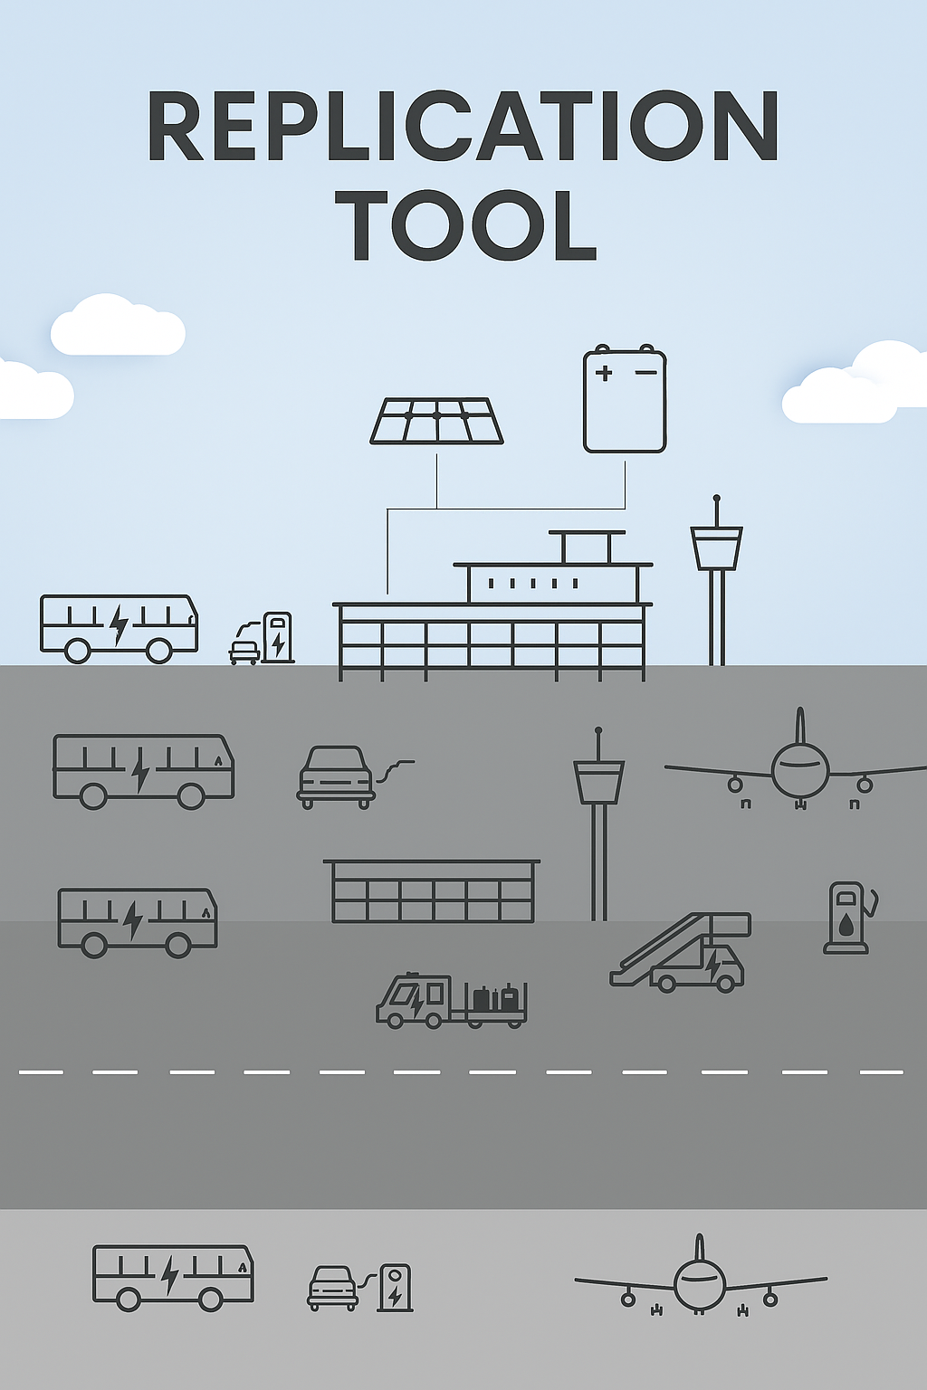

This project has received funding from the European Union’s Horizon 2020 research and innovation programme under grant agreement No 957824

The SAF Pool Program

Tool 2.8

The purpose of the SAF pool
- The aviation industry is collaborating on a common climate challenge
- The initiative must state that the aviation industry is ready for increased climate action
- Better conditions must be created for more and better SAF products on the marked
- This first step is followed up with the involvement of more partners who wants this development
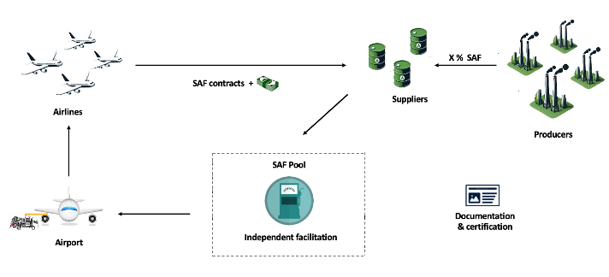
- SAF Pool must provide experience with practical and administrative challenges

Main steps of the SAF Pool initiative

- Find out if there is a basis and sufficient interest in the initiative
- Call in key players and clarify the further process
- Clarify the prerequisites
  - Participants in the value chain: Producer, supplier, airport, airlines
  - Financially and interest – neutral facilitator is chosen
  - SAF availability, quantities, delivery time, price
  - Legal and competitive conditions
- Assess the initiative in relation to other initiatives, legislation, mandates, etc.
- Primary players are airlines/payer: Ensure that SAF purchases can be incorporated into conventional fuel contracts
  - Can secondary players participate, for example airports, customers, etc.?
  - Assess the advantages and disadvantages:
  - Value of participating (marketing, CO2 reduction, lower price?)
  - Investigate the marked for SAF qualities, feedstock, transparency, etc.
  - Assess whether joint or individual marketing is initiated (possibly combined)
  - Clarify who is responsible for which administrative and computational tasks

