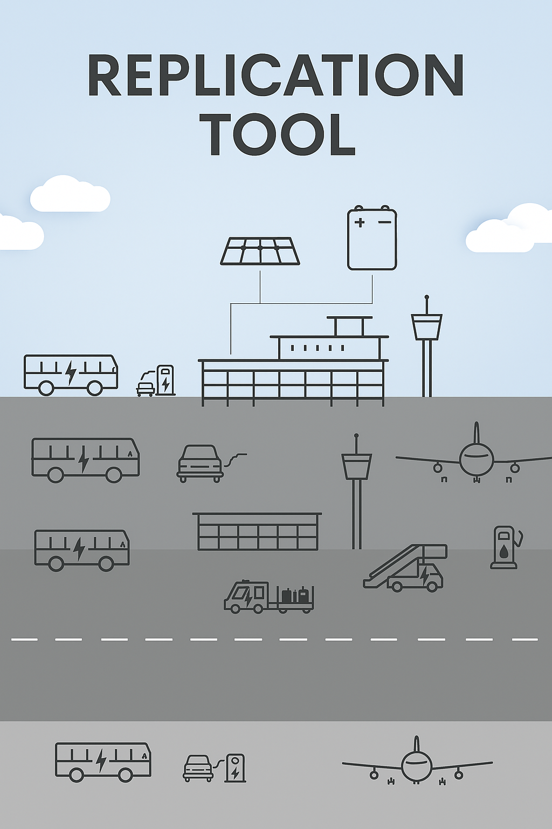

This project has received funding from the European Union’s Horizon 2020 research and innovation programme under grant agreement No 957824

Global overview of SAF producers

Tool 2.9

A geographical map combined with a comprehensive list of current and emerging SAF producers serves as a strategic planning and decision-support tool for the aviation industry. By providing a visual representation of producer locations in relation to buyers, airports, fuel distribution networks, and logistical corridors, the tool enables airlines, airport operators, and aviation fuel purchasers to assess regional supply availability and infrastructure compatibility. The map and list are also relevant to stakeholders as a combined overview of global SAF production capacity and development status. This broader overview is especially useful for understanding how the SAF market is developing and where production is growing. With access to contact details and key information about producers, it becomes easier to get in touch, compare options, plan agreements, and make long-term decisions about fuel sourcing.
The SAF producers are marked with a color based on their production pathway.
Link to map: SAF producers map overview
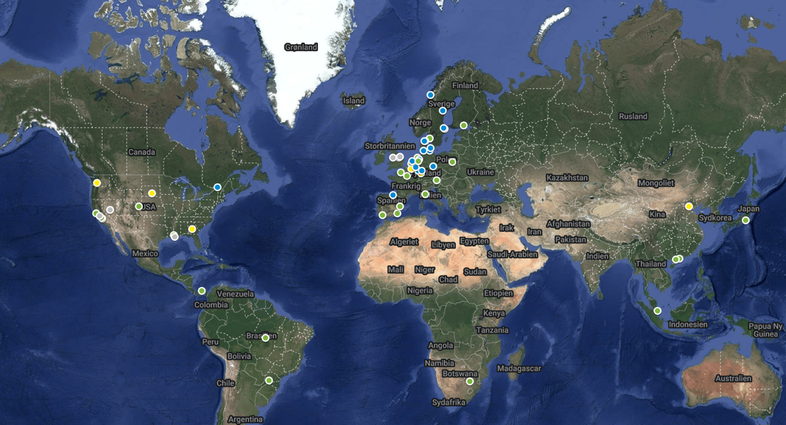
The list features the following types of information:
- Partner, projects and agreements
- Producer/supplier company
- Location for plant
- Start year
- Pathway
- Feedstock
- Capacity/Year
- Link to placement on SAF producer map overview
Link to list: SAF producers list overview

