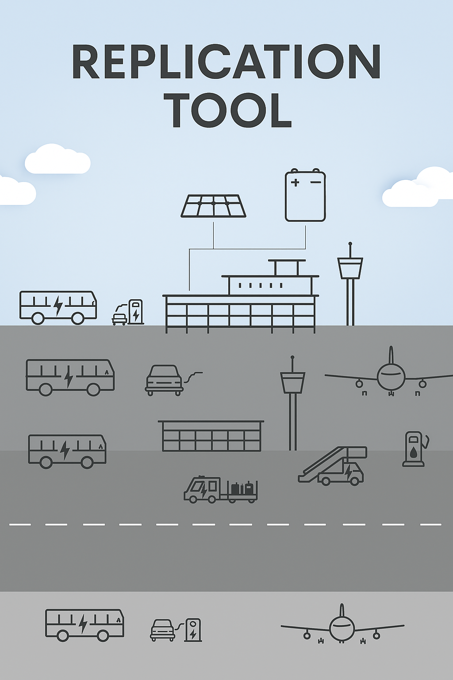
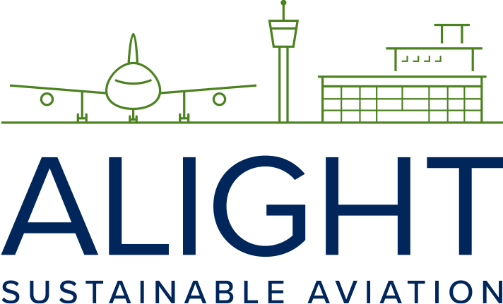
This project has received funding from the European Union’s Horizon 2020 research and innovation programme under grant agreement No 957824

Checklist of Airport’s role in SAF purchase and development

Tool 2.10

This checklist outlines the airport’s role in SAF procurement and development, and operates as a practical tool to clarify responsibilities, identify opportunities, and ensure coordinated action across stakeholders. Airports play a central role in the SAF ecosystem by acting as infrastructure hubs, logistical enablers, and potential facilitators of offtake agreements. They can support the transition by integrating SAF into existing fuel supply chains, engaging with fuel producers and airlines, and encouraging investment in on-site blending, storage, and distribution facilities. The checklist helps airports assess their current readiness, define next steps, and contribute actively to scaling up the use of sustainable aviation fuel.
What role can airports play in the development and use of SAF
Indicate yes/no if it is up to the airport to decide | Direct | Indirect | Airport decision  yes/no
Purchase SAF for the airport's own flights or shipments
Purchase SAF for the airport's users against full or partial payment
Price agreement with producers/supplier or bulk purchase agreements on behalf of airlines/customers (SAF Pool)
Investment in own tanks to purchase SAF
Financial support for airlines and customers' purchases of SAF
Increase in Pax or take-off fees to pay SAF premium price
Establish airport incentive schemes to co-finance SAF premium prices
Establish airport incentive schemes to co-finance SAF premium prices
Establish partnerships to scale up the SAF-marked

