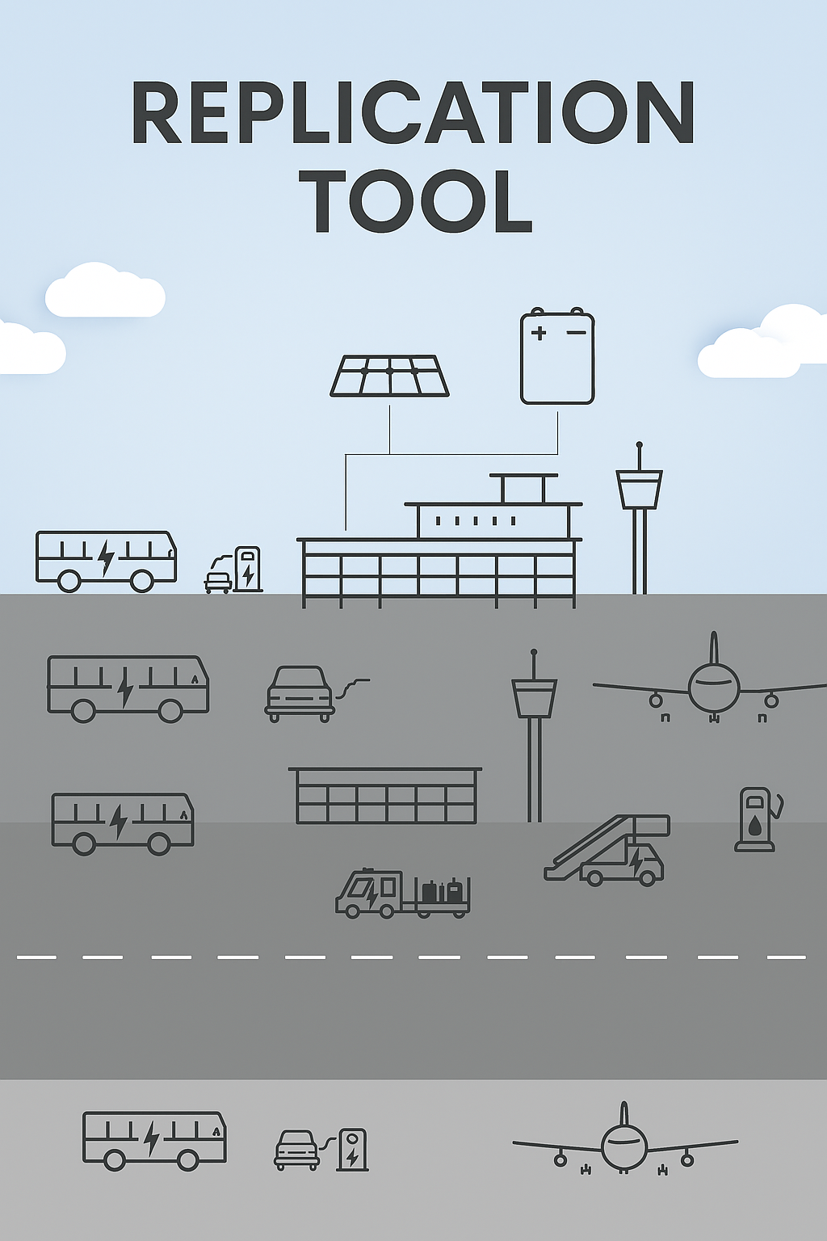
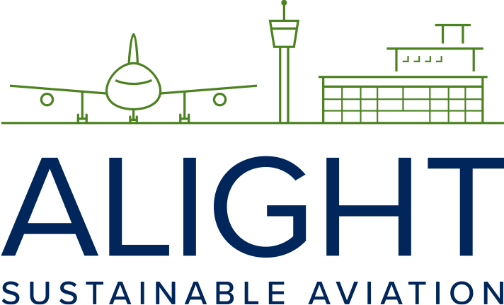
This project has received funding from the European Union’s Horizon 2020 research and innovation programme under grant agreement No 957824

SAF purchasing option

Fly Green Fund

Tool 2.12

Fly Green Fund can be used as a practical tool for exploring and understanding voluntary SAF purchasing options, especially for aviation stakeholders and companies focused on climate impact. The text provides insight into pricing structure, certification, CO₂ savings, and how SAF can serve as an alternative to traditional carbon offsetting. As a working tool, it helps assess concrete opportunities for partnerships, procurement, and reporting related to Scope 3 emissions and upcoming CSRD requirements.

Fly Green Fund is a non-profit organization established* in 2015, dedicated to enabling air travelers to reduce their climate impact through carbon in setting using sustainable aviation fuel (SAF). As an alternative to traditional carbon offsetting, the fund also actively supports research initiatives aimed at expanding SAF supply.

Since its inception, Fly Green Fund has facilitated the funding of 2,600 tons of SAF, resulting in the avoidance of approximately 6,600 tons of fossil CO₂ emissions.

The current charge is €0.45 per kilogram of fossil CO₂ avoided through SAF use. This reflects the price premium of SAF over conventional jet fuel. Notably, SAF procured by Fly Green Fund on behalf of its customers is purchased by airlines or airports at the market price for conventional jet fuel—ensuring customers are not double-charged (once by the airline and once by the Fly Green Fund).

All SAF procured is third-party certified under either the International Sustainability and Carbon Certification (ISCC) or the Roundtable on Sustainable Biomaterials (RSB). The associated carbon credits are retired in accordance with the respective SAF registries. SAF bought via the Fly Green Fund is not included in the EU ETS and cannot be used by fuel suppliers or airlines to meet any blending requirements.

To date, Fly Green Fund has sourced SAF from leading producers including World Energy, Neste, and St1. Deliveries have been made as drop-in fuel to airports in Sweden, Finland, the Netherlands, and the United States.

At present, there are no indications that the RefuelEU Aviation initiative will negatively affect the voluntary SAF market—largely due to its modest initial mandate of 2%, alongside the steady growth of new production capacity. Furthermore, Fly Green Fund anticipates that the Corporate Sustainability Reporting Directive (CSRD) will stimulate increased demand for SAF-based carbon in setting, particularly as scrutiny around traditional carbon offsetting continues to rise.

*Established by Karlstad Airport, SkyNRG and NISA with support from several Nordic partners within the aviation industry.

